Supplementary material
Table S1. Overview of the questions and answer options included in the Muggenradar questionnaire.
Question | Answer options
Do you have any pets at home, and if so, which ones? | Yes  Bird  Cat  Dog  Rabbit  Rodent  Other  No
Do you have a crawlspace underneath your residence and if so, is it filled with water? | Yes, and it is (partially) filled with stagnant water.  Yes, and it is dry.  No
Did you experience any mosquito nuisance? | Yes, on (date)  No
Where did you collect the mosquito? | Bathroom  Bedroom  Kitchen  Living room  Other;
How many mosquitoes did you find indoors? | Between 1 – 5  Between 6 – 10  More than 10

Table S2. Number of georeferenced submissions (including filled-out questionnaire) to the Muggenradar platform between February 16th and February 26th, 2021, divided per province. Per province, the number of submissions per inhabitant was calculated, based on the number of inhabitants as of September 2022 [1]. In addition, the total number and percentages of submissions with crawlspaces, both dry and wet, are displayed. Percentages of dry and wet crawlspaces are based on residences with crawlspaces only.
Province | Total | No. of inhabitants (Sep. 2022) | No. of submissions per inhabitant (* 10.000) | Residences with crawlspaces (%) | Dry crawlspace (%) | Wet crawlspace (%)
Groningen | 223 | 595,011 | 3.7 | 155 (69.5) | 120 (77.4) | 35 (22.6)
Friesland | 245 | 658,747 | 3.7 | 202 (82.4) | 160 (79.2) | 42 (20.8)
Drenthe | 219 | 501,327 | 4.4 | 167 (76.3) | 144 (86.2) | 23 (13.8)
Overijssel | 294 | 1,181,720 | 2.5 | 243 (82.7) | 217 (89.3) | 26 (10.7)
Flevoland | 100 | 441,874 | 2.3 | 91 (91.0) | 83 (91.2) | 8 (8.8)
Gelderland | 554 | 2127,493 | 2.6 | 400 (72.2) | 370 (92.5) | 30 (7.5)
Utrecht | 667 | 1,382,302 | 4.8 | 524 (78.6) | 456 (87.0) | 68 (13.0)
Noord-Holland | 1103 | 2,941,163 | 3.8 | 789 (71.5) | 661 (83.8) | 128 (16.2)
Zuid-Holland | 1067 | 3,787,452 | 2.8 | 844 (79.1) | 653 (77.4) | 191 (22.6)
Zeeland | 48 | 390,636 | 1.2 | 23 (47.9) | 16 (69.6) | 7 (30.4)
Noord-Brabant | 405 | 2,617,331 | 1.5 | 164 (40.4) | 145 (88.4) | 19 (11.6)
Limburg | 94 | 1,124,206 | 0.8 | 46 (48.9) | 44 (95.7) | 2 (4.3)
The Netherlands | 5019 | 17,749,262 | 2.8 | 3648 (72.7) | 3069 (84.1) | 579 (15.9)
Figure S1. Map depicting the proportion of Muggenradar submissions originating from residences without a crawlspace, with a dry crawlspace, and with a wet (flooded) crawlspace per province. A relatively high percentage of crawlspace flooding (20%) can be observed in the coastal provinces, compared to a lower percentage of crawlspace flooding (10.8%) in inland provinces. The map was created by the authors, using QGIS software (version 3.22 ‘Białowieża’; QGIS Development Team, 2021). Administrative boundary data were obtained from Statistics Netherlands (CBS): ‘CBS Gebiedsindelingen 2016-2025’ (https://www.cbs.nl/nl-nl/dossier/nederland-regionaal/geografische-data/cbs-gebiedsindelingen).
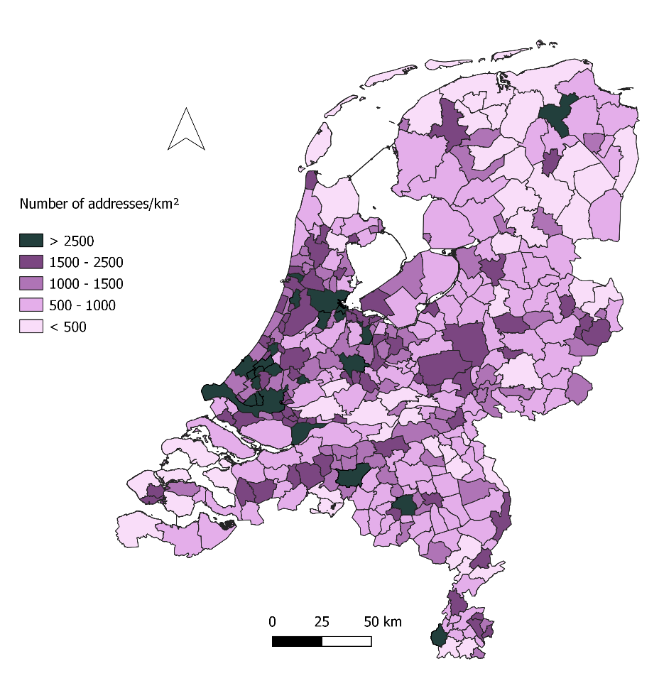
Figure S2. Map displaying the human population density per municipality, expressed in number of addresses per km² [1]. The map was created by the authors, using QGIS software (version 3.22 ‘Białowieża’; QGIS Development Team, 2021). Administrative boundary data were obtained from Statistics Netherlands (CBS): ‘CBS Gebiedsindelingen 2016-2025’ (https://www.cbs.nl/nl-nl/dossier/nederland-regionaal/geografische-data/cbs-gebiedsindelingen).

Table S3. Results of the statistical analyses performed on the different population density levels used in our study: low (<500 postal codes/km²), low-medium (500-1000 postal codes/km²), medium (1000-1500 postal codes/ km²), medium-high (1500-2500 postal codes/km²), and high (>2500 postal codes/km²). Overall differences were calculated using Pearson’s chi-square test and pairwise comparisons were corrected with a Bonferroni correction. Adjusted p-values < 0.05 are depicted in bold.
Pairwise comparison |  | Χ²-value | df | p-value | Adjusted p- value
Pop. Density
Low | Low-medium | 7.075 | 2 | 0.029 | 0.291
Low | Medium | 10.12 | 2 | 0.006 | 0.063
Low | Medium-high | 16.213 | 2 | < 0.001 | 0.003
Low | High | 33.367 | 2 | < 0.001 | < 0.001
Low-medium | Medium | 6.2433 | 2 | 0.044 | 0.441
Low-medium | Medium-high | 8.1749 | 2 | 0.017 | 0.168
Low-medium | High | 13.478 | 2 | 0.001 | 0.012
Medium | Medium-high | 1.0382 | 2 | 0.595 | 5.950
Medium | High | 11.464 | 2 | < 0.001 | 0.032
Medium-high | High | 6.1538 | 2 | 0.046 | 0.461
Overall |  | 44.324 | 8 | 4.94E-07

Table S4. Overview of the successful blood meal identifications originating from Cx. pipiens s.s. mosquitoes submitted to Muggenradar. Distinctions are made between biotype molestus, biotype pipiens, pipiens/molestus hybrids, and specimens of which the molecular identification was unsuccessful (NA).
Culex pipiens s.s. biotype | Blood meal host | No.
Molestus | H. sapiens | 168
 | N. hollandicus | 1
 | C. lupus familiaris | 2
Pipiens | C. palumbus | 1
 | H. sapiens | 2
pipiens/molestus hybrid | H. sapiens | 22
NA | B. taurus | 1
 | G. gallus | 1
 | H. sapiens | 9

References
[1] CBS. (2023). Inwonertal per provincie, 1 september 2022. https://www.cbs.nl/nl-nl/maatwerk/2023/07/inwonertal-per-provincie-1-september-2022

