Supplementary Figures and Tables
Supplementary Figures

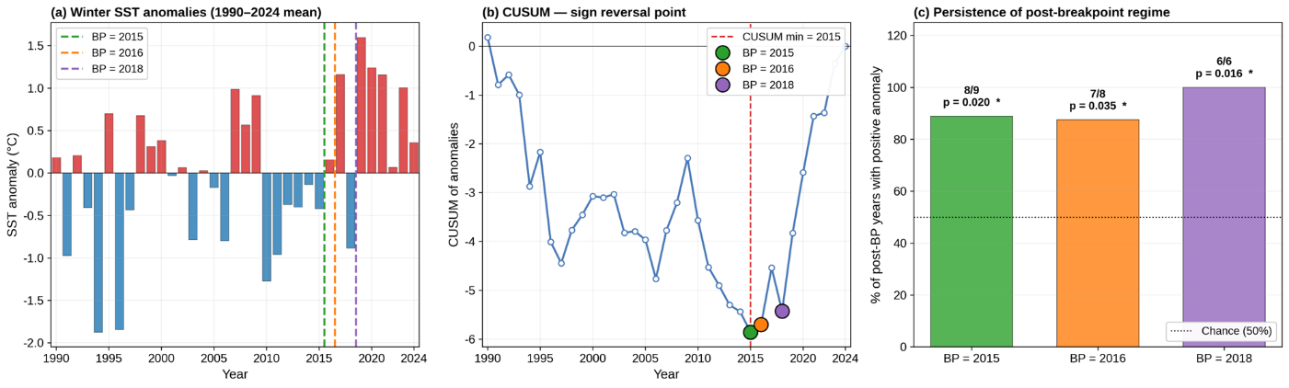
Supplementary Figure S1. The figure shows (a) the winter SST anomaly time series with the three candidate breakpoints (2015, 2016, 2018) overlaid; (b) the CUSUM of SST anomalies calculated relative to the 1990–2024 full-period mean, with its minimum at 2015 marking the onset of a sustained sign reversal; and (c) the binomial persistence test for each candidate breakpoint, where post-breakpoint positive anomaly persistence was evaluated relative to the 1990–2014 pre-onset climatology.

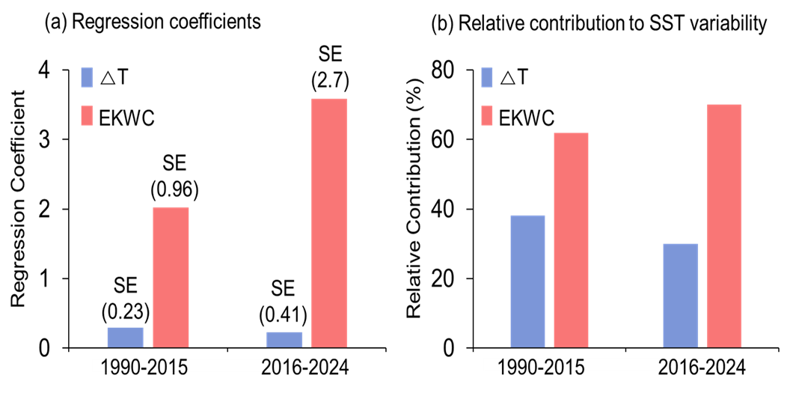
Supplementary Figure S2. Regression results of winter SST variability in the WES using ΔT (SST–AT thermal contrast, blue) and EKWC strength (red) as predictors. (a) Raw regression coefficients and (b) standardized contributions are shown for the pre-shift (1990–2015) and post-shift (2016–2024) periods. The results suggest a qualitative increase in the relative contribution of EKWC after 2015; however, the low explanatory power of the two-predictor model and the non-significant coefficient change indicate that this pattern should be interpreted cautiously.

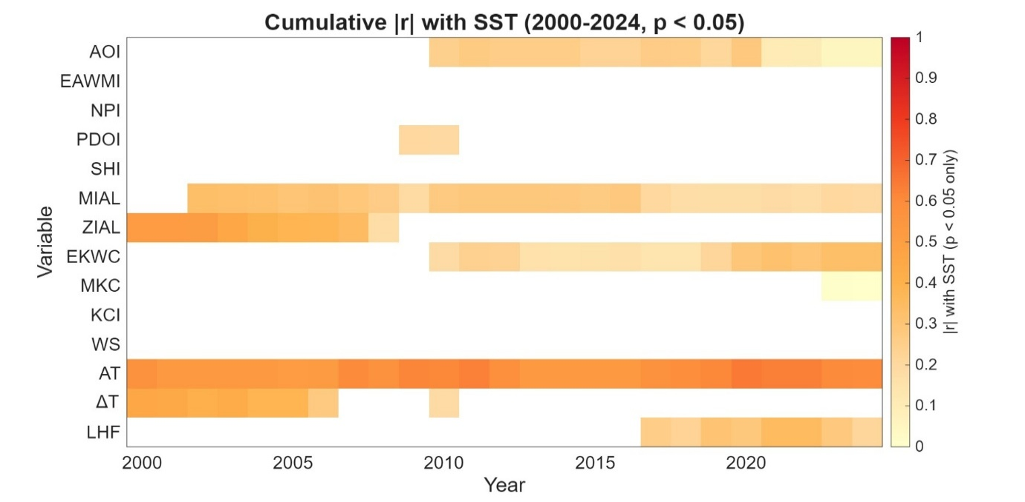
Supplementary Figure S3. Expanding correlations between winter SST in the WES and candidate atmospheric and oceanic drivers during 2000–2024. Absolute correlation coefficients (|r|) with p < 0.05 are displayed in color; values with p ≥ 0.05 are left blank. Variables include climate indices (AOI, EAWMI, NPI, PDOI, SHI, MIAL, ZIAL) and local forcing variables (EKWC, MKC, KCI, AT, WS, ΔT, LHF). Warmer colors indicate stronger correlations. The results show that atmospheric indices (AOI, MIAL, ZIAL) and ΔT were prominently associated with SST variability during the earlier part of the record, while EKWC and other local variables showed stronger recent associations in some expanding windows. These patterns should be interpreted as evolving associations rather than direct evidence of causality.

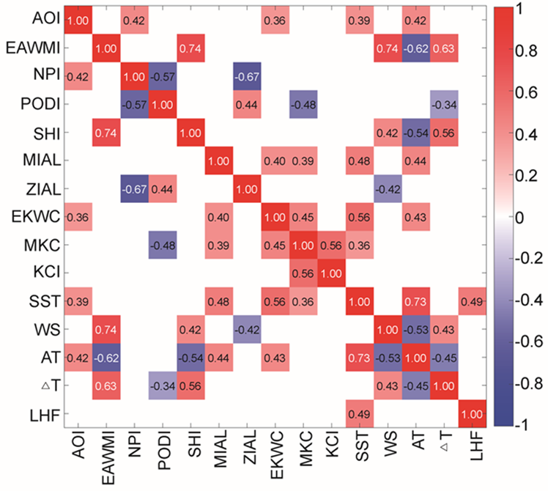
Supplementary Figure S4. Correlation matrix among winter SST, large-scale climate indices, and local forcing variables in the WES during 1990–2024. Variables include atmospheric indices (AOI, EAWMI, NPI, PDOI, SHI, MIAL, ZIAL), oceanic drivers (EKWC, MKC, KCI), and local flux terms (AT, WS, ΔT, LHF). Color shading denotes the magnitude and sign of Pearson correlation coefficients, with red (positive) and blue (negative) indicating the direction of association. Positive correlations are observed among SST, EKWC, and MIAL, suggesting coherent covariation among atmosphere–ocean indices. These correlations should not be interpreted as evidence of direct causality.

Supplementary Table

Period | Variable | VIF | Partial r | p-value | Sig.
Pre-2015 | AT | 2.23 | +0.687 | 0.007 | **
(n = 14) | WS | 2.48 | +0.182 | 0.534 | ns
 | LHF | 2.69 | –0.068 | 0.817 | ns
 | EKWC | 1.17 | +0.631 | 0.016 | *
Post-2015 | AT | 36.54 | –0.384 | 0.307 | ns
(n = 9) | WS | 30.13 | –0.525 | 0.146 | ns
 | LHF | 10.95 | +0.714 | 0.031 | *
 | EKWC | 4.41 | +0.671 | 0.048 | *
Supplementary Table S1. Multicollinearity diagnostics and partial correlations for the Table 1 regression model (SST ~ AT + WS + LHF + EKWC). VIF values below 5 indicate acceptable collinearity, 5–10 moderate concern, and > 10 high collinearity. Partial correlations quantify each predictor’s unique association with SST after controlling for the remaining predictors. Significance symbols: ** p < 0.01, * p < 0.05, † p < 0.10.

Model type | Predictors | R² | p-value
Full period (1990–2024, n = 35)
Single | MIAL | 0.232 | 0.003
Single | AOI | 0.149 | 0.022
Single | PDOI | 0.094 | 0.074
2-variable | AOI + MIAL | 0.326 | 0.002
2-variable | PDOI + MIAL | 0.311 | 0.003
2-variable | NPI + MIAL | 0.277 | 0.006
3-variable | AOI + PDOI + MIAL | 0.377 | 0.002
3-variable | AOI + EAWMI + MIAL | 0.328 | 0.006
All-variable | AOI + EAWMI + NPI + PDOI + SHI + MIAL + ZIAL | 0.397 | 0.039
Pre-shift (Group A: 1990–2015, n = 26)
Single | MIAL | 0.277 | 0.006
Single | AOI | 0.251 | 0.009
Single | PDOI | 0.105 | 0.107
2-variable | AOI + MIAL | 0.412 | 0.002
2-variable | PDOI + MIAL | 0.368 | 0.005
2-variable | NPI + MIAL | 0.289 | 0.020
2-variable | EAWMI + MIAL | 0.283 | 0.022
3-variable | AOI + PDOI + MIAL | 0.459 | 0.003
3-variable | AOI + NPI + MIAL | 0.415 | 0.007
Post-shift (Group B: 2016–2024, n = 9)
Single | MIAL | 0.002 | 0.918
Single | AOI | 0.003 | 0.882
Single | EAWMI | 0.281 | 0.142
Single | PDOI | 0.010 | 0.793
2-variable | EAWMI + MIAL | 0.344 | 0.283
2-variable | AOI + EAWMI | 0.287 | 0.362
2-variable | AOI + MIAL | 0.004 | 0.989
3-variable | AOI + EAWMI + MIAL | 0.406 | 0.418
Supplementary Table S2. Performance of multiple linear regression models explaining winter SST variability in the WES. Models are reported separately for the full period (1990–2024), pre-shift period (Group A: 1990–2015), and post-shift period (Group B: 2016–2024). Candidate predictors include large-scale atmospheric indices (AOI, PDOI, NPI, EAWMI, SHI) and Aleutian Low position indices (MIAL, ZIAL). The coefficient of determination (R²) and the model p-value (F-test for overall regression significance) are reported. After the regime shift (Group B), no single atmospheric index provided a statistically robust explanation of SST variability, reflecting the limited post-shift sample size; only the AOI–EAWMI–MIAL combination showed moderate apparent explanatory power, but the model was not statistically significant.

Period | PSC variable | North sub-domain |  | South sub-domain
 |  | r | p | r | p
Full period (2003–2023) | pico | +0.14 | 0.545 | +0.37 | 0.102
 | nano | −0.14 | 0.547 | −0.36 | 0.106
 | micro | +0.01 | 0.958 | +0.02 | 0.930
 | chl | +0.18 | 0.441 | +0.13 | 0.590
Detrended (2003–2023) | pico | +0.11 | 0.630 | +0.37 | 0.097†
 | nano | −0.11 | 0.633 | −0.37 | 0.104
 | micro | +0.01 | 0.967 | +0.02 | 0.944
 | chl | +0.19 | 0.403 | +0.15 | 0.528
Pre-2015 (2003–2015) | pico | −0.03 | 0.932 | +0.20 | 0.503
 | nano | +0.05 | 0.874 | −0.20 | 0.512
 | micro | −0.10 | 0.740 | −0.04 | 0.890
 | chl | +0.09 | 0.769 | +0.13 | 0.674
Post-2015 (2016–2023) | pico | +0.26 | 0.542 | +0.70 | 0.053†
 | nano | −0.27 | 0.517 | −0.68 | 0.062†
 | micro | +0.14 | 0.735 | +0.00 | 0.992
 | chl | +0.35 | 0.390 | +0.04 | 0.932
Supplementary Table S3. Pearson correlation coefficients (r) and p-values between winter stratification intensity in the northern and southern sub-domains and phytoplankton size class (PSC) proportions and total chl-a.

Period | Response | n | Selected Predictors | R² | Adj. R²
2003–2015 | chl | 13 | PDOI, △T, EAWMI, WS | 0.61 | 0.42
2003–2015 | micro | 13 | PDOI, NPI, KCI, WS | 0.54 | 0.30
2003–2015 | nano | 13 | NPI, △T, ZIMA, PDOI | 0.39 | 0.08
2003–2015 | pico | 13 | NPI, △T, PDOI, ZIMA | 0.50 | 0.25
2016–2024 | chl | 9 | AOI, LHF, KCI | 0.58 | 0.34
2016–2024 | micro | 9 | LHF, KCI, EKWC | 0.58 | 0.33
2016–2024 | nano | 9 | EKWC, SST_EAST, MKC | 0.61 | 0.37
2016–2024 | pico | 9 | EKWC, SST_EAST, MKC | 0.57 | 0.32
Supplementary Table S4. Results of standardized multiple regression models identifying climatic and oceanic predictors of phytoplankton variability before (2003–2015) and after (2016–2024) the 2015 SST regime shift in the WES. For each response variable (total chlorophyll-a, micro-, nano-, and pico-phytoplankton), the table shows the number of years (n), selected predictors, and model performance (R² and adjusted R²).

Period (Years) | Variable | Significant Index | r | p-value | Direction
2003-2015 | Total chl-a | PDOI | 0.65 | 0.017 | Positive
 | micro | PDOI | 0.59 | 0.033 | Positive
 | nano | NPI | -0.56 | 0.045 | Negative
 | Pico | NPI | 0.64 | 0.017 | Positive
2016-2024 | Total chl-a | - | - | - | -
 | micro | LHF | -0.70 | 0.035 | Negative
 | nano | EKWC | -0.71 | 0.032 | Negative
 | pico | - | - | - | -
Test | Statistic | Effect size | p-value | Notes
PERMANOVA (pre vs post) | F = 3.05 | R² = 0.132 | 0.007 | n_pre = 13, n_post = 9
Procrustes (PCA loadings) | M² = 0.845 | - | 0.011 | Significant difference
Supplementary Table S5. Significant correlations between winter phytoplankton variables (total chlorophyll-a, micro-, nano-, and pico-phytoplankton) and climate indices before (2003–2015) and after (2016–2024) the 2015 SST regime shift in the WES. For each variable, the table lists the significant index, correlation coefficient (r), p-value, and direction of the relationship.

Supplementary Table S6. Results of multivariate statistical tests assessing regime-dependent shifts in phytoplankton–climate relationships before (2003–2015) and after (2016–2024) the 2015 SST regime shift in the WES. PERMANOVA detected a significant difference in community–climate structure between the two periods (F = 3.05, R² = 0.132, p = 0.007), based on 13 pre-shift and 9 post-shift years.

