EZH2 association with stemness signature and driver of esophageal squamous cell carcinomas

Fatemeh Nourmohammadi, Maryam M. Matin, Ahmad Reza Bahrami , Bingwei Lu, Vajiheh Zarrinpour, Mohammad Mahdi Forghanifard..

Table of contents

Supplemental Fig. S1 | Bar plot related to expression level differences between EZH2 and CSC markers in EZH2 manipulated KYSE-30 and YM-1 cell. Pro-Pro interaction and EZH2 western blotting. Related to Figure 1 and 2.
Supplemental Fig. S2 | Scatter plots related to CD44, CD133 and CD117 and Colony formation expression in EZH2 manipulated KYSE-30 and YM-1 cells. Related to Figure 3.
Supplemental Fig. S3 | Cell cycle analysis of EZH2 manipulated KYSE-30 and YM-1 cells by flow cytometry. Related to Figure 4.
Supplemental Fig. S4 | Assessment of cell death mechanism in EZH2 manipulated KYSE-30 and YM-1 cells. Related to Figure 5.
Supplemental Fig. S5 | Evaluating the effects of chemotherapeutic agents Cisplatin, 5-FU and their combination on the survival of EZH2 manipulated KYSE-30 and YM-1 cells by MTT assay. Related to Figure 5.
Supplemental Fig. S6 | Angiogenesis macroscopic images. Related to Figure 6.
Supplemental Table S1| ESCC patients EZH2 expression results.
Supplemental Table S2| Extracted via DAVID21and GEO34 analysis tools.
Supplementary Table S3| Extracted via Reactome23 and PANTHER analysis tools.
Supplemental Table S4|Molecular Docking Results for Protein-DNA Interactions with Selected CpG Islands.
Supplemental Table S5| The table demonstrates the nude mice weight changing after tumor transplantation.
Supplemental Table S6| The table demonstrates the scoring of H&E staining in nude mice esophageal tumor tissues.
Supplemental Table S7| Quantitative Analysis of Immunohistochemical Staining for Stemness Markers.
Supplemental Fig. S7 | The schematic summarizing EZH2 association with CSC.
Supplemental Table S8| Stemness CSC Markers in ESCC under EZH2 regulation and their expression.
Supplemental Table S9| Abbreviations used.
Supplemental Table S10| Primer utilized.
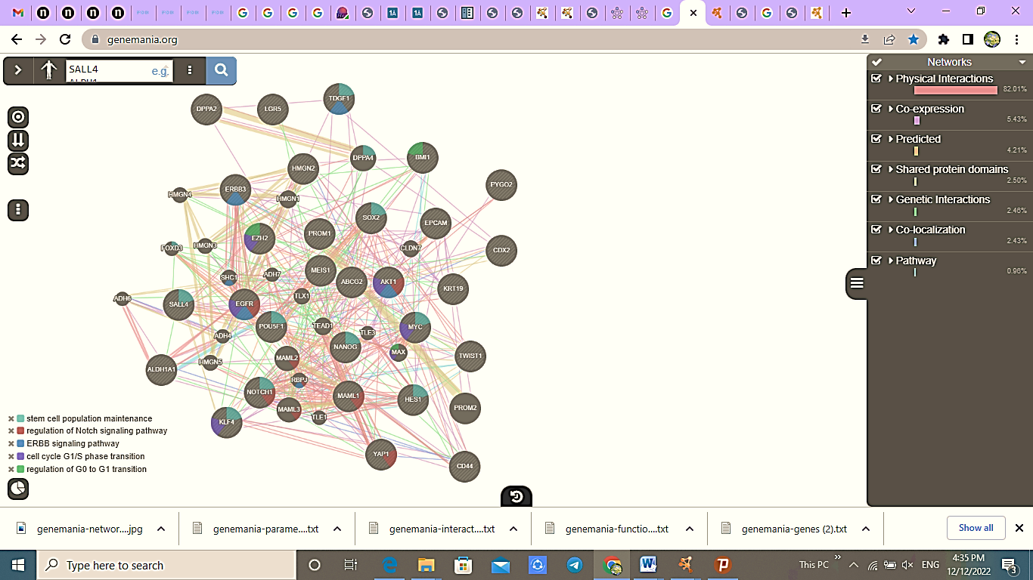
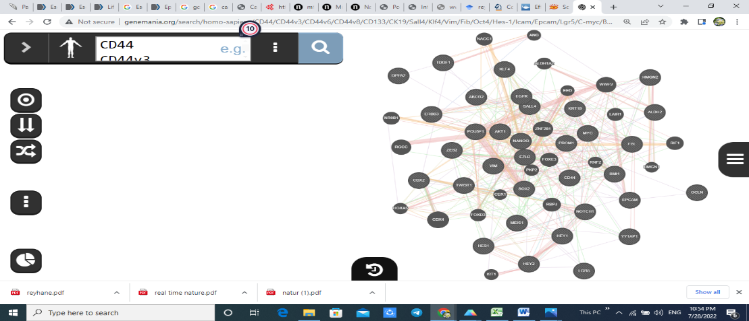
Fig.S1
b
b
a

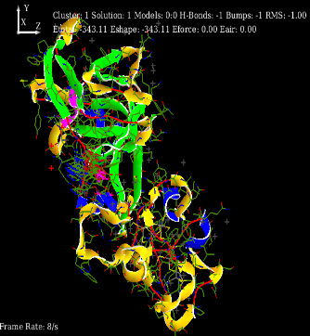
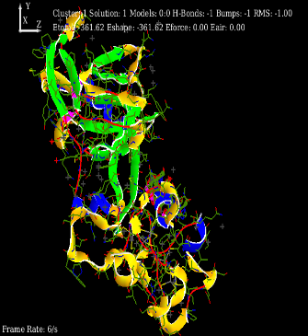
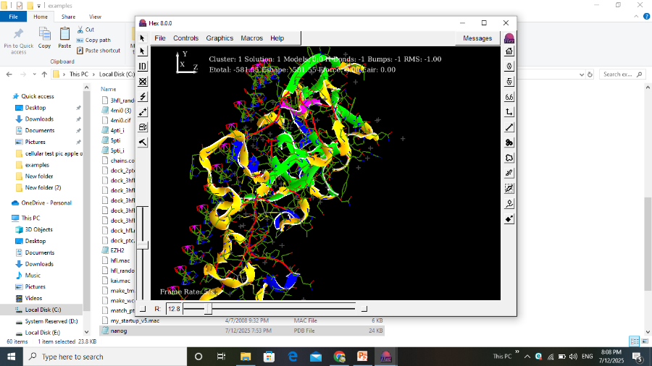
c
d
e
fg
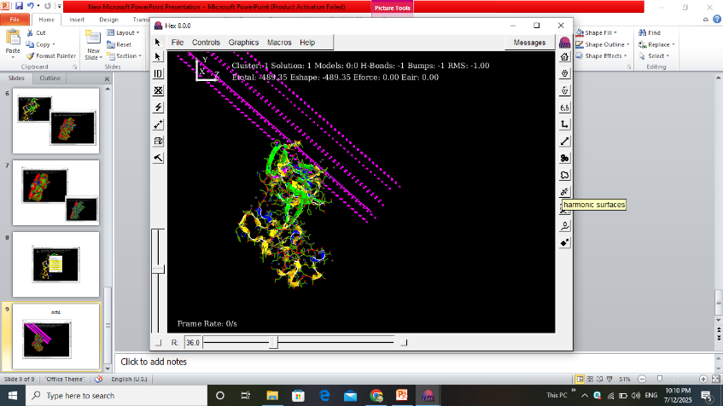

g
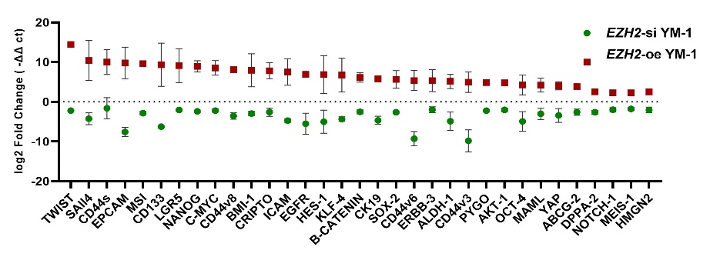

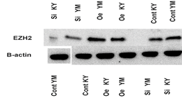
h
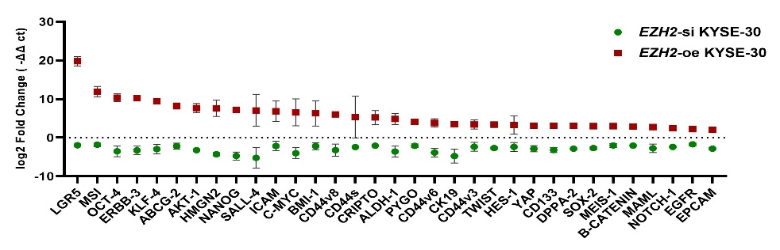

Fig. S1. a) Pro-pro interaction analysis via GeneMANIA. b) GeneMANIA released network analysis demonstrated EZH2 interaction with crucial CSC markers in stem cell maintenance, NOTCH signaling pathway, ERBB signaling pathway, Cell cycle G1/S and G0/G1 transition. c) In Silico Docking Analysis of Protein–DNA Interactions Involving Pluripotency-Associated CpG Islands. Molecular docking analysis between the EZH2 protein and the SOX2 CpG1 island DNA. d) Docking of EZH2 with SOX2 CpG2 island DNA. e) Docking of EZH2 with NANOG CpG island DNA. f) Docking of EZH2 with OCT4 CpG island DNA. g) The plot represents the differential expression differences between EZH2 and CSC markers in EZH2 manipulated KYSE-30 and YM-1 cells. Summary of one-sample t-tests and group comparisons are presented. Mean values (± standard deviation) for each experimental group are shown. h) Western blot validation of EZH2 expression.

Table S1
Table S1. ESCC patients. This study included a cohort of 33 newly-diagnosed ESCC patients, comprising 17 males and 16 females. The patients had a mean age of 60.94 (± 11.50) years, ranging from 30 to 80. The male-to-female ratio was 1:1. The tumor samples varied in size, ranging from 1.50 cm to 8.00 cm, with a mean size of 3.99 (± 1.57) cm. The samples were predominantly resected from the middle (21/40, 52.5%) or lower (19/40, 47.5%) regions of the esophagus. Among the tumor tissues, 65% (26/33) were classified as stages I/II, while 35% (14/33) were advanced stages (III/IV). The majority of the tumor tissues (77.5%, 31/33) exhibited invasion of the adventitia (T3 or T4 stage). Additionally, 45% (18/33) of the tumor samples showed metastasis to the local lymph nodes.

 |  | EZH2
 |  | Under |  | Normal Over
 |  | Valid Percent | Case | Case | Case | Std. Deviation | ANOVA
sex | MALE | 51.5 | 4 | 3 | 10 | 2.63872
sex | FEMALE | 48.5 | 2 | 4 | 10 | 2.26081
node | No metastasis | 53.1 | 6 | 2 | 9 | 3.08575
node | Node metastasis | 46.9 | 0 | 5 | 10 | 1.57753
T1 | T1,2 | 18.2 | 2 | 1 | 3 | 3.48570
T1 | T3,4 | 81.8 | 4 | 6 | 17 | 2.21059
stage1 | Stage1,2 | 60.6 | 6 | 3 | 11 | 2.86591
stage1 | Stage3,4 | 39.4 | 0 | 4 | 9 | 1.59889
Grade
location | lower | 15.2 | 2 | 3 | 11
location | middle | 72.7 | 4 | 3 | 9
location | upper | 12.1 | 0 | 1 | 0 |  | 2.239
T | T1 | 6.1 | 1 | 0 | 1
T | T2 | 12.1 | 1 | 1 | 2
T | T3 | 78.8 | 4 | 6 | 16 |  | 0.502
T | T4 | 3.0 | 0 | 0 | 1
Stage | I | 6.1 | 1 | 0 | 1
Stage | II | 54.5 | 5 | 3 | 10 |  | 1.247
Stage | III | 39.4 | 0 | 4 | 9

Table S2. Extracted via DAVID21and GEO34 analysis tools.
Table S2
Regulation of gene expression | GO:0010468 | 0.0019 | SALL4,NANOG,HES1,TWIST1,NOTCH1,OCT4,EPCAM,ERBB3,EGFR,EZH2,SOX2,YAP1,KLF4,BMI1, MYC
Regulation of cell population proliferation | GO:0042127 | 2.59e-05 | NANOG,HES1,TWIST1,JAG1,EPCAM,LGR5,  ERBB3,EGFR,TDGF1,EZH2,SOX2,KLF4,BMI1,MCC,MYC
Cell differentiation | GO:0030154 | 2.86e-05 | NANOG,HES1,TWIST1,CDH1,EPCAM,LGR5,ERBB3,EGFR, EZH2,SOX2,KRT19,YAP1 ,KLF4
Developmental process | GO:0032502 | 7.12e-05 | SALL4,NANOG,HES1,TWIST1,OCT4,CDH1,EPCAM,LGR5,ERBB3,EGFR,Cripto,EZH2,SOX2,KRT19,YAP1 ,KLF4,BMI1,CD133,MYC
Negative regulation of transcription by rna polymerase ii | GO:0000122 | 0.00035 | SALL4,HES1,TWIST1 ,OCT4,EZH2,SOX2,KLF4,BMI1 ,MYC
Positive regulation of cellular metabolic process | GO:0031325 | 0.00052 | SALL4,NANOG,HES1,TWIST1,NOTCH1,OCT4,CDH1,EPCAM,ERBB3,EGFR,CRIPTO,EZH2,SOX2,KLF4,BMI1 ,MYC
Positive regulation of transcription, dna-templated | GO:0045893 | 0.0015 | SALL4,NANOG,HES1,TWIST1,NOTCH1,POU5F1,CDH1,EPCAM,ERBB3,EGFR,CRIPTO,EZH2,SOX2,KLF4,BMI1,MYC
Positive regulation of cell population proliferation | GO:0008284 | 0.00056 | NANOG,HES1,TWIST1,EPCAM,ERBB3,EGFR,TDGF1,EZH2,BMI1,MYC
Negative regulation of cellular process | GO:0048523 | 0.00071 | SALL4,NANOG,HES1,TWIST1,NOTCH1,OCT4,,EPCAM,ERBB3,EGFR,CRIPTO,EZH2,SOX2,OCLN,KLF4,BMI1 ,MYC
Regulation of cell differentiation | GO:0045595 | 0.0011 | NANOG,HES1,TWIST1,NOTCH1,OCT4,EGFR,EZH2,SOX2,KLF4,CD133 ,MYC
Regulation of protein phosphorylation | GO:0001932 | 0.0023 | HES1,TWIST1,ERBB3,EGFR,CRIPTO,EZH2,SOX2 ,KLF4, MYC
Regulation of protein modification process | GO:0031399 | 0.0036 | HES1,TWIST1,ERBB3,EGFR,CRIPTO,EZH2,SOX2,KLF4,BMI1 ,MYC
Positive regulation of biological process | GO:0048518 | 0.0036 | ICAM,SALL4,NANOG,HES1,TWIST1,NOTCH1,OCT4,EPCAM,LGR5,ERBB3,EGFR,CRIPTO,EZH2,SOX2 ,KLF4,BMI1CD133 ,MYC
Regulation of mapk cascade | GO:0043408 | 0.0139 | EGFR,CRIPTO,EZH2,SOX2,KLF4 ,MYC
Regulation of cellular protein metabolic process | GO:0032268 | 0.0182 | HES1,TWIST1,ERBB3,EGFR,CRIPTO,EZH2,SOX2,KLF4,BMI1, MYC
Negative regulation of cell cycle | GO:0045786 | 0.0238 | EGFR,EZH2,SOX2,KLF4,BMI1,MYC
Positive regulation of molecular function | GO:0044093 | 0.0380 | HES1,TWIST1,ERBB3,EGFR,cripto,EZH2,KLF4,BMI1,MYC

Table S3

Table.S3 Extracted via Reactome23 and PANTHER analysis tools.

EZH2 | CSC markers | Interaction | Weight | Network group
EZH2 | HMGN2 | Co-expression | 0.0073948246 | Ramaswamy-Golub-2001
EZH2 | BMI-1  KLF4 | Genetic interaction | 0.102434576  0.0017748259 | Han-Bassik-2017 B  Lin-Smith-2010
EZH2 | SALL4  BMI-1  AKT-1  OCT4  C-myc | Physical interaction | 0.028358376  0.024539618  0.0021349934  0.0064390614  0.003274821 | Oliviero-Cagney-2016  IREF-intact  BIOGRID-SMALL-SCALE-STUDIES  BIOGRID-SMALL-SCALE-STUDIES  BIOGRID-SMALL-SCALE-STUDIES
EZH2 | ABCG2  NANOG | Predicted | 0.07867217  0.0059956275 | I2D-BioGRID-Fly2Human  I2D-IntAct-Mouse2Human

Table S4
Table S4.Molecular Docking Results for Protein-DNA Interactions with Selected CpG Islands. This table summarizes the docking parameters obtained from in silico analyses of EZH2 binding to CpG islands associated with pluripotency genes. The genomic intervals and lengths of CpG islands analyzed are listed alongside clustering and docking solutions. Energy terms including total energy (Etotal), shape complementarity energy (Eshape), force field energy (Eforce), air contact energy (Eair), hydrogen bonds (Hbond), steric bumps (Bumps), and Aramovsky score (AramS) are reported. CpG islands were defined based on standard bioinformatics criteria: GC content >50%, observed/expected CpG ratio >0.6, and length >200 b
CpG Island | Genomic Interval (nt) | Length (bp) | Cluster | Solution | Model | Etotal | Eshape | Eforce | Eair | Hbond | Bumps | AramS
Sox2.1 | 100–400 | ~300 | 1 | 1 | 0 | –343.11 | –343.11 | 0 | 0 | –1 | –1 | –1
Sox2.2 | 700–1000 | ~300 | 1 | 1 | 0 | –361.62 | –361.62 | 0 | 0 | –1 | –1 | –1
Nanog | (Approximate) | ~300 | 1 | 1 | 0 | –581.55 | –581.55 | 0 | 0 | –1 | –1 | –1
Oct4 | (Approximate) | ~1000 | 1 | 1 | 0 | –489.35 | –489.35 | 0 | 0 | –1 | –1 | –1
Note: CpG islands were defined as regions with GC content >50%, observed/expected CpG ratio >0.6, and length >200 bp, consistent with standard bioinformatics criteria.

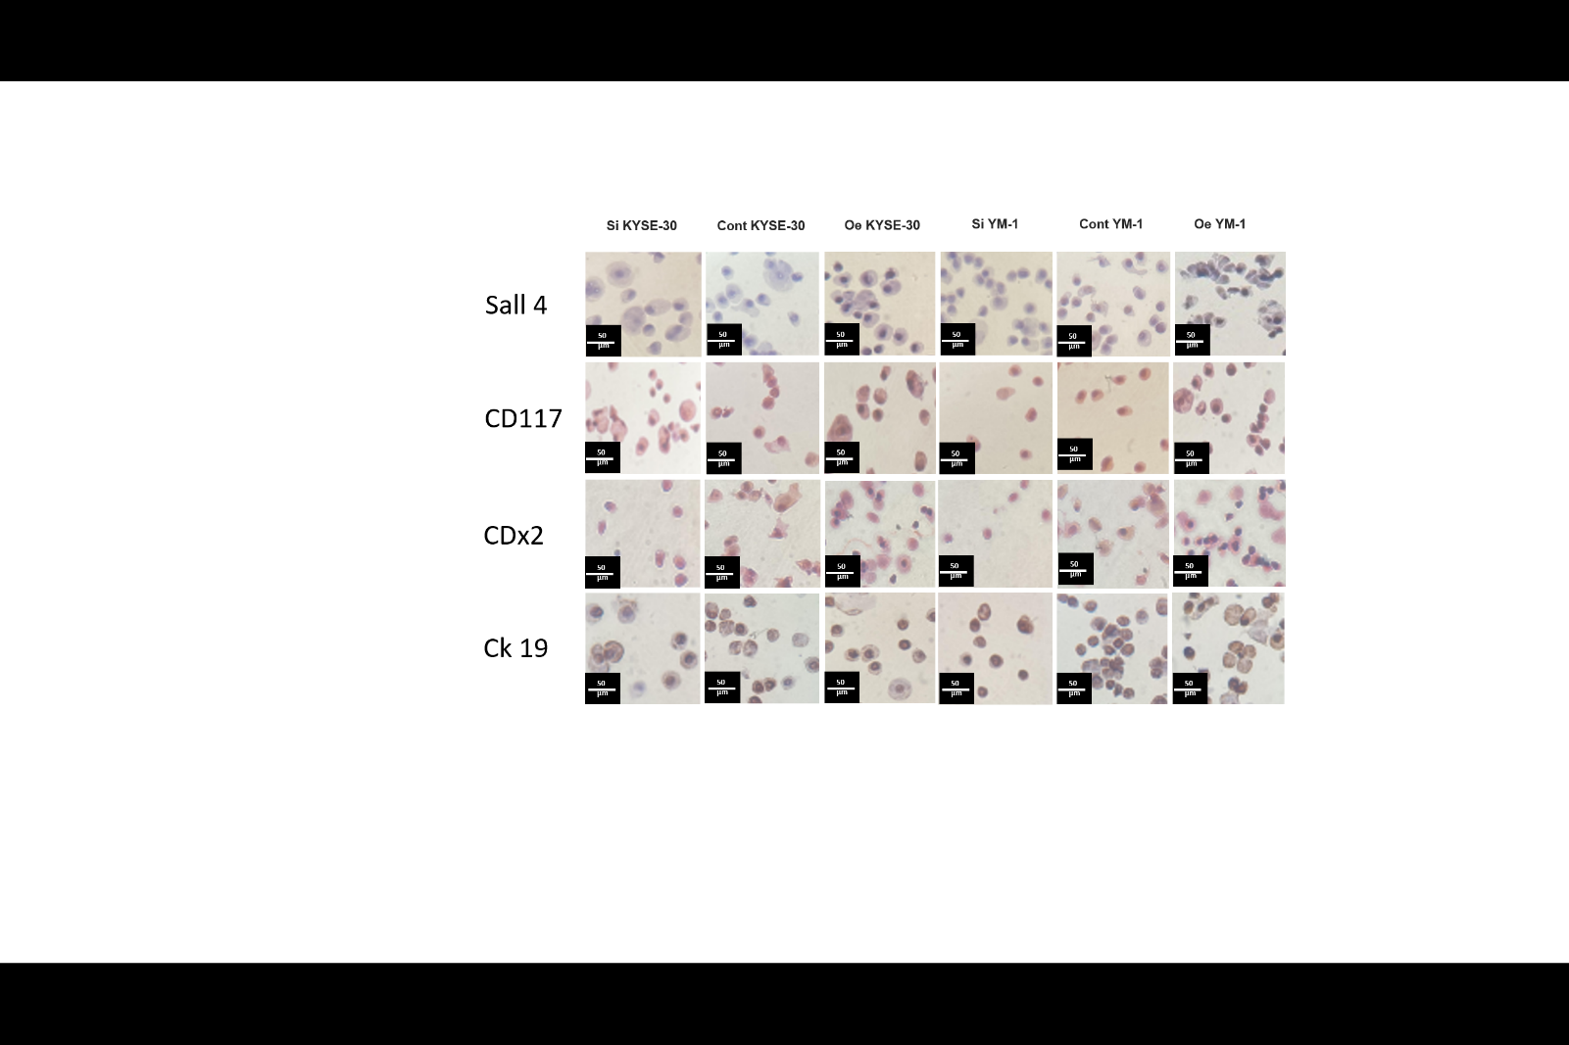
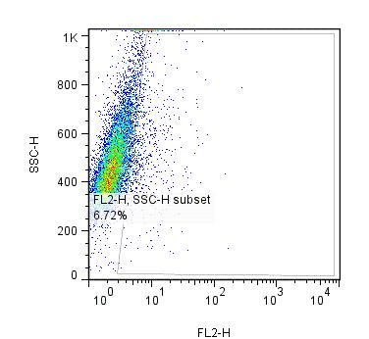
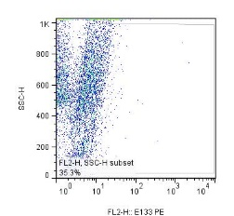
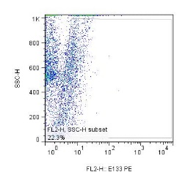
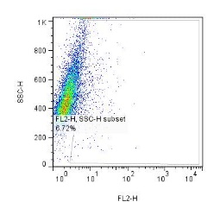
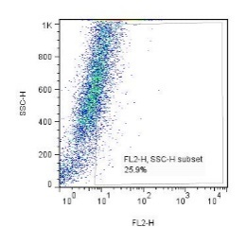
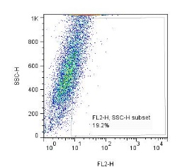
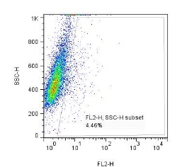
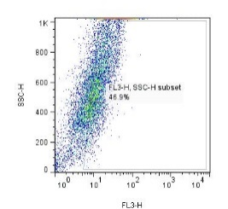
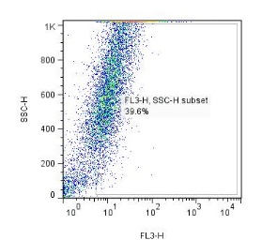
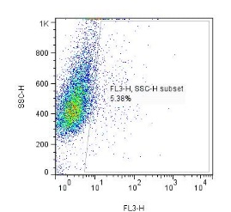
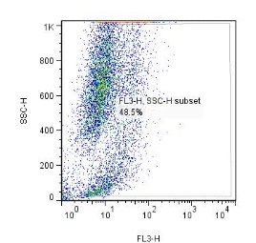
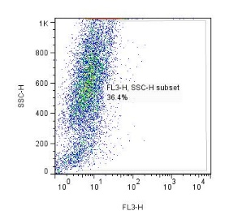
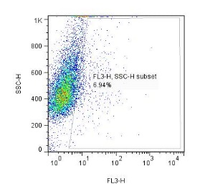
d
EZH2-oe KY
EZH2-si KY
EZH2-si KY
Cont
EZH2-oe YM
EZH2-si YM
Cont
Cont
Cont
EZH2-oe YM
EZH2-si YM
EZH2-oe KY
Fig.S2
CD117
CD133
b
CD44
a
c
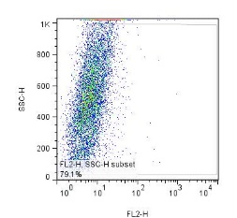
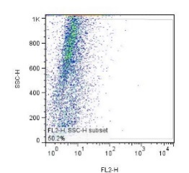

EZH2-oe KY
EZH2-si KY
Cont
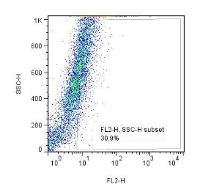
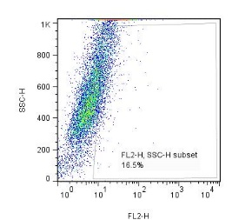
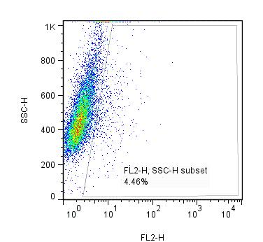

EZH2-si YM
EZH2-oe YM
Cont

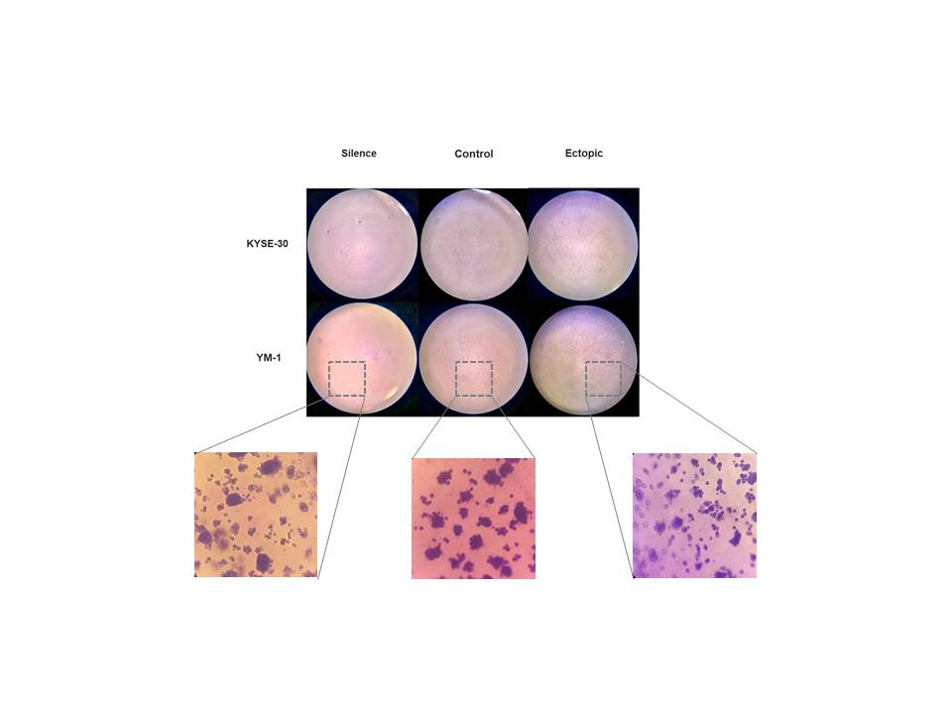
e

Fig.S2. Scatter plots related to CD44, CD133 and CD117 expression in EZH2 manipulated KYSE-30 and YM-1 cells. a) CD44 staining scatter plot of EZH2 manipulated cells, positive area bordered illustrated more CD44 positive in EZH2-oe cells. b) CD133 staining scatter plot of EZH2 manipulated cells. c) CD117 staining scatter plot of EZH2 manipulated cells. d) Image of ICC staining of EZH2 transfected KYSE-30 and YM-1 cells, independently repeated three times with consistent results. e) Colony formation of EZH2 manipulated ESCC cells after 14 days. Scale bar = 500 µm
Fig.S3
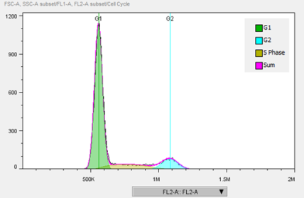
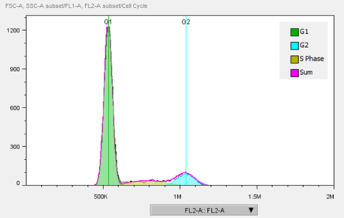
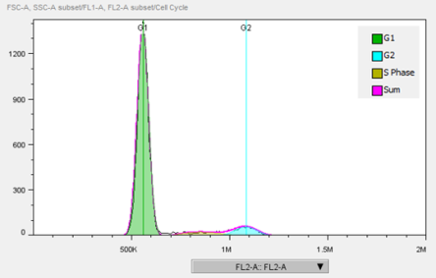
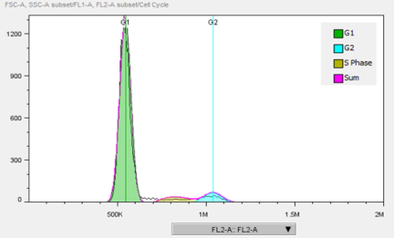
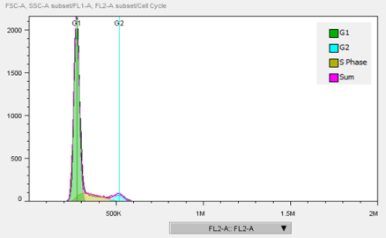
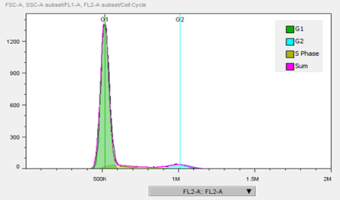
EZH2-oe KYSE-30
EZH2-si KYSE-30
Control KYSE-30
EZH2-oe YM-1
Control YM-1
EZH2-si YM-1

Control KYSE-30
EZH2 silenced KYSE-30
Control YM-1
EZH2 silenced YM-1

Fig.S3. Cell cycle analysis of EZH2 manipulated KYSE-30 and YM-1 cells by flow cytometry. Proportion of cells in sub-G0, G1, S, and G2 phases of the cell cycle are presented in EZH2 manipulated ESCC cells. G1 duration was the longest phase due to G1/S transition cell arrest through EZH2 silencing.

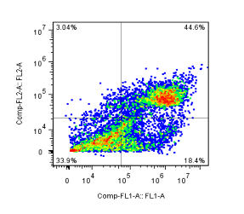
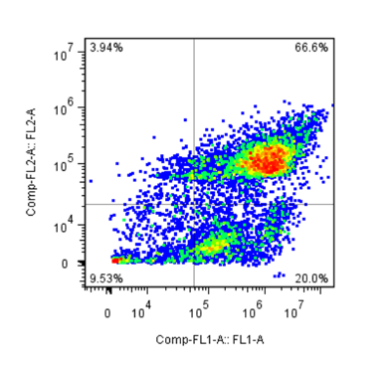
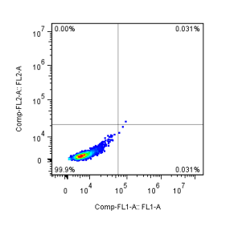
Fig.S4

EZH2-oe KYSE-30
EZH2-si KYSE-30
Control KYSE-30

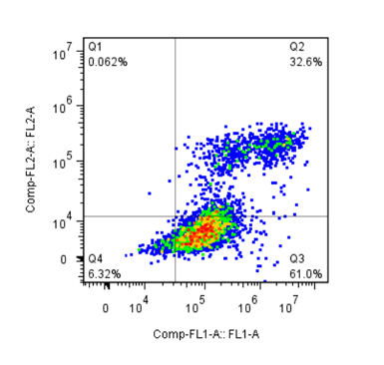
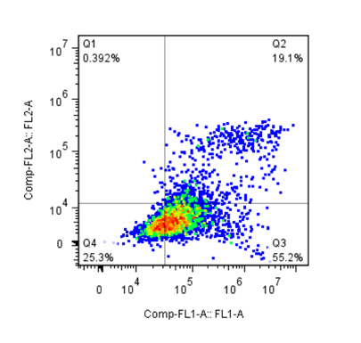
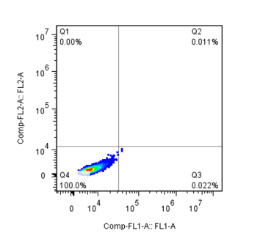

EZH2-oe YM-1
EZH2-si YM-1
Control YM-1

Fig.S4. Assessment of cell death mechanism in EZH2 manipulated KYSE-30 and YM-1 cells. The scatter graph characterizes the percentage of apoptotic cells in each groups. Forward scatter manifested more cell percentage than side scatter following EZH2 silencing in KYSE-30 and YM-1 cells.

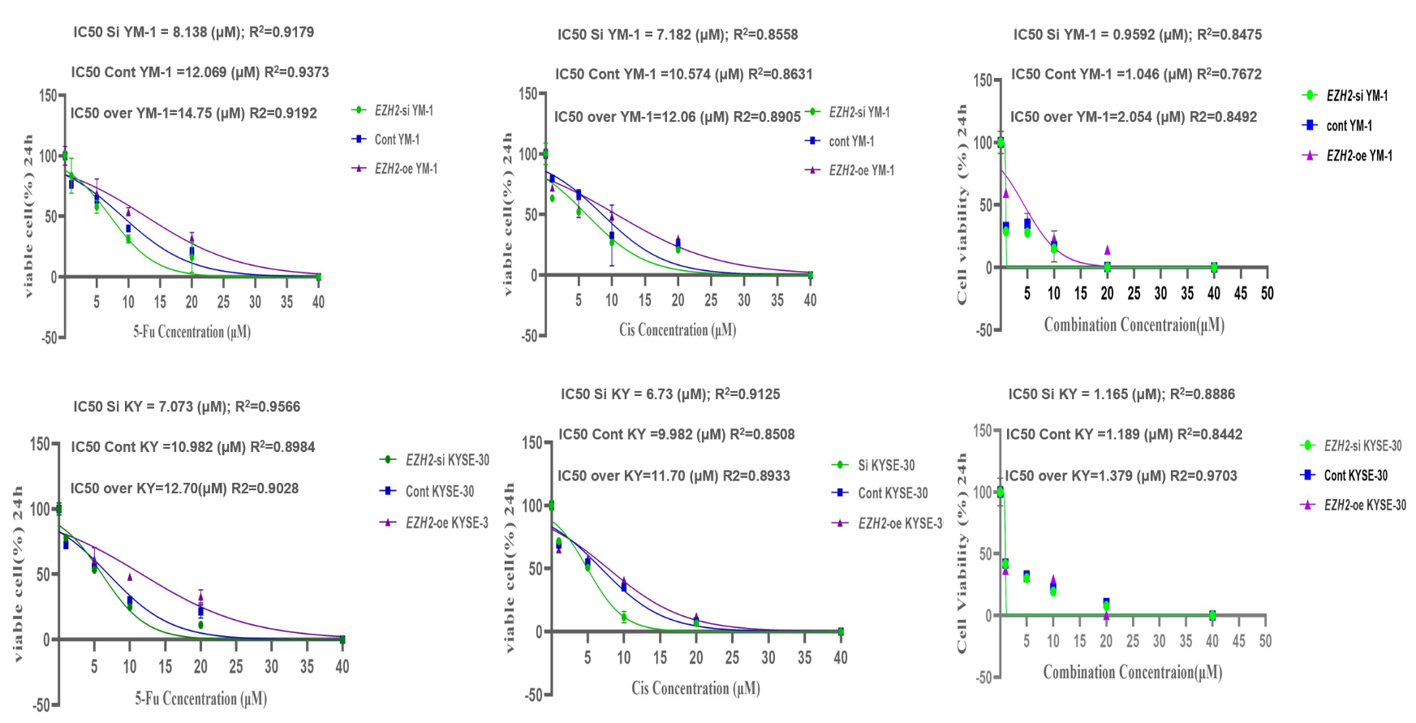
a
Fig.S5
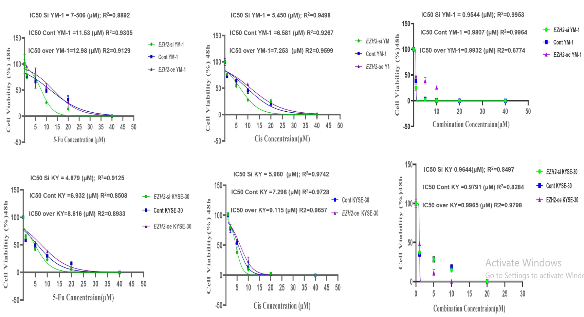
b

Fig.S5.Evaluating the effects of chemotherapeutic agents Cisplatin, 5-FU and their combination on the survival of EZH2 manipulated KYSE-30 and YM-1 cells by MTT assay. a) After 24 h treatment, results showed that the survival rates were significantly influenced by EZH2 modulation and drug treatment. In particular, the YM-1 cells with elevated EZH2 expression exhibited the highest survival rates when treated with 5-FU, with an IC₅₀ value of 14.75 mM. Conversely, the KYSE-30 cells with reduced EZH2 expression demonstrated the lowest survival rates when exposed to Cisplatin, with an IC₅₀ value of 6.73 mM. EZH2-oe YM-1 cells under combination of 5-FU and Cisplatin drug treatment with IC₅₀=2.054 mM had the highest survival rate, while EZH2-si KYSE-30 cells under combination of 5-FU and Cisplatin with IC₅₀=1.165 mM showed the lowest survival rate after 24 h b) The concentration plot of the MTT after 48 h. The highest survival rate after 48 h was related to YM-1 cells with increased overexpression of EZH2 under 5-FU drug treatment with IC₅₀=12.98 mM and the lowest survival rate was related to KYSE-30 cells with reduced EZH2 under 5-FU drug treatment with IC₅₀=4.87 mM. Following treatment with a combination of 5-FU and Cisplatin, the YM-1 cells with reduced EZH2 expression exhibited the lowest survival rates, with an IC₅₀ value of 0.9544 mM after 48 h.
Table.S5

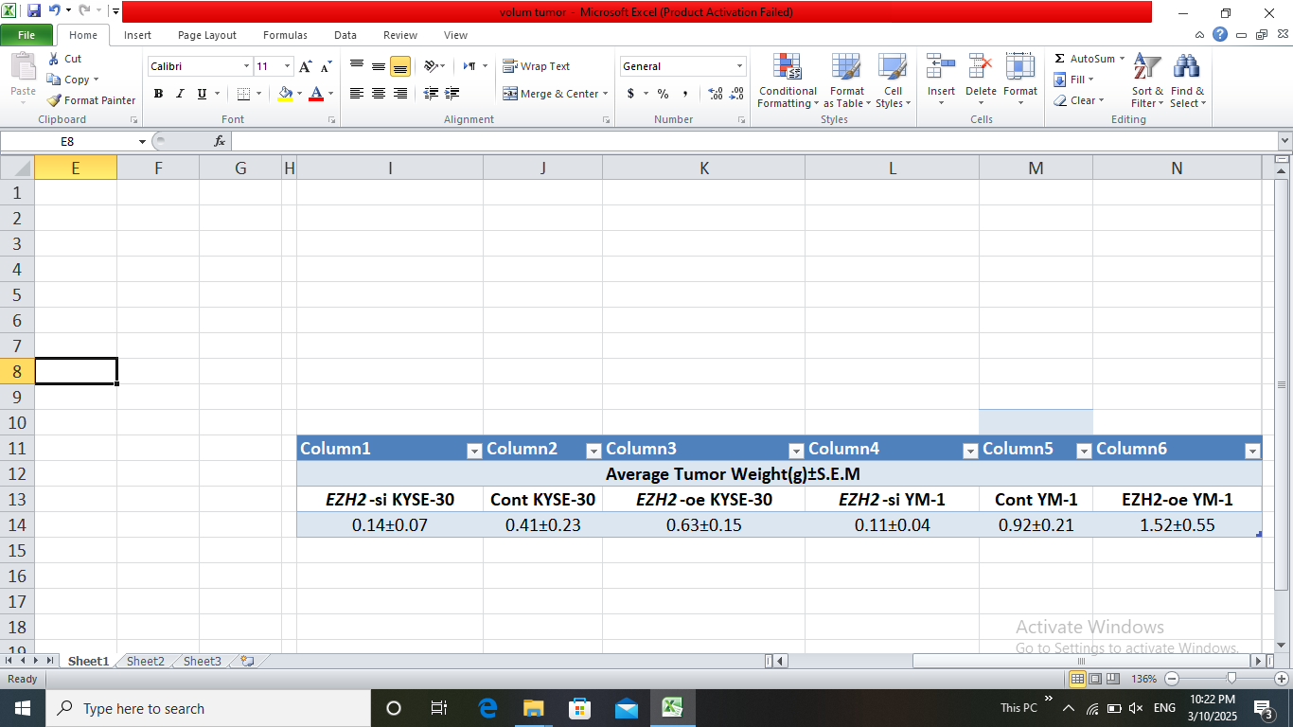
The weight of primary tumors from mice in each group with EZH2 manipulated ESCC tumors is presented. Data are presented as mean ± SD of three independent biological replicates per group (n = 3). Statistical significance was determined using paired two-tailed Student’s t-test (**P = 0. 0019, ****P < 0. 0001).

Fig.S6
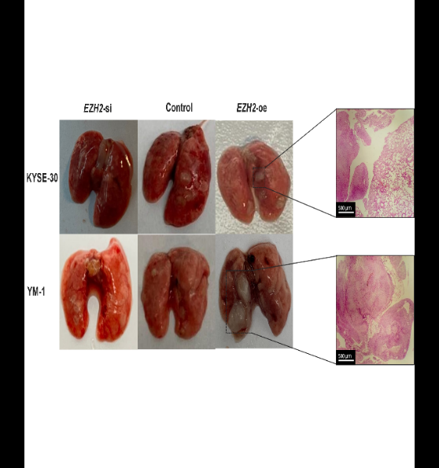
a
b
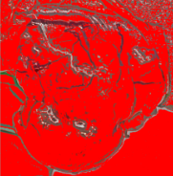


Fig.S6 a) The formation of lung metastatic xenografts by EZH2 manipulated cells in nude mice. Representative images of H&E-stained histological sections of nude mice lungs. b) Angiogenesis macroscopic images developed during examinations of EZH2 overexpressed group in nude mice tumor.
Cell line | EZH2-si KYSE-30 | Cont  KYSE-30 | EZH2-oe  KYSE-30 | EZH2-si  YM-1 | Cont  YM-1 | EZH2-oe  YM-1
Grade | 1 | 2 | 2 | 1 | 2 | 3
description | Tumor cells with disorder and different sizes | Moderate anarchism Moderate dysplasia Moderate atypia | Proliferation Squamous cells  mitotic figures Moderate anarchism Moderate dysplasia Sever atypia | Tumor cells with disorder and different sizes | Moderate anarchism Moderate dysplasia Moderate atypia | Proliferation Squamous cells  high mitotic figures Sever Anarchism Sever dysplasia  Sever atypia
Table S6. The table demonstrates the scoring of H&E staining in nude mice esophageal tumor tissues. Histopathology study of EZH2 manipulated xenograft primary tumor cells presenting features of dysplasia, and malignancy with higher grades of the tumor in the EZH2 overexpressed group.
Table. S6
Table. S7
b
a
d
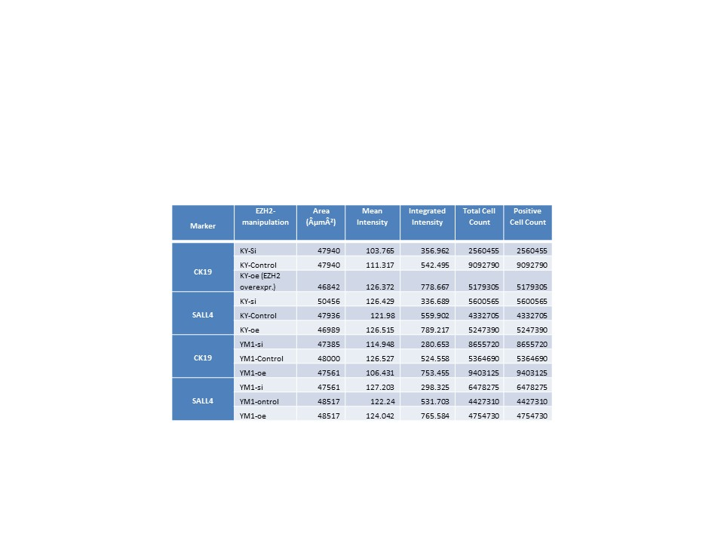
Table S7. A Quantitative Analysis of Immunohistochemical Staining for Stemness Markers in KYSE30 and YM1 Xenograft Tissues under Different EZH2 Manipulation Condition. Parameters measured by image-j software analysis include area (µm²), mean staining intensity, integrated intensity, total cell count, and positive cell count

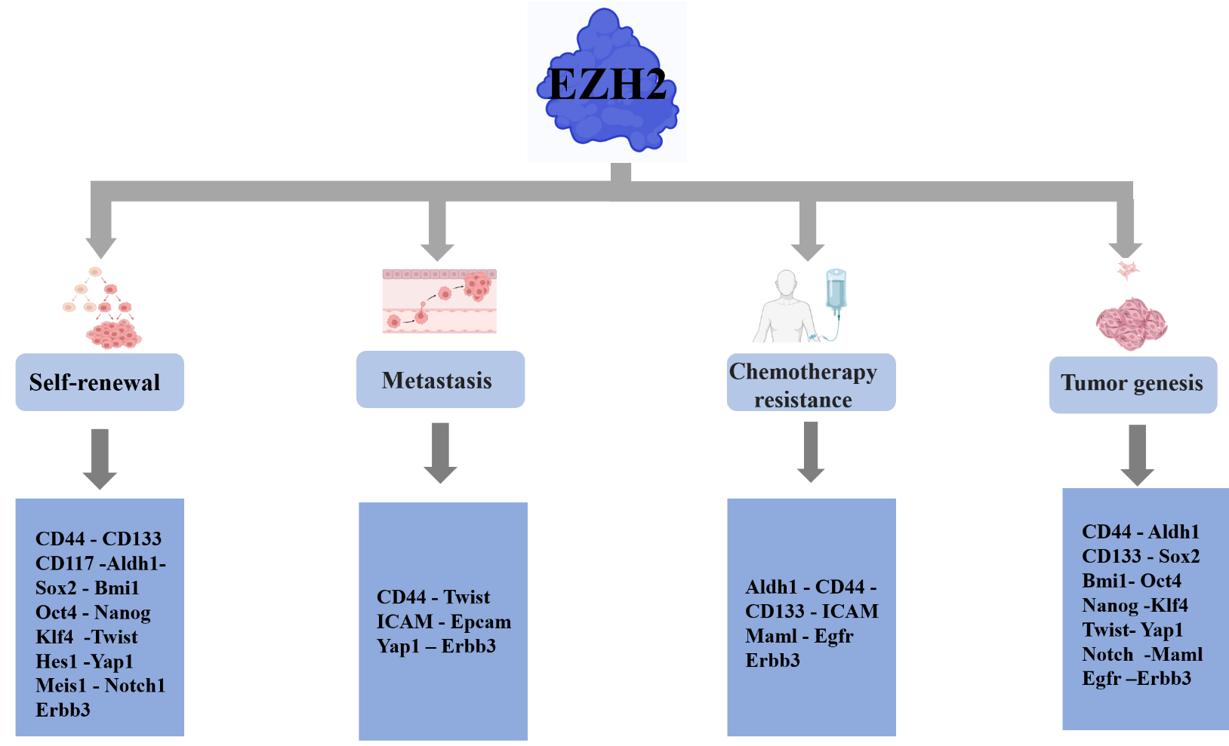
Fig.S7

Fig.S7) The schematic summarizing EZH2 association with CSC maintenance features through regulating key stemness markers.

Table S8. Stemness CSC Markers in ESCC under EZH2 regulation and their expression, Scored from Fair (2.5-4 log2fold change), Medium (4-6), High (7-9), and Extremely High (9-15). The expression levels for ESCC (Esophageal Squamous Cell Carcinoma) under EZH2 regulation are provided. The table provides information on the function, function in ESCC, EZH2-regulated stemness marker in cancer, and ESCC expression under EZH2 regulation for various CSC markers. (68-88)
Table S8

CSC marker | Function | Function in ESCC | EZH2 regulated Stemness marker in cancer | ESCC expression under EZH2 regulation
CD44 | The cell surface protein contributes to tumor invasion and regulates epithelial-mesenchymal transition (EMT) | Upregulation of CD44 is associated with positive lymph node metastasis and lymph vascular invasion | Colorectal Cancer (12, 17)  pancreatic adenocarcinoma (16)  Breast cancer (37) (16)  Bladder cancer (38) | Extremely high  (-2.76/+9.18)
ABCG2 | The ATP-binding cassette transporter (membrane transporter) is associated with drug resistance and metastasis | The presence of ABCG2-positive cells is associated with poor independent survival, regardless of the size of the primary tumor, and positive lymph node metastasis | Bladder cancer (38) | Medium  (-2.4/+6.02)
ALDH1 | Intracellular enzyme aldehyde dehydrogenases (ALDH) oxidize aldehydes: ALDH1+ cancer cells possess invasive and metastatic capabilities with an epithelial-mesenchymal transition (EMT) phenotype, and are associated with treatment resistance | Positive ALDH1 staining was associated with higher clinical stage and shorter overall survival | Colorectal Cancer (17)  Breast cancer (37) | Medium  (-4.23/+5.01)
CD133 | Cell surface protein: enhances tumor initiation, self-renewal capacity, and chemoresistance | The presence of CD133+ cancer cells was associated with tumor cell differentiation | Colorectal Cancer (17)-(12)  Liver Cancer (39)  hepatocellular carcinoma (40) | Medium  (-3.36/+6.22)
LGR5 | Cell surface protein: enhances proliferation, migration, and invasive capacity | Elevated Lgr5 expression was associated with worse survival outcomes |  | Extremely high  (-2.01/+14.46)
ICAM-1 | Intercellular adhesion molecule 1 (ICAM-1): promotes migration of cancer cells, invasion, EMT, formation of spheroids, tumorigenesis, and drug resistance | elevate cell migration, invasion and EMT markers |  | High  (-3.20/+7.18)
SOX2 | Transcription factor: enhances migration and invasion of cancer cells, as well as chemoresistance to cisplatin | There are conflicting results regarding the prognostic value of SOX2 expression due to divergent conclusions found among studies. | Colorectal Cancer (12)  prostate cancer (41)  peripheral neuroectodermal tumors (42)  Bladder Cancer (43)  Breast cancer (44)  Gastric cancer (45)  Glioma (46) | Medium  (-2.64/+4. 6)
ERBB3 | proto-oncogene: regulates the proliferation of cancer cells and confers drug resistance |  |  | High  (-2.06/+7.8)
BMI1 | Transcription regulator: regulates the sensitivity of tumor cells to radiation and inhibits cellular growth and invasion | Excessive expression of BMI-1 is associated with the progression and invasion of esophageal cancer (EC) | Breast cancer (44) | High  (-2.57/+7.8)
OCT4 | Transcription regulator: enhances cell cycle progression and accelerates proliferation and invasion of cancer cells in the bone marrow | Significant overexpression of OCT-4 is notably associated with higher histological grade and poorer survival outcomes | prostate cancer (41)  Gastric cancer (45)  neuroectodermal tumors (42)  Glioma (46)  Bladder cancer (38) | High  (-4.22/+7.30)
EPCAM | Transmembrane glycoprotein: Ep-CAM assists in cellular proliferation and tumorigenesis | The expression level of Ep-CAM is inversely correlated with the degree of differentiation | pancreatic adenocarcinoma (16)  Breast and Pancreatic Cancer (16)  hepatocellular carcinoma (40, 47) | Medium  (-4.9/+5.9)
SALL4 | Transcription factor: promotes cellular proliferation, migration, invasion, and chemoresistance to cisplatin, contributing to tumorigenesis within the body | Excessive expression of SALL4 was found in most ESCC tissues and is associated with poor survival outcomes |  | High  (-4.73/+8.73)
CRIPTO1 | One extracellular membrane-bound protein plays a fundamental role in embryonic development and tumor growth | Excessive expression is associated with the pathological stage (deep invasion and lymph node involvement) of ESCC |  | Medium  (-2.33/+6.52)
NANOG | Transcription regulator and self-renewal controller | Expression is associated with lower tumor regression after chemotherapy | Colorectal Cancer (12)  prostate cancer (41)  neuroectodermal tumors (42)  Glioma (46) | High  (-3.55/+8.07)
KLF4 | Transcription regulator factor 4-like: plays a role in numerous cellular processes such as proliferation, differentiation, and inflammation in the esophageal epithelium | The loss of KLF4 is essential for esophageal tumorigenesis, but re-expression of KLF4 in ESCC promotes tumor growth | pancreatic adenocarcinoma (16)  gastric cancer (48)  Ovarian cancer (49)  Bladder cancer (38) | High  (-3.65/+8.09)
AKT1 | Specific serine/threonine kinase protein: induces increased proliferation, metastasis, and decreased survival in ESCC cancer | It leads to poor prognosis in patients by causing weak pre-advertisement | Colorectal cancer (17)  Gastric cancer (45)  Breast Cancer (50) | High  (-2.61/+6.23)
HMGN2 | The high mobility group N (HMGN) family: a group of nucleosome-binding proteins that optimize the genetic processes necessary for maintaining cellular identity and proper execution of specific cellular functions |  |  | Medium  (-3. 16/+5.06)
C-MYC | The proto-oncogene C-myc: promotes proliferation, growth, and development of ESCC cancer | Patients with high expression of C-myc have poor survival outcomes | Colorectal Cancer (12)  glioblastoma cancer (11)  Chronic Myelogenous Leukemia (51) | High  (-3. 11/+7.55)
PYGO2 | The main transcription factor of the Wnt pathway increases the depth and invasiveness of ESCC tumors | There is a significant association with the surgical stage and tumor grade |  | Medium  (-2. 16/+4.49)
CK19 | Cytokeratin 19: a marker for stem cells | It is associated with micrometastases to the bone marrow in patients |  | Extremely high  (-4. 69/+13.32)
TWIST | Transcription factor: plays a role in the epithelial-to-mesenchymal transition (EMT) | The prognostic factor acts as a predictor and leads to overall increased survival in ESCC patients | Endometrial cancer (52)  Liver Cancer (39)  prostate cancer (53)  ovarian cancer (54) | High  (-2. 44/+8.9)
HES1 | The Notch pathway transcription factor: a regulator of the cell cycle | HES1 in ESCC patients has a significant correlation with tumor invasion depth | Breast cancer (37) | High  (-3. 73/+5.08)
YAP1 | Oncogene: a protein associated with Yes and a nuclear effector of the Hippo pathway, promoting cell proliferation in the G0-G1 phase | It leads to a decrease in the survival of ESCC patients |  | Fair  (-3. 13/+3.58)
DPPA2 | Developmental pluripotency-associated 2 (DPPA2) protein: from the self-renewal and CSC (cancer stem cell) stability family |  |  | Fair  (-2. 73/+2. 80)
MEIS1 | Myeloid ecotropic viral integration site 1; a transcription factor involved in self-renewal and CSC (cancer stem cell) stability." | there is an association with metastasis, lymph node involvement, and tumor stage, |  | Fair  (-1. 9/+2.62)
B-CATENIN | This protein is linked to membrane receptors and plays a pivotal role in the signaling pathway. Furthermore, it is implicated in cellular differentiation and proliferation, exerting its influence on the promoters of c-myc and cyclin D1 genes. | It is associated with the histological grade of ESCC cancer and serves as a prognostic factor. | Colorectal Cancer (12)  Liver cancer (55)  Breast cancer (56)  hepatocellular carcinoma (57)  parathyroid tumor (58) | Medium  (-2. 17/+4.49)
MAML | Mastermind Like Transcriptional Coactivator: It acts as an activator of the Notch pathway and the Wnt/β-catenin pathway. | It is associated with tumorigenesis and malignancy, as well as the clinicopathological features and lymph node metastasis in ESCC patients. |  | Fair  (-2. 88/+3.47)
NOTCH1 | The important protein in the Notch signaling pathway plays a role in cell proliferation, tissue regeneration, and cellular fate determination. | It is associated with tumor staging, metastasis, and poor prognosis in patients. | Breast cancer (37) (59)  Colorectal cancer (60)  Leukemia (61) | Fair  (-2. 19/+2.35)
EGFR | Epidermal growth factor receptor (EGFR): plays a crucial role in cell growth and angiogenesis. | It is associated with high-grade ESCC stages and serves as a prognostic factor. | lung tumors (62)  colon cancer (63) | Medium  (-3. 61/+4.57)
MSI | Microsatellite Instability (MSI): recently emerged as potent oncoproteins in a range of malignancies. | Inversely associated with the depth of invasion of ESCC. | Prostate Cancer (64)  pan-cancer (65)  colorectal cancer (66)  glioma (67) | Extremely high  (-2. 75/+10.51)
Table S9. Abbreviations used.
Table S9
Table S9

Abbreviation | Full Name
Gene Name
EZH2 | Enhancer of Zeste Homolog 2
GAPDH | Glyceraldehyde 3-phosphate dehydrogenase
Cell Typed
EZH2-oe | EZH2 overexpressed cells
EZH2-si | EZH2 silenced cells
Cancer Type
ESCC | Esophageal Squamous Cell Carcinoma
Examination level
In silico | Performed on computer or using computer simulation
In vitro | Performed in a controlled environment outside a living organism
In vivo | Performed in a living organism
Technical Assay
H & E | Hematoxylin and Eosin
ICC | Immunocytochemistry
IHC | Immunohistochemistry
Q-RT-PCR | Quantitative Reverse Transcription Polymerase Chain Reaction
Statistical Parameters
SD | Standard Deviation
L2FC | Log2 fold change
RU | Relative units
n | Sample size
Pro-pro | protein-protein interaction
Measurements
OD | Optical density
FSC | Forward Scatter
SSC | Side Scatter

Table.S10. primer utilized.
Table S10
Sequence | Locuce Primer
TTGTTGGCGGAAGCGTGTAAAATC | EZH2 F
TCCCTAGTCCCGCGCAATGAGC | EZH2 R
GTCCCCCACTCCATGGCCGCCTCG | hPygo2 F
TCGCTTCTTTTCTGGACTCTTC | hPygo2 R
GGAGTCCGCAGTCTTACGAG | TWIST F
TCTGGAGGACCTGGTAGAGG | TWIST R
GGCCGACAGCTATGAGATGGA | EGFR F
ACCGGCAGGATGTGGAGATC | EGFR R
GAGACTGACGCGCCCCAGCC | Msi1 F
CGCCTGGTCCATGAAAGTGACG | Msi1 R
CCC AAC GCA GTG TCACCT TC | Hes1 F
TAC AAA GGC GCA ATCCAA TAT G | Hes1 R
CCCTGCCATGAGAACTGCAC | ERBB3 F
TCACTGTCAAAGCCATTGTCAGAT | ERBB3 R
TTTTGGATCC ATG TCA GATGCA AAT TTG GAT | DPPA2 F
TTTTCTCGAG CTA CTT CTC TAC TGT CATTAA | DPPA2 R
TCCAACACCTCCCAGTATGACA | CD44S F
GGCAGGTCTGTGACTGATGTACA | CD44S R
GCACTTCAGGAGGTTACATC | CD44v3 F
CTGAGGTGTCTGTCTCTTTC | CD44v3 R
AGGAACAGTGGTTTGGCAAC | CD44v6 F
CGAATGGGAGTCTTCTCTGG | CD44v6 R
CCAAAGGCAACTTAAAGGTTCAC | SALL4 F
CCGTGAAGACCAATGAGATCTC | SALL4 R
TCTTCTCTTCGTTGACTTTG | KLF4 F
GCCAGCGGTTATTCGG | KLF4 R
CGTGTATTGTTCGTTACCTGGAGAC | BMI1 F
CATTGGCAGCATCAGCAGAAGG | BMI1 R
GGGATACAGCACAGTAAGGAG | Cripto F
ACGGTGGTAGTTCTGGAGTC | Cripto R
GCAATGGTGTGACGCAGAAGGC | Nanog F
GCTCCAGGTTGAATTGTTCCAGGTC | Nanog R
TGAGGGTTTGGAACTGTGG | ABCG2 F
GATTCTGACGCACACCTGG | ABCG2 R
GCGGAACAGGAGAAGCAAC | MAML1 F
GGCACGGCAGCAGAGG | MAML1 R
ACGCCTACCTCTGCTTCTG | NOTCH1 F
GCACACTCGTAGCCATCG | NOTCH1 R
AGCGACTCTGAGGAGGAACAAG | C_MYC F
TGGGCTGTGAGGAGGTTTGC | C_MYC R
CAGTGTGGATGAGATGGATACAGGTGATAC | YAP F
GGCTTCAAGGTAGTCTGGGAAACGG | YAP R
CAAGTCGGCTGTGGAGATGCG | TAZ F
AGGCTGGAGGTGGTTGTGGAG | TAZ R
GGAGTCCGCAGTCTTACGAG | TWIST1 F
TCTGGAGGACCTGGTAGAGG | TWIST1 R
GGAAGGTGAAGGTCGGAGTCA | GAPDH F
GTCATTGATGGCAACAATATCCACT | GAPDH R
AACAGCCCGGACCGCGTCAA | SOX2 F
TCGCAGCCGCTTAGCCTCGT | SOX2 R
AGGCAGGTGAGAAGGTGAGAG | C-MYC F
TGGTTGTGAAGGCAGCAGAAG | C-MYC R
CAGATACTGGCTAAATGGG | TIM3 F
CTTGGCTGGTTTGATGAC | TIM3 R
CAACTAAACAGGAAGGGATGGAAGG | B-CATENIN F
CAGATGACGAAGAGCACAGATGG | B- CATENIN R
CACTACCAAGGACAAGGCGT | CD133 F
TCCAACGCCTCTTTGGTCTC | CD133 R
CCTTCCAACCTCAGCGTCTT | Lgr5 F
AGGGATTGAAGGCTTCGCAA | Lgr5 R
GATCCCCGTGGCGTACTATG | ALDH1A1 F
TGGATCTTGTCAGCCCAACC | ALDH1A1 R
GTGCTGGTGTGTGAACACTG | EPCAM F
GAAGTGCAGTCCGCAAACTT | EPCAM R

References
1. Sanches JGP, Song B, Zhang Q, Cui X, Yabasin IB, Ntim M, et al. The role of KDM2B and EZH2 in regulating the stemness in colorectal cancer through the PI3K/AKT pathway. Frontiers in Oncology. 2021;11:637298.
2. Chen J-F, Luo X, Xiang L-S, Li H-T, Zha L, Li N, et al. EZH2 promotes colorectal cancer stem-like cell expansion by activating p21cip1-Wnt/β-catenin signaling. Oncotarget. 2016;7(27):41540.
3. van Vlerken LE, Kiefer CM, Morehouse C, Li Y, Groves C, Wilson SD, et al. EZH2 is required for breast and pancreatic cancer stem cell maintenance and can be used as a functional cancer stem cell reporter. Stem cells translational medicine. 2013;2(1):43-52.
4. Gonzalez ME, Moore HM, Li X, Toy KA, Huang W, Sabel MS, et al. EZH2 expands breast stem cells through activation of NOTCH1 signaling. Proceedings of the National Academy of Sciences. 2014;111(8):3098-103.
5. Lee S-R, Roh Y-G, Kim S-K, Lee J-S, Seol S-Y, Lee H-H, et al. Activation of EZH2 and SUZ12 regulated by E2F1 predicts the disease progression and aggressive characteristics of bladder cancer. Clinical cancer research. 2015;21(23):5391-403.
6. Wu J, Sun L, Liu T, Dong G. Ultrasound-targeted microbubble destruction-mediated downregulation of EZH2 inhibits stemness and epithelial-mesenchymal transition of liver cancer stem cells. OncoTargets and therapy. 2021:221-37.
7. Chiba T, Suzuki E, Negishi M, Saraya A, Miyagi S, Konuma T, et al. 3‐Deazaneplanocin A is a promising therapeutic agent for the eradication of tumor‐initiating hepatocellular carcinoma cells. International journal of cancer. 2012;130(11):2557-67.
8. Wen S, Tian J, Niu Y, Li L, Yeh S, Chang C. ASC-J9®, and not Casodex or Enzalutamide, suppresses prostate cancer stem/progenitor cell invasion via altering the EZH2-STAT3 signals. Cancer letters. 2016;376(2):377-86.
9. Burdach S, Plehm S, Unland R, Borkhardt A, Staege MS, Müller-Tidow C, et al. Epigenetic maintenance of stemness and malignancy in peripheral neuroectodermal tumors by EZH2. Cell cycle. 2009;8(13):1991-6.
10. Chen X, Xie R, Gu P, Huang M, Han J, Dong W, et al. Long noncoding RNA LBCS inhibits self-renewal and chemoresistance of bladder cancer stem cells through epigenetic silencing of SOX2. Clinical Cancer Research. 2019;25(4):1389-403.
11. Lee Y-C, Chang W-W, Chen Y-Y, Tsai Y-H, Chou Y-H, Tseng H-C, et al. Hsp90α mediates BMI1 expression in breast cancer stem/progenitor cells through facilitating nuclear translocation of c-Myc and EZH2. International Journal of Molecular Sciences. 2017;18(9):1986.
12. Gan L, Xu M, Hua R, Tan C, Zhang J, Gong Y, et al. The polycomb group protein EZH2 induces epithelial–mesenchymal transition and pluripotent phenotype of gastric cancer cells by binding to PTEN promoter. Journal of hematology & oncology. 2018;11:1-12.
13. Cao Y, Chai W, Wang Y, Tang D, Shao D, Song H, et al. lncRNA TUG1 inhibits the cancer stem cell‑like properties of temozolomide‑resistant glioma cells by interacting with EZH2. Molecular Medicine Reports. 2021;24(1):1-10.
14. Elkot HA, Ragab I, Saleh NM, Amin MN, Al-Rashood ST, El-Messery SM, et al. Design, synthesis, and antitumor activity of PLGA nanoparticles incorporating a discovered benzimidazole derivative as EZH2 inhibitor. Chemico-Biological Interactions. 2021;344:109530.
15. Ba M-C, Long H, Cui S-Z, Gong Y-F, Yan Z-F, Wu Y-B, et al. Long noncoding RNA LINC00673 epigenetically suppresses KLF4 by interacting with EZH2 and DNMT1 in gastric cancer. Oncotarget. 2017;8(56):95542.
16. Zhang C, Liu J, Zhang Y, Luo C, Zhu T, Zhang R, et al. LINC01210 accelerates proliferation, invasion and migration in ovarian cancer through epigenetically downregulating KLF4. Biomedicine & Pharmacotherapy. 2019;119:109431.
17. Gonzalez ME, DuPrie ML, Krueger H, Merajver SD, Ventura AC, Toy KA, et al. Histone methyltransferase EZH2 induces Akt-dependent genomic instability and BRCA1 inhibition in breast cancer. Cancer research. 2011;71(6):2360-70.
18. Suvà M-L, Riggi N, Janiszewska M, Radovanovic I, Provero P, Stehle J-C, et al. EZH2 is essential for glioblastoma cancer stem cell maintenance. Cancer research. 2009;69(24):9211-8.
19. Zhou J, Nie D, Li J, Du X, Lu Y, Li Y, et al. PTEN is fundamental for elimination of leukemia stem cells mediated by GSK126 targeting EZH2 in chronic myelogenous leukemia. Clinical Cancer Research. 2018;24(1):145-57.
20. Ihira K, Dong P, Xiong Y, Watari H, Konno Y, Hanley SJ, et al. EZH2 inhibition suppresses endometrial cancer progression via miR-361/Twist axis. Oncotarget. 2017;8(8):13509.
21. de Mello DC, Saito KC, Cristovão MM, Kimura ET, Fuziwara CS. Modulation of EZH2 activity induces an antitumoral effect and cell redifferentiation in anaplastic thyroid cancer. International Journal of Molecular Sciences. 2023;24(9):7872.
22. Cardenas H, Zhao J, Vieth E, Nephew KP, Matei D. EZH2 inhibition promotes epithelial-to-mesenchymal transition in ovarian cancer cells. Oncotarget. 2016;7(51):84453.
23. Zhu P, Wang Y, Huang G, Ye B, Liu B, Wu J, et al. lnc-β-Catm elicits EZH2-dependent β-catenin stabilization and sustains liver CSC self-renewal. Nature structural & molecular biology. 2016;23(7):631-9.
24. Chang C-J, Yang J-Y, Xia W, Chen C-T, Xie X, Chao C-H, et al. EZH2 promotes expansion of breast tumor initiating cells through activation of RAF1-β-catenin signaling. Cancer cell. 2011;19(1):86-100.
25. Rountree CB, Mishra L, Willenbring H. Stem cells in liver diseases and cancer: recent advances on the path to new therapies. Hepatology. 2012;55(1):298-306.
26. Svedlund J, Barazeghi E, Stålberg P, Hellman P, Åkerström G, Björklund P, et al. The histone methyltransferase EZH2, an oncogene common to benign and malignant parathyroid tumors. Endocr Relat Cancer. 2014;21(2):231-9.
27. Zhao L, Zhang Q, Luan X, Huang X, Zhao S, Zhao H. Relationship between the expression of Notch1 and EZH2 and the prognosis of breast invasive ductal carcinoma. Genet Mol Res. 2016;15(1).
28. Jin L, Vu T, Yuan G, Datta PK. STRAP promotes stemness of human colorectal cancer via epigenetic regulation of the NOTCH pathway. Cancer research. 2017;77(20):5464-78.
29. Safaei S, Baradaran B, Mansoori B, Fardi M, Baghbani E, Amini M, et al. EZH2 knockdown upregulates expression of the genes involved in T-ALL cell differentiation. Pharmaceutical Sciences. 2021;28(3):405-13.
30. Phi LTH, Sari IN, Yang Y-G, Lee S-H, Jun N, Kim KS, et al. Cancer stem cells (CSCs) in drug resistance and their therapeutic implications in cancer treatment. Stem cells international. 2018;2018.
31. Katona BW, Liu Y, Ma A, Jin J, Hua X. EZH2 inhibition enhances the efficacy of an EGFR inhibitor in suppressing colon cancer cells. Cancer biology & therapy. 2014;15(12):1677-87.
32. Du T-Q, Liu R, Zhang Q, Luo H, Liu Z, Sun S, et al. EZH2 as a prognostic factor and its immune implication with molecular characterization in prostate cancer: an integrated multi-omics in silico analysis. Biomolecules. 2022;12(11):1617.
33. Luo L, Wang Z, Hu T, Feng Z, Zeng Q, Shu X, et al. Multiomics characteristics and immunotherapeutic potential of EZH2 in pan-cancer. Bioscience Reports. 2023;43(1):BSR20222230.
34. Yamamoto I, Nosho K, Kanno S, Igarashi H, Kurihara H, Ishigami K, et al. EZH2 expression is a prognostic biomarker in patients with colorectal cancer treated with anti-EGFR therapeutics. Oncotarget. 2017;8(11):17810.
35. Chen Yn, Hou Sq, Jiang R, Sun Jl, Cheng Cd, Qian Zr. EZH2 is a potential prognostic predictor of glioma. Journal of cellular and molecular medicine. 2021;25(2):925-36.

c

