Supplementary Figures

Supplementary Fig. S1. HR-ESI-Orbitrap mass spectrum of 9α,11αOH-KA

Supplementary Fig. S2. ¹H NMR (Pyridine-d₅, 400 MHz) spectrum of 9α,11αOH-KA

Supplementary Fig. S3. ¹³C NMR (Pyridine-d₅, 100 MHz) spectrum of 9α,11αOH-KA

Supplementary Fig. S4. HR-ESI-Orbitrap mass spectrum of 11αOH-KA

Supplementary Fig. S5. ¹H NMR (Pyridine-d₅, 400 MHz) spectrum of 11αOH-KA

Supplementary Fig. S6. ¹³C NMR (Pyridine-d₅, 100 MHz) spectrum of 11αOH-KA

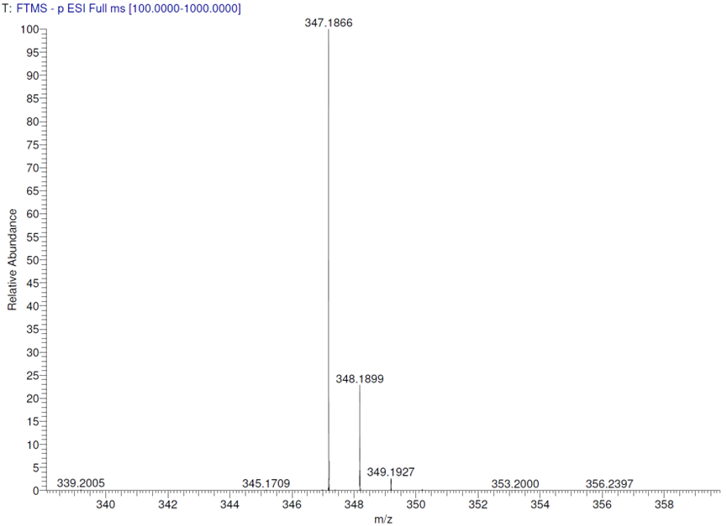

Supplementary Fig. S1. HR-ESI-Orbitrap mass spectrum of 9α,11αOH-KA.

Supplementary Fig. S2. ¹H NMR (Pyridine-d₅, 400 MHz) spectrum of 9α,11αOH-KA.

Supplementary Fig. S3. ¹³C NMR (Pyridine-d₅, 100 MHz) spectrum of 9α,11αOH-KA.

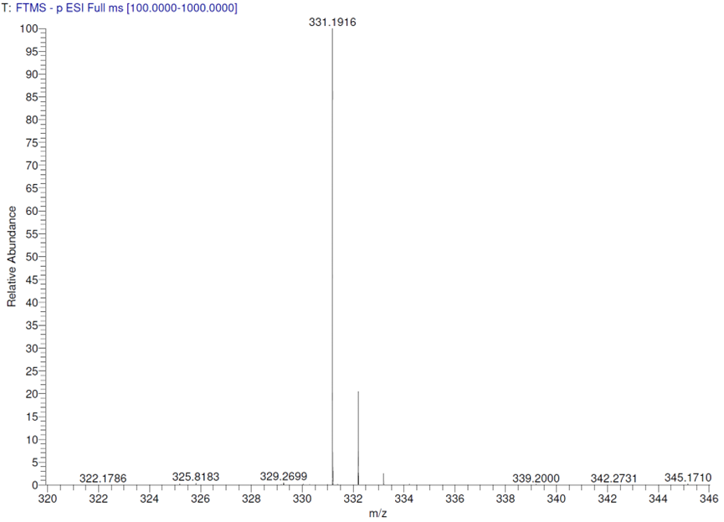

Supplementary Fig. S4. HR-ESI-Orbitrap mass spectrum of 11αOH-KA.

Supplementary Fig. S5. ¹H NMR (Pyridine-d₅, 400 MHz) spectrum of 11αOH-KA.

Supplementary Fig. S6. ¹³C NMR (Pyridine-d₅, 100 MHz) spectrum of 11αOH-KA.

