Supplementary File
Conserved genetic and antigenic profiles of Pf12 and Pf41 in asymptomatic Plasmodium falciparum carriers in Tanzania

Fadhila Fitriana1, Wang-Jong Lee1,2, Hyun-Young Sim1, Hojong Jun1,2, Jadidan Hada Syahada1, Fauzi Muh2, Se Jin Lee3, Sunghun Na3, Kyu Joon Lee4, Joo-Won Nam5, Eun-Taek Han1, Jim Todd6,7, Alphaxard Manjurano8, Winifrida Kidima9, Ernest Mazigo1,10 , and Jin-Hee Han1,2,*
1Department of Tropical Medicine, School of Medicine, Kangwon National University, Chuncheon, Republic of Korea
2Department of Epidemiology and Tropical Diseases, Faculty of Public Health, Universitas Diponegoro, Semarang, Indonesia
3Department of Obstetrics and Gynecology, Kangwon National University Hospital, Chuncheon, Republic of Korea
4Department of Tropical Medicine, College of Medicine, Soonchunhyang University, Cheonan, Republic of Korea
5College of Pharmacy, Yeungnam University, Gyeongsan, Republic of Korea
6Department of Population Health, London School of Hygiene and Tropical Medicine, London, UK
7Department of Biostatistics, Catholic University of Health and Allied Sciences (CUHAS), Mwanza, Tanzania
8Department of Parasitic Diseases, National Institute for Medical Research, Dar es Salaam, Tanzania
9Department of Zoology, College of Natural and Applied Sciences, University of Dar es Salaam, Dar es Salaam, Tanzania
10Department of Parasitic Diseases and Vector Control, National Institute for Medical Research (NIMR), NIMR Head Quarters, Dodoma, Tanzania

*Co-responding: Jin-Hee Han (han.han@kangwon.ac.kr)

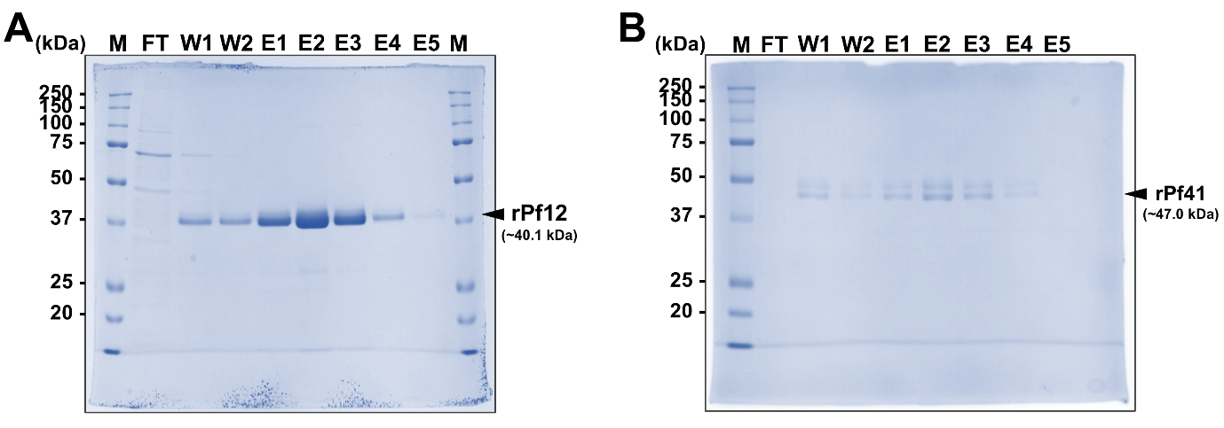
Supplementary Figure 1. Uncropped SDS-PAGE gel images of recombinant protein purification.
- Full-length SDS-PAGE gel image with visible gel boundaries of recombinant Pf12 protein purification, including flow-through, wash, and elution fractions.;
- Full-length SDS-PAGE gel image with visible gel boundaries of recombinant Pf41 protein purification, including flow-through, wash, and elution fractions.
The cropped regions shown in Figure 4A correspond to the elution fractions used for the protein microarray experiments.
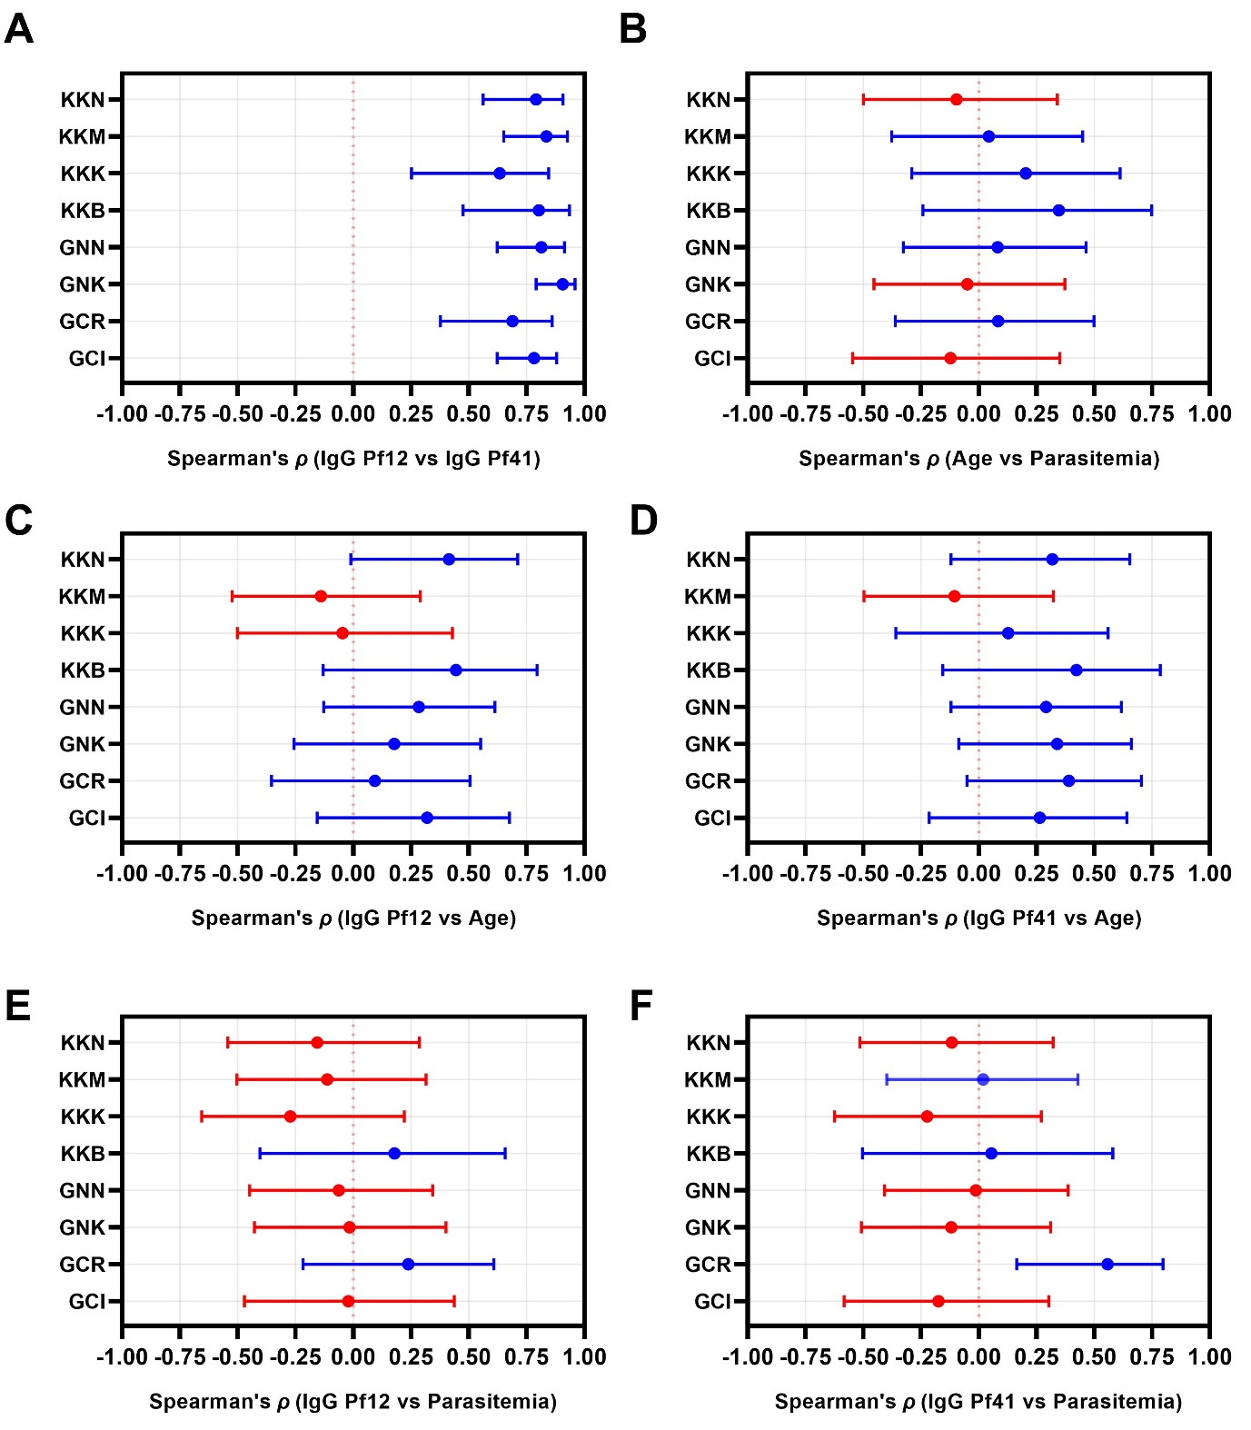
Supplementary Figure 2. Village-specific correlations between parasitological, immunological, and demographic factors. (A–F) Spearman’s correlation coefficients (ρ) were calculated for each village to assess relationships among age, parasitemia, and IgG responses to Pf12 and Pf41, with 95% confidence intervals. Village name abbreviations: GCI = Ihanga, GCR = Rwantaba, GNK = Kayenze, GNN = Nyangalamila, KKB = Bunyambo, KKK = Kumuhasha, KKM = Mugombe, KKN = Nyamnyusi. Red dots represent negative correlations, while blue dots represent positive correlations.
(A) Correlation between IgG responses to Pf12 and Pf41 in each village, with 95% confidence intervals;
(B) Correlation between age and parasitemia in each village, with 95% confidence intervals;
(C) Correlation between IgG response to Pf12 and age in each village, with 95% confidence intervals;
(D) Correlation between IgG response to Pf41 and age in each village, with 95% confidence intervals;
(E) Correlation between IgG response to Pf12 and parasitemia in each village, with 95% confidence intervals;
(F) Correlation between IgG response to Pf41 and parasitemia in each village, with 95% confidence intervals.

Supplementary Table 1. Primer sequences used for amplification and sequencing of pf12 and pf41.
Primer ID | 5’-Primer sequence-3’ | Size  (bp)
pf12 PCR primer | F: TTGTTGTCTGTTTGTGAAGGGCA | 891
pf12 PCR primer | R: GAATGATGTGATAATAAAAGTGATGAAGGCAC | 891
pf12 sequencing primer | F: ACTATTAATGGTTCCAATGGAAATCCTTCA
pf12 sequencing primer | R: TCCTTTTGAGAAAATTGTAGATTCGCTTGT
Pf12 In-fusion cloning primer* | F: cttggaGCGGCCGCACACAAGAACCTGGCCTGC | 894
Pf12 In-fusion cloning primer* | R: gttctcTGGCGCGCCGCTGTTGCTGATGTAGTCCTGG | 894
pf41 PCR primer | F: TGGAGACAAGCATGGGTATCG | 1,074
pf41 PCR primer | R: TGACGTCTTAAAAGAGTTAAGAACAACTTC | 1,074
pf41 sequencing primer | F: GGTGGGAATGTTAGCGAGGC
pf41 sequencing primer | R: ACGAACAAAAACACTCATTATTCCACG
Pf41 In-fusion cloning primer* | F: cttggaGCGGCCGCAAAGAGCCACAAGTGCGAC | 1,074
Pf41 In-fusion cloning primer* | R: gttctcTGGCGCGCCGCTGGTCTTGAAGCTGTTCAGC | 1,074
*, Lowercase letters indicate the pTT5 vector backbone sequence; uppercase italic letters indicate restriction enzyme recognition sites for NotI and AscI.

Supplementary Table 2. Demographic characteristics of study participants in relation to Plasmodium falciparum prevalence.
Study sites (n) ª | Characteristics
Study sites (n) ª | Age | Age group [n (%)] |  |  |  |  |  | Sex [n (%)] |  | Parasitemia
Study sites (n) ª | Median (IQR)^{b} | ≤ 5 | 6–10 | 11–15 | 16–20 | 21–25 | > 25 | Male | Female | IQR | Median
Geita (92) | 10.0  (6.0 – 16.0) | 20  (21.7) | 31  (33.7) | 17 (18.5) | 11  (12.0) | 4  (4.4) | 9  (9.8) | 37  (40.2) | 55  (59.8) | 330 – 2,730 | 740
Chato (42) | 10.0  (6.8 – 13.3) | 7 (16.7) | 17  (40.5) | 11  (26.2) | 2  (4.8) | 1  (2.4) | 4  (9.5) | 19  (45.2) | 23 (54.8) | 330 – 2,670 | 720
GCI (20) | 10.0  (7.3 – 12.8) | 2  (10.0) | 11 (55.0) | 6 (30.0) | 0  (0.0) | 1  (5.0) | 0  (0.0) | 8 (40.0) | 12 (60.0) | 580 – 3,280 | 1,040
GCR (22) | 10.5  (5.8 – 19.3) | 5 (22.7) | 6 (27.3) | 5 (22.7) | 2  (9.1) | 0  (0.0) | 4  (18.2) | 11 (50.0) | 11 (50.0) | 230 – 1,760 | 360
Nyang'hwale (50) | 9.0  (5.0 – 18.0) | 13 (26.0) | 14 (28.0) | 6 (12.0) | 9 (18.0) | 3  (6.0) | 5  (10.0) | 18 (36.0) | 32 (64.0) | 310 – 2,900 | 840
GNK (24) | 10.5  (6.0 – 18.0) | 5 (20.8) | 7 (29.2) | 1  (4.2) | 8 (33.3) | 1  (4.2) | 2  (8.3) | 11 (45.8) | 13 (54.2) | 200 – 1,760 | 560
GNN (26) | 8.5  (5.0 – 15.3) | 8  (30.8) | 7 (26.9) | 5 (19.2) | 1  (3.9) | 2  (7.7) | 3  (11.5) | 7 (26.9) | 19 (73.1) | 400 – 6,460 | 1,780
Kigoma (80) | 9.0  (6.3 – 12.8) | 16 (20.0) | 37 (46.3) | 16 (20.0) | 4  (5.0) | 4  (5.0) | 3  (3.8) | 40 (50.0) | 40 (50.0) | 560 – 3,290 | 1,100
Kibondo (33) | 11.0  (6.5 – 14.0) | 8 (24.2) | 8 (24.3) | 11 (33.3) | 4 (12.1) | 2  (6.1) | 0  (0.0) | 15 (45.5) | 18 (54.6) | 660 – 5,480 | 1,280
KKB (14) | 8.5  (1.8 – 12.3) | 6 (42.9) | 4 (28.6) | 3 (21.4) | 1  (7.1) | 0  (0.0) | 0  (0.0) | 6 (42.9) | 8 (57.1) | 350 – 2,060 | 860
KKK (19) | 12.0  (10.0 – 18.0) | 2 (10.5) | 4 (21.1) | 8 (42.1) | 3 (15.8) | 2  (10.5) | 0  (0.0) | 9 (47.4) | 10 (52.6) | 720 – 34,920 | 3,680
Kasulu (47) | 8.0  (6.0 – 10.0) | 8 (17.0) | 29 (61.7) | 5 (10.6) | 0  (0.0) | 2  (4.3) | 3  (6.4) | 25 (53.2) | 22 (46.8) | 520 – 1,920 | 760
KKM (24) | 8.0  (5.0 – 9.0) | 7 (29.2) | 16 (66.7) | 1  (4.2) | 0  (0.0) | 0  (0.0) | 0  (0.0) | 13 (54.2) | 11 (45.8) | 540 – 1,950 | 1,080
KKN (23) | 9.0  (7.0 – 14.0) | 1  (4.4) | 13 (56.5) | 4 (17.4) | 0  (0.0) | 2  (8.7) | 3  (13.0) | 12 (52.2) | 11 (47.8) | 480 – 1,920 | 720
Overall (172) | 9.0  (6.0 – 14.0) | 36 (20.9) | 68 (39.5) | 33 (19.2) | 15 (8.7) | 8  (4.7) | 12  (7.0) | 77 (44.8) | 95 (55.2) | 440 – 2,790 | 880
- Study site village = Ihanga (GCI), Rwantaba (GCR), Kayenze (GNK), Nyangalamila (GNN), Bunyambo (KKB), Kumuhasha (KKK), Mugombe (KKM), Nyamnyusi (KKN). The bold text indicated the region level.
- Interquartile range (IQR) = Q1–Q3.
Supplementary Table 3. Estimates of nucleotide diversity, haplotype diversity and neutrality indices of pf12 based on the geographical location in Tanzania.
Study sites | No. of samples | SNPs | No. of haplotype | Diversity |  | Tajima's D | Fu and Li's |  | Fu's Fs
 |  |  |  | Haplotype (Hd) | Nucleotide (π) X 10⁻³ | Tajima's D | D* | F* | Fu's Fs
Geita | 90 | 8 | 8 | 0.303±0.063 | 0.39±0.09 | -1.92313† | -2.70236† | -2.88472† | -7.238
Chato | 42 | 3 | 4 | 0.302±0.089 | 0.36±0.11 | -1.16699 | -0.36427 | -0.70074 | -1.99
GCI | 20 | 1 | 2 | 0.189±0.108 | 0.21±0.32 | -0.59155 | 0.64952 | 0.36728 | -0.097
GCR | 22 | 3 | 4 | 0.398±0.122 | 0.48±0.16 | -1.23957 | -1.30921 | -1.48629 | -1.827
Nyang'hwale | 48 | 7 | 7 | 0.307±0.086 | 0.42±0.13 | -2.03897† | -2.61804† | -2.85660† | -6.098
GNK | 24 | 3 | 3 | 0.163±0.099 | 0.28±0.18 | -1.73253 | -2.52572† | -2.65835† | -1.355
GNN | 24 | 5 | 6 | 0.442±0.124 | 0.55±0.18 | -1.83144† | -2.17281 | -2.40327 | -4.343
Kigoma | 77 | 11 | 11 | 0.351±0.070 | 0.46±0.11 | -2.21555‡ | -4.24920‡ | -4.20397‡ | -12.366
Kibondo | 32 | 5 | 6 | 0.389±0.106 | 0.48±0.15 | -1.76428 | -2.41317 | -2.58384 | -4.436
KKB | 14 | 1 | 2 | 0.363±0.130 | 0.41±0.15 | 0.32440 | 0.71557 | 0.69871 | 0.643
KKK | 18 | 4 | 5 | 0.405±0.143 | 0.50±0.20 | -1.85306† | -2.52547† | -2.69100† | -3.486
Kasulu | 45 | 8 | 8 | 0.326±0.091 | 0.45±0.14 | -2.17923‡ | -3.57862‡ | -3.67828‡ | -7.734
KKM | 23 | 5 | 5 | 0.391±0.125 | 0.58±0.22 | -1.82093† | -2.13592 | -2.36790 | -2.731
KKN | 22 | 3 | 4 | 0.260±0.120 | 0.31±0.15 | -1.72938 | -2.45980 | -2.60101† | -2.889
Overall | 167 | 15 | 14 | 0.324±0.047 | 0.42±0.07 | -2.22862‡ | -4.96005‡ | -4.70725‡ | -17.575
† indicates p < 0.05 (statistically significant)
‡ indicates p < 0.01 (highly statistically significant)
Study site village = Ihanga (GCI), Rwantaba (GCR), Kayenze (GNK), Nyangalamila (GNN), Bunyambo (KKB), Kumuhasha (KKK), Mugombe (KKM), Nyamnyusi (KKN).

Supplementary Table 4. Estimates of nucleotide diversity, haplotype diversity and neutrality indices of pf41 based on the geographical location in Tanzania.
Location | No. of samples | SNPs | No. of haplotype | Diversity |  | Tajima's D | Fu and Li's |  | Fu's Fs
 |  |  |  | Haplotype (Hd) | Nucleotide (π) X 10⁻³ | Tajima's D | D* | F* | Fu's Fs
Geita | 84 | 5 | 6 | 0.551±0.024 | 0.57±0.04 | -0.87671 | -3.10634† | -2.80461† | -2.121
Chato | 40 | 4 | 5 | 0.582±0.042 | 0.62±0.08 | -0.7177 | -2.16725 | -2.01667 | -1.451
GCI | 20 | 2 | 3 | 0.563±0.063 | 0.58±0.10 | 0.23837 | -0.59347 | -0.42346 | 0.204
GCR | 20 | 3 | 4 | 0.621±0.063 | 0.68±0.11 | -0.39341 | -1.25499 | -1.17202 | -0.748
Nyang'hwale | 44 | 2 | 3 | 0.534±0.027 | 0.52±0.04 | 0.38983 | -0.85624 | -0.57052 | 0.528
GNK | 18 | 1 | 2 | 0.523±0.048 | 0.49±0.04 | 1.50518 | 0.66689 | 1.01128 | 1.405
GNN | 26 | 2 | 3 | 0.557±0.043 | 0.56±0.07 | 0.28496 | -0.68907 | -0.48185 | 0.310
Kigoma | 76 | 6 | 8 | 0.604±0.032 | 0.67±0.06 | -0.99063 | -1.61967 | -1.66519 | -3.864
Kibondo | 32 | 4 | 5 | 0.605±0.048 | 0.66±0.09 | -0.74109 | -2.02389 | -1.91304 | -1.498
KKB | 14 | 2 | 3 | 0.604±0.076 | 0.63±0.12 | 0.17874 | -0.44573 | -0.32441 | 0.055
KKK | 18 | 3 | 4 | 0.634±0.069 | 0.71±0.13 | -0.38329 | -1.19315 | -1.11812 | -0.763
Kasulu | 44 | 3 | 5 | 0.613±0.042 | 0.68±0.08 | 0.09656 | 0.90523 | 0.77231 | -1.116
KKM | 21 | 3 | 5 | 0.690±0.066 | 0.83±0.13 | 0.16336 | 0.99896 | 0.88496 | -1.365
KKN | 23 | 2 | 3 | 0.549±0.060 | 0.55±0.08 | 0.17742 | -0.64558 | -0.48287 | 0.191
Overall | 160 | 10 | 12 | 0.575±0.019 | 0.61±0.04 | -1.51468 | -3.94050‡ | -3.66188‡ | -8.537
† indicates p < 0.05 (statistically significant)
‡ indicates p < 0.01 (highly statistically significant)
Study site village = Ihanga (GCI), Rwantaba (GCR), Kayenze (GNK), Nyangalamila (GNN), Bunyambo (KKB), Kumuhasha (KKK), Mugombe (KKM), Nyamnyusi (KKN).
Supplementary Table 5. Humoral immune responses against Pf12.
Pf12 | No. of patients samples |  |  | 95%CI^{b} | MFI^{c} | No. of healthy samples |  |  | 95%CI | MFI | p-value^{e}
Pf12 | Positive | Negative | Total (%)ª | 95%CI^{b} | MFI^{c} | Positive | Negative | Total (%)^{c} | 95%CI | MFI | p-value^{e}
Overall | 168 | 4 | 172 (97.7) | 94.2-99.1 | 16221 | 1 | 63 | 64 (98.4) | 91.7-99.7 | 753.2 | <0.0001
Geita | 90 | 2 | 92 (97.8) | 92.4-99.4 | 17370 |  |  |  |  |  | <0.0001
Chato | 42 | 0 | 42 (100) | 91.6-1.00 | 14619 |  |  |  |  |  | <0.0001
GCI | 20 | 0 | 20 (100) | 83.9-1.00 | 14223 |  |  |  |  |  | <0.0001
GCR | 22 | 0 | 22 (100) | 85.1-1.00 | 14980 |  |  |  |  |  | <0.0001
Nyang'hwale | 48 | 2 | 50 (96.0) | 86.5-98.9 | 19681 |  |  |  |  |  | <0.0001
GNK | 22 | 2 | 24 (91.7) | 74.2-97.7 | 17298 |  |  |  |  |  | <0.0001
GNN | 26 | 0 | 26 (100) | 87.1-1.00 | 21880 |  |  |  |  |  | <0.0001
Kigoma | 78 | 2 | 80 (97.5) | 91.3-99.3 | 14899 |  |  |  |  |  | <0.0001
Kibondo | 31 | 2 | 33 (93.9) | 80.4-98.3 | 11611 |  |  |  |  |  | <0.0001
KKB | 13 | 1 | 14 (92.9) | 68.5-98.7 | 6853 |  |  |  |  |  | <0.0001
KKK | 18 | 1 | 19 (94.7) | 75.4-99.1 | 15117 |  |  |  |  |  | <0.0001
Kasulu | 47 | 0 | 47 (100) | 92.44-1.00 | 17208 |  |  |  |  |  | <0.0001
KKM | 24 | 0 | 24 (100) | 86.2-1.00 | 16910 |  |  |  |  |  | <0.0001
KKN | 23 | 0 | 23 (100) | 85.7-1.00 | 17519 |  |  |  |  |  | <0.0001
- Percentage of positive samples.
- CI: confidence interval.
- MFI: mean fluorescence intensity.
- Percentage of negative in healthy samples.
- The difference of total IgG prevalence for each antigen between patient and healthy individuals were calculated using unpaired student’s t-test, p-value of < 0.05 is considered statistically significant.
The bold text indicated the region level. Study site village = Ihanga (GCI), Rwantaba (GCR), Kayenze (GNK), Nyangalamila (GNN), Bunyambo (KKB), Kumuhasha (KKK), Mugombe (KKM), Nyamnyusi (KKN).
Supplementary Table 6. Humoral immune responses against Pf41.
Pf41 | No. of patients samples |  |  | 95%CI^{b} | MFI^{c} | No. of healthy samples |  |  | 95%CI | MFI | p-value^{e}
Pf41 | Positive | Negative | Total (%)ª | 95%CI^{b} | MFI^{c} | Positive | Negative | Total (%)^{d} | 95%CI | MFI | p-value^{e}
Overall | 169 | 3 | 172 (98.3) | 95.0-99.4 | 13194 | 1 | 63 | 64 (98.4) | 91.7-99.7 | 803.9 | <0.0001
Geita | 90 | 2 | 92 (97.8) | 92.4-99.4 | 16524 |  |  |  |  |  | <0.0001
Chato | 41 | 1 | 42 (97.6) | 87.7-99.6 | 13011 |  |  |  |  |  | <0.0001
GCI | 20 | 0 | 20 (100) | 83.9-1.00 | 11694 |  |  |  |  |  | <0.0001
GCR | 21 | 1 | 22 (95.5) | 78.2-99.2 | 14208 |  |  |  |  |  | <0.0001
Nyang'hwale | 49 | 1 | 50 (98.0) | 89.5-99.7 | 17097 |  |  |  |  |  | <0.0001
GNK | 23 | 1 | 24 (95.8) | 79.8-99.3 | 19006 |  |  |  |  |  | <0.0001
GNN | 26 | 0 | 26 (100) | 87.1-1.00 | 15334 |  |  |  |  |  | <0.0001
Kigoma | 79 | 1 | 80 (98.8) | 93.3-99.8 | 9582 |  |  |  |  |  | <0.0001
Kibondo | 33 | 0 | 33 (100) | 89.6-1.00 | 13233 |  |  |  |  |  | <0.0001
KKB | 14 | 0 | 14 (100) | 78.5-1.00 | 8417 |  |  |  |  |  | <0.0001
KKK | 19 | 0 | 19 (100) | 83.2-1.00 | 16782 |  |  |  |  |  | <0.0001
Kasulu | 46 | 1 | 47 (97.9) | 88.9-99.6 | 9177 |  |  |  |  |  | <0.0001
KKM | 23 | 1 | 24 (95.8) | 79.8-1.00 | 9374 |  |  |  |  |  | <0.0001
KKN | 23 | 0 | 23 (100) | 85.7-1.00 | 8972 |  |  |  |  |  | <0.0001
- Percentage of positive samples.
- CI: confidence interval.
- MFI: mean fluorescence intensity.
- Percentage of negative in healthy samples.
- The difference of total IgG prevalence for each antigen between patient and healthy individuals were calculated using unpaired student’s t-test, p-value of < 0.05 is considered statistically significant.
The bold text indicated the region level. Study site village = Ihanga (GCI), Rwantaba (GCR), Kayenze (GNK), Nyangalamila (GNN), Bunyambo (KKB), Kumuhasha (KKK), Mugombe (KKM), Nyamnyusi (KKN).

Supplementary Table 7. Age-stratified MFI and seropositivity against Pf12/Pf41.
Parameter |  | Children (<15 years) | Adults (≥15 years) | p-value
n (%) |  | 132/172 (76.7%) | 40/172 (23.3%) | -
Pf12 | Median MFI (IQR) ª | 11121 (3283–20669) | 13420 (4177–29350) | p = 0.17
Pf12 | Seropositivity ^{b} | 128/132 (96.9%) | 40/40 (100.0%) | p = 0.17
Pf41 | Median MFI (IQR) | 3942 (1166–15185) | 8007 (2905–20790) | p = 0.01
Pf41 | Seropositivity | 129/132 (97.7%) | 40/40 (100.0) | p = 0.01
- Median MFI (IQR): Median (IQR) of mean fluorescence intensity values across samples.
- Seropositivity: the proportion of antibody-positive samples out of the total samples tested.
* indicates p < 0.05 (statistically significant)

