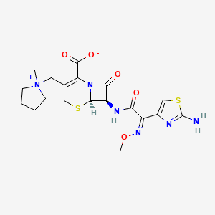
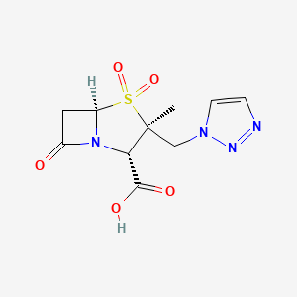
Supplementary Figures
A
B

Fig. S1. Chemical structure of (A) CFPM and (B) TAZO.

Fig. S2. RMSECV plot of the calibration set as a function of the optimum latent variables (LVs) for the (A) PCR, and (B) FA-PLS models.
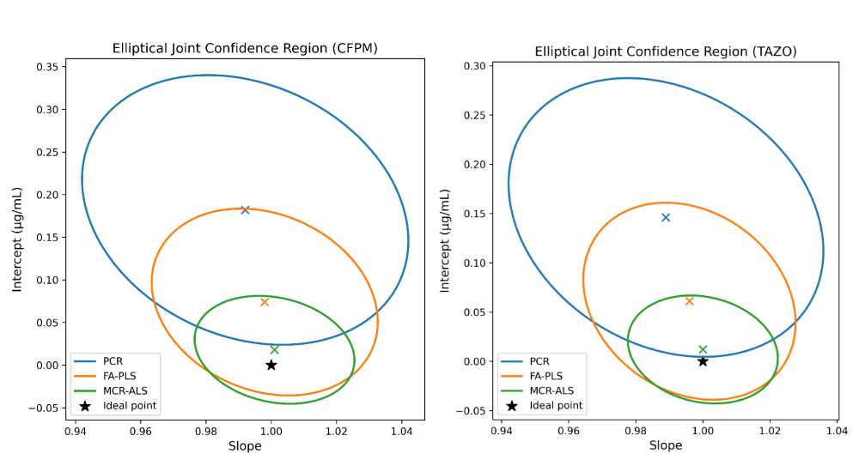
Fig. S3. Elliptical confidence regions for CFPM and TAZO with the ideal point.

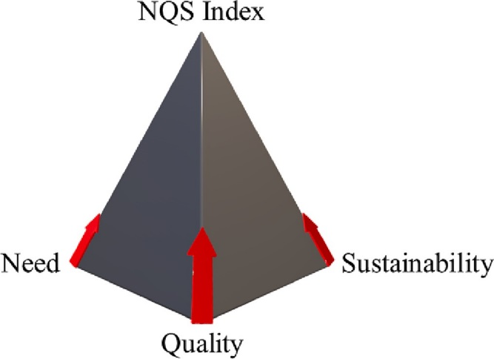
Fig. S4. Triangular pyramid illustrating the analytical chemistry for sustainability concept based on the Need – Quality - Sustainability (NQS) index.

Supplementary Tables

Table S1: Optimized parameters of the Firefly algorithm used for variable selection to enhance the predictability of the PLS models.

Parameter | CFPM | TAZO
Number of fireflies | 25 | 25
Maximum number of generations | 100 | 100
Randomization parameter (α) | 0.25 | 0.20
Attractiveness coefficient (β_{ο}) | 1.0 | 1.0
Absorption coefficient (γ) | 0.9 | 0.8

Table S2: Validation parameters for the determination of CFPM and TAZO in pharmaceutical preparations using the proposed chemometric models.
Parameters | PCR |  | GA-PLS
 | CFPM | TAZO | CFPM | TAZO
Working range (μg mL⁻¹) | 1–17 | 1–9 | 1–17 | 1–9
Slope ª | 0.9984 | 0.9976 | 0.9992 | 0.9988
Intercept ª | 0.0132 | 0.0179 | 0.0086 | 0.0114
r² ª | 0.9992 | 0.9991 | 0.9996 | 0.9995
LOD (μg mL⁻¹) ^{b} | 0.0863 | 0.0724 | 0.0648 | 0.0529
LOQ (μg mL⁻¹) ^{b} | 0.2615 | 0.2194 | 0.1964 | 0.1603
RMSEC ^{c} | 0.326 | 0.301 | 0.248 | 0.221
RMSEP ^{d} | 0.371 | 0.345 | 0.281 | 0.257
RRMSEP ^{e} | 2.218 | 2.457 | 1.684 | 1.923
BCRMSEP ^{f} | 0.129 | 0.118 | 0.082 | 0.074
SEC ^{g} | 0.341 | 0.315 | 0.262 | 0.236
Accuracy ^{h} (M.R % ± S.D) | 99.32 ± 0.618 | 99.56 ± 0.689 | 99.71 ± 0.487 | 99.83 ± 0.532
Repeatability ^{h} (%RSD ) | 0.653 | 0.724 | 0.492 | 0.548
Intermediate precision ^{h} (%RSD ) | 0.768 | 0.832 | 0.611 | 0.657
Robustness ^{h} (%RSD ) | 0.846 | 0.901 | 0.689 | 0.742
Experimental t value ^{i} | 3.97 | 2.31 | 2.13 | 1.15
Critical value t_{(0.025, 12)} | 2.179 | 2.179 | 2.179 | 2.179
Critical value t_{(0.01, 12)} | 2.681 | 2.681 | 2.681 | 2.681
Parameters | MCR-ALS
Parameters | CFPM | TAZO
Range (μg mL⁻¹) | 1–17 | 1–9
Slope ª | 0.9997 | 0.9994
Intercept ª | 0.0041 | 0.0063
r² ª | 0.9999 | 0.9998
LOD (μg mL⁻¹) ^{b} | 0.0487 | 0.0396
LOQ (μg mL⁻¹)^{b} | 0.1476 | 0.1200
RMSEC ^{c} | 0.186 | 0.163
RMSEP ^{d} | 0.214 | 0.192
RRMSEP ^{e} | 1.283 | 1.437
BCRMSEP ^{f} | 0.047 | 0.041
SEC ^{g} | 0.197 | 0.171
Accuracy ^{h} (M.R % ± S.D) | 100.12 ± 0.352 | 100.05 ± 0.398
Repeatability ^{h} (%RSD ) | 0.361 | 0.402
Intermediate precision ^{h} (%RSD ) | 0.452 | 0.496
Robustness ^{h} (%RSD ) | 0.518 | 0.563
Experimental t value ^{i} | 1.22 | 0.45
Critical value t_{(0.025, 12)} | 2.179 | 2.179
Critical value t_{(0.01, 12)} | 2.681 | 2.681

ª Data of the straight line plotted between predicted concentrations versus actual concentrations of the validation set.
^{b} The LOD and LOQ calculations are based on the net analyte signals.
^{c} Root mean square error of calibration.
^{d} Root mean square error of prediction.
^{e} Relative root mean square error of prediction.
^{f} Bias corrected mean square error of prediction.
^{g} standard error of calibration
^{h} Average of three determinations.
^{i}t_{exp} = |100 - R̄_{exp}| × √n/S_{R}, Where: R̄exp is the mean recovery percentage, n is the number of samples (13), and S_{R} is the standard deviation of recoveries.

Table S3: One-way ANOVA statistical analysis comparing the performance of three chemometric methods for the simultaneous determination of CFPM and TAZO (95% confidence level)

Component |  | Sum of squares | df | Mean square | F | P value
CFPM | Between Groups | 0.284 | 2 | 0.142 | 1.38 (3.89) ª | 0.279
CFPM | Within Groups | 2.468 | 24 | 0.103 | — | —
CFPM | Total | 2.752 | 26 | — | — | —
TAZO | Between Groups | 0.196 | 2 | 0.098 | 1.11 (3.89) ª | 0.346
TAZO | Within Groups | 2.119 | 24 | 0.088 | — | —
TAZO | Total | 2.315 | 26 | — | — | —
ª Figures in parentheses represent the corresponding critical value of F at P < 0.05.

Table S4: Matrix effect assessment for Cefepime (CFPM) and Tazobactam (TAZO) in human plasma using the optimized MCR-ALS model

Analyte | Spiked Level (µg mL⁻¹) | Calculated Concentration in Neat Solution (µg mL⁻¹) ª | Calculated Concentration in Post-Extraction Spiked Plasma (µg mL⁻¹) ª | Response in Neat Solution (a.u.) | Response in Post-Extraction Spiked Plasma (a.u.) | Matrix Factor (MF) ^{b, d} | Matrix Effect (%) ^{c,e}
CFPM | 5.0 | 4.99 | 4.88 | 0.284 | 0.277 | 0.9780 | −2.20
CFPM | 10.0 | 9.97 | 9.81 | 0.566 | 0.555 | 0.9839 | −1.61
CFPM | 15.0 | 14.96 | 14.77 | 0.848 | 0.835 | 0.9873 | −1.27
TAZO | 3.0 | 2.98 | 2.91 | 0.196 | 0.190 | 0.9765 | −2.35
TAZO | 5.0 | 4.99 | 4.88 | 0.327 | 0.319 | 0.9780 | −2.20
TAZO | 7.0 | 6.97 | 6.86 | 0.458 | 0.449 | 0.9842 | −1.58
ª Calculated concentrations were obtained using the optimized MCR-ALS chemometric model.
^{b} Matrix factor (MF) was calculated as the ratio of the calculated concentration in post-extraction spiked plasma to that obtained for the corresponding neat aqueous standard at the same nominal concentration.
^{c} Matrix effect (%) was calculated as: Matrix Effect (%) = (MF − 1) × 100.
^{d} Matrix factor values close to unity indicate negligible matrix-induced interference.
^{e} Negative values indicate signal suppression, positive values indicate signal enhancement, and zero indicates the absence of matrix effect.

