Supplementary data:
Supplementary data 1: ICD-10 codes for excluded diseases
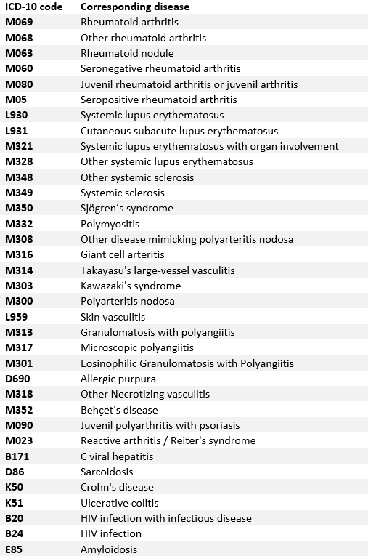

Supplementary data 2: Timeline of our study

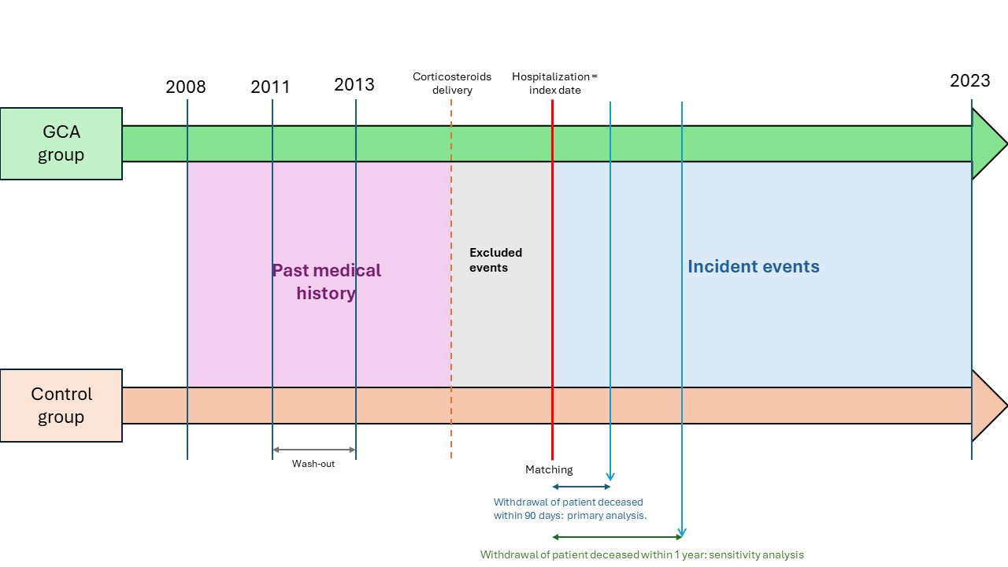GCA = giant cell arteritis

Supplementary data 3: algorithms for variable of interests
Obesity | - ≥ 1 Hospitalization with a diagnosis among ICD-10 codes listed below (and their branch)
Obesity | ICD-10 | E66
High blood pressure | - ≥ 3 dispensing of drugs with ATC codes listed above in one year  AND/OR  - ≥ 1 Hospitalization with a diagnosis among ICD-10 codes listed below (and their branch)
High blood pressure | ATC | C02AB02, C02AC01, C02AC02, C02AC05, C02AC06, C02CA01, C02CA06, C02DC01, C02LA01, C03AA01, C03AA03, C03BA04, C03BA10, C03BA11, C03BX03, C03CA01, C03CA02, C03CA03, C03DA01, C03DB01, C03EA, C03EA01, C03EA04, C07AA02, C07AA03, C07AA05, C07AA06, C07AA12, C07AA15, C07AA16, C07AA23, C07AB02, C07AB03, C07AB04, C07AB05, C07AB07, C07AB08, C07AB12, C07AG01, C07BA02, C07BB02, C07BB03, C07BB07, C07BB12, C07CA03, C07DA06, C07FB02, C07FB03, C08CA01, C08CA02, C08CA03, C08CA04, C08CA05, C08CA08, C08CA09, C08CA11, C08CA13, C08CX01, C08DA01, C08DB01, C08GA02, C09AA01, C09AA02, C09AA03, C09AA04, C09AA05, C09AA06, C09AA07, C09AA08, C09AA09, C09AA10,C09AA13, C09AA15, C09AA16, C09BA01, C09BA02, C09BA03, C09BA04, C09BA05, C09BA06, C09BA07, C09BA09, C09BA15, C09BB02, C09BB04, C09BB10, C09BX02, C09CA01, C09CA02, C09CA03, C09CA04, C09CA06, C09CA07, C09CA08, C09DA01, C09DA02, C09DA03, C09DA04, C09DA06, C09DA07, C09DA08, C09DB01, C09DB02, C09DB04, C09XA02, C09XA52, C10BX03
High blood pressure | ICD-10 | I10, I15
Dyslipidemia | ≥ 3 dispensing of drugs with ATC codes listed above in one year
Dyslipidemia | ATC | C10AA01, C10AA02, C10AA03, C10AA04, C10AA05, C10AA06, C10AA07, C10AA08, C10AB01, C10AB02, C10AB03, C10AB04, C10AB05, C10AB06, C10AB07, C10AB08, C10AB09, C10AB10, C10AB11, C10AC01, C10AC02, C10AC03, C10AC04, C10AD01, C10AD02, C10AD03, C10AD04, C10AD05, C10AD06, C10AD52,C10AX01, C10AX02, C10AX03, C10AX05, C10AX06, C10AX07, C10AX08, C10AX09, C10AX10, C10AX11, C10AX12, C10AX13, C10AX14, C10AX15, C10AX16,C10BA01,C10BA02, C10BA03, C10BA04,C10BA05, C10BA06, C10BA07, C10BA08, C10BA09, C10BA10, C10BX01, C10BX02, C10BX03, C10BX04, C10BX05, C10BX06, C10BX07, C10BX08, C10BX09, C10BX10, C10BX11, C10BX12, C10BX13, C10BX14, C10BX15, C10BX16, C10BX17, C10BX18
Diabetes | ≥ 1 Hospitalization with a diagnosis among ICD-10 codes listed below (and their branch)  AND/OR  ≥ 3 dispensing of drugs with ATC codes listed above in one year
Diabetes | ICD-10 | E10, E11, E12, E13, E14
Diabetes | ATC | A10AB01, A10AB03, A10AB04, A10AB05, A10AB06, A10AC01, A10AC03, A10AC04, A10AD01, A10AD03, A10AD04, A10AD05, A10AE01, A10AE02, A10AE03, A10AE04, A10AE05, A10AE06, A10AE30, A10AE56, A10BA02, A10BB01, A10BB03, A10BB04, A10BB06, A10BB07, A10BB09, A10BB12, A10BD02, A10BD03, A10BD05, A10BD07, A10BD08, A10BD10, A10BD11, A10BD12, A10BD13, A10BD14, A10BD15, A10BD16, A10BD17, A10BD18, A10BD19, A10BD20, A10BF01, A10BF02, A10BG02, A10BG03, A10BH01, A10BH02, A10BH03, A10BH51, A10BX02, A10BX04, A10BX07, A10BX09, A10BX10, A10BX11, A10BX12, A10BJ01, A10BJ02, A10BJ05, A10BJ06, A10BK01, A10BK02, A10BK03, A10BK04, A10BK06
Stroke | - ≥ 1 Hospitalization with a diagnosis among ICD-10 codes listed below (and their branch):
Stroke | ICD-10 | I60, I61, I62, I63, I64, I67, I68
Stroke sequelae | - ≥ 1 Hospitalization with a diagnosis among ICD-10 codes listed below (and their branch) :
Stroke sequelae | ICD-10 | I69
Myocardial infarction | - ≥ 1 Hospitalization with a diagnosis among ICD-10 codes listed below (and their branch)
Myocardial infarction | ICD-10 | I20, I21, I22, I23, I24
Chronic ischemic heart disease | - ≥ 1 Hospitalization with a diagnosis among ICD-10 codes listed below (and their branch)
Chronic ischemic heart disease | ICD-10 | I25
Heart failure | - ≥ 1 Hospitalization with a diagnosis among ICD-10 codes listed below (and their branch)
Heart failure | ICD-10 | I50, I11, I13
Atrial fibrillation | - ≥ 1 Hospitalization with a diagnosis among ICD-10 codes listed below (and their branch)
Atrial fibrillation | ICD-10 | I47, I48, I49
Conduction disorders | - ≥ 1 Hospitalization with a diagnosis among ICD-10 codes listed below (and their branch)
Conduction disorders | ICD-10 | I44, I45
Peripheral arterial disease | - ≥ 1 Hospitalization with a diagnosis among ICD-10 codes listed below (and their branch)
Peripheral arterial disease | ICD-10 | I70.2, I73.9, I74.0, I74.3, I74.4, I74.5, I70, I73, I74
Chronic kidney disease | - ≥ 1 Hospitalization with a diagnosis among ICD-10 codes listed below (and their branch)
Chronic kidney disease | ICD-10 | N18, Z491
Sleep apnoea syndrome | - ≥ 1 Hospitalization with a diagnosis among ICD-10 codes listed below (and their branch)  AND/OR  - ≥ 1 dispensing of continuous positive airway pressure (CPAP) machine
Sleep apnoea syndrome | ICD-10 | G473
Sleep apnoea syndrome | sleep apnoea treatment equipment | 1100040,1100637,1100867,1102470,1102731,1103156,1103446,1103854,1104285,1104405,1106663,1107272,1107958,1108544,108739,1110080,1111233,1111339,1112830,1113545,1113930,1114310,1114527,1115455,1115538,1115863,1116450,1116911,1118614,1118904,1119045,1119542,1120137,1120723,1121131,1122024,1122337,1124112,1124460,1124796,1125301,1125531,1125620,1126275,1126571,1126660,1126720,1127688,1128601,1129888,1130897,1130970,1131595,1132608,1133163,1134464,1137221,1137818,1138634,1139266,1141116,1141197,1141205,1142417,1142541,1145002,1147567,1148064,1148070,1149365,1149833,1151250,1151907,1152686,1154290,1154886,1156767,1157459,1157637,1158200,1158832,1159234,1160645,1161805,1162006,1162093,1162124,1163460,1164531,1166116,1166300,1166688,1168569,1171761,1172513,1173174,1174742,1176340,1179248,1179350,1179633,1180524,1181080,1181311,1182598,1183327,1183528,1183623,1185361,1185421,1185496,1187880,1188661,1188684,1188767,1189991,1191864,1192131,1192148,1192987,1194064,1196962,1197128,1198010,1199742
Antiplatelets agents | - ≥ 3 dispensing of drugs with ATC codes listed above in one year
Antiplatelets agents | ATC | B01AC04, B01AC06, B01AC30, B01AC56, B01AC24, B01AC22, B01AC25

Supplementary data 4: ICD-10 codes for ophthalmological complications in GCA group
Ophthalmological events associated to giant cell arteritis | - ≥ 1 Hospitalization with a diagnosis among ICD-10 codes listed below within 3 months before or after index date
Ophthalmological events associated to giant cell arteritis | ICD-10 | H54, H340, H341, H342, H349, H4701

Supplementary data 5: Cause of deaths for patients with GCA and control who deceased in the 90 days following the index date
 | Patients with GCA who died within 90 days after index date (n = 964) | Controls who died within 90 days after index date (n = 715)
Age (mean (sd), years) | 83.66 (7,56) | 82.44 (7,70)
Gender (n, (%))
Male | 395 (41,0%) | 265 (37,1%)
Female | 569 (59,0%) | 450 (62,9 %)
Cause of death (n, (%))
Cardiovascular diseases | 189 (19,6 %) | 116 (16,2 %)
Infections | 119 (12,3 %) | 57 (8,0 %)
Neoplasm | 135 (14 %) | 172 (24,1 %)
Hemopathy | 30 (3,1 %) | 24 (3,4 %)
Respiratory diseases | 20 (2,1 %) | 16 (2,2 %)
Metabolic diseases | 22 (2,3 %) | 33 (4,6 %)
Traumatological diseases | 26 (2,7 %) | 13 (1,8 %)
Digestive diseases | 34 (3,5 %) | 7 (1,0 %)
Giant cell arteritis | 46 (5,4 %)
Other/cause of death non available | 343 (35,6%) | 277 (38,7%)

Supplementary data 6: Past medical history of patients with giant cell arteritis under 65 years old and their controls.
 | Control  N = 6216 | GCA  N = 2132 | p-value
Age. years (mean (sd)) | 60.6 (3.75) | 60.6 (3.74)
Sex (n (%))  Male  Female | 2203 (35.4%)  4013 (64.6%) | 766 (35.9%)  1366 (64.1%)
Past medical history (n. (%))
Cardiovascular factors
High blood pressure | 2090 (33.6%) | 816 (38.3%) | < 0.001
Diabetes | 554 (8.9%) | 226 (10.6%) | 0.023
Obesity | 377 (6.1%) | 167 (7.8%) | 0.005
Dyslipidemia | 1398 (22.5%) | 497 (23.3%) | 0.453
Cardiovascular associated factors
Chronic kidney disease | 56 (0.9%) | 23 (1.1%) | 0.547
Sleep apnoea syndrome | 264 (4.2%) | 133 (6.2%) | < 0.001
Past cardiovascular events
Atrial fibrillation | 136 (2.2%) | 62 (2.9%) | 0.071
Conduction disorders | 54 (0.9%) | 21 (1.0%) | 0.720
Peripheral artery disease | 86 (1.4%) | 63 (3.0%) | < 0.001
Myocardial infarction | 323 (5.2%) | 138 (6.5%) | 0.030
Stroke | 74 (1.2%) | 64 (3.0%) | < 0.001
Heart failure | 59 (0.9%) | 25 (1.2%) | 0.444
Anti-platelet agents’ delivery | 663 (10.7%) | 362 (17.0%) | < 0.001
Supplementary data 7: Sensitivity analysis after excluding patients and controls who died within the year following index date.
 | Crude HR | Adjusted HR* | p-value adjusted analysis
Cardiovascular events
MACE | 1.55 (1.44-1.67) | 1.45 (1.35-1.56) | < 0.001
Death | 1.18 (1.12-1.24) | 1.11 (1.06-1.18) | < 0.001
Death from cardiovascular causes | 1.25 (1.08-1.60) | 1.14 (0.98-1.32) | 0.093
Myocardial infarction | 1.72 (1.47-2.01) | 1.57 (1.34-1.84) | < 0.001
Stroke | 1.37 (1.21-1.56) | 1.28 (1.12-1.46) | < 0.001
Heart failure | 1.55 (1.43-1.68) | 1.35 (1.24-1.46) | < 0.001
Atrial fibrillation | 1.33 (1.24-1.44) | 1.16 (1.07-1.25) | < 0.001
Conduction disorders | 1.39 (1.24-1.55) | 1.24 (1.10-1.39) | < 0.001
Peripheral artery disease | 2.12 (1.89-2.38) | 1.96 (1.74-2.19) | < 0.001
Cardiovascular factors
High blood pressure | 1.77 (1.65-1.91) | 1.57 (1.45-1.69) | < 0.001
Diabetes | 1.67 (1.52-1.83) | 1.60 (1.46-1.76) | < 0.001
Dyslipidemia | 1.87 (1.72-2.04) | 1.79 (1.64-1.95) | < 0.001
Obesity | 1.38 (1.25-1.53) | 1.28 (1.16-1.42) | < 0.001
Cardiovascular associated factors
Chronic kidney disease | 1.49 (1.36-1.65) | 1.33 (1.21-1.47) | < 0.001
Sleep apnoea syndrom | 2.23 (2.01-2.49) | 2.19 (1.96-2.44) | < 0.001
Cox model adjusted on age, sex, past medical history of: myocardial infarction, stroke, heart failure, hypertension, diabetes, dyslipidemia, obesity, sleep apnoea syndrome, chronic kidney disease, antiplatelet agent use at time of first identification of GCA.

