Supplementary 2

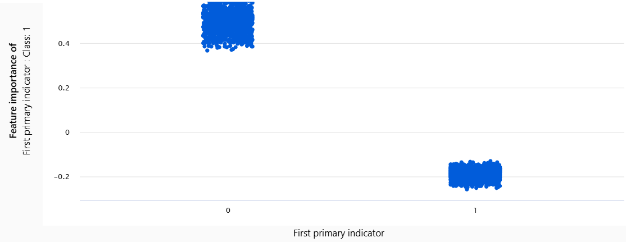
Supplementary 2a. Aggregate feature importance for the presence of earlier primary malignant tumors besides HNSCC. [0 = The presence of earlier primary malignant tumors besides HNSCC; 1 = The absence of earlier primary malignant tumors besides HNSCC].

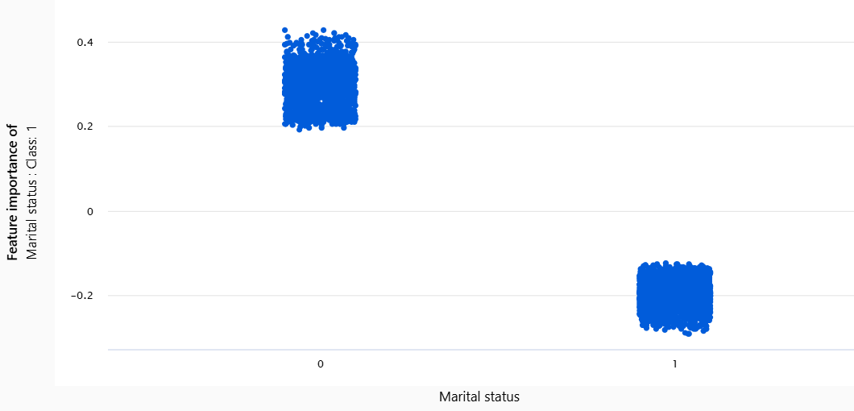
Supplementary 2b. Aggregate feature importance for the unmarried patients being associated with early mortality. [ 0 = Unmarried T1-T3 patients with HNSCC; 1 = Married T1-T3 patients with HNSCC; See Table 1 for legend].

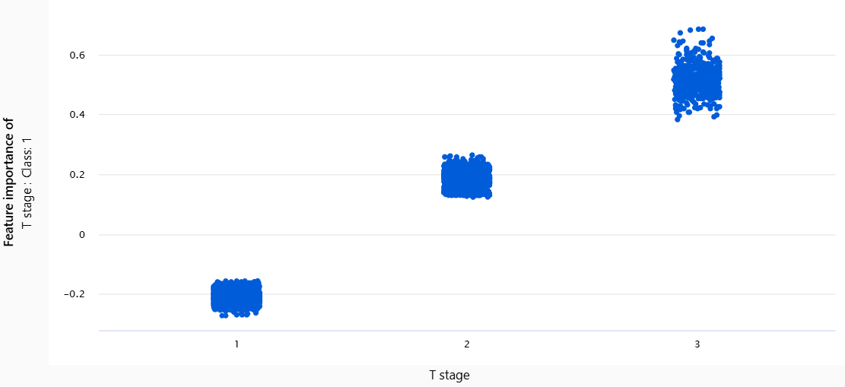
Supplementary 2c. Aggregate feature importance for T3 stage being associated with early mortality. [ 1 = T1; 2 = T2; 3 = T3; See Table 1 for legend].

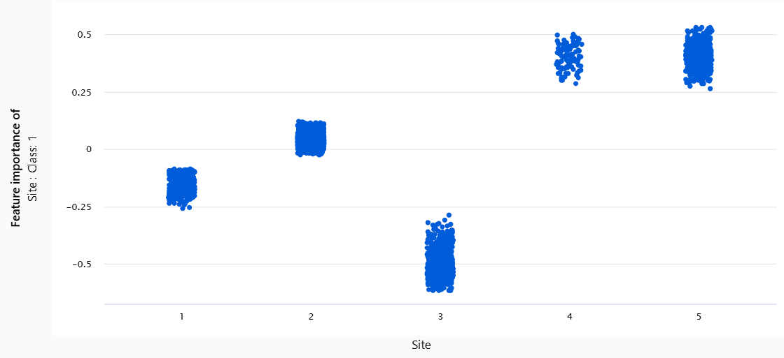

Supplementary 2d. Aggregate feature importance showed that hypopharyngeal or laryngeal cancer were associated with early mortality. [1 = Lip ; 2 = Oral cavity; 3 = Oropharynx; 4 = Hypopharyngeal; 5 = Laryngeal; See Table 1 for legend].

