Figure S1: Nucleotide diversity across autosomes.

Figure S2. LD decay estimated for the IW population.

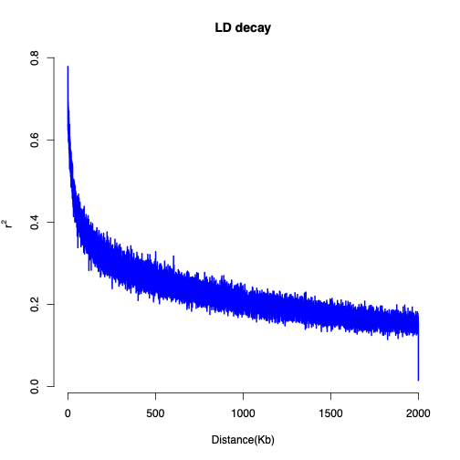

Figure S3. Descriptive statistics of ROH identified using Sliding-window method ROH analysis results: (A) descriptive statistics of identified ROH; (B) ROH distribution by classes of length; C) Relation between number of ROH and Total ROH length per samples; D) Manhattan plot showing the proportion of SNPs in ROH across the genome, which corresponds to the % of individuals in which each SNP is homozygous within a ROH. The blue line indicates the 85% threshold, above which SNPs are considered part of an ROH island.

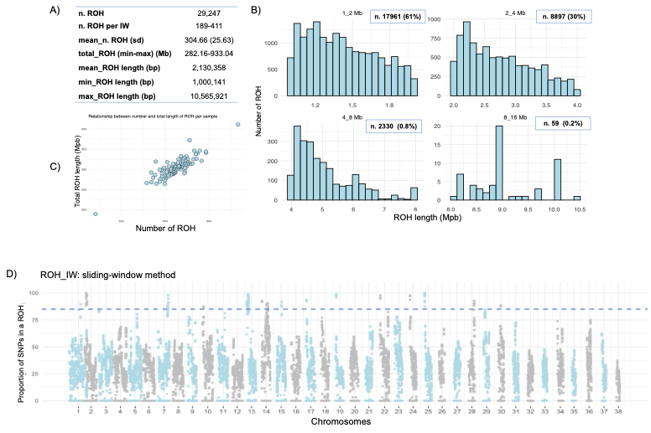

Figure S4: Pairwise IBD estimates (proportion of the genome shared identical by descent) among all sampled individuals, computed with SVS. The overall patterns of relatedness are consistent with the estimates obtained using PLINK.

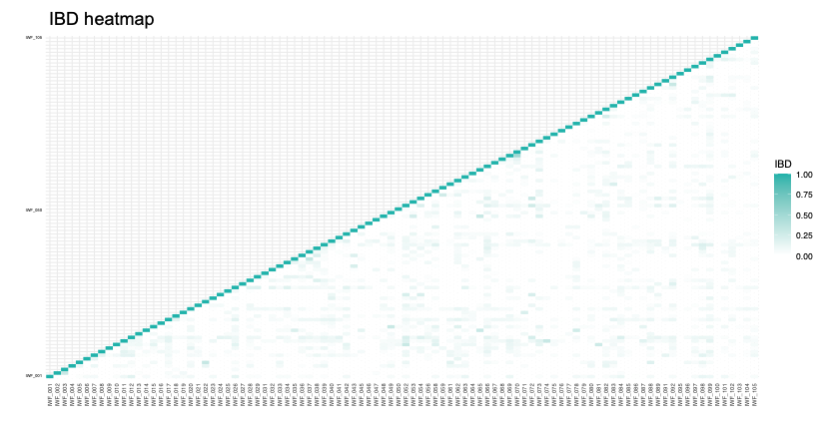

Table S1. Genes already associated with canine behavior traits.
Genes | Behavior Traits [1]
ANGPT1 | Stranger Fear
ASAP2 | Energy
CAB39L | Stranger Aggression, Stranger Fear
CSMD3 | Excitability
CUBN | Dog Fear, Nonsocial Fear, Stranger Fear
EBPL | Stranger Aggression
FAM214A | Separation Problems
FNDC3A | Stranger Aggression
KPNA3 | Stranger Aggression
LHFPL6 | Chasing, Touch Sensitivity
LRP12 | Attachment/attention-seeking, Chasing, Stranger Aggression
MATN2 | Attachment/attention-seeking, Energy, Trainability
MSRB3 | Dog Fear
MYO5A | Chasing
NBEA | Chasing
NUDCD1 | Dog Rivalry, Touch Sensitivity
RB1 | Dog Aggression, Dog Fear, Stranger Aggression
RCBTB1 | Stranger Aggression
RCBTB2 | Nonsocial Fear
RIMS2 | Chasing
RSPO2 | Touch Sensitivity
RSU1 | Dog Fear
SETDB2 | Stranger Aggression
SLC24A3 | Attachment/attention-seeking, Excitability
SLC7A11 | Dog Rivalry, Owner Aggression
TBC1D30 | Dog Fear
TRDMT1 | Separation Problems, Trainability
VPS13B | Stranger Aggression, Trainability
WIF1 | Dog Aggression
ZFPM2 | Attachment/attention-seeking, Dog Aggression, Dog Fear, Dog Rivalry
1. MacLean, E. L., Snyder-Mackler, N., VonHoldt, B. M. & Serpell, J. A. Highly heritable and functionally relevant breed differences in dog behaviour. Proceedings of the Royal Society B 286, 20190716 (2019).

Table S2. Functional annotation of genes provided by the DAVID online database. Genes located in ROH islands are shown in normal font, while genes identified through the iHS analysis are highlighted in bold.

Category | Term | Count | PValue | Genes
Go Biological Process | GO:0051301~cell division | 8 | 0.00 | RB1, SPART, CCNA1, USP44, SETDB2, RBBP8, ARPP19, NDC80
Go Biological Process | GO:0009653~anatomical structure morphogenesis | 5 | 0.00 | FOXI2, ONECUT1, SMAD9, ZFPM2, FREM2
Go Biological Process | GO:0048856~anatomical structure development | 4 | 0.01 | ZEB1, RXRA, WIF1, NR2C1
Go Biological Process | GO:0030154~cell differentiation | 10 | 0.02 | RB1, RXRA, ANGPT1, ID2, FOXI2, SOHLH2, SMAD9, ZFPM2, NR2C1, ELK3
Go Biological Process | GO:0030512~negative regulation of transforming growth factor beta receptor signaling pathway | 4 | 0.02 | ADAM17, BAMBI, ONECUT1, LEMD3
Go Biological Process | GO:0007229~integrin-mediated signaling pathway | 4 | 0.04 | ADAM17, ITGA8, ITGB8, ITGB1BP1
Go Biological Process | GO:0007179~transforming growth factor beta receptor signaling pathway | 4 | 0.04 | BAMBI, ONECUT1, ITGB8, SMAD9
Go Biological Process | GO:0033627~cell adhesion mediated by integrin | 3 | 0.05 | ADAM17, ITGA8, ITGB8
Go Biological Process | GO:0045600~positive regulation of fat cell differentiation | 3 | 0.05 | WIF1, NOCT, STK3
Go Cellular Component | GO:0005829~cytosol | 45 | 0.01 | VEZT, LRGUK, NDUFA12, DPYS, MLNR, AKR1B1, NOD1, ASAP2, SPATA7, AK8, NCALD, IPO5, RIDA, NUDCD1, RASSF3, TBC1D30, EXOSC8, METTL4, MAP3K8, LTA4H, RGS22, RALGDS, SVIL, SETDB2, SCP2D1, SMAD9, MYO5A, YWHAZ, PLEKHA8, SPART, GGCT, GARS1, ADAM17, RAP2A, ZEB1, NBEA, ID2, SP4, ZNF438, SPAG1, EIF3E, ITGB1BP1, DOCK1, RIN2, METAP2
Go Cellular Component | GO:0005737~cytoplasm | 57 | 0.01 | RB1, DPYS, PTPN21, RCBTB1, IPO5, AQP1, YWHAQ, RASSF3, NUDCD1, KIF5B, RNF19A, KPNA3, CDADC1, MBNL2, USP44, WDR72, VRK2, YWHAZ, RNF144A, CCNA1, CMPK2, PABPC1, ZFPM2, DOCK1, NOD1, ASAP2, ARPP19, AK8, ARHGAP12, STK3, FGD6, ZNF706, AMDHD1, NOCT, EXOSC8, LTA4H, RSU1, ZC3H14, DTD1, TRDMT1, SVIL, MACC1, SMAD9, MYO5A, TMEM196, DCLK1, PLEKHA8, PTPRE, GARS1, HAL, UFM1, BAMBI, ID2, SPAG1, MSRB3, EIF3E, METAP2
Go Cellular Component | GO:0031965~nuclear membrane | 6 | 0.02 | MINDY3, SCRN1, SETDB2, GATA6, AQP1, IPO5
Go Cellular Component | GO:0005911~cell-cell junction | 5 | 0.03 | ADAM17, TRPC4, GRHL2, MPP7, JCAD
Go Cellular Component | GO:0098686~hippocampal mossy fiber to CA3 synapse | 3 | 0.04 | RNF19A, YWHAZ, C1QL3
Go Cellular Component | GO:0062023~collagen-containing extracellular matrix | 5 | 0.04 | FCN2, POSTN, ANGPT1, FREM2, MATN2
Go Cellular Component | GO:0005634~nucleus | 56 | 0.05 | RB1, VEZT, FOXI2, ONECUT1, MKI67, IPO5, ELK3, YWHAQ, NUDCD1, KPNA3, OSR2, CDADC1, MBNL2, USP44, WDR72, VRK2, YWHAZ, CCNA1, ZEB1, WAC, ZNF438, ZFPM2, GTF3C5, GATA6, FBXO43, NR2C1, STK3, RXRA, ZNF706, NOCT, SOHLH2, RBBP8, METTL4, LTA4H, ZC3H14, RALGDS, TRDMT1, POLR2K, SVIL, FANCL, CPSF3, MACC1, SETDB2, SMAD9, OXR1, GRHL2, NDC80, PTPRE, GFI1B, UFM1, NBEA, ID2, MAB21L1, SP4, RFXAP, EIF3E
Go Molecular Process | GO:0008528~G protein-coupled peptide receptor activity | 4 | 0.00 | GHRHR, ADCYAP1R1, MLNR, CRHR2
Go Molecular Process | GO:0017046~peptide hormone binding | 3 | 0.03 | GHRHR, ADCYAP1R1, CRHR2
Go Molecular Process | GO:0043565~sequence-specific DNA binding | 6 | 0.04 | RXRA, SP4, FOXI2, ZNF438, NR2C1, ELK3
Go Molecular Process | GO:0003700~DNA-binding transcription factor activity | 8 | 0.05 | ZEB1, FOXI2, SOHLH2, ONECUT1, GATA6, NR2C1, GRHL2, ELK3
Go Molecular Process | GO:0042802~identical protein binding | 17 | 0.05 | RB1, IAH1, ANGPT1, YWHAZ, C1QL3, GRHL2, NDC80, AQP1, STK3, GARS1, RXRA, YWHAQ, RASSF3, SP4, KIF5B, EXOSC8, RBBP8
KEGG  PATHWAY | clud05160:Hepatitis C | 6 | 0.03 | RB1, RXRA, YWHAQ, RSAD2, EIF3E, YWHAZ
KEGG  PATHWAY | clud04080:Neuroactive ligand-receptor interaction | 8 | 0.05 | NPS, GHRHR, ADCYAP1R1, CYSLTR2, LPAR6, MLNR, TRHR, CRHR2

Table S3. List of Irish Wolfhounds used in this study, including sex and country of breeding.
ID_LAB | sex | country of breeding | ID_LAB | sex | country of breeding
IWF_001 | M | France | IWF_052 | M | Czechia
IWF_002 | F | Austria | IWF_053 | M | Czechia
IWF_003 | F | Austria | IWF_054 | M | Italy
IWF_004 | M | the Netherlands | IWF_056 | M | Czechia
IWF_005 | F | United Kingdom | IWF_058 | M | Poland
IWF_006 | M | Italy | IWF_059 | M | Czechia
IWF_007 | F | Italy | IWF_061 | F | France
IWF_008 | M | Canada | IWF_062 | M | France
IWF_009 | M | Slovakia | IWF_063 | F | France
IWF_010 | M | Czechia | IWF_064 | M | Czechia
IWF_011 | M | Norway | IWF_065 | M | Germany
IWF_012 | M | France | IWF_066 | M | Ireland
IWF_013 | M | Czechia | IWF_067 | F | Ireland
IWF_014 | M | Russia | IWF_068 | M | Ireland
IWF_015 | M | Belarus | IWF_069 | F | France
IWF_016 | M | Italy | IWF_070 | F | Ireland
IWF_017 | F | France | IWF_071 | F | Finland
IWF_018 | F | Poland | IWF_072 | M | Italy
IWF_019 | F | Germany | IWF_073 | M | Germany
IWF_020 | F | Ireland | IWF_074 | M | Norway
IWF_021 | M | Germany | IWF_075 | F | Finland
IWF_022 | M | Ireland | IWF_076 | M | Germany
IWF_023 | F | Germany | IWF_077 | F | Germany
IWF_024 | F | Italy | IWF_078 | M | Finland
IWF_025 | F | France | IWF_079 | F | Finland
IWF_026 | F | Canada | IWF_080 | F | Switzerland
IWF_027 | M | Canada | IWF_081 | F | Germany
IWF_028 | F | USA | IWF_082 | F | Germany
IWF_029 | F | Canada | IWF_083 | F | France
IWF_031 | F | USA | IWF_084 | F | France
IWF_032 | M | USA | IWF_085 | M | the Netherlands
IWF_033 | F | USA | IWF_086 | F | Finland
IWF_034 | F | Canada | IWF_087 | F | Germany
IWF_035 | F | Canada | IWF_088 | F | United Kingdom
IWF_036 | F | USA | IWF_089 | M | United Kingdom
IWF_037 | F | Canada | IWF_091 | F | United Kingdom
IWF_038 | M | USA | IWF_092 | f | United Kingdom
IWF_039 | M | USA | IWF_095 | M | United Kingdom
IWF_040 | F | Hungary | IWF_096 | M | Czechia
IWF_041 | F | Poland | IWF_097 | M | USA
IWF_042 | F | Croatia | IWF_098 | F | Italy
IWF_043 | F | USA | IWF_099 | F | Sweden
IWF_045 | F | Hungary | IWF_100 | F | Sweden
IWF_046 | F | Germany | IWF_101 | M | Sweden
IWF_047 | F | France | IWF_102 | M | Sweden
IWF_048 | F | United Kingdom | IWF_103 | F | Australia
IWF_049 | F | Belgium | IWF_104 | F | Australia
IWF_050 | F | Denmark | IWF_105 | f | Australia

Table S4. List of IW samples available from Shannon et al., 2015.

Samples Code
PFZ20C06 | PFZ21C11 | PFZ22F01 | PFZ30C10 | PFZ31F08 | PFZ33E10
PFZ20F05 | PFZ21F10 | PFZ22D02 | PFZ30A11 | PFZ31D09 | PFZ33C11
PFZ20D06 | PFZ21D11 | PFZ30E11 | PFZ30D10 | PFZ31G08 | PFZ33F10
PFZ20G05 | PFZ21E11 | PFZ30C12 | PFZ30B11 | PFZ31E09 | PFZ33D11
PFZ20E06 | PFZ21C12 | PFZ30F11 | PFZ30E10 | PFZ31H08 | PFZ33E08
PFZ20H05 | PFZ21F11 | PFZ30D12 | PFZ30F10 | PFZ31F09 | PFZ33C09
PFZ20F06 | PFZ21G11 | PFZ30G11 | PFZ30D11 | PFZ31A09 | PFZ33F08
PFZ20A06 | PFZ21E12 | PFZ30E12 | PFZ30A07 | PFZ31B09 | PFZ33D09
PFZ20G06 | PFZ21H11 | PFZ30G12 | PFZ30G07 | PFZ31C12 | PFZ33G08
PFZ20B06 | PFZ21F12 | PFZ30B12 | PFZ30B07 | PFZ31F11 | PFZ33E09
PFZ20H06 | PFZ21A12 | PFZ30H12 | PFZ30H07 | PFZ31D12 | PFZ33H08
PFZ20G04 | PFZ21G12 | PFZ30E05 | PFZ30C07 | PFZ31G11 | PFZ33F09
PFZ20H04 | PFZ21B12 | PFZ30C06 | PFZ30A08 | PFZ31E12 | PFZ33A09
PFZ20C04 | PFZ21H12 | PFZ30F05 | PFZ30D07 | PFZ31H11 | PFZ33G09
PFZ20A08 | PFZ22E02 | PFZ30D06 | PFZ30E07 | PFZ31F12 | PFZ33B09
PFZ20D04 | PFZ22C03 | PFZ30G05 | PFZ30F07 | PFZ31A12 | PFZ33H09
PFZ20B08 | PFZ22F02 | PFZ30E06 | PFZ30D08 | PFZ31G12 | PFZ37C10
PFZ20E04 | PFZ22D03 | PFZ30H05 | PFZ31E05 | PFZ31B12
PFZ20C08 | PFZ22G02 | PFZ30F06 | PFZ31C06 | PFZ31H12
PFZ20A07 | PFZ22E03 | PFZ30A06 | PFZ31F05 | PFZ32E11
PFZ20G07 | PFZ22H02 | PFZ30G06 | PFZ31D06 | PFZ32C12
PFZ20H07 | PFZ22F03 | PFZ30B06 | PFZ31G05 | PFZ32F11
PFZ20C07 | PFZ22A03 | PFZ30H06 | PFZ31E06 | PFZ32D12
PFZ20D07 | PFZ22G03 | PFZ30E08 | PFZ31H05 | PFZ32G11
PFZ20C05 | PFZ22B03 | PFZ30F08 | PFZ31F06 | PFZ32E12
PFZ20F07 | PFZ22H03 | PFZ30D09 | PFZ31A06 | PFZ32H11
PFZ20D05 | PFZ22A04 | PFZ30G08 | PFZ31G06 | PFZ32F12
PFZ21C09 | PFZ22G04 | PFZ30E09 | PFZ31B06 | PFZ32A12
PFZ21D09 | PFZ22B04 | PFZ30H08 | PFZ31H06 | PFZ32G12
PFZ21G08 | PFZ22H04 | PFZ30F09 | PFZ31A11 | PFZ32B12
PFZ21E09 | PFZ22C04 | PFZ30A09 | PFZ31A07 | PFZ32H12
PFZ21H08 | PFZ22A05 | PFZ30G09 | PFZ31G07 | PFZ32G10
PFZ21F09 | PFZ22D04 | PFZ30B09 | PFZ31B07 | PFZ32A11
PFZ21A09 | PFZ22B05 | PFZ30H03 | PFZ31H07 | PFZ32B11
PFZ21G09 | PFZ22E04 | PFZ30G04 | PFZ31C07 | PFZ32E10
PFZ21B09 | PFZ22F04 | PFZ30B04 | PFZ31A08 | PFZ32C11
PFZ21H09 | PFZ22A01 | PFZ30H04 | PFZ31D07 | PFZ32F10
PFZ21A10 | PFZ22G01 | PFZ30A05 | PFZ31B08 | PFZ32D11
PFZ21G10 | PFZ22B01 | PFZ30D04 | PFZ31E07 | PFZ33A08
PFZ21B10 | PFZ22H01 | PFZ30B05 | PFZ31C08 | PFZ33B08
PFZ21H10 | PFZ22C01 | PFZ30E04 | PFZ31F07 | PFZ33C08
PFZ21C10 | PFZ22A02 | PFZ30C05 | PFZ31D08 | PFZ33D08
PFZ21A11 | PFZ22D01 | PFZ30F04 | PFZ31C05 | PFZ33A10
PFZ21D10 | PFZ22B02 | PFZ30D05 | PFZ31D05 | PFZ33B10
PFZ21B11 | PFZ22E01 | PFZ30G10 | PFZ31E08 | PFZ33C10
PFZ21E10 | PFZ22C02 | PFZ30H10 | PFZ31C09 | PFZ33D10

