Supplementary Information
Supplementary Figure S1. Expression analyses of additional POTE family members in hepatocellular carcinoma.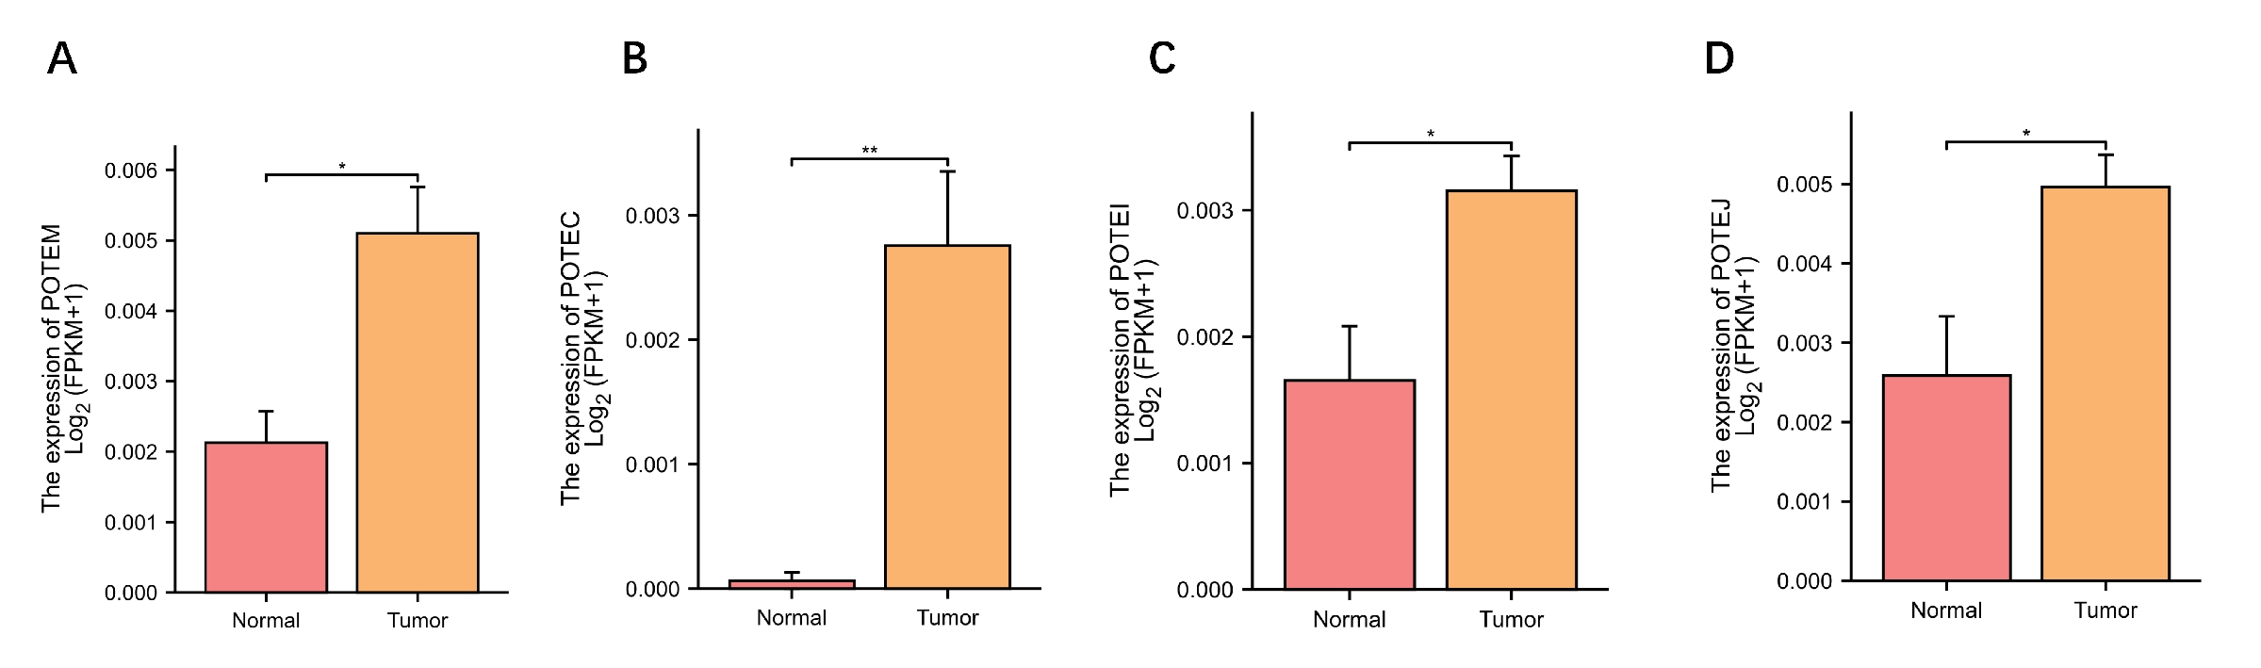
Supplementary Figure S2. Prognostic and diagnostic analyses of additional POTE family members in hepatocellular carcinoma.
Supplementary Figure S3. Pan-cancer expression profiles of POTE family members across TCGA datasets.
Supplementary Figure S4. Positively correlated genes associated with POTEF expression in hepatocellular carcinoma.

Supplementary Figure S5. Correlation analysis between POTEF mRNA expression and CD66b-positive areas in matched hepatocellular carcinoma tissues. Correlations were analyzed using Spearman’s rank correlation test.

