Supplementary Materials

Supplementary Figure 1. Distribution of ED length of stay according to steroid administration

Supplementary Figure 2. ED length of stay based patient flow diagram

Supplementary Table 1. Additional multivariable regression analysis for steroid administration

Supplementary Table 2. Subgroup, interaction, and exploratory analysis for steroid administration

Supplementary Table 3. Additional subgroup, interaction, and exploratory analysis for steroid administration

Supplementary Table 4. Multivariable logistic regression analysis for steroid timing and dose

Supplementary Table 5. Additional multivariable logistic regression analysis for steroid timing and dose

Supplementary Table 6. Subgroup analysis according to vasopressin use for steroid timing and dose

Supplementary Table 7. Additional subgroup analysis according to vasopressin use for steroid timing and dose

Supplementary Figure 3. Exploratory analysis of norepinephrine-equivalent dose at first hydrocortisone administration. (A) Restricted cubic spline (RCS) regression plot for norepinephrine-equivalent dose at first hydrocortisone administration, showing adjusted predicted probabilities of 28-day mortality and 95% confidence intervals (CI). (B) RCS analysis with bootstrap resampling (1,000 iterations), showing adjusted predicted probabilities and 95% CI. (C) Adjusted odds ratio (aOR) curve using the bootstrap-derived cutoff. The reference point corresponds to the nadir of the adjusted predicted probabilities. The dashed vertical line indicates the cutoff at which the lower bound of the 95% CI exceeds 1. (D) Bootstrap distribution of adjusted odds ratios based on 1,000 resampled datasets using the bootstrap-derived cutoff. The empirical two-sided p-value was calculated as the proportion of samples with OR <1.

Supplementary Figure 4. Additional exploratory analysis of norepinephrine-equivalent dose at first hydrocortisone administration. (A) Restricted cubic spline (RCS) regression plot for norepinephrine-equivalent dose at first hydrocortisone administration, showing the adjusted predicted probabilities and 95% confidence intervals (CI). (B) RCS with bootstrap (1,000 iterations), showing the adjusted predicted probabilities and 95% CI. (C) Adjusted odds ratio (aOR) curve using bootstrap-derived cutoff. The reference point is the nadir of the adjusted predicted probabilities. The dashed vertical line indicates the cutoff where 95% CI lower bound exceeds 1. (D) Bootstrap distribution of adjusted odds ratios based on 1,000 resampled datasets, using the bootstrap-derived cutoff. The empirical two-sided p-value was calculated from the proportion of samples with OR < 1.

Supplementary Figure 5. Exploratory analysis of time from first vasopressor to first hydrocortisone administration. (A) Restricted cubic spline (RCS) regression plot for time from first vasopressor to first hydrocortisone administration, showing adjusted predicted probabilities of 28-day mortality and 95% confidence intervals (CI). (B) RCS analysis with bootstrap resampling (1,000 iterations), showing adjusted predicted probabilities and 95% CI. (C) Adjusted odds ratio (aOR) curve using the bootstrap-derived cutoff. The reference point corresponds to the nadir of the adjusted predicted probabilities. The dashed vertical line indicates the cutoff at which the lower bound of the 95% CI exceeds 1. (D) Bootstrap distribution of adjusted odds ratios based on 1,000 resampled datasets using the bootstrap-derived cutoff. The empirical two-sided p-value was calculated as the proportion of samples with OR <1.

Supplementary Figure 6. Additional exploratory analysis of time from first vasopressor to first hydrocortisone administration. (A) Restricted cubic spline (RCS) regression plot for time from first vasopressor to first hydrocortisone administration, showing the adjusted predicted probabilities and 95% confidence intervals (CI). (B) RCS with bootstrap (1,000 iterations), showing the adjusted predicted probabilities and 95% CI. (C) Adjusted odds ratio (aOR) curve using bootstrap-derived cutoff. The reference point is the nadir of the adjusted predicted probabilities. The dashed vertical line indicates the cutoff where 95% CI lower bound exceeds 1. (D) Bootstrap distribution of adjusted odds ratios based on 1,000 resampled datasets, using the bootstrap-derived cutoff. The empirical two-sided p-value was calculated from the proportion of samples with OR < 1.

Supplementary Figure 7. Exploratory analysis of hydrocortisone dose. (A) Restricted cubic spline (RCS) regression plot for hydrocortisone dose, showing adjusted predicted probabilities of 28-day mortality and 95% confidence intervals (CI). (B) RCS analysis with bootstrap resampling (1,000 iterations), showing adjusted predicted probabilities and 95% CI. (C) Adjusted odds ratio (aOR) curve using the bootstrap-derived cutoff. The reference point corresponds to the nadir of the adjusted predicted probabilities. The dashed vertical line indicates the cutoff at which the lower bound of the 95% CI exceeds 1. (D) Bootstrap distribution of adjusted odds ratios based on 1,000 resampled datasets using the bootstrap-derived cutoff. The empirical two-sided p-value was calculated as the proportion of samples with OR <1.

Supplementary Figure 8. Additional exploratory analysis of hydrocortisone dose. (A) Restricted cubic spline (RCS) regression plot for hydrocortisone dose, showing the adjusted predicted probabilities and 95% confidence intervals (CI). (B) RCS with bootstrap (1,000 iterations), showing the adjusted predicted probabilities and 95% CI. (C) Adjusted odds ratio (aOR) curve using bootstrap-derived cutoff. The reference point is the nadir of the adjusted predicted probabilities. The dashed vertical line indicates the cutoff where 95% CI lower bound exceeds 1. (D) Bootstrap distribution of adjusted odds ratios based on 1,000 resampled datasets, using the bootstrap-derived cutoff. The empirical two-sided p-value was calculated from the proportion of samples with OR < 1.

Supplementary Table 8. Sensitivity analysis using hydrocortisone-equivalent dose after including patients who received steroids other than hydrocortisone (n = 1,601)

Supplementary Table 9. Additional sensitivity analysis using hydrocortisone-equivalent dose after including patients who received other than hydrocortisone (n=1601).

Supplementary Table 10. Sensitivity analysis after multiple imputation for missing hydrocortisone dose and vasopressor dose at initial hydrocortisone administration (n = 1,631)

Supplementary Table 11. Additional sensitivity analysis after multiple imputations for cases with missing hydrocortisone dose and vasopressor dose at initial steroid administration (n=1631).

Supplementary Figure 1. Distribution of ED length of stay according to steroid administration

Supplementary Figure 2. ED length of stay based patient flow diagram
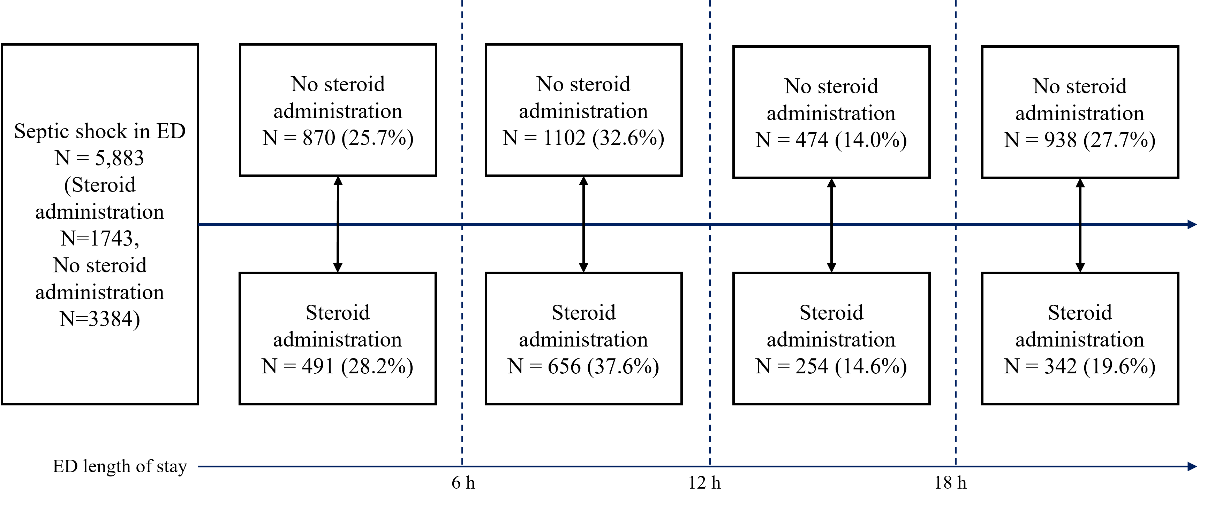

Supplementary Table 1. Additional multivariable regression analysis for steroid administration
 | aOR / aHR | 95% CI | p-value
Steroid administration (any type of steroid vs. none)
Multivariable logistic regression
Model 1 | 0.745 | 0.630–0.882 | 0.001
Model 2 | 0.797 | 0.675–0.943 | 0.008
Multivariable logistic regression after PSM
Model 1 | 0.761 | 0.621–0.932 | 0.008
Model 2 | 0.760 | 0.621–0.931 | 0.008
Multivariable logistic regression after IPTW
Model 1 | 0.710 | 0.617–0.816 | <0.001
Model 2 | 0.710 | 0.617–0.817 | <0.001
Multivariable Cox proportional hazards model
Model 1 | 0.777 | 0.687–0.880 | <0.001
Model 2 | 0.819 | 0.722–0.930 | 0.002
Multivariable time-dependent Cox proportional hazards model
Model 1 | 0.792 | 0.700–0.897 | <0.001
Model 2 | 0.836 | 0.736–0.948 | 0.005
Steroid administration (hydrocortisone vs. none)
Multivariable logistic regression
Model 1 | 0.736 | 0.619–0.876 | 0.001
Model 2 | 0.798 | 0.671–0.949 | 0.011
Multivariable logistic regression after PSM
Model 1 | 0.776 | 0.628–0.958 | 0.019
Model 2 | 0.775 | 0.628–0.956 | 0.018
Multivariable logistic regression after IPTW
Model 1 | 0.690 | 0.598–0.797 | <0.001
Model 2 | 0.691 | 0.598–0.798 | <0.001
Multivariable Cox proportional hazards model
Model 1 | 0.770 | 0.678–0.875 | <0.001
Model 2 | 0.818 | 0.718–0.932 | 0.003
Multivariable time-dependent Cox proportional hazards model
Model 1 | 0.782 | 0.689–0.889 | <0.001
Model 2 | 0.832 | 0.730–0.948 | 0.006
aOR>1 indicates higher odds of 28 d mortality. aHR>1 indicates higher hazards of 28 d mortality
Hosmer–Lemeshow test showed p>0.05 in all models.
Model 1: sex, admission year, APACHE II score, infection focus, chronic lung disease, chronic renal disease, chronic liver disease, malignancy, AIDS, and immunosuppressive disorders, length of stay in ED, lactate, and use of ≥2 types of vasopressors were adjusted.
Model 2: sex, admission year, APACHE II score, infection focus, chronic lung disease, chronic renal disease, chronic liver disease, malignancy, AIDS, and immunosuppressive disorders, length of stay in ED, lactate, and vasopressin use were adjusted.

Supplementary Table 2. Subgroup, interaction, and exploratory analysis for steroid administration
 | aOR / aHR | 95% CI | p-value
Subgroup analysis*
Subgroup with vasopressin use (N=1652) | 0.629 | 0.492–0.803 | <0.001
Subgroup without vasopressin use (N=3475) | 0.904 | 0.721–1.135 | 0.386
Interaction analysis**
Vasopressin use (N=1652) | 0.631 | 0.494–0.805 | <0.001
No vasopressin use (N=3475) | 0.967 | 0.773–1.209 | 0.769
Steroid administration × Vasopressin use | 0.693 | 0.503–0.955 | 0.025
Exploratory analysis
Multivariable logistic regression model*
No steroid administration | reference
Time from first vasopressor to first steroid administration <6 h | 0.638 | 0.522–0.779 | <0.001
Time from first vasopressor to first steroid administration 6–12 h | 0.741 | 0.585–0.938 | 0.013
Time from first vasopressor to first steroid administration >12 h | 1.085 | 0.838–1.404 | 0.536
Multivariable logistic regression model***
No steroid administration | reference
Time from first vasopressor to first steroid administration <6 h | 0.678 | 0.555–0.829 | <0.001
Time from first vasopressor to first steroid administration 6–12 h | 0.787 | 0.622–0.997 | 0.047
Time from first vasopressor to first steroid administration >12 h | 1.131 | 0.874–1.464 | 0.348
Multivariable logistic regression model*
No steroid administration | reference
Time from first vasopressor to first steroid administration <12 h | 0.674 | 0.564–0.805 | <0.001
Time from first vasopressor to first steroid administration ≥12 h | 1.086 | 0.839–1.405 | 0.532
Multivariable logistic regression model***
No steroid administration | reference
Time from first vasopressor to first steroid administration <12 h | 0.717 | 0.600–0.857 | <0.001
Time from first vasopressor to first steroid administration ≥12 h | 1.132 | 0.875–1.465 | 0.345
Multivariable Cox proportional hazards model*
No steroid administration | reference
Time from first vasopressor to first steroid administration <6 h | 0.731 | 0.632–0.845 | <0.001
Time from first vasopressor to first steroid administration 6–12 h | 0.764 | 0.642–0.910 | 0.003
Time from first vasopressor to first steroid administration >12 h | 0.973 | 0.806–1.174 | 0.778
Multivariable Cox proportional hazards model***
No steroid administration | reference
Time from first vasopressor to first steroid administration <6 h | 0.764 | 0.659–0.886 | <0.001
Time from first vasopressor to first steroid administration 6–12 h | 0.800 | 0.671–0.954 | 0.013
Time from first vasopressor to first steroid administration >12 h | 1.007 | 0.833–1.216 | 0.946
Multivariable Cox proportional hazards model*
No steroid administration | reference
Time from first vasopressor to first steroid administration <12 h | 0.742 | 0.652–0.846 | <0.001
Time from first vasopressor to first steroid administration ≥12 h | 0.973 | 0.806–1.174 | 0.778
Multivariable Cox proportional hazards model***
No steroid administration | reference
Time from first vasopressor to first steroid administration <12 h | 0.776 | 0.680–0.887 | <0.001
Time from first vasopressor to first steroid administration ≥12 h | 1.007 | 0.834–1.216 | 0.945
aOR>1 indicates higher odds of 28 d mortality. aHR>1 indicates higher hazards of 28 d mortality
Hosmer–Lemeshow test showed p>0.05 in all models.
*Sex, admission year, APACHE II score, infection focus, lactate, and use of ≥2 types of vasopressors were adjusted.
**Interaction analysis: All estimates are derived from the same multivariable model including sex, admission year, APACHE II score, infection focus, lactate, vasopressin use, steroid administration, and their interaction term (steroid administration × vasopressin use).
***Sex, admission year, APACHE II score, infection focus, lactate, and vasopressin use were adjusted.

Supplementary Table 3. Additional subgroup, interaction, and exploratory analysis for steroid administration
 | aOR / aHR | 95% CI | p-value
Subgroup analysis*
Subgroup with vasopressin use (N=1652) | 0.644 | 0.502–0.826 | 0.001
Subgroup without vasopressin use (N=3475) | 0.908 | 0.723–1.143 | 0.414
Interaction analysis**
Vasopressin use (N=1652) | 0.646 | 0.503–0.829 | 0.001
No vasopressin use (N=3475) | 0.976 | 0.780–1.223 | 0.835
Steroid administration × Vasopressin use | 0.694 | 0.488–0.931 | 0.017
Exploratory analysis
Multivariable logistic regression model*
No steroid administration | reference
Time from first vasopressor to first steroid administration <6 h | 0.631 | 0.512–0.776 | <0.001
Time from first vasopressor to first steroid administration 6–12 h | 0.730 | 0.570–0.932 | 0.012
Time from first vasopressor to first steroid administration >12 h | 1.059 | 0.801–1.396 | 0.685
Multivariable logistic regression model***
No steroid administration | reference
Time from first vasopressor to first steroid administration <6 h | 0.685 | 0.555–0.844 | <0.001
Time from first vasopressor to first steroid administration 6–12 h | 0.793 | 0.619–1.012 | 0.064
Time from first vasopressor to first steroid administration >12 h | 1.128 | 0.854–1.486 | 0.393
Multivariable logistic regression model*
No steroid administration | reference
Time from first vasopressor to first steroid administration <12 h | 0.665 | 0.552–0.800 | <0.001
Time from first vasopressor to first steroid administration ≥12 h | 1.059 | 0.801–1.395 | 0.687
Multivariable logistic regression model***
No steroid administration | reference
Time from first vasopressor to first steroid administration <12 h | 0.723 | 0.600–0.87 | 0.001
Time from first vasopressor to first steroid administration ≥12 h | 1.128 | 0.854–1.486 | 0.393
Multivariable Cox proportional hazards model*
No steroid administration | reference
Time from first vasopressor to first steroid administration <6 h | 0.718 | 0.618–0.834 | <0.001
Time from first vasopressor to first steroid administration 6–12 h | 0.751 | 0.627–0.900 | 0.002
Time from first vasopressor to first steroid administration >12 h | 0.956 | 0.783–1.168 | 0.662
Multivariable Cox proportional hazards model***
No steroid administration | reference
Time from first vasopressor to first steroid administration <6 h | 0.762 | 0.654–0.888 | 0.001
Time from first vasopressor to first steroid administration 6–12 h | 0.798 | 0.664–0.958 | 0.016
Time from first vasopressor to first steroid administration >12 h | 1.005 | 0.822–1.229 | 0.958
Multivariable Cox proportional hazards model*
No steroid administration | reference
Time from first vasopressor to first steroid administration <12 h | 0.729 | 0.637–0.834 | <0.001
Time from first vasopressor to first steroid administration ≥12 h | 0.956 | 0.783–1.167 | 0.657
Multivariable Cox proportional hazards model***
No steroid administration | reference
Time from first vasopressor to first steroid administration <12 h | 0.774 | 0.674–0.889 | <0.001
Time from first vasopressor to first steroid administration ≥12 h | 1.005 | 0.822–1.228 | 0.962
aOR>1 indicates higher odds of 28 d mortality. aHR>1 indicates higher hazards of 28 d mortality
Hosmer–Lemeshow test showed p>0.05 in all models.
*Sex, admission year, APACHE II score, infection focus, chronic lung disease, chronic renal disease, chronic liver disease, malignancy, AIDS, and immunosuppressive disorders, length of stay in ED, lactate, and use of ≥2 types of vasopressors were adjusted.
** Interaction analysis: All estimates are derived from the same multivariable model including sex, admission year, APACHE II score, infection focus, lactate, vasopressin use, steroid administration, and their interaction term (steroid administration × vasopressin use).
***Sex, admission year, APACHE II score, infection focus, chronic lung disease, chronic renal disease, chronic liver disease, malignancy, AIDS, and immunosuppressive disorders, length of stay in ED, lactate, and vasopressin use were adjusted.

Supplementary Table 4. Multivariable logistic regression analysis for steroid timing and dose
 | aOR | 95% CI | p-value
Multivariable model (each variable of interest was adjusted to a separate multivariable model; exploratory model)*
Vasopressor dose at first hydrocortisone administration
Norepinephrine-equivalent dose (μg/kg/min) as categorical variable (<0.250 μg/kg/min, ≥0.250 μg/kg/min)**
Norepinephrine-equivalent dose <0.250 μg/kg/min | reference
Norepinephrine-equivalent dose ≥0.250 μg/kg/min | 1.451 | 1.080–1.949 | 0.014
Norepinephrine-equivalent dose (μg/kg/min) as categorical variable (<0.250 μg/kg/min, 0.250–0.500 μg/kg/min, >0.500 μg/kg/min)**
Norepinephrine-equivalent dose <0.250 μg/kg/min | reference
Norepinephrine-equivalent dose 0.250–0.500 μg/kg/min | 1.364 | 1.004–1.855 | 0.047
Norepinephrine-equivalent dose >0.500 μg/kg/min | 1.688 | 1.177–2.422 | 0.005
Time from first vasopressor to first hydrocortisone administration
Vasopressor to hydrocortisone time as categorical variable (<6 h, 6–12 h, >12 h)
Vasopressor to hydrocortisone time <6 h | reference
Vasopressor to hydrocortisone time 6–12 h | 1.407 | 0.946–2.095 | 0.092
Vasopressor to hydrocortisone time >12 h | 1.413 | 1.029–1.941 | 0.033
Time from ED visit to first hydrocortisone administration
Time from ED visit to first hydrocortisone administration (h) | 1.021 | 1.007–1.035 | 0.003
Hydrocortisone dose
Hydrocortisone dose (mg/day) | 1.001 | 0.999–1.002 | 0.299
Multivariable model (all variables of interest were entered into a single multivariable model; exploratory model)**
Norepinephrine-equivalent dose (μg/kg/min) | 1.922 | 1.242–2.973 | 0.003
Vasopressor to hydrocortisone time (h) | 1.016 | 1.002–1.031 | 0.026
Hydrocortisone dose (mg/day) | 1.001 | 0.999–1.002 | 0.253
Multivariable model 1 (all variables of interest as categorical variables were entered into a single multivariable model; exploratory model)***
Norepinephrine-equivalent dose <0.250 μg/kg/min | reference
Norepinephrine-equivalent dose ≥0.250 μg/kg/min | 1.428 | 1.060–1.923 | 0.019
Vasopressor to hydrocortisone time <6 h | reference
Vasopressor to hydrocortisone time 6–12 h | 1.489 | 0.996–2.228 | 0.053
Vasopressor to hydrocortisone time >12 h | 1.470 | 1.067–2.024 | 0.018
Hydrocortisone dose <200 mg/day | 1.437 | 0.941–2.195 | 0.093
Hydrocortisone dose 200–300 mg/day | reference
Hydrocortisone dose >300 mg/day | 1.613 | 1.203–2.165 | 0.001
Multivariable model 2 (all variables of interest as categorical variables were entered into a single multivariable model; exploratory model)***
Norepinephrine-equivalent dose <0.25 μg/kg/min | reference
Norepinephrine-equivalent dose 0.250–0.500 μg/kg/min | 1.333 | 0.978–1.818 | 0.069
Norepinephrine-equivalent dose >0.500 μg/kg/min | 1.685 | 1.170–2.426 | 0.005
Vasopressor to hydrocortisone time <6 h | reference
Vasopressor to hydrocortisone time 6–12 h | 1.447 | 0.965–2.177 | 0.074
Vasopressor to hydrocortisone time >12 h | 1.454 | 1.055–2.003 | 0.022
Hydrocortisone dose <200 mg/day | 1.442 | 0.944–2.203 | 0.090
Hydrocortisone dose 200–300 mg/day | reference
Hydrocortisone dose >300 mg/day | 1.655 | 1.231–2.225 | 0.001
aOR>1 indicates higher odds of 28 d mortality
Hosmer–Lemeshow test showed p>0.05 in all models.
*Sex, admission year, APACHE II score, infection focus, lactate (nearest to initial steroid administration), and use of ≥2 types of vasopressors were adjusted.
**Sex, admission year, APACHE II score, infection focus, lactate (nearest to initial steroid administration), use of ≥2 types of vasopressors, norepinephrine-equivalent dose, vasopressor to steroid time, and hydrocortisone dose were entered into multivariable model.
***Sex, admission year, APACHE II score, infection focus, lactate (nearest to initial steroid administration), use of ≥2 types of vasopressors, norepinephrine-equivalent dose (categorical variable), vasopressor to steroid time (categorical variable), and hydrocortisone dose (categorical variable) were entered into multivariable model.

Supplementary Table 5. Additional multivariable logistic regression analysis for steroid timing and dose
 | aOR | 95% CI | p-value
Multivariable model (each variable of interest was adjusted to a separate multivariable model; exploratory model)*
Vasopressor dose at first hydrocortisone administration
Norepinephrine-equivalent dose at first hydrocortisone administration (μg/kg/min) | 2.115 | 1.363–3.323 | 0.001
Norepinephrine-equivalent dose (μg/kg/min) as categorical variable (<0.250 μg/kg/min, ≥0.250 μg/kg/min)**
Norepinephrine-equivalent dose <0.250 μg/kg/min | reference
Norepinephrine-equivalent dose ≥0.250 μg/kg/min | 1.458 | 1.084–1.971 | 0.013
Norepinephrine-equivalent dose (μg/kg/min) as categorical variable (<0.250 μg/kg/min, 0.250–0.500 μg/kg/min, >0.500 μg/kg/min)**
Norepinephrine-equivalent dose <0.250 μg/kg/min | reference
Norepinephrine-equivalent dose 0.250–0.500 μg/kg/min | 1.364 | 1.002–1.863 | 0.050
Norepinephrine-equivalent dose >0.500 μg/kg/min | 1.736 | 1.203–2.508 | 0.003
Time from first vasopressor to first hydrocortisone administration
Time from first vasopressor to first hydrocortisone administration (h) | 1.018 | 1.004–1.035 | 0.014
Vasopressor to hydrocortisone time as categorical variable (<6 h, 6–12 h, >12 h)
Vasopressor to hydrocortisone time <6 h | reference
Vasopressor to hydrocortisone time 6–12 h | 1.413 | 0.941–2.112 | 0.093
Vasopressor to hydrocortisone time >12 h | 1.439 | 1.042–1.985 | 0.027
Time from ED visit to first hydrocortisone administration
Time from ED visit to first hydrocortisone administration (h) | 1.021 | 1.007–1.036 | 0.004
Hydrocortisone dose
Hydrocortisone dose (mg/day) | 1.001 | 0.999–1.002 | 0.316
Hydrocortisone dose as categorical variable (<200, 200–300, >300 mg/day)
Hydrocortisone dose <200 mg/day | 1.431 | 0.932–2.188 | 0.099
Hydrocortisone dose 200–300 mg/day | reference
Hydrocortisone dose >300 mg/day | 1.579 | 1.178–2.118 | 0.002
Multivariable model (all variables of interest were entered into a single multivariable model; exploratory model)**
Norepinephrine-equivalent dose (μg/kg/min) | 2.074 | 1.336–3.219 | 0.001
Vasopressor to hydrocortisone time (h) | 1.018 | 1.003–1.032 | 0.019
Hydrocortisone dose (mg/day) | 1.001 | 0.999–1.002 | 0.270
Multivariable model 1 (all variables of interest as categorical variables were entered into a single multivariable model; exploratory model)***
Norepinephrine-equivalent dose <0.250 μg/kg/min | reference
Norepinephrine-equivalent dose ≥0.250 μg/kg/min | 1.436 | 1.064–1.946 | 0.019
Vasopressor to hydrocortisone time <6 h | reference
Vasopressor to hydrocortisone time 6–12 h | 1.496 | 0.992–2.250 | 0.054
Vasopressor to hydrocortisone time >12 h | 1.495 | 1.079–2.068 | 0.015
Hydrocortisone dose <200 mg/day | 1.501 | 0.974–2.304 | 0.064
Hydrocortisone dose 200–300 mg/day | reference
Hydrocortisone dose >300 mg/day | 1.615 | 1.201–2.172 | 0.002
Multivariable model 2 (all variables of interest as categorical variables were entered into a single multivariable model; exploratory model)***
Norepinephrine-equivalent dose <0.25 μg/kg/min | reference
Norepinephrine-equivalent dose 0.250–0.500 μg/kg/min | 1.335 | 0.978–1.830 | 0.070
Norepinephrine-equivalent dose >0.500 μg/kg/min | 1.730 | 1.195–2.511 | 0.004
Vasopressor to hydrocortisone time <6 h | reference
Vasopressor to hydrocortisone time 6–12 h | 1.450 | 0.958–2.187 | 0.077
Vasopressor to hydrocortisone time >12 h | 1.477 | 1.066–2.045 | 0.019
Hydrocortisone dose <200 mg/day | 1.506 | 0.976–2.314 | 0.062
Hydrocortisone dose 200–300 mg/day | reference
Hydrocortisone dose >300 mg/day | 1.656 | 1.230–2.232 | 0.001
aOR>1 indicates higher odds of 28 d mortality
Hosmer–Lemeshow test showed p>0.05 in all models.
*Sex, admission year, APACHE II score, infection focus, chronic lung disease, chronic renal disease, chronic liver disease, malignancy, AIDS, and immunosuppressive disorders, length of stay in ED, lactate (nearest to initial steroid administration), and use of ≥2 types of vasopressors were adjusted.
**Sex, admission year, APACHE II score, infection focus, chronic lung disease, chronic renal disease, chronic liver disease, malignancy, AIDS, and immunosuppressive disorders, length of stay in ED, lactate (nearest to initial steroid administration), use of ≥2 types of vasopressors, norepinephrine-equivalent dose, vasopressor to steroid time, and hydrocortisone dose were entered into multivariable model.
***Sex, admission year, APACHE II score, infection focus, chronic lung disease, chronic renal disease, chronic liver disease, malignancy, AIDS, and immunosuppressive disorders, length of stay in ED, lactate (nearest to initial steroid administration), use of ≥2 types of vasopressors, norepinephrine-equivalent dose (categorical variable), vasopressor to steroid time (categorical variable), and hydrocortisone dose (categorical variable) were entered into multivariable model.

Supplementary Table 6. Subgroup analysis according to vasopressin use for steroid timing and dose
 | aOR | 95% CI | p-value
Vasopressin use
Multivariable model (each variable of interest was adjusted to a separate multivariable model)*
Norepinephrine-equivalent dose (μg/kg/min) | 1.871 | 1.137–3.078 | 0.014
Vasopressor to hydrocortisone time (h) | 1.044 | 1.018–1.070 | 0.001
Hydrocortisone dose (mg/day) | 1.001 | 0.999–1.003 | 0.194
Hydrocortisone dose as categorical variable (<200 mg/day, 200–300 mg/day, >300 mg/day)
Hydrocortisone dose <200 mg/day | 1.209 | 0.709–2.061 | 0.487
Hydrocortisone dose 200–300 mg/day | reference
Hydrocortisone dose >300 mg/day | 1.540 | 1.104–2.147 | 0.011
No vasopressin use
Multivariable model (each variable of interest was adjusted to a separate multivariable model)*
Norepinephrine-equivalent dose (μg/kg/min) | 3.171 | 1.301–7.728 | 0.011
Vasopressor to hydrocortisone time (h) | 0.997 | 0.973–1.022 | 0.827
Hydrocortisone dose (mg/day) | 1.000 | 0.998–1.003 | 0.771
Hydrocortisone dose as categorical variable (<200 mg/day, 200–300 mg/day, >300 mg/day)
Hydrocortisone dose <200 mg/day | 1.509 | 0.766–2.970 | 0.234
Hydrocortisone dose 200–300 mg/day | reference
Hydrocortisone dose >300 mg/day | 1.914 | 1.033–3.546 | 0.039
aOR>1 indicates higher odds of 28 d mortality
Hosmer–Lemeshow test showed p>0.05 in all models.
*Sex, admission year, APACHE II score, infection focus, lactate (nearest to initial steroid administration), and use of ≥2 types of vasopressors were adjusted.

Supplementary Table 7. Additional subgroup analysis according to vasopressin use for steroid timing and dose
 | aOR | 95% CI | p-value
Vasopressin use
Multivariable model (each variable of interest was adjusted to a separate multivariable model)*
Norepinephrine-equivalent dose (μg/kg/min) | 2.037 | 1.233–3.365 | 0.006
Vasopressor to hydrocortisone time (h) | 1.047 | 1.020–1.074 | 0.001
Hydrocortisone dose (mg/day) | 1.001 | 0.999–1.003 | 0.233
Hydrocortisone dose as categorical variable (<200 mg/day, 200–300 mg/day, >300 mg/day)
Hydrocortisone dose <200 mg/day | 1.230 | 0.715–2.114 | 0.455
Hydrocortisone dose 200–300 mg/day | reference
Hydrocortisone dose >300 mg/day | 1.540 | 1.104–2.147 | 0.011
No vasopressin use
Multivariable model (each variable of interest was adjusted to a separate multivariable model)*
Norepinephrine-equivalent dose (μg/kg/min) | 3.537 | 1.426–8.772 | 0.006
Vasopressor to hydrocortisone time (h) | 0.998 | 0.972–1.024 | 0.875
Hydrocortisone dose (mg/day) | 1.001 | 0.998–1.004 | 0.705
Hydrocortisone dose as categorical variable (<200 mg/day, 200–300 mg/day, >300 mg/day)
Hydrocortisone dose <200 mg/day | 1.501 | 0.751–2.999 | 0.251
Hydrocortisone dose 200–300 mg/day | reference
Hydrocortisone dose >300 mg/day | 1.898 | 1.021–3.528 | 0.043
aOR>1 indicates higher odds of 28 d mortality
Hosmer–Lemeshow test showed p>0.05 in all models.
*Sex, admission year, APACHE II score, infection focus, chronic lung disease, chronic renal disease, chronic liver disease, malignancy, AIDS, and immunosuppressive disorders, length of stay in ED, lactate (nearest to initial steroid administration), and use of ≥2 types of vasopressors were adjusted.

Supplementary Figure 3. Exploratory analysis of norepinephrine-equivalent dose at first hydrocortisone administration. (A) Restricted cubic spline (RCS) regression plot for norepinephrine-equivalent dose at first hydrocortisone administration, showing the adjusted predicted probabilities and 95% confidence intervals (CI). (B) RCS with bootstrap (1,000 iterations), showing the adjusted predicted probabilities and 95% CI. (C) Adjusted odds ratio (aOR) curve using bootstrap-derived cutoff. The reference point is the nadir of the adjusted predicted probabilities. The dashed vertical line indicates the cutoff where 95% CI lower bound exceeds 1. (D) Bootstrap distribution of adjusted odds ratios based on 1,000 resampled datasets, using the bootstrap-derived cutoff. The empirical two-sided p-value was calculated from the proportion of samples with OR < 1.

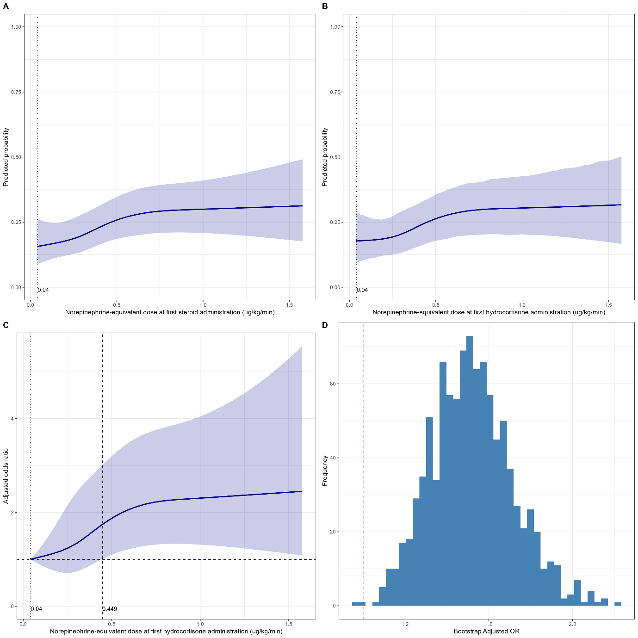

Supplementary Figure 4. Additional exploratory analysis of norepinephrine-equivalent dose at first hydrocortisone administration. (A) Restricted cubic spline (RCS) regression plot for norepinephrine-equivalent dose at first hydrocortisone administration, showing the adjusted predicted probabilities and 95% confidence intervals (CI). (B) RCS with bootstrap (1,000 iterations), showing the adjusted predicted probabilities and 95% CI. (C) Adjusted odds ratio (aOR) curve using bootstrap-derived cutoff. The reference point is the nadir of the adjusted predicted probabilities. The dashed vertical line indicates the cutoff where 95% CI lower bound exceeds 1. (D) Bootstrap distribution of adjusted odds ratios based on 1,000 resampled datasets, using the bootstrap-derived cutoff. The empirical two-sided p-value was calculated from the proportion of samples with OR < 1.
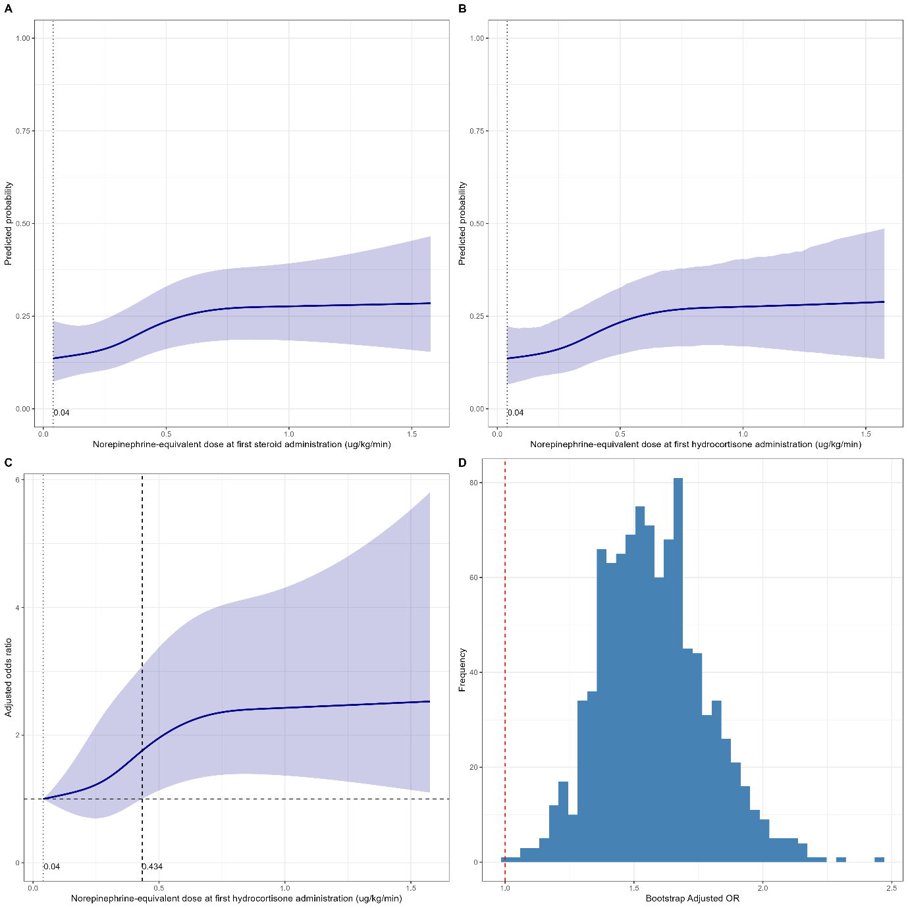

Supplementary Figure 5. Exploratory analysis of time from first vasopressor to first hydrocortisone administration. (A) Restricted cubic spline (RCS) regression plot for time from first vasopressor to first hydrocortisone administration, showing the adjusted predicted probabilities and 95% confidence intervals (CI). (B) RCS with bootstrap (1,000 iterations), showing the adjusted predicted probabilities and 95% CI. (C) Adjusted odds ratio (aOR) curve using bootstrap-derived cutoff. The reference point is the nadir of the adjusted predicted probabilities. The dashed vertical line indicates the cutoff where 95% CI lower bound exceeds 1. (D) Bootstrap distribution of adjusted odds ratios based on 1,000 resampled datasets, using the bootstrap-derived cutoff. The empirical two-sided p-value was calculated from the proportion of samples with OR < 1.
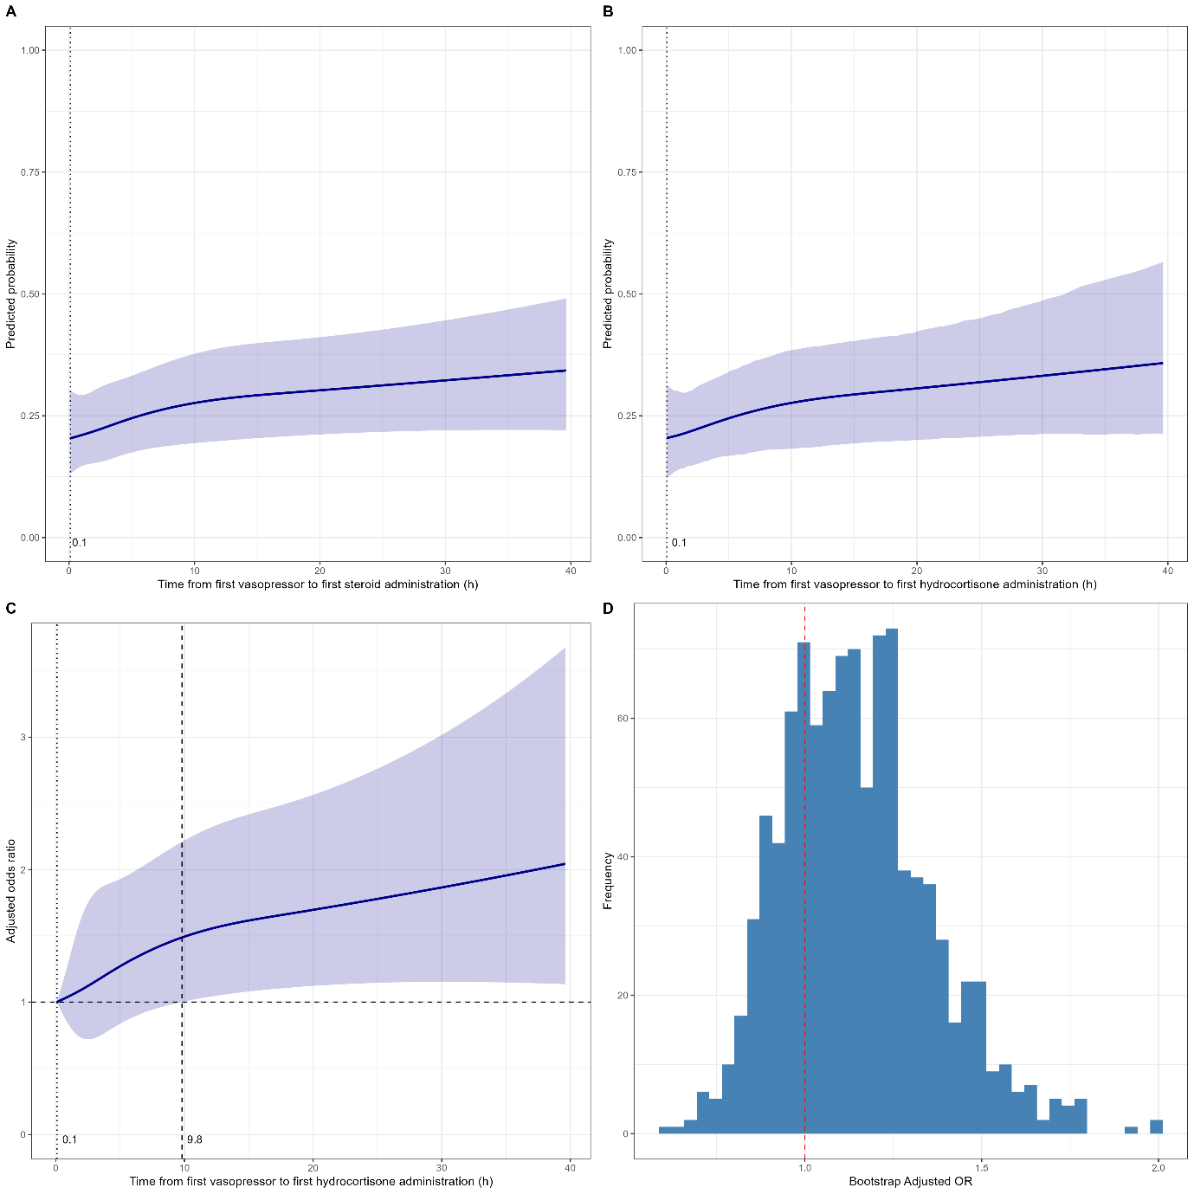

Supplementary Figure 6. Additional exploratory analysis of time from first vasopressor to first hydrocortisone administration. (A) Restricted cubic spline (RCS) regression plot for time from first vasopressor to first hydrocortisone administration, showing the adjusted predicted probabilities and 95% confidence intervals (CI). (B) RCS with bootstrap (1,000 iterations), showing the adjusted predicted probabilities and 95% CI. (C) Adjusted odds ratio (aOR) curve using bootstrap-derived cutoff. The reference point is the nadir of the adjusted predicted probabilities. The dashed vertical line indicates the cutoff where 95% CI lower bound exceeds 1. (D) Bootstrap distribution of adjusted odds ratios based on 1,000 resampled datasets, using the bootstrap-derived cutoff. The empirical two-sided p-value was calculated from the proportion of samples with OR < 1.
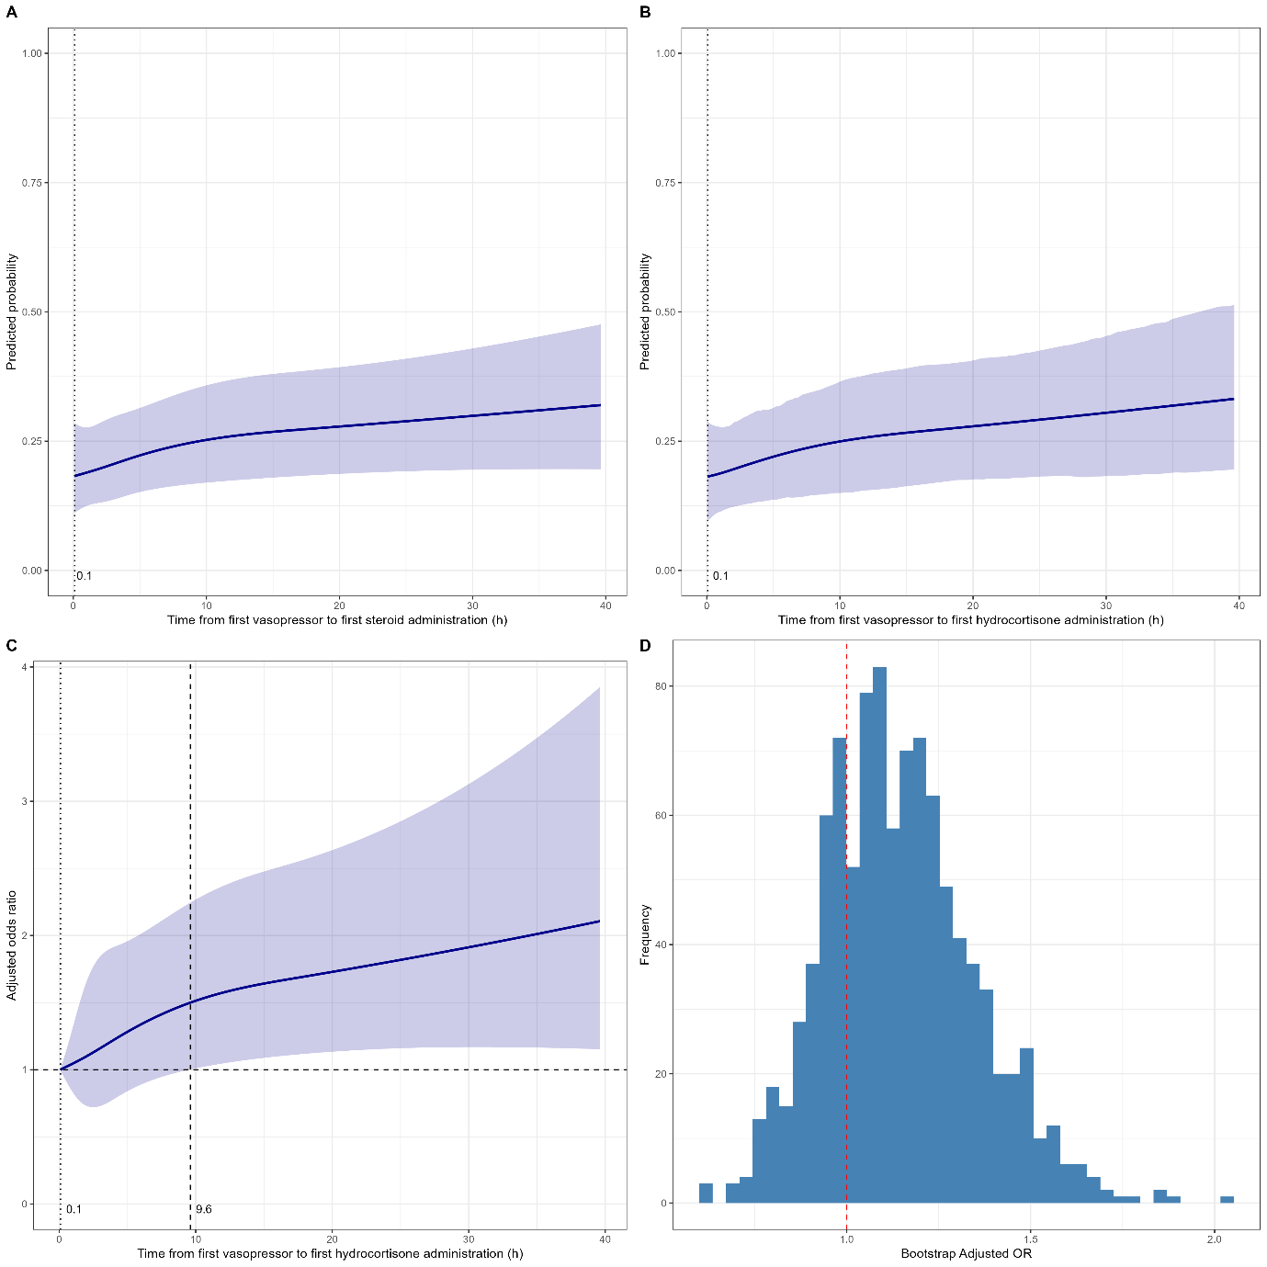

Supplementary Figure 7. Exploratory analysis of hydrocortisone dose. (A) Restricted cubic spline (RCS) regression plot for hydrocortisone dose, showing the adjusted predicted probabilities and 95% confidence intervals (CI). (B) RCS with bootstrap (1,000 iterations), showing the adjusted predicted probabilities and 95% CI. (C) Adjusted odds ratio (aOR) curve using bootstrap-derived cutoff. The reference point is the nadir of the adjusted predicted probabilities. The dashed vertical line indicates the cutoff where 95% CI lower bound exceeds 1. (D) Bootstrap distribution of adjusted odds ratios based on 1,000 resampled datasets, using the bootstrap-derived cutoff. The empirical two-sided p-value was calculated from the proportion of samples with OR < 1.
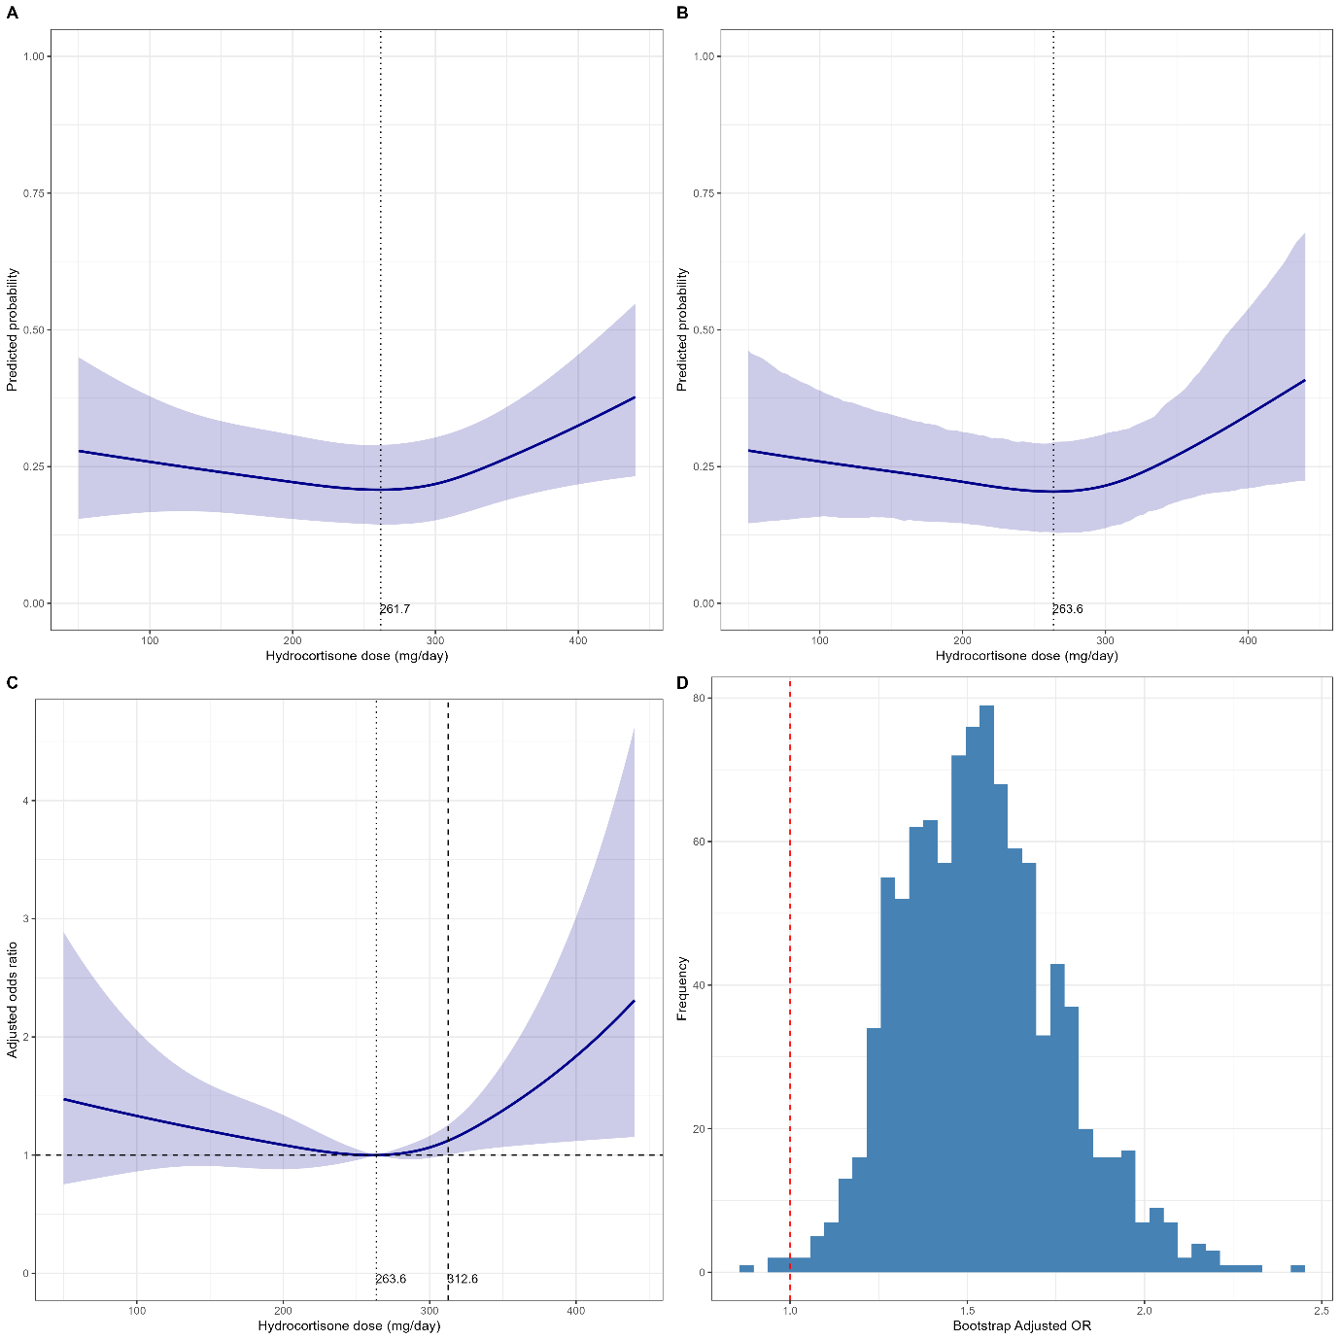

Supplementary Figure 8. Additional exploratory analysis of hydrocortisone dose. (A) Restricted cubic spline (RCS) regression plot for hydrocortisone dose, showing the adjusted predicted probabilities and 95% confidence intervals (CI). (B) RCS with bootstrap (1,000 iterations), showing the adjusted predicted probabilities and 95% CI. (C) Adjusted odds ratio (aOR) curve using bootstrap-derived cutoff. The reference point is the nadir of the adjusted predicted probabilities. The dashed vertical line indicates the cutoff where 95% CI lower bound exceeds 1. (D) Bootstrap distribution of adjusted odds ratios based on 1,000 resampled datasets, using the bootstrap-derived cutoff. The empirical two-sided p-value was calculated from the proportion of samples with OR < 1.
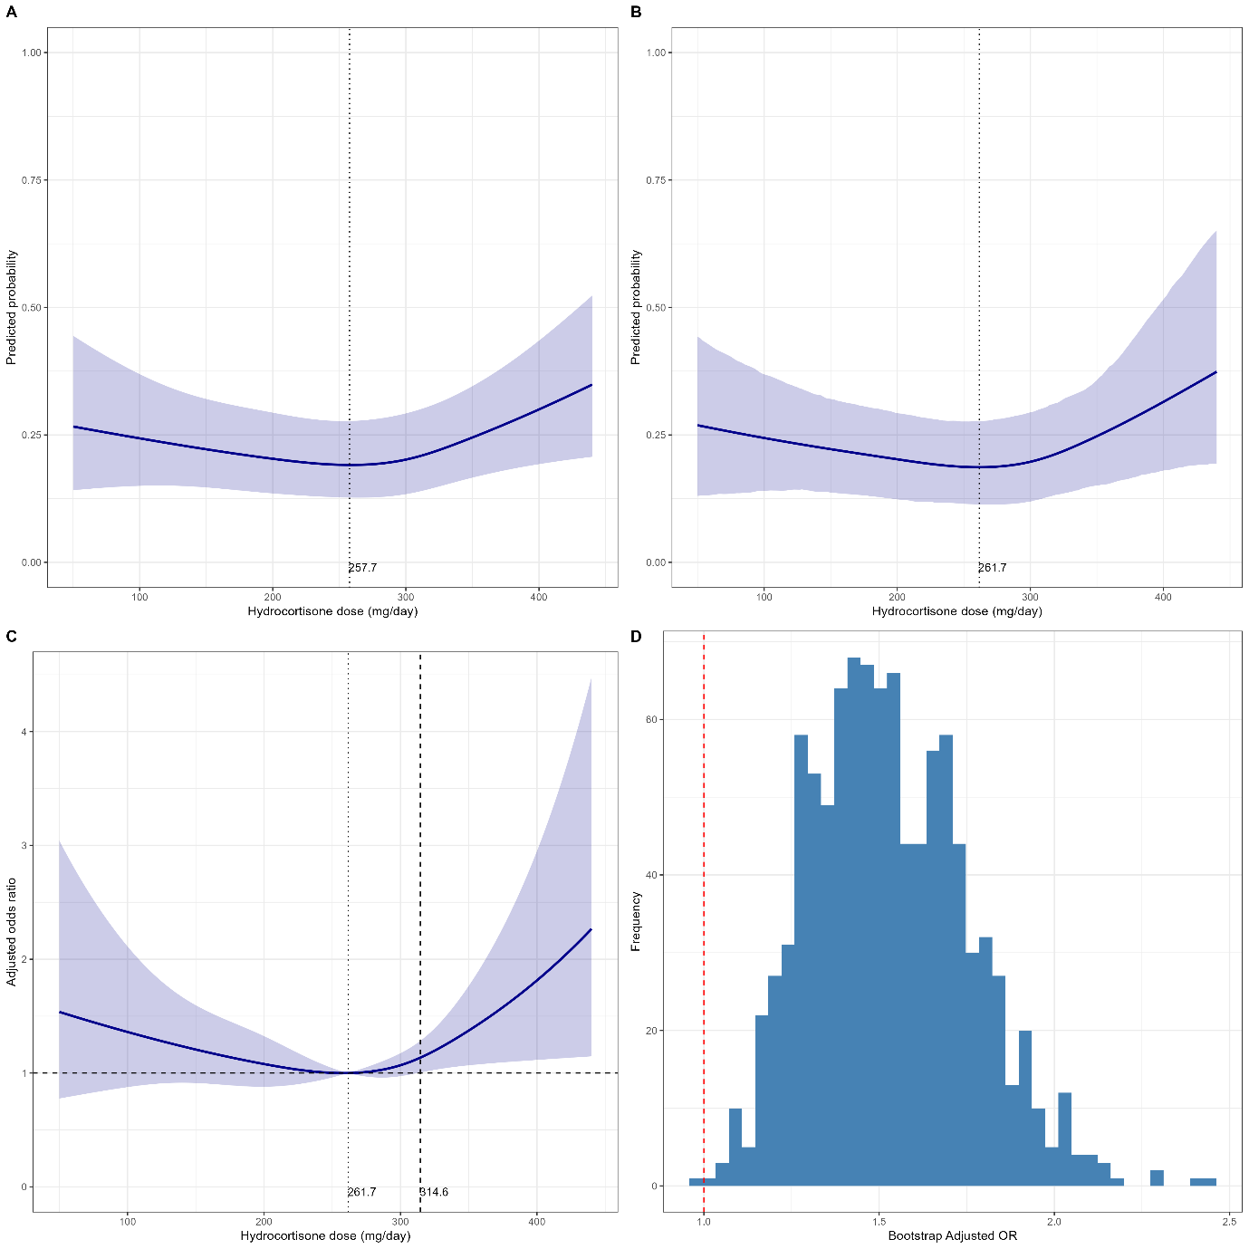

Supplementary Table 8. Sensitivity analysis using hydrocortisone-equivalent dose after including patients who received other than hydrocortisone (n=1601).
 | aOR | 95% CI | p-value
Multivariable model (each variable of interest was adjusted to each multivariable model)*
Vasopressor dose at first steroid administration
Norepinephrine-equivalent dose (μg/kg/min) | 2.162 | 1.411–3.313 | <0.001
Norepinephrine-equivalent dose (μg/kg/min) as categorical variable (<0.250 μg/kg/min, ≥0.250 μg/kg/min)**
Norepinephrine-equivalent dose <0.250 μg/kg/min | reference
Norepinephrine-equivalent dose ≥0.250 μg/kg/min | 1.449 | 1.094–1.919 | 0.010
Norepinephrine-equivalent dose (μg/kg/min) as categorical variable (<0.250 μg/kg/min, 0.250–0.500 μg/kg/min, >0.500 μg/kg/min)**
Norepinephrine-equivalent dose <0.25 μg/kg/min | reference
Norepinephrine-equivalent dose 0.250–0.500 μg/kg/min | 1.344 | 1.003–1.801 | 0.048
Norepinephrine-equivalent dose >0.500 μg/kg/min | 1.746 | 1.233–2.472 | 0.002
Time from first vasopressor to first steroid administration
Vasopressor to steroid time (h) | 1.018 | 1.003–1.032 | 0.015
Vasopressor to steroid time as categorical variable (<6 h, 6–12 h, >12 h)
Vasopressor to steroid time <6 h | reference
Vasopressor to steroid time 6–12 h | 1.364 | 0.931–1.998 | 0.111
Vasopressor to steroid time >12 h | 1.399 | 1.028–1.903 | 0.033
Hydrocortisone dose
Hydrocortisone-equivalent dose (mg/day) | 1.001 | 0.999–1.002 | 0.378
Hydrocortisone-equivalent dose as categorical variable (<200 mg/day, 200–300 mg/day, >300 mg/day)
Hydrocortisone-equivalent dose <200 mg/day | 1.257 | 0.839–1.884 | 0.267
Hydrocortisone-equivalent dose 200–300 mg/day | reference
Hydrocortisone-equivalent dose >300 mg/day | 1.539 | 1.165–2.034 | 0.002
Multivariable model (all variable of interest were entered into single multivariable model)**
Norepinephrine-equivalent dose (μg/kg/min) | 2.093 | 1.364–3.211 | 0.001
Vasopressor to steroid time (h) | 1.016 | 1.002–1.031 | 0.024
Hydrocortisone-equivalent dose (mg/day) | 1.001 | 0.999–1.002 | 0.243
Multivariable model (all variables of interest as categorical variable were entered into single multivariable model) 1***
Norepinephrine-equivalent dose <0.250 μg/kg/min | reference
Norepinephrine-equivalent dose ≥0.250 μg/kg/min | 1.460 | 1.100–1.936 | 0.009
Vasopressor to steroid time <6 h | reference
Vasopressor to steroid time 6–12 h | 1.445 | 0.982–2.128 | 0.062
Vasopressor to steroid time >12 h | 1.449 | 1.063–1.975 | 0.019
Hydrocortisone-equivalent dose <200 mg/day | 1.306 | 0.869–1.965 | 0.199
Hydrocortisone-equivalent dose 200–300 mg/day | reference
Hydrocortisone-equivalent dose >300 mg/day | 1.589 | 1.200–2.106 | 0.001
Multivariable model (all variables of interest as categorical variable were entered into single multivariable model) 2***
Norepinephrine-equivalent dose <0.25 μg/kg/min | reference
Norepinephrine-equivalent dose 0.250–0.500 μg/kg/min | 1.346 | 1.002–1.808 | 0.049
Norepinephrine-equivalent dose >0.500 μg/kg/min | 1.784 | 1.255–2.535 | 0.001
Vasopressor to steroid time <6 h | reference
Vasopressor to steroid time 6–12 h | 1.399 | 0.947–2.066 | 0.091
Vasopressor to steroid time >12 h | 1.432 | 1.050–1.953 | 0.024
Hydrocortisone-equivalent dose <200 mg/day | 1.312 | 0.872–1.974 | 0.193
Hydrocortisone-equivalent dose 200–300 mg/day | reference
Hydrocortisone-equivalent dose >300 mg/day | 1.631 | 1.230–2.164 | 0.001
aOR>1 indicates higher odds of 28 d mortality
Hosmer–Lemeshow test showed p>0.05 in all models.
*Sex, admission year, APACHE II score, infection focus, lactate (nearest to initial steroid administration), use of ≥2 types of vasopressors were adjusted.
**Sex, admission year, APACHE II score, infection focus, lactate (nearest to initial steroid administration), use of ≥2 types of vasopressors, norepinephrine-equivalent dose, vasopressor to steroid time, and hydrocortisone-equivalent dose were entered into multivariable model.
***Sex, admission year, APACHE II score, infection focus, lactate (nearest to initial steroid administration), use of ≥2 types of vasopressors, norepinephrine-equivalent dose (categorical variable), vasopressor to steroid time (categorical variable), and hydrocortisone-equivalent dose (categorical variable) were entered into multivariable model.

Supplementary Table 9. Additional sensitivity analysis using hydrocortisone-equivalent dose after including patients who received other than hydrocortisone (n=1601).
 | aOR | 95% CI | p-value
Multivariable model (each variable of interest was adjusted to each multivariable model)*
Vasopressor dose at first steroid administration
Norepinephrine-equivalent dose (μg/kg/min) | 2.276 | 1.482–3.541 | <0.001
Norepinephrine-equivalent dose (μg/kg/min) as categorical variable (<0.250 μg/kg/min, ≥0.250 μg/kg/min)**
Norepinephrine-equivalent dose <0.250 μg/kg/min | reference
Norepinephrine-equivalent dose ≥0.250 μg/kg/min | 1.465 | 1.105–1.950 | 0.008
Norepinephrine-equivalent dose (μg/kg/min) as categorical variable (<0.250 μg/kg/min, 0.250–0.500 μg/kg/min, >0.500 μg/kg/min)**
Norepinephrine-equivalent dose <0.25 μg/kg/min | reference
Norepinephrine-equivalent dose 0.250–0.500 μg/kg/min | 1.351 | 1.007–1.818 | 0.046
Norepinephrine-equivalent dose >0.500 μg/kg/min | 1.805 | 1.269–2.572 | 0.001
Time from first vasopressor to first steroid administration
Vasopressor to steroid time (h) | 1.018 | 1.004–1.033 | 0.013
Vasopressor to steroid time as categorical variable (<6 h, 6–12 h, >12 h)
Vasopressor to steroid time <6 h | reference
Vasopressor to steroid time 6–12 h | 1.352 | 0.916–1.987 | 0.126
Vasopressor to steroid time >12 h | 1.415 | 1.034–1.932 | 0.029
Hydrocortisone dose
Hydrocortisone-equivalent dose (mg/day) | 1.001 | 0.999–1.002 | 0.346
Hydrocortisone-equivalent dose as categorical variable (<200 mg/day, 200–300 mg/day, >300 mg/day)
Hydrocortisone-equivalent dose <200 mg/day | 1.282 | 0.849–1.923 | 0.233
Hydrocortisone-equivalent dose 200–300 mg/day | reference
Hydrocortisone-equivalent dose >300 mg/day | 1.535 | 1.160–2.033 | 0.003
Multivariable model (all variable of interest were entered into single multivariable model)**
Norepinephrine-equivalent dose (μg/kg/min) | 2.196 | 1.429–3.418 | <0.001
Vasopressor to steroid time (h) | 1.016 | 1.003–1.032 | 0.023
Hydrocortisone-equivalent dose (mg/day) | 1.001 | 0.999–1.002 | 0.235
Multivariable model (all variables of interest as categorical variable were entered into single multivariable model) 1***
Norepinephrine-equivalent dose <0.250 μg/kg/min | reference
Norepinephrine-equivalent dose ≥0.250 μg/kg/min | 1.478 | 1.112–1.971 | 0.007
Vasopressor to steroid time <6 h | reference
Vasopressor to steroid time 6–12 h | 1.431 | 0.965–2.115 | 0.073
Vasopressor to steroid time >12 h | 1.465 | 1.068–2.006 | 0.017
Hydrocortisone-equivalent dose <200 mg/day | 1.335 | 0.881–2.012 | 0.169
Hydrocortisone-equivalent dose 200–300 mg/day | reference
Hydrocortisone-equivalent dose >300 mg/day | 1.584 | 1.193–2.103 | 0.001
Multivariable model (all variables of interest as categorical variable were entered into single multivariable model) 2***
Norepinephrine-equivalent dose <0.25 μg/kg/min | reference
Norepinephrine-equivalent dose 0.250–0.500 μg/kg/min | 1.356 | 1.008–1.829 | 0.045
Norepinephrine-equivalent dose >0.500 μg/kg/min | 1.845 | 1.292–2.641 | 0.001
Vasopressor to steroid time <6 h | reference
Vasopressor to steroid time 6–12 h | 1.383 | 0.929–2.050 | 0.108
Vasopressor to steroid time >12 h | 1.447 | 1.054–1.982 | 0.022
Hydrocortisone-equivalent dose <200 mg/day | 1.343 | 0.886–2.026 | 0.161
Hydrocortisone-equivalent dose 200–300 mg/day | reference
Hydrocortisone-equivalent dose >300 mg/day | 1.626 | 1.223–2.162 | 0.001
aOR>1 indicates higher odds of 28 d mortality
Hosmer–Lemeshow test showed p>0.05 in all models.
*Sex, admission year, APACHE II score, infection focus, chronic lung disease, chronic renal disease, chronic liver disease, malignancy, AIDS, and immunosuppressive disorders, length of stay in ED, lactate (nearest to initial steroid administration), use of ≥2 types of vasopressors were adjusted.
**Sex, admission year, APACHE II score, infection focus, chronic lung disease, chronic renal disease, chronic liver disease, malignancy, AIDS, and immunosuppressive disorders, length of stay in ED, lactate (nearest to initial steroid administration), use of ≥2 types of vasopressors, norepinephrine-equivalent dose, vasopressor to steroid time, and hydrocortisone-equivalent dose were entered into multivariable model.
***Sex, admission year, APACHE II score, infection focus, chronic lung disease, chronic renal disease, chronic liver disease, malignancy, AIDS, and immunosuppressive disorders, length of stay in ED, lactate (nearest to initial steroid administration), use of ≥2 types of vasopressors, norepinephrine-equivalent dose (categorical variable), vasopressor to steroid time (categorical variable), and hydrocortisone-equivalent dose (categorical variable) were entered into multivariable model.

Supplementary Table 10. Sensitivity analysis after multiple imputations for cases with missing hydrocortisone dose and vasopressor dose at initial steroid administration (n=1631).
 | aOR | 95% CI | p-value
Multivariable model (each variable of interest was adjusted to each multivariable model)*
Vasopressor dose at first hydrocortisone administration
Norepinephrine-equivalent dose (μg/kg/min) | 1.987 | 1.286–3.070 | 0.002
Norepinephrine-equivalent dose (μg/kg/min) as categorical variable (<0.250 μg/kg/min, ≥0.250 μg/kg/min)**
Norepinephrine-equivalent dose <0.250 μg/kg/min | reference
Norepinephrine-equivalent dose ≥0.250 μg/kg/min | 1.404 | 1.088–1.813 | 0.009
Norepinephrine-equivalent dose (μg/kg/min) as categorical variable (<0.250 μg/kg/min, 0.250–0.500 mcg/kg/min, >0.500 μg/kg/min)**
Norepinephrine-equivalent dose <0.25 μg/kg/min | reference
Norepinephrine-equivalent dose 0.250–0.500 μg/kg/min | 1.323 | 1.012–1.728 | 0.040
Norepinephrine-equivalent dose >0.500 μg/kg/min | 1.643 | 1.182–2.285 | 0.003
Time from first vasopressor to first hydrocortisone administration
Vasopressor to hydrocortisone time (h) | 1.016 | 1.002–1.031 | 0.026
Vasopressor to hydrocortisone time as categorical variable (<6 h, 6–12 h, >12 h)
Vasopressor to hydrocortisone time <6 h | reference
Vasopressor to hydrocortisone time 6–12 h | 1.426 | 1.051–1.936 | 0.023
Vasopressor to hydrocortisone time >12 h | 1.448 | 1.001–2.093 | 0.049
Hydrocortisone dose
Hydrocortisone dose (mg/day) | 1.001 | 0.994–1.002 | 0.264
Hydrocortisone dose as categorical variable (<200 mg/day, 200–300 mg/day, >300 mg/day)
Hydrocortisone dose <200 mg/day | 1.288 | 0.843–1.968 | 0.240
Hydrocortisone dose 200–300 mg/day | reference
Hydrocortisone dose >300 mg/day | 1.504 | 1.122–2.016 | 0.006
Multivariable model (all variable of interest were entered into a single multivariable model)**
Norepinephrine-equivalent dose (μg/kg/min) | 1.922 | 1.242–2.974 | 0.003
Vasopressor to hydrocortisone time (h) | 1.016 | 1.002–1.031 | 0.026
Hydrocortisone dose (mg/day) | 1.001 | 0.999–1.002 | 0.253
Multivariable model (all variables of interest as categorical variable were entered into a single multivariable model) 1***
Norepinephrine-equivalent dose <0.250 μg/kg/min | reference
Norepinephrine-equivalent dose ≥0.250 μg/kg/min | 1.311 | 1.001–1.718 | 0.049
Vasopressor to hydrocortisone time <6 h | reference
Vasopressor to hydrocortisone time 6–12 h | 1.487 | 1.092–2.023 | 0.017
Vasopressor to hydrocortisone time >12 h | 1.541 | 1.061–2.239 | 0.023
Hydrocortisone dose <200 mg/day | 1.342 | 0.874–2.060 | 0.178
Hydrocortisone dose 200–300 mg/day | reference
Hydrocortisone dose >300 mg/day | 1.549 | 1.153–2.082 | 0.003
Multivariable model (all variables of interest as categorical variable were entered into a single multivariable model) 2***
Norepinephrine-equivalent dose <0.25 μg/kg/min | reference
Norepinephrine-equivalent dose 0.250–0.500 μg/kg/min | 1.220 | 0.972–1.621 | 0.171
Norepinephrine-equivalent dose >0.500 μg/kg/min | 1.559 | 1.108–2.192 | 0.010
Vasopressor to hydrocortisone time <6 h | reference
Vasopressor to hydrocortisone time 6–12 h | 1.471 | 1.080–2.004 | 0.014
Vasopressor to hydrocortisone time >12 h | 1.501 | 1.031–2.185 | 0.034
Hydrocortisone dose <200 mg/day | 1.347 | 0.877–2.069 | 0.172
Hydrocortisone dose 200–300 mg/day | reference
Hydrocortisone dose >300 mg/day | 1.589 | 1.180–2.140 | 0.002
aOR>1 indicates higher odds of 28 d mortality
Hosmer–Lemeshow test showed p>0.05 in all models.
*Sex, admission year, APACHE II score, infection focus, lactate (nearest to initial steroid administration), and use of ≥2 types of vasopressors were adjusted.
**Sex, admission year, APACHE II score, infection focus, lactate (nearest to initial steroid administration), use of ≥2 types of vasopressors, norepinephrine-equivalent dose, vasopressor to steroid time, and hydrocortisone dose were entered into multivariable model.
***Sex, admission year, APACHE II score, infection focus, lactate (nearest to initial steroid administration), use of ≥2 types of vasopressors, norepinephrine-equivalent dose (categorical variable), vasopressor to steroid time (categorical variable), and hydrocortisone dose (categorical variable) were entered into multivariable model.

Supplementary Table 11. Additional sensitivity analysis after multiple imputations for cases with missing hydrocortisone dose and vasopressor dose at initial steroid administration (n=1631).
 | aOR | 95% CI | p-value
Multivariable model (each variable of interest was adjusted to each multivariable model)*
Vasopressor dose at first hydrocortisone administration
Norepinephrine-equivalent dose (μg/kg/min) | 1.865 | 1.230–2.827 | 0.003
Norepinephrine-equivalent dose (μg/kg/min) as categorical variable (<0.250 μg/kg/min, ≥0.250 μg/kg/min)**
Norepinephrine-equivalent dose <0.250 μg/kg/min | reference
Norepinephrine-equivalent dose ≥0.250 μg/kg/min | 1.437 | 1.079–1.914 | 0.013
Norepinephrine-equivalent dose (μg/kg/min) as categorical variable (<0.250 μg/kg/min, 0.250–0.500 mcg/kg/min, >0.500 μg/kg/min)**
Norepinephrine-equivalent dose <0.25 μg/kg/min | reference
Norepinephrine-equivalent dose 0.250–0.500 μg/kg/min | 1.188 | 0.895–1.577 | 0.233
Norepinephrine-equivalent dose >0.500 μg/kg/min | 1.555 | 1.103–2.191 | 0.012
Time from first vasopressor to first hydrocortisone administration
Vasopressor to hydrocortisone time (h) | 1.012 | 1.001–1.023 | 0.042
Vasopressor to hydrocortisone time as categorical variable (<6 h, 6–12 h, >12 h)
Vasopressor to hydrocortisone time <6 h | reference
Vasopressor to hydrocortisone time 6–12 h | 1.448 | 1.062–1.975 | 0.019
Vasopressor to hydrocortisone time >12 h | 1.483 | 1.021–2.156 | 0.039
Hydrocortisone dose
Hydrocortisone dose (mg/day) | 1.001 | 0.999–1.002 | 0.346
Hydrocortisone dose as categorical variable (<200 mg/day, 200–300 mg/day, >300 mg/day)
Hydrocortisone dose <200 mg/day | 1.316 | 0.872–1.988 | 0.191
Hydrocortisone dose 200–300 mg/day | reference
Hydrocortisone dose >300 mg/day | 1.504 | 1.105–2.047 | 0.010
Multivariable model (all variable of interest were entered into a single multivariable model)**
Norepinephrine-equivalent dose (μg/kg/min) | 1.842 | 1.216–2.790 | 0.004
Vasopressor to hydrocortisone time (h) | 1.010 | 1.000–1.021 | 0.049
Hydrocortisone dose (mg/day) | 1.001 | 0.999–1.002 | 0.314
Multivariable model (all variables of interest as categorical variable were entered into a single multivariable model) 1***
Norepinephrine-equivalent dose <0.250 μg/kg/min | reference
Norepinephrine-equivalent dose ≥0.250 μg/kg/min | 1.400 | 1.045–1.876 | 0.024
Vasopressor to hydrocortisone time <6 h | reference
Vasopressor to hydrocortisone time 6–12 h | 1.504 | 1.100–2.056 | 0.011
Vasopressor to hydrocortisone time >12 h | 1.579 | 1.081–2.306 | 0.018
Hydrocortisone dose <200 mg/day | 1.359 | 0.897–2.060 | 0.148
Hydrocortisone dose 200–300 mg/day | reference
Hydrocortisone dose >300 mg/day | 1.550 | 1.135–2.116 | 0.006
Multivariable model (all variables of interest as categorical variable were entered into a single multivariable model) 2***
Norepinephrine-equivalent dose <0.25 μg/kg/min | reference
Norepinephrine-equivalent dose 0.250–0.500 μg/kg/min | 1.182 | 0.887–1.576 | 0.253
Norepinephrine-equivalent dose >0.500 μg/kg/min | 1.565 | 1.107–2.212 | 0.011
Vasopressor to hydrocortisone time <6 h | reference
Vasopressor to hydrocortisone time 6–12 h | 1.487 | 1.087–2.033 | 0.013
Vasopressor to hydrocortisone time >12 h | 1.533 | 1.047–2.245 | 0.028
Hydrocortisone dose <200 mg/day | 1.366 | 0.901–2.070 | 0.142
Hydrocortisone dose 200–300 mg/day | reference
Hydrocortisone dose >300 mg/day | 1.591 | 1.164–2.176 | 0.004
aOR>1 indicates higher odds of 28 d mortality
Hosmer–Lemeshow test showed p>0.05 in all models.
*Sex, admission year, APACHE II score, infection focus, chronic lung disease, chronic renal disease, chronic liver disease, malignancy, AIDS, and immunosuppressive disorders, length of stay in ED, lactate (nearest to initial steroid administration), and use of ≥2 types of vasopressors were adjusted.
**Sex, admission year, APACHE II score, infection focus, chronic lung disease, chronic renal disease, chronic liver disease, malignancy, AIDS, and immunosuppressive disorders, length of stay in ED, lactate (nearest to initial steroid administration), use of ≥2 types of vasopressors, norepinephrine-equivalent dose, vasopressor to steroid time, and hydrocortisone dose were entered into multivariable model.
***Sex, admission year, APACHE II score, infection focus, chronic lung disease, chronic renal disease, chronic liver disease, malignancy, AIDS, and immunosuppressive disorders, length of stay in ED, lactate (nearest to initial steroid administration), use of ≥2 types of vasopressors, norepinephrine-equivalent dose (categorical variable), vasopressor to steroid time (categorical variable), and hydrocortisone dose (categorical variable) were entered into multivariable model.

