Supplementary Table 1: Cognitive absorption items
Item # | Item
1 | The time passed very rapidly
2 | At certain moments I forgot the notion of time
3 | I could concentrate on the details of the performance, the music and the staging
4 | In general, I was absorbed in the performance
5 | In general, I felt pleasure
6 | In general, the performance aroused my interest
7 | In general, the performance aroused my curiosity to discover the rest as it unfolded
8 | In general, the performance stimulated my imagination
9 | I intend to see more live opera performances in the future
10 | During the performance, I thought of other things, or things unrelated to the performance*
* As the directionality of this item is opposite the others, scores for this item were normalized by inversion prior to analysis (e.g., a score of 4 was converted to 6).

 |  |  | Supplementary Table 2: Cognitive absorption scores across items and subjects
 |  |  |  |  | Item #
Subject # |  | Sex |  | Age(yrs) | 1 | 2 | 3 | 4 | 5 | 6 | 7 | 8 | 9 | 10 | Total
1 |  | F |  | 37 | 8 | 8 | 9 | 9 | 9 | 9 | 9 | 10 | 10 | 6 | 87
2 |  | M |  | 44 | 9 | 8 | 9 | 9 | 10 | 10 | 8 | 8 | 10 | 4 | 85
3 |  | M |  | 57 | 7 | 7 | 8 | 5 | 8 | 7 | 6 | 5 | 10 | 8 | 71
4 |  | M |  | 35 | 8 | 8 | 8 | 9 | 9 | 9 | 9 | 9 | 9 | 8 | 86
5 |  | F |  | 42 | 10 | 9 | 10 | 10 | 10 | 10 | 10 | 10 | 10 | 1 | 90
6 |  | M |  | 36 | 8 | 9 | 7 | 8 | 9 | 10 | 10 | 9 | 10 | 3 | 83
7 |  | M |  | 60 | 9 | 9 | 9 | 9 | 8 | 9 | 9 | 9 | 10 | 1 | 82
8 |  | M |  | 37 | 8 | 9 | 9 | 7 | 8 | 8 | 6 | 6 | 10 | 3 | 74
9 |  | F |  | 66 | 8 | 7 | 8 | 7 | 7 | 7 | 7 | 6 | 9 | 9 | 75
10 |  | F |  | 53 | 10 | 9 | 9 | 9 | 9 | 9 | 9 | 8 | 9 | 8 | 89
11 |  | F |  | 49 | 7 | 7 | 7 | 6 | 8 | 7 | 6 | 6 | 10 | 9 | 73
12 |  | F |  | 42 | 6 | 5 | 8 | 6 | 6 | 8 | 9 | 6 | 8 | 4 | 66
13 |  | M |  | 59 | 6 | 5 | 7 | 7 | 5 | 8 | 8 | 8 | 8 | 2 | 64
14 |  | F |  | 64 | 10 | 0 | 8 | 8 | 8 | 8 | 9 | 7 | 10 | 10 | 78
15 |  | F |  | 64 | 7 | 1 | 9 | 7 | 8 | 7 | 7 | 2 | 10 | 8 | 66
16 |  | F |  | 53 | 9 | 1 | 9 | 10 | 10 | 10 | 10 | 9 | 10 | 9 | 87
17 |  | F |  | 36 | 4 | 7 | 8 | 5 | 7 | 7 | 9 | 8 | 9 | 4 | 68
18 |  | M |  | 46 | 8 | 6 | 8 | 8 | 8 | 8 | 8 | 6 | 9 | 6 | 75
19 |  | M |  | 39 | 7 | 7 | 6 | 7 | 6 | 9 | 10 | 4 | 10 | 5 | 71
20 |  | F |  | 43 | 5 | 6 | 7 | 5 | 7 | 8 | 9 | 6 | 10 | 1 | 64
21 |  | F |  | 39 | 6 | 4 | 8 | 7 | 5 | 5 | 4 | 2 | 7 | 7 | 55
22 |  | M |  | 68 | 5 | 9 | 6 | 6 | 7 | 7 | 6 | 9 | 9 | 0 | 64
23 |  | F |  | 44 | 7 | 6 | 9 | 7 | 7 | 6 | 6 | 7 | 10 | 0 | 65
24 |  | F |  | 54 | 8 | 10 | 9 | 8 | 8 | 8 | 4 | 7 | 10 | 7 | 79
Question 10 results are normalized as per the explanation in Supplemental Table 1. F: Female, M: Male.

Figure legends for Supplementary Figures S1 and S2 and S3

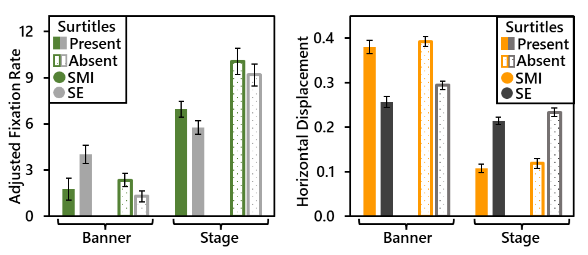
Supplementary Figure S1. Fixation analyses results (N = 17). Fixation rates (left) according to device type (SMI vs. Smart Eye (SE)), fixation zone (Banner vs. Stage) and surtitle presence (Present vs. Absent). Although there was a significant three-way interaction between main factors, there were no significant differences between devices for any of the four within-subjects conditions. Meanwhile, normalized mean horizontal displacement between consecutive fixations (right) according to the same three factors revealed a significant two-way interaction between device type and fixation zone. This was driven by larger differences in magnitude of horizontal displacement between the banner and the stage fixation zones for the SMI devices compared to the Smart Eye devices. Error bars are standard error.

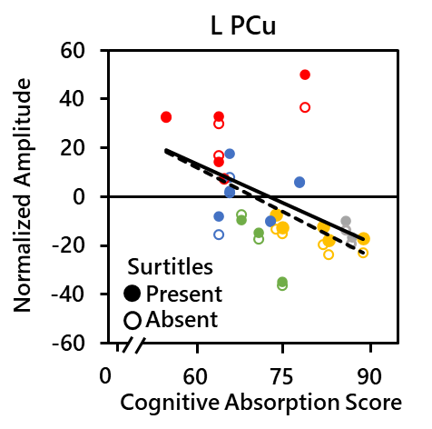
Supplementary Figure S2. Theta activity (5-7 Hz) CA relationships grouped by opera performance (N = 20). This scatterplot shows the significant negative correlation between theta activity and cognitive absorption in the left PCu. Solid and dashed lines represent the overall trendlines for the Present and Absent conditions, respectively. The data is identical to that in the scatter plot in Figure 5 in the manuscript except that this version has grouped subjects attending the same operatic performance by color to highlight the significantly negative relationship between performance and CA based on linear regression (R = 0.823, p < 0.001; relationship not directly shown) L: left.

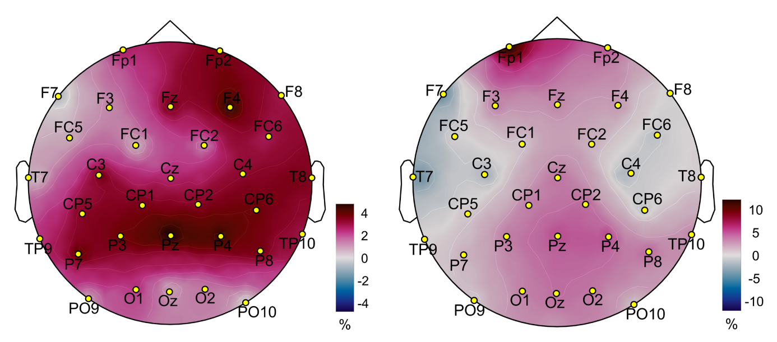
Supplementary Figure S3. Sensor-level contrast topographical maps of mean surtitle present > absent theta activity (5-7 Hz, left) and beta activity (15-29 Hz, right) (N = 20). Activities were normalized as a percent deviation from baseline. These maps are for reference only with respect to the source level statistical analyses performed and reported in the manuscript. Sensor-level statistical analyses were not performed.

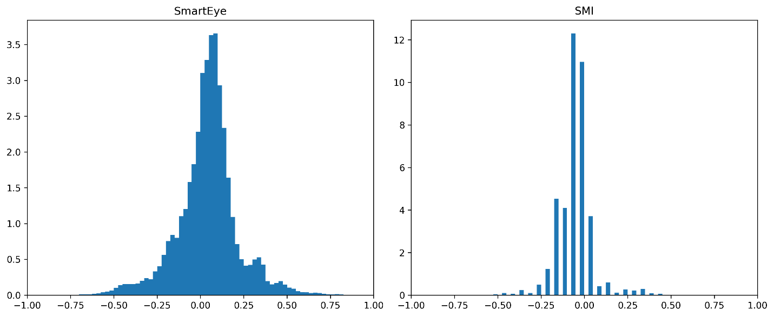
Supplementary Figure S4. Quality-control distributions of horizontal gaze-position data. Distributions of x-axis gaze coordinates are shown for the SmartEye (left) and SMI (right) oculometric systems. Histograms were generated using pooled valid observations from each system with bin widths of 0.025 x-coordinate units. Histogram values are shown as probability densities rather than raw counts, such that the area under each distribution sums to 1. The distributions are provided as supplemental quality-control visualizations of the spatial gaze-position data used in the analyses.

