Supplemental Material

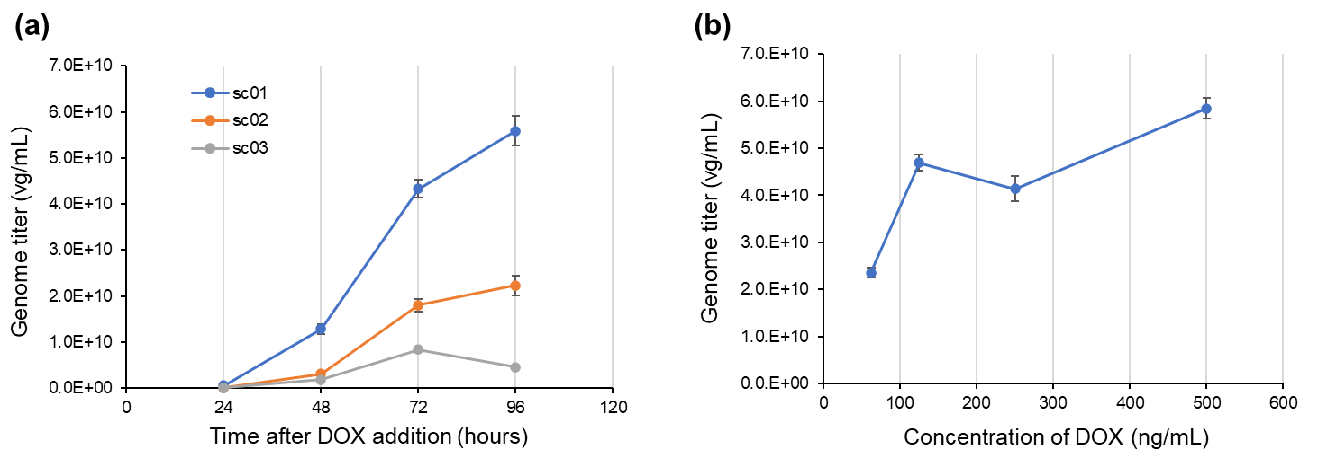
Figure S1. Relationship between Doxycycline (DOX) treatment duration or concentration and rAAV genome titer.
(a) rAAV genome titers (vg/mL) of inducible producer cell line (PCL) clones sc01, sc02, and sc03 measured at 24, 48, 72, and 96 hours after DOX addition (n=3). Although clone sc03 showed a peak genome titer at 72 h, whereas sc01 and sc02 peaked at 96 h, a unified harvest time of 72 h was selected to ensure consistency with the transient transfection (TT) method and to avoid clone-dependent optimization. (b) rAAV genome titers of PCL clone sc01 measured 72 hours after DOX treatment at final concentrations of 62.5, 125, 250, and 500 ng/mL (n=3). The genome titer increased with higher DOX concentrations, reaching its peak at 500 ng/mL. Therefore, 500 ng/mL was selected as the final DOX concentration for this study. No cytotoxic effects were observed under the selected DOX condition (500 ng/mL, 72 h), supporting its suitability for routine production.

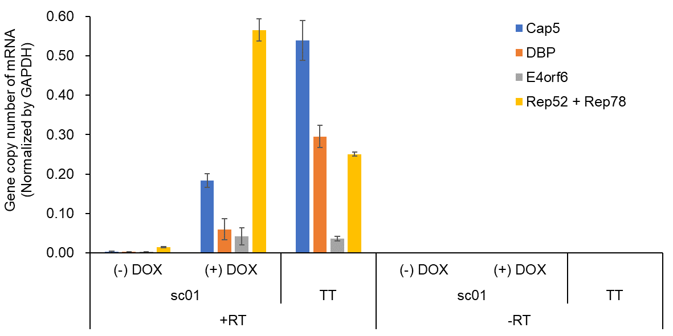
Figure S2. Analysis of gene expression levels by ddPCR.
PCL sc01 samples treated with DOX at a final concentration of 500 ng/mL for 72 hours and untreated control samples were used. For the transient transfection (TT) method, samples were collected 72 hours post-transfection. Messenger RNA was extracted from each sample, and reverse-transcribed cDNA samples (+RT) as well as non-reverse-transcribed control samples (-RT) were subjected to ddPCR to quantify the expression levels for Cap5, DBP, E4orf6, and Rep (n=3). Gene expression levels were normalized to GAPDH, which was set to 1.0. Primers targeting the Rep gene were designed against a region common to Rep52 and Rep78. Expression levels in sc01 samples ranged from 0.21- to 2.1-fold relative to those observed in the TT method. Leakage in the absence of DOX was suppressed to 1.4%–7.6%. Background signals detected in -RT samples were all less than 1% of those detected in the +RT samples. The residual basal expression in the absence of DOX (1.4–7.6%) was minimal and did not result in detectable rAAV production, indicating tight transcriptional control.

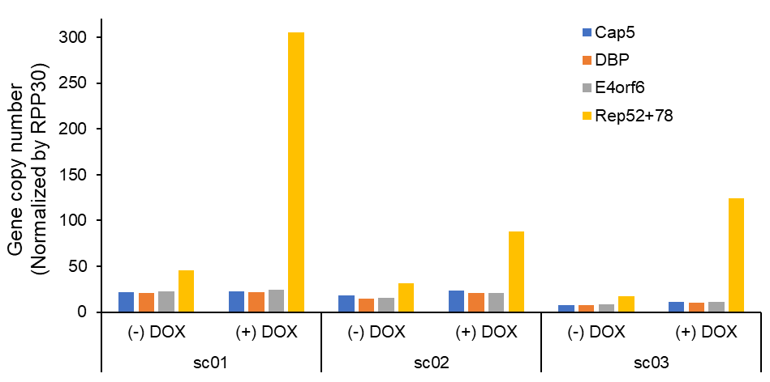
Figure S3. Quantitative evaluation of DNA copy numbers of various genes under DOX-induced and non-induced conditions.
The DNA copy numbers of each gene inserted into the genome (Cap5, DBP, E4orf6, Rep52 + Rep78) are shown normalized to the RPP30 gene. DOX treatment resulted in an approximately 2.7- to 7.0-fold increase in the copy number of the Rep gene compared to the untreated condition, suggesting the possibility of local amplification and/or replication-related enrichment rather than global genomic instability. Notably, the primers used for Rep gene quantification target the common region of Rep52 and Rep78, so the copy number of the Rep gene in the untreated condition was calculated to be about twice that of the other genes. Importantly, the Rep gene was barely detectable in purified rAAV preparations after CsCl ultracentrifugation, indicating that DOX-induced Rep DNA enrichment did not compromise vector purity or quality. (Table S3). The copy numbers of the other genes remained constant regardless of DOX treatment.

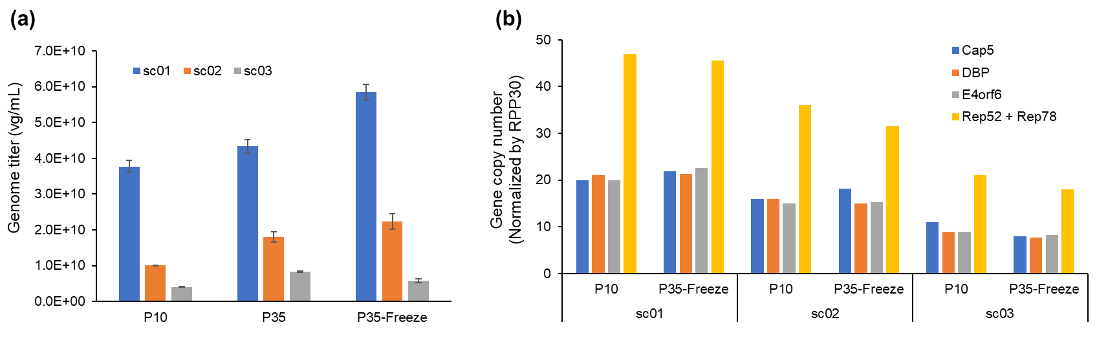
Figure S4. Stability evaluation of PCLs after long-term passaging and freeze-thaw cycles.
For each PCL clone (sc01, sc02, sc03), genome titers of rAAV (n=3) (a) and copy numbers of inserted genes (b) were evaluated at passage 10 (P10), passage 35 (P35), and cells frozen at passage 30, then thawed and cultured to passage 35 (P35-Freeze). Copy numbers of each gene were normalized to the reference gene RPP30. Note that primers for Rep gene quantification target a region common to Rep52 and Rep78, thus the copy number of the Rep gene is estimated to be approximately twice that of the other genes. Genome titers and copy numbers were maintained after 25 passages from P10 to P35 and following freeze-thaw treatment. The stability over 25 passages corresponds to extended continuous culture, supporting the robustness of the PCL system for long-term manufacturing.

(a) rAAV produced by TT method (b) rAAV produced by PCL sc01
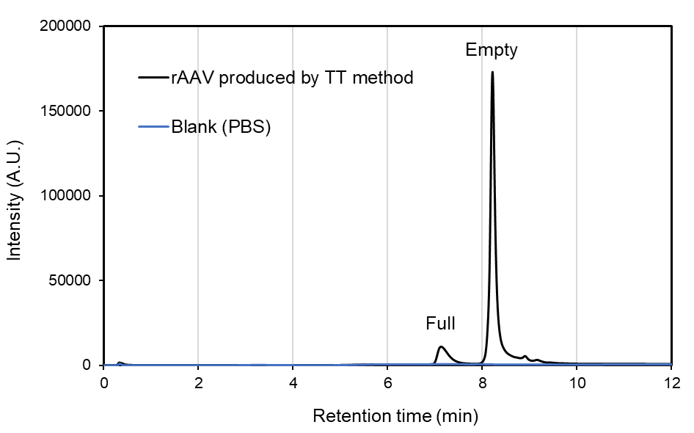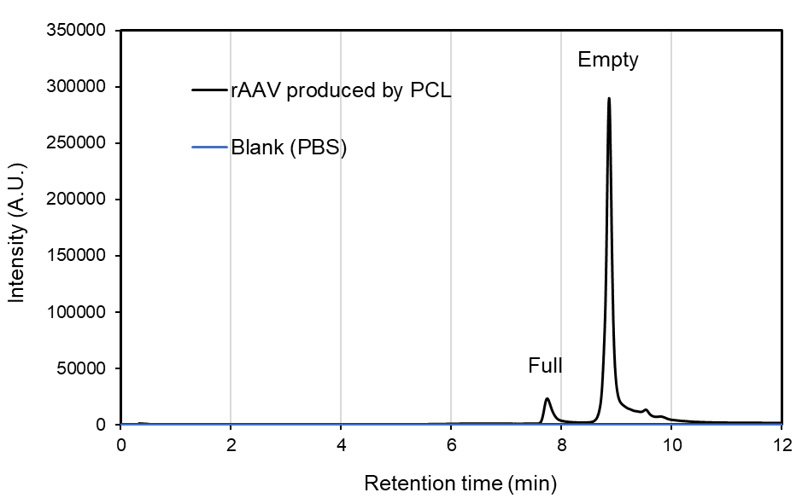
Full particle ratio: 8.5% Full particle ratio: 10.4%
Figure S5. Separation of full and empty rAAV vector particles by AEX-HPLC and quantification of the full particle ratio.
(a) rAAV produced by the transient transfection (TT) method and (b) rAAV produced by PCL. The full particle ratio was calculated as: (Full particle area) / (Full particle area + Empty particle area) × 100. The full particle ratio of PCL-derived rAAV was comparable to that of TT-derived rAAV, indicating no adverse impact of the PCL system on capsid packaging efficiency.

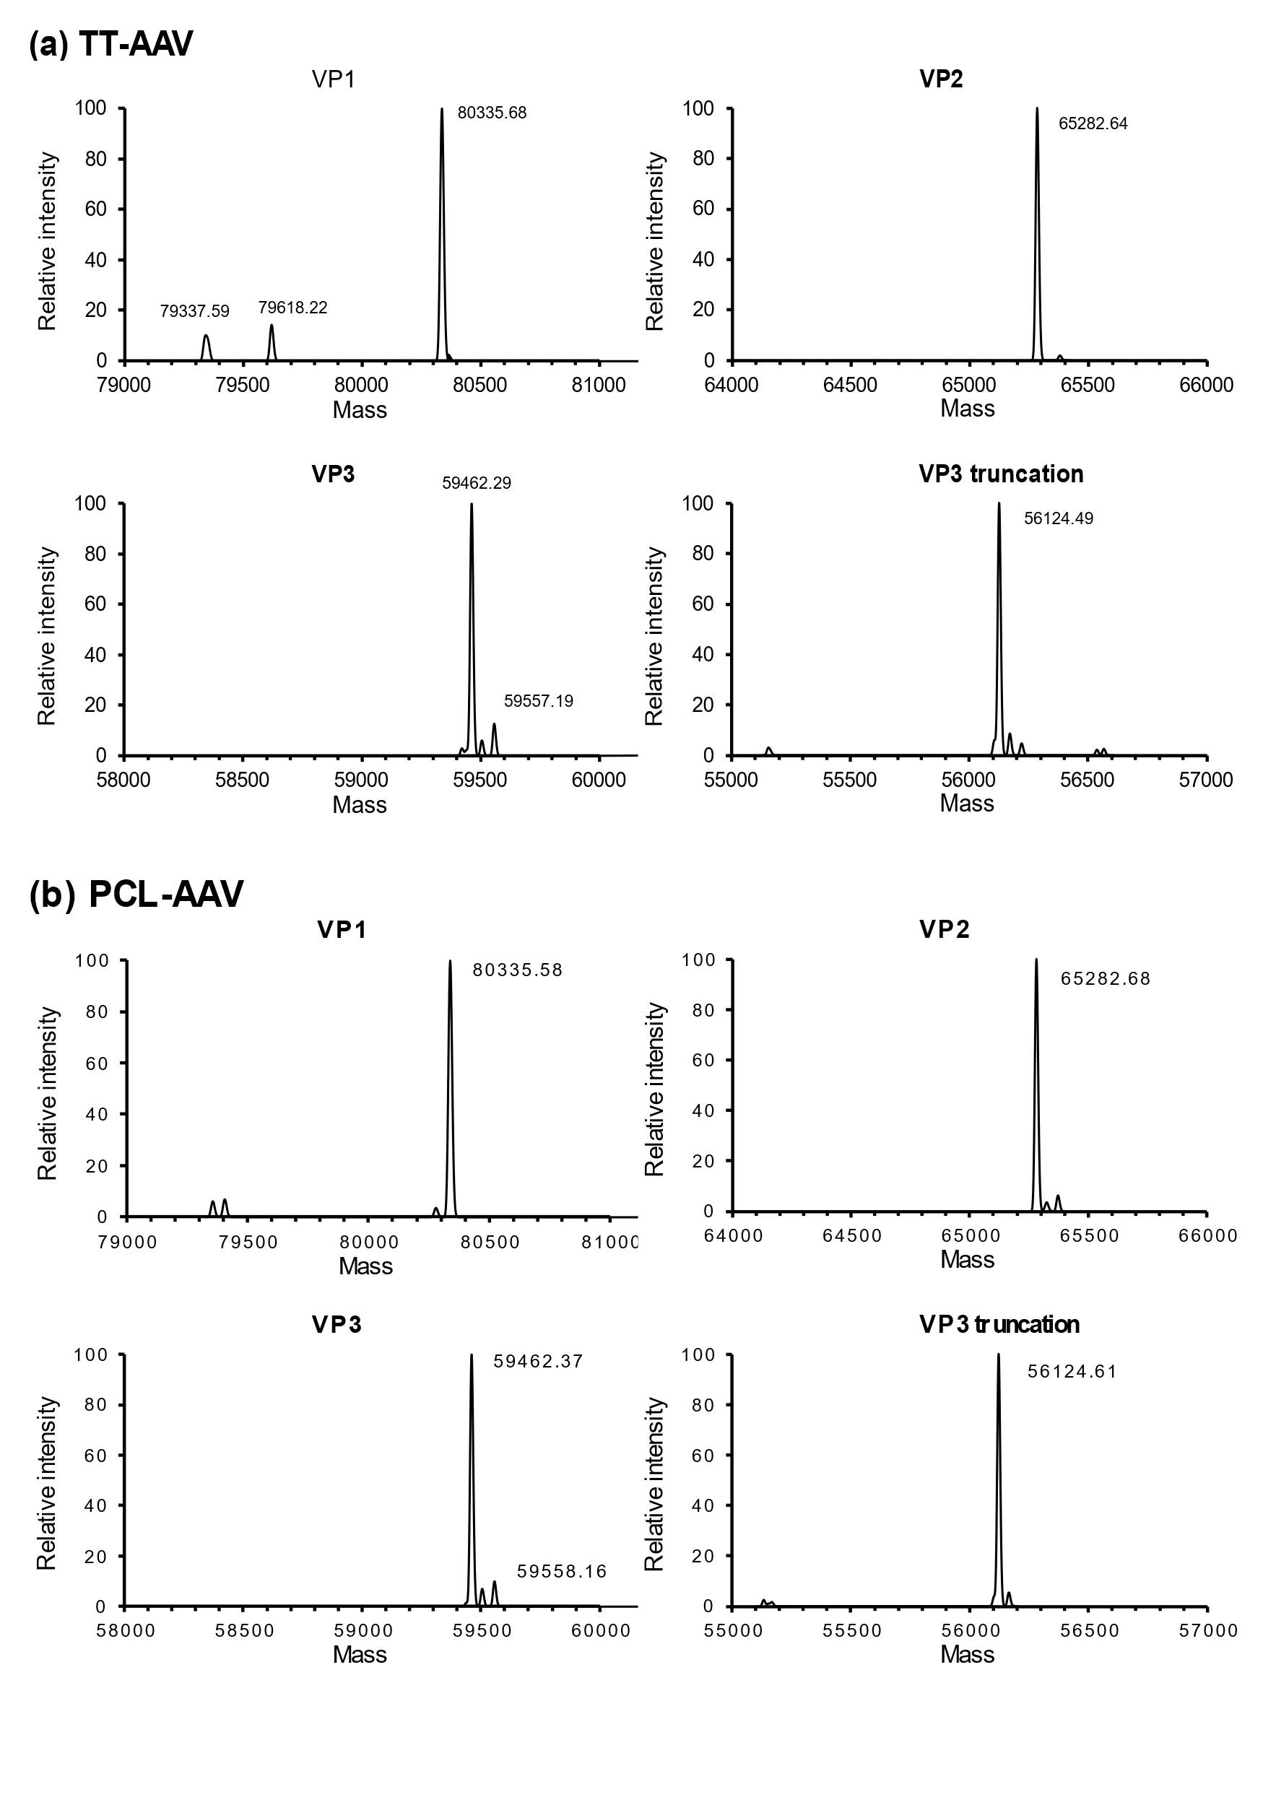
Figure S6. Deconvoluted mass spectra of the separated peaks corresponding to VP1, VP2, VP3, and VP3 truncation from (a) TT-AAV and (b) PCL-AAV.
The detected VP3 truncation corresponded to known processing products and was observed in both TT-AAV and PCL-AAV, indicating no PCL-specific aberrant capsid species.

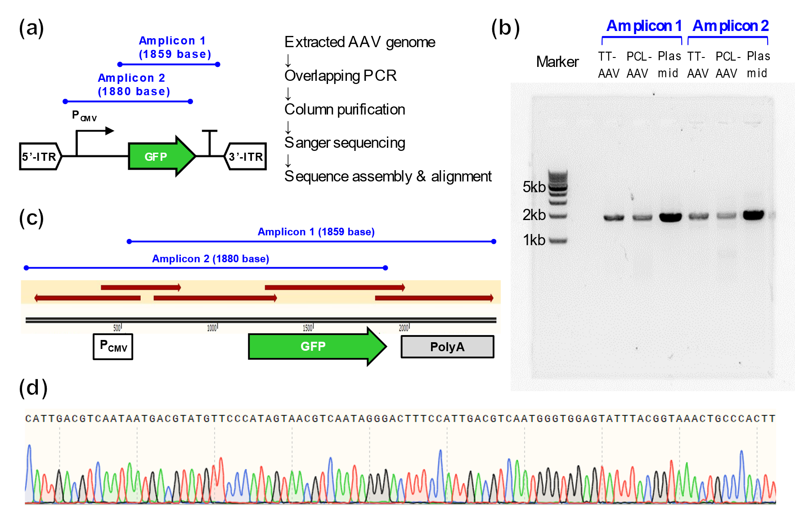
Figure S7. Verification of genome identity of TT-AAV and PCL-AAV by Sanger sequencing.
(a) Schematic overview of the experimental design. Primers were designed to generate two overlapping PCR amplicons covering the region from the CMV promoter within the ITR to the GFP gene and the polyadenylation signal (PolyA) of the vector genome. PCR products from each AAV vector genome were purified by spin column and subjected to Sanger sequencing using primer walking. Obtained sequence data were quality-trimmed and assembled and aligned using SnapGene software (version 8.1.1, GSL Biotech). (b) Agarose gel electrophoresis image of the PCR products. Two expected overlapping amplicons were clearly detected in both TT-AAV and PCL-AAV samples. PCR products amplified from a plasmid DNA containing the same sequence were included as a control. (c) Sequence alignment of the Sanger sequencing results. Including the overlapping regions of Amplicon 1 and Amplicon 2, the entire target region—from the CMV promoter within the ITR through the GFP gene to the PolyA signal—showed 100% identity to the reference sequence in both production methods. Notably, no sequence alterations were detected even in rAAV genomes derived from long-term cultured PCL cells, demonstrating the genetic stability of the platform. (d) Representative Sanger sequencing chromatogram of the GC-rich CMV promoter region, which is prone to sequencing errors. High-quality chromatogram peaks demonstrate reliable sequence resolution in this region.

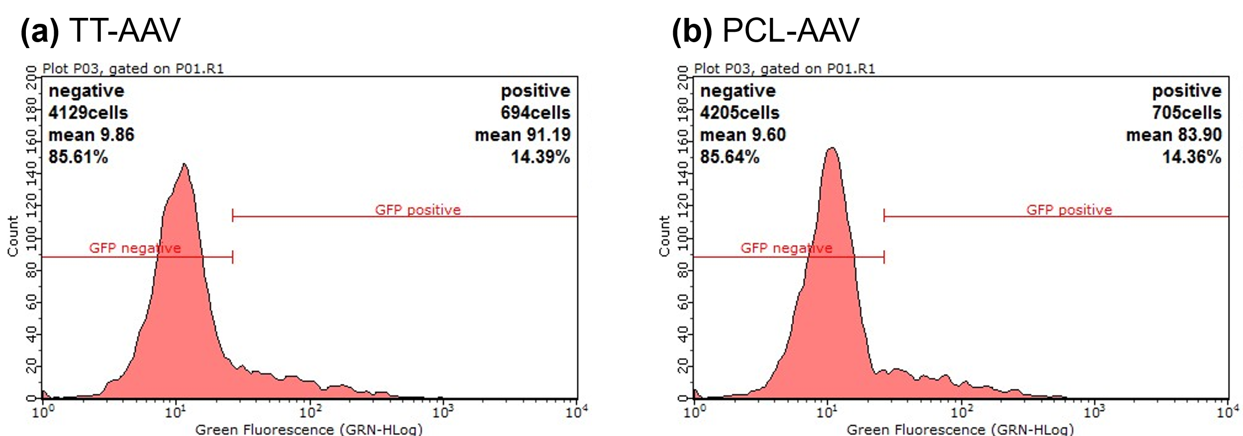
Figure S8. Representative FACS histogram of GFP-positive and GFP-negative cells following infection at MOIs of 20,000 vg/cell with (a) TT-AAV and (b) PCL-AAV.
The histogram displays the green fluorescence intensity within the cell population gated by forward scatter (FSC-HLin) and side scatter (SSC-HLin) in the range of 1700 to 7000. In the histogram, GFP-negative and GFP-positive populations are distinguished by a fluorescence intensity threshold (red vertical line), with the respective cell counts and percentages indicated.

Table S1. List of primers and probes used for quantification.
Abbreviations: FAM (fluorescein amidite); HEX (hexachlorofluorescein); BHQ1 (Black Hole Quencher 1), TAMRA (Carboxytetramethylrhodamine).
Target | Primer type | Sequence (5' → 3') | Fluorophore / Quencher
ITR | Forward | GGAACCCCTAGTGATGGAGTT | -
ITR | Reverse | CGGCCTCAGTGAGCGA | -
ITR | Probe | CACTCCCTCTCTGCGCGCTCG | FAM / BHQ1
Cap5 | Forward | ACTTTGACTTTAACCGCTTCCAC | -
Cap5 | Reverse | CCTGCACCGTGACCTCTTT | -
Cap5 | Probe | AGACTCATCAACAACTACT | FAM / BHQ1
DBP | Forward | GCCCCAACTGCGACTTCA | -
DBP | Reverse | CTCCACTTAAACTCAGGCACAAC | -
DBP | Probe | CGCACCATCACCAACGC | FAM / BHQ1
E4orf6 | Forward | TGGTTTAGGATGGTGGTGGATG | -
E4orf6 | Reverse | CGCAGGTAGATTAAGTGGCGA | -
E4orf6 | Probe | GAGGTAATGTTTATGTCCAGCGTG | FAM / BHQ1
Rep | Forward | GGCAGCCTTGATTTGGGA | -
Rep | Reverse | GACCAGGCCTCATACATCTCCTT | -
Rep | Probe | AATGCGGCCTCCAACTCGCG | FAM / BHQ1
NeoR | Forward | GCTTGGGTGGAGAGGCTATT | -
NeoR | Reverse | CGTCTTGCAGTTCATTCAGGG | -
NeoR | Probe | GGGCGTCCGGTTCTTTTTG | FAM / BHQ1
RPP30 | Forward | TCAGCATGGCGGTGTTT | -
RPP30 | Reverse | GCTGTCTCCACAAGTC | -
RPP30 | Probe | TTCTGACCTGAAGGCTCTGCGC | HEX / BHQ1
GFP | Forward | ACTTCAAGATCCGCCACAACA | -
GFP | Reverse | CTCGTTGGGGTCTTTGCTCA | -
GFP | Probe | GCACCCAGTCCGCCC | HEX / BHQ1
Outside of 3'-ITR | Forward | AAGTTGGGTGAATTTTGGCTCATT | -
Outside of 3'-ITR | Reverse | CGTTTGATCGCGGGACTTT | -
Outside of 3'-ITR | Probe | TGTGTGTCAGTTAGGGTGTGG | FAM / BHQ1
Outside of 5'-ITR | Forward | CGCGCCGAATTCAAGCTA | -
Outside of 5'-ITR | Reverse | CTAGGGATAACAGGGTAATATTTAACTCAT | -
Outside of 5'-ITR | Probe | TTGTTATTTCATGTTCTACTTACGT | FAM / BHQ1
Ori | Forward | GCGCGTAATCTGCTGCTTG | -
Ori | Reverse | CTACGGCTACACTAGAAGAACAGTA | -
Ori | Probe | CGCTCTGCTGAAGCCAGTTACCTTCGG | FAM / BHQ1
Alu | Forward | GAGGCGGGCGGATCA | -
Alu | Reverse | CCCGGCTAATTTTTGTATTTTTAGTAG | -
Alu | Probe | CAGCCTGGCCAACATGGTGAAACC | FAM / TAMRA

Table S2. Evaluation of post-translational modifications of viral proteins (VPs).
Deamidation: Only residues homologous to those reported to affect viral activity in AAV8 and AAV9 [20] were examined. Oxidation, acetylation, and phosphorylation: Residues were listed only if the modification level was ≥0.1% in either PCL-AAV or TT-AAV. Notably, no phosphorylation exceeding 0.1% was detected in any sample.

(a) Deamidation
Residues | Peptide | Sequence | Modification ratio (%)
Residues | Peptide | Sequence | PCL-AAV | TT-AAV
N56 | G4−R60 | GLVLPGYNYLGPQNGLD | 16.5 ± 0.6 * | 6.8 ± 0.4 **
N93 | Y92−K102 | YNHDADEFQEK | 4.0 ± 0.9 | 2.0 ± 0.1 *
N243 | T236−R248 | TWVLPSYNNHQYR | 0.4 ± 0.0 | 0.4 ± 0.0
N244 | T236−R248 | TWVLPSYNNHQYR | 0.4 ± 0.0 | 0.3 ± 0.0
N259 | S252−R277 | SGSVDGSNANAYFGRFGPTYGFDFNR | N.D. | N.D.
N293 | L290−R300 | LINNYWGFPR | 0.0 ± 0.0 | 0
N442 | F438−K451 | FVSTNNTTGVQFNK | 0.2 ± 0.0 | 0.2 ± 0.0
N443 | F438−K451 | FVSTNNTTGVQFNK | N.D. | N.D.
N463 | N463−R471 | NWFPGPMGR | 0.0 ± 0.0 | 0.1 ± 0.0
N640 | N640−K676 | NTPVPGNITSFSDVPVSSFITQYSTGQVT VEMEWELK | N.D. | N.D.
N692 | W683−R710 | WNPEIQTNNYNYNDPQVFDAPDSTGEYR | N.D. | N.D.
Q697 | W683−R710 | WNPEIQTNNYNYNDPQVFDAPDSTGEYR | N.D. | N.D.
* p < 0.05; ** p < 0.01 (both vs. PCL-AAV). N.D. = not detected.
(b) Oxidation
Residues | Peptide | Sequence | Modification ratio (%)
Residues | Peptide | Sequence | PCL-AAV | TT-AAV
M395 | S383−R397 | SSFFCLEYFPSKMLR | 12.7 ± 8.2 | 5.1 ± 2.2
M469 | N463−R471 | NWFPGPMGR | 1.5 ± 0.5 | 0.7 ± 0.1
M511 | M495−R560 | MELLEGASYQVPPQNGMTNNILQGSNTYALENTMIFNSQAPNQGTATYYLEGLMILTSESQETPVNR | 1.0 ± 0.4 | 1.0 ± 0.6
M547 | M495−R560 | MELLEGASYQVPPQNGMTNNILQGSNTYALENTMIFNSQAPNQGTATYYLEGLMILTSESQETPVNR | 0.2 ± 0.2 | 0.3 ± 0.1
M569 | V561−R599 | VAIYNVGGQANNNQSTTAFAGTYNDLQETLVPGSVWMER | 1.6 ± 0.2 | 1.3 ± 0.5
M597 | V561−R599 | VAIYNVGGQANNNQSTTAFAGTYNDLQETLVPGSVWMER | 2.0 ± 0.2 | 1.8 ± 0.9
M624 | I611−K630 | EIPETGAHFHPSPAMGGFGLK | 2.1 ± 0.4 | 1.5 ± 0.5
M635 | H631−K639 | HPPPMMLIK | 3.1 ± 0.7 | 2.1 ± 0.5
M671 | N640−K676 | NTPVPGNITSFSDVPVSSFITQYSTGQVTVEMEWELK | 0.7 ± 0.2 | 0.7 ± 0.2

(c) Acetylation
Residues | Peptide | Sequence | Modification ratio (%)
Residues | Peptide | Sequence | PCL-AAV | TT-AAV
VP1 S2 | S2−R19 | SFVDHPPDWLEEVGEGLR | 100.0 ± 0.0 | 100.0 ± 0.0
VP3 S2 | S2−R36 | SAGGGGPLGDNNQGADGVGNASGDWHCDSTWMGDR | 100.0 ± 0.0 | 97.1 ± 0.6 **
** p < 0.01 vs. PCL-AAV.

Table S3. Evaluation of non-vector sequence contamination.
qPCR analysis of non-vector sequence contamination in the rAAV vector genome (n=3). The targeted regions for qPCR quantification are indicated by red arrows in the PCL vector gene map, covering multiple sites including the GFP gene, ITR-adjacent sequences indicative of reverse packaging, and PCL-specific sequences such as Rep52 and Rep78. Relative abundance of each target was calculated using the GFP gene (gene of interest, GOI) as the 100% reference, with average values and standard deviations (S.D.) reported. Both PCL-AAV and TT-AAV showed similarly low levels (<1%) of non-vector DNA contamination, with some elements detected at even lower levels in PCL-AAV.
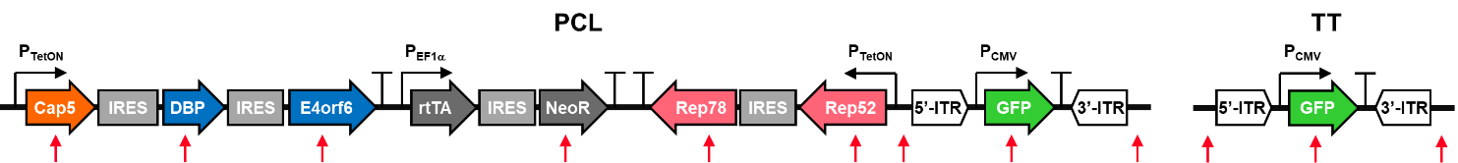
Category | Target gene | PCL-AAV |  |  | TT-AAV
Category | Target gene | Designed distance from ITR (base) | Frequency vs. GFP |  | Frequency vs. GFP
Category | Target gene | Designed distance from ITR (base) | Average | S.D. | Average | S.D.
GOI | GFP | - | 100.0% | 0.0% | 100.0% | 0.0%
Outside of 3'-ITR | - | 146 | 0.0% | 0.0% | 0.0% | 0.0%
Outside of 5'-ITR | - | 116 | 0.1% | 0.0% | 1.6% | 0.9%
Outside of 5'-ITR | Rep52 + Rep78 | 1178, 3711 | 0.9% | 0.3% | - | -
Outside of 5'-ITR | NeoR | 6600 | 0.1% | 0.0% | - | -
Outside of 5'-ITR | E4orf6 | 10076 | 0.0% | 0.0% | - | -
Outside of 5'-ITR | DBP | 11310 | 0.0% | 0.0% | - | -
Outside of 5'-ITR | Cap5 | 14675 | 0.0% | 0.0% | - | -
Plasmid backbone | Ori | - | 0.0% | 0.0% | 0.4% | 0.0%
hcDNA | Alu | - | 0.1% | 0.0% | 0.1% | 0.0%

