Supplementary Material
A zebrafish stable model of Galectin-3 to elucidate its role in Arrhythmogenic Cardiomyopathy
Giovanni Risato^{1,3}†, Rudy Celeghin^{1,2}†, Marco Cason^{1,2}, Maria Bueno Marinas^{1,2}, Serena Pinci^{1,2}, Raquel Brañas Casas³, Monica de Gaspari^{1,2}, Mila Della Barbera^{1,2}, Nicola Facchinello^{4,5}, Stefania Rizzo^{1,2}, Francesco Argenton³, Gaetano Thiene¹, Cristina Basso^{1,2}, Natascia Tiso^{3*}, Kalliopi Pilichou^{1,2*}

¹Department of Cardiac-Thoracic-Vascular Sciences and Public Health, University of Padova, Padova, 35128, Italy.
²Cardiovascular Pathology Unit, Azienda Ospedale Università Padova
³Department of Biology, University of Padova, Padova, 35131, Italy.
⁴Department of Pharmacy and Biotechnology, University of Bologna, Bologna, 40126, Italy.

⁵Neuroscience Institute, Italian Research Council (CNR), Padova, 35131, Italy

† These authors contributed equally to this work
* Corresponding authors

Natascia Tiso, PhD
Associate Professor of Biology
Dept. of Biology
University of Padua
via Ugo Bassi 58/b
35131 Padova, Italy
Phone n. +39 049 8276302
Email natascia.tiso@unipd.it
http://zfin.org/ZDB-PERS-020116-8
Kalliopi Pilichou, PhD
Associate Professor of Genetics
Head of Cardiovascular Genetics Lab
Dept. of Cardiac-Thoracic-Vascular Sciences and Public Health
University of Padua
Via A. Gabelli 61
35121 Padova, Italy
Phone n. +39 049 8272293 Email kalliopi.pilichou@unipd.it

Supplementary Table 1: List of oligonucleotides for lgals3 mutant generation and analysis.
The table lists the sgRNA oligos for -aa and lgals3b mutant lines generation (A), the primers for PCR-based genotyping (B), and for gene expression analysis by quantitative Real-Time (RT-PCR) (C).
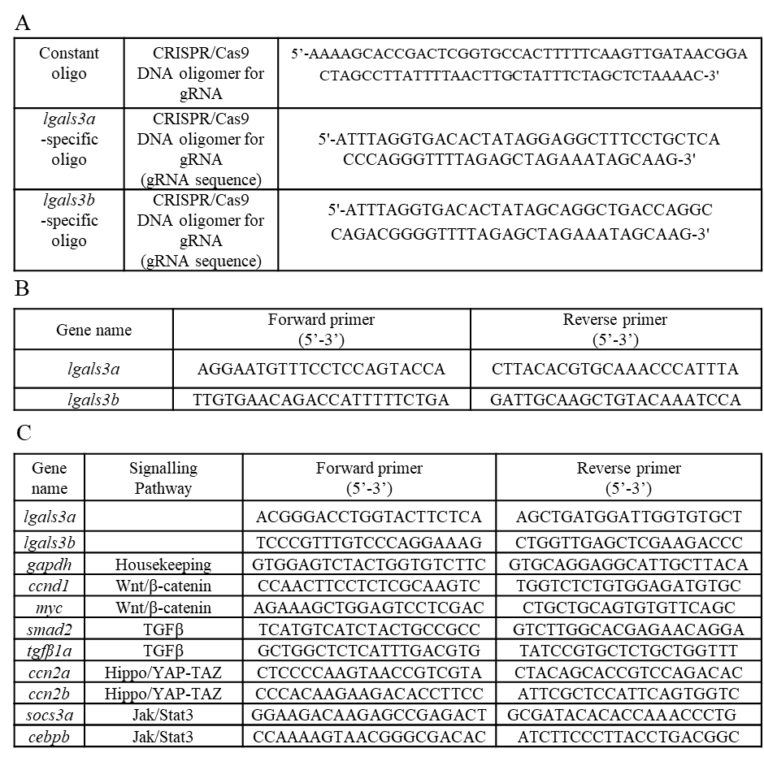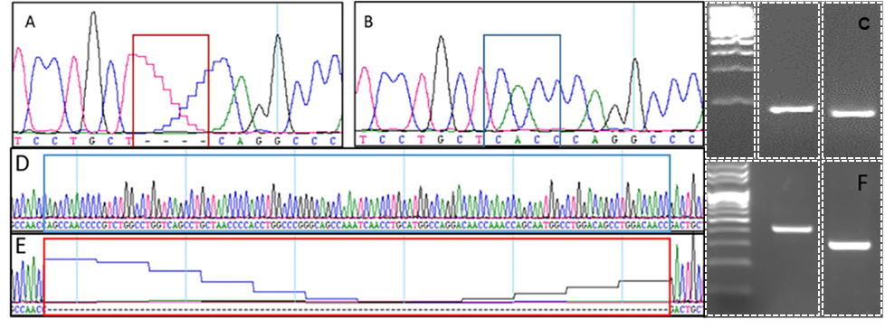
Supplementary Figure 1: Genotyping of -aa and lgals3b zebrafish mutants. A-B-D-E: sequence-based identification of the -aa 4-nt and lgals3b 114-nt deletions (red boxes) in case of homozygous control (B-D) and homozygous mutant (A-E). C- F: gel-based identification of the -aa (C) and lgals3b (F) genotypes; from left to right: size marker, WT control, and homozygous mutant. The C and F panels are photo-compositions of non-adjacent lanes. Cropped regions used are indicated in the figure. Original gels are presented at the end of the Supplementary Material.

Supplementary Figure 2: Graphical representation of fertility analysis of lgals3b homozygous male and female adult zebrafish. Left: lgals3b homozygous male fish fertilize 72% of the total eggs. Right: lgals3b homozygous female fish may exhibit abnormal ovulation, releasing already degrading eggs; 67% of the obtained eggs resulted unfertilized. Data are shown as percentage of total eggs analyzed. Sample size: n = 100 eggs per condition.
Supplementary Figure 3: Conduction score and larval diastolic ventricular area analysis. Quantification of the pyHeart4Fish conduction score and larval diastolic ventricular area in WT and -aa mutant larvae at 3 and 6 dpf. No statistically significant differences in conduction score were observed between WT and -aa mutants at either developmental stage, suggesting that overt atrioventricular conduction delay was not detected under the conditions analyzed. Larval diastolic ventricular area was also not significantly different between WT and -aa mutant larvae. Embryos from all the different experimental conditions were acquired at 3 and 6 dpf, in ventral view. Sample size at 3 dpf: WT n ≈ 115; -aa n ≈ 130. Sample size at 6 dpf: WT n ≈ 70; -aa n ≈ 70. Each data point represents one larva. Data are shown as mean ± SEM. Statistical analysis: unpaired t-test. ns, not significant.
Supplementary Figure 4: Decreased survival of zebrafish -aa mutants at juvenile stages. One-month survival analysis of mutant lines showed a significant decrease in the survival rate of -aa mutant larvae compared with WT controls. Data are shown as percentage survival over time. Sample size: WT n = 100; -aa n = 100 larvae. Statistical analysis: log-rank (Mantel-Cox) test. p < 0.0001.

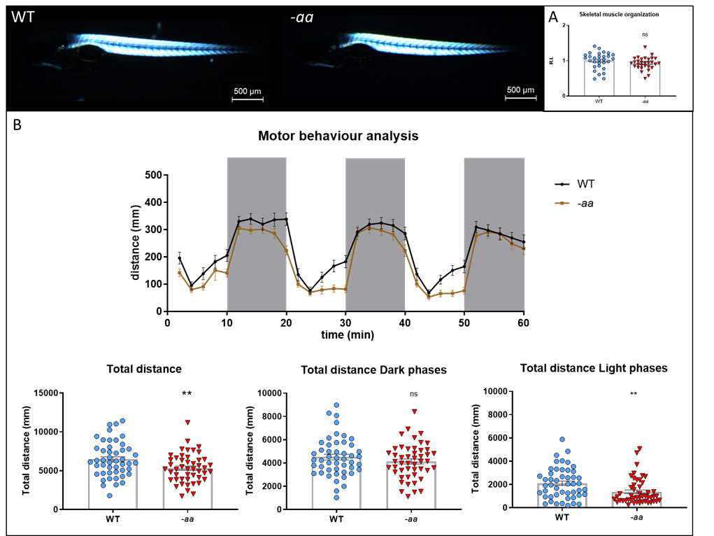
Supplementary Figure 5: Preserved gross skeletal muscle birefringence and impaired motor behaviour in zebrafish -aa mutant larvae. A: Birefringence analysis on WT and -aa larvae at 5 dpf did not detect significant differences in gross skeletal muscle organization. Embryos from all the different experimental conditions were acquired at 5 dpf, in lateral view, anterior to the left. Sample size: WT n = 30; -aa n = 30 larvae. Each data point represents one larva. Data are shown as mean ± SEM. R.I., relative intensity normalized to WT controls. Statistical analysis: unpaired t-test. ns, not significant. B: WT and -aa larvae at 5 dpf display normal response to light (white areas) and dark (grey areas) stimuli, but with reduced motor performances in the mutants, evaluated as total distance swum. Embryos from all the different experimental conditions were recorded at 5 dpf. Sample size: WT n = 47; -aa n = 47 larvae. Each data point represents one larva. Data are shown as mean ± SEM. Statistical analysis: unpaired t-test. ** p<0.01.

Supplementary Figure 6: Signalling pathways dysregulation in -aa mutants. qPCR analysis detected dysregulation in all the pathways analysed in lgals3a mutant larvae. Wnt/β-catenin and Hippo/YAP-TAZ target genes showed significant downregulation, while TGFβ signaling appeared only mildly dysregulated. Each data point represents one pool of 30 embryos at 3 dpf from all the different experimental conditions. Sample size: WT n ≈ 15; -aa n ≈ 15 larvae. Log2 FC: Log2 Fold Change. Error bars indicate SEM. Statistical analysis: unpaired t-test. * p<0.05; ** p<0.01; *** p<0.001; **** p<0.0001; ns, not significant.

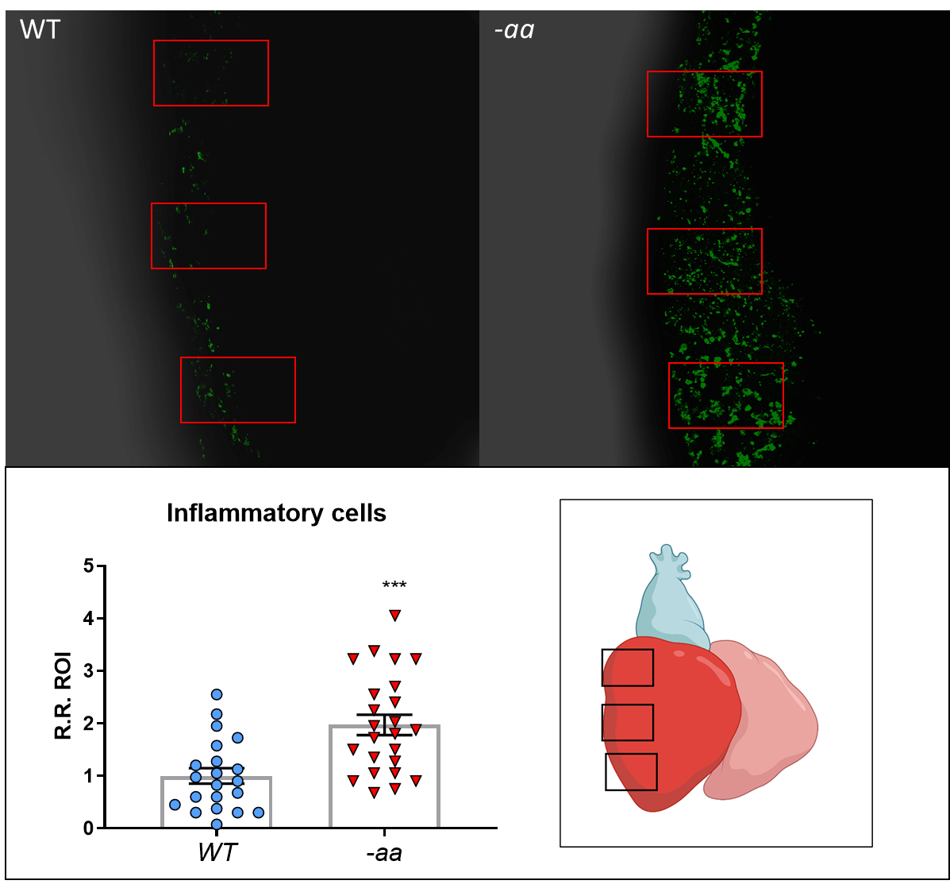
Supplementary Figure 7: Inflammatory response in -aa mutants. Cells expressing the inflammatory marker L-plastin are significantly more abundant in the epicardial layer of -aa mutants compared to WT. Hearts from all the different experimental conditions were extracted and acquired at 1 year post fertilization. Sample size: n ≈ 20 ROIs per group. Each data point represents one ROI. R. R. ROI: relative ratio within the region of interest normalized to WT controls. Error bars indicate SEM. Statistical analysis: unpaired t-test. *** p<0.001.
Supplementary Figure 8: RT-qPCR analysis of selected RNA-seq inflammatory/macrophage-associated genes highlighted in the -aa whole-heart RNA-seq dataset. mmp25b and il12rb2 were significantly upregulated in -aa mutant hearts, whereas ccl38a.4 remained unchanged and ccl38.1 was downregulated. These results provide partial validation of the inflammatory/macrophage-associated transcriptional signature identified. Each data point represents one pool of 3 adult hearts at 1 year post fertilization from all the different experimental conditions. Sample size: WT n = 6; -aa n = 6 adult hearts. Log2 FC: Log2 Fold Change. Error bars indicate SEM. Statistical analysis: unpaired t-test. ** p<0.01; ns, not significant.

Original agarose gel image used for Supplementary Figure 1. Cropped region used (red boxes).
