A 3-D whole-body human thermoregulatory model to simulate
extreme cold stress
Manpreet Singh^{1,2}, Lahcen Akerkouch^{1,2},
Margaret C. Morrissey³, Michael Szymanski³, Erica M. Filep³, Sean Langan³, Douglas J. Casa³, Jaques Reifman^{1*}, and Jose E. Rubio^{1,2}
¹Department of Defense Biotechnology High Performance Computing Software Applications Institute, Defense Health Agency Research & Development, Medical Research and Development Command, Fort Detrick, MD 21702-5012, USA
²The Henry M. Jackson Foundation for the Advancement of Military Medicine, Inc., Bethesda, MD 20817, USA
³Korey Stringer Institute, University of Connecticut, Storrs, CT 06269, USA

*Correspondence:
Jaques Reifman, Ph.D.
Senior Research Scientist
Director, Department of Defense Biotechnology High Performance Computing Software Applications Institute
Defense Health Agency Research & Development
Medical Research and Development Command
ATTN: FCMR-TT, 504 Scott Street
Fort Detrick, MD 21702-5012, USA
Email: jaques.reifman.civ@health.mil
Phone: +1 301-639-3637
Fax: +1 301-619-1983

Supplementary Material
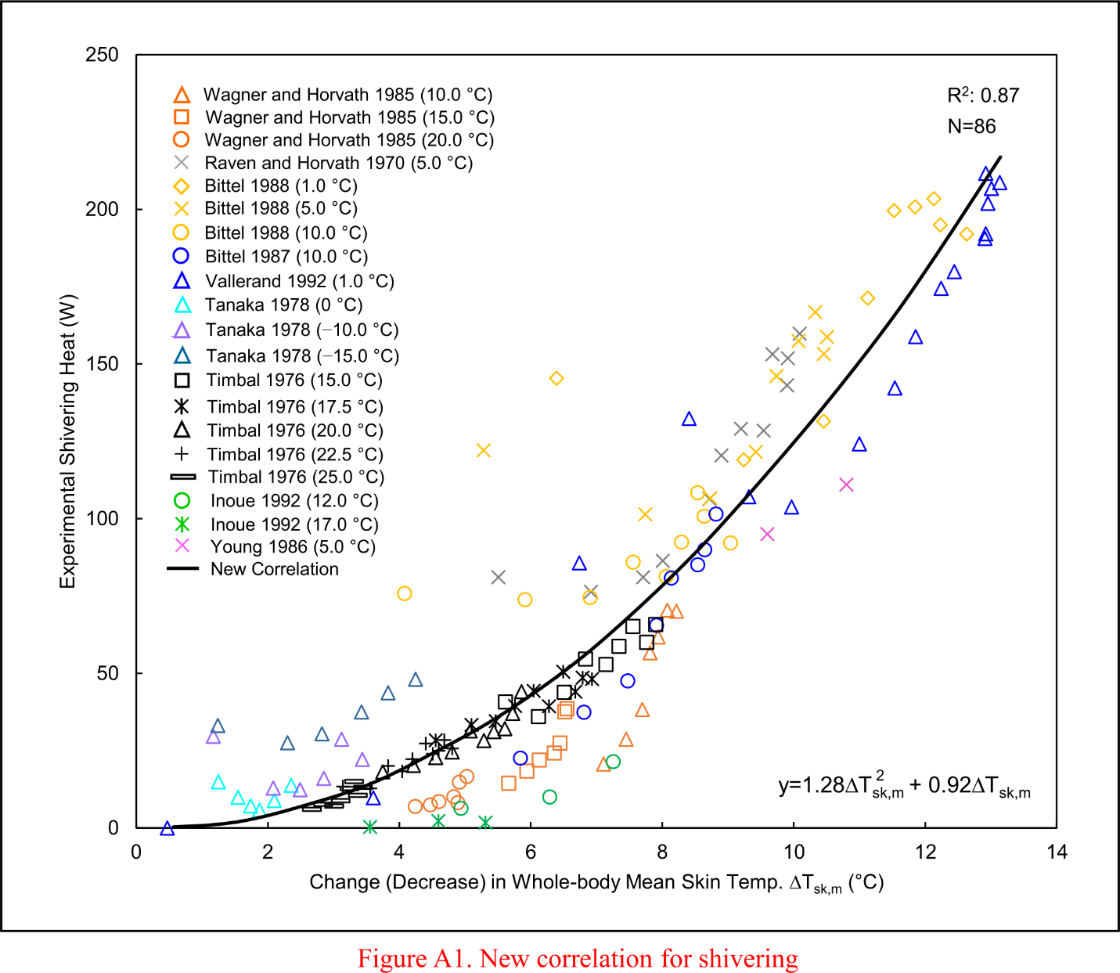
Figure S1. Updated correlation between experimentally observed heat generation due to shivering ${\dot{\text{Q}}}_{\text{Sh}}$ and changes (decrease) in mean skin temperature ∆T_{sk,m}, obtained by collating experimental data from multiple studies performed in cold air [1-9]. Here, we included additional experimental data [1-4], which covered extreme cold-stress conditions down to a temperature of −15.0 °C to more accurately represent the gradual increase in shivering (see second term in Equation 2) as the mean skin temperature decreased. Open symbols represent mean experimental values (for a total N=86 subjects), and the solid black line denotes the updated correlation function y. R²: coefficient of determination; ∆T_{sk,m}: change in mean skin temperature from an initial thermoneutral state.

Table S1. Anthropometric measurements for the subjects in the 12 experimental studies used to calibrate or validate the virtual human model
Study | No. of Subjects | Age  (years) | Height  (m) | Weight  (kg) | BMI  (kg⸱m⁻²) | BF  (%) | BSA  (m²)
C1 | 5 | ‒ | ‒ | ‒ | ‒ | ‒ | ‒
C2 | 7 | 25.7 (2.5) | ‒ | 83.6 (5.9) | ‒ | ‒ | 2.04 (0.07)
C3 | 34 | 26.5 (8.6) | 1.77 (0.07) | 77.2 (7.9) | 24.7 (‒) | ‒ | 1.95 (0.17)
C4 | 12 | 24.5 (1.1) | 1.74 (0.04) | 69.1 (8.0) | 22.9 (‒) | ‒ | 1.83 (‒)
C5 | 8 | 26.0 (9.0) | 1.70 (0.06) | 77.6 (16.2) | 26.9 (‒) | 16.4 (5.3) | 1.91 (‒)
V1 | 7 | 32.0 (14.0) | 1.75 (0.05) | 75.7 (14.2) | 24.7 (4.4) | ‒ | 1.92 (‒)
V2 | 8 | 32.8 (7.4) | 1.76 (0.06) | 82.4 (7.5) | 26.5 (‒) | ‒ | 2.01 (‒)
V3 | 12 | 24.5 (1.1) | 1.74 (0.04) | 69.1 (8.0) | 22.9 (2.3) | ‒ | 1.83 (‒)
V4 | 6 | 28.7 (6.2) | 1.78 (0.07) | 75.8 (2.4) | 23.9 (‒) | ‒ | 1.93 (0.07)
V5 | 10 | 22.0 (3.0) | 1.78 (0.07) | 82.4 (17.9) | 26.0 (‒) | 18.6 (3.6) | 2.02 (0.20)
V7 | 9 | 27.0 (3.0) | 1.74 (0.06) | 66.6 (9.6) | 22.0 (‒) | 15.1 (1.2) | 1.79 (0.15)
V8 | 9 | 21.7 (1.3) | 1.73 (0.05) | 64.5 (7.9) | 21.6 (1.9) | 13.7 (2.4) | 1.76 (0.13)
The data are presented as mean [± 1 standard deviation (SD)]. Dashes (‒) denote cases where the original study did not report the corresponding data. BMI: body mass index; BF: body fat; BSA: body surface area.

Table S2. Anthropometric measurements of the 15 young, healthy men in Study V6 conducted in an environmentally controlled chamber at the University of Connecticut
 | Age  (years) | Height  (m) | Weight  (kg) | BMI  (kg⸱m⁻²) | BF  (%)
Mean (±SD) | 23.67 (2.79) | 1.74 (0.11) | 80.04 (12.35) | 26.32 (3.45) | 15.79 (6.99)
Range | 18−27 | 1.51−1.93 | 59.80−109.28 | 22.23−34.49 | 5.70−31.80
BMI: body mass index; BF: body fat; SD: standard deviation.

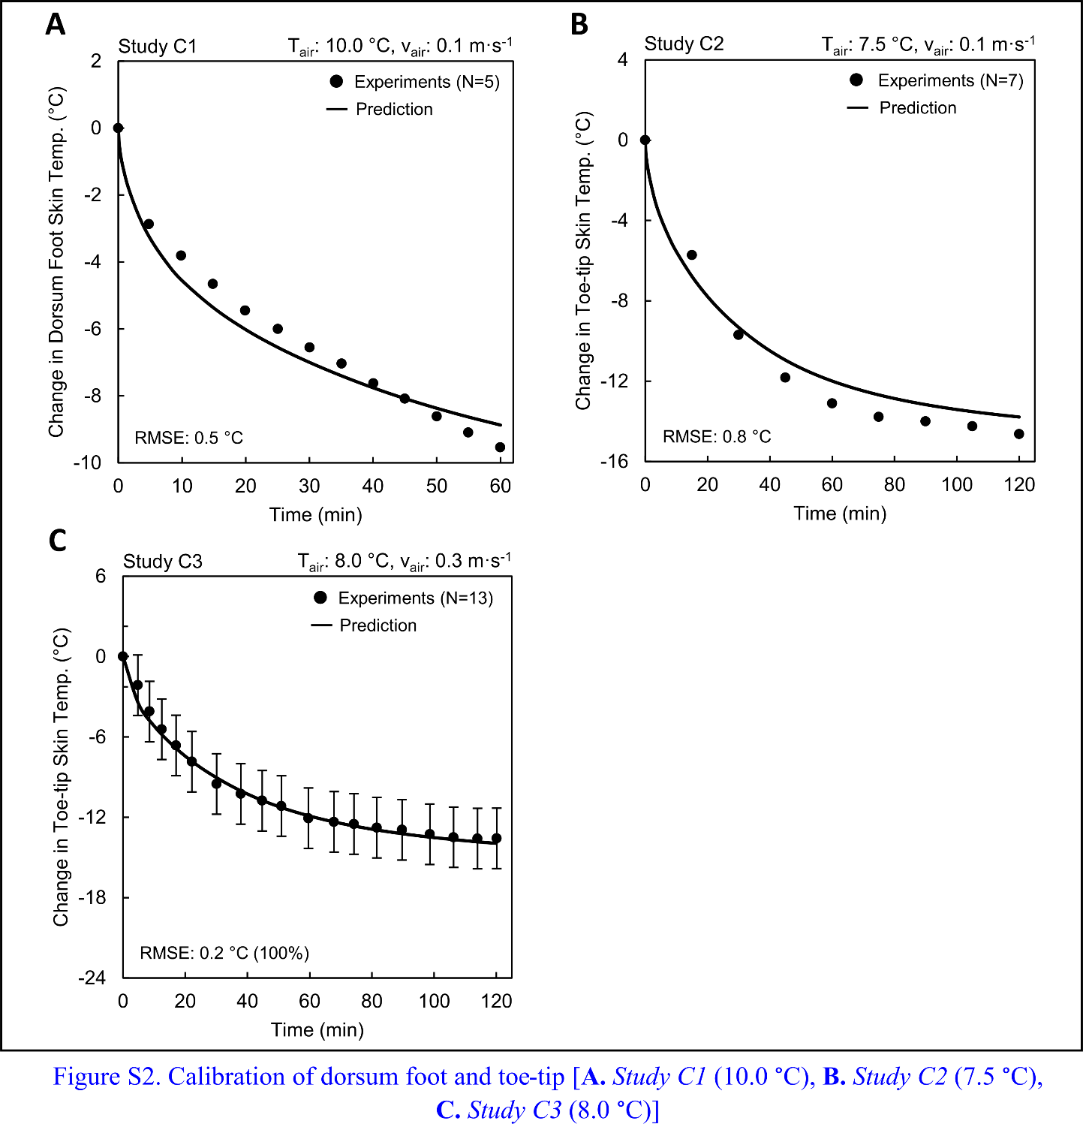
Figure S2. (A) Model calibration of the dorsum foot skin temperature during a mild cold-air exposure, using data from Study C1 [air temperature (T_{air}): 10.0 °C; wind speed (v_{air}): 0.1 m⸱s⁻¹, in which five subjects rested in the supine position with bare hands, bare cheeks, and bare feet for 60 minutes while wearing only shorts (0.57 clo); Table 1]. (B) Model calibration of the toe-tip skin temperature during a mild cold-air exposure, using data from Study C2 [T_{air}: 7.5 °C; v_{air}: 0.1 m⸱s⁻¹, in which seven subjects rested in the supine position with bare hands, bare cheeks, and bare feet for 120 minutes while wearing only shorts (0.57 clo); Table 1]. (C) Model calibration of the toe-tip skin temperature during a mild cold-air exposure, using data from Study C3 [T_{air}: 8.0 °C; v_{air}: 0.3 m⸱s⁻¹, in which 13 subjects rested in the supine position with bare hands, bare cheeks, and bare feet for 120 minutes while wearing only shorts (0.57 clo); Table 1]. In each panel, the solid black circles denote the average of the experimentally measured temperature change, the vertical black bars indicate two standard errors of the mean (SEM), the solid black line denotes the model-predicted temperature, and the percentages in parentheses next to the root mean square error (RMSE) represent the fraction of predictions that lie within two SEM. The experimental measurement uncertainty was not available for the dorsum foot (panel A) and toe-tip skin temperatures (panel B). N: number of subjects.

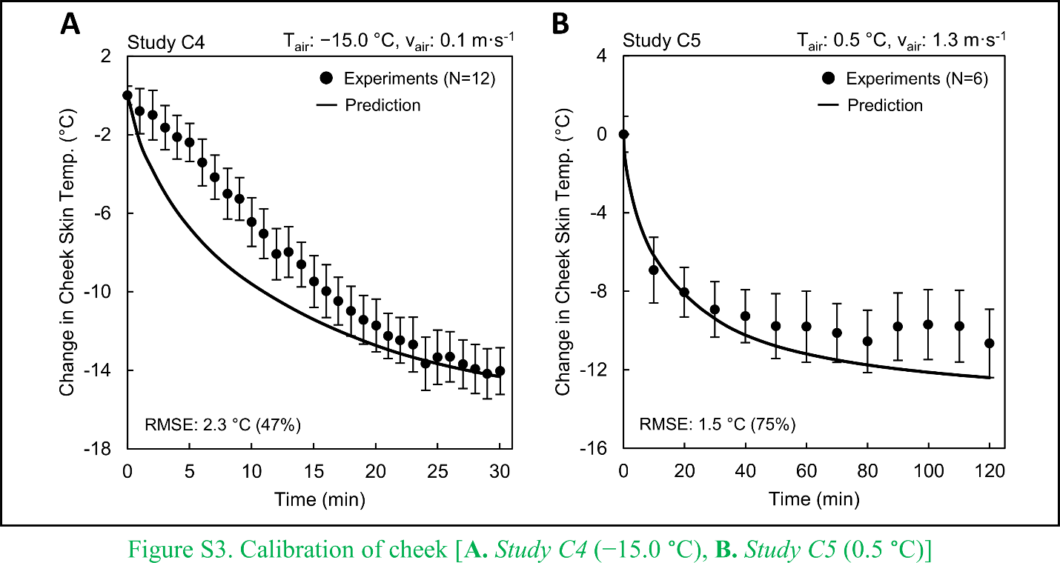
Figure S3. (A) Model calibration of the cheek skin temperature, using data from Study C4 [air temperature (T_{air}): −15.0 °C; wind speed (v_{air}): 0.1 m⸱s⁻¹, in which 12 subjects sat barehanded with bare cheeks for 30 minutes while wearing a cold-protective uniform, including a long-sleeve shirt, cotton jacket, cotton trousers, cotton hat, and cold-proof boots, with a total clothing thermal resistance of 2.16 clo; Table 1]. A 35-minute adaptation or pre-conditioning phase at T_{air} of 24.0 °C preceded the cold exposure. For the duration of exposure, the subjects’ footwear were in direct contact with the cold ground. We used a temperature profile at the bottom of the footwear so as to consider the conductive heat loss resulting from the contact between the shoe sole and the ground. (B) Model calibration of the cheek skin temperature, using data from Study C5 (T_{air}: 0.5 °C; v_{air}: 1.3 m⸱s⁻¹, in which six subjects sat barehanded with bare cheeks for 120 minutes while wearing a cold-weather clothing ensemble, including three layers on the torso and two layers on the legs as well as wool socks, U.S. Army Improved Intermediate Cold-Wet Boots, and an Army fleece hat, with a total clothing thermal resistance of 1.25 clo; Table 1). In each panel, the solid black circles denote the average of the experimentally measured temperature change, the vertical black bars indicate two standard errors of the mean (SEM), the solid black line denotes the model-computed temperature, and the percentages in parentheses next to the root mean square error (RMSE) represent the fraction of predictions that lie within two SEM. N: number of subjects.

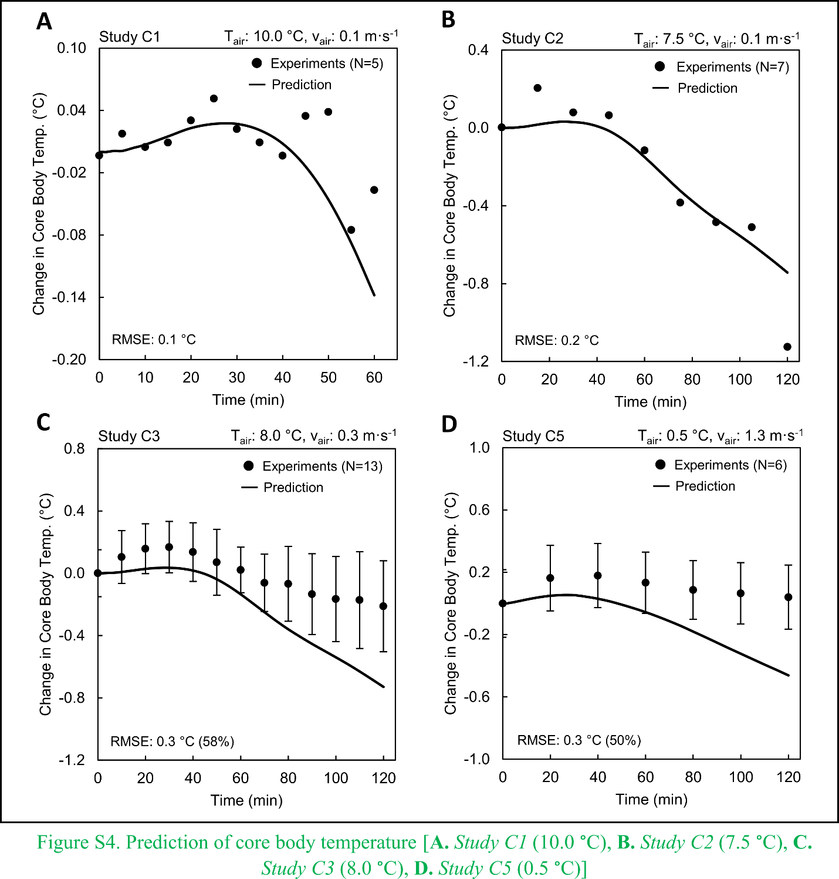
Figure S4. (A) Model prediction of core body temperature at a depth of 10 cm beyond the anal sphincter during a mild cold-air exposure, using data from Study C1 [air temperature (T_{air}): 10.0 °C; wind speed (v_{air}): 0.1 m⸱s⁻¹, in which five subjects rested in the supine position with bare hands, bare cheeks, and bare feet for 60 minutes while wearing only shorts (0.57 clo); Table 1]. (B) Model prediction of core body temperature at a depth of 10 to 12 cm beyond the anal sphincter during a mild cold-air exposure, using data from Study C2 [T_{air}: 7.5 °C; v_{air}: 0.1 m⸱s⁻¹, in which seven subjects rested in the supine position with bare hands, bare cheeks, and bare feet for 120 minutes while wearing only shorts (0.57 clo); Table 1]. (C) Model prediction of core body temperature at a depth of 10 to 12 cm beyond the anal sphincter during a mild cold-air exposure, using data from Study C3 [T_{air}: 8.0 °C; v_{air}: 0.3 m⸱s⁻¹, in which 13 subjects rested in the supine position with bare hands, bare cheeks, and bare feet for 120 minutes while wearing only shorts (0.57 clo); Table 1]. (D) Model prediction of core body temperature measured in the gastrointestinal tract using an ingestible temperature capsule, based on data from Study C5 (T_{air}: 0.5 °C; v_{air}: 1.3 m⸱s⁻¹, in which six subjects sat barehanded with bare cheeks for 120 minutes while wearing a cold-weather clothing ensemble, including three layers on the torso and two layers on the legs as well as wool socks, U.S. Army Improved Intermediate Cold-Wet Boots, and an Army fleece hat, with a total clothing thermal resistance of 1.25 clo; Table 1). In each panel, the solid black circles denote the average of the experimentally measured temperature change, the vertical black bars indicate two standard errors of the mean (SEM), the solid black line denotes the model-predicted temperature, and the percentages in parentheses next to the root mean square error (RMSE) represent the fraction of predictions that lie within two SEM. The experimental measurement uncertainty for core body temperature was not reported in Studies C1 and C2 (panels A and B, respectively). N: number of subjects.

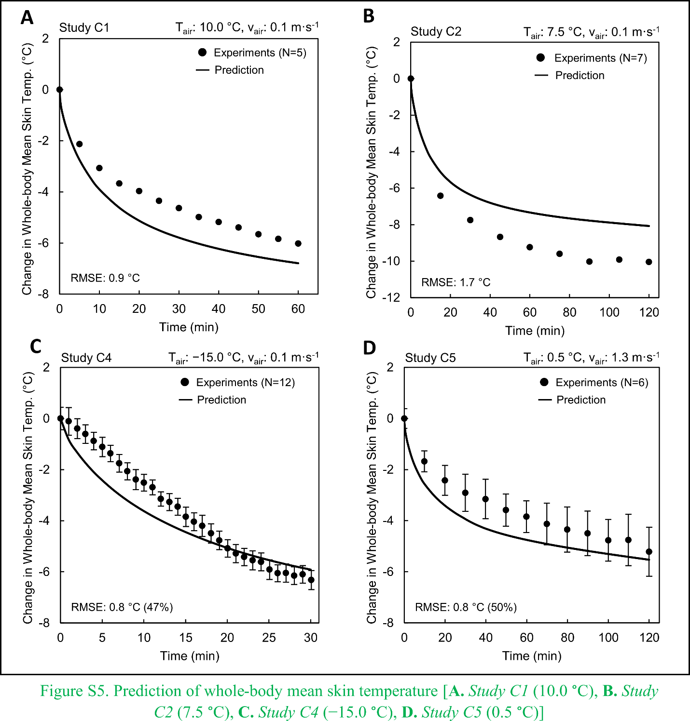
Figure S5. (A) Model prediction of whole-body mean skin temperature during a mild cold-air exposure, using data from Study C1 [air temperature (T_{air}): 10.0 °C; wind speed (v_{air}): 0.1 m⸱s⁻¹, in which five subjects rested in the supine position with bare hands, bare cheeks, and bare feet for 60 minutes while wearing only shorts (0.57 clo); Table 1]. (B) Model prediction of whole-body mean skin temperature during a mild cold-air exposure, using data from Study C2 [T_{air}: 7.5 °C; v_{air}: 0.1 m⸱s⁻¹, in which seven subjects rested in the supine position with bare hands, bare cheeks, and bare feet for 120 minutes while wearing only shorts (0.57 clo); Table 1]. (C) Model prediction of whole-body mean skin temperature, using data from Study C4 (T_{air}: −15.0 °C; v_{air} 0.1 m⸱s⁻¹, in which 12 subjects sat barehanded with bare cheeks for 30 minutes while wearing a cold-protective uniform, including a long-sleeve shirt, cotton jacket, cotton trousers, cotton hat, and cold-proof boots, with a total clothing thermal resistance of 2.16 clo; Table 1). A 35-minute adaptation or pre-conditioning phase at T_{air} 24.0 °C preceded the cold exposure. For the duration of exposure, the subjects’ footwear were in direct contact with the cold ground. We used a temperature profile at the bottom of the footwear so as to consider the conductive heat loss resulting from the contact between the shoe sole and the ground. (D) Model prediction of whole-body mean skin temperature, using data from Study C5 (T_{air}: 0.5 °C; v_{air}: 1.3 m⸱s⁻¹, in which six subjects sat barehanded with bare cheeks for 120 minutes while wearing a cold-weather clothing ensemble, including three layers on the torso and two layers on the legs as well as wool socks, U.S. Army Improved Intermediate Cold-Wet Boots, and an Army fleece hat, with a total clothing thermal resistance of 1.25 clo; Table 1). In each panel, the solid black circles denote the average of the experimentally measured temperature change, the vertical black bars indicate two standard errors of the mean (SEM), the solid black line denotes the model-predicted temperature, and the percentages in parentheses next to the root mean square error (RMSE) represent the fraction of predictions that lie within two SEM. The experimental measurement uncertainty for whole-body mean skin temperature was not reported in Studies C1 and C2 (panels A and B, respectively). N: number of subjects.

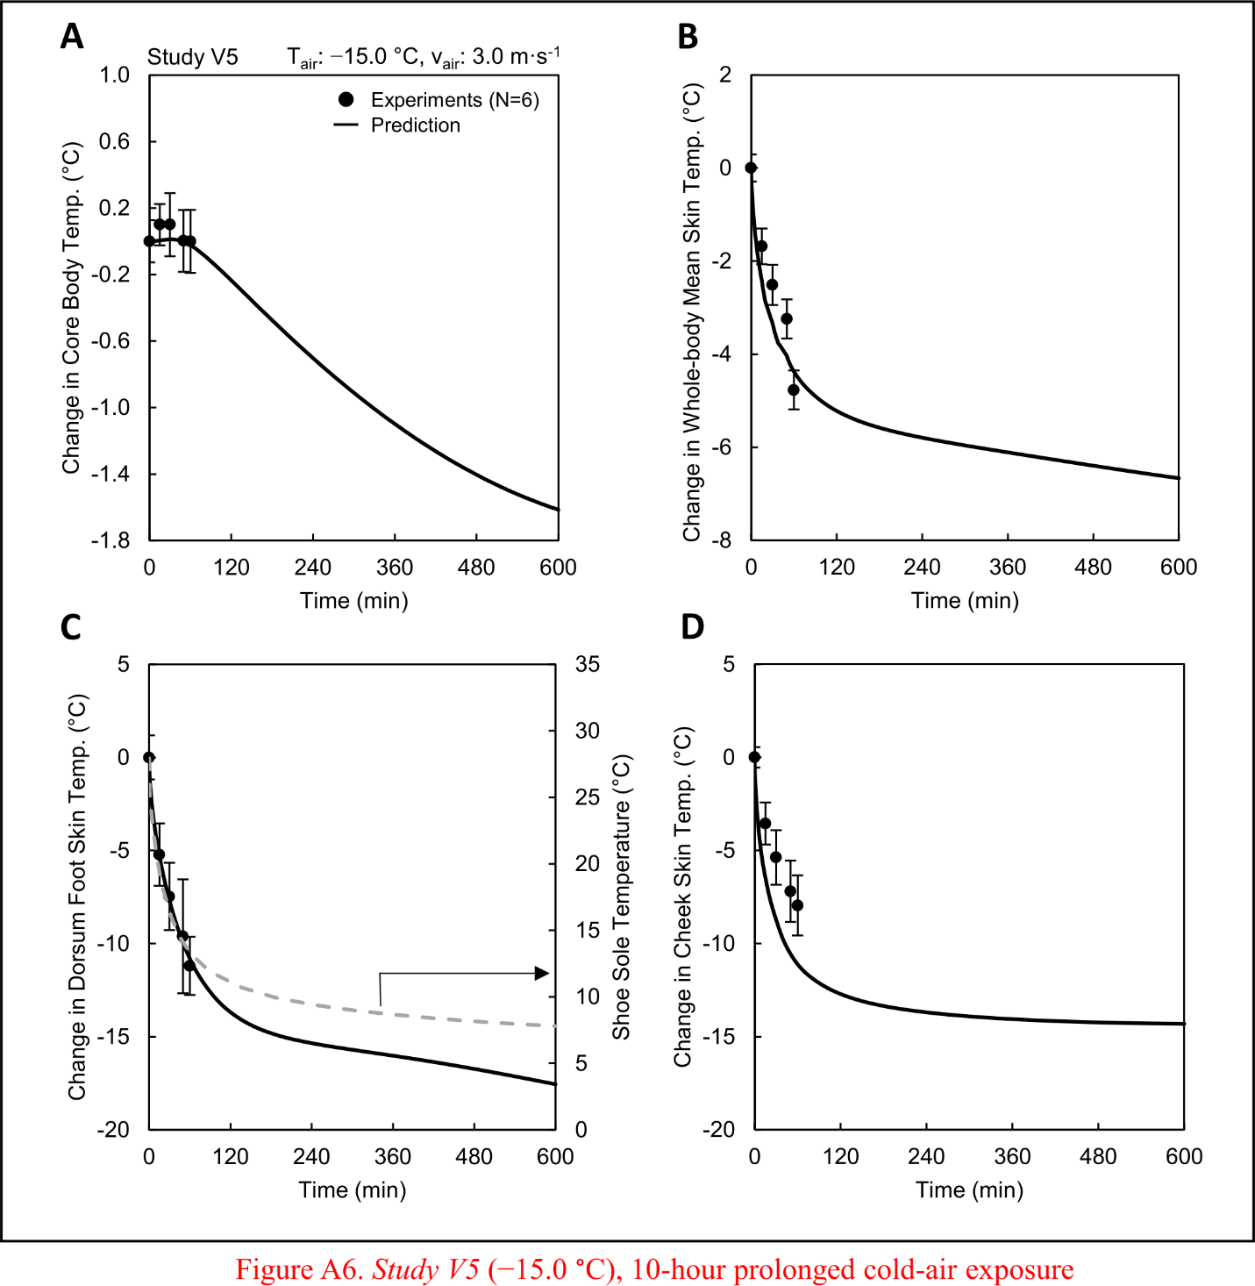
Figure S6. The same model predictions as in Figure 5 for Study V5 (Table 2) [air temperature (T_{air}): −15.0 °C; wind speed (v_{air}): 3.0 m⸱s⁻¹], but here we extended the model predictions for up to 600 minutes instead of 60 minutes, as in the experimental study.

References
1. Tanaka, M. Metabolic and thermal responses of men wearing cold-protective clothing to various degrees of cold stress. Eur. J. Appl. Physiol. Occup. Physiol. 39, 137–144, doi:10.1007/BF00421718 (1978).
2. Vallerand, A. L., Savourey, G. & Bittel, J. H. Determination of heat debt in the cold: partitional calorimetry vs. conventional methods. J. Appl. Physiol. 72, 1380–1385, doi:10.1152/jappl.1992.72.4.1380 (1992).
3. Bittel, J. H. Heat debt as an index for cold adaptation in men. J. Appl. Physiol. 62, 1627–1634, doi:10.1152/jappl.1987.62.4.1627 (1987).
4. Inoue, Y., Nakao, M., Araki, T. & Ueda, H. Thermoregulatory responses of young and older men to cold exposure. Eur. J. Appl. Physiol. Occup. Physiol. 65, 492–498, doi:10.1007/BF00602354 (1992).
5. Raven, P. R. & Horvath, S. M. Variability of physiological parameters of unacclimatized males during a two-hour cold stress of 5°C. Int. J. Biometeorol. 14, 309–320, doi:10.1007/BF01742075 (1970).
6. Timbal, J., Boutelier, C., Loncle, M. & Bougues, L. Comparison of shivering in man exposed to cold in water and in air. Pflügers Arch. 365, 243–248, doi:10.1007/BF01067024 (1976).
7. Wagner, J. A. & Horvath, S. M. Influences of age and gender on human thermoregulatory responses to cold exposures. J. Appl. Physiol. 58, 180–186, doi:10.1152/jappl.1985.58.1.180 (1985).
8. Young, A. J., Muza, S. R., Sawka, M. N., Gonzalez, R. R. & Pandolf, K. B. Human thermoregulatory responses to cold air are altered by repeated cold water immersion. J. Appl. Physiol. 60, 1542–1548, doi:10.1152/jappl.1986.60.5.1542 (1986).
9. Bittel, J. H., Nonotte-Varly, C., Livecchi-Gonnot, G. H., Savourey, G. L. & Hanniquet, A. M. Physical fitness and thermoregulatory reactions in a cold environment in men. J. Appl. Physiol. 65, 1984–1989, doi:10.1152/jappl.1988.65.5.1984 (1988).

