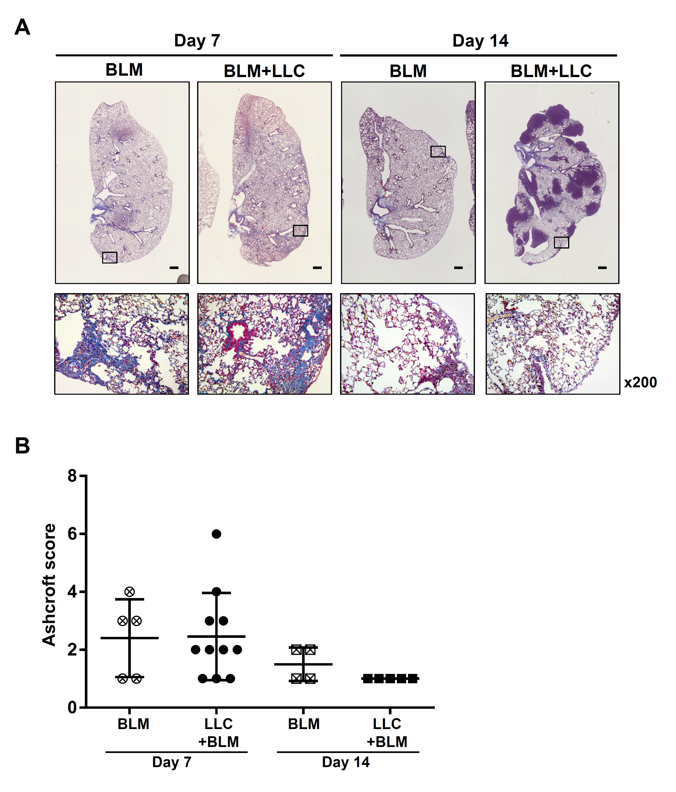
Supplementary Fig. 1 Assesment of fibrosis of lung sections from BLM-only and BLM + LLC mice
(A) Lung sections from BLM-only and BLM + LLC mice were stained with Masson’s trichrome at Day 7 and Day 14 (scale bars = 500 μm). (B) Ashcroft scores of BLM-only and BLM + LLC mice at Day 7 and Day 14. Values presented as mean ± SEM.
Supplementary Fig. 2 Representative gating strategy for CD8⁺ T cells and CD25⁺Foxp3⁺CD4⁺ Tregs
Representative flow cytometric plots illustrating sequential gating strategy used to identify CD8⁺ T cells and Tregs from the obtained tissues. Lymphocytes were first gated based on forward scatter, side scatter, and CD45 expression, followed by live-cell gating. CD3⁺ T cells were then divided into CD4⁺ and CD8⁺ subsets, and Tregs were defined as CD25⁺Foxp3⁺CD4⁺ T cells. Percentages indicate the frequency within the parent population.
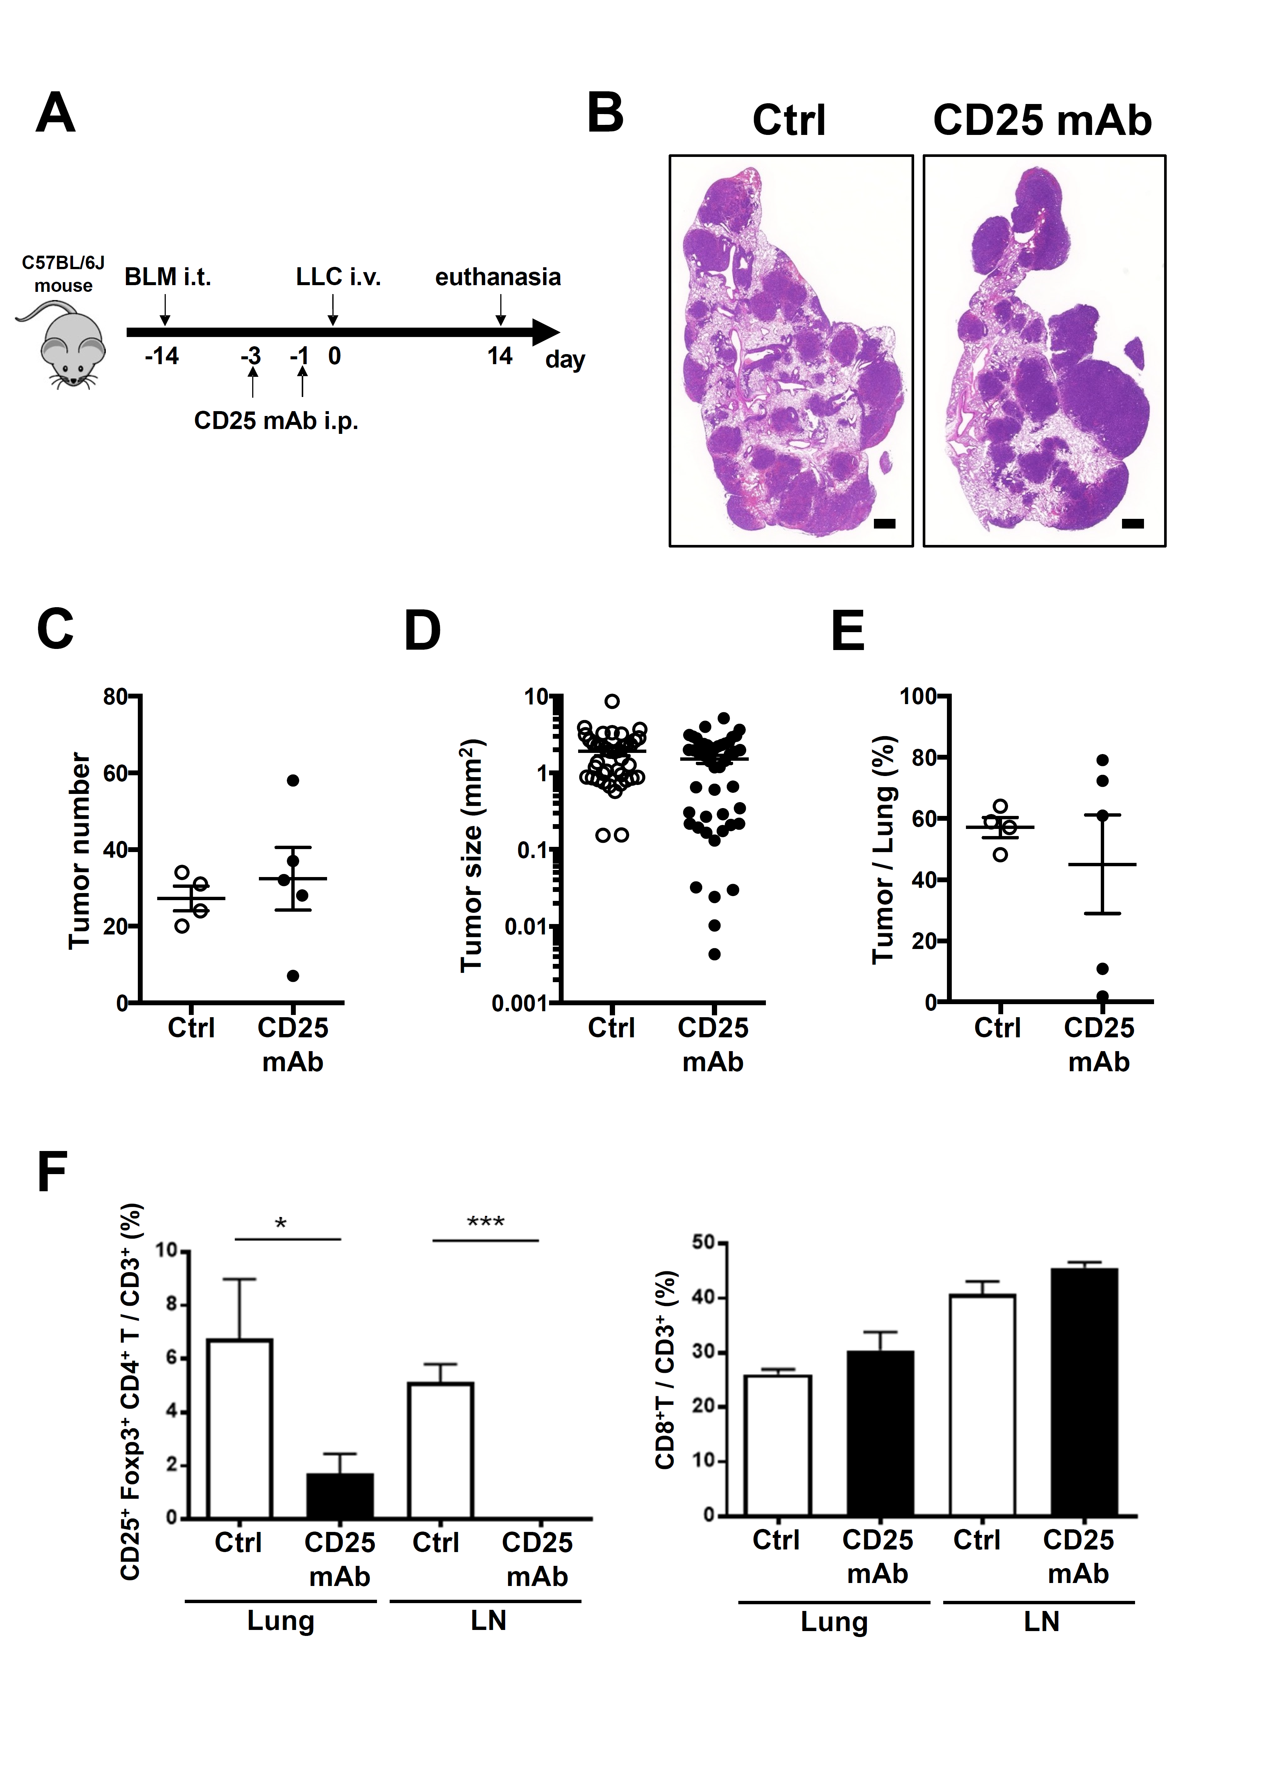Supplementary Fig. 3 Tumor-shrinking effects of anti-CD25 mAb treatment in fibrotic lung
(A) Schematic representation of experimental protocol. C57BL/6J mice were challenged with 0.75 mg/kg BLM, followed 14 days later by injection of LLC. Mice were treated with either anti-CD25 mAb or control IgG (Ctrl) at 3 and 1 days prior to LLC injection. Mice were analyzed 14 days after LLC injection. (B) Histological appearance of lungs. HE staining (scale bars = 500 μm). (C-E) Tumor measurement in lungs: (C) number of tumors, (D) size of 10 largest tumors in each sample, and (E) percentage of total tumor area in lungs were assessed by HE staining. (F) Flow cytometric analysis of T cells in the lungs and LNs. Percentages of Tregs (CD25⁺Foxp3⁺CD4⁺ T cells) among CD3⁺ cells, CD8⁺ T cells among CD3⁺ cells. Ctrl group: n = 4; CD25 mAb group: n = 5 (n = 4 in CD25 mAb group for analysis of LN lymphocytes). Values presented as mean ± SEM.
***P < 0.001.
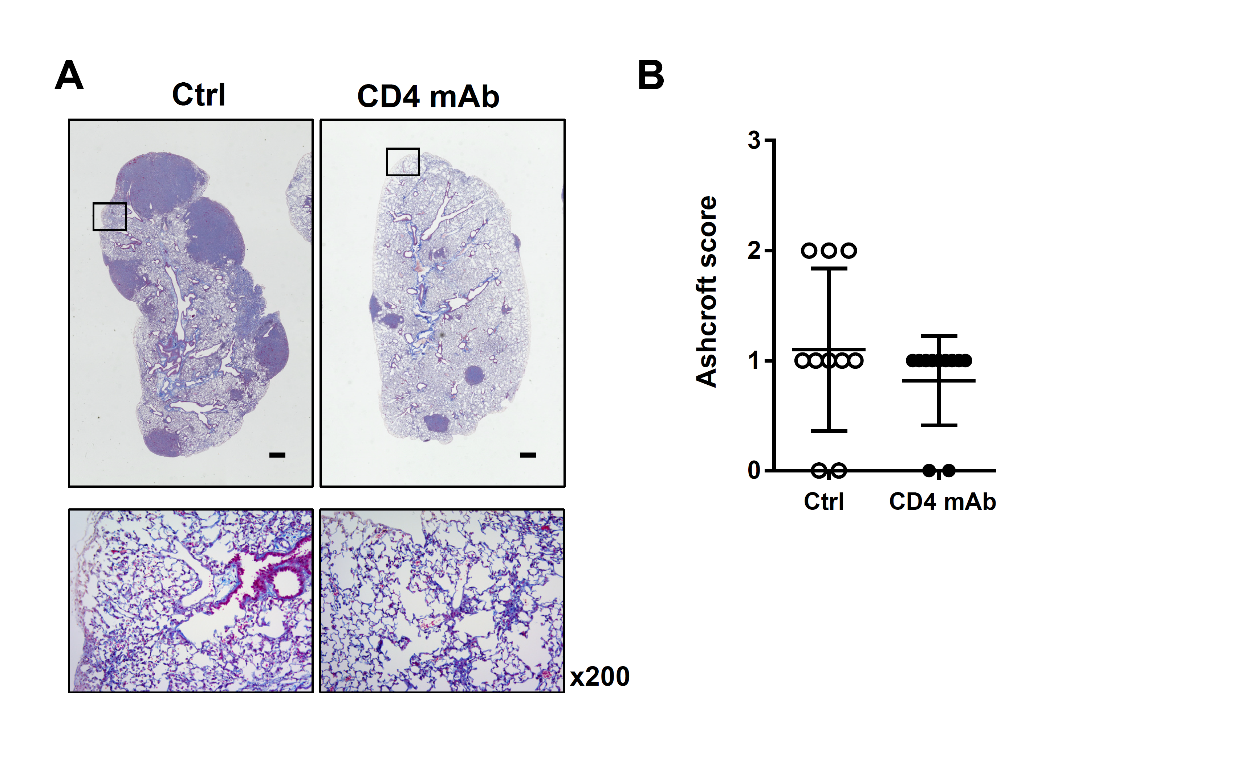
Supplementary Fig. 4 Assesment of fibrosis of lung sections from BLM + LLC mice treated with control Ab or anti-CD4 mAb
(A) Lung sections of BLM + LLC mice treated with control Ab or anti-CD4 mAb were stained with Masson’s trichrome at Day 14 (scale bars = 500 μm). (B) Ashcroft scores of BLM + LLC mice treated with control Ab or anti-CD4 mAb. Values presented as mean ± SEM.

