Appendix

Table S1 Model performance indicators, including goodness-of-fit (R²Y), goodness-of-prediction (Q²), and root mean square relative error (RMSRE), for the PLS-DA analysis
Year | Crop | R²X(cum) | R²Y(cum) | Q²(cum) | RMSRE (%) | pR²Y | pQ²
2022 | Wheat | 0.901 | 0.904 | 0.641 | 16 | 0.005 | 0.005
2022 | Maize | 0.967 | 0.968 | 0.642 | 11.3 | 0.005 | 0.005
2023 | Wheat | 0.525 | 0.537 | 0.442 | 22.4 | 0.005 | 0.005
2023 | Maize | 0.637 | 0.707 | 0.457 | 20.2 | 0.005 | 0.005

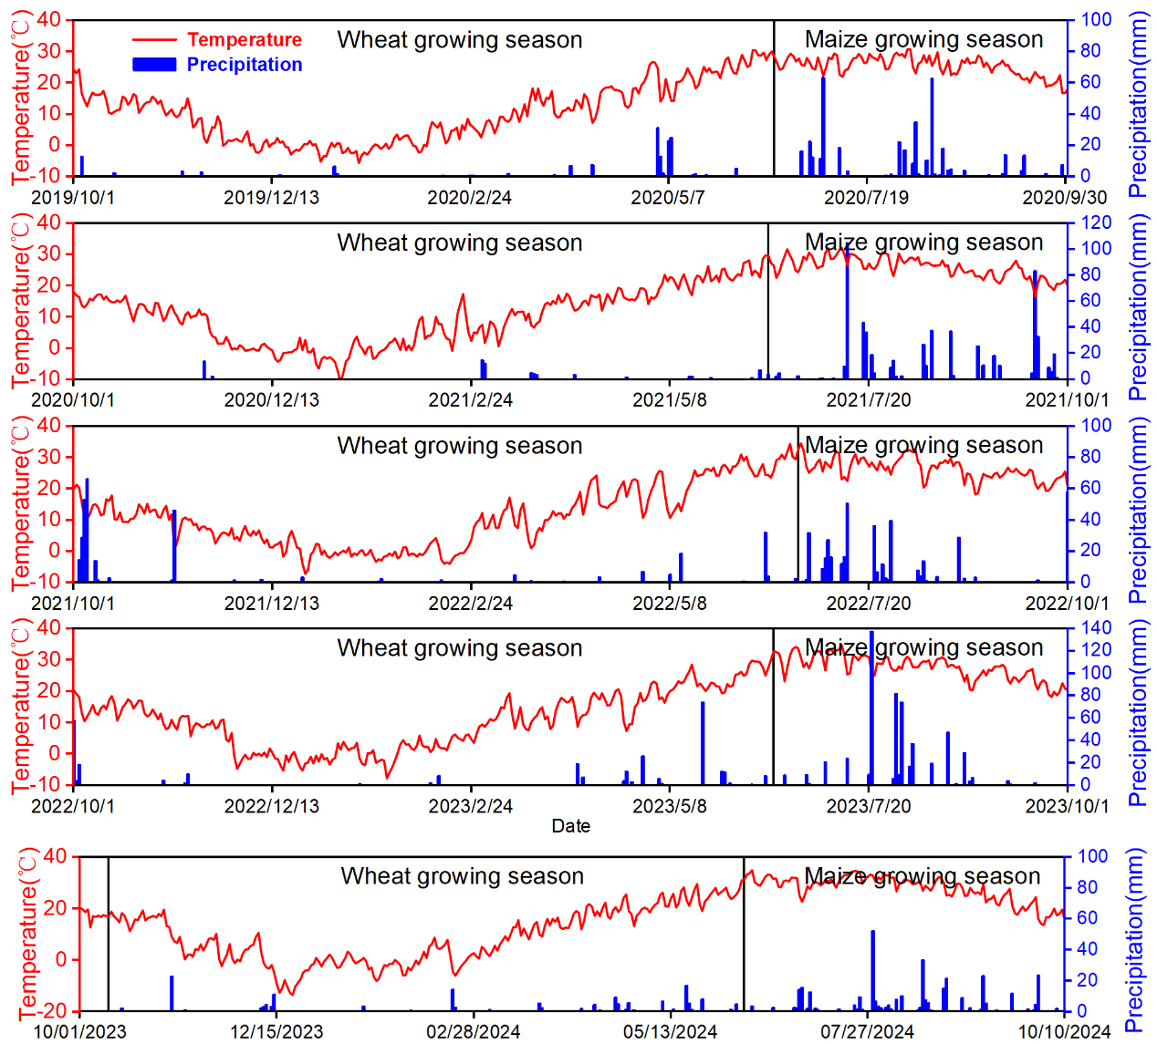
Figure S1. Precipitation and temperature conditions at the experimental site.

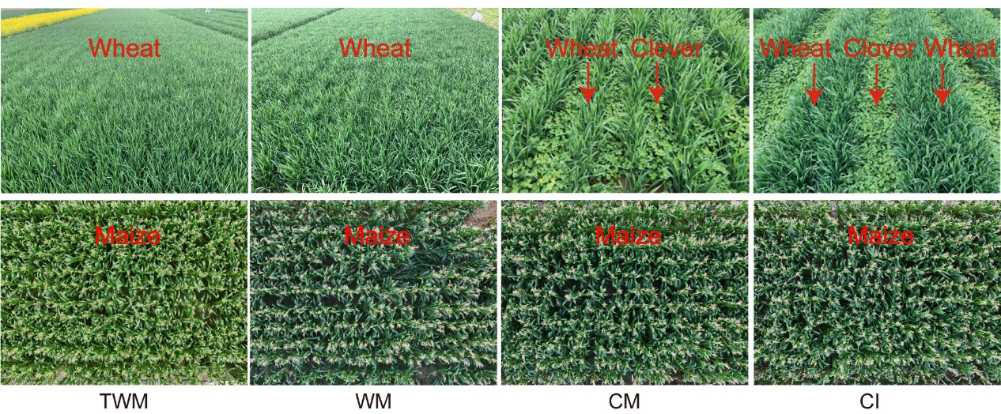
Figure S2. Schematic diagram of the planting systems, fertilization, and irrigation regimes used in this experiment. TWM, conventional wheat–maize system; WM, reduced-input wheat–maize system; CM, white clover–wheat mixed cropping followed by maize; CI, wheat–white clover strip intercropping with relay-intercropped maize.

Figure S3. Effects of different planting systems on soil total nutrients. TN: total nitrogen; TP: total phosphorus; TK: total potassium; SAN: alkali-hydrolyzable nitrogen. Different lowercase letters indicate significant differences among treatments according to the LSD test (P < 0.05).
Figure S4. Effects of different planting systems on soil available nutrients. SAN: alkali-hydrolyzable nitrogen; SAP: available phosphorus; SAK: available potassium; SOC: soil organic carbon. Different lowercase letters indicate significant differences among treatments according to the LSD test (P < 0.05).
Figure S5. Effects of different planting systems on soil enzyme activities. SCAT: soil catalase; SCAP: soil alkaline phosphatase; SUE: soil urease; and SSC: soil saccharase. Different lowercase letters indicate significant differences among treatments according to the LSD test (P < 0.05).

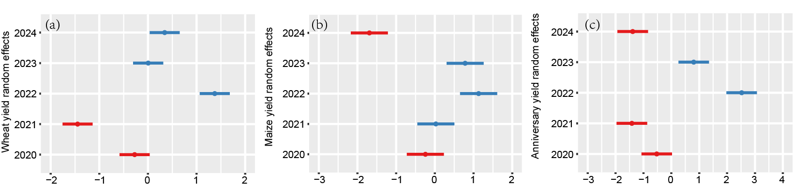
Figure S6. The effect of year on yield. (a) Effects of year on wheat yield; (b) effects of year on maize yield; and (c) effects of year on annual yield.

