Supplementary Figure S1 Anatomical mapping and precise locations of the acupoints used in the rat model.
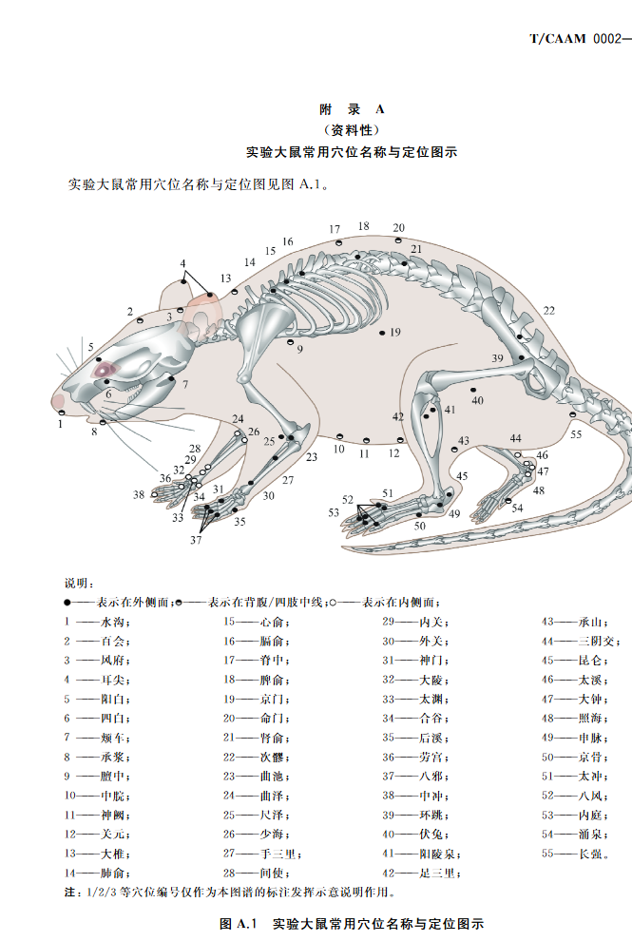
Zhongwan (CV 12):
Located on the anterior midline of the abdomen, approximately 20 mm superior to the umbilicus.
Guanyuan (CV 4):
Located on the anterior midline of the abdomen, approximately 25 mm inferior to the umbilicus.
Tianshu (ST 25):
Located approximately 5 mm lateral to the umbilicus, bilaterally. The umbilicus is defined as the point located at the junction of the upper 8/13 and lower 5/13 of the line connecting the xiphoid process of the sternum to the upper border of the pubic symphysis along the abdominal midline.
Zusanli (ST 36):
Located on the posterolateral aspect of the knee joint, approximately 3 mm inferior to the fibular head.
Sanyinjiao (SP 6):
Located on the medial aspect of the hindlimb, approximately 10 mm superior to the tip of the medial malleolus.

