Supplementary data

Characterization of IgG N-glycan patterns in COVID-19, sepsis and healthy subjects

Victoria Paredes-Orejudo^{1,2$}, Yosra Helali3$, Axelle Bourez^{1,2}, Alexandre Rousseau^{4,5}, Pierre Van Antwerpen^{1,2},
Karim Zouaoui Boudjeltia⁴, Michael Piagnerelli^{4,5}, Arnaud Marchant⁶, Cédric Delporte^{1,2*}

¹RD3 Unit of Pharmacognosy, Bioanalysis and Drug Discovery, Faculty of Pharmacy, Université libre de Bruxelles, Campus Plaine, CP 205/09, 1050 Brussels, Belgium.
²APFP Analytical platform of the Faculty of Pharmacy, Faculty of Pharmacy, Université libre de Bruxelles, Campus Plaine, CP 205/5, 1050 Brussels, Belgium.
³CPBL, Crop Production and biostimulation Laboratory, Ecole de Bioingénierie de Bruxelles, Faculté des sciences, Université libre de Bruxelles, Campus Plaine, CP 245, 1050 Brussels, Belgium.
⁴Laboratory of Experimental Medicine (ULB 222 Unit), CHU Charleroi-Chimay, Université libre de Bruxelles, Charleroi, Belgium.
⁵Intensive Care, CHU-Charleroi Marie-Curie, Université libre de Bruxelles, Charleroi, Belgium.
⁶Immunology laboratory, Faculty of medicine, Université libre de Bruxelles, Campus Erasme, CP580/45, 1070 Brussels, Belgium.
$These authors equally contributed to the work.
*Corresponding author: cedric.delporte@ulb.be
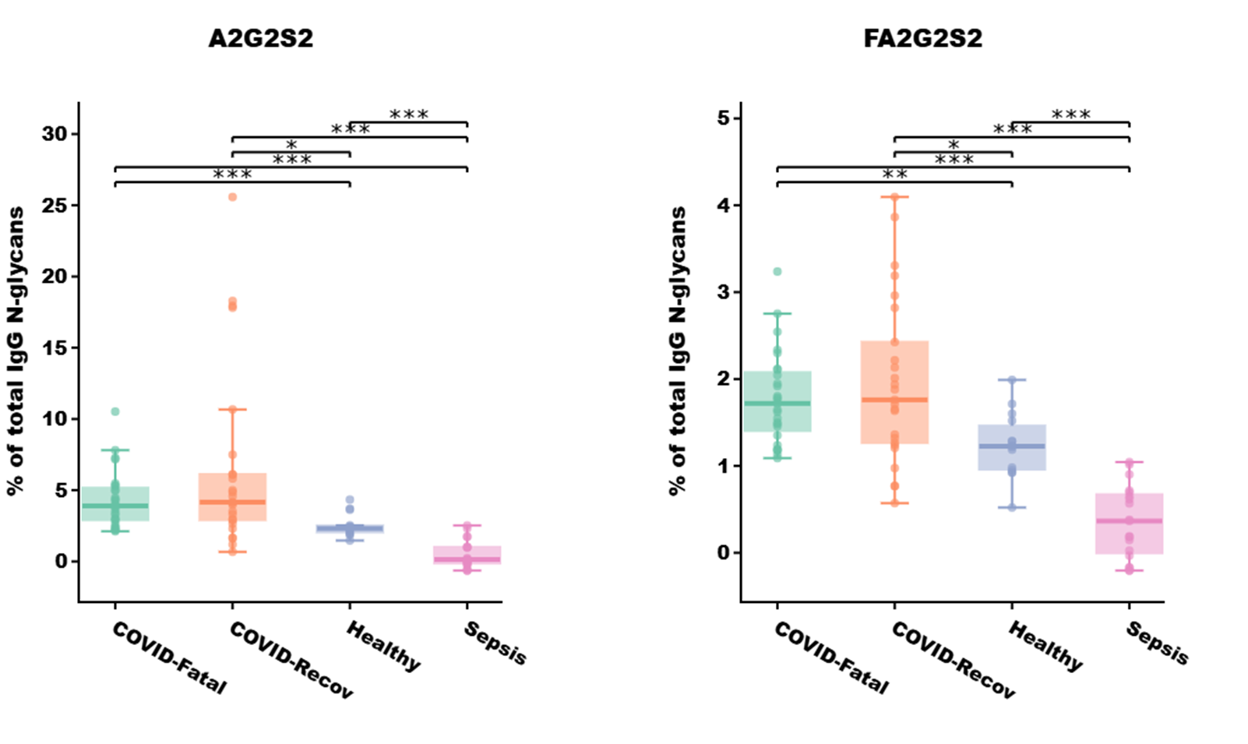
Figure S1: Relative abundance of A2G2S2 and FA2G2S2 N-glycans in COVID-Fatal (n=27), COVID-Recov (n=25), Sepsis (n=19) and Healthy (n=15) groups. Kruskal–Wallis test, *p-value < 0.05; **p-value < 0.005; ***p-value < 0.001. The data were corrected for age using linear regression model.

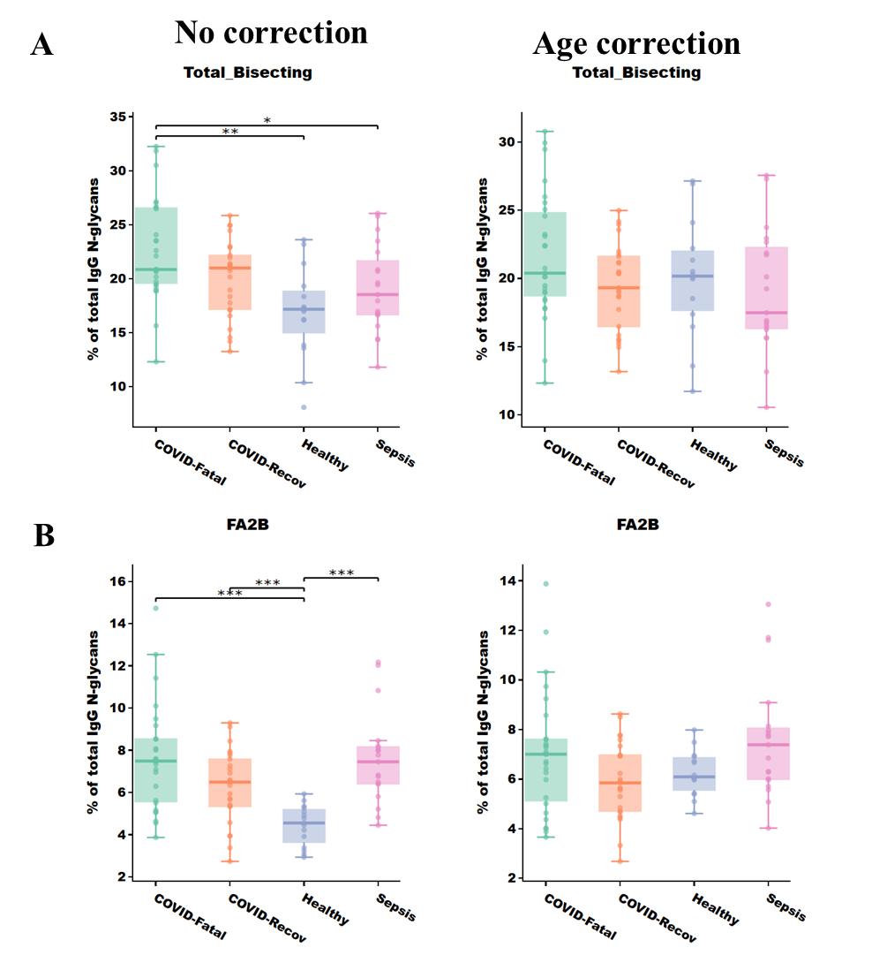

Figure S2: Relative abundance of (A) Total bisecting without (left) and with (right) age correction and (B) FA2B without (left) and with (right) age correction and FA2G2S2 N-glycans in COVID-Fatal (n=27), COVID-Recov (n=25), Sepsis (n=19) and Healthy (n=15) groups. Kruskal–Wallis test, *p-value < 0.05; **p-value < 0.005; ***p-value < 0.001. A linear regression model was used for data correction for age.
Sample collection
Sample number | Groups | Tube Number | Sex | Age | Collection day
1 | COVID-Recov | 12971562 | Man | 58 | 1
5 | COVID-Fatal | 12973468 | Woman | 73 | 1
7 | COVID-Recov | 12995293 | Man | 72 | 1
9 | COVID-Fatal | 12981647 | Man | 76 | 1
11 | COVID-Recov | 12981883 | Man | 51 | 1
14 | COVID-Recov | 12994486 | Man | 59 | 1
16 | COVID-Recov | 12976985 | Man | 75 | 1
18 | COVID-Recov | 12989969 | Man | 70 | 1
20 | COVID-Fatal | 13030189 | Woman | 73 | 1
23 | COVID-Fatal | 13018324 | Man | 72 | 1
25 | COVID-Fatal | 13010790 | Man | 62 | 1
26 | COVID-Fatal | 13024071 | Woman | 58 | 1
28 | COVID-Recov | 12983703 | Man | 71 | 1
30 | COVID-Fatal | 12977930 | Man | 74 | 1
32 | COVID-Fatal | 13022480 | Woman | 74 | 1
34 | COVID-Recov | 12983900 | Man | 73 | 1
36 | COVID-Fatal | 12954868 | Man | 66 | 1
40 | COVID-Recov | 12977696 | Man | 79 | 1
42 | COVID-Recov | 12998554 | Man | 61 | 1
44 | COVID-Recov | 12993384 | Man | 75 | 1
46 | COVID-Fatal | 12981780 | Woman | 68 | 1
48 | COVID-Fatal | 13004833 | Man | 75 | 1
49 | COVID-Recov | 12987482 | Man | 49 | 1
51 | COVID-Fatal | 12989766 | Man | 71 | 1
53 | COVID-Recov | 12975558 | Man | 71 | 1
55 | COVID-Fatal | 13002114 | Man | 65 | 1
57 | COVID-Recov | 13000551 | Woman | 50 | 1
59 | COVID-Fatal | 12986997 | Man | 69 | 1
61 | COVID-Fatal | 13003052 | Man | 75 | 1
62 | COVID-Recov | 12983505 | Man | 59 | 1
64 | COVID-Recov | 12996516 | Man | 78 | 1
66 | COVID-Recov | 12996677 | Man | 76 | 1
68 | COVID-Fatal | 13031203 | Man | 64 | 1
70 | COVID-Fatal | 12995219 | Woman | 67 | 1
73 | COVID-Recov | 12984380 | Man | 50 | 1
75 | COVID-Fatal | 13003816 | Man | 57 | 1
76 | COVID-Fatal | 13022366 | Woman | 71 | 1
78 | COVID-Fatal | 12971519 | Man | 60 | 1
80 | COVID-Fatal | 13015981 | Woman | 74 | 1
82 | COVID-Fatal | 12953094 | Woman | 65 | 1
84 | COVID-Recov | 12981417 | Man | 59 | 1
86 | COVID-Recov | 12982164 | Man | 75 | 1
88 | COVID-Fatal | 12990720 | Man | 67 | 1
90 | COVID-Recov | 12990912 | Man | 66 | 1
92 | COVID-Recov | 12993704 | Man | 53 | 1
94 | COVID-Fatal | 13028564 | Woman | 46 | 1
97 | COVID-Recov | 12987344 | Man | 51 | 1
99 | COVID-Fatal | 12981846 | Man | 76 | 1
101 | COVID-Fatal | 12991984 | Woman | 71 | 1
103 | COVID-Fatal | 12986004 | Man | 68 | 1
107 | COVID-Recov | 12993968 | Man | 60 | 1
109 | COVID-Recov | 12991189 | Man | 61 | 1
P16T1 | Sepsis | - | Man | 70 | 1
P16T2 | Sepsis | - | Man | 70 | 4
P17T1 | Sepsis | - | Man | 44 | 1
P17T2 | Sepsis | - | Man | 44 | 4
P18T1 | Sepsis | - | Man | 60 | 1
P18T2 | Sepsis | - | Man | 60 | 3
S10J1 | Sepsis | - | Woman | 65 | 1
S10J7 | Sepsis | - | Woman | 65 | 5
S11J1 | Sepsis | - | Man | 68 | 1
S11J3 | Sepsis | - | Man | 68 | 3
S1J1 | Sepsis | - | Man | 46 | 1
S1J3 | Sepsis | - | Man | 46 | 3
S4J1 | Sepsis | - | Woman | 66 | 1
S4J5 | Sepsis | - | Woman | 66 | 5
S6J1 | Sepsis | - | Man | 71 | 1
S8J1 | Sepsis | - | Man | 62 | 1
S8J4 | Sepsis | - | Man | 62 | 4
S9J1 | Sepsis | - | Man | 37 | 1
S9J3 | Sepsis | - | Man | 37 | 3
PM 1409 | Healthy | - | Woman | 23 | 1
PM 1410 | Healthy | - | Woman | 31 | 1
PM 1415 | Healthy | - | Man | 30 | 1
PM 1420 | Healthy | - | Woman | 28 | 1
PM 1426 | Healthy | - | Man | 36 | 1
PM 1439 | Healthy | - | Man | 25 | 1
PM 1445 | Healthy | - | Woman | 45 | 1
PX 1068 | Healthy | - | Man | 33 | 1
PX 1085 | Healthy | - | Man | 24 | 1
PX 1086 | Healthy | - | Woman | 30 | 1
PX 1088 | Healthy | - | Woman | 31 | 1
PX 1090 | Healthy | - | Man | 25 | 1
PX 1092 | Healthy | - | Woman | 33 | 1
PX 1909 | Healthy | - | Woman | 23 | 1
PX 1914 | Healthy | - | Woman | 25 | 1

Data analysis:
On the following table, the N-glycan structure and their masses have been described. The formulae used for the different calculation are also listed:
Different N-glycan: $FA2 \%=\frac{FA2 area under the peak*100}{The sum of all peaks area of the chromatogram}$
Bisecting trait: $Bisecting=FA2B \%+FA2BG1 \%+FA2BG2 \%+FA2BG2S1 \%+FA2BG2S2 \%$
High-mannose trait: $High-mannose=M5 \%+M6 \%+M7\%+M8\%$
Fucosylation trait: $Fucosylation=FA1\%+FA2\%+FA2B\%+FA2G1\%+FA2BG1\%+FA2G2\%+FA1G1\%+FA2G1S1\%+FA2BG2\%+FA2G2S1\%+FA2BG2S1\%+$FA2G2S2% + FA2BG2S2%
Afucosylation trait : $Afucosylation=A2\%+A2G1\%+A2G2S1\%+A2G2S2\%$
Galactosylation trait : $Galactosylation=A2G1\%+FA2G1\%+FA2BG1\%+FA2G2\%+FA1G1\%+FA2G1S1\%+FA2BG2\%+A2G2S1\%+FA2G2S1\%+FA2BG2S1\%+A2G2S2\%+FA2G2S2\%+FA2BG2S2\%$
Sialylation trait : $Sialylation=FA2G1S1\%+A2G2S1\%+FA2G2S1\%+FA2BG2S1\%+A2G2S2\%+FA2G2S2\%+FA2BG2S2$

Details on detected N-glycan peaks are presented below.
