Supplementary Information
Synthesis, Structure, Fluorescence Properties and Catalytic Application of Uranyl Complexes Supported by Salen Ligands
Nakul S.,ª Varad M. Phadke,^{b} Ayisha I.,ª Jomon Mathew,*^{c} Sanjeev P. Maradur,*^{d} Ajeetkumar Patil,*^{b} Naveen V. Kulkarni*ª
ª Department of Chemistry, Amrita Vishwa Vidyapeetham, Amritapuri 690525, Kerala, India.
^{b} Manipal Institute of Applied Physics, Manipal Academy of Higher Education, Manipal, 576104, India.
^{c} Research and Post-graduate Department of Chemistry, St. Joseph’s College, Devagiri 673008 Kerala, India.
^{d} Materials Science and Catalysis Division, Poornaprajna Institute of Scientific Research (PPISR), Bidalur Post, Devanahalli, Bangalore 562164, Karnataka, India.

Corresponding author E-mail. jomonmat@gmail.com (JM), sanjeevpm@poornaprajna.org (SPM), ajeetkumar.p@manipal.edu (AP), naveenvkulkarni@am.amrita.edu (NVK).

Experimental section
Synthesis of Schiff base ligands
Synthesis of Salen ligands (L1-L3)
The general protocol used for the synthesis of Salen ligands (L1-L3) is described below.
To a solution of salicylaldehyde (20.4 mmol) dissolved in methanol, stirred at room temperature, a diamine (10 mmol) (i.e., o-phenylenediamine, 1,2-diamino cyclohexane or ethylenediamine) dissolved in methanol was added along with a drop of acetic acid. The mixture was stirred for 3 hours to obtain yellow/orange coloured precipitate. The solid product obtained was filtered, washed with methanol and dried under air.
1,2 phenylenebis(azaneylylidene)bis(methaneylylidene)diphenol (L1)
Yield. 95%, M.P.. 138 ⁰C, IR (KBr, selected, cm⁻¹) 3322 (b), 2945 (w), 1612 (s), 1560 (s), 1480 (s), 1454(s), 1398 (m), 1269 (s), 1191 (s), 1149 (m), 909 (s), 753 (s). UV–Vis (Acetonitrile, 10⁻⁴ M) (λ_{max} in nm (absorbance) 211 (0.38), 270 (0.19), 327 (0.17). ¹H NMR (CDCl₃, 400 MHz, 298 K, ppm) δ 13.05 (s, 2H), δ 8.66 (s, 2H), 7.41 -7.35 (m, 6H), 7.28-7.25 (m, 2H), 7.05 (d, 2H), 6.97 (t, 2H).
Cyclohexane-1,2- diylbis(azaneylylidene)bis(methaneylylidene)diphenol (L2)
Yield. 88%, M.P.. 98-102 ⁰C, IR (KBr, selected, cm−1) 3416 (b), 2934 (s), 2896 (w), 2859 (m), 1628 (s), 1579 (s), 1500 (s), 1466(s), 1398 (m), 1280 (s), 1202 (s), 1143 (m), 767 (s), 757 (s). UV–Vis (Acetonitrile, 10⁻⁴ M) (λ_{max} in nm (absorbance) 214 (1.12), 253(0.52), 314 (0.19). ¹H NMR (CDCl₃, 400 MHz, 298 K, ppm) δ 13.46 (bs, 1H), δ 13.34 (bs, 1H), δ 8.38 (s, 1H), δ 8.28 (s, 1H), 7.16-7.33 (m, 4H), 6.87-6.80 (m,4H), 3.38 (d, 1H), 3.34 (m, 1H), 1.96-1.57 (m, 6H).
Ethane-1,2 diylbis(azaneylylidene)bis(methaneylylidene)diphenol (L3)
Yield. 83%, M.P.. 120-125 ⁰C, IR (KBr, selected, cm−1) 3432 (b), 2932 (s), 2899 (w), 1636 (s), 1577 (s), 1497 (s), 1460 (s), 1283 (s), 1248 (m), 1199 (s), 1149 (m), 981 (s), 856 (s), 749 (s), 741 (s). UV–Vis (Acetonitrile, 10⁻⁴ M) (λ_{max} in nm (absorbance) 213 (0.59), 255 (0.27), 314 (0.09). ¹H NMR (CDCl₃, 400 MHz, 298 K, ppm) δ 13.20 (s, 2H), δ 8.38 (s, 2H), δ 7.29 (t, 2H), δ 7.24 (d, 2H), δ 6.95 (d, 2H), δ 6.88 (t, 2H), δ 3.97 (s, 4H).
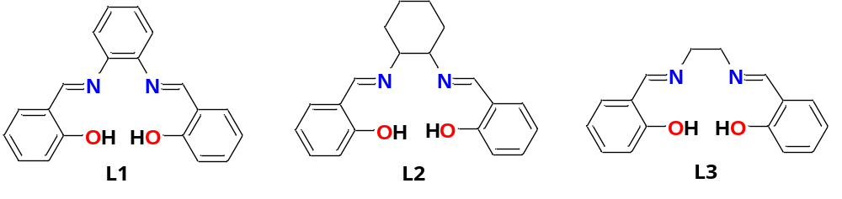
Figure S1. Molecular structures of ligands.
Handling and disposing chemicals and radioactive chemicals
All the chemicals and reagents were handled according to standard laboratory safety protocols. The compound is stored in a closed container in a cool and well-ventilated area to avoid hazardous vapour accumulations. Personal protective gears such as coats, gloves and gloves were used while handing the chemicals. The reactions are done in an isolated area. The chemical waste produced during the reactions was collected, separately stored and labelled. These were disposed following the institution safety and environmental regulations. Stock solutions containing hazardous or radioactive materials were clearly labelled with appropriate warning symbols and placed in isolated area to prevent accidental exposure and ensure proper handling.
Lifetime Analysis
The parameter values derived from the fitting study of the three unique samples at 350 nm excitation provide comprehensive insights into their decay behaviour. Sample C1 has a triple-exponential decay characterised by unique time constants τ1=1.103×10⁻¹⁰s, τ2=1.56×10⁻⁹s, and τ3=1.00×10⁻⁹s, indicating the presence of various decay mechanisms influencing its dynamics. C2 exhibits a double-exponential decline, defined by time constants τ1=1.835×10⁻¹⁰s and τ2=2.371×10⁻⁹s, mostly influenced by 𝐵1. C3 demonstrates a double-exponential decay characterised by time constants τ1=2.016×10⁻¹⁰s and τ2=2.773×10⁻⁹s, with B1as the dominant contributor.
For all of the samples, B1 is the dominant parameter as shown in Table S1.
Table S1. The Fitting-derived lifetime parameters for all the samples.
Sample name | B1 | B2 | B3
C1 | 89.55 % | 10.24% | 0.21 %
C2 | 93.94 % | 6.06 % | -
C3 | 94.45 % | 5.55% | -

Quantum yield may show some variation with different excitation wavelengths, as other excitation wavelengths will excite different electronic states. So, there are the chances of non-radiative processes, i.e. internal conversion, where energy transfer is different with excitation energy.
According to the absorption spectra, C2 and C3 exhibit stronger absorption around 335nm, corresponding to higher emission intensity upon excitation. This shows that the excitation in this region provides a more effective energy absorption and emission conversion pathway for these complexes. If we keep the excitation wavelength at longer wavelengths, i.e. above 400 nm, it will provide lower energy absorption, which may offer lower fluorescence yield. If we keep excitation wavelengths at shorter wavelengths, i.e. below 300 nm, it may cause non-radiative decay and photobleaching because of exciting other transitions that don't fluoresce efficiently.
IR Studies
FTIR Spectra of Ligands.

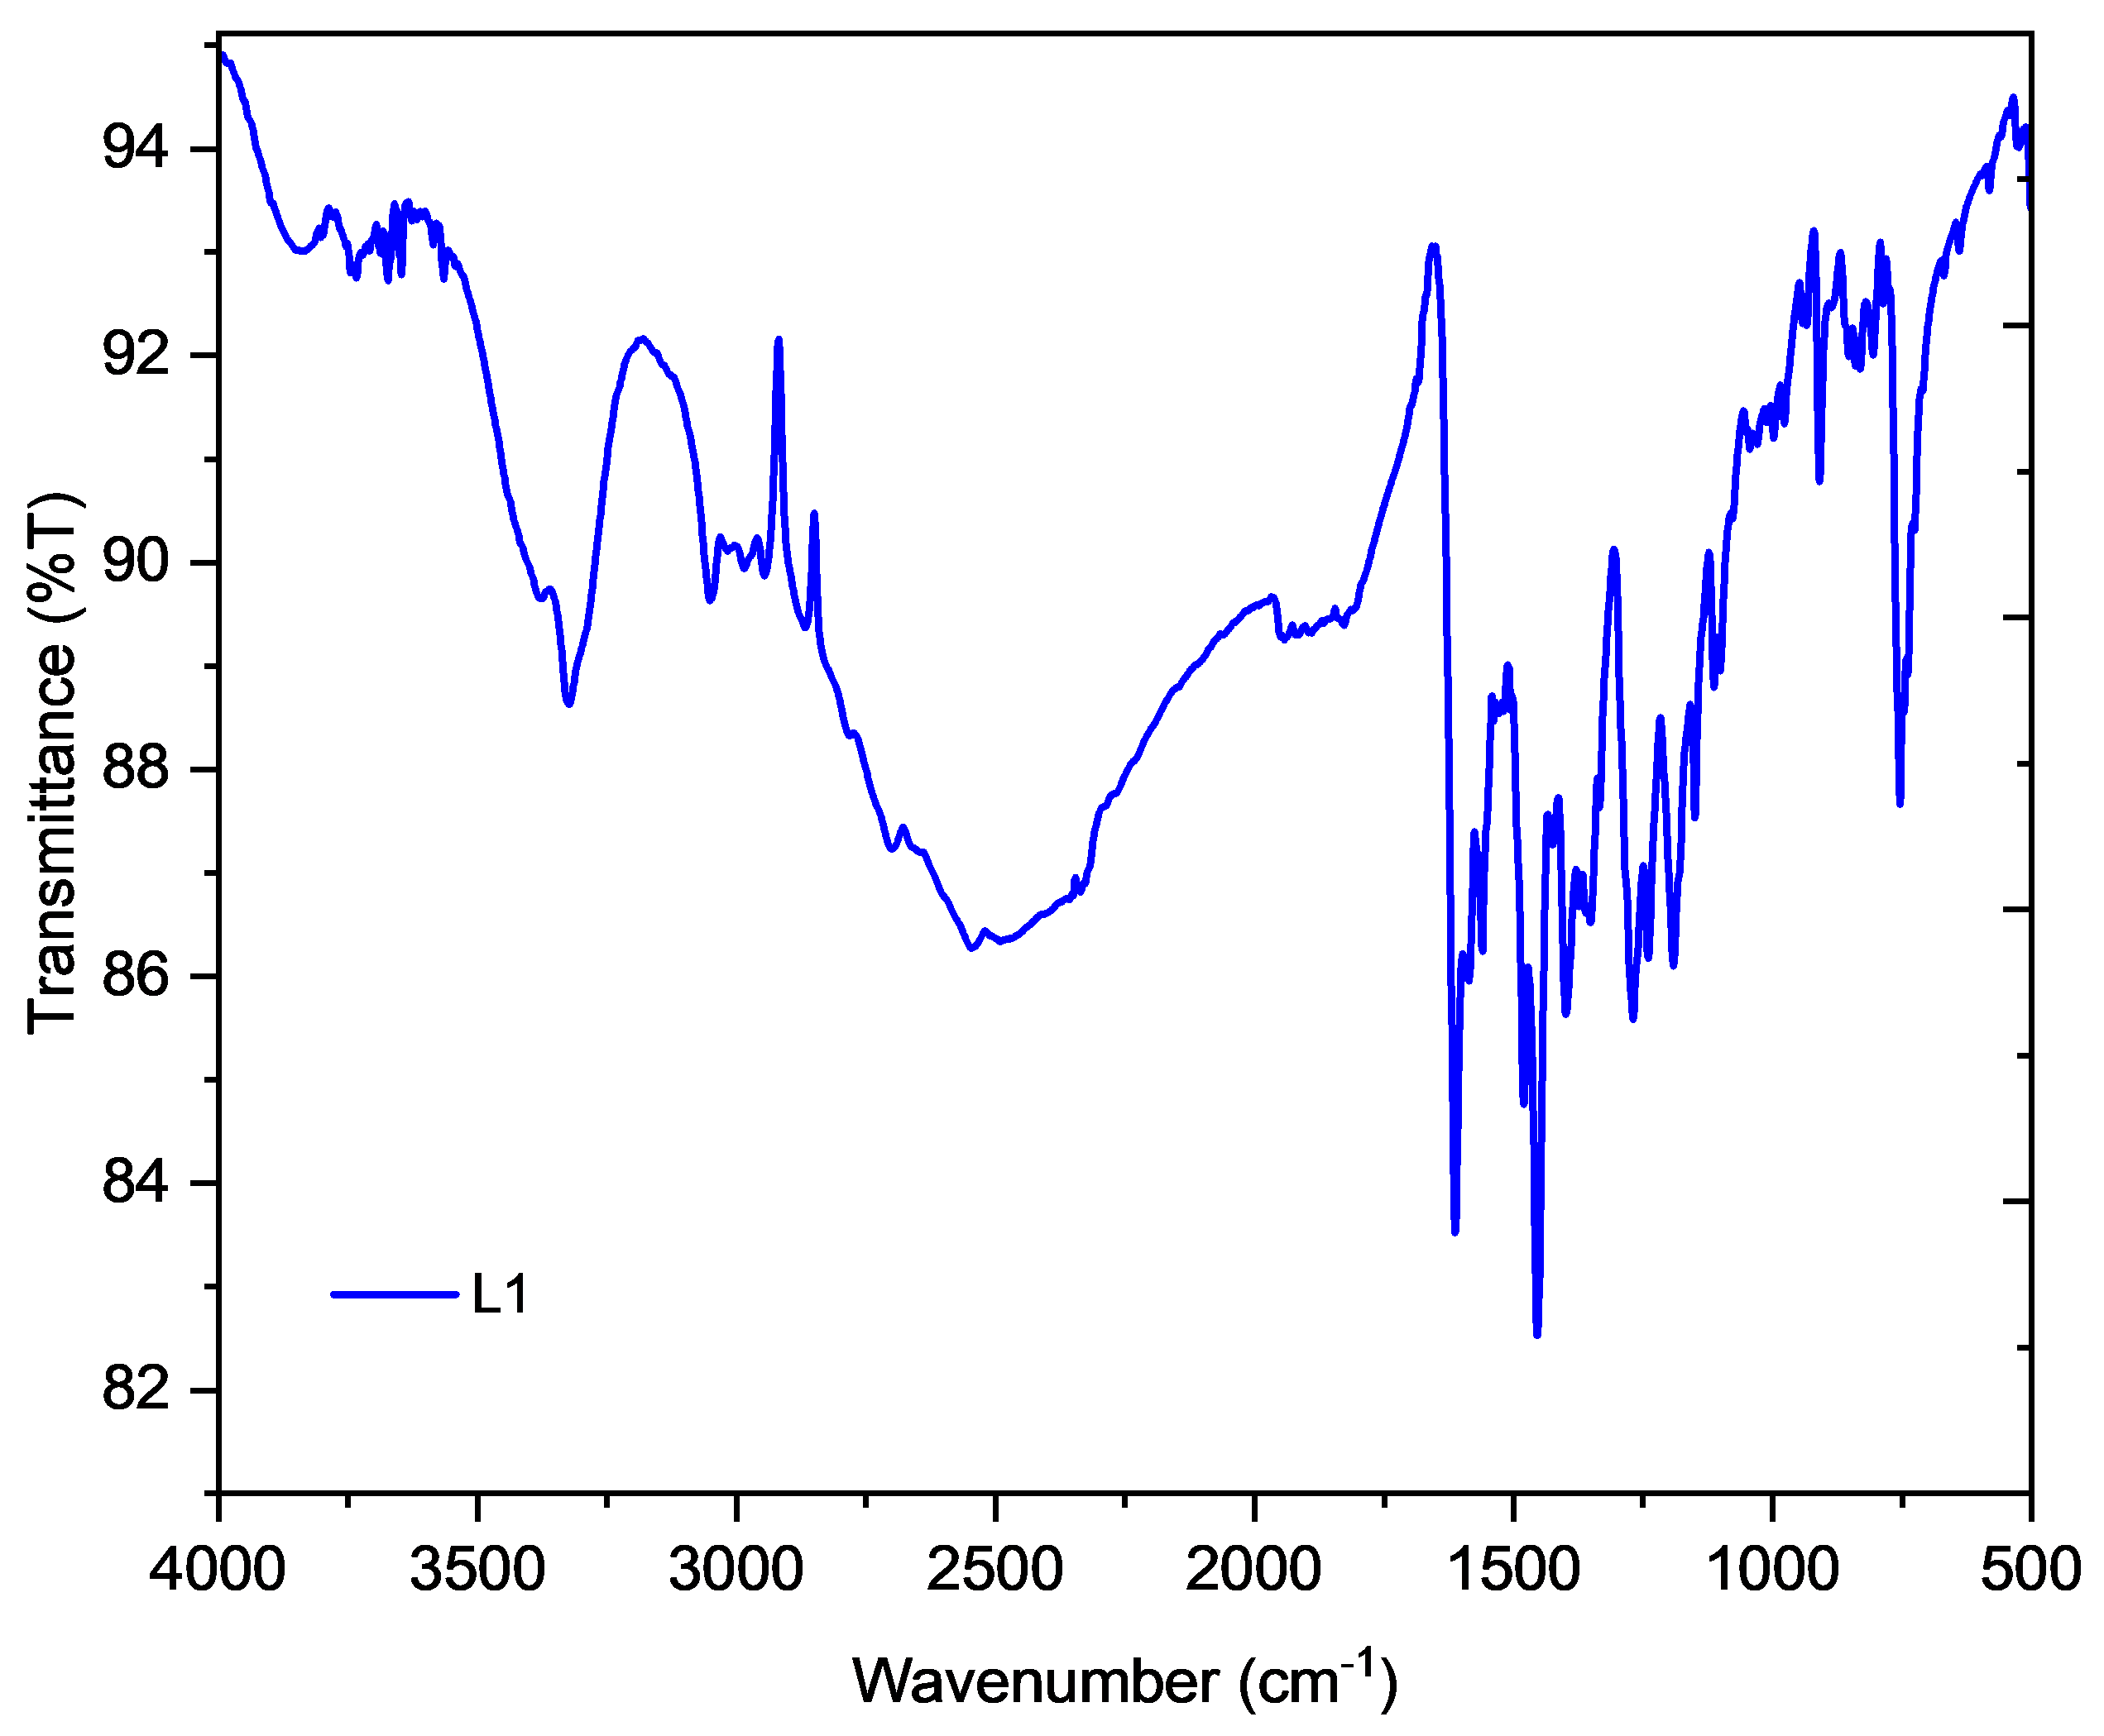
Figure S2. IR spectrum of ligand L1.
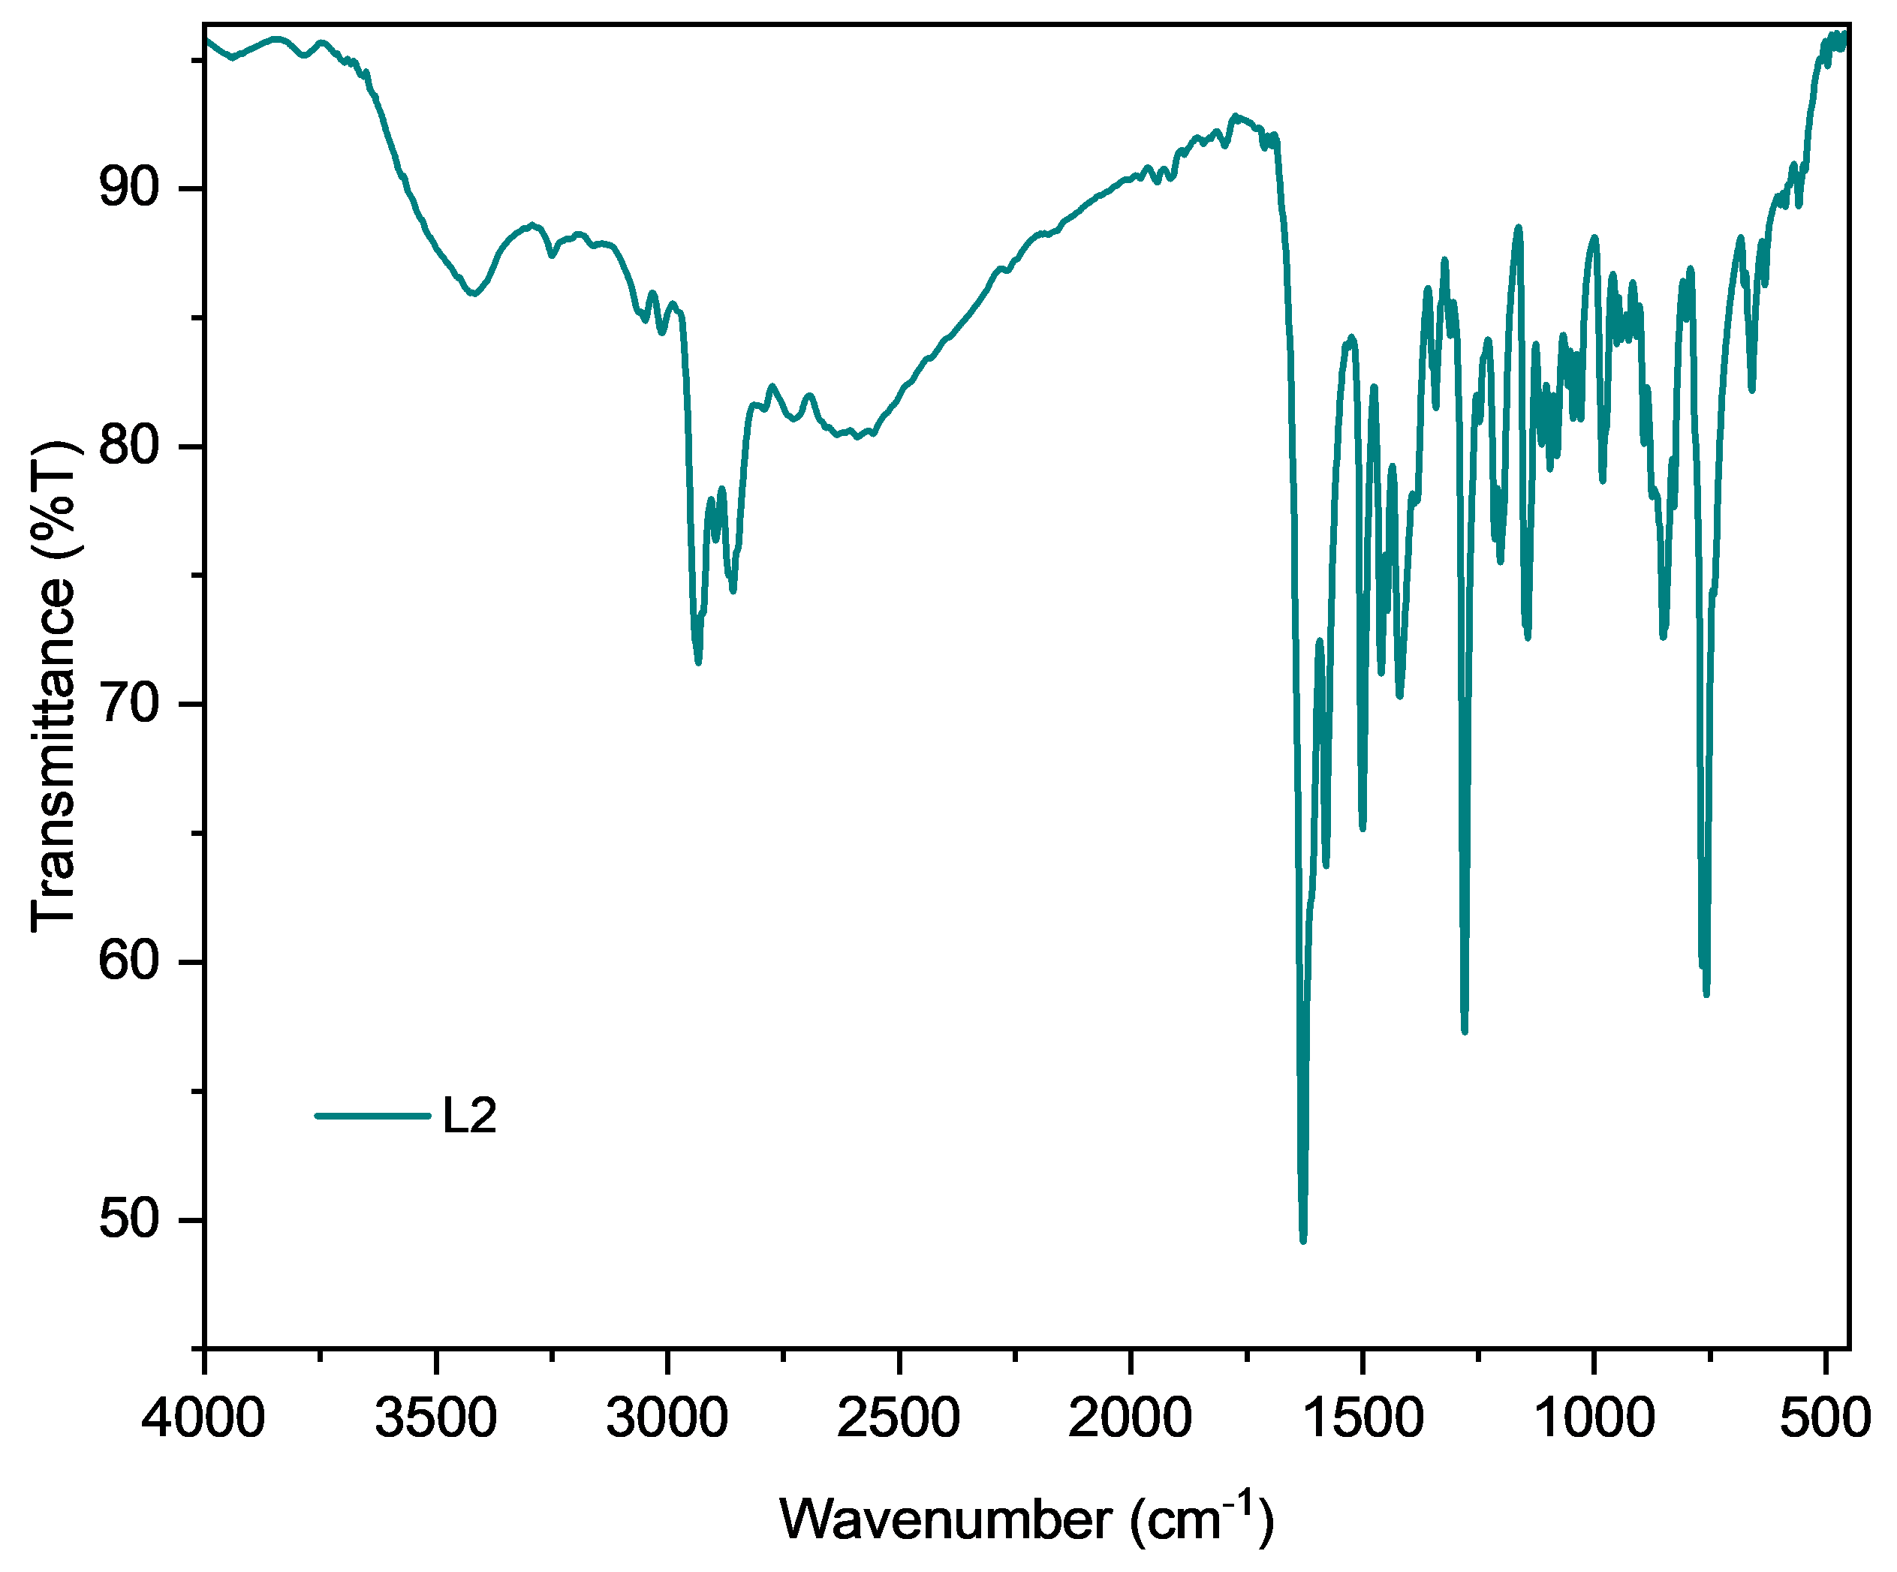
Figure S3. IR spectrum of ligand L2.
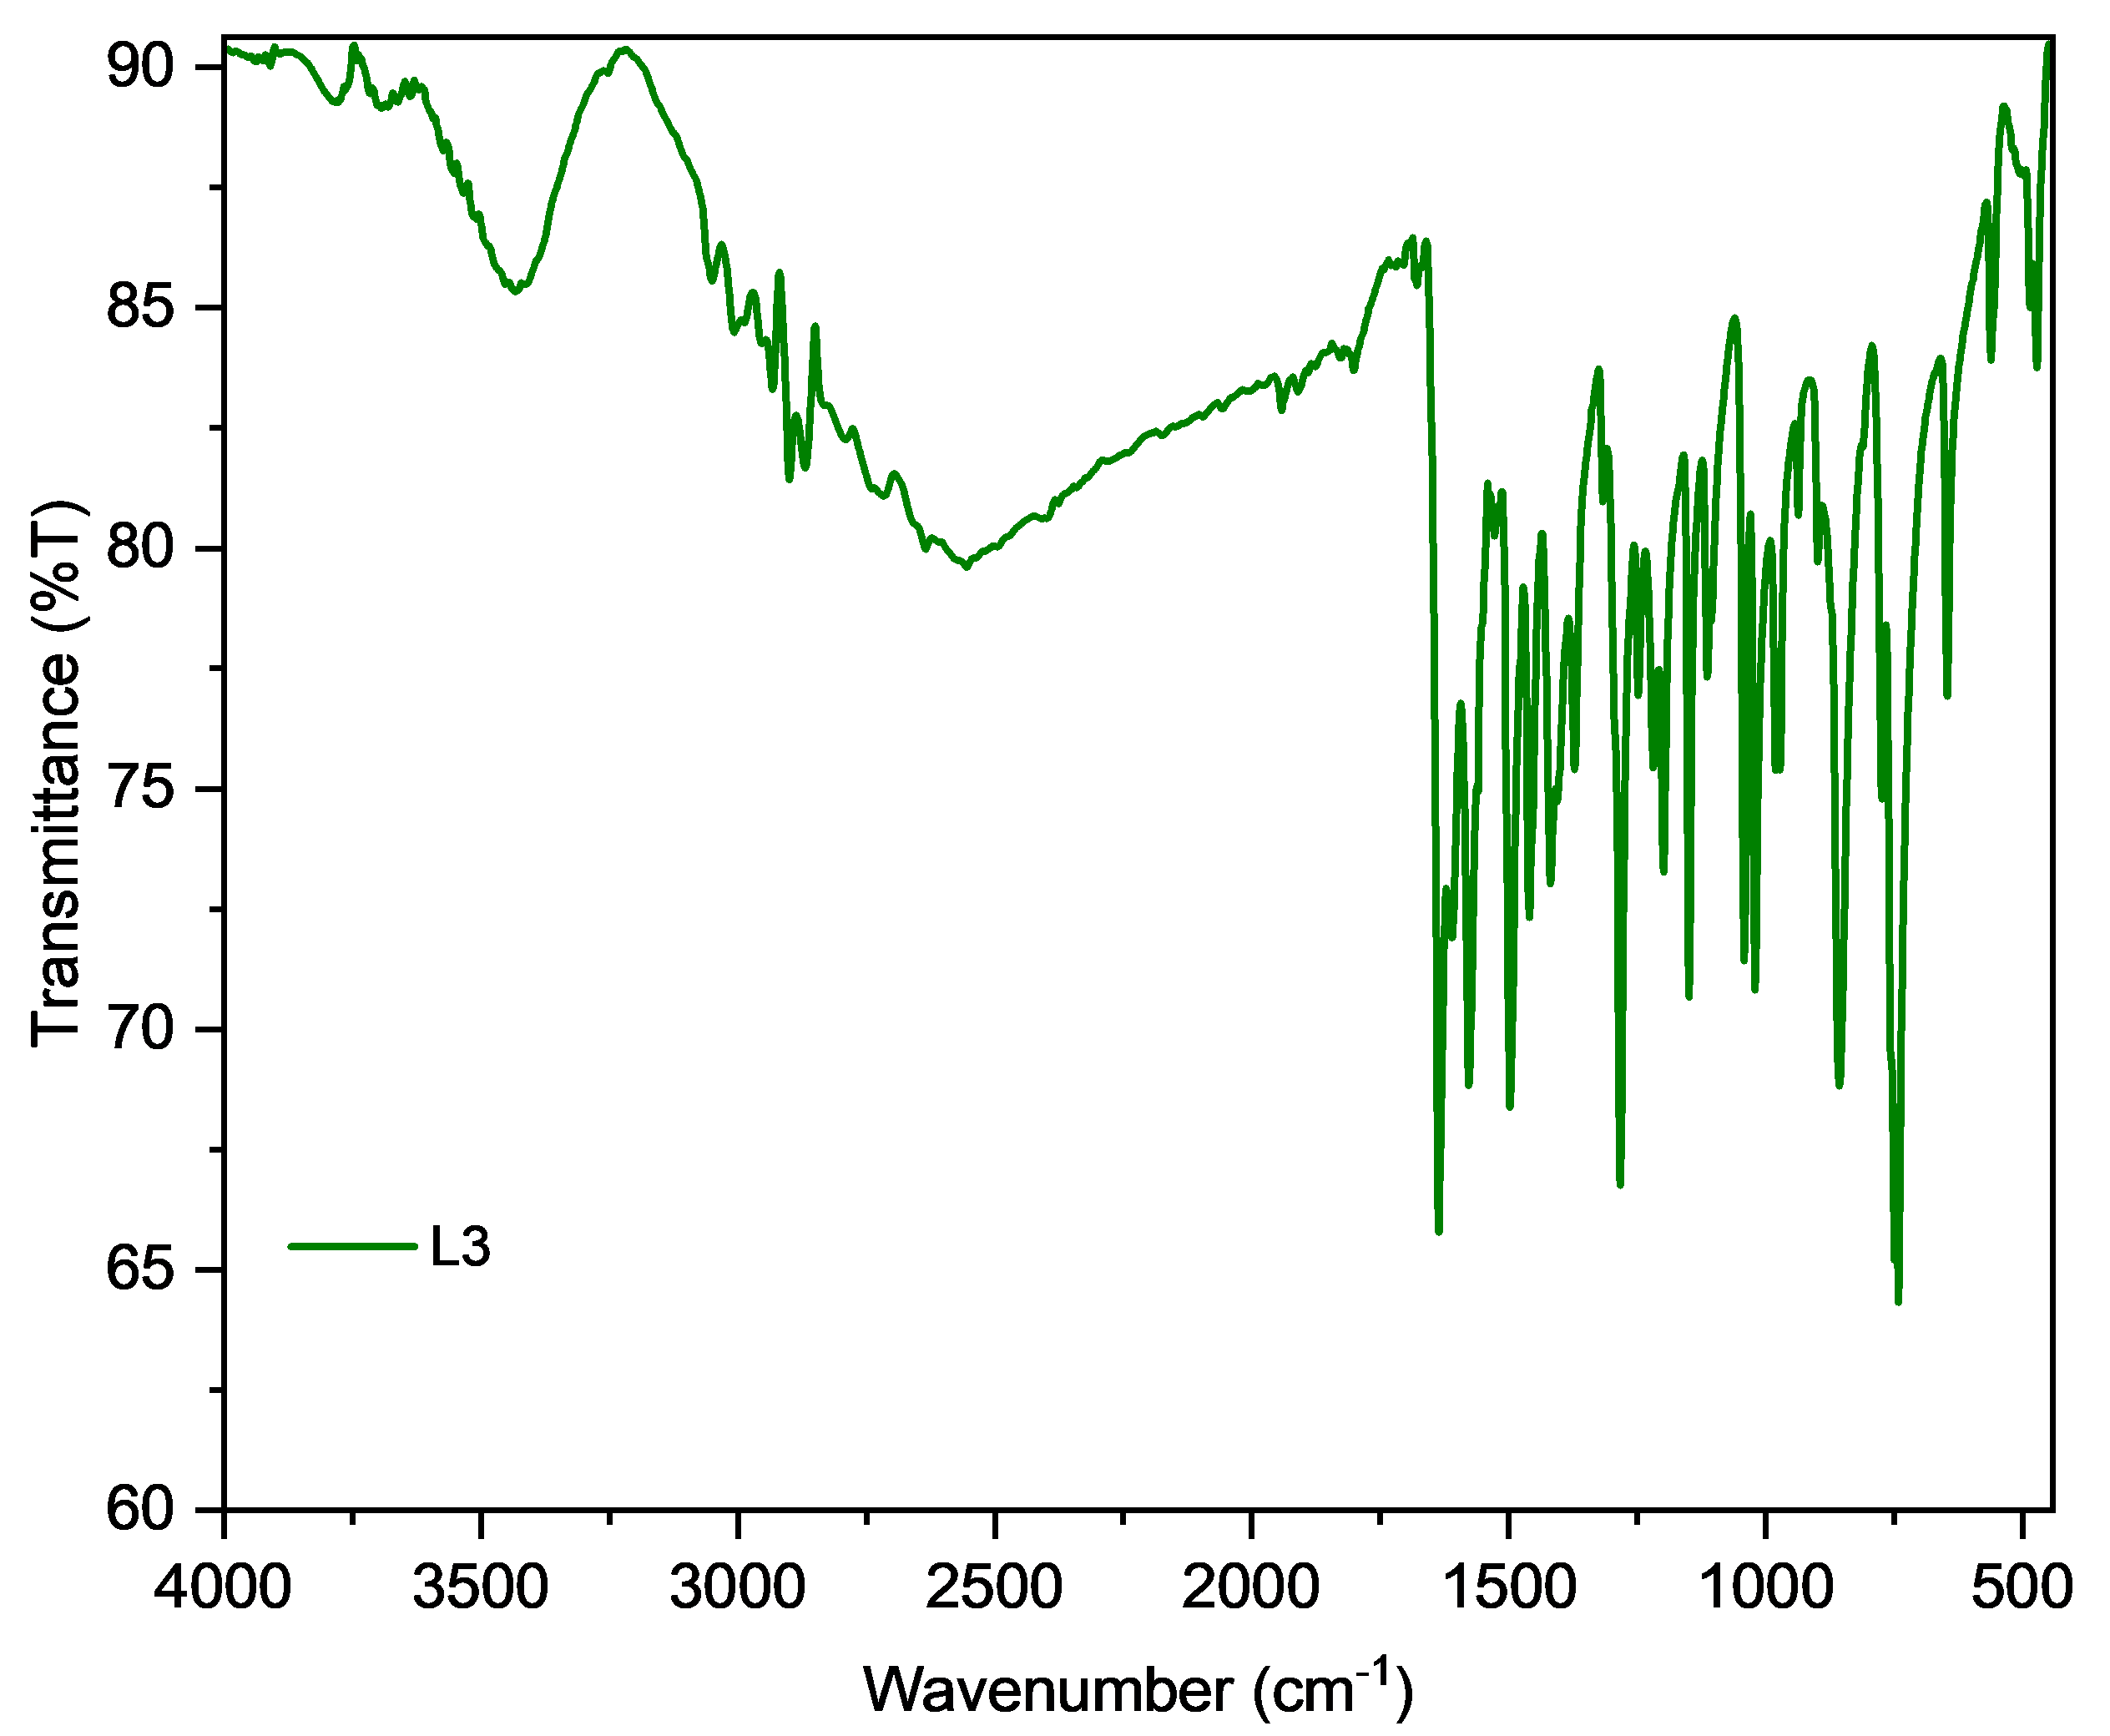
Figure S4. IR spectrum of ligand L3.
FTIR Spectra of Uranyl Complexes

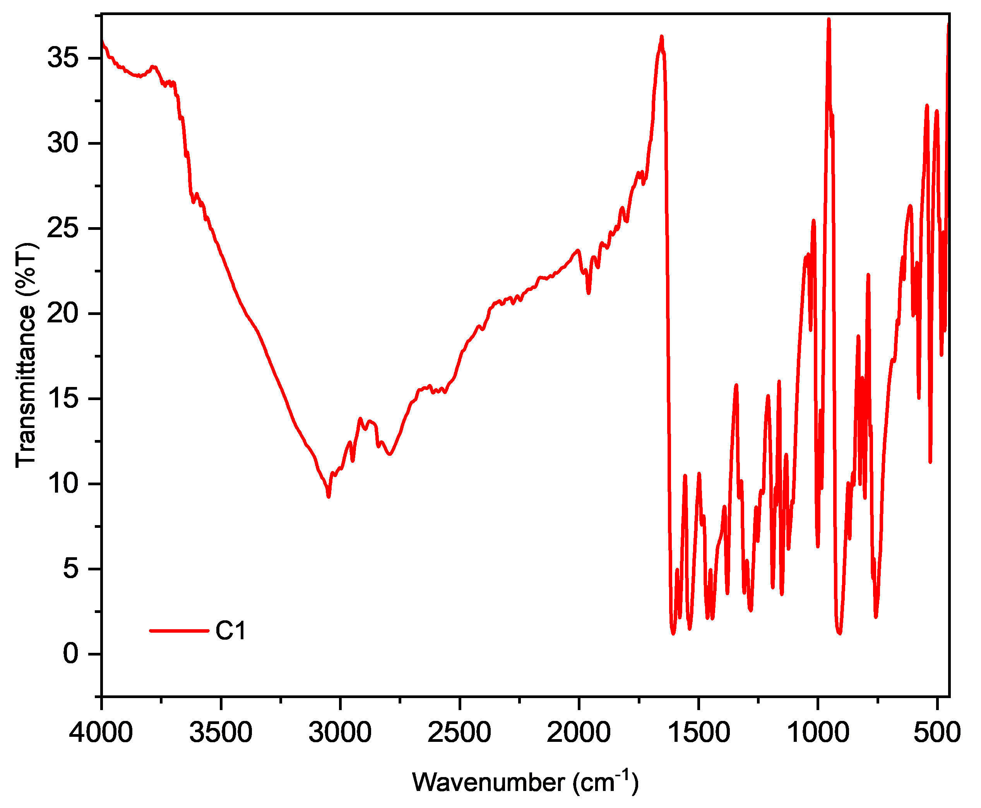
Figure S5. IR spectrum of uranyl complex C1.
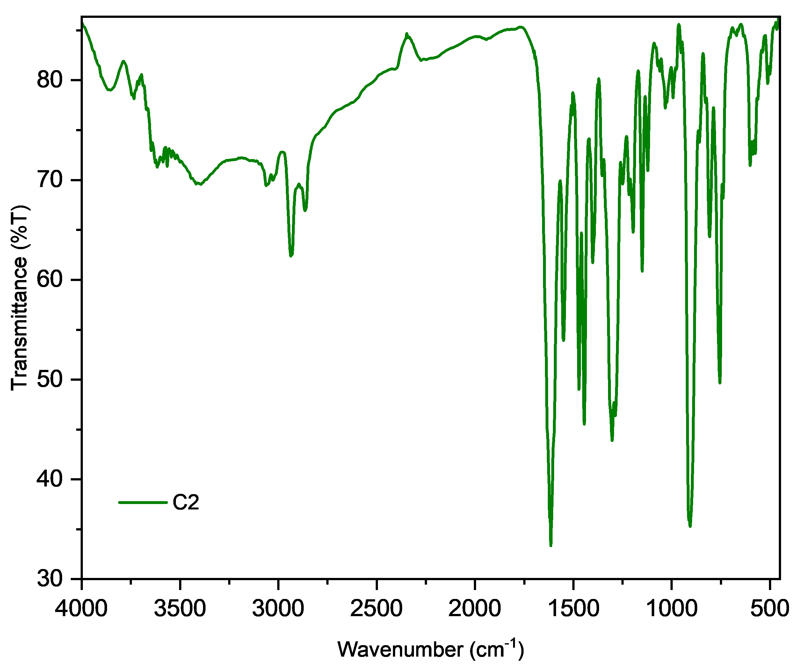
Figure S6. IR spectrum of uranyl complex C2.

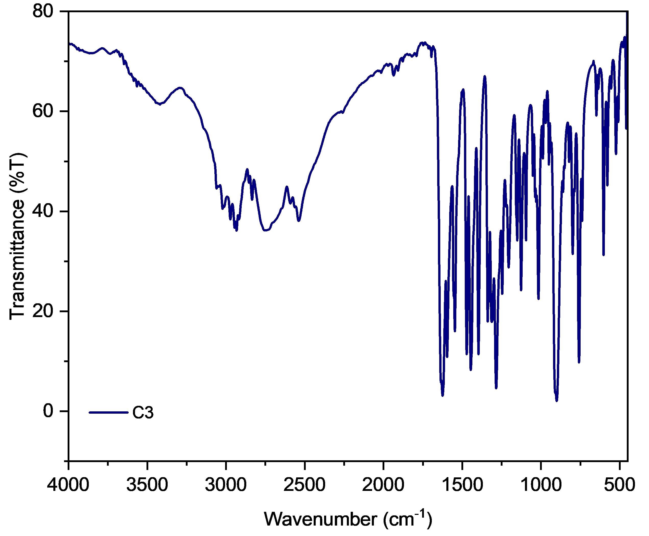
Figure S7. IR spectrum of uranyl complex C3.
UV-Vis Studies of Ligand

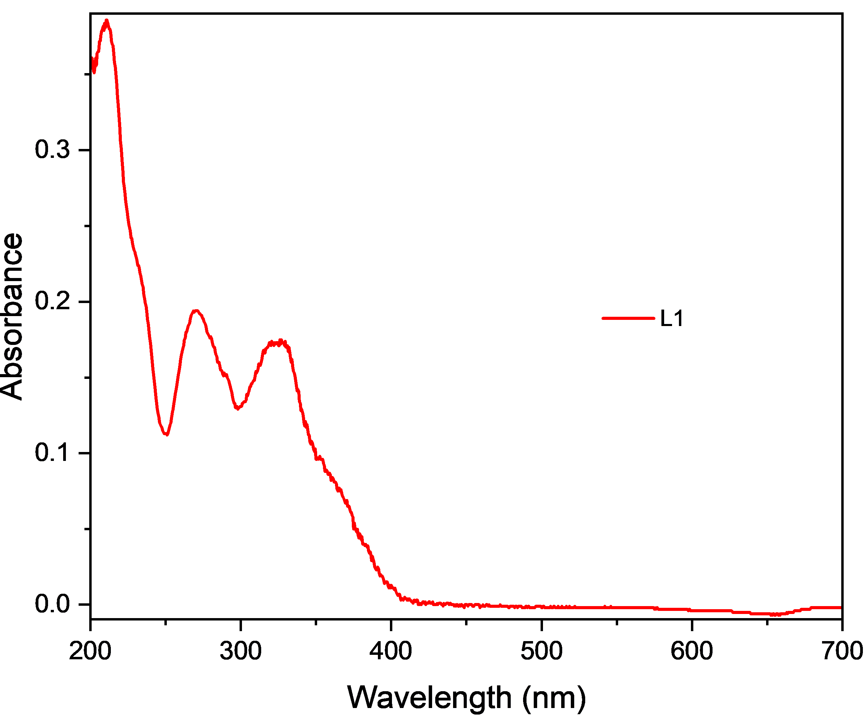
Figure S8. UV-Vis spectrum of Ligand L1.
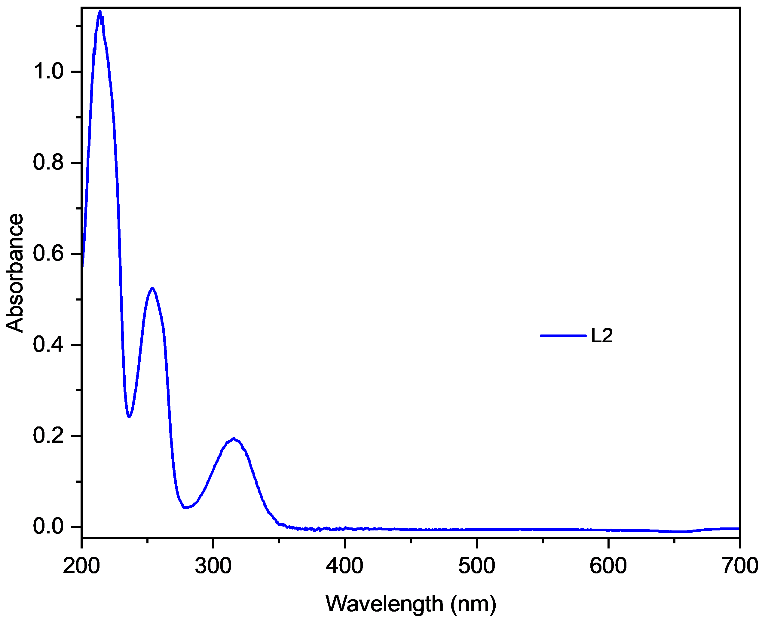
Figure S9. UV-Vis spectrum of Ligand L2.
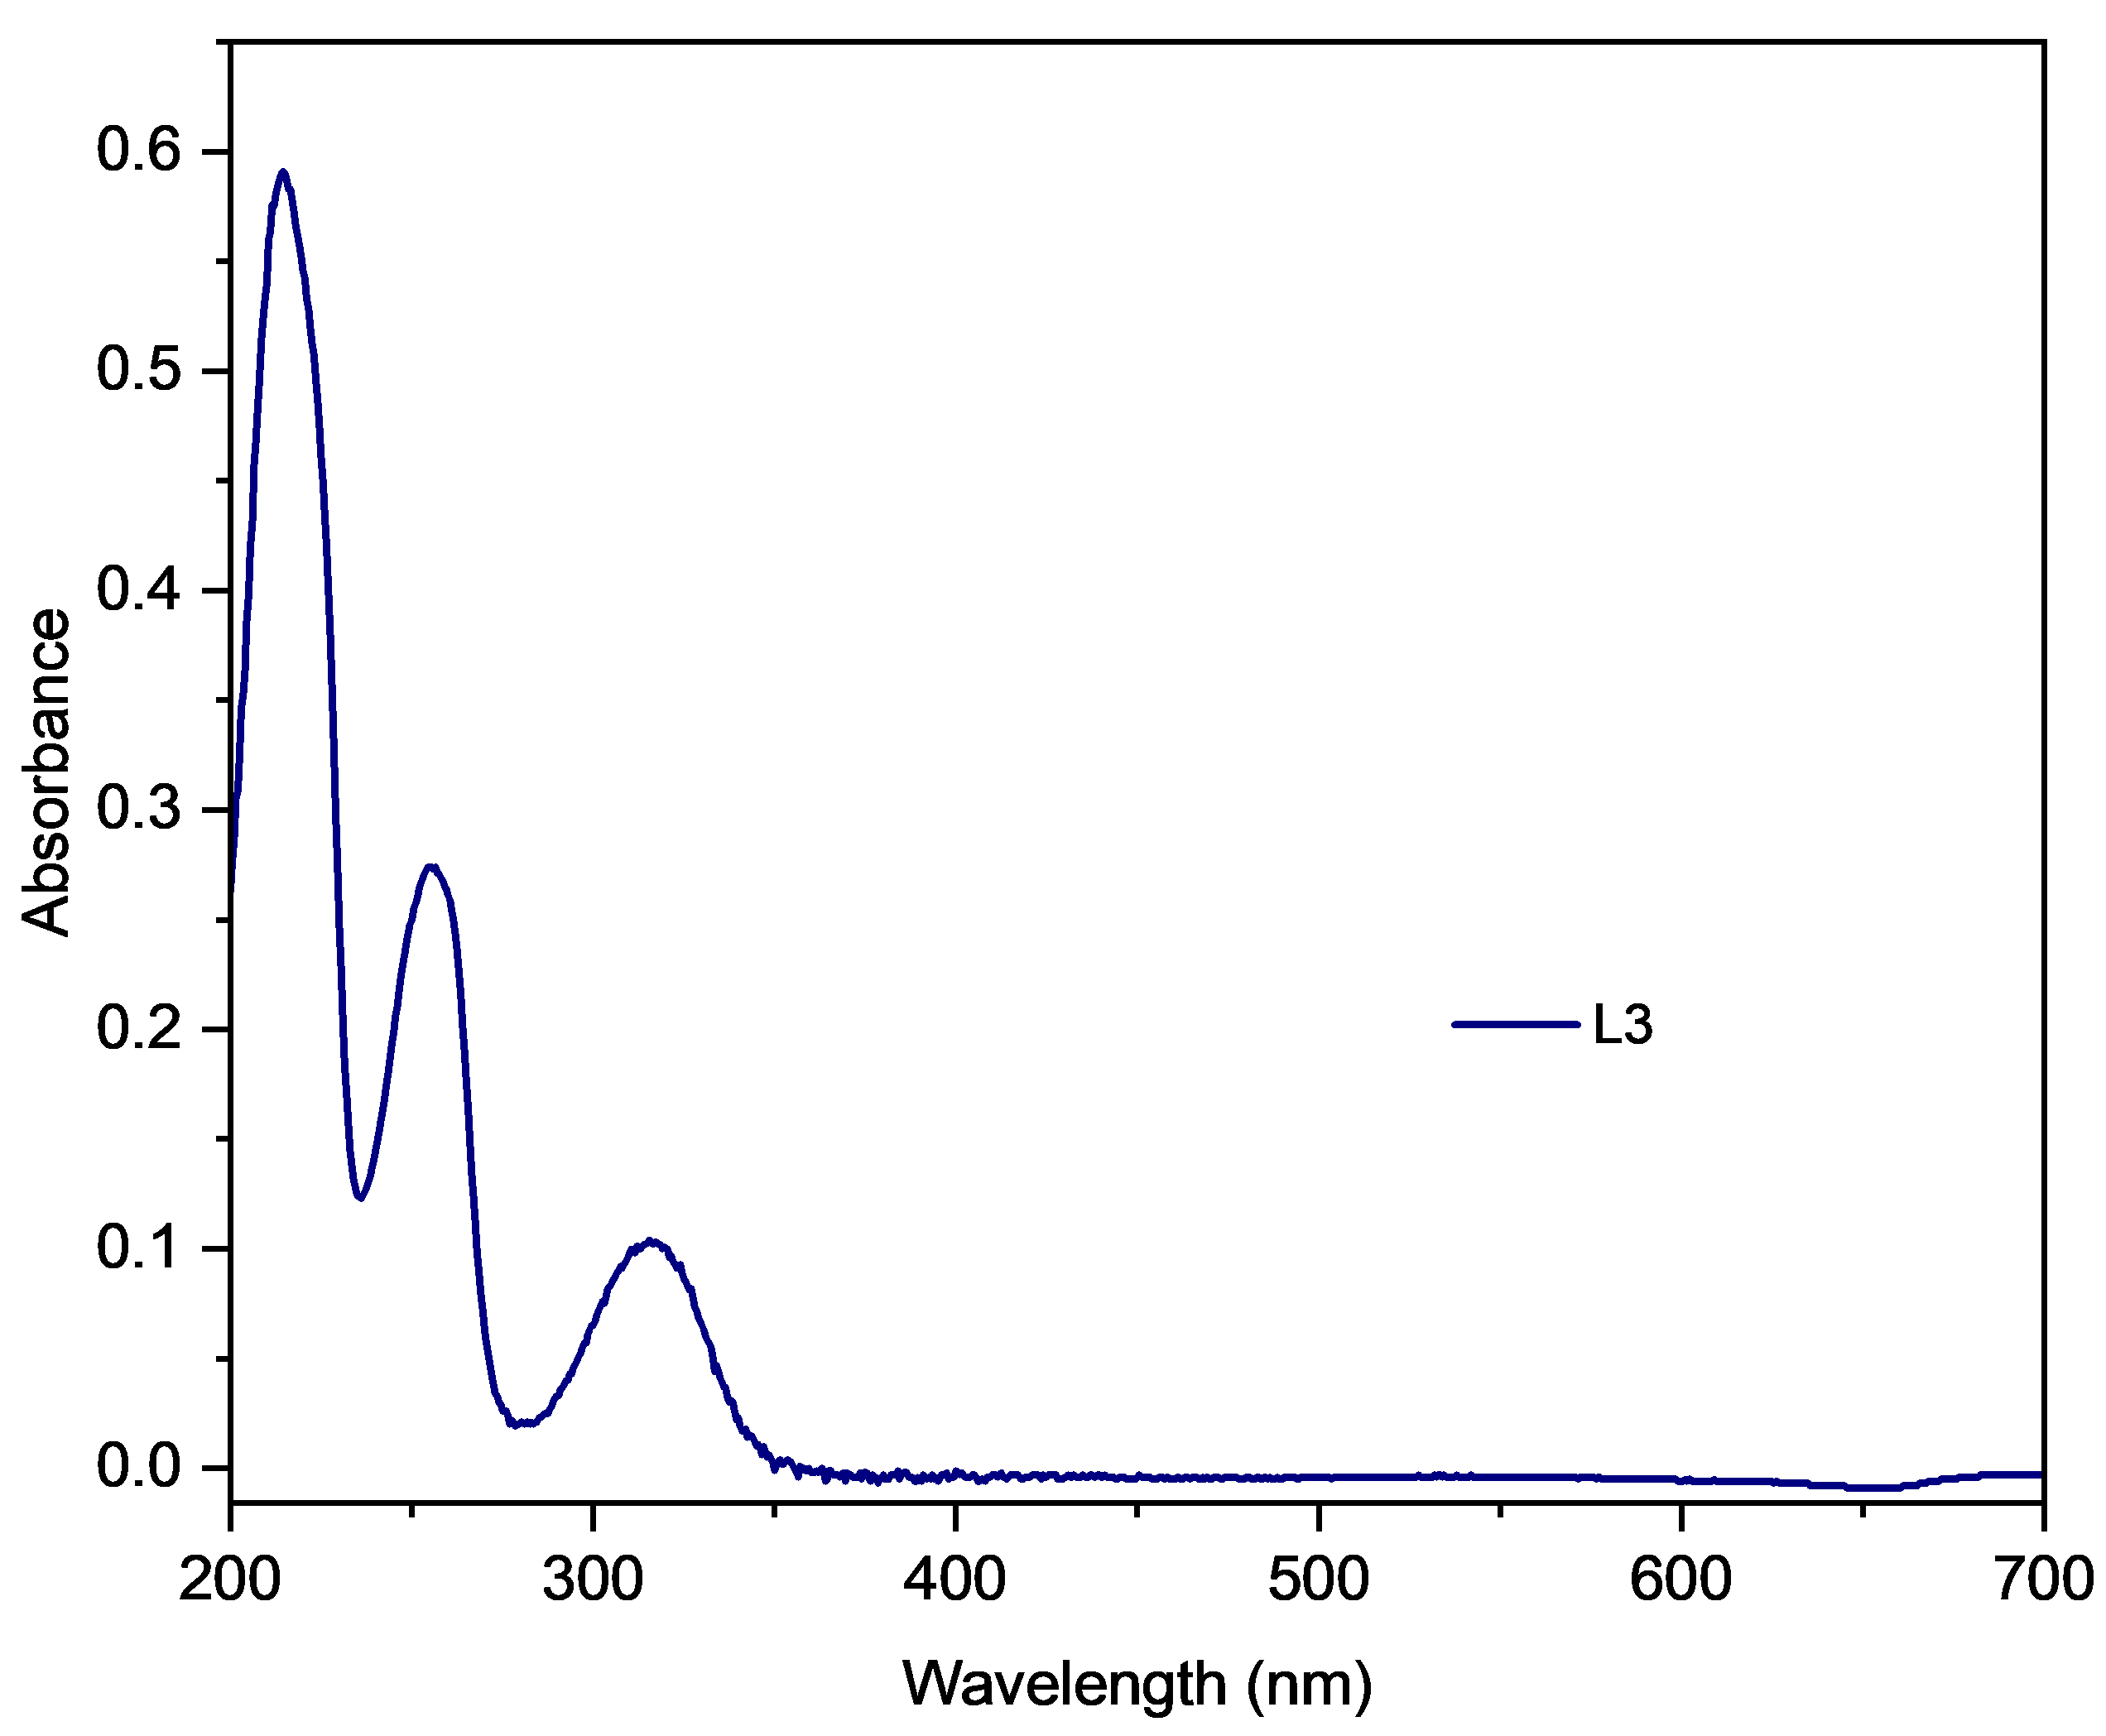
Figure S10. UV-Vis spectrum of Ligand L3.

UV-Vis Studies of Complexes.

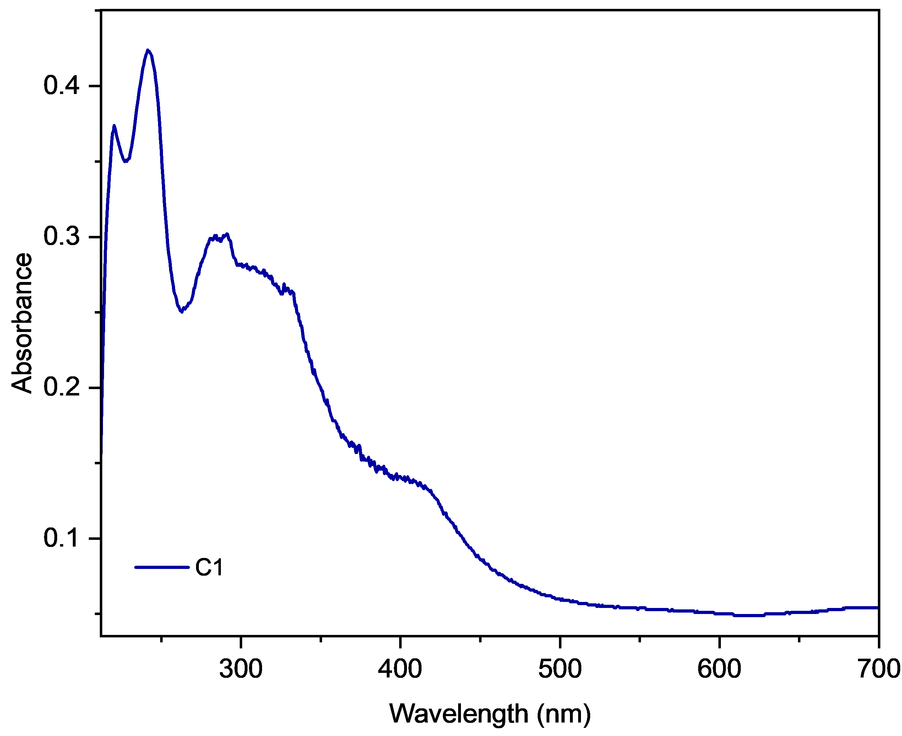
Figure S11. UV-Vis spectrum of Complex C1.
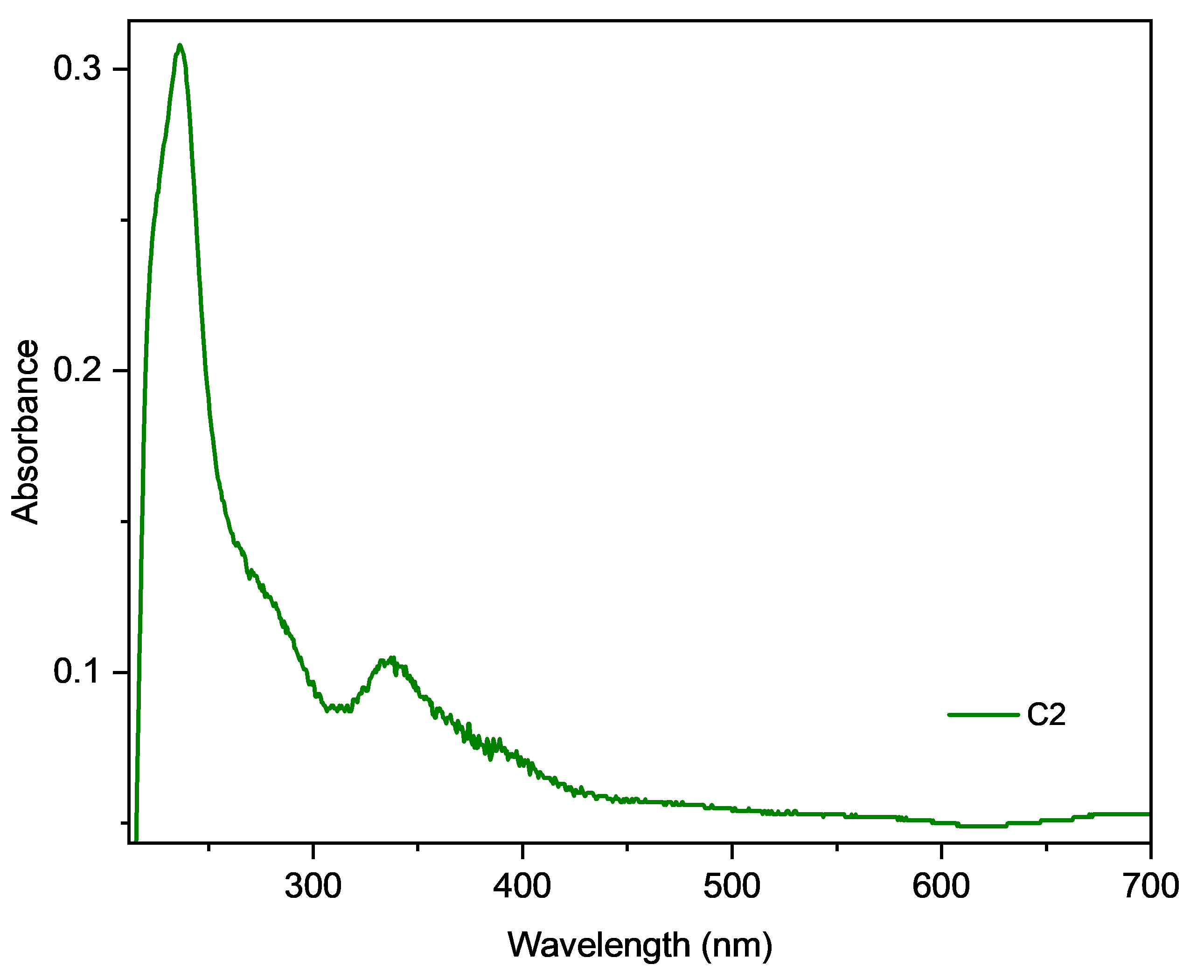
Figure S12. UV-Vis spectrum of Complex C2.

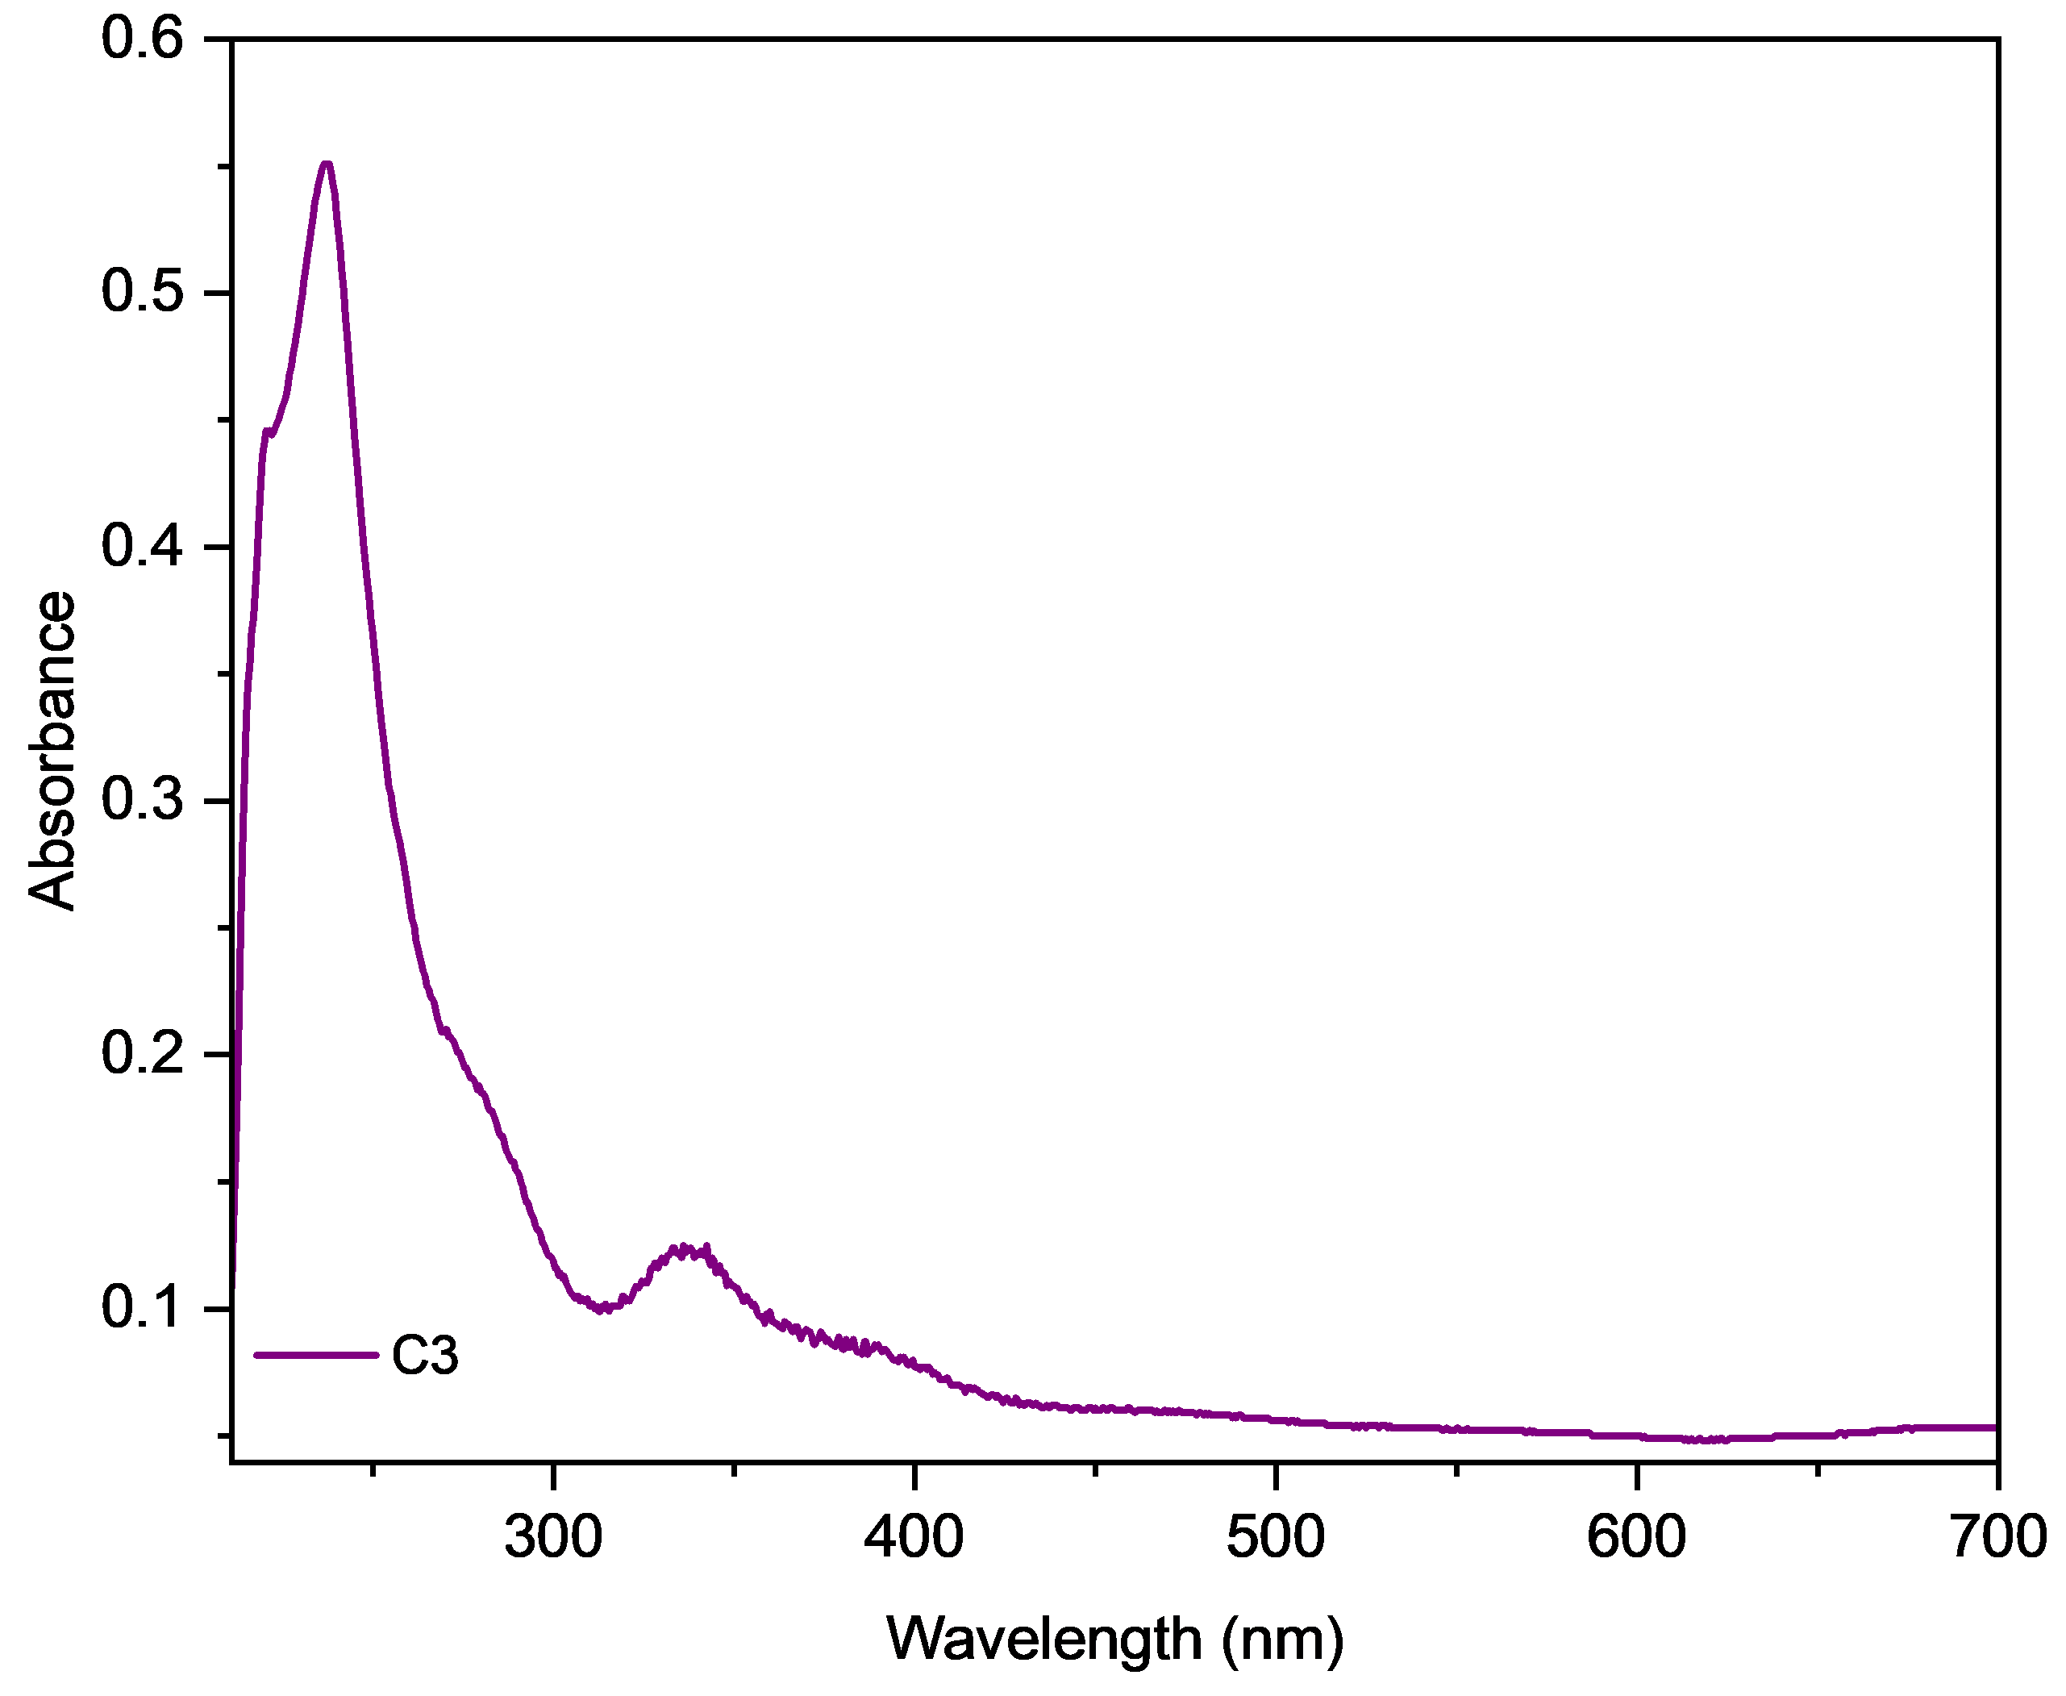
Figure S13. UV-Vis spectrum of Complex C3.

Fluorescence spectra, CIE and Fluorescence lifetime decay.

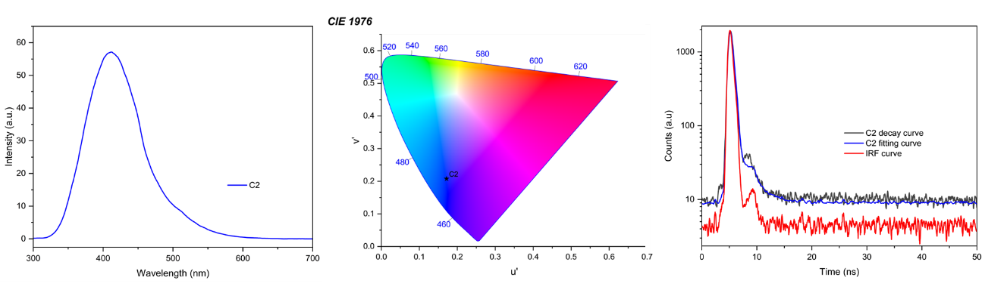
Figure S14. Fluorescence spectra, CIE and Fluorescence lifetime decay of complex C2.

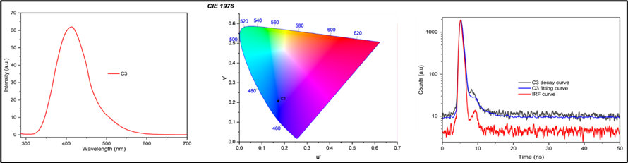
Figure S15. Fluorescence spectra, CIE and Fluorescence lifetime decay of complex C3.

Tauc Plots
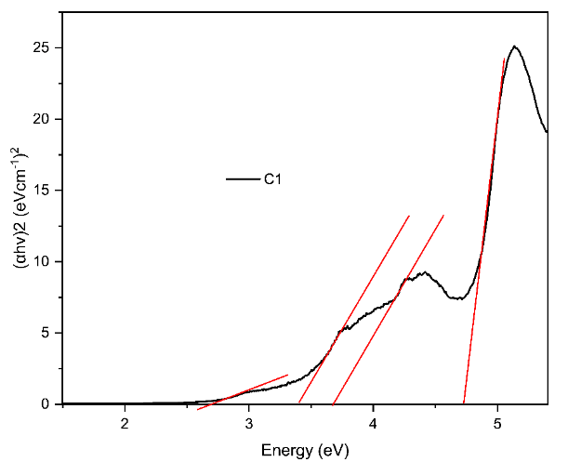
Figure S16. Tauc plot of complex C1.
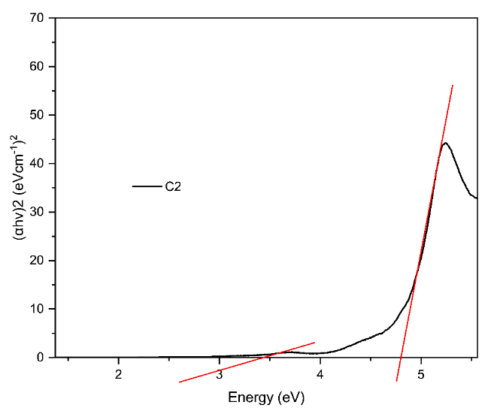
Figure S17. Tauc plot of complex C2.
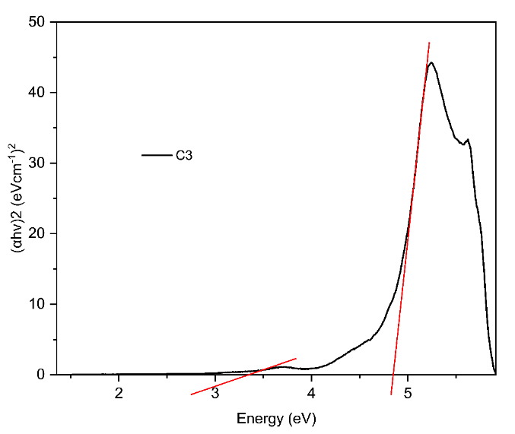
Figure S18. Tauc plot of complex C3.

NMR Studies

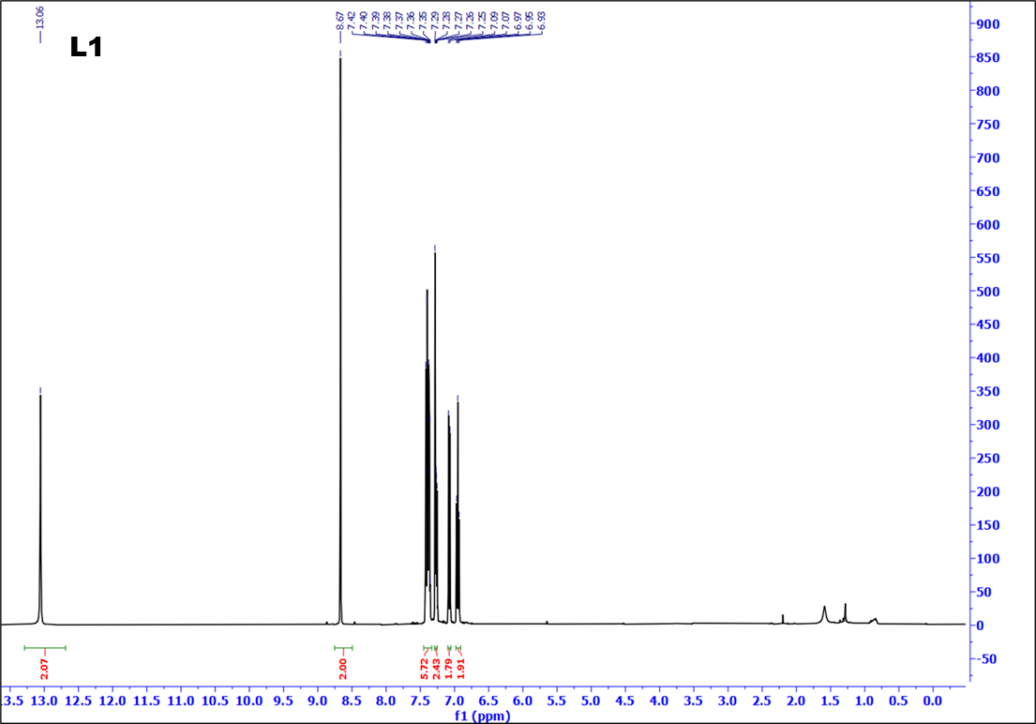
Figure S19. ¹H spectrum of Ligand L1
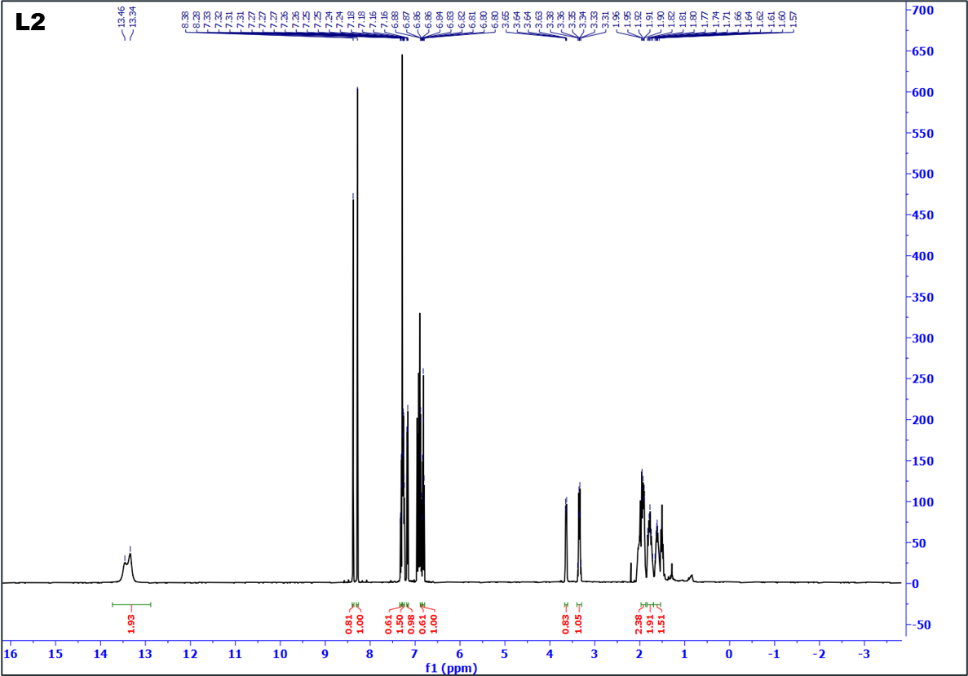
Figure S20.¹H spectrum of Ligand L2

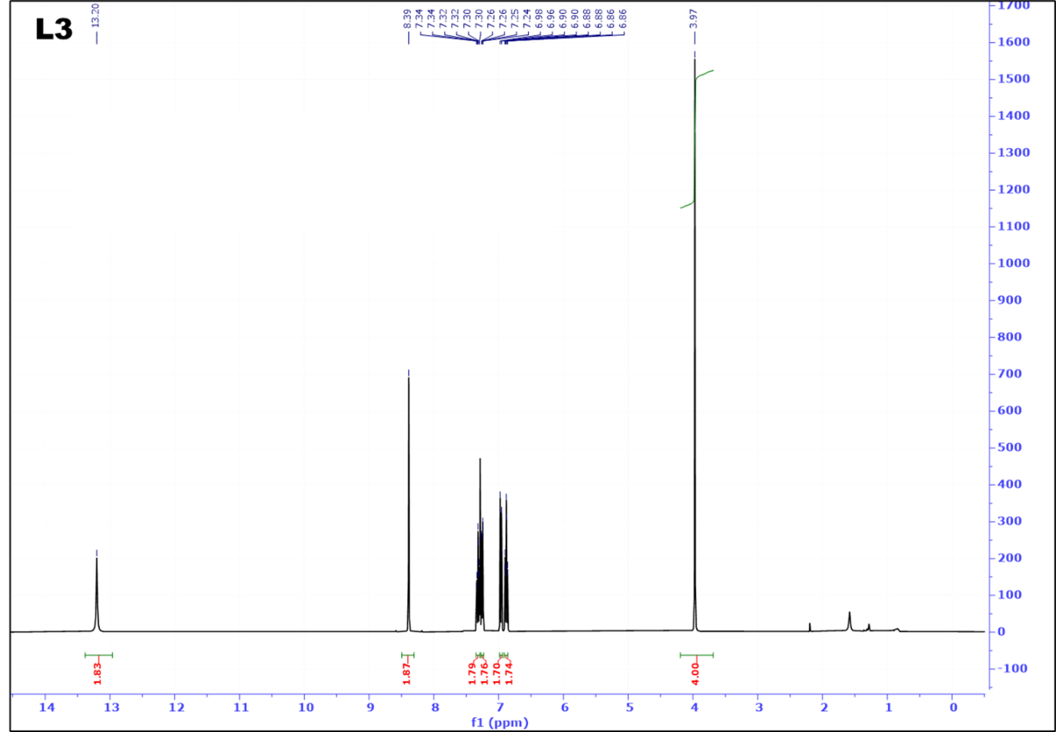
Figure S21. ¹H spectrum of Ligand L3.

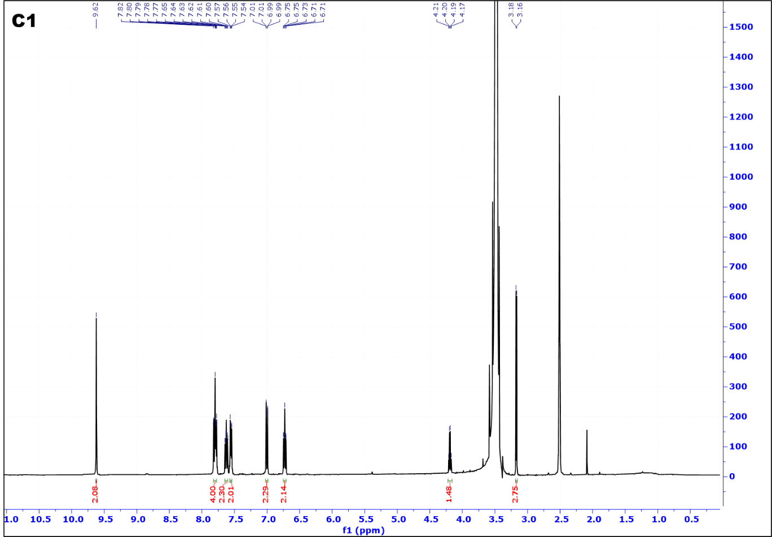
Figure S22. ¹H spectrum of Complex C1.
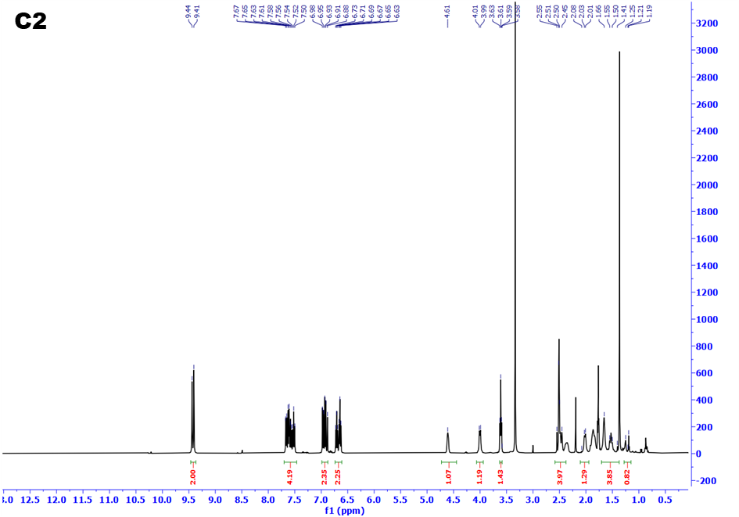
Figure S23. ¹H spectrum of Complex C2.

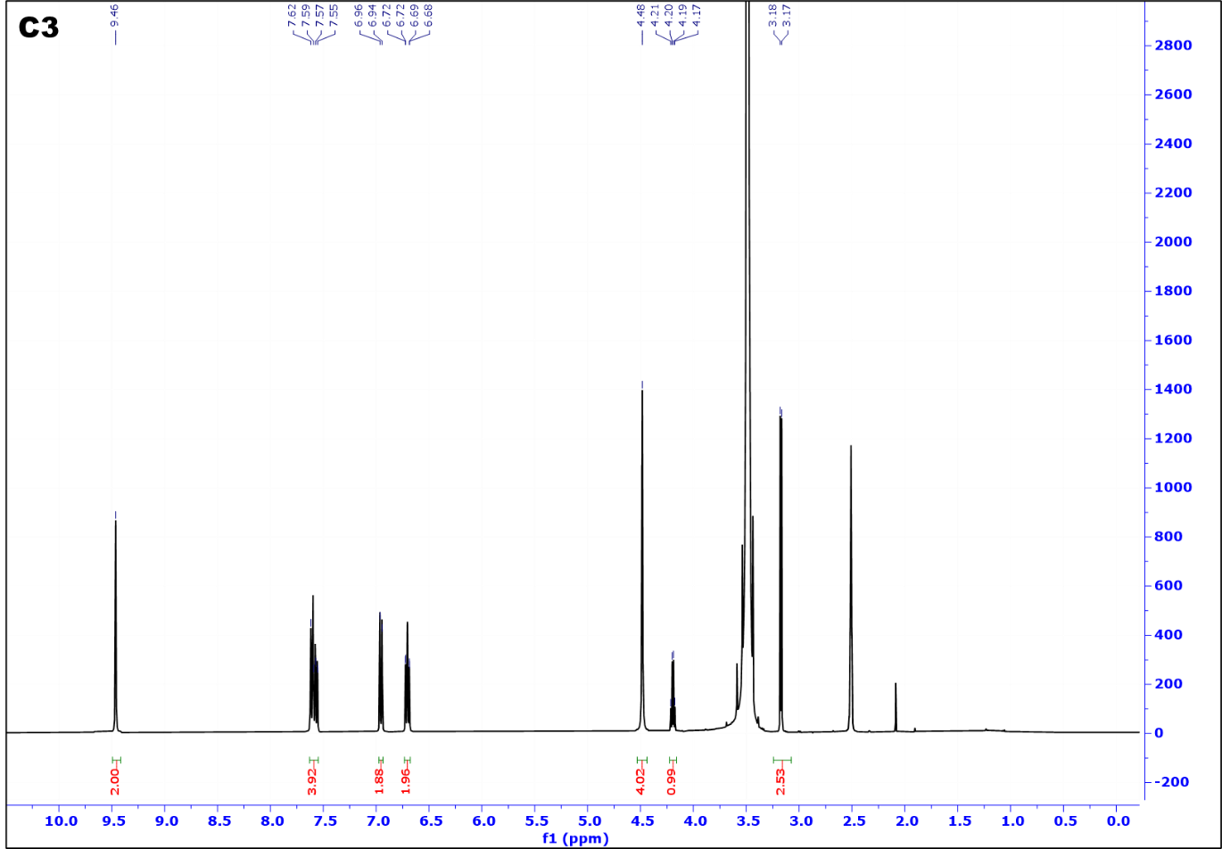
Figure S24. ¹H spectrum of complex C3.

TGA
Figure S25. TG curve of the complexes.

Single Crystal X-Ray Diffraction Data for Complex C1

Table S2. Crystal data and structure refinement for C1.
Identification code | C1
Empirical formula | C₂₁H₁₈N₂O₅U
Formula weight | 616.40
Temperature/K | 150(2)
Crystal system | tetragonal
Space group | P4₁
a/Å | 9.95440(10)
b/Å | 9.95440(10)
c/Å | 38.5557(10)
α/° | 90
β/° | 90
γ/° | 90
Volume/Å³ | 3820.49(13)
Z | 8
ρ_{calc}g/cm³ | 2.143
μ/mm⁻¹ | 8.534
F(000) | 2320.0
Crystal size/mm³ | 0.275 × 0.123 × 0.095
Radiation | MoKα (λ = 0.71073)
2Θ range for data collection/° | 2.112 to 57.868
Index ranges | -13 ≤ h ≤ 13, -13 ≤ k ≤ 13, -52 ≤ l ≤ 50
Reflections collected | 71846
Independent reflections | 10046 [R_{int} = 0.0595, R_{sigma} = 0.0458]
Data/restraints/parameters | 10046/647/492
Goodness-of-fit on F² | 1.044
Final R indexes [I>=2σ (I)] | R₁ = 0.0266, wR₂ = 0.0510
Final R indexes [all data] | R₁ = 0.0276, wR₂ = 0.0513
Largest diff. peak/hole / e Å⁻³ | 1.12/-0.80
Flack parameter | 0.011(4)

Table S3. Fractional Atomic Coordinates (×10⁴) and Equivalent Isotropic Displacement Parameters (Å²×10³) for C1. U_{eq} is defined as 1/3 of the trace of the orthogonalised U_{IJ} tensor.
Atom | x | y | z | U(eq)
U1_1 | 5485.9(3) | 878.6(3) | 4303.8(2) | 12.04(8)
O1_1 | 6911(6) | 348(7) | 4748.7(19) | 19.4(17)
C2_1 | 8241(9) | 231(10) | 4755(3) | 18(2)
C3_1 | 8860(10) | -817(11) | 4929(3) | 24(2)
C4_1 | 10240(11) | -878(13) | 4959(3) | 30(3)
C5_1 | 11041(11) | 99(12) | 4811(3) | 26(2)
C6_1 | 10464(9) | 1142(11) | 4637(3) | 22(2)
C7_1 | 9046(9) | 1237(10) | 4608(3) | 21(2)
C8_1 | 8550(10) | 2451(10) | 4448(3) | 20(2)
N9_1 | 7304(7) | 2668(7) | 4352(2) | 13.8(6)
C10_1 | 6968(9) | 3967(9) | 4237(2) | 13.8(6)
C11_1 | 7536(9) | 5160(8) | 4363(2) | 13.8(6)
C12_1 | 7125(11) | 6388(10) | 4224(2) | 21(2)
C13_1 | 6154(11) | 6446(9) | 3969(3) | 20(2)
C14_1 | 5588(11) | 5279(9) | 3850(3) | 20(2)
C15_1 | 5993(9) | 4037(8) | 3973(2) | 13.8(6)
N16_1 | 5460(8) | 2781(7) | 3865(2) | 15.7(18)
C17_1 | 5164(10) | 2640(9) | 3540(3) | 16(2)
C18_1 | 4497(10) | 1522(10) | 3387(3) | 18(2)
C19_1 | 4449(12) | 1438(11) | 3020(3) | 23(2)
C20_1 | 3741(10) | 474(10) | 2854(3) | 24(2)
C21_1 | 3008(10) | -454(11) | 3045(3) | 23(2)
C22_1 | 3046(10) | -434(10) | 3404(3) | 21(2)
C23_1 | 3780(9) | 535(9) | 3587(3) | 15(2)
O24_1 | 3789(7) | 597(7) | 3929(2) | 18.9(16)
O25_1 | 4493(7) | -1164(7) | 4550(2) | 18.2(17)
C26_1 | 3525(10) | -2048(11) | 4400(3) | 21(3)
O27_1 | 4490(7) | 1827(7) | 4600.9(19) | 18.5(16)
O28_1 | 6517(7) | -45(7) | 4015.7(19) | 19.3(16)
U1_2 | 9690.5(3) | 6014.0(3) | 3196.4(2) | 12.02(8)
O1_2 | 8229(6) | 5793(7) | 2737.5(19) | 17.1(16)
C2_2 | 6876(9) | 5719(10) | 2752(3) | 15(2)
C3_2 | 6189(9) | 4759(10) | 2563(3) | 18(2)
C4_2 | 4801(10) | 4713(10) | 2567(3) | 18(2)
C5_2 | 4048(10) | 5594(10) | 2770(3) | 18(2)
C6_2 | 4714(9) | 6525(10) | 2966(3) | 15(2)
C7_2 | 6130(9) | 6627(9) | 2958(3) | 12.9(19)
C8_2 | 6726(9) | 7736(9) | 3142(2) | 12.7(19)
N9_2 | 7990(7) | 7927(7) | 3206(2) | 13.8(6)
C10_2 | 8417(9) | 9142(9) | 3359(2) | 13.8(6)
C11_2 | 7898(9) | 10389(9) | 3264(2) | 13.8(6)
C12_2 | 8435(11) | 11536(9) | 3409(3) | 18(2)
C13_2 | 9453(11) | 11446(9) | 3659(3) | 19(2)
C14_2 | 9936(11) | 10210(9) | 3754(3) | 18(2)
C15_2 | 9439(9) | 9050(8) | 3606(2) | 13.8(6)
N16_2 | 9898(8) | 7745(7) | 3680(2) | 13.1(17)
C17_2 | 10217(10) | 7441(10) | 3996(2) | 17(2)
C18_2 | 10834(10) | 6235(10) | 4116(3) | 17(2)
C19_2 | 10916(11) | 6014(11) | 4480(3) | 22(2)
C20_2 | 11643(11) | 4971(11) | 4605(3) | 30(3)
C21_2 | 12297(10) | 4098(11) | 4387(3) | 31(2)
C22_2 | 12199(10) | 4239(11) | 4032(3) | 24(2)
C23_2 | 11471(9) | 5293(9) | 3885(3) | 18(2)
O24_2 | 11400(7) | 5458(7) | 3547(2) | 19.0(16)
O25_2 | 10469(7) | 3940(7) | 2899(2) | 20.7(19)
C26_2 | 11505(11) | 3037(10) | 3008(3) | 26(3)
O27_2 | 10774(7) | 6992(7) | 2931(2) | 18.6(16)
O28_2 | 8584(7) | 5066(7) | 3460(2) | 19.6(16)

Table S4. Anisotropic Displacement Parameters (Å²×10³) for C1. The Anisotropic displacement factor exponent takes the form. -2π²[h²a*²U₁₁+2hka*b*U₁₂+…].
Atom | U₁₁ | U₂₂ | U₃₃ | U₂₃ | U₁₃ | U₁₂
U1_1 | 12.37(16) | 12.32(17) | 11.4(2) | 1.49(15) | 2.29(15) | -1.30(13)
O1_1 | 17(3) | 29(4) | 12(4) | 9(3) | 1(3) | -1(3)
C2_1 | 19(4) | 30(5) | 6(5) | -3(4) | 2(4) | -1(4)
C3_1 | 28(5) | 34(6) | 11(5) | 2(5) | -4(4) | 2(5)
C4_1 | 28(5) | 41(7) | 22(6) | 1(5) | 0(5) | 12(5)
C5_1 | 22(5) | 41(6) | 16(6) | -13(5) | -3(4) | 6(4)
C6_1 | 19(4) | 36(6) | 12(6) | -6(4) | 5(4) | -5(4)
C7_1 | 19(4) | 22(5) | 21(6) | -5(4) | -2(4) | -3(4)
C8_1 | 20(4) | 26(5) | 13(6) | -3(4) | 5(4) | -5(4)
N9_1 | 19.3(16) | 16.1(13) | 6.0(17) | -0.1(12) | 5.6(12) | -0.7(13)
C10_1 | 19.3(16) | 16.1(13) | 6.0(17) | -0.1(12) | 5.6(12) | -0.7(13)
C11_1 | 19.3(16) | 16.1(13) | 6.0(17) | -0.1(12) | 5.6(12) | -0.7(13)
C12_1 | 33(5) | 16(4) | 15(5) | -2(4) | 13(4) | -8(4)
C13_1 | 36(6) | 11(4) | 13(6) | 6(4) | 10(4) | -2(4)
C14_1 | 30(6) | 21(4) | 8(5) | 2(4) | 7(4) | 1(4)
C15_1 | 19.3(16) | 16.1(13) | 6.0(17) | -0.1(12) | 5.6(12) | -0.7(13)
N16_1 | 16(4) | 18(4) | 14(4) | 1(3) | 2(3) | 1(3)
C17_1 | 17(5) | 10(4) | 21(5) | 1(4) | 1(4) | 3(4)
C18_1 | 14(5) | 18(5) | 21(5) | 1(4) | -6(4) | 5(4)
C19_1 | 30(6) | 19(5) | 20(5) | -3(4) | -2(5) | 6(4)
C20_1 | 21(5) | 30(5) | 20(5) | -1(4) | -6(4) | 12(4)
C21_1 | 18(5) | 24(5) | 25(5) | -11(5) | -6(4) | 5(4)
C22_1 | 18(5) | 18(5) | 29(5) | -5(5) | -5(4) | 3(4)
C23_1 | 9(4) | 18(4) | 19(5) | -5(4) | -4(4) | 4(3)
O24_1 | 22(4) | 19(4) | 16(4) | 4(3) | -1(3) | -5(3)
O25_1 | 23(4) | 17(3) | 14(4) | 4(3) | 3(3) | -6(3)
C26_1 | 21(5) | 25(5) | 18(6) | -4(4) | -1(4) | -4(4)
O27_1 | 21(4) | 22(4) | 12(4) | 0(3) | 7(3) | 4(3)
O28_1 | 23(4) | 15(3) | 20(4) | 1(3) | 5(3) | 2(3)
U1_2 | 12.32(16) | 12.26(17) | 11.5(2) | -1.77(15) | 1.02(15) | 2.55(13)
O1_2 | 8(3) | 20(4) | 23(4) | -3(3) | 4(3) | 2(3)
C2_2 | 16(4) | 20(5) | 10(5) | 6(4) | 2(4) | 5(3)
C3_2 | 15(4) | 22(5) | 18(6) | -2(4) | 3(4) | 3(4)
C4_2 | 22(4) | 25(5) | 6(5) | -2(4) | -6(4) | -5(4)
C5_2 | 17(4) | 25(5) | 12(6) | 5(4) | 4(4) | 0(4)
C6_2 | 16(4) | 23(5) | 6(5) | 3(4) | 1(4) | 7(4)
C7_2 | 15(4) | 14(4) | 9(5) | 3(4) | -2(4) | 4(3)
C8_2 | 18(4) | 17(4) | 3(5) | 4(4) | 1(4) | 7(3)
N9_2 | 19.3(16) | 16.1(13) | 6.0(17) | -0.1(12) | 5.6(12) | -0.7(13)
C10_2 | 19.3(16) | 16.1(13) | 6.0(17) | -0.1(12) | 5.6(12) | -0.7(13)
C11_2 | 19.3(16) | 16.1(13) | 6.0(17) | -0.1(12) | 5.6(12) | -0.7(13)
C12_2 | 30(5) | 11(4) | 13(6) | 4(4) | 8(4) | 1(4)
C13_2 | 33(6) | 8(4) | 15(5) | -8(4) | 4(4) | -4(4)
C14_2 | 26(5) | 21(4) | 6(5) | -4(4) | 0(4) | -3(4)
C15_2 | 19.3(16) | 16.1(13) | 6.0(17) | -0.1(12) | 5.6(12) | -0.7(13)
N16_2 | 15(4) | 15(4) | 9(4) | -2(3) | 2(3) | 1(3)
C17_2 | 15(5) | 24(5) | 12(5) | -3(4) | 2(4) | -3(4)
C18_2 | 13(5) | 20(5) | 18(5) | 5(4) | -2(4) | -3(4)
C19_2 | 22(5) | 26(5) | 17(5) | 1(4) | -6(4) | -11(4)
C20_2 | 32(6) | 34(6) | 23(6) | 14(5) | -15(5) | -13(4)
C21_2 | 19(5) | 31(6) | 42(6) | 12(5) | -12(4) | -11(4)
C22_2 | 15(5) | 18(5) | 38(6) | 1(5) | -4(4) | -1(4)
C23_2 | 11(4) | 19(5) | 25(5) | -2(4) | -3(4) | -4(3)
O24_2 | 14(3) | 23(4) | 20(4) | 1(3) | -1(3) | 6(3)
O25_2 | 24(4) | 23(4) | 14(4) | -8(3) | -2(3) | 11(3)
C26_2 | 28(6) | 14(5) | 36(8) | -1(5) | -11(5) | 11(4)
O27_2 | 20(4) | 20(4) | 16(4) | -2(3) | 1(3) | -1(3)
O28_2 | 25(4) | 15(4) | 19(4) | 1(3) | 8(3) | 4(3)

Table S5. Bond Lengths for C1.
Atom | Atom | Length/Å |  | Atom | Atom | Length/Å
U1_1 | O1_1 | 2.288(7) |  | U1_2 | O1_2 | 2.301(7)
U1_1 | N9_1 | 2.546(7) |  | U1_2 | N9_2 | 2.548(7)
U1_1 | N16_1 | 2.539(8) |  | U1_2 | N16_2 | 2.547(7)
U1_1 | O24_1 | 2.240(7) |  | U1_2 | O24_2 | 2.243(7)
U1_1 | O25_1 | 2.453(7) |  | U1_2 | O25_2 | 2.486(7)
U1_1 | O27_1 | 1.785(7) |  | U1_2 | O27_2 | 1.777(7)
U1_1 | O28_1 | 1.770(7) |  | U1_2 | O28_2 | 1.771(7)
O1_1 | C2_1 | 1.329(10) |  | O1_2 | C2_2 | 1.350(10)
C2_1 | C3_1 | 1.386(12) |  | C2_2 | C3_2 | 1.383(12)
C2_1 | C7_1 | 1.401(12) |  | C2_2 | C7_2 | 1.415(12)
C3_1 | C4_1 | 1.380(13) |  | C3_2 | C4_2 | 1.382(12)
C4_1 | C5_1 | 1.381(15) |  | C4_2 | C5_2 | 1.393(13)
C5_1 | C6_1 | 1.364(13) |  | C5_2 | C6_2 | 1.367(12)
C6_1 | C7_1 | 1.419(12) |  | C6_2 | C7_2 | 1.414(12)
C7_1 | C8_1 | 1.445(13) |  | C7_2 | C8_2 | 1.440(12)
C8_1 | N9_1 | 1.312(11) |  | C8_2 | N9_2 | 1.296(10)
N9_1 | C10_1 | 1.407(11) |  | N9_2 | C10_2 | 1.411(10)
C10_1 | C11_1 | 1.402(11) |  | C10_2 | C11_2 | 1.394(11)
C10_1 | C15_1 | 1.409(11) |  | C10_2 | C15_2 | 1.397(11)
C11_1 | C12_1 | 1.395(12) |  | C11_2 | C12_2 | 1.378(12)
C12_1 | C13_1 | 1.381(14) |  | C12_2 | C13_2 | 1.402(13)
C13_1 | C14_1 | 1.370(12) |  | C13_2 | C14_2 | 1.370(12)
C14_1 | C15_1 | 1.384(12) |  | C14_2 | C15_2 | 1.379(11)
C15_1 | N16_1 | 1.420(10) |  | C15_2 | N16_2 | 1.406(10)
N16_1 | C17_1 | 1.295(11) |  | N16_2 | C17_2 | 1.294(11)
C17_1 | C18_1 | 1.425(12) |  | C17_2 | C18_2 | 1.426(12)
C18_1 | C19_1 | 1.417(12) |  | C18_2 | C19_2 | 1.423(11)
C18_1 | C23_1 | 1.438(12) |  | C18_2 | C23_2 | 1.441(12)
C19_1 | C20_1 | 1.353(13) |  | C19_2 | C20_2 | 1.354(13)
C20_1 | C21_1 | 1.389(13) |  | C20_2 | C21_2 | 1.374(14)
C21_1 | C22_1 | 1.384(12) |  | C21_2 | C22_2 | 1.380(13)
C22_1 | C23_1 | 1.401(11) |  | C22_2 | C23_2 | 1.395(12)
C23_1 | O24_1 | 1.322(10) |  | C23_2 | O24_2 | 1.316(11)
O25_1 | C26_1 | 1.427(11) |  | O25_2 | C26_2 | 1.432(10)

Table S6. Bond Angles for C1.
Atom | Atom | Atom | Angle/˚ |  | Atom | Atom | Atom | Angle/˚
O1_1 | U1_1 | N9_1 | 70.5(3) |  | O1_2 | U1_2 | N9_2 | 70.3(2)
O1_1 | U1_1 | N16_1 | 132.7(3) |  | O1_2 | U1_2 | N16_2 | 132.8(2)
O1_1 | U1_1 | O25_1 | 76.6(3) |  | O1_2 | U1_2 | O25_2 | 76.3(2)
N16_1 | U1_1 | N9_1 | 62.2(3) |  | N16_2 | U1_2 | N9_2 | 62.5(2)
O24_1 | U1_1 | O1_1 | 157.2(3) |  | O24_2 | U1_2 | O1_2 | 156.9(3)
O24_1 | U1_1 | N9_1 | 132.1(3) |  | O24_2 | U1_2 | N9_2 | 132.8(3)
O24_1 | U1_1 | N16_1 | 69.9(3) |  | O24_2 | U1_2 | N16_2 | 70.4(3)
O24_1 | U1_1 | O25_1 | 80.9(3) |  | O24_2 | U1_2 | O25_2 | 80.6(3)
O25_1 | U1_1 | N9_1 | 147.0(3) |  | O25_2 | U1_2 | N9_2 | 146.6(3)
O25_1 | U1_1 | N16_1 | 150.7(3) |  | O25_2 | U1_2 | N16_2 | 151.0(3)
O27_1 | U1_1 | O1_1 | 89.2(3) |  | O27_2 | U1_2 | O1_2 | 89.6(3)
O27_1 | U1_1 | N9_1 | 88.7(3) |  | O27_2 | U1_2 | N9_2 | 90.1(3)
O27_1 | U1_1 | N16_1 | 91.5(3) |  | O27_2 | U1_2 | N16_2 | 90.1(3)
O27_1 | U1_1 | O24_1 | 93.5(3) |  | O27_2 | U1_2 | O24_2 | 91.3(3)
O27_1 | U1_1 | O25_1 | 88.1(3) |  | O27_2 | U1_2 | O25_2 | 90.0(3)
O28_1 | U1_1 | O1_1 | 89.5(3) |  | O28_2 | U1_2 | O1_2 | 89.8(3)
O28_1 | U1_1 | N9_1 | 89.8(3) |  | O28_2 | U1_2 | N9_2 | 88.7(3)
O28_1 | U1_1 | N16_1 | 88.6(3) |  | O28_2 | U1_2 | N16_2 | 89.5(3)
O28_1 | U1_1 | O24_1 | 88.2(3) |  | O28_2 | U1_2 | O24_2 | 89.7(3)
O28_1 | U1_1 | O25_1 | 92.7(3) |  | O28_2 | U1_2 | O25_2 | 90.9(3)
O28_1 | U1_1 | O27_1 | 178.3(3) |  | O28_2 | U1_2 | O27_2 | 178.8(3)
C2_1 | O1_1 | U1_1 | 130.6(6) |  | C2_2 | O1_2 | U1_2 | 127.2(6)
O1_1 | C2_1 | C3_1 | 121.1(9) |  | O1_2 | C2_2 | C3_2 | 120.6(8)
O1_1 | C2_1 | C7_1 | 120.0(9) |  | O1_2 | C2_2 | C7_2 | 120.8(8)
C3_1 | C2_1 | C7_1 | 118.7(9) |  | C3_2 | C2_2 | C7_2 | 118.6(8)
C4_1 | C3_1 | C2_1 | 121.1(11) |  | C4_2 | C3_2 | C2_2 | 120.7(9)
C3_1 | C4_1 | C5_1 | 120.6(11) |  | C3_2 | C4_2 | C5_2 | 121.6(9)
C6_1 | C5_1 | C4_1 | 119.8(10) |  | C6_2 | C5_2 | C4_2 | 118.4(9)
C5_1 | C6_1 | C7_1 | 120.5(10) |  | C5_2 | C6_2 | C7_2 | 121.4(9)
C2_1 | C7_1 | C6_1 | 119.3(9) |  | C2_2 | C7_2 | C8_2 | 123.4(8)
C2_1 | C7_1 | C8_1 | 125.1(9) |  | C6_2 | C7_2 | C2_2 | 119.3(9)
C6_1 | C7_1 | C8_1 | 115.4(9) |  | C6_2 | C7_2 | C8_2 | 117.1(8)
N9_1 | C8_1 | C7_1 | 125.5(9) |  | N9_2 | C8_2 | C7_2 | 127.3(8)
C8_1 | N9_1 | U1_1 | 125.3(6) |  | C8_2 | N9_2 | U1_2 | 122.2(6)
C8_1 | N9_1 | C10_1 | 117.7(7) |  | C8_2 | N9_2 | C10_2 | 119.9(7)
C10_1 | N9_1 | U1_1 | 116.8(5) |  | C10_2 | N9_2 | U1_2 | 116.5(5)
N9_1 | C10_1 | C15_1 | 115.9(7) |  | C11_2 | C10_2 | N9_2 | 122.9(8)
C11_1 | C10_1 | N9_1 | 125.0(8) |  | C11_2 | C10_2 | C15_2 | 120.4(8)
C11_1 | C10_1 | C15_1 | 119.1(8) |  | C15_2 | C10_2 | N9_2 | 116.6(8)
C12_1 | C11_1 | C10_1 | 119.5(9) |  | C12_2 | C11_2 | C10_2 | 119.3(9)
C13_1 | C12_1 | C11_1 | 121.0(9) |  | C11_2 | C12_2 | C13_2 | 120.3(9)
C14_1 | C13_1 | C12_1 | 119.4(9) |  | C14_2 | C13_2 | C12_2 | 119.7(9)
C13_1 | C14_1 | C15_1 | 121.6(9) |  | C13_2 | C14_2 | C15_2 | 121.1(9)
C10_1 | C15_1 | N16_1 | 115.1(8) |  | C10_2 | C15_2 | N16_2 | 115.8(8)
C14_1 | C15_1 | C10_1 | 119.4(8) |  | C14_2 | C15_2 | C10_2 | 119.2(8)
C14_1 | C15_1 | N16_1 | 125.4(8) |  | C14_2 | C15_2 | N16_2 | 125.0(8)
C15_1 | N16_1 | U1_1 | 117.3(6) |  | C15_2 | N16_2 | U1_2 | 116.7(6)
C17_1 | N16_1 | U1_1 | 124.5(6) |  | C17_2 | N16_2 | U1_2 | 123.4(6)
C17_1 | N16_1 | C15_1 | 117.6(8) |  | C17_2 | N16_2 | C15_2 | 119.1(8)
N16_1 | C17_1 | C18_1 | 126.3(9) |  | N16_2 | C17_2 | C18_2 | 127.5(9)
C17_1 | C18_1 | C23_1 | 122.9(9) |  | C17_2 | C18_2 | C23_2 | 122.4(9)
C19_1 | C18_1 | C17_1 | 118.4(9) |  | C19_2 | C18_2 | C17_2 | 118.4(9)
C19_1 | C18_1 | C23_1 | 118.5(9) |  | C19_2 | C18_2 | C23_2 | 119.0(9)
C20_1 | C19_1 | C18_1 | 122.2(10) |  | C20_2 | C19_2 | C18_2 | 120.0(10)
C19_1 | C20_1 | C21_1 | 119.6(10) |  | C19_2 | C20_2 | C21_2 | 121.4(10)
C22_1 | C21_1 | C20_1 | 120.4(10) |  | C20_2 | C21_2 | C22_2 | 120.7(10)
C21_1 | C22_1 | C23_1 | 121.9(10) |  | C21_2 | C22_2 | C23_2 | 121.0(10)
C22_1 | C23_1 | C18_1 | 117.4(9) |  | C22_2 | C23_2 | C18_2 | 117.9(9)
O24_1 | C23_1 | C18_1 | 120.0(8) |  | O24_2 | C23_2 | C18_2 | 120.5(9)
O24_1 | C23_1 | C22_1 | 122.6(9) |  | O24_2 | C23_2 | C22_2 | 121.5(9)
C23_1 | O24_1 | U1_1 | 130.9(6) |  | C23_2 | O24_2 | U1_2 | 132.0(6)
C26_1 | O25_1 | U1_1 | 128.8(7) |  | C26_2 | O25_2 | U1_2 | 127.6(7)

Table S7 Torsion Angles for C1.
A | B | C | D | Angle/˚ |  | A | B | C | D | Angle/˚
U1_1 | O1_1 | C2_1 | C3_1 | -137.2(9) |  | U1_2 | O1_2 | C2_2 | C3_2 | -134.0(8)
U1_1 | O1_1 | C2_1 | C7_1 | 48.2(14) |  | U1_2 | O1_2 | C2_2 | C7_2 | 46.4(12)
U1_1 | N9_1 | C10_1 | C11_1 | 152.0(7) |  | U1_2 | N9_2 | C10_2 | C11_2 | 152.4(7)
U1_1 | N9_1 | C10_1 | C15_1 | -28.5(10) |  | U1_2 | N9_2 | C10_2 | C15_2 | -25.4(10)
U1_1 | N16_1 | C17_1 | C18_1 | 16.5(15) |  | U1_2 | N16_2 | C17_2 | C18_2 | 17.6(14)
O1_1 | C2_1 | C3_1 | C4_1 | -174.7(11) |  | O1_2 | C2_2 | C3_2 | C4_2 | -177.7(10)
O1_1 | C2_1 | C7_1 | C6_1 | 175.8(10) |  | O1_2 | C2_2 | C7_2 | C6_2 | 179.7(10)
O1_1 | C2_1 | C7_1 | C8_1 | 0.8(17) |  | O1_2 | C2_2 | C7_2 | C8_2 | 5.1(15)
C2_1 | C3_1 | C4_1 | C5_1 | -0.9(19) |  | C2_2 | C3_2 | C4_2 | C5_2 | -2.1(17)
C2_1 | C7_1 | C8_1 | N9_1 | -14.8(18) |  | C2_2 | C7_2 | C8_2 | N9_2 | -14.8(16)
C3_1 | C2_1 | C7_1 | C6_1 | 1.1(16) |  | C3_2 | C2_2 | C7_2 | C6_2 | 0.1(15)
C3_1 | C2_1 | C7_1 | C8_1 | -173.9(10) |  | C3_2 | C2_2 | C7_2 | C8_2 | -174.5(9)
C3_1 | C4_1 | C5_1 | C6_1 | 0.7(19) |  | C3_2 | C4_2 | C5_2 | C6_2 | 0.2(17)
C4_1 | C5_1 | C6_1 | C7_1 | 0.4(18) |  | C4_2 | C5_2 | C6_2 | C7_2 | 1.8(16)
C5_1 | C6_1 | C7_1 | C2_1 | -1.3(18) |  | C5_2 | C6_2 | C7_2 | C2_2 | -2.0(16)
C5_1 | C6_1 | C7_1 | C8_1 | 174.1(10) |  | C5_2 | C6_2 | C7_2 | C8_2 | 173.0(9)
C6_1 | C7_1 | C8_1 | N9_1 | 170.1(10) |  | C6_2 | C7_2 | C8_2 | N9_2 | 170.5(10)
C7_1 | C2_1 | C3_1 | C4_1 | 0.0(17) |  | C7_2 | C2_2 | C3_2 | C4_2 | 1.9(16)
C7_1 | C8_1 | N9_1 | U1_1 | -13.3(15) |  | C7_2 | C8_2 | N9_2 | U1_2 | -20.7(14)
C7_1 | C8_1 | N9_1 | C10_1 | 172.7(9) |  | C7_2 | C8_2 | N9_2 | C10_2 | 173.5(9)
C8_1 | N9_1 | C10_1 | C11_1 | -33.5(13) |  | C8_2 | N9_2 | C10_2 | C11_2 | -41.0(14)
C8_1 | N9_1 | C10_1 | C15_1 | 146.0(9) |  | C8_2 | N9_2 | C10_2 | C15_2 | 141.2(9)
N9_1 | C10_1 | C11_1 | C12_1 | 179.4(8) |  | N9_2 | C10_2 | C11_2 | C12_2 | -175.5(9)
N9_1 | C10_1 | C15_1 | C14_1 | 178.8(9) |  | N9_2 | C10_2 | C15_2 | C14_2 | 177.3(9)
N9_1 | C10_1 | C15_1 | N16_1 | 1.4(12) |  | N9_2 | C10_2 | C15_2 | N16_2 | -1.6(12)
C10_1 | C11_1 | C12_1 | C13_1 | 1.0(14) |  | C10_2 | C11_2 | C12_2 | C13_2 | -2.7(14)
C10_1 | C15_1 | N16_1 | U1_1 | 26.5(10) |  | C10_2 | C15_2 | N16_2 | U1_2 | 27.9(10)
C10_1 | C15_1 | N16_1 | C17_1 | -144.6(9) |  | C10_2 | C15_2 | N16_2 | C17_2 | -142.6(9)
C11_1 | C10_1 | C15_1 | C14_1 | -1.8(13) |  | C11_2 | C10_2 | C15_2 | C14_2 | -0.5(14)
C11_1 | C10_1 | C15_1 | N16_1 | -179.1(8) |  | C11_2 | C10_2 | C15_2 | N16_2 | -179.4(8)
C11_1 | C12_1 | C13_1 | C14_1 | 0.0(15) |  | C11_2 | C12_2 | C13_2 | C14_2 | 1.6(16)
C12_1 | C13_1 | C14_1 | C15_1 | -1.9(16) |  | C12_2 | C13_2 | C14_2 | C15_2 | 0.2(16)
C13_1 | C14_1 | C15_1 | C10_1 | 2.8(15) |  | C13_2 | C14_2 | C15_2 | C10_2 | -0.7(15)
C13_1 | C14_1 | C15_1 | N16_1 | 179.8(10) |  | C13_2 | C14_2 | C15_2 | N16_2 | 178.1(10)
C14_1 | C15_1 | N16_1 | U1_1 | -150.7(8) |  | C14_2 | C15_2 | N16_2 | U1_2 | -150.9(9)
C14_1 | C15_1 | N16_1 | C17_1 | 38.3(14) |  | C14_2 | C15_2 | N16_2 | C17_2 | 38.6(14)
C15_1 | C10_1 | C11_1 | C12_1 | -0.1(13) |  | C15_2 | C10_2 | C11_2 | C12_2 | 2.2(13)
C15_1 | N16_1 | C17_1 | C18_1 | -173.1(9) |  | C15_2 | N16_2 | C17_2 | C18_2 | -172.6(9)
N16_1 | C17_1 | C18_1 | C19_1 | -170.0(11) |  | N16_2 | C17_2 | C18_2 | C19_2 | -170.6(11)
N16_1 | C17_1 | C18_1 | C23_1 | 15.2(17) |  | N16_2 | C17_2 | C18_2 | C23_2 | 14.6(17)
C17_1 | C18_1 | C19_1 | C20_1 | -174.3(9) |  | C17_2 | C18_2 | C19_2 | C20_2 | -171.5(10)
C17_1 | C18_1 | C23_1 | C22_1 | 173.3(10) |  | C17_2 | C18_2 | C23_2 | C22_2 | 171.6(10)
C17_1 | C18_1 | C23_1 | O24_1 | -4.2(16) |  | C17_2 | C18_2 | C23_2 | O24_2 | -6.1(16)
C18_1 | C19_1 | C20_1 | C21_1 | 1.4(18) |  | C18_2 | C19_2 | C20_2 | C21_2 | -0.9(19)
C18_1 | C23_1 | O24_1 | U1_1 | -47.5(13) |  | C18_2 | C23_2 | O24_2 | U1_2 | -43.9(13)
C19_1 | C18_1 | C23_1 | C22_1 | -1.6(16) |  | C19_2 | C18_2 | C23_2 | C22_2 | -3.1(16)
C19_1 | C18_1 | C23_1 | O24_1 | -179.0(11) |  | C19_2 | C18_2 | C23_2 | O24_2 | 179.1(10)
C19_1 | C20_1 | C21_1 | C22_1 | -2.8(17) |  | C19_2 | C20_2 | C21_2 | C22_2 | -1.9(18)
C20_1 | C21_1 | C22_1 | C23_1 | 2.0(17) |  | C20_2 | C21_2 | C22_2 | C23_2 | 2.1(17)
C21_1 | C22_1 | C23_1 | C18_1 | 0.2(16) |  | C21_2 | C22_2 | C23_2 | C18_2 | 0.4(16)
C21_1 | C22_1 | C23_1 | O24_1 | 177.6(10) |  | C21_2 | C22_2 | C23_2 | O24_2 | 178.2(10)
C22_1 | C23_1 | O24_1 | U1_1 | 135.2(8) |  | C22_2 | C23_2 | O24_2 | U1_2 | 138.4(8)
C23_1 | C18_1 | C19_1 | C20_1 | 0.8(19) |  | C23_2 | C18_2 | C19_2 | C20_2 | 3.4(19)

Table S8. Hydrogen Atom Coordinates (Å×10⁴) and Isotropic Displacement Parameters (Å²×10³) for C1.
Atom | x | y | z | U(eq)
H3_1 | 8325.38 | -1505.65 | 5029.68 | 29
H4_1 | 10642.86 | -1598.03 | 5082.97 | 36
H5_1 | 11990.35 | 44.71 | 4830.88 | 32
H6_1 | 11016.13 | 1810.78 | 4533.93 | 27
H8_1 | 9180.06 | 3151.78 | 4408.05 | 23
H11_1 | 8194.24 | 5132.63 | 4541.1 | 17
H12_1 | 7518.76 | 7196.56 | 4307.2 | 26
H13_1 | 5881.76 | 7287.66 | 3876.26 | 24
H14_1 | 4901.7 | 5323.88 | 3679.46 | 24
H17_1 | 5416.64 | 3351.45 | 3389.43 | 19
H19_1 | 4929.73 | 2080.66 | 2887.1 | 28
H20_1 | 3744.35 | 432.83 | 2607.8 | 28
H21_1 | 2477.28 | -1107.14 | 2928.71 | 27
H22_1 | 2560.44 | -1095.97 | 3529.38 | 26
H25_1 | 4380(90) | -1320(90) | 4788(9) | 10(30)
H26A_1 | 3752.06 | -2978.75 | 4459.32 | 32
H26B_1 | 3527.61 | -1940.49 | 4147.76 | 32
H26C_1 | 2631.26 | -1832.82 | 4491.2 | 32
H3_2 | 6675.71 | 4125.15 | 2428.01 | 22
H4_2 | 4349.97 | 4063.79 | 2429.31 | 21
H5_2 | 3094.93 | 5549.67 | 2771.23 | 22
H6_2 | 4214.06 | 7115.01 | 3109.95 | 18
H8_2 | 6125.22 | 8403.61 | 3225.2 | 15
H11_2 | 7182.23 | 10447.99 | 3102.29 | 17
H12_2 | 8113.86 | 12392.56 | 3338.06 | 22
H13_2 | 9806.11 | 12236.97 | 3762.05 | 23
H14_2 | 10623.51 | 10151.74 | 3923.82 | 21
H17_2 | 10017.27 | 8097.3 | 4167.18 | 21
H19_2 | 10460.08 | 6597.8 | 4635.81 | 26
H20_2 | 11701.82 | 4840.21 | 4848.58 | 35
H21_2 | 12822.46 | 3390.41 | 4481.24 | 37
H22_2 | 12633.63 | 3607.95 | 3884.62 | 28
H25_2 | 9920(100) | 3640(120) | 2720(20) | 50(40)
H26A_2 | 11131.98 | 2130.87 | 3032.44 | 39
H26B_2 | 11868.55 | 3335.36 | 3230.97 | 39
H26C_2 | 12224.8 | 3025.71 | 2834.19 | 39

Check CIF/PLATON report
Structure factors have been supplied for datablock(s) C1
THIS REPORT IS FOR GUIDANCE ONLY. IF USED AS PART OF A REVIEW PROCEDURE FOR PUBLICATION, IT SHOULD NOT REPLACE THE EXPERTISE OF AN EXPERIENCED CRYSTALLOGRAPHIC REFEREE.
No syntax errors found. CIF dictionary Interpreting this report

Data block. C1

Bond precision. C-C = 0.0142 A Wavelength=0.71073
Cell.  Temperature. | a=9.9544(1)  alpha=90  150 K |  | b=9.9544(1)  beta=90 |  | c=38.5557(10)  gamma=90
 | Calculated |  |  | Reported
Volume Space group Hall group  Moiety formula | 3820.49(13)  P 41  P 4w  C21 H18 N2 | O5 | U | 3820.49(13)  P 41  P 4w  C21 H18 N2 O5 U
Sum formula | C21 H18 N2 | O5 | U | C21 H18 N2 O5 U
Mr | 616.40 |  |  | 616.40
Dx,g cm-3 | 2.143 |  |  | 2.143
Z | 8 |  |  | 8
Mu (mm-1) | 8.534 |  | 8.534
F000 | 2320.0 |  | 2320.0
F000’ | 2244.52
h,k,lmax | 13,13,52 |  | 13,13,52
Nref | 10112[ 5128] |  | 10046
Tmin,Tmax | 0.295,0.445 |  | 0.339,0.746
Tmin’ | 0.092

Correction method= # Reported T Limits. Tmin=0.339 Tmax=0.746 AbsCorr = MULTI-SCAN

Data completeness= 1.96/0.99 Theta(max)= 28.934

R(reflections)= 0.0266( 9827) wR2(reflections)=
0.0513( 10046)
S = 1.044 Npar= 4

The following ALERTS were generated. Each ALERT has the format
test-name_ALERT_alert-type_alert-level.
Click on the hyperlinks for more details of the test.
Alert level C
PLAT213_ALERT_2_C Atom C13_1 has ADP max/min Ratio ..... 3.3 prolat PLAT213_ALERT_2_C Atom C8_2 has ADP max/min Ratio ..... 3.6 prolat PLAT213_ALERT_2_C Atom C13_2 has ADP max/min Ratio ..... 3.6 prolat PLAT342_ALERT_3_C Low Bond Precision on C-C Bonds ............... 0.01425 Ang.

Alert level G
PLAT002_ALERT_2_G Number of Distance or Angle Restraints on AtSite 60 Note PLAT171_ALERT_4_G The CIF-Embedded .res File Contains EADP Records 1 Report PLAT172_ALERT_4_G The CIF-Embedded .res File Contains DFIX Records 1 Report PLAT175_ALERT_4_G The CIF-Embedded .res File Contains SAME Records 1 Report PLAT187_ALERT_4_G The CIF-Embedded .res File Contains RIGU Records 1 Report PLAT232_ALERT_2_G Hirshfeld Test Diff (M-X) U1_2 --N9_2 . 5.6 s.u.
PLAT794_ALERT_5_G Tentative Bond Valency for U1_1 (VI) . 5.19 Info PLAT794_ALERT_5_G Tentative Bond Valency for U1_2 (VI) . 5.17 Info PLAT860_ALERT_3_G Number of Least-Squares Restraints ............. 647 Note
PLAT870_ALERT_4_G ALERTS Related to Twinning Effects Suppressed .. | ! | Info
PLAT912_ALERT_4_G Missing # of FCF Reflections Above STh/L= 0.600 | 11 | Note
PLAT916_ALERT_2_G Hooft y and Flack x Parameter Values Differ by . | 0.21 | Check
PLAT931_ALERT_5_G CIFcalcFCF Twin Law ( 1 1 0) Est.d BASF | 0.42 | Check
PLAT969_ALERT_5_G The ’Henn et al.’ R-Factor-gap value ........... | 1.432 | Note
Predicted wR2. Based on SigI**2 3.58 or SHELX Weight | 4.92

0 ALERT level A = Most likely a serious problem - resolve or explain
0 ALERT level B = A potentially serious problem, consider carefully
4 ALERT level C = Check. Ensure it is not caused by an omission or oversight
14 ALERT level G = General information/check it is not something unexpected

0 | ALERT | type | 1 | CIF construction/syntax error, inconsistent or missing data
6 | ALERT | type | 2 | Indicator that the structure model may be wrong or deficient
2 | ALERT | type | 3 | Indicator that the structure quality may be low
6 | ALERT | type | 4 | Improvement, methodology, query or suggestion
4 | ALERT | type | 5 | Informative message, check

It is advisable to attempt to resolve as many as possible of the alerts in all categories. Often the minor alerts point to easily fixed oversights, errors and omissions in your CIF or refinement strategy, so attention to these fine details can be worthwhile. In order to resolve some of the more serious problems it may be necessary to carry out additional measurements or structure refinements. However, the purpose of your study may justify the reported deviations and the more serious of these should normally be commented upon in the discussion or experimental section of a paper or in the "special_details" fields of the CIF. checkCIF was carefully designed to identify outliers and unusual parameters, but every test has its limitations and alerts that are not important in a particular case may appear. Conversely, the absence of alerts does not guarantee there are no aspects of the results needing attention. It is up to the individual to critically assess their own results and, if necessary, seek expert advice.
Publication of your CIF in IUCr journals
A basic structural check has been run on your CIF. These basic checks will be run on all CIFs submitted for publication in IUCr journals (Acta Crystallographica, Journal of Applied Crystallography, Journal of Synchrotron Radiation); however, if you intend to submit to Acta Crystallographica Section C or E or IUCrData, you should make sure that full publication checks are run on the final version of your CIF prior to submission.
Publication of your CIF in other journals
Please refer to the Notes for Authors of the relevant journal for any special instructions relating to CIF submission.

PLATON version of 04/06/2025; check.def file version of 30/05

Data block C1 - ellipsoid plot
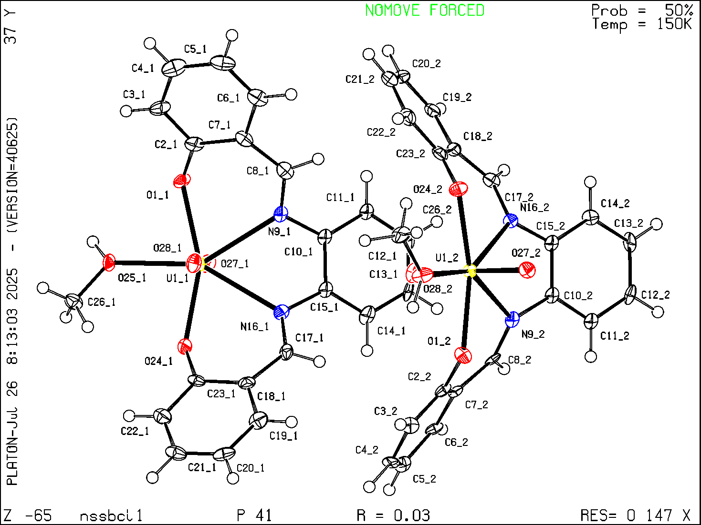
Single Crystal X-Ray Diffraction Data for complex C2

Table S9. Crystal data and structure refinement for C2.
Identification code | C2
Empirical formula | C₂₃H₂₇N₃O₅U
Formula weight | 663.50
Temperature/K | 296(2)
Crystal system | monoclinic
Space group | C2/c
a/Å | 27.631(2)
b/Å | 8.9151(7)
c/Å | 22.6103(17)
α/° | 90
β/° | 121.678(2)
γ/° | 90
Volume/Å³ | 4739.8(6)
Z | 8
ρ_{calc}g/cm³ | 1.860
μ/mm⁻¹ | 6.887
F(000) | 2544.0
Crystal size/mm³ | 0.11 × 0.048 × 0.038
Radiation | MoKα (λ = 0.71073)
2Θ range for data collection/° | 4.886 to 49.996
Index ranges | -32 ≤ h ≤ 32, -10 ≤ k ≤ 10, -26 ≤ l ≤ 26
Reflections collected | 26046
Independent reflections | 4184 [R_{int} = 0.0416, R_{sigma} = 0.0285]
Data/restraints/parameters | 4184/0/289
Goodness-of-fit on F² | 1.046
Final R indexes [I>=2σ (I)] | R₁ = 0.0257, wR₂ = 0.0579
Final R indexes [all data] | R₁ = 0.0348, wR₂ = 0.0617
Largest diff. peak/hole / e Å⁻³ | 1.09/-0.40

Table S10. Fractional Atomic Coordinates (×10⁴) and Equivalent Isotropic Displacement Parameters (Å²×10³) for C2. U_{eq} is defined as 1/3 of the trace of the orthogonalised U_{IJ} tensor.
Atom | x | y | z | U(eq)
C1 | 6044(2) | 8569(5) | 6991(3) | 42.7(12)
C2 | 5507(2) | 8876(5) | 6360(3) | 42.1(12)
C3 | 5191(3) | 10114(6) | 6353(4) | 63.8(17)
C4 | 4667(3) | 10430(7) | 5799(4) | 70.1(19)
C5 | 4431(3) | 9510(7) | 5221(4) | 62.8(18)
C6 | 4725(2) | 8279(7) | 5212(3) | 50.6(14)
C7 | 5267(2) | 7930(6) | 5772(3) | 39.6(12)
C8 | 7867(2) | 6742(5) | 7371(3) | 37.7(11)
C9 | 7996(2) | 6784(5) | 6831(3) | 35.3(11)
C10 | 8511(2) | 7422(6) | 6982(3) | 51.2(14)
C11 | 8664(3) | 7464(7) | 6497(4) | 64.1(17)
C12 | 8313(3) | 6819(8) | 5855(4) | 67.8(18)
C13 | 7814(3) | 6134(6) | 5698(3) | 49.9(14)
C14 | 7639(2) | 6091(5) | 6176(3) | 34.2(11)
C15 | 7307(2) | 6280(6) | 7882(3) | 43.7(13)
C16 | 6892(2) | 7439(6) | 7822(3) | 42.6(12)
C17 | 6729(2) | 7139(6) | 8355(3) | 47.7(13)
C18 | 7237(3) | 6930(7) | 9081(3) | 59.0(16)
C19 | 7665(3) | 5877(7) | 9128(3) | 60.7(17)
C20 | 7830(2) | 6198(6) | 8591(3) | 40.4(12)
C21 | 5475(2) | 5405(6) | 4453(3) | 46.0(13)
C22 | 5663(3) | 3897(7) | 3731(4) | 66.9(18)
C23 | 4747(3) | 5211(8) | 3257(3) | 68.4(18)
N1 | 6406.8(16) | 7532(4) | 7109(2) | 35.7(9)
N2 | 7382.4(17) | 6454(4) | 7283(2) | 34.4(9)
N3 | 5310.9(18) | 4875(5) | 3836(2) | 43.5(11)
O1 | 5534.2(14) | 6725(4) | 5754.1(18) | 41.5(8)
O2 | 6526.9(15) | 7956(3) | 5860.7(18) | 42.1(8)
O3 | 6371.8(14) | 4377(4) | 6442.7(18) | 41.5(8)
O4 | 5948.7(16) | 5190(4) | 4967.4(19) | 54.3(10)
O5 | 7173.7(14) | 5398(4) | 6030.3(16) | 36.9(8)
U1 | 6449.7(2) | 6157.6(2) | 6138.8(2) | 30.58(7)

Table S11. Anisotropic Displacement Parameters (Å²×10³) for C2. The Anisotropic displacement factor exponent takes the form. -2π²[h²a*²U₁₁+2hka*b*U₁₂+…].
Atom | U₁₁ | U₂₂ | U₃₃ | U₂₃ | U₁₃ | U₁₂
C1 | 41(3) | 41(3) | 40(3) | -11(2) | 17(3) | -1(2)
C2 | 31(3) | 40(3) | 50(3) | 5(2) | 18(3) | 6(2)
C3 | 55(4) | 47(3) | 80(5) | -5(3) | 29(4) | 9(3)
C4 | 47(4) | 51(4) | 98(6) | 9(4) | 28(4) | 18(3)
C5 | 36(3) | 61(4) | 77(5) | 27(4) | 20(3) | 11(3)
C6 | 32(3) | 61(3) | 51(4) | 16(3) | 16(3) | 2(3)
C7 | 31(3) | 44(3) | 42(3) | 5(2) | 18(3) | -1(2)
C8 | 32(3) | 40(3) | 30(3) | -4(2) | 9(2) | 3(2)
C9 | 27(3) | 35(3) | 40(3) | 2(2) | 15(2) | 3(2)
C10 | 43(3) | 52(3) | 52(4) | -5(3) | 21(3) | -4(3)
C11 | 50(4) | 83(5) | 66(5) | -7(4) | 35(4) | -17(3)
C12 | 73(5) | 78(4) | 81(5) | 12(4) | 60(4) | 2(4)
C13 | 51(3) | 58(4) | 44(3) | -3(3) | 27(3) | 2(3)
C14 | 34(3) | 31(2) | 36(3) | 3(2) | 17(2) | 8(2)
C15 | 34(3) | 58(3) | 33(3) | -2(2) | 13(2) | 0(2)
C16 | 37(3) | 56(3) | 30(3) | 1(2) | 14(2) | 6(2)
C17 | 52(4) | 55(3) | 40(3) | -1(3) | 27(3) | 2(3)
C18 | 66(4) | 77(4) | 34(3) | 0(3) | 27(3) | -4(3)
C19 | 71(4) | 67(4) | 40(3) | 8(3) | 26(3) | 9(3)
C20 | 35(3) | 43(3) | 34(3) | 5(2) | 12(2) | 2(2)
C21 | 45(3) | 47(3) | 47(4) | -4(3) | 24(3) | 0(3)
C22 | 71(5) | 80(5) | 63(4) | -5(3) | 44(4) | -1(4)
C23 | 49(4) | 104(5) | 43(4) | 7(3) | 17(3) | -3(4)
N1 | 27(2) | 40(2) | 34(2) | -2.5(18) | 11.9(19) | 1.7(18)
N2 | 31(2) | 41(2) | 30(2) | 2.7(18) | 15.0(19) | 6.4(18)
N3 | 38(3) | 62(3) | 26(2) | -7(2) | 14(2) | -8(2)
O1 | 27.8(18) | 47.6(19) | 43(2) | -4.1(16) | 14.1(17) | 1.3(16)
O2 | 43(2) | 36.8(19) | 41(2) | 8.0(16) | 17.7(18) | 0.6(16)
O3 | 40(2) | 38.2(18) | 43(2) | 1.2(16) | 19.3(18) | -0.4(16)
O4 | 39(2) | 67(3) | 38(2) | -12.7(19) | 7(2) | -1.8(19)
O5 | 31.4(19) | 44.3(19) | 34.5(19) | -5.5(15) | 17.1(16) | -1.5(15)
U1 | 27.42(11) | 30.45(11) | 27.16(11) | -1.36(8) | 9.71(8) | -0.35(8)

Table S12. Bond Lengths for C2.
Atom | Atom | Length/Å |  | Atom | Atom | Length/Å
C1 | C2 | 1.446(7) |  | C15 | C20 | 1.494(7)
C1 | N1 | 1.285(6) |  | C15 | N2 | 1.484(6)
C2 | C3 | 1.403(7) |  | C16 | C17 | 1.516(7)
C2 | C7 | 1.411(7) |  | C16 | N1 | 1.461(6)
C3 | C4 | 1.357(9) |  | C17 | C18 | 1.512(8)
C4 | C5 | 1.383(9) |  | C18 | C19 | 1.468(8)
C5 | C6 | 1.372(8) |  | C19 | C20 | 1.533(7)
C6 | C7 | 1.397(7) |  | C21 | N3 | 1.307(7)
C7 | O1 | 1.316(6) |  | C21 | O4 | 1.227(6)
C8 | C9 | 1.441(7) |  | C22 | N3 | 1.416(7)
C8 | N2 | 1.272(6) |  | C23 | N3 | 1.446(7)
C9 | C10 | 1.400(7) |  | N1 | U1 | 2.569(4)
C9 | C14 | 1.418(7) |  | N2 | U1 | 2.530(4)
C10 | C11 | 1.368(8) |  | O1 | U1 | 2.258(3)
C11 | C12 | 1.378(9) |  | O2 | U1 | 1.775(3)
C12 | C13 | 1.375(8) |  | O3 | U1 | 1.787(3)
C13 | C14 | 1.397(7) |  | O4 | U1 | 2.414(4)
C14 | O5 | 1.303(6) |  | O5 | U1 | 2.244(3)
C15 | C16 | 1.495(7)

Table S13. Bond Angles for C2.
Atom | Atom | Atom | Angle/˚ |  | Atom | Atom | Atom | Angle/˚
N1 | C1 | C2 | 128.7(5) |  | C1 | N1 | C16 | 115.7(4)
C3 | C2 | C1 | 118.1(5) |  | C1 | N1 | U1 | 123.2(3)
C3 | C2 | C7 | 118.6(5) |  | C16 | N1 | U1 | 119.2(3)
C7 | C2 | C1 | 123.2(4) |  | C8 | N2 | C15 | 121.3(4)
C4 | C3 | C2 | 122.1(6) |  | C8 | N2 | U1 | 127.2(3)
C3 | C4 | C5 | 119.6(6) |  | C15 | N2 | U1 | 111.5(3)
C6 | C5 | C4 | 120.0(6) |  | C21 | N3 | C22 | 121.2(5)
C5 | C6 | C7 | 121.8(6) |  | C21 | N3 | C23 | 119.7(5)
C6 | C7 | C2 | 118.0(5) |  | C22 | N3 | C23 | 119.0(5)
O1 | C7 | C2 | 121.6(5) |  | C7 | O1 | U1 | 134.7(3)
O1 | C7 | C6 | 120.4(5) |  | C21 | O4 | U1 | 134.1(4)
N2 | C8 | C9 | 125.5(5) |  | C14 | O5 | U1 | 130.3(3)
C10 | C9 | C8 | 118.4(5) |  | N2 | U1 | N1 | 63.66(12)
C10 | C9 | C14 | 119.5(5) |  | O1 | U1 | N1 | 71.18(12)
C14 | C9 | C8 | 121.9(4) |  | O1 | U1 | N2 | 134.75(12)
C11 | C10 | C9 | 121.3(6) |  | O1 | U1 | O4 | 77.08(13)
C10 | C11 | C12 | 119.3(6) |  | O2 | U1 | N1 | 86.55(14)
C13 | C12 | C11 | 121.0(6) |  | O2 | U1 | N2 | 91.18(14)
C12 | C13 | C14 | 121.3(6) |  | O2 | U1 | O1 | 88.85(14)
C13 | C14 | C9 | 117.6(5) |  | O2 | U1 | O3 | 178.07(15)
O5 | C14 | C9 | 121.5(4) |  | O2 | U1 | O4 | 92.32(15)
O5 | C14 | C13 | 120.9(5) |  | O2 | U1 | O5 | 87.36(14)
C20 | C15 | C16 | 113.3(4) |  | O3 | U1 | N1 | 91.52(14)
N2 | C15 | C16 | 108.3(4) |  | O3 | U1 | N2 | 87.90(14)
N2 | C15 | C20 | 117.6(4) |  | O3 | U1 | O1 | 90.59(14)
C15 | C16 | C17 | 109.9(4) |  | O3 | U1 | O4 | 89.35(15)
N1 | C16 | C15 | 110.8(4) |  | O3 | U1 | O5 | 93.91(14)
N1 | C16 | C17 | 113.8(4) |  | O4 | U1 | N1 | 148.26(13)
C18 | C17 | C16 | 113.0(5) |  | O4 | U1 | N2 | 148.05(13)
C19 | C18 | C17 | 114.3(5) |  | O5 | U1 | N1 | 132.91(12)
C18 | C19 | C20 | 112.7(5) |  | O5 | U1 | N2 | 69.84(12)
C15 | C20 | C19 | 109.6(5) |  | O5 | U1 | O1 | 155.22(12)
O4 | C21 | N3 | 123.6(5) |  | O5 | U1 | O4 | 78.61(12)

Table S14. Hydrogen Bonds for C2.
D | H | A | d(D-H)/Å | d(H-A)/Å | d(D-A)/Å | D-H-A/°
C8 | H8 | O3¹ | 0.93 | 2.62 | 3.348(6) | 135.2
C20 | H20B | O2² | 0.97 | 2.46 | 3.276(6) | 141.7
C21 | H21 | O1 | 0.93 | 2.57 | 3.091(6) | 116.0
C23 | H23B | O1³ | 0.96 | 2.46 | 3.225(7) | 136.9
¹3/2-X,1/2+Y,3/2-Z; ²3/2-X,-1/2+Y,3/2-Z; ³1-X,1-Y,1-Z

Table S15. Torsion Angles for C2.
A | B | C | D | Angle/˚ |  | A | B | C | D | Angle/˚
C1 | C2 | C3 | C4 | -175.8(6) |  | C13 | C14 | O5 | U1 | -131.6(4)
C1 | C2 | C7 | C6 | 175.0(5) |  | C14 | C9 | C10 | C11 | 3.6(8)
C1 | C2 | C7 | O1 | -2.7(8) |  | C15 | C16 | C17 | C18 | 50.8(6)
C2 | C1 | N1 | C16 | -175.3(5) |  | C15 | C16 | N1 | C1 | -175.4(5)
C2 | C1 | N1 | U1 | 20.6(7) |  | C15 | C16 | N1 | U1 | -10.6(5)
C2 | C3 | C4 | C5 | 0.3(10) |  | C16 | C15 | C20 | C19 | 57.5(6)
C2 | C7 | O1 | U1 | -38.5(7) |  | C16 | C15 | N2 | C8 | 119.9(5)
C3 | C2 | C7 | C6 | -0.1(7) |  | C16 | C15 | N2 | U1 | -58.9(4)
C3 | C2 | C7 | O1 | -177.8(5) |  | C16 | C17 | C18 | C19 | -48.7(7)
C3 | C4 | C5 | C6 | 0.4(10) |  | C17 | C16 | N1 | C1 | 60.3(6)
C4 | C5 | C6 | C7 | -1.0(9) |  | C17 | C16 | N1 | U1 | -134.9(4)
C5 | C6 | C7 | C2 | 0.8(8) |  | C17 | C18 | C19 | C20 | 49.2(8)
C5 | C6 | C7 | O1 | 178.6(5) |  | C18 | C19 | C20 | C15 | -52.6(7)
C6 | C7 | O1 | U1 | 143.8(4) |  | C20 | C15 | C16 | C17 | -57.0(6)
C7 | C2 | C3 | C4 | -0.5(9) |  | C20 | C15 | C16 | N1 | 176.5(4)
C8 | C9 | C10 | C11 | 178.4(5) |  | C20 | C15 | N2 | C8 | -10.1(7)
C8 | C9 | C14 | C13 | -177.1(4) |  | C20 | C15 | N2 | U1 | 171.1(3)
C8 | C9 | C14 | O5 | 0.8(7) |  | N1 | C1 | C2 | C3 | -178.1(6)
C9 | C8 | N2 | C15 | 173.5(5) |  | N1 | C1 | C2 | C7 | 6.8(9)
C9 | C8 | N2 | U1 | -7.9(7) |  | N1 | C16 | C17 | C18 | 175.6(5)
C9 | C10 | C11 | C12 | -2.2(10) |  | N2 | C8 | C9 | C10 | 166.6(5)
C9 | C14 | O5 | U1 | 50.6(6) |  | N2 | C8 | C9 | C14 | -18.7(8)
C10 | C9 | C14 | C13 | -2.4(7) |  | N2 | C15 | C16 | C17 | 170.7(4)
C10 | C9 | C14 | O5 | 175.5(4) |  | N2 | C15 | C16 | N1 | 44.1(6)
C10 | C11 | C12 | C13 | -0.2(10) |  | N2 | C15 | C20 | C19 | -174.9(4)
C11 | C12 | C13 | C14 | 1.3(10) |  | N3 | C21 | O4 | U1 | 171.9(4)
C12 | C13 | C14 | C9 | 0.1(8) |  | O4 | C21 | N3 | C22 | 5.1(8)
C12 | C13 | C14 | O5 | -177.8(5) |  | O4 | C21 | N3 | C23 | -178.9(5)

Table S16. Hydrogen Atom Coordinates (Å×10⁴) and Isotropic Displacement Parameters (Å²×10³) for C2.
Atom | x | y | z | U(eq)
H1 | 6139.95 | 9209.31 | 7361.78 | 51
H3 | 5345.08 | 10736.74 | 6739.84 | 77
H4 | 4467.31 | 11261.92 | 5807.64 | 84
H5 | 4072.59 | 9723.96 | 4838.24 | 75
H6 | 4559.23 | 7660.58 | 4822.97 | 61
H8 | 8163.01 | 6941.84 | 7822.14 | 45
H10 | 8754.44 | 7825.5 | 7420.83 | 61
H11 | 9002.18 | 7922.7 | 6599.32 | 77
H12 | 8415.54 | 6848.73 | 5523.68 | 81
H13 | 7587.38 | 5689.06 | 5264.15 | 60
H15 | 7114.24 | 5314.15 | 7811.66 | 52
H16 | 7086.64 | 8410.72 | 7935.7 | 51
H17A | 6502.81 | 7972.49 | 8354.84 | 57
H17B | 6494.04 | 6245.13 | 8220.58 | 57
H18A | 7417.12 | 7896.78 | 9258.01 | 71
H18B | 7105.93 | 6573.76 | 9378.63 | 71
H19A | 7516.37 | 4863.92 | 9060.89 | 73
H19B | 8002.31 | 5933.19 | 9590.78 | 73
H20A | 8035.64 | 7139.48 | 8700.32 | 48
H20B | 8077.28 | 5407.74 | 8604.37 | 48
H21 | 5217.79 | 5977.41 | 4504.57 | 55
H22A | 5473.66 | 3625.83 | 3249.22 | 100
H22B | 6014.57 | 4393.1 | 3866.08 | 100
H22C | 5738.94 | 3010.29 | 4007.44 | 100
H23A | 4692.85 | 4742.87 | 2844.44 | 103
H23B | 4468.91 | 4836.12 | 3352.75 | 103
H23C | 4703.69 | 6277.17 | 3189.95 | 103

Check CIF/PLATON report
Structure factors have been supplied for datablock(s) shelx

THIS REPORT IS FOR GUIDANCE ONLY. IF USED AS PART OF A REVIEW PROCEDURE FOR PUBLICATION, IT SHOULD NOT REPLACE THE EXPERTISE OF AN EXPERIENCED CRYSTALLOGRAPHIC REFEREE.

No syntax errors found. CIF dictionary Interpreting this report

Datablock. shelx

Bond precision. C-C = 0.0096 A Wavelength=0.71073

Cell.  Temperature. | a=27.631(2)  alpha=90  296 K |  | b=8.9151(7) beta=121.678(2) |  | c=22.6103(17)  gamma=90
 | Calculated |  |  | Reported
Volume Space group Hall group  Moiety formula | 4739.9(6)  C 2/c  -C 2yc  C23 H27 N3 | O5 | U | 4739.8(6)  C 2/c  -C 2yc  C23 H27 N3 O5 U
Sum formula | C23 H27 N3 | O5 | U | C23 H27 N3 O5 U
Mr | 663.51 |  |  | 663.50
Dx,g cm-3 | 1.860 |  |  | 1.860
Z | 8 |  |  | 8
Mu (mm-1) | 6.887 |  |  | 6.887
F000 | 2544.0 |  |  | 2544.0
F000’ | 2468.44
h,k,lmax | 32,10,26 |  |  | 32,10,26
Nref | 4188 |  |  | 4184
Tmin,Tmax | 0.679,0.770 |  |  | 0.518,0.780
Tmin’ | 0.464

Correction method= # Reported T Limits. Tmin=0.518 Tmax=0.780 AbsCorr = MULTI-SCAN

Data completeness= 0.999 Theta(max)= 24.998

R(reflections)= 0.0257( 3531) wR2(reflections)=
0.0617( 4184)
S = 1.046 Npar= 289

The following ALERTS were generated. Each ALERT has the format
test-name_ALERT_alert-type_alert-level.
Click on the hyperlinks for more details of the test.

Alert level C
PLAT094_ALERT_2_C Ratio of Maximum / Minimum Residual Density .... 2.70 Report PLAT234_ALERT_4_C Large Hirshfeld Difference C11 --C12 . 0.18 Ang.
PLAT241_ALERT_2_C High ’MainMol’ Ueq as Compared to Neighbors of O4 Check PLAT242_ALERT_2_C Low ’MainMol’ Ueq as Compared to Neighbors of N3 Check PLAT342_ALERT_3_C Low Bond Precision on C-C Bonds ............... 0.0096 Ang. PLAT601_ALERT_2_C Unit Cell Contains Solvent Accessible VOIDS of . 51 Ang**3 PLAT761_ALERT_1_C CIF Contains no X-H Bonds ...................... Please Check PLAT762_ALERT_1_C CIF Contains no X-Y-H or H-Y-H Angles .......... Please Check PLAT911_ALERT_3_C Missing FCF Refl Between Thmin & STh/L= 0.595 3 Report

Alert level G
PLAT083_ALERT_2_G SHELXL Second Parameter in WGHT Unusually Large 10.69 Why ? PLAT128_ALERT_4_G Alternate Setting for Input Space Group C2/c I2/a Note PLAT380_ALERT_4_G Incorrectly? Oriented X(sp2)-Methyl Moiety ..... C22 Check PLAT380_ALERT_4_G Incorrectly? Oriented X(sp2)-Methyl Moiety ..... C23 Check PLAT480_ALERT_4_G Long H...A H-Bond Reported H8 ..O3 . 2.62 Ang. PLAT793_ALERT_4_G Model has Chirality at C15 (Centro SPGR) S Verify PLAT793_ALERT_4_G Model has Chirality at C16 (Centro SPGR) S Verify PLAT794_ALERT_5_G Tentative Bond Valency for U1 (VI) . 5.24 Info PLAT883_ALERT_1_G No Info/Value for _atom_sites_solution_primary . Please Do !
PLAT909_ALERT_3_G Percentage of I>2sig(I) Data at Theta(Max) Still 71% Note PLAT910_ALERT_3_G Missing # of FCF Reflection(s) Below Theta(Min). 3 Note PLAT913_ALERT_3_G Missing # of Very Strong Reflections in FCF .... 1 Note PLAT933_ALERT_2_G Number of HKL-OMIT Records in Embedded .res File 1 Note PLAT965_ALERT_2_G The SHELXL WEIGHT Optimisation has not Converged Please Check PLAT967_ALERT_5_G Note. Two-Theta Cutoff Value in Embedded .res .. 50.0 Degree PLAT978_ALERT_2_G Number C-C Bonds with Positive Residual Density. 2 Info

0 ALERT level A = Most likely a serious problem - resolve or explain
0 ALERT level B = A potentially serious problem, consider carefully
9 ALERT level C = Check. Ensure it is not caused by an omission or oversight
16 ALERT level G = General information/check it is not something unexpected

3 | ALERT | type | 1 | CIF construction/syntax error, inconsistent or missing data
8 | ALERT | type | 2 | Indicator that the structure model may be wrong or deficient
5 | ALERT | type | 3 | Indicator that the structure quality may be low
7 | ALERT | type | 4 | Improvement, methodology, query or suggestion
2 | ALERT | type | 5 | Informative message, check

Datablock shelx - ellipsoid plot
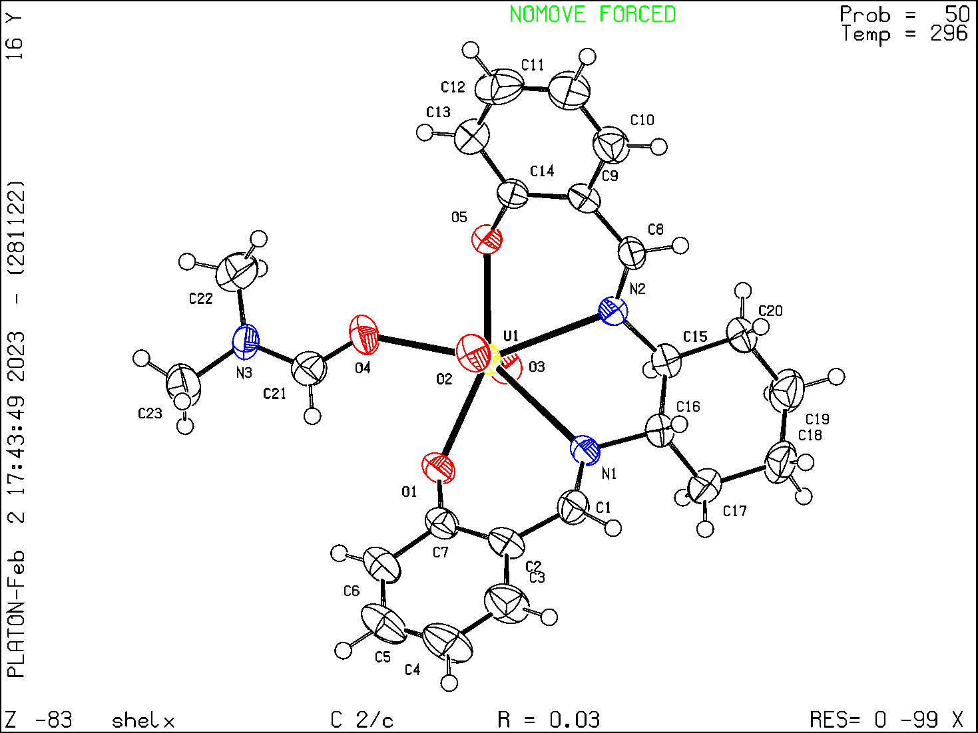

GC Data

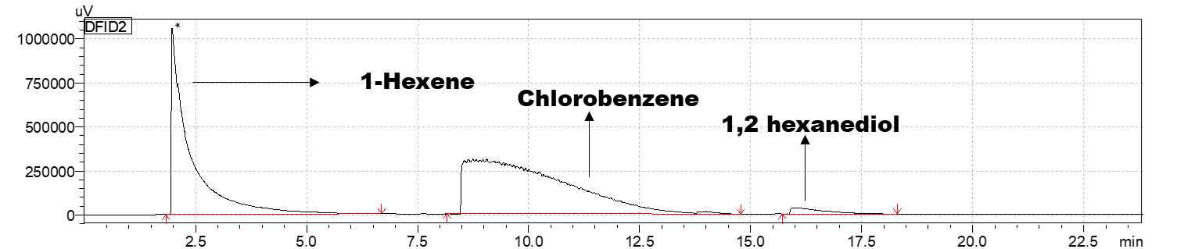
Figure S26. Standard data - Shimadzu GC-14 AF

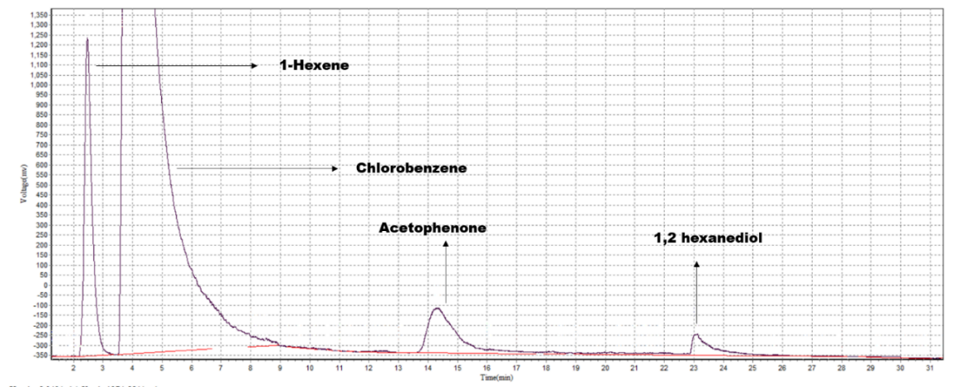
Figure S27. Standard data - Mayura Analytical GC-2014 AF

Catalytic Reaction Data

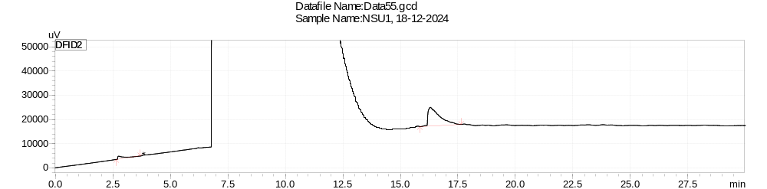
Figure S28. Gas chromatogram- conversion of 1,2-hexanediol to 1-hexene when C1 (1.30) was used as a catalyst.

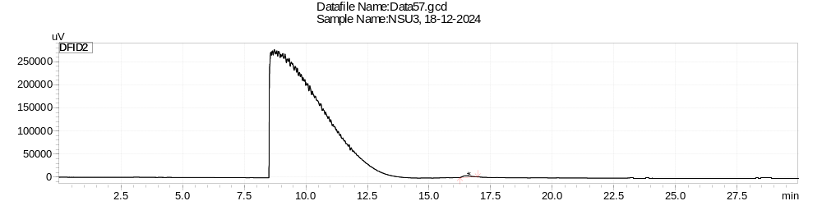
Figure S29. Gas chromatogram- conversion of 1,2-hexanediol to 1-hexene when C2 (1.30) was used as a catalyst.

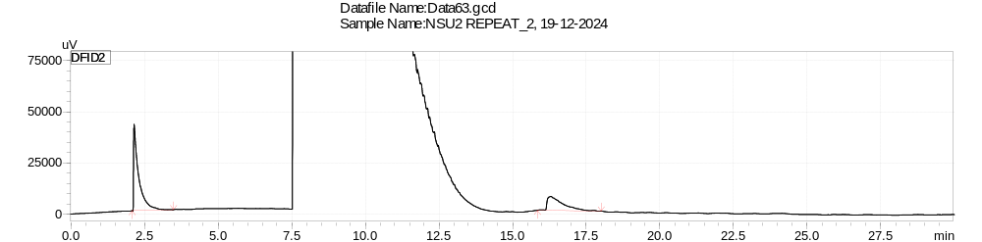
Figure S30. Gas chromatogram- conversion of 1,2-hexanediol to 1-hexene when C3 (1.30) was used as a catalyst.

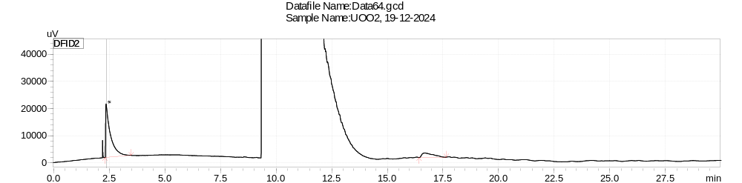
Figure S31. Gas chromatogram- conversion of 1,2-hexanediol to 1-hexene when UA(1.30) was used as a catalyst and analysed in Shimadzu GC-2014-AF.
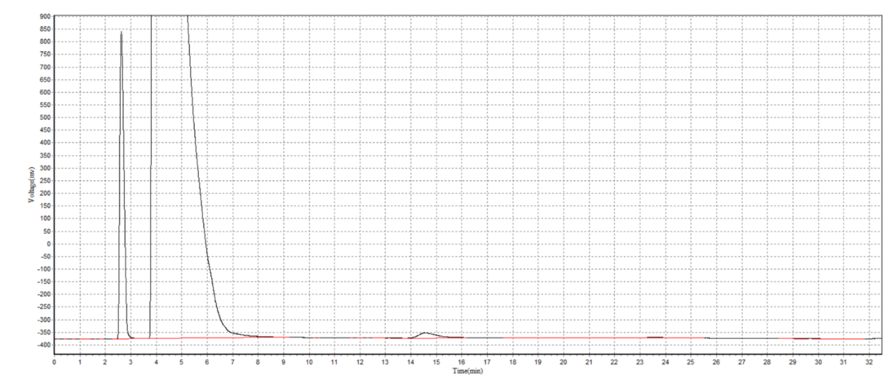
Figure S32. Gas chromatogram- conversion of 1,2-hexanediol to 1-hexene when UA (1.30) was used as a catalyst.
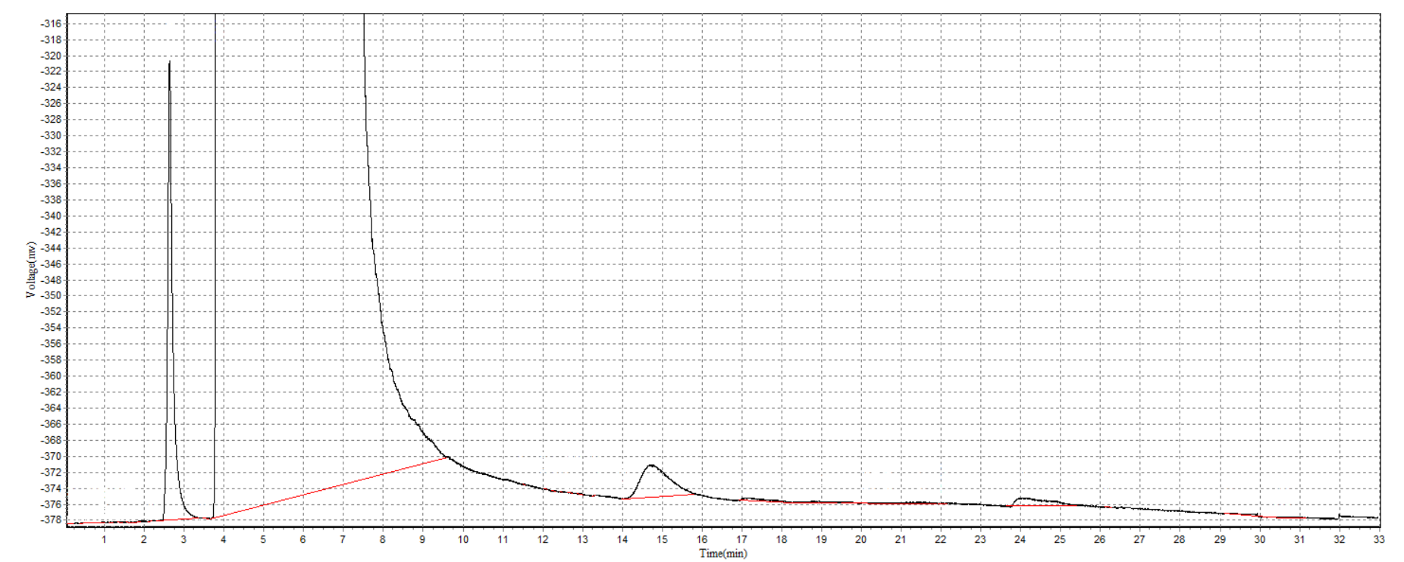
Figure S33. Gas chromatogram- conversion of 1,2-hexanediol to 1-hexene when UA (1.30) was used as a catalyst for a reaction time of 6 h.
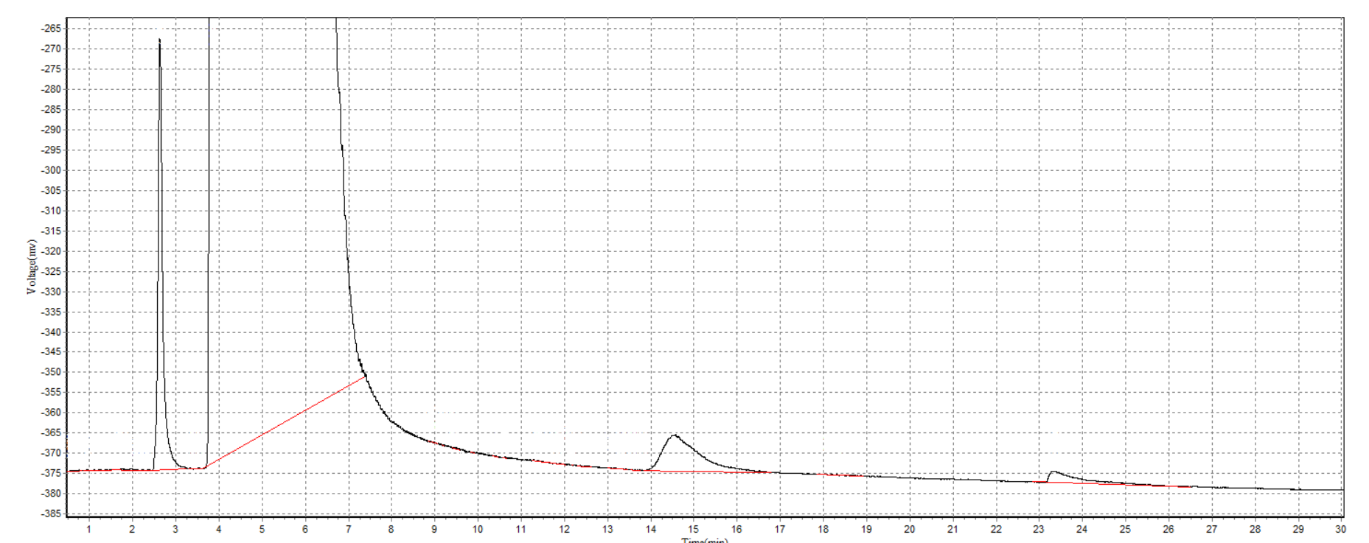
Figure S34. Gas chromatogram- conversion of 1,2-hexanediol to 1-hexene when UA (1.30) was used as a catalyst for a reaction time of 24 h.

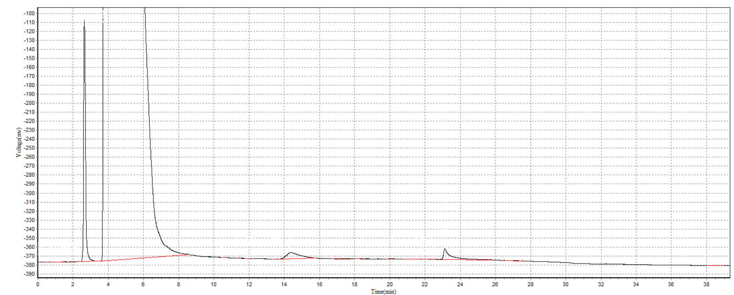
Figure S35. Gas chromatogram- conversion of 1,2-hexanediol to 1-hexene when UA (1.30) was used as a catalyst for a reaction temperature of 90 °C.

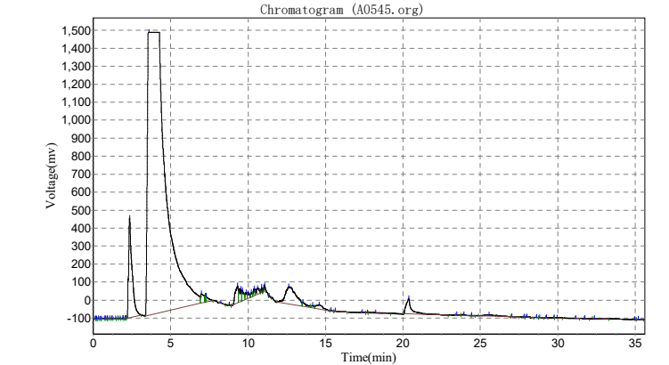
Figure S36. Gas chromatogram- conversion of 1,2-hexanediol to 1-hexene when UA (1.30) was used as a catalyst and sodium sulfite as a reducing agent.

Table S17. Cartesian Coordinates of DFT-Optimized Structures of C1
Ground state geometry
Atomic
No x y z
92 -0.000010000 -0.806953000 -0.648606000
8 -2.220923000 -1.264965000 -0.768449000
6 -3.243122000 -1.124636000 0.041685000
6 -4.235714000 -2.125055000 0.124307000
6 -5.323004000 -1.980613000 0.970392000
6 -5.482417000 -0.826465000 1.755441000
6 -4.536006000 0.176810000 1.670014000
6 -3.403125000 0.054686000 0.832929000
6 -2.509248000 1.179636000 0.747486000
7 -1.357432000 1.225640000 0.146888000
6 -0.705367000 2.475514000 0.016273000
6 -1.393105000 3.682220000 -0.158556000
6 -0.697414000 4.878252000 -0.306836000
6 0.697351000 4.878259000 -0.306921000
6 1.393075000 3.682235000 -0.158725000
6 0.705376000 2.475518000 0.016186000
7 1.357466000 1.225644000 0.146730000
6 2.509330000 1.179661000 0.747243000
6 3.403177000 0.054694000 0.832825000
6 4.536099000 0.176930000 1.669839000
6 5.482512000 -0.826335000 1.755365000
6 5.323043000 -1.980609000 0.970513000
6 4.235696000 -2.125184000 0.124525000
6 3.243112000 -1.124765000 0.041796000
8 2.220832000 -1.265238000 -0.768197000
8 0.000111000 -0.119271000 -2.309164000
8 -0.000134000 -1.337612000 1.065843000
1 -4.118318000 -3.011936000 -0.487427000
1 -6.063786000 -2.771383000 1.021846000
1 -6.339108000 -0.721277000 2.409320000
1 -4.652880000 1.083552000 2.254685000
1 -2.869848000 2.084662000 1.240214000
1 -2.474704000 3.680637000 -0.213604000
1 -1.244124000 5.802029000 -0.454033000
1 1.244033000 5.802042000 -0.454189000
1 2.474666000 3.680672000 -0.213913000
1 2.869899000 2.084675000 1.240014000
1 4.653014000 1.083763000 2.254361000
1 6.339243000 -0.721048000 2.409175000
1 6.063820000 -2.771378000 1.022053000
1 4.118246000 -3.012171000 -0.487046000
First excited state

Atomic
No x y z
92 -0.044295000 -0.818040000 -0.514635000
8 -2.304418000 -1.278395000 -0.783833000
6 -3.326613000 -1.109825000 -0.000999000
6 -4.340683000 -2.096943000 0.075793000
6 -5.436785000 -1.931041000 0.891178000
6 -5.601370000 -0.766934000 1.664534000
6 -4.643326000 0.215570000 1.591120000
6 -3.493455000 0.071019000 0.781825000
6 -2.585464000 1.183957000 0.723029000
7 -1.413690000 1.202617000 0.169893000
6 -0.730685000 2.424444000 0.052999000
6 -1.386367000 3.639738000 -0.152713000
6 -0.669136000 4.819609000 -0.260940000
6 0.726677000 4.794241000 -0.191162000
6 1.394324000 3.599630000 -0.013618000
6 0.686782000 2.383642000 0.112650000
7 1.304303000 1.150473000 0.260406000
6 2.542739000 1.150140000 0.779127000
6 3.481156000 0.095577000 0.797826000
6 4.717098000 0.310627000 1.465954000
6 5.688189000 -0.656397000 1.513763000
6 5.487545000 -1.918193000 0.890116000
6 4.313116000 -2.181495000 0.237134000
6 3.283565000 -1.202125000 0.159208000
8 2.194751000 -1.461120000 -0.454995000
8 0.044840000 -0.168096000 -2.156227000
8 -0.193099000 -1.379257000 1.152413000
1 -4.219988000 -2.991850000 -0.526212000
1 -6.190439000 -2.712269000 0.933497000
1 -6.472649000 -0.645802000 2.297976000
1 -4.758707000 1.130719000 2.166461000
1 -2.946318000 2.099536000 1.200675000
1 -2.466013000 3.653465000 -0.256396000
1 -1.191457000 5.755668000 -0.426384000
1 1.292998000 5.712072000 -0.307953000
1 2.477884000 3.591608000 -0.024345000
1 2.878999000 2.059153000 1.275354000
1 4.884728000 1.270178000 1.945681000
1 6.619722000 -0.459875000 2.033276000
1 6.267175000 -2.670748000 0.938038000
1 4.128678000 -3.134445000 -0.247234000

Table S18. Cartesian Coordinates of DFT-Optimized Structures of C2
C2
Atomic
No. x y z
6 1.540695000 3.515544000 0.077326000
6 0.782913000 4.846000000 0.101616000
6 -0.567063000 4.737883000 -0.650178000
6 -1.057736000 3.281074000 -0.764439000
6 -0.765080000 2.492279000 0.525289000
6 0.760589000 2.421869000 0.837853000
7 -1.360197000 1.149657000 0.444363000
7 1.333168000 1.089492000 0.537535000
6 -2.485895000 0.973670000 1.048882000
6 2.431843000 0.815991000 1.158155000
6 -3.356587000 -0.181829000 0.972857000
6 3.304923000 -0.325560000 0.978424000
6 -4.439814000 -0.254675000 1.873425000
6 -5.360900000 -1.286278000 1.815291000
6 -5.225910000 -2.261550000 0.815272000
6 -4.186549000 -2.205445000 -0.100224000
6 -3.220997000 -1.177690000 -0.039760000
6 3.172603000 -1.237467000 -0.109915000
6 4.143153000 -2.251234000 -0.257238000
6 5.184032000 -2.377606000 0.649557000
6 5.313467000 -1.489412000 1.728306000
6 4.386632000 -0.471653000 1.872662000
8 -2.246106000 -1.123322000 -0.920181000
8 2.189394000 -1.122087000 -0.974629000
92 -0.024540000 -0.672678000 -0.738869000
8 -0.022033000 -1.559941000 0.822755000
8 -0.020310000 0.313356000 -2.244269000
1 2.530440000 3.621479000 0.529499000
1 1.699661000 3.190008000 -0.956142000
1 1.400568000 5.634063000 -0.336085000
1 0.610941000 5.135289000 1.144439000
1 -1.321635000 5.341829000 -0.137584000
1 -0.470312000 5.151628000 -1.657833000
1 -2.134005000 3.258795000 -0.954543000
1 -0.580082000 2.777867000 -1.608216000
1 -1.239287000 3.031873000 1.353891000
1 0.880186000 2.601698000 1.912305000
1 -2.866838000 1.787429000 1.674093000
1 2.789247000 1.530946000 1.906517000
1 -4.541616000 0.519968000 2.626914000
1 -6.179668000 -1.333768000 2.522521000
1 -5.946801000 -3.069695000 0.751211000
1 -4.088655000 -2.952363000 -0.879637000
1 4.046832000 -2.932381000 -1.094883000
1 5.908899000 -3.173969000 0.518272000
1 6.131732000 -1.592447000 2.430152000
1 4.483790000 0.236558000 2.689342000

Table S18. Cartesian Coordinates of DFT-Optimized Structures of C3
C3
Atomic
No. x y z
6 -0.952860000 2.582479000 0.039812000
6 0.269027000 2.377176000 -0.854174000
7 -1.612075000 1.285338000 0.183476000
7 1.040546000 1.209175000 -0.397028000
6 -2.789358000 1.117376000 -0.299377000
6 2.260478000 1.137927000 -0.791858000
6 -3.499538000 -0.147893000 -0.371367000
6 3.182408000 0.039099000 -0.569517000
6 -4.875421000 -0.123013000 -0.670374000
6 -5.607427000 -1.292108000 -0.801929000
6 -4.954670000 -2.523382000 -0.661720000
6 -3.593721000 -2.580199000 -0.392543000
6 -2.843298000 -1.402317000 -0.238361000
6 2.764484000 -1.222756000 -0.069778000
6 3.712947000 -2.255559000 0.046935000
6 5.038591000 -2.043074000 -0.305104000
6 5.459943000 -0.800465000 -0.796906000
6 4.531214000 0.218714000 -0.934156000
8 -1.529891000 -1.482329000 -0.026111000
8 1.499840000 -1.449339000 0.256662000
92 -0.158329000 -0.461257000 1.350788000
8 -1.549207000 -0.440392000 2.579797000
8 1.050476000 0.454229000 2.412800000
1 -1.618523000 3.334269000 -0.396390000
1 -0.642665000 2.931158000 1.029270000
1 -0.075712000 2.182921000 -1.875634000
1 0.887003000 3.280607000 -0.871363000
1 -3.319468000 1.978484000 -0.718123000
1 2.676939000 1.966918000 -1.374678000
1 -5.362934000 0.838790000 -0.791346000
1 -6.667697000 -1.253839000 -1.019072000
1 -5.513594000 -3.446239000 -0.771090000
1 -3.082197000 -3.530901000 -0.299896000
1 3.381133000 -3.217576000 0.419709000
1 5.752735000 -2.852559000 -0.199869000
1 6.494918000 -0.641187000 -1.073190000
1 4.838501000 1.182325000 -1.327696000

Fit parameters
Fluoracle 30/05/2025
Fit Results
Fit. A+B1exp(-t/t₁)+B2exp(-t/t₂)+B3exp(-t/t₃)
Instrument Response | . IR5 sample holder
Range (ch) | . 0 to 2047
Peak Count | . 1969 in channel 212
Total Count | . 107685
Background | . 5.0864
Decay Scan | . C1
File location | . File has not been saved.
Range (ch) | . 0 to 2047
Peak Count | . 1908 in channel 212
Total Count | . 107685
Time Calibration | . 0.024 ns/ch
Total Experiment Time | . 41.85 s
Fit Range (ch) | . 1 to 2047
Parameter | Value | Std. Dev. | Rel %
t1 | 1.103E-010 s | 5.886E-012 s
t2 | 1.560E-009 s | 9.752E-011 s
t3 | 1.000E-008 s | 3.781E-008 s
Shift | 3.787E-011 s | 4.619E-012 s
B1 | 0.2194 | 0.0112 | 89.55
B2 | 0.0018 | 0.0001 | 10.24
B3 | 0.0000 | 0.0000 | 0.21
A | 7.3503
c² | 1.3527

Fluoracle 30/05/2025
Fit Results
Fit. A+B1exp(-t/t₁)+B2exp(-t/t₂)
Instrument Response | . IR5 sample holder
Range (ch) | . 0 to 2047
Peak Count | . 1888 in channel 215
Total Count | . 110948
Background | . 5.0864
Decay Scan | . C2
File location | . File has not been saved.
Range (ch) | . 0 to 2047
Peak Count | . 1896 in channel 215
Total Count | . 110948
Time Calibration | . 0.024 ns/ch
Total Experiment Time | . 452.57 s
Fit Range (ch) | . 1 to 2047
Parameter | Value | Std. Dev. | Rel %
t1 | 1.835E-010 s | 4.519E-012 s
t2 | 2.371E-009 s | 1.193E-010 s
Shift | 1.066E-010 s | 3.447E-012 s
B1 | 0.1415 | 0.0033 | 93.94
B2 | 0.0007 | 0.0001 | 6.06
A | 8.4415
c² | 1.2660

Fluoracle 30/05/2025

Fit Results
Fit. A+B1exp(-t/t₁)+B2exp(-t/t₂)
Instrument Response | . IR5 sample holder
Range (ch) | . 0 to 2047
Peak Count | . 1926 in channel 213
Total Count | . 115492
Background | . 5.0864
Decay Scan | . C3
File location | . File has not been saved.
Range (ch) | . 0 to 2047
Peak Count | . 1996 in channel 213
Total Count | . 115492
Time Calibration | . 0.024 ns/ch
Total Experiment Time | . 522.78 s
Fit Range (ch) | . 1 to 2047
Parameter | Value | Std. Dev. | Rel %
t1 | 2.016E-010 s | 4.145E-012 s
t2 | 2.773E-009 s | 1.459E-010 s
Shift | 1.274E-010 s | 3.176E-012 s
B1 | 0.1344 | 0.0026 | 94.45
B2 | 0.0006 | 0.0000 | 5.55
A | 8.8145
c² | 1.4326

