Supplementary files
Supplementary file 1
Distribution of global perceived change scores
Characteristic | N = 2,848¹
Global perceived change score
Much better | 716 (37%)
Better | 629 (32%)
Slightly better | 342 (18%)
Almost the same | 205 (10%)
Slightly worse | 29 (1.5%)
Worse | 22 (1.1%)
Much worse | 10 (0.5%)
Missing | 895
Global perceived change score (dichotomized)
Not worse | 1,892 (97%)
Worse | 61 (3.1%)
Missing | 895
¹n (%)

Supplementary file 2
Odds ratios for responding to the global perceived change score at 2 weeks
Characteristic | N | OR¹ | 95% CI¹
Back pain intensity | 2,791 | 1.00 | 0.96, 1.04
Disability score | 2,749 | 1.00 | 0.96, 1.03
Leg pain intensity | 2,783 | 1.01 | 0.98, 1.04
Age | 2,848
Young aged adult |  | — | —
Middle aged adult |  | 1.90 | 1.59, 2.28
Older aged adult |  | 2.03 | 1.59, 2.62
Sex | 2,848
Male |  | — | —
Female |  | 1.37 | 1.16, 1.61
Body mass index | 2,072 | 1.01 | 0.99, 1.04
Episode duration | 2,828
< 1 week |  | — | —
1 - 4 weeks |  | 0.98 | 0.80, 1.19
4 - 52 weeks |  | 1.20 | 0.92, 1.58
> 52 weeks |  | 0.97 | 0.78, 1.21
Pain trajectory | 2,030
Episodic trajectory |  | — | —
Mild pain trajectory |  | 0.99 | 0.66, 1.54
Intermediate to severe pain trajectory |  | 0.81 | 0.61, 1.08
Unrecognized |  | 0.63 | 0.43, 0.92
STarT Back Tool | 2,800
Low risk |  | — | —
Medium risk |  | 0.98 | 0.82, 1.18
High risk |  | 0.79 | 0.64, 0.97
Education | 2,021
Short education |  | — | —
longer education |  | 1.02 | 0.79, 1.33
Overall Health | 1,443
Excellent |  | — | —
Very Good |  | 1.08 | 0.67, 1.70
Good |  | 0.93 | 0.56, 1.50
Fair |  | 0.95 | 0.54, 1.66
Bad |  | 0.45 | 0.20, 1.11
Medication | 2,043
No |  | — | —
Yes, prescription |  | 1.26 | 0.89, 1.81
Yes, no prescription |  | 1.11 | 0.85, 1.46
¹OR = Odds Ratio, CI = Confidence Interval

Supplementary file 3
Distribution of change scores in pain and disability by global perceived change scores
Changes in: | Global perceived change (dichotomized) | Change score | n (%)
Back pain | Worse | 9 | 1 (1.6%)
Back pain | Not worse | 5 | 2 (0.1%)
Back pain | Worse | 5 | 1 (1.6%)
Back pain | Not worse | 4 | 7 (0.4%)
Back pain | Worse | 4 | 7 (11.5%)
Back pain | Not worse | 3 | 16 (0.9%)
Back pain | Worse | 3 | 2 (3.3%)
Back pain | Not worse | 2 | 36 (1.9%)
Back pain | Worse | 2 | 8 (13.1%)
Back pain | Not worse | 1 | 84 (4.5%)
Back pain | Worse | 1 | 12 (19.7%)
Back pain | Not worse | 0 | 177 (9.6%)
Back pain | Worse | 0 | 16 (26.2%)
Back pain | Not worse | -1 | 206 (11.1%)
Back pain | Worse | -1 | 9 (14.8%)
Back pain | Not worse | -2 | 260 (14.1%)
Back pain | Not worse | -3 | 239 (12.9%)
Back pain | Not worse | -4 | 239 (12.9%)
Back pain | Worse | -4 | 2 (3.3%)
Back pain | Not worse | -5 | 234 (12.7%)
Back pain | Not worse | -6 | 171 (9.2%)
Back pain | Not worse | -7 | 109 (5.9%)
Back pain | Not worse | -8 | 51 (2.8%)
Back pain | Worse | -8 | 3 (4.9%)
Back pain | Not worse | -9 | 15 (0.8%)
Back pain | Not worse | -10 | 3 (0.2%)
Leg pain | Not worse | 9 | 2 (0.1%)
Leg pain | Not worse | 8 | 2 (0.1%)
Leg pain | Worse | 8 | 1 (1.7%)
Leg pain | Not worse | 7 | 3 (0.2%)
Leg pain | Worse | 7 | 2 (3.4%)
Leg pain | Not worse | 6 | 9 (0.5%)
Leg pain | Not worse | 5 | 13 (0.7%)
Leg pain | Worse | 5 | 1 (1.7%)
Leg pain | Not worse | 4 | 24 (1.3%)
Leg pain | Worse | 4 | 6 (10.2%)
Leg pain | Not worse | 3 | 31 (1.7%)
Leg pain | Worse | 3 | 6 (10.2%)
Leg pain | Not worse | 2 | 70 (3.8%)
Leg pain | Worse | 2 | 7 (11.9%)
Leg pain | Not worse | 1 | 142 (7.7%)
Leg pain | Worse | 1 | 9 (15.3%)
Leg pain | Not worse | 0 | 630 (34.3%)
Leg pain | Worse | 0 | 16 (27.1%)
Leg pain | Not worse | -1 | 232 (12.6%)
Leg pain | Worse | -1 | 6 (10.2%)
Leg pain | Not worse | -2 | 204 (11.1%)
Leg pain | Worse | -2 | 2 (3.4%)
Leg pain | Not worse | -3 | 150 (8.2%)
Leg pain | Worse | -3 | 1 (1.7%)
Leg pain | Not worse | -4 | 138 (7.5%)
Leg pain | Worse | -4 | 1 (1.7%)
Leg pain | Not worse | -5 | 84 (4.6%)
Leg pain | Not worse | -6 | 52 (2.8%)
Leg pain | Not worse | -7 | 35 (1.9%)
Leg pain | Worse | -7 | 1 (1.7%)
Leg pain | Not worse | -8 | 11 (0.6%)
Leg pain | Not worse | -9 | 5 (0.3%)
Leg pain | Not worse | -10 | 2 (0.1%)
Combined pain | Not worse | 6 | 3 (0.2%)
Combined pain | Not worse | 5 | 4 (0.2%)
Combined pain | Worse | 5 | 2 (3.3%)
Combined pain | Not worse | 4 | 10 (0.5%)
Combined pain | Worse | 4 | 6 (9.8%)
Combined pain | Not worse | 3 | 18 (1%)
Combined pain | Worse | 3 | 2 (3.3%)
Combined pain | Not worse | 2 | 27 (1.4%)
Combined pain | Worse | 2 | 9 (14.8%)
Combined pain | Not worse | 1 | 90 (4.8%)
Combined pain | Worse | 1 | 13 (21.3%)
Combined pain | Not worse | 0 | 186 (9.9%)
Combined pain | Worse | 0 | 18 (29.5%)
Combined pain | Not worse | -1 | 215 (11.5%)
Combined pain | Worse | -1 | 9 (14.8%)
Combined pain | Not worse | -2 | 259 (13.8%)
Combined pain | Not worse | -3 | 252 (13.4%)
Combined pain | Not worse | -4 | 252 (13.4%)
Combined pain | Not worse | -5 | 222 (11.8%)
Combined pain | Worse | -5 | 2 (3.3%)
Combined pain | Not worse | -6 | 164 (8.7%)
Combined pain | Not worse | -7 | 104 (5.5%)
Combined pain | Not worse | -8 | 51 (2.7%)
Combined pain | Not worse | -9 | 17 (0.9%)
Combined pain | Not worse | -10 | 3 (0.2%)
Disability | Not worse | 10 | 1 (0.1%)
Disability | Not worse | 5 | 2 (0.1%)
Disability | Worse | 5 | 1 (1.8%)
Disability | Not worse | 3 | 9 (0.5%)
Disability | Worse | 3 | 5 (8.9%)
Disability | Not worse | 2 | 34 (1.9%)
Disability | Worse | 2 | 10 (17.9%)
Disability | Not worse | 1 | 96 (5.3%)
Disability | Worse | 1 | 11 (19.6%)
Disability | Not worse | 0 | 323 (17.7%)
Disability | Worse | 0 | 18 (32.1%)
Disability | Not worse | -1 | 274 (15%)
Disability | Worse | -1 | 7 (12.5%)
Disability | Not worse | -2 | 226 (12.4%)
Disability | Worse | -2 | 2 (3.6%)
Disability | Not worse | -3 | 257 (14.1%)
Disability | Not worse | -4 | 161 (8.8%)
Disability | Worse | -4 | 2 (3.6%)
Disability | Not worse | -5 | 150 (8.2%)
Disability | Not worse | -6 | 110 (6%)
Disability | Not worse | -7 | 133 (7.3%)
Disability | Not worse | -8 | 41 (2.2%)
Disability | Not worse | -9 | 10 (0.5%)
Disability | Not worse | -10 | 1 (0.1%)

Supplementary file 4
Odds ratios of reporting worse for relative changes in pain and disability at two weeks compared to baseline
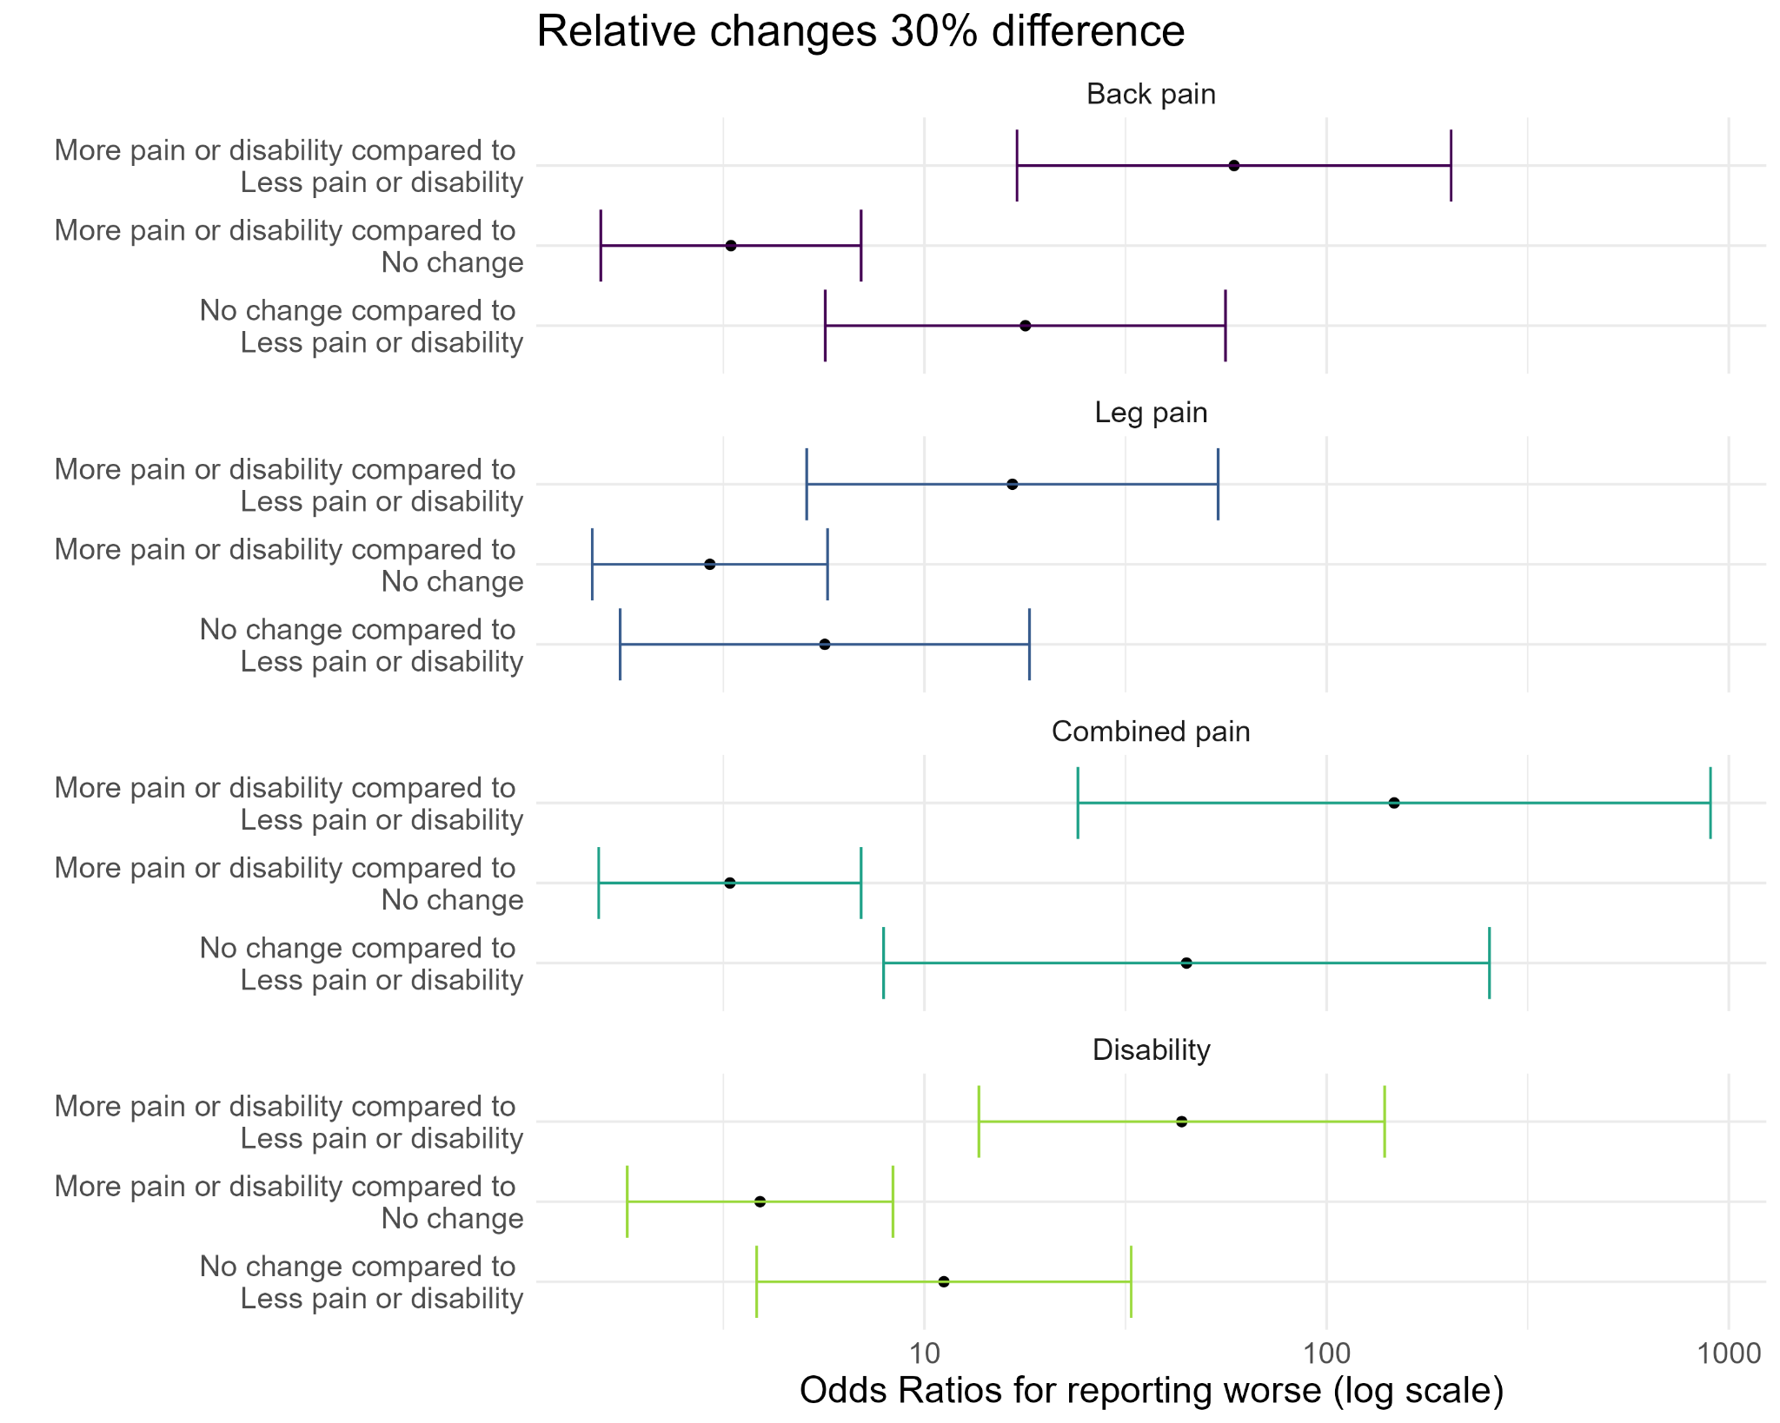
More pain and disability were categorized as >30% difference, no changes were ≤30% and ≥-30% and, and less pain and disability were categorized as < -30%

