Supplementary Information
Emotion regulation variability and flexibility in daily life show distinct associations with well-being, age, and executive functions

Figure S1

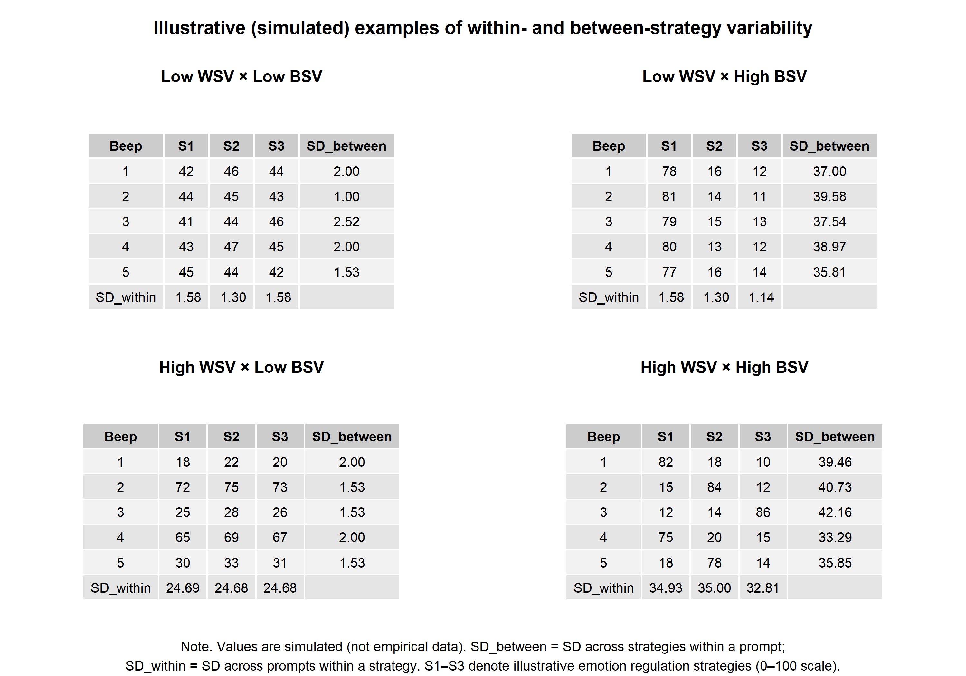
Illustrative examples of within- and between-strategy variability

Figure S2
Distribution of Depressive Symptom Severity

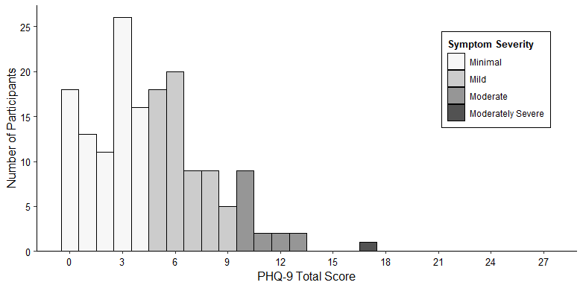

Note. N=161. PHQ-9 total scores showed a characteristic right-skewed distribution. Frequencies (n) and percentages per category were: Minimal (0–4; n=84, 52.2%), Mild (5–9; n=61, 37.9%), Moderate (10–14; n=15, 9.3%), and Moderately Severe (15–19; n=1, 0.6%).

Figure S3
Executive Function Performance as a Function of Age
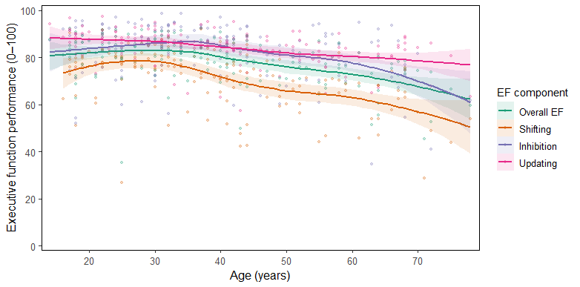

Note. Executive function performance (overall EF, shifting, inhibition, updating) as a function of age. Lines show LOESS smoothers with 95% confidence intervals.

Table S1

Extended Correlation Matrix of Study Variables
Variable | 1 | 2 | 3 | 4 | 5 | 6 | 7 | 8 | 9 | 10 | 11 | 12 | 13 | 14 | 15 | 16
1. Age | —
2. PHQ-9 | -.35* | —
3. EF overall | -.47* | .04 | —
4. Shifting | -.50* | .08 | .85* | —
5. Inhibition | -.24* | -.01 | .77* | .43* | —
6. Updating | -.41* | .02 | .78* | .63* | .41* | —
7. Within-strategy variability | -.06 | .06 | -.06 | -.10 | -.12 | -.00 | —
8. Between-strategy variability | .06 | .02 | -.12 | -.19* | -.14 | -.02 | .91* | —
9. Mean ER strategy endorsement | .25* | -.05 | -.21* | -.28* | -.16* | -.09 | .76* | .91* | —
10. Unpleasant mood | -.11 | .44* | -.09 | -.05 | -.10 | -.06 | .07 | .00 | -.08 | —
11. Flexibility (within; valence) | .02 | -.03 | -.07 | .02 | -.08 | -.05 | -.47* | -.43* | -.34* | .07 | —
12. Flexibility (within; alone) | -.07 | .06 | -.04 | -.10 | -.07 | .03 | .95* | .93* | .80* | .04 | -.54* | —
13. Flexibility (within; with others) | -.07 | .07 | -.01 | -.08 | -.03 | .03 | .87* | .84* | .70* | -.00 | -.78* | .94* | —
14. Flexibility (between; valence) | -.06 | -.02 | .12 | .18 | .12 | .01 | -.90* | -.99* | -.91* | .02 | .44* | -.94* | -.85* | —
15. Flexibility (between; alone) | .09 | -0.08 | -.00 | -.03 | .01 | -.06 | -.27* | -.25* | -.23* | -.06 | -.06 | -.22* | -.14 | .27* | —
16. Flexibility (between; with others) | -.00 | -0.07 | .06 | .09 | .09 | -.05 | -.82* | -.87* | -.80* | .00 | .31* | -.81* | -.71* | .88* | .65* | —
Note. N = 161. Spearman rank-order correlations are reported at the between-person level. AA-based variables reflect averages across the two-week assessment period; EF and depressive symptoms were assessed once. PHQ-9 = Patient Health Questionnaire–9, assessing depressive symptoms. * p < .05. p-values were adjusted using the Benjamini–Hochberg false discovery rate procedure.

