Supplementary Materials:

S1:
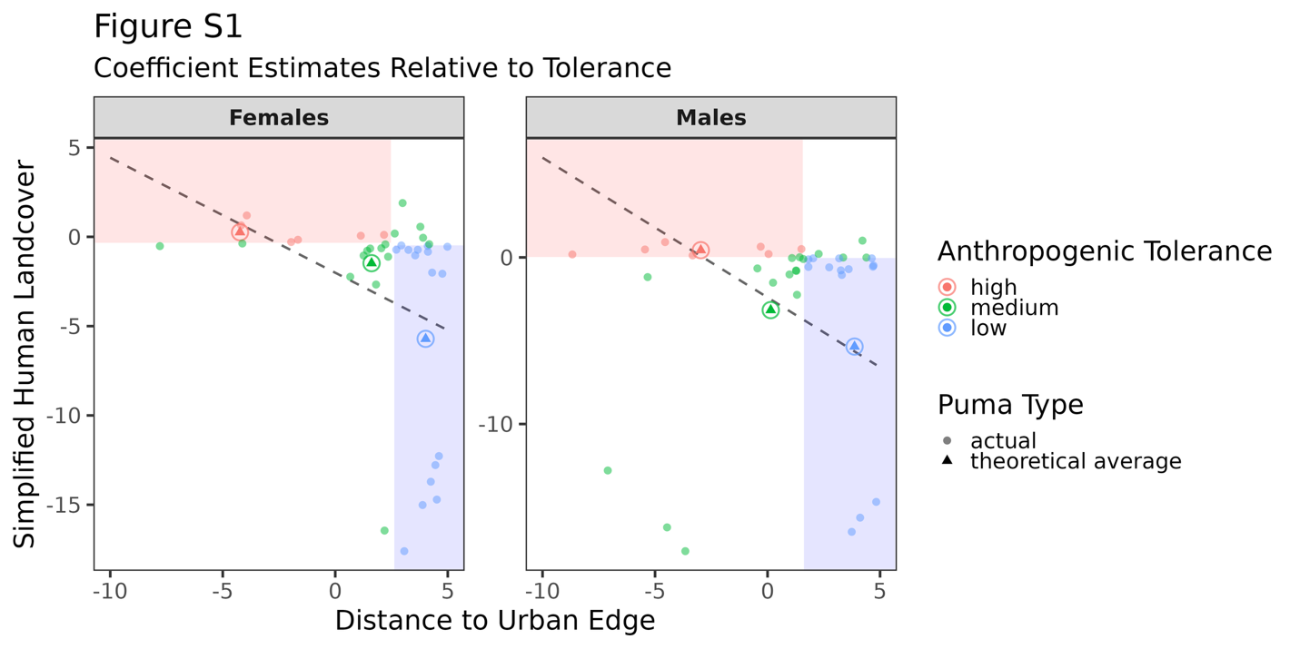
Figure S1: Coefficient estimates for human landcover (y-axis) and distance to urban edge (x-axis) per individual puma by sex. We colored in regions depicting high or low tolerance in red and blue, respectively, based on identified thresholds used to group individuals according to tolerance level. We also modelled the relationship between coefficient estimates per sex using a generalized linear model, and show the linear relationship on the plot as a dotted black line. The theoretical averaged pumas, whose respective coefficients are the result of tolerance-specific averages, are shown as circled triangles. Here we illustrate how the theoretical averaged fall relatively close to the negative linear relationship between the two covariates, illustrating a continuous range of tolerance levels among individual pumas by sex.

S2: Summary Table of Data Availability
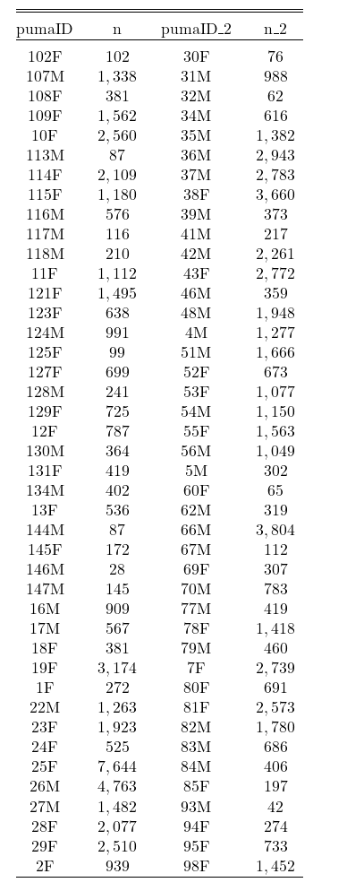

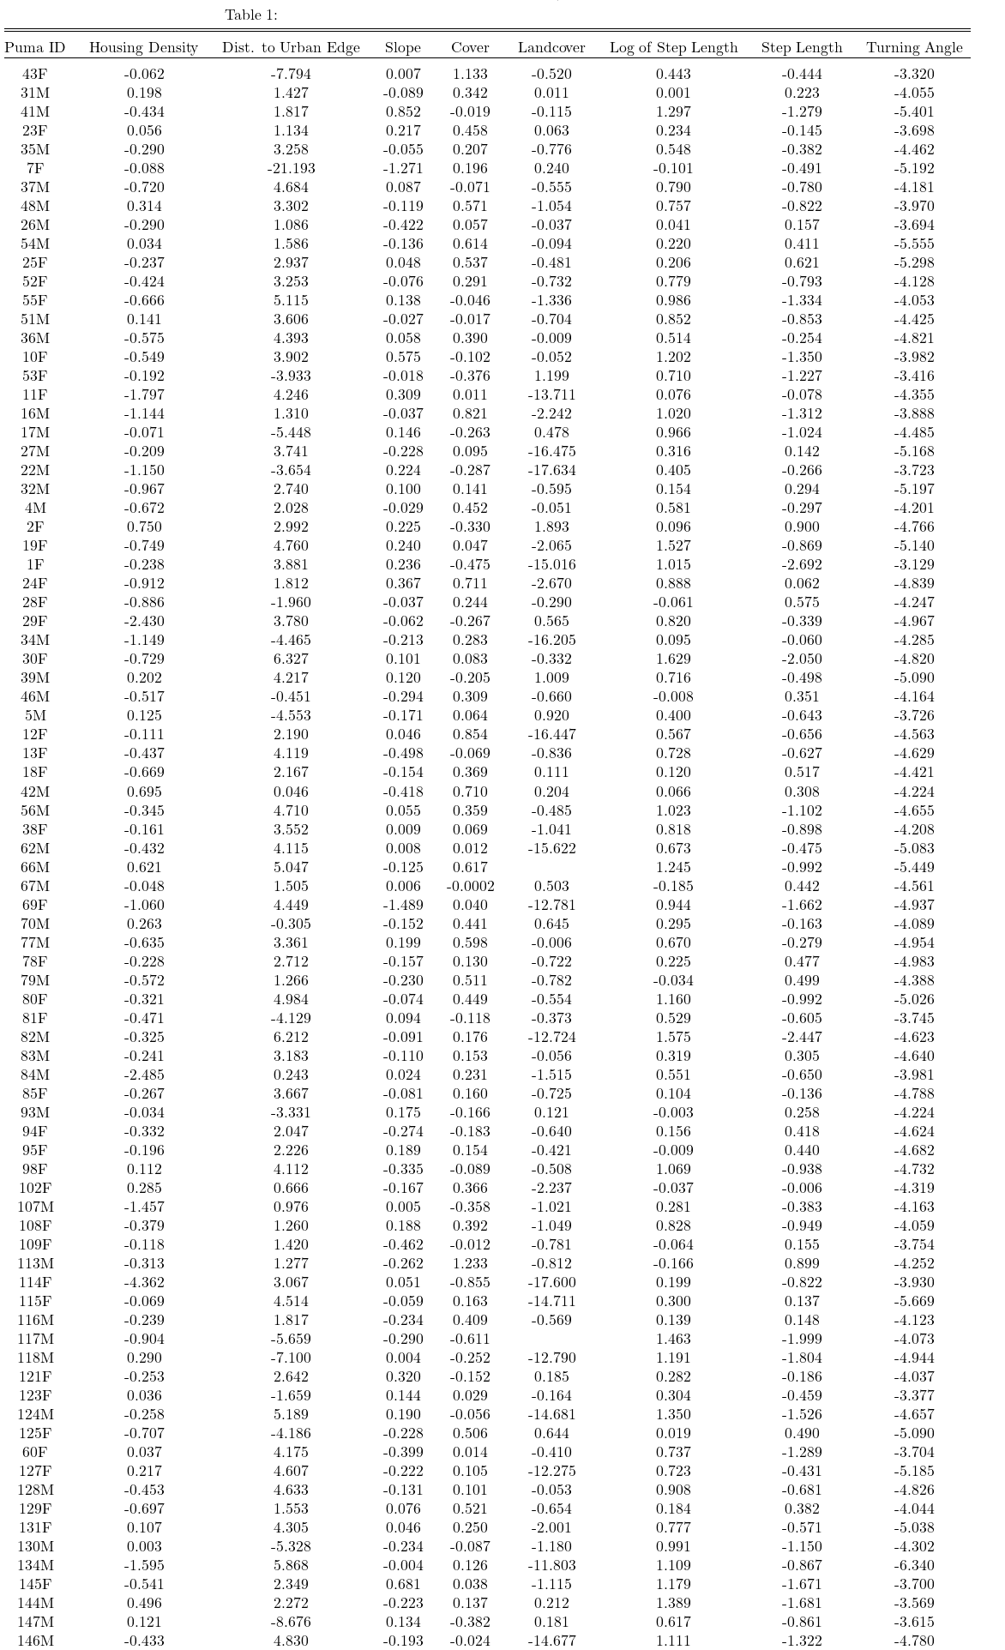
S3: Table of Individual Coefficients

S4: Individual Puma Model Coefficients- Training versus Testing Data

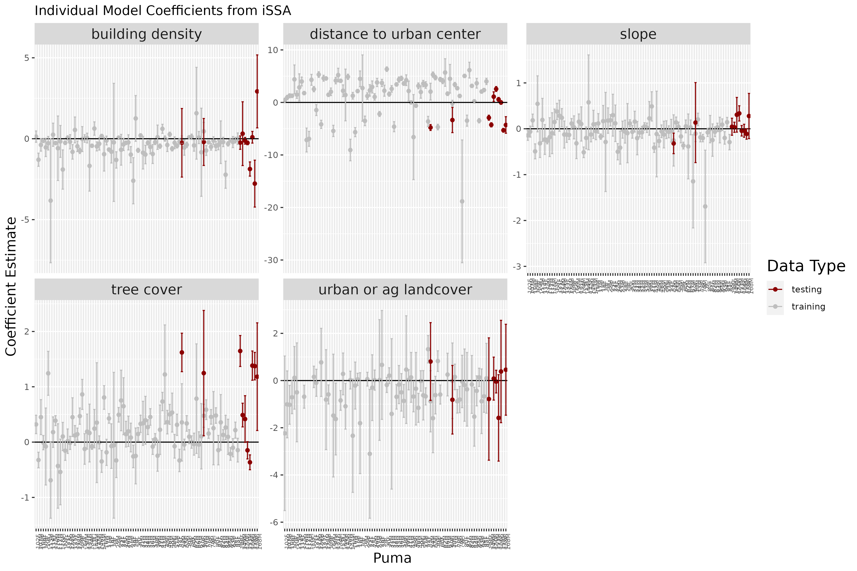
Figure S4
Figure S4: We ran an identical iSSA procedure on a dataset of 10 individual pumas that either dispersed from Santa Cruz southward, or were resident outside of our study area (specifically in Hollister). We generated available points in the same manner described in the manuscript, centered and scaled the environmental covariates using the Santa Cruz-derived mean and standard deviation for each environmental covariate, and fit the same iSSA model to these new ‘testing’ data (e.g., one model per individual). The individual model coefficients are shown in red in the figure above, relative to the individual model coefficients of the 84 Santa Cruz individuals shown in grey. Here we can see that our 10 ‘test’ individuals have a relative selection strength of all covariates within the overall population sample. Specifically, they select distance to urban center and urban or agricultural landcover in a way that is represented by our Santa Cruz population, suggesting that our model and our tolerance thresholds apply to pumas outside of Santa Cruz.

S5: Visual Overlay of Dispersing Pumas and Connectivity Maps

Figure S5
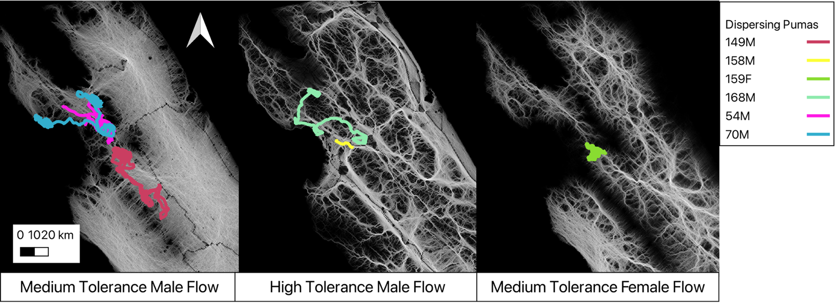
A B C

Figure S5: We visualized the dispersal data of n = 6 dispersing individuals that either dispersed out of Santa Cruz or tried to enter Santa Cruz from the greater Central Coast region. The purpose of this exercise was to determine whether and how our flow maps accurately identified movement ‘pinch-points’, where pumas attempted dispersals, and to see whether certain individuals were better predicted by specific tolerance level maps. We visually matched each dispersal track to the relevant sex-tolerance level flow map. In panel A we mapped three dispersing males who either lost their collars or had a mortality event that we could not contribute to a specific cause. All three attempted to break through the bottlenecking point at the southeast part of our study area, and none succeeded. In panel B we see two males who dispersed across large urban and agricultural areas, and succeeded in crossing the county line. However both were killed. In panel C is one female who attempted a dispersal through a pinch-point. We were unable to determine whether she completed her dispersal because her collar failed transmitting.

S6: Connectivity Probability Along Critical County Line

Figure S6
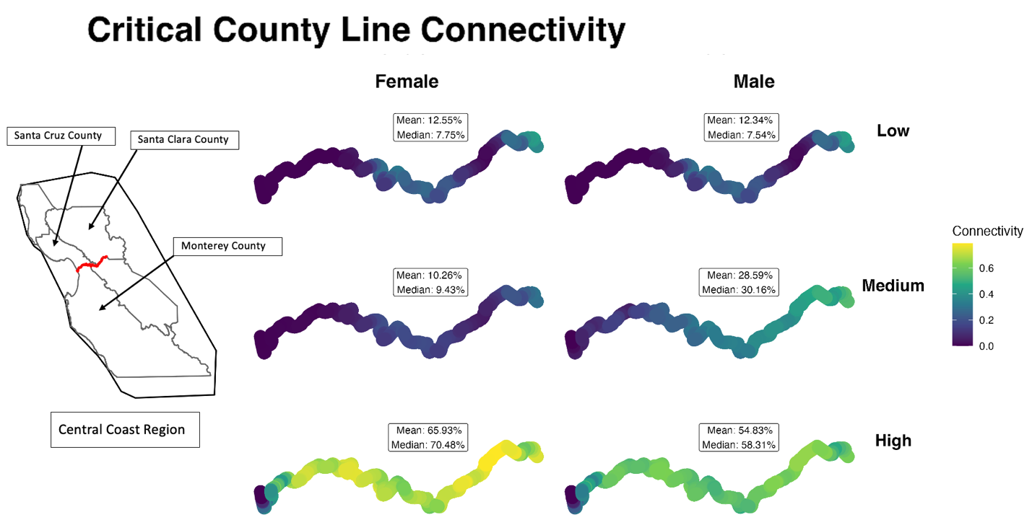
We extracted a shapefile of the southern border of Santa Cruz and East Santa Clara counties, where we identified a potential bottleneck to movement in our connectivity and flow maps. We buffered the county line by 900 meters, and extracted the connectivity probabilities across the buffered county line per sex and tolerance level. We included a reference figure to the Central Coast region, relevant county lines and labels, and highlighted the critical southern border in red.

