Supplementary Information for

Palaeoproteomic insights into the evolutionary history of cave bears from southwestern Europe
Amanda Gutiérrez-Carbajal^{a*}, Elena Santos^{b,c,d}, Esther Lizano^{a,e,f}, Tomas Marques- Bonet^{a,e,g,h}, Ricardo Fong- Zazueta^{i}, Aurora Grandal- d’Anglade ^{j}, David M. Alba^{e,f}, Ana García-Vázquez^{k}, Asier Gómez-Olivencia^{l,m,b}, Mónica Villalba de Alvarado^{n,m,b} Luca Pandolfiº, Lorenzo Rook^{p}, Montserrat Sanz^{q,r}, Joan Daura^{q,r}, João Zilhão^{r}, Juan Luis Arsuaga^{b,s}, José María Bermúdez de Castro^{c} & María Martinón-Torres ^{c,t}
ª Departament de Medicina i Ciències de la Vida, Institut de Biologia Evolutiva (CSIC-UPF), Universitat Pompeu Fabra, Barcelona, Spain; ^{b} Centro Mixto UCM–ISCIII de Evolución y Comportamiento Humanos Madrid, Spain; ^{c} CENIEH (Centro Nacional de Investigación sobre la Evolución Humana), Burgos, Spain; ^{d} Cátedra de Otoacústica Evolutiva y Paleoantropología (HM Hospitales-Universidad de Alcalá), Departamento de Ciencias de la Vida, Universidad de Alcalá, Alcalá de Henares, Madrid, Spain; ^{e} Institut Català de Paleontologia Miquel Crusafont (ICP-CERCA), Universitat Autònoma de Barcelona, Cerdanyola del Vallès, Barcelona, Spain; ^{f} Unidad de Paleobiología, ICP-CERCA, Unidad Asociada al CSIC por el IBE UPF-CSIC, Cerdanyola del Vallès, Barcelona, Spain; ^{g} Catalan Institution of Research and Advanced Studies (ICREA), Passeig de Lluís Companys, Barcelona, Spain; ^{h} CNAG, Centro Nacional de Análisis Genómico, Barcelona, Spain; ^{i} Département de sciences biologiques, Université de Montréal, Montréal, Canada; ^{j} Instituto Universitario de Xeoloxía, Universidade da Coruña, ESCI, A Coruña, Spain; ^{k} ArchaeoScience Platform (ASp), Research Institute of the University of Bucharest (ICUB), University of Bucharest, Bucharest, Romania; ^{l} Departamento de Geología, Facultad de Ciencia y Tecnología, Universidad del País Vasco–Euskal Herriko Unibertsitatea (UPV/EHU), Leioa, Spain; ^{m} Sociedad de Ciencias Aranzadi, Donostia–San Sebastián, Spain; ^{n} Departamento de Procesos Psicológicos Básicos y su Desarrollo, Universidad de País Vasco- Euskal Herrilo Unibertsitatea (UPV/EHU); º Dipartimento di Scienze della Terra, Università di Pisa, Pisa, Italy; ^{p} Dipartimento di Scienze della Terra, Paleo[Fab]Lab, Università degli Studi di Firenze Firenze, Italy; ^{q} Grup de Recerca del Quaternari (GRQ)-SERP, Departament d’Història i Arqueologia, Universitat de Barcelona, Barcelona, Spain; ^{r} Faculdade de Letras, UNIARQ-Centro de Arqueologia da Universidade de Lisboa, Lisboa, Portugal; ^{s} Departamento de Geodinámica, Estratigrafía y Paleontología, Facultad de Ciencias Geológicas, Universidad Complutense de Madrid, Madrid, Spain; ^{t} Department of Anthropology, University College London, London, UK.
SI Contents

I. Additional Methodology
I.1. Database Construction
I.2. Protein Identification and Search Engines
I.3. Sequence Reconstruction and SAP Identification
I.4. Phylogenetic Methods and Tree Reconstruction
I.5. Deamidation and Oxidation rates

II. Results
II.1. Proteomic Recovery Intensity
II.2. SAP Validation:
II.2.1. AMBN-249
II.2.2. AMBN-278
II.2.3. SERPINA1-341
II.2.4. ENAM-269
II.3. Expanded Phylogenetic Trees
II.4. Sex Determination

III. Supplementary References

IV. Dataset S1 (Excel Sheet) – Databases

V. Dataset S2 (Excel Sheet)– Peptide Recovery and Identification

VI. Dataset S3 (Excel Sheet) – SAP Identification and Phylogenetic Support

I. Additional Methodology
I.1. Database Construction
To support protein identification and subsequent phylogenetic analysis, three curated protein databases were generated, each corresponding to a different analytical stage:
- DB_Preliminary: Initial screening database including enamel-associated and systemic proteins (72 proteins, 296 entries) from three extant Ursus species (U. americanus, U. maritimus, U. arctos) and Ailuropoda melanoleuca. Sequences were retrieved from NCBI.
- DB_Main: Updated database excluding Ailuropoda and incorporating additional ursid proteins (76 proteins, 140 entries), including translated sequences from Ursus thibetanus japonicus obtained from previous published whole-genome data.
- DB_Validation: A reduced and highly conservative set (21 proteins, 76 sequences) including only proteins consistently detected across multiple fossil samples with strong peptide support. This database served as the final reference for SAP confirmation and sequence reconstruction.
All three databases included a set of systemic proteins (e.g., AHSG, ALB, SERPINA1, SERPINC1 and APOA1). Although these proteins are not enamel-specific, they have been repeatedly identified in both modern and fossil enamel proteomes [1-3] and are considered recurrent components of the enamel proteome beyond the core enamel-specific proteins.
Genomic Reconstruction of Ursid Proteins. Protein sequences from U. thibetanus japonicus and U. spelaeus were reconstructed when full or reliable reference proteins were unavailable. Sequence processing and protein translation were performed on the Castilla y León Supercomputing Infrastructure (SCAYLE; https://www.scayle.es/).
For the modern genome of Ursus thibetanus japonicus (~30×), raw sequencing data were obtained from the ENA (DRR320311) [4], derived from blood and hair of a male individual. Reads were quality-filtered and trimmed using fastP v0.20.4 [5], discarding those shorter than 30 bp. Paired-end reads were merged and mapped to the Ursus arctos reference genome (RefSeq GCF_023065955.2) [6] using BWA mem v0.7.17 [7]. Duplicates were removed with biobambam v2.0.35 [8] with the bammarkduplicates command. Variant calling was performed with GATK HaplotypeCaller algorithm [9]. Gene coordinates (coding sequences) were extracted from genome annotations [6]. Protein translation was carried out in silico using internally developed Python scripts [2, https://github.com/RicardoFong/primate_enamelome]. This workflow yielded nearly complete sequences for 16 proteins, including AMELX, ENAM, AMBN, AMTN, COL17A1, COL1A1, ALB, ODAM, MMP20, SERPINC1, COL2A1, AHSG, KLK11, SERPINF1, and F2.
For Ursus spelaeus, an ancient genome (~2.85×) from Cova Eirós (Galicia, Spain) was obtained from the ENA (ERR2678619 and ERR2678620) [10]. The individual, dated to ~31 ka [11], corresponds to specimen E-VD-1838, also analyzed proteomically in this study. Given the degraded nature of ancient DNA, a modified pipeline was used: reads were trimmed and merged using fastp, then mapped to the Ursus arctos genome with BWA v0.7.74 [12] with the aln algorithm. Duplicates were removed with biobambam as described before. Base calling was performed using ANGSD with dofasta option[13], coding sequences were obtained through in-house bash scripts, and protein translation followed a modified version of the previously described Python-based protocol. Five enamel-related proteins were successfully reconstructed: AMBN, AMTN, MMP20, ODAM and SERPINC1. Missing regions were completed using consensus sequences generated with EMBOSS Cons [14] from homologous alignments within the reference set. These sequences were not used for peptide searches, but only for independent validation, avoiding circularity.
Amelogenin (AMELX/AMELY) reconstruction. To enable peptide-based sex determination, AMELX and AMELY isoforms were reconstructed for Ursus arctos because database versions were incomplete. Canonical AMELX transcript of Ailuropoda melanoleuca (Ensembl v112, ENSAMET00000045715.1) was retrieved and translated. For Ursus arctos, the X and Y chromosome assemblies (RefSeq CM057520.1 and CM057521.1) were obtained from NCBI (PRJNA807323). Homologous regions corresponding to AMELX and AMELY exons were identified using BLAST+ v2.13.0+ with the following commands:
blastn -db Y_scaff_pbio_hap2.fasta -query ailme_amelx.fa -out ursarctos_amely.out
blastn -db X_scaff_pbio_hap2.fasta -query ailme_amelx.fa -out ursarctos_amelx.out
Exons were translated into amino acid sequences using the ExPASy Translate Tool [15] and assembled into full-length AMELX and AMELY proteins. These sequences were incorporated into the “DB_Main” and “DB_Validation”. To increase sequence diversity, AMELX proteins from Ursus maritimus and Ailuropoda melanoleuca were also included.
I.2. Protein Identification Parameters and Search Engines
Mass spectrometry data were processed using MaxQuant v2.0.2 [16] and PEAKS Studio Xpro v10.6, whose complementary strengths (database-dependent identification vs. powerful de novo detection) increased peptide recovery and SAP discovery. A two-stage approach was adopted for the peptide search, with a final stage for sequence validation:
- MQ1 – Preliminary search. MaxQuant search against DB_Preliminary to identify candidate proteins and estimate basic coverage.
- MQ2 – Main search. Parallel MaxQuant and PEAKS searches against DB_Main, which included reconstructed proteins and candidate SAPs predicted by the PEAKS SPIDER module.
- MQ3 – Validation search. MaxQuant search against the conservative DB_Validation to confirm protein identities and filter SAPs. High-confidence peptides uniquely identified in PEAKS were incorporated only if they met strict criteria: robust spectra, endogenous PTMs, and reproducibility across engines.
The final dataset used for all analyses presented in this study corresponds to the MQ3 workflow. Previous to sequence reconstruction, the results obtained in this third search were combined with the results from the advanced search in PEAKS to increase, in some cases, the coverage of the identified protein sequences. Any SAP observed by PEAKS was accepted only if validated in MQ3 under MaxQuant, ensuring consistency across platforms.
I.3. Sequence Reconstruction and SAP Identification
Protein reconstruction from ancient peptide fragments was carried out using a combined automated–manual workflow designed to maximize accuracy while minimizing false positives, particularly for single amino acid polymorphisms (SAPs).
Reconstruction of Sample-Specific Protein Sequences. For the reconstruction of proteins from ancient peptide fragments, MaxQuant output files (summary.txt, msms.txt, evidence.txt) were processed using an adapted semi-automated R pipeline [17] to map peptide coordinates onto the DB_Validation reference proteins, producing preliminary FASTA reconstructions for each specimen. All discrepancies between MaxQuant-derived sequences and de novo suggestions from MaxNovo and PEAKS were inspected manually.
Peptides were excluded when they met one or more of the following criteria:
- Low-quality MS/MS spectra, including poor ion coverage, low Andromeda scores (<70), or absence of a consistent b/y ion series across the peptide sequence (limited gaps at terminal positions were tolerated).
- Very low signal intensity relative to background noise (< 20%).
- Peptides likely of non-endogenous origin (e.g., microbial or contaminant sequences).
Peptides uniquely identified by PEAKS were incorporated only if they satisfied the following conditions:
- Consistent recovery across PEAKS modules (de novo, DB and SPIDER).
- High-quality spectra, with well-resolved b/y ion series.
- Presence of ancient-typical PTMs, such as deamidation or hydroxylation.
- No conflicting evidence in overlapping peptides detected by MaxQuant.
Final sequences were exported in FASTA format. Ambiguous residues were denoted by a hyphen ("-") to indicate gaps in the sequence reconstruction.
SAP Identification and Validation. A multi-criteria validation framework was applied to all SAP candidates detected across search engines.
Candidate SAPs initially identified in PEAKS were also considered for further validation en MaxQuant even when supported by a single PSM, provided that the MS/MS spectra showed a high- quality fragmentation. These candidates where evaluated in MaxQuant (MQ2 and MQ3) to confirm their presence. A variant was retained only when satisfying all of the following requirements:
- Redundant peptide-level support: at least two PSMs and/or overlapping peptides containing the same amino acid substitution [18,19].
- BLAST validation: peptides were aligned against public protein databases to confirm their taxonomic assignment and consistent alignment to the homologous position within the reference protein sequence.
- High-quality fragment-ion evidence: manual inspection of MS/MS spectra confirming clear ion series across the variable residue.
- PTM consideration: potential interference from PTMs (especially deamidation at N/Q) were evaluated to exclude modification-derived artefacts.
- Nucleotide substitution plausibility: substitutions were required to be compatible with realistic single-base or chemically plausible double-base changes.
- Reproducibility: where possible, recurrence of the same substitution across multiple specimens from the same species or stratigraphic context was considered as additional support.
SAPs meeting all criteria were considered high-confidence and retained for analysis. This filtering explains why, out of the 48 substitutions detected across all proteins, only a subset, including AMBN-249, AMBN-278 and SERPINA1-341, qualified as robust lineage-informative markers.
I.4. Phylogenetic Methods and Tree Reconstruction
12 proteins were included in the final phylogenetic dataset: AHSG, ALB, AMBN, AMELX, AMTN, COL1A1, COL17A1, ENAM, MMP20, ODAM, SERPINA1, SERPINC1. The dataset includes both enamel-specific proteins, collagens and systemically expressed proteins (AHSG, ALB, SERPINA1, SERPINC1). Although their incorporation in enamel proteome may reflect more complex biological pathways, their inclusion increases the number of informative positions available for phylogenetic analysis. Proteins were selected based on the following criteria:
- Functional relevance (enamel-associated or highly expressed in the enamel proteome), in line with previous palaeoproteomic studies [17-20].
- Sequence variability, quantified as the number of validated SAPs supported across specimens.
- Reconstruction reliability, with priority given to proteins showing robust and overlapping peptide coverage.

In addition to proteins showing high numbers of informative SAPs, a subset of more conserved proteins (e.g., COL1A1, AMELX) was also retained due to their high sequence coverage. Although these proteins contribute limited amino acid variation, their inclusion helps avoid overrepresentation of highly variable loci and provides a more balanced representation of the recovered proteome. This approach reduces potential bias in phylogenetic inference and is consistent with recent work highlighting differences in evolutionary rates and informational content across enamel and collagen proteins [21].
For sequence reconstruction and downstream phylogenetic analyses, when multiple variants occurred at the same site, the amino acid supported by the highest number of high-confidence PSMs was selected. This step is required by FASTA format constraints, which allow only a single residue per position. As a result, in cases of heterozygosity, the majority-supported amino acid was retained for downstream phylogenetic analyses. While this approach enables the generation of complete alignments, it may lead to the loss of biologically relevant variation and should therefore be interpreted with caution.
To maximize phylogenetic signal and reduce missing data, consensus sequences were generated for phylogenetic analyses at the level of species, site, and stratigraphic unit using EMBOSS Cons (European Bioinformatics Institute, EMBL-EBI). This strategy increased coverage in poorly sampled regions and improved the robustness of downstream analyses. A conservative filtering scheme was applied, whereby only specimens displaying consistent amino acid patterns were merged, while sequences with ambiguous positions, were excluded from species-level consensus construction.
Despite this conservative framework, the use of consensus sequences may still obscure intra-population variability, including heterozygous positions and site-specific variation observed such as AMBN-249. As such, the resulting phylogenetic reconstructions primarily reflect dominant sequence patterns and should not be interpreted as capturing the full extent of underlying population-level diversity.
The origin of the sequences included in each species-level consensus is detailed below:
- For Ursus dolinensis, all specimens from level TD4 of Gran Dolina were merged.
- For Ursus deningeri, samples from Sima de los Huesos, Cueva Mayor, and Sala de las Oseras were combined.
- For Ursus spelaeus, sequences from Cova Eirós and Coro Trasito, and specimen from Monte Cucco were merged.
Reference Databases for Comparative Alignment. Two taxonomically structured reference sets were compiled:
- Carnivora Reference Database (“Carnivora Dataset”): A broad panel of 11 species representing six families (Ursidae, Canidae, Mustelidae, Phocidae, Odobenidae, Felidae). This dataset includes 132 curated entries for the 12 proteins, primarily retrieved from NCBI (see Supplementary Dataset S1, Table S1.5 for accession numbers). Missing sequences were reconstructed from published genomes when needed. Panthera tigris served as the outgroup.
- Ursid Reference Database (“Ursidae Dataset”): Focused on intra-family resolution, including Ursus arctos, U. maritimus, U. americanus, U. thibetanus, and Ailuropoda melanoleuca (outgroup: Canis lupus familiaris). This dataset comprises 60 entries for the same 12 proteins, predominantly retrieved from NCBI (see Supplementary Dataset S1, Table S1.6 for accession numbers).
All reconstructed ancient protein sequences and reference proteins were aligned using MAFFT v7.520 [22]. Reference proteins from the comparative database were aligned using the following parameters:
mafft --amino --maxiterate 1000 --globalpair reference_db.fasta > aligned_reference_db.fasta
Reconstructed sequences from ancient samples were added using the --addfragments method to minimize misalignment due to gaps or missing data:
mafft --reorder --keeplength --addfragments cavebear_samples.fasta --auto aligned_reference_db.fa > final_msa_cavebear.fa
Alignments were visually inspected and corrected manually. To retain only the most phylogenetically informative regions, alignments were filtered using GBlocks [23], which removes ambiguous or poorly aligned regions. To address the ambiguity caused by isobaric amino acids leucine (L) and isoleucine (I), which are indistinguishable in ancient proteomics, all isoleucine residues were converted to leucines at variable positions. Signal peptides, when present, were removed based on annotations from UniProt, with the exception of COL17A1, where the signal peptide was retained. Final per-protein alignments were concatenated in the following order:
AHSG, ALB, AMBN, AMELX, AMTN, COL1A1, COL17A1, ENAM, MMP20, ODAM, SERPINA1, and SERPINC1.
Two concatenated alignments were generated based on the reference database used: a Carnivora-wide dataset and a Ursidae-focused dataset. Both alignments comprised 6614 amino acid positions. Non-missing positions per specimen (excluding gaps and ambiguous residues) were consistent across modern samples (~6600 positions), while fossil specimens showed reduced coverage, ranging from 1461 to 2528 positions (Table S1). Missing or unobserved sequence positions were encoded as "?" in final FASTA format.
Especies | No-missing positions
Mustela erminea | 6600
Mustela putorius furo | 6398
Phoca vitulina | 6255
Mirounga leonina | 6019
Odobenus rosmarus | 6581
Panthera tigris | 6595
Canis lupus familiaris | 6598
Ailuropoda melanoleuca | 6603
Ursus americanus | 6569
Ursus arctos | 6602
Ursus maritimus | 6606
Ursus thibetanus | 6604
Ursus dolinensis | 1461
Ursus spelaeus | 2528
Ursus deningeri | 2278
Table S1. Summary of the number of non-missing amino acid positions per specimen in final concatenations, excluding gaps and ambiguous residues.
Phylogenetic Inference. Phylogenetic relationships were inferred from the concatenated protein alignments using both maximum likelihood (ML) and Bayesian inference (BI) methods:
- ML analyses were performed with IQ-TREE v1.6.12 [24] using partition-specific models selected by ModelFinder [25]. Ultrafast bootstrap (5,000 replicates) was used to assess node support. Main command:
iqtree -nt 4 -s Namefile_concatenated.fasta -spp $partfile -alrt 5000 -bb 5000 -nstop 500 -nm 10000 -wsplits -pre $outdir
- MrBayes v3.2.7a [26] was used with the same partitioning scheme as in IQ-TREE. Each protein was defined as a separate partition with unlinked parameters. The mixed amino acid model prior was used to allow model averaging across substitution matrices:
mcmc nchains=8 nruns=4 ngen=3000000 samplefreq=100 diagnfreq=1000 burninfrac=0.25
All phylogenetic trees were visualized and annotated in R using the ape package. Final trees display both ML bootstrap values and Bayesian posterior probabilities where applicable.

I.5. Deamidation and Oxidation rates
Deamidation of glutamine (Q) and asparagine (N), together with oxidation of methionine (M) and proline (P), was quantified using a custom script. The script calculates conversion ratios between modified and unmodified residues, normalized to peptide spectrum matches (PSMs), and validated by 1000 bootstrap replicates. Early Pleistocene specimens displayed more advanced diagenesis, with lower yields and shorter peptides.

II. Supplementary Results
II.1. Proteomic Recovery Intensity
Relative peptide intensities (log10-transformed) were compared with the number of peptide-spectrum matches (PSMs) for all specimens (Main Text, Fig. 2A). Across the dataset, Pleistocene samples show comparable intensity values, while the modern Ursus arctos individual exhibits the expected higher abundance characteristic of fresh enamel. Some Middle and Late Pleistocene specimens display higher PSM counts than the modern bear despite comparable intensity. This mismatch reflects differences in spectrum assignment efficiency rather than true protein abundance, since intensity quantifies peptide signal directly, whereas PSM counts depend on database matching and fragmentation behavior. Thus, intensity provides a complementary metric of preservation, confirming that peptide abundance aligns with the expected diagenetic gradient even when PSM numbers vary. All samples were analyzed using identical extraction, LC–MS/MS, and instrument settings.

Figure S1. Total peptide intensity (log10 scale) across all enamel samples.

II.2. SAP Validation
A complete summary of all identified SAPs across specimens, including their phylogenetic support and confidence classification, is provided in Dataset S3- SAP Identification and Phylogenetic Support. The distribution of validated single amino acid polymorphisms (SAPs) varies across enamel and serum proteins. Enamel proteins such as AMBN and ENAM show the highest number of substitutions, while proteins including MMP20 and AHSG carry only limited variation. Some SAPs appear restricted to single individuals, whereas others are shared across multiple taxa or temporal ranges. Figure S2 illustrates the distribution of SAPs along the aligned protein sequences, highlighting regions of concentrated variability, whereas Table S1 lists all variations and their corresponding proteins, classified by phylogenetic significance.
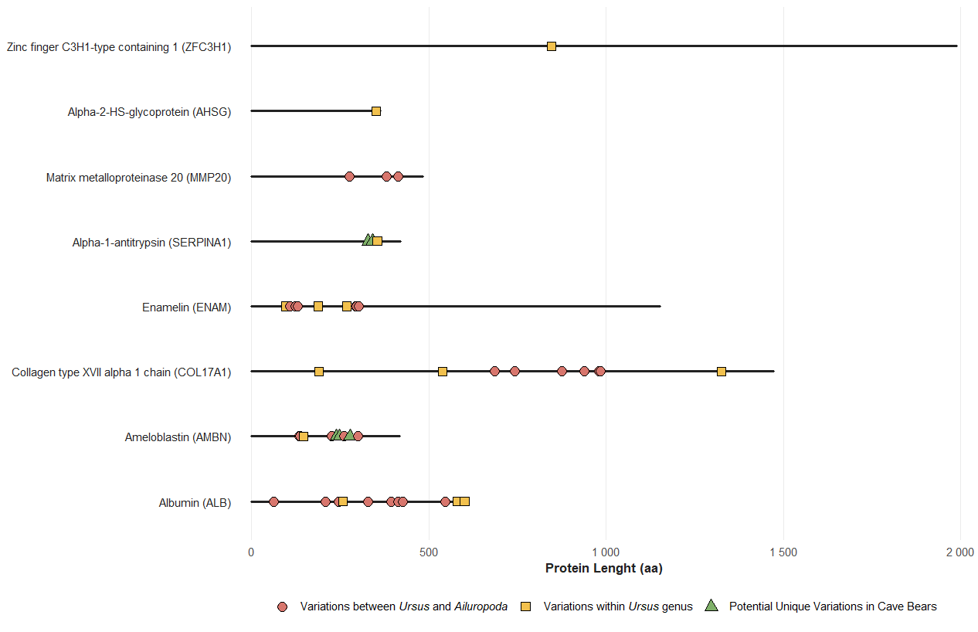Figure S2. Distribution of identified single amino acid polymorphisms (SAPs) across protein sequences. Lollipop plot depicting variable amino acid positions along enamel and serum proteins. Each marker represents a SAP, scaled by frequency.

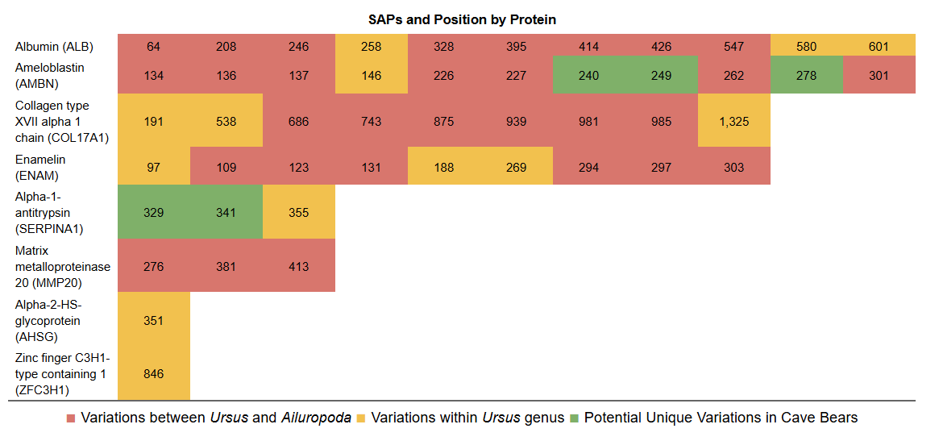
Table S2. Single amino acid polymorphisms (SAPs) identified in enamel and serum proteins. Summary of proteins with their respective number and positions of SAPs, including novel variants.

II.2.1. SAP AMBN-249 (Y→S)
The AMBN-249 substitution [tyrosine (Y) → serine (S)] is consistently present in all Middle and Late Pleistocene U. deningeri and U. spelaeus specimens, as well as several individuals assigned to Ursus sp. (Main Text, Figure 3). High-quality, overlapping spectra from both MaxQuant and PEAKS confirm this variant (Figure S3- Figure S6).
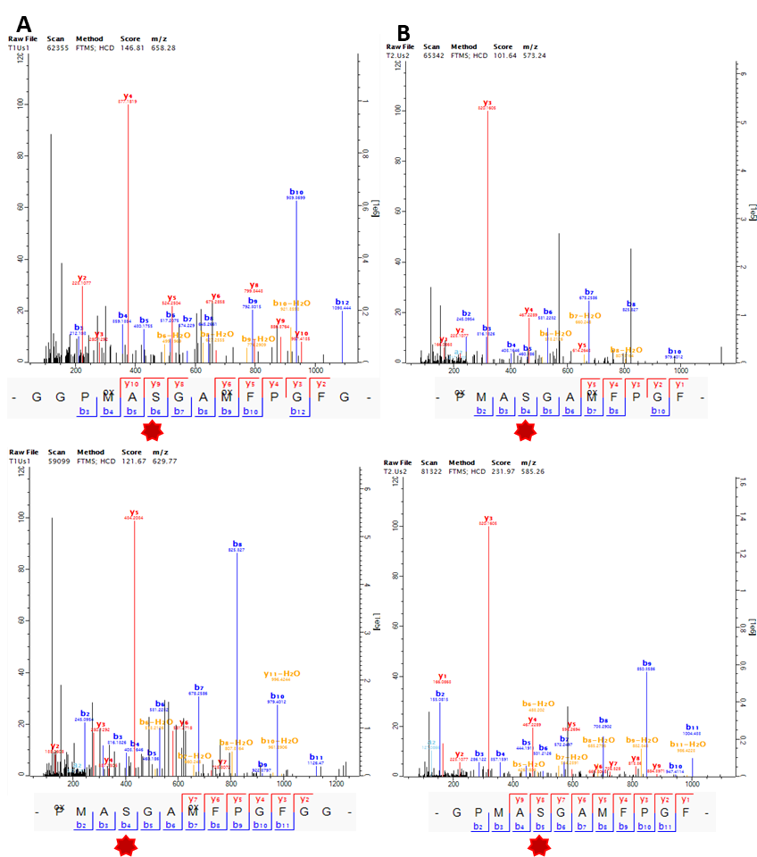
Figure S3. Selection of mass spectra and corresponding fragment ions covering AMBN-249 obtained with MaxQuant from Ursus spelaeus specimens. (A) Sample CT.1. (B) Sample CT.2.
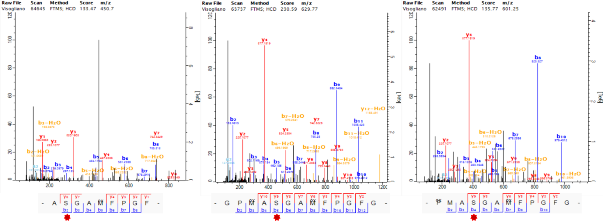
Figure S4. Selection of mass spectra and corresponding fragment ions covering AMBN-249 obtained with MaxQuant in Vis.1 sample Ursus deningeri.
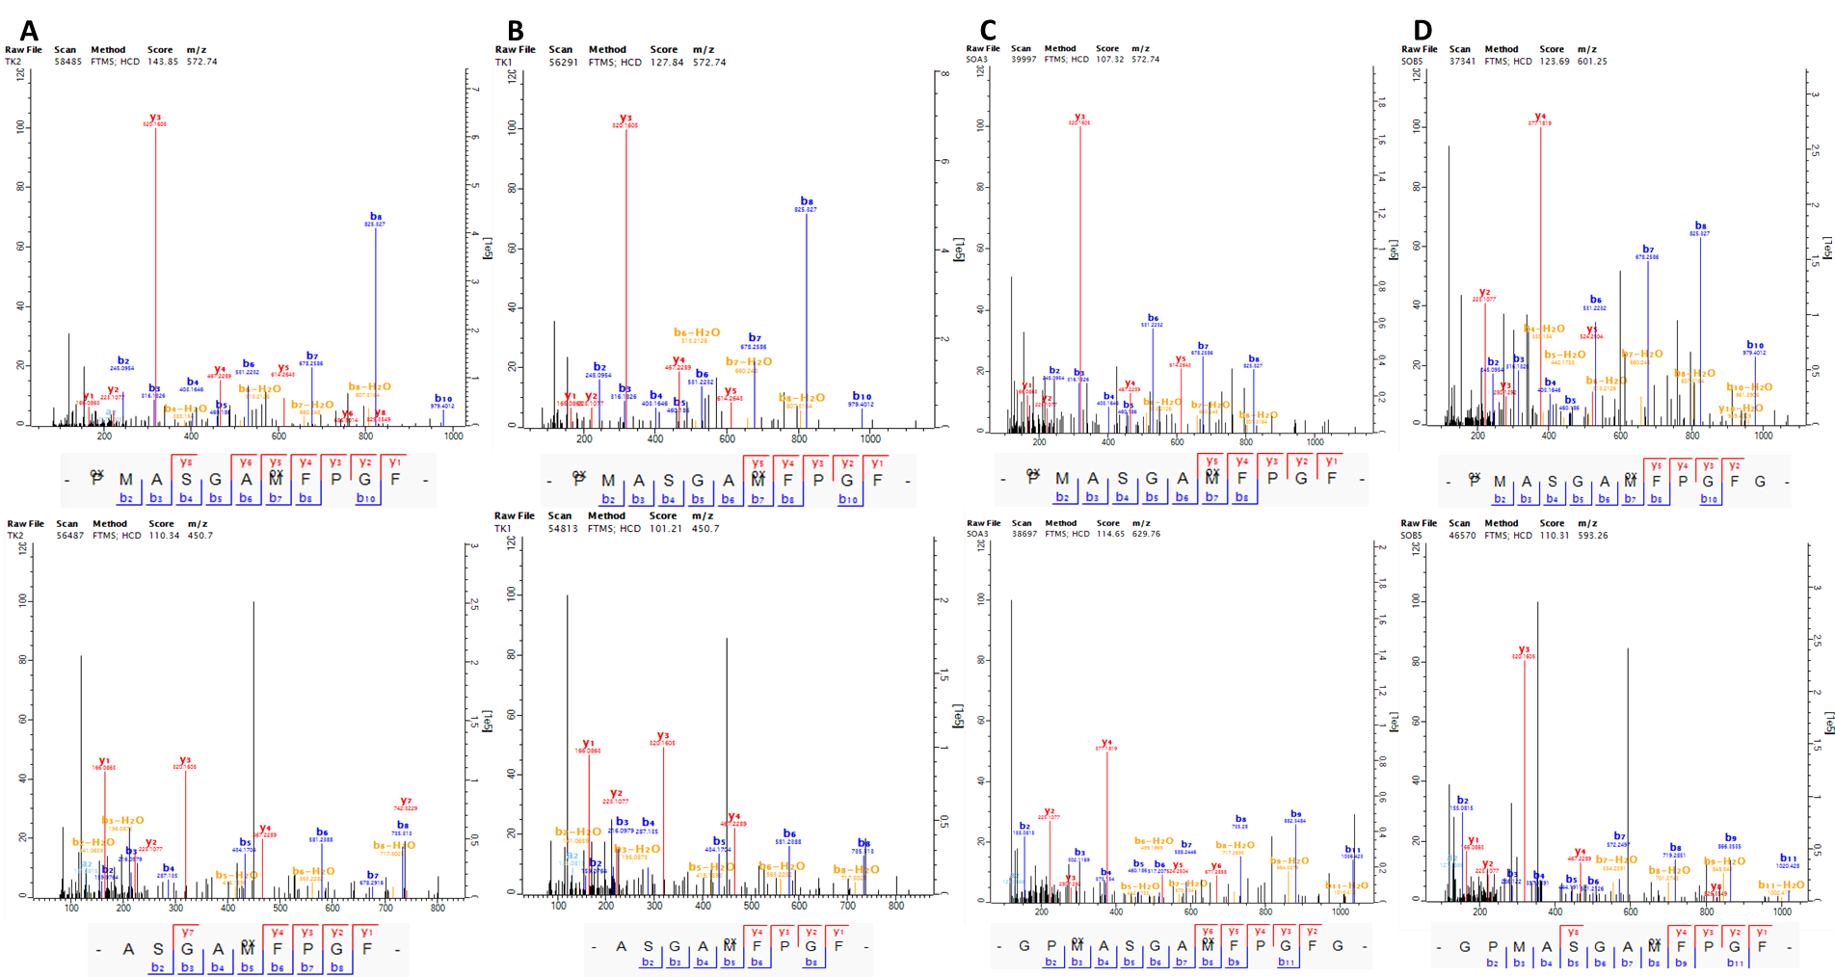Figure S5. Selection of mass spectra and corresponding fragment ions covering AMBN-249 obtained with MaxQuant from Ursus deningeri specimens. (A) Sample TK.2. (B) Sample TK.1. (C) Sample TK.A3. (D) Sample TK.B5.
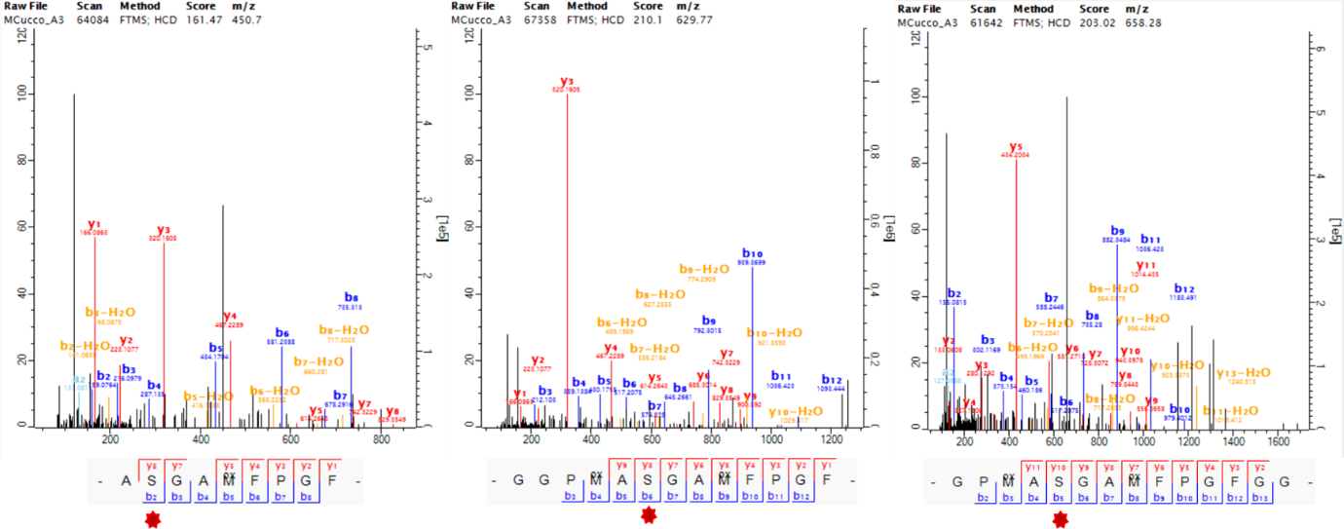
Figure S6. Selection of mass spectra and corresponding fragment ions covering AMBN-249 obtained with MaxQuant in MC.A3 sample Ursus spelaeus.
In addition, two specimens (ARO.1 and TD8.J21) show evidence of heterozygosity at this position: both the reference and substituted peptide variants were identified within the same individual, with co-occurring spectra supporting true heterozygosity rather than analytical noise. All corresponding spectra are presented below, with annotated ion series confirming each variant.
Sample TD8.J21 from TD8 level in Gran Dolina Site, shows clear evidence of heterozygosity, with both tyrosine (Y) and serine (S, derived state) variants detected. Independent identifications from MaxQuant (Figure S7 and Figure S8) and PEAKS (Figure S9) confirmed the presence of both forms in equal proportions, with peptide-spectrum matches (PSMs) supporting each amino acid at 50%,ruling out analytical noise. Consistent post-translational modifications were observed in spectra of both variants.
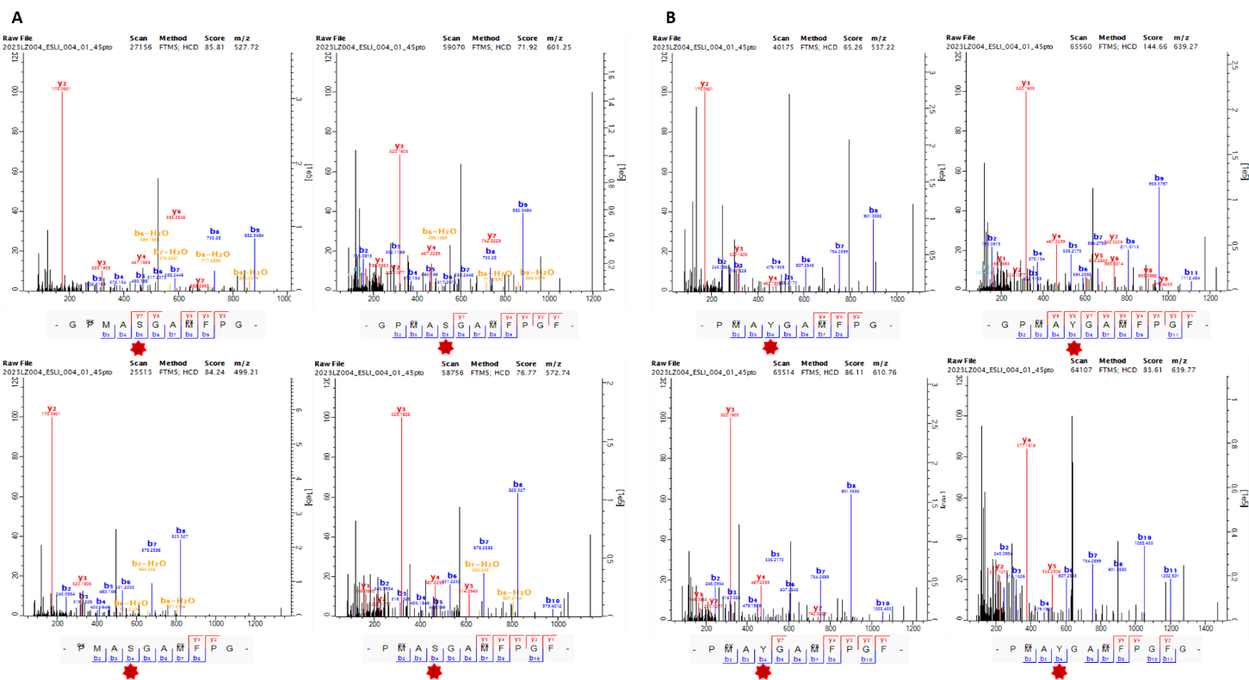
Figure S7. Mass spectra and corresponding fragment ions covering AMBN-249 in TD8.J21 Ursus deningeri, obtained with MaxQuant. (A) Peptides containing serine (S). (B) Peptides containing Tyrosine (Y).
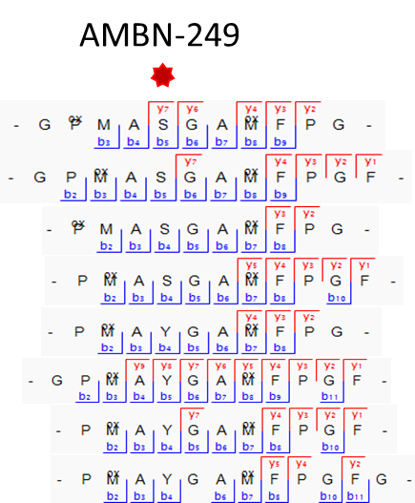
Figure S8. Peptide and fragment-ion coverage of AMBN; position 249 in specimen TD8.J21, marked with a red asterisk.
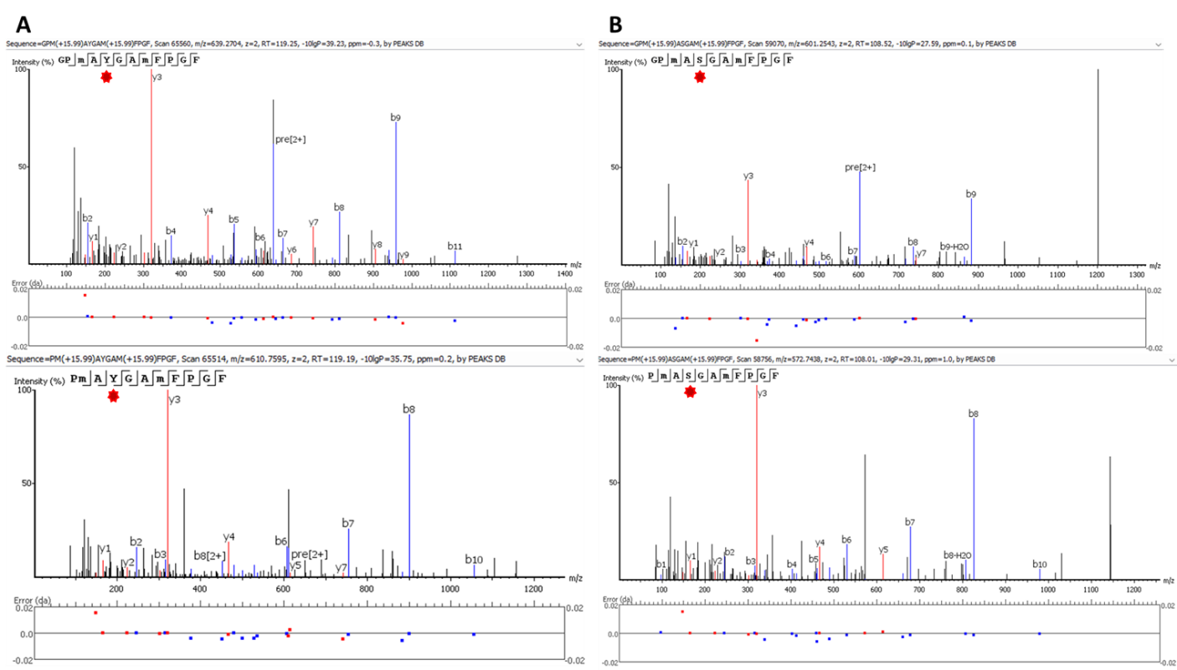
Figure S9. Mass spectra covering AMBN-249 in TD8.J21 Ursus deningeri obtained with PEAKS. (A) Unique peptides containing Y. (B) Unique peptides containing S.

Sample ARO.1 from Aroeira Site, shows tentative evidence for heterozygosity. MaxQuant identified a peptide carrying S, while PEAKS recovered both Y-containing peptides and one additional S peptide supported by a low-quality spectrum (Figure S10). Although engine-specific discrepancies and limited spectral support caution against over-interpretation, the co-occurrence of Y and S at this site is consistent with putative heterozygosity in this specimen.
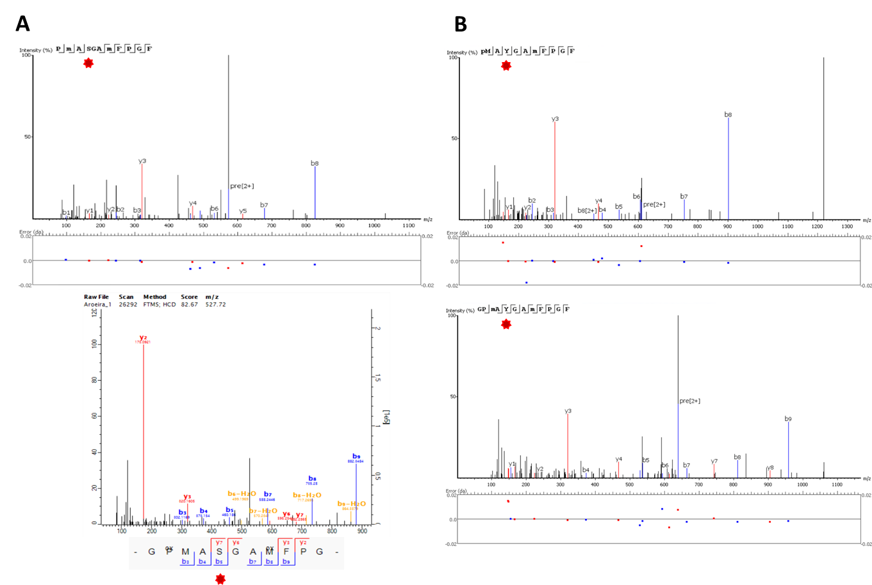
Figure S10. Mass spectra and corresponding fragment ions covering AMBN-249 in ARO.1 Ursus deningeri (A) Unique peptides containing S obtained by PEAKS and MaxQuant. (B) Unique peptides containing Y obtained by PEAKS.

II.2.2. SAP AMBN-278 (L→V)
The AMBN-278 substitution was identified exclusively in the Sala Fantasma specimen SF30.A (Figure S11). Multiple overlapping peptides from both MaxQuant and PEAKS confirming the presence of a residue change from leucine (L) to valine (V) (Figure S12 and Figure S13). This substitution could be explained by a single nucleotide change affecting the codon for leucine (CUU, CUC, CUA, or CUG) into a codon for valine (GUU, GUC, GUA, or GUG), consistent with a transversion at the first nucleotide position. Both L and V are hydrophobic and nonpolar, suggesting that this substitution is unlikely to drastically alter the protein’s structure or function.
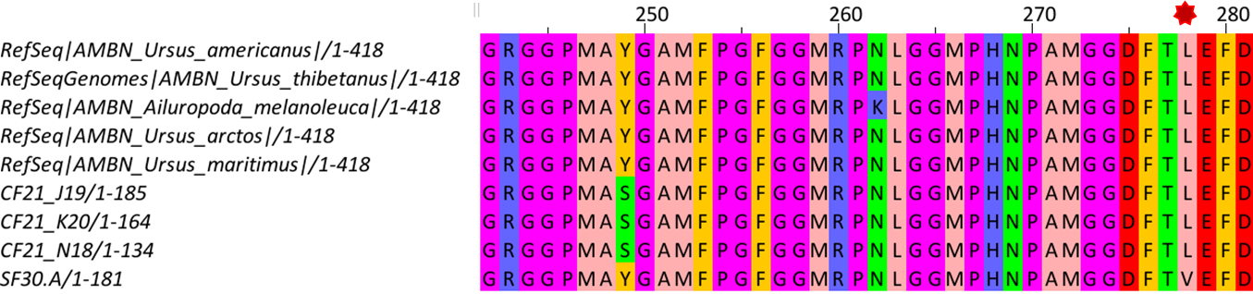
Figure S11. Multiple sequence alignment of the ameloblastin (AMBN) protein generated with Jalview using the comparative dataset, showing the variable positions AMBN-249 and AMBN-278, with the latter highlighted by a red asterisk.
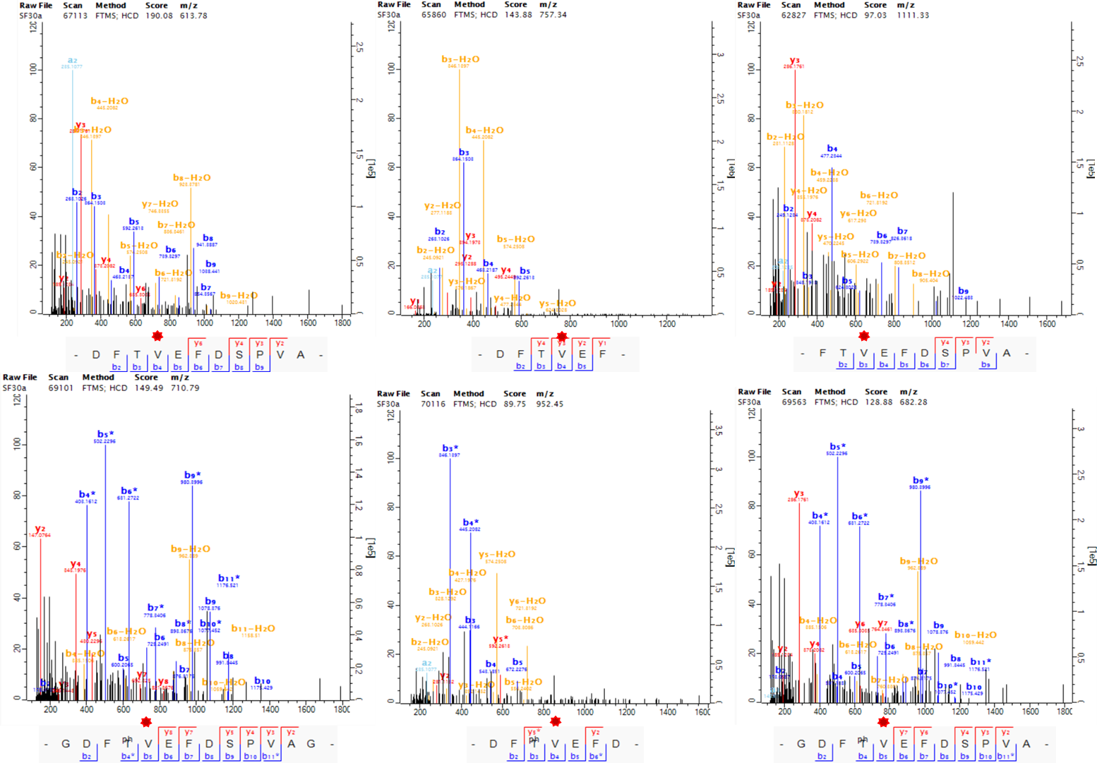
Figure S12. Mass spectra and corresponding fragment ions covering AMBN-278 in SF30.A Ursus sp. using MaxQuant, highlighted by a red asterisk.

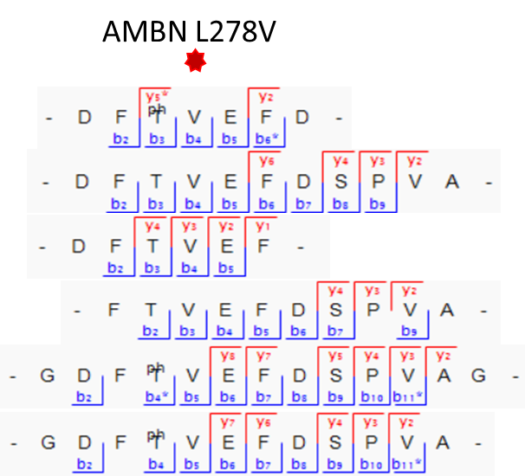
Figure S13. Peptide and fragment-ion coverage of AMBN; position 278 in specimen SF30.A (Ursus sp.) marked with a red asterisk.

II.2.3. SAP SERPINA1-341 (N→T)
The substitution at SERPINA1-341 [asparagine (N) → threonine (T)], is widespread among Middle and Late Pleistocene U. deningeri, U. spelaeus, and several Ursus sp. individuals, as well as one U. arctos. Early Pleistocene specimens consistently retain the N. High-confidence spectra from both search engines confirm the substitution (Figure S14- S17).
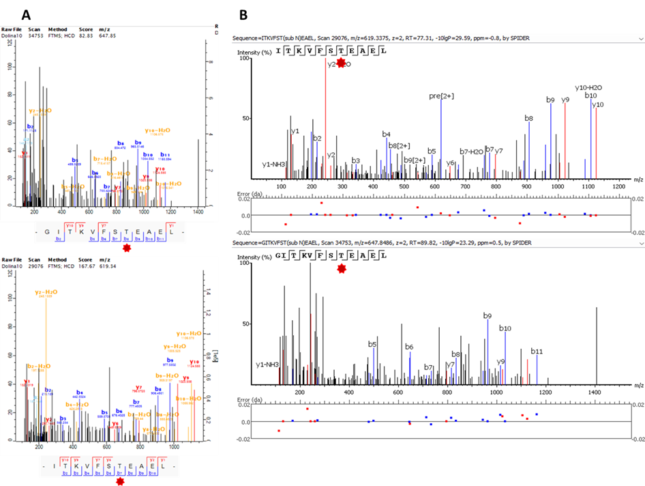
Figure S14. Mass spectra and corresponding fragment ions covering SERPINA1-341 in TD10.4.J11 Ursus deningeri. (A) Unique peptides containing Threonine obtained by MaxQuant. (B) Unique peptides containing Threonine obtained by PEAKS.
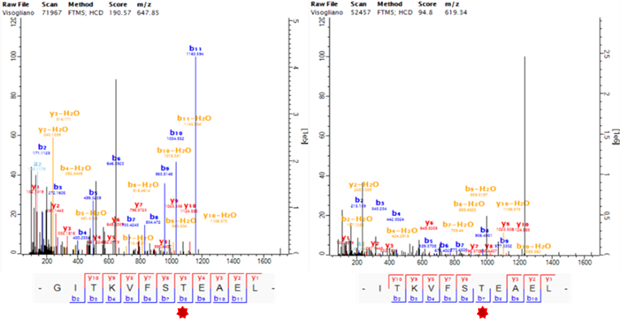
Figure S15. Mass spectra and corresponding fragment ions covering SERPINA1-341 in Vis.1 Ursus deningeri specimen using MaxQuant.
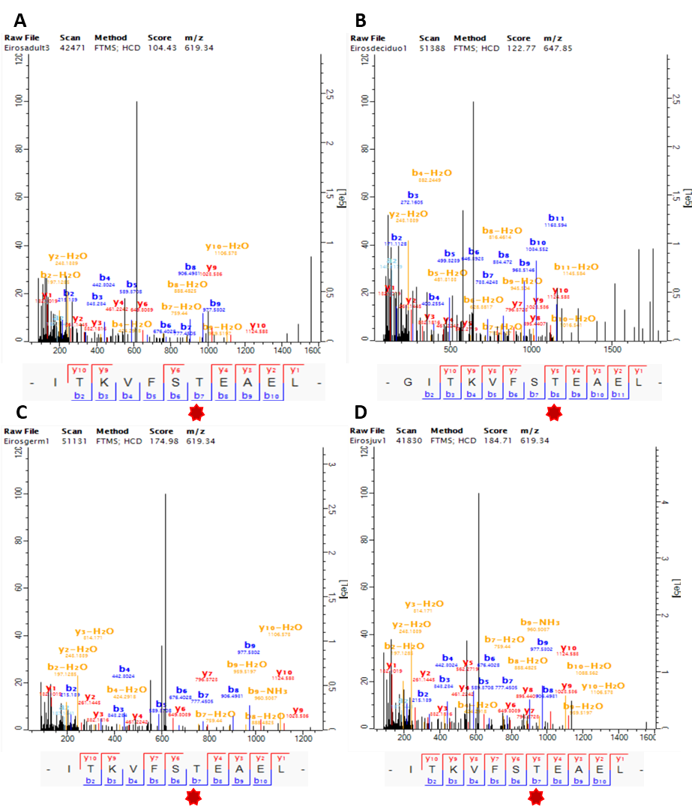
Figure S16. Selection of mass spectra and corresponding fragment ions covering SERPINA1-341 obtained with MaxQuant from Ursus spelaeus specimens. (A) Sample EA.3. (B) Sample Ed.1. (C) Sample EG.1. (D) Sample EJ.1.

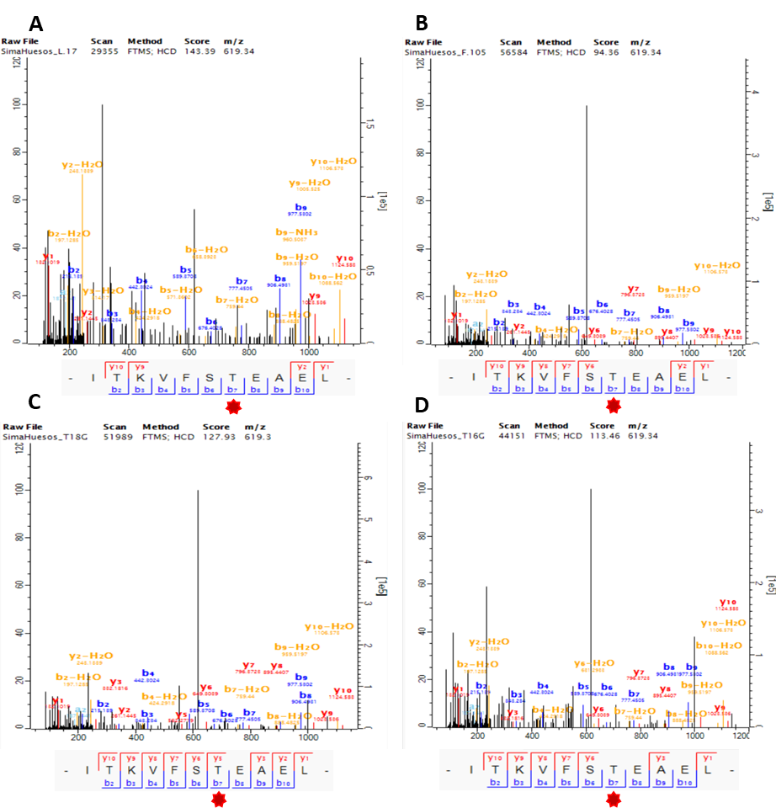
Figure S17. Selection of mass spectra and corresponding fragment ions covering SERPINA1-341 obtained with MaxQuant from Ursus deningeri specimens. (A) Sample SH.T18.L17. (B) Sample SH.Q20.F105. (C) Sample SH.T18.L75. (D) Sample SH.T16G.
The Monte Cucco Ursus samples reveal unusual signatures in SERPINA1. At position 341, both MC.879 and MC.A3 display T instead of the conserved asparagine (N) observed in all reference sequences. This variant is supported by overlapping peptides identified with MaxQuant and PEAKS (Fig. S22). In addition, MC.804 exhibits allelic diversity at position 355, with peptides containing lysine (K, ~75%) and methionine (M, ~25%). While K only matches U. americanus. Their co-occurrence suggests heterozygosity or unrecognized allelic variation at this site (Figure S20). These findings underscore that each Monte Cucco specimen carries a distinct proteomic signature, adding complexity to the evolutionary interpretation of the locus. A further possibility is misattribution of specimens, since U. spelaeus is also reported from Monte Cucco. However, the morphometric data do not support a reassignment to this taxon [27].
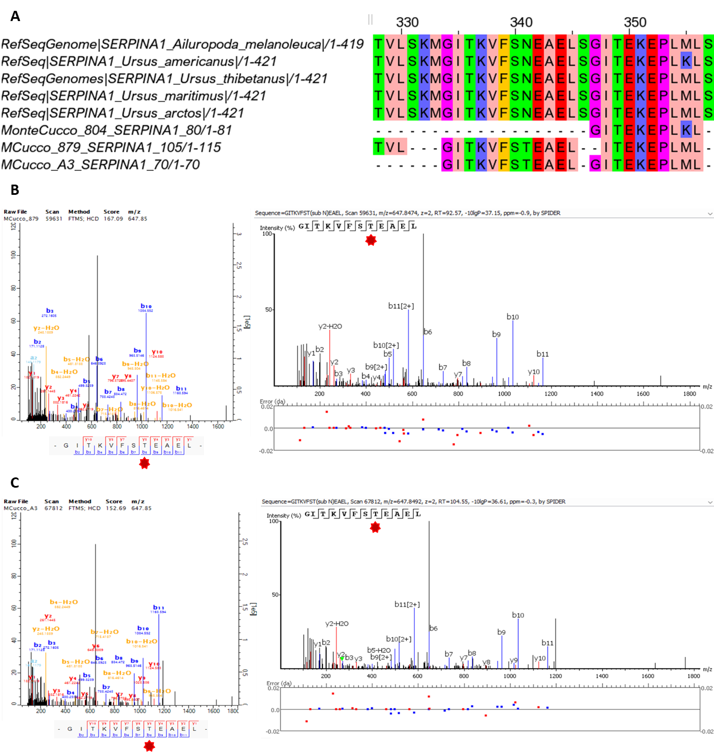
Figure S18. Variability in SERPINA1 from Monte Cucco specimens. (A) Multiple sequence alignment of SERPINA1 showing two variable sites (positions 341 and 355) in the Monte Cucco samples compared with the reference dataset. (B) Representative MS/MS spectra from MC.879 Ursus arctos, supporting the novel T substitution at position 341, identified with MaxQuant and PEAKS. (C) Equivalent spectra from MC.A3 Ursus spelaeus confirming the same substitution, identified with MaxQuant and PEAKS.
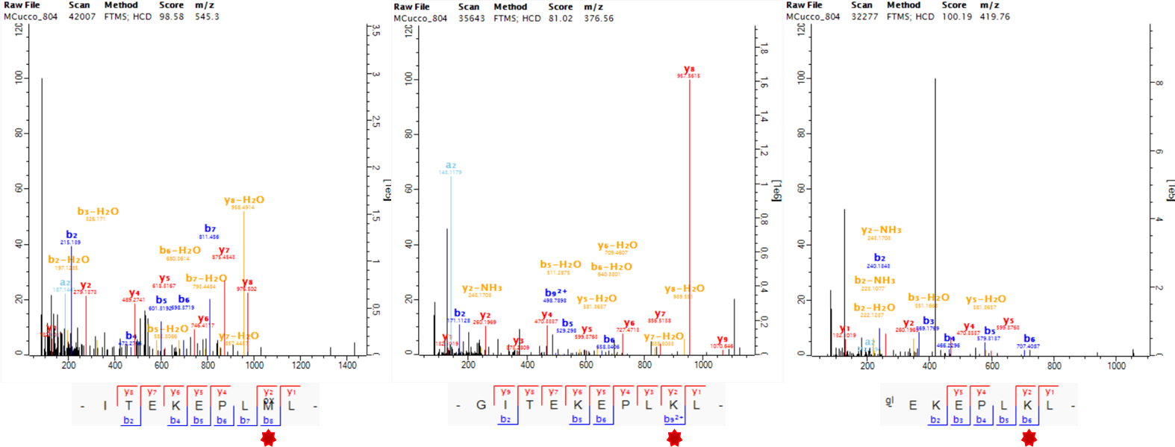
Figure S19. SERPINA1-355 variation in MC.804. Representative MS/MS spectra obtained with MaxQuant showing two coexisting variants at position 355.

II.2.4. SAP ENAM-269 (N→I)
ENAM-269 [asparagine (N)→ isoleucine (I)] was consistently detected in seven specimens of U. deningeri and U. spelaeus, as well as in U. maritimus, but not in U. dolinensis, where no peptide coverage was recovered at this site (Figure S20). High-confidence identifications and characteristic deamidation rates support authenticity [28]. At the nucleotide level, this change could result from two possible single-base substitutions (AAU→AUU or AAC→AUC), both requiring an A→U transition at the second codon position, although the exact codon change cannot be determined unambiguously from proteomic data alone. The presence of the same substitution in both cave bears and U. maritimus may reflect independent parallel evolution driven by similar selective pressures, or alternatively, complex demographic dynamics, given the documented hybridization of U. arctos with both U. maritimus and U. spelaeus [29,30]. Absence of Early Pleistocene coverage limits evaluation of its temporal origin (Figure S21).
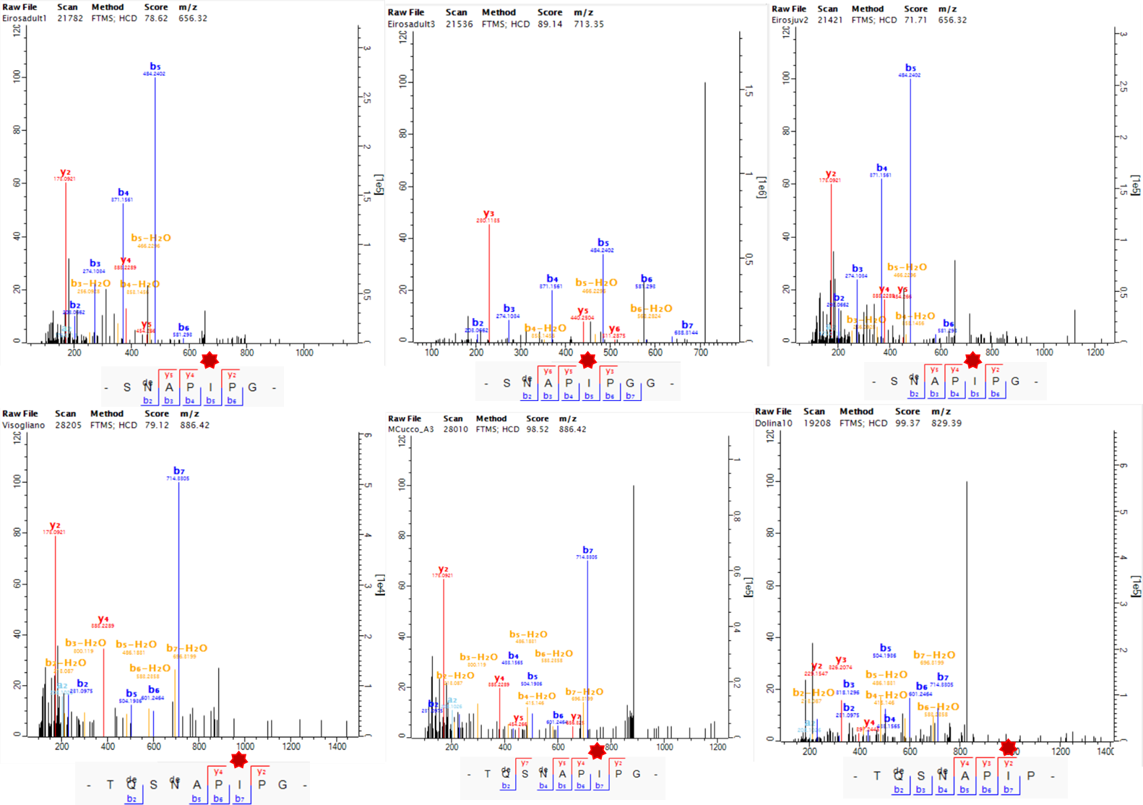
Figure S20. Mass spectra and corresponding fragment ions covering ENAM-269 in several samples from the Middle and Late Pleistocene using MaxQuant. ENAM-1328 position is highlighted by a red asterisk.
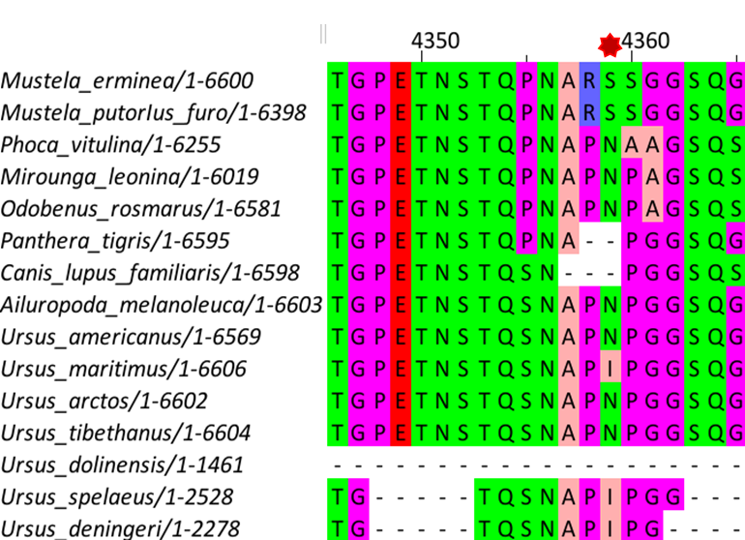

Figure S21. Multiple sequence alignment of ENAM across different Carnivora species. ENAM-269 position is highlighted by a red asterisk.

II.3. Expanded Phylogenetic Trees
To complement the phylogenetic analyses presented in the Main Text, additional reconstructions were generated using both comparative datasets (Carnivora and Ursidae) and including all available specimens at the individual level (Figure S22- Figure S23).
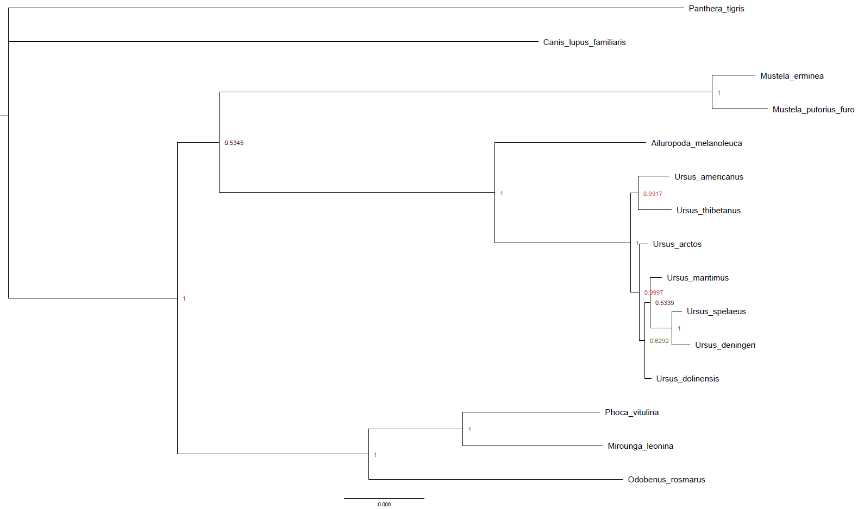
Figure S22. Bayesian phylogenetic tree generated using MrBayes and the “Carnivora Dataset”.

Figure S23. Maximum likelihood phylogenetic tree generated using IQTree and the “Ursidae Dataset”.

Analyses were restricted to specimens with sufficient peptide coverage. Individuals from Pirro Nord and Estació Vallparadís were excluded due to extensive fragmentation and limited SAP recovery: among the seven most informative sites, only AMBN-278 was detected consistently, and SERPINA1-355 was identified in two Vallparadís specimens (EVT7.1 and EVT12.2). Including these individuals would have introduced excessive missing data and reduced resolution.
Maximum likelihood analysis (Figure S24) recovered the expected split between arctoid and speleoid lineages, consistent with previous studies, although support values were moderate (bootstrap = 58/100). As in earlier analyses, Ursus maritimus clustered within the speleoid lineage, close to the divergence with U. arctos, albeit with weak support (IQ-TREE = 34/100). Notably, specimen SF30.A.G30 (Sala Fantasma, Ursus sp.) grouped with U. arctos with moderate support (IQ-TREE = 49/100), suggesting shared ancestry.
Bayesian inference (Figure S25) yielded a broadly congruent topology, generally recovering fewer resolved nodes but with higher posterior probabilities. In this framework, the separation between arctoid and speleoid lineages was not clearly recovered, and the placement of some specimens differed from the maximum likelihood reconstruction.
Figure S24. Maximum likelihood phylogenetic tree generated using IQTree and the “Ursidae Dataset” including all recovered specimens.

Figure S25. Bayesian phylogenetic tree generated using MrBayes and the “Ursidae Dataset” including all recovered specimens.

II.4. Sex Determination: Peptides from AMELX/AMELY
The reconstructed Ursus arctos AMELX and AMELY sequences correspond to the canonical X- and Y-linked amelogenin isoforms. The present analysis focuses on the reference protein sequences used for database construction and peptide mapping. For consistency, amino acid positions are reported according to the AMELX sequence. These sequences reveal diagnostic sequence differences that enable sex determination in cave bear specimens. AMELX spans 201 amino acids, whereas AMELY comprises 182 amino acids, consistent with typical mammalian amelogenin divergence. Despite high overall identity (89.05%), several isoform-specific markers provide robust peptide-level differentiation: At the N-terminal region, AMELX contains an alanine at position 16, whereas AMELY displays a threonine (T), marking the earliest divergence point between the sequences (Figure S26). A single-residue deletion is observed relative to AMELX at position 45, where AMELY lacks a methionine present in AMELX. Further substitutions occur in the central portion of the sequence: at position 101, methionine in AMELX is replaced by valine in AMELY, while at position 104, leucine is replaced by valine. The most striking difference is located in the C-terminal domain, where AMELY exhibits an 18 amino acid deletion spanning positions 138–156 relative to the AMELX sequence, as defined in the reference sequence used for database construction. These features, particularly the deletion at position 45, substitutions at positions 101 and 104, and the C-terminal 18 aa deletion, produce distinct peptide signatures that were consistently detected in male individuals across the dataset. Multiple high-confidence MS/MS spectra from both MaxQuant and PEAKS confirm the presence of AMELY-specific peptides, ensuring reliable assignment. Importantly, absence of AMELY peptides must be interpreted cautiously: AMELY is naturally expressed at much lower levels (~10% of AMELX) [31], and allelic loss or taphonomic degradation can obscure its detection.
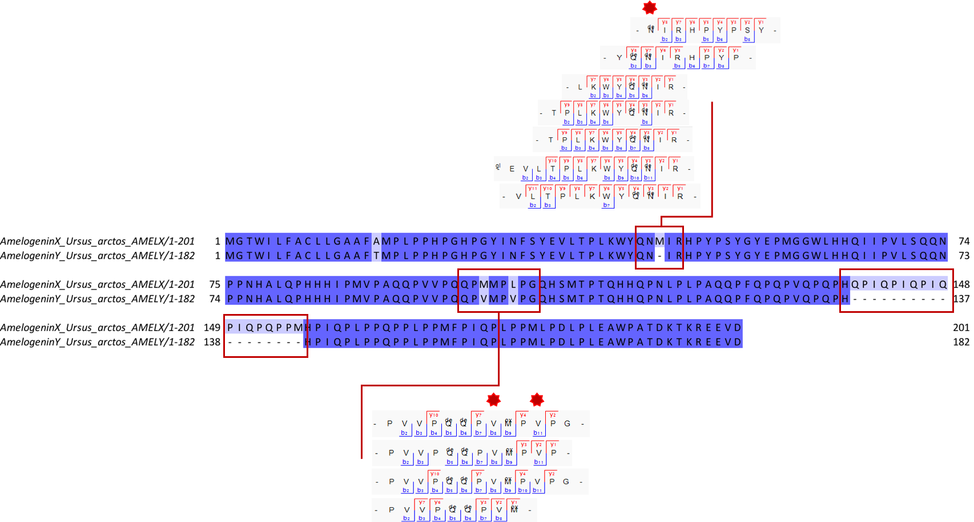
Figure S26. Alignment of reconstructed Ursus arctos AMELX and AMELY sequences. Amino acid alignment highlighting diagnostic differences between X- and Y-linked isoforms. Diagnostic ion series from representative peptides are shown below, illustrating the MS/MS fragmentation patterns that confirm the presence of the Y-specific isoform in male specimens. Amino acid positions are reported relative to the AMELX sequence.

III. Supplementary References

- C. Froment, et al., Protein sequence comparison of human and non-human primate tooth proteomes. Journal of Proteomics 231, 104045 (2021).
- R. Fong-Zazueta, et al., Phylogenetic Signal in Primate Tooth Enamel Proteins and its Relevance for Paleoproteomics. Genome Biol Evol 17, evaf007 (2025).
- Fu, Q. et al. Enamel proteins from six Homo erectus specimens across China. Nature 1–7 (2026) doi:10.1038/s41586-026-10478-8.
- T. Kishida, M. Ohashi, Y. Komatsu, Genetic diversity and population history of the Japanese black bear ( Ursus thibetanus japonicus ) based on the genome‐wide analyses. Ecological Research 37, 647–657 (2022).
- S. Chen, Y. Zhou, Y. Chen, J. Gu, fastp: an ultra-fast all-in-one FASTQ preprocessor. Bioinformatics 34, i884–i890 (2018).
- E. E. Armstrong, et al., A Beary Good Genome: Haplotype-Resolved, Chromosome-Level Assembly of the Brown Bear (Ursus arctos). Genome Biology and Evolution 14, evac125 (2022).
- H. Li, Aligning sequence reads, clone sequences and assembly contigs with BWA-MEM. arXiv preprint arXiv:1303.3997 (2013).
- G. Tischler, S. Leonard, biobambam: tools for read pair collation based algorithms on BAM files. Source Code Biol Med 9, 13 (2014).
- A. McKenna, et al., The Genome Analysis Toolkit: A MapReduce framework for analyzing next-generation DNA sequencing data. Genome Res. 20, 1297–1303 (2010).
- A. Barlow, et al., Partial genomic survival of cave bears in living brown bears. Nat Ecol Evol 2, 1563–1570 (2018).
- G. G. Fortes, et al., Ancient DNA reveals differences in behaviour and sociality between brown bears and extinct cave bears. Molecular Ecology 25, 4907–4918 (2016).
- H. Li, R. Durbin, Fast and accurate short read alignment with Burrows-Wheeler transform. Bioinformatics 25, 1754–1760 (2009).
- T. S. Korneliussen, A. Albrechtsen, R. Nielsen, ANGSD: Analysis of Next Generation Sequencing Data. BMC Bioinformatics 15, 356 (2014).
- F. Madeira, et al., Search and sequence analysis tools services from EMBL-EBI in 2022. Nucleic acids research 50, W276–W279 (2022).
- E. Gasteiger, et al., ExPASy: the proteomics server for in-depth protein knowledge and analysis. Nucleic acids research 31, 3784–3788 (2003).
- J. Cox, M. Mann, MaxQuant enables high peptide identification rates, individualized ppb-range mass accuracies and proteome-wide protein quantification. Nature biotechnology 26, 1367–1372 (2008).
- P. P. Madupe, et al., Enamel proteins reveal biological sex and genetic variability in southern African Paranthropus. Science 388, 969–973 (2025).
- A. J. Taurozzi, et al., Deep-time phylogenetic inference by paleoproteomic analysis of dental enamel. Nat Protoc 19, 2085–2116 (2024).
- E. Cappellini, et al., Early Pleistocene enamel proteome from Dmanisi resolves Stephanorhinus phylogeny. Nature 574, 103–107 (2019).
- F. Welker, et al., The dental proteome of Homo antecessor. Nature 580, 235–238 (2020).
- I. Patramanis, et al., Assessing the potential of ancient protein sequences in the study of hominid evolution. Genome Biol. Evol. 18, evag035 (2026).
- K. Katoh, K. Misawa, K. Kuma, T. Miyata, MAFFT: a novel method for rapid multiple sequence alignment based on fast Fourier transform. Nucleic Acids Research 30, 3059–3066 (2002).
- J. Castresana, Selection of Conserved Blocks from Multiple Alignments for Their Use in Phylogenetic Analysis. Molecular Biology and Evolution 17, 540–552 (2000).
- L.-T. Nguyen, H. A. Schmidt, A. Von Haeseler, B. Q. Minh, IQ-TREE: a fast and effective stochastic algorithm for estimating maximum-likelihood phylogenies. Molecular biology and evolution 32, 268–274 (2015).
- S. Kalyaanamoorthy, B. Q. Minh, T. K. Wong, A. Von Haeseler, L. S. Jermiin, ModelFinder: fast model selection for accurate phylogenetic estimates. Nature methods 14, 587–589 (2017).
- F. Ronquist, et al., MrBayes 3.2: Efficient Bayesian Phylogenetic Inference and Model Choice Across a Large Model Space. Systematic Biology 61, 539–542 (2012).
- L. Capasso Barbato, M. R. Minieri, C. Petronio, A. Vigna Taglianti, Strutture dentarie di Ursus arctos e di Ursus spelaeus della Grotta di Monte Cucco (Sigillo, Perugia, Italia). Bollettino della Società paleontologica italiana 29 (1990).
- E. R. Schroeter, T. P. Cleland, Glutamine deamidation: an indicator of antiquity, or preservational quality? Rapid Communications in Mass Spectrometry 30, 251–255 (2016).
- J. D. Pongracz, D. Paetkau, M. Branigan, E. Richardson, Recent Hybridization between a Polar Bear and Grizzly Bears in the Canadian Arctic. Arctic 70, 151–160 (2017).
- J. A. Cahill, et al., Genomic evidence of widespread admixture from polar bears into brown bears during the last ice age. Molecular Biology and Evolution 35, 1120–1129 (2018).
- E. C. Salido, P. H. Yen, K. Koprivnikar, L.-C. Yu, L. J. Shapiro, The human enamel protein gene amelogenin is expressed from both the X and the Y chromosomes. American journal of human genetics 50, 303 (1992).
- A. Grandal-D’Anglade, J. R. Vidal Romaní, A population study on the cave bear (Ursus spelaeus Ros.-Hein.) from Cova Eirós (Triacastela, Galicia, Spain). Geobios 30, 723–731 (1997).
- T. J. Torres Pérez-Hidalgo, Cueva Coro Tracito (Tella Sin, Huesca) el primer yacimiento de alta montaña español de Ursus spelaeus Ros-Hein. Nota preliminar. Geogaceta 303–306 (1998).
- J. Rodríguez, et al., One million years of cultural evolution in a stable environment at Atapuerca (Burgos, Spain). Quaternary Science Reviews 30, 1396–1412 (2011).
- A. Gómez-Olivencia & M. M. Villalba de Alvarado, Informe de Baio.(2020).
- M. M. Villalba de Alvarado, “Aportes paleobiológicos sobre la familia Ursidae en la península ibérica durante el Pleistoceno Medio.: Ursus arctos Linnaeus, 1789, Ursus thibetanus (Cuvier, 1823) y Ursus deningeri von Reichenau, 1904,” Universidad Complutense de Madrid. (2022).
- J. Daura, et al., New Middle Pleistocene hominin cranium from Gruta da Aroeira (Portugal). Proceedings of the National Academy of Sciences 114, 3397–3402 (2017).
- N. Garcı́a, J. L. Arsuaga, T. Torres, The carnivore remains from the Sima de los Huesos Middle Pleistocene site (Sierra de Atapuerca, Spain). Journal of Human Evolution 33, 155–174 (1997).
- N. García, Osos y otros carnívoros de la Sierra de Atapuerca (Asturias : Fundación Oso de Asturias, 2003, 2003).
- T. J. Torres Pérez-Hidalgo, Análisis Multivariante de la morfología dental de los Ursidos del Plio-Pleistoceno, con algunas consideraciones sobre la posición filogenética de Ursus deningeri von REICHENAU de Cueva Mayor (Sima de los Huesos) in Evolución humana en Europa y los yacimientos de la Sierra de Atapuerca : Jornadas Científicas = Human evolution in Europa and the Atapuerca evidence : Workshop. | Jornadas Científicas Internacionales sobre “Evolución Humana en Europa y los Yacimientos de la Sierra de Atapuerca” | Junio-Julio 1992 | Castillo de la Mota, Medina del Campo, Valladolid, (E.T.S.I. Minas (UPM), 1995).
- L. Cattani, et al., Le gisement du Pléistocène moyen de Visogliano (Trieste): restes humains, industries, environnement. L’anthropologie 95, 9–36 (1991).
- N. García, J. L. Arsuaga, Les carnivores (Mammalia) des sites du Pléistocène ancien et moyen d’Atapuerca (Espagne). L’Anthropologie 105, 83–93 (2001).
- J. Madurell-Malapeira, J. Aurell, D. M. Alba, S. Moyà-Solà, The Epivillafranchian fossiliferous levels of Vallparadís (Terrassa, Barcelona, Spain). Paleolusitana 1, 237–243 (2009b).
- M. Petrucci, Analisi sistematica dei macromammiferi di Pirro Nord (Apricena, Foggia, Puglia) (Università degli Studi, 2008).

