Table S1: Fold changes of ATZ in relation to control.
Parameter | Control | ATZ
Sperm motility (%) | 1 | 2.97↓
Sperm count (Millions/ml) | 1 | 3.06↓
Sperm morphology (Abnormal %) | 1 | 5.67↑
Sperm viability (Viable sperm %) | 1 | 2.97↓
Testosterone (ng/ml) | 1 | 7.13↓
FSH (mIU/ml) | 1 | 7.01↓
LH (mIU/ml) | 1 | 7.02↓
MDA (nmol/ml) | 1 | 3.99↑
SOD (U/ml) | 1 | 3.43↓
GPx (U/L) | 1 | 1.98↓
CAT (U/L) | 1 | 3.67↓
3β-HSD  mRNA relative expression level | 1 | 4.17↓
StAR  mRNA relative expression level | 1 | 3.03↓
CYP11A1  mRNA relative expression level | 1 | 3.23↓

↓ means that the values are decreased compared to the control.
↑means that the values are increased compared to control.

Table S2: Fold changes of the study treatments in relation to ATZ
Parameter | ATZ | ATZ+LC | ATZ+LCLN | ATZ+QT | ATZ+QTLN
Sperm motility (%) | 1 | 1.36↑ | 1.89↑ | 1.51↑ | 1.83↑
Sperm count (Millions/ml) | 1 | 1.65↑ | 2.28↑ | 1.79↑ | 2.38↑
Sperm morphology (Abnormal %) | 1 | 1.41↓ | 1.59↓ | 1.88↓ | 2.28↓
Sperm viability (Viable sperm %) | 1 | 1.47↑ | 1.97↑ | 1.58↑ | 1.90↑
Testosterone (ng/ml) | 1 | 3.16↑ | 3.96↑ | 2.68↑ | 3.27↑
FSH (mIU/ml) | 1 | 3.12↑ | 3.93↑ | 2.74↑ | 3.01↑
LH (mIU/ml) | 1 | 3.12↑ | 3.92↑ | 2.73↑ | 3.01↑
MDA (nmol/ml) | 1 | 1.39↓ | 1.69↓ | 1.41↓ | 1.72↓
SOD (U/ml) | 1 | 1.92↑ | 2.51↑ | 1.93↑ | 2.54↑
GPx (U/L) | 1 | 1.20↑ | 1.52↑ | 1.36↑ | 1.54↑
CAT (U/L) | 1 | 2.25↑ | 2.52↑ | 2.28↑ | 2.67↑
3β-HSD  mRNA relative expression level | 1 | 1.92↑ | 1.71↑ | 2.33↑ | 2.83↑
StAR  mRNA relative expression level | 1 | 1.48↑ | 1.67↑ | 1.91↑ | 2.21↑
CYP11A1  mRNA relative expression level | 1 | 1.58↑ | 1.77↑ | 2.35↑ | 2.55↑

↓ means that the values are decreased compared to ATZ.
↑means that the values are increased compared to ATZ.
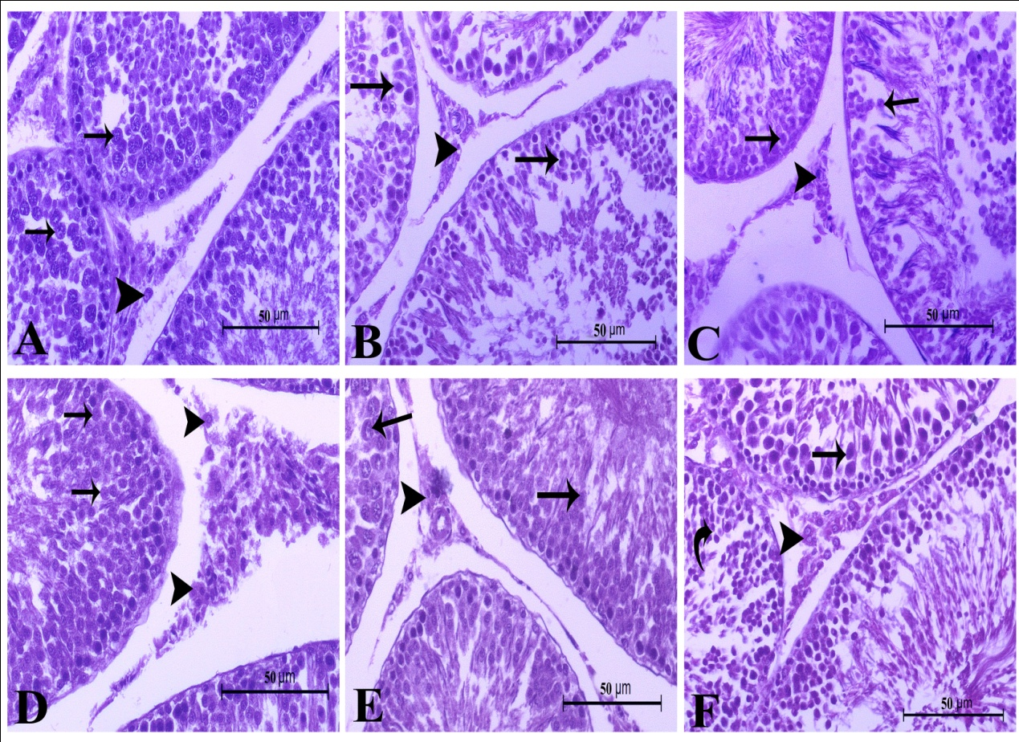
Fig. S1: A higher magnification of testicular tissues in adult male albino rats of the studied groups showing:
A: control group showed higher magnification of testicular tissue, including normal spermatogenic cells (arrow). The Leydig cells (arrowhead) appeared active.
B: Atrazine-treated group showed higher magnification of seminiferous tubules with degenerated spermatogenic cells (arrow). The interstitial tissue showed marked inactive Leydig cells (arrowhead).
C: Atrazine + L-carnitine group showed higher magnification of testicular tissue including more or less normal spermatogenic cells (arrow). The Leydig cells (arrowhead) appeared less active.
D: Atrazine + L-carnitine-loaded niosomes group showed higher magnification of testicular tissue including normal spermatogenic cells (arrow). The Leydig cells (arrowhead) appeared active.
E: Atrazine + quercetin-treated group showed higher magnification of testicular tissue including normal spermatogenic cells (arrow). The Leydig cells (arrowhead) appeared less active.
F: Atrazine + quercetin-loaded niosomes -treated group showed higher magnification of testicular tissue including normal spermatogenic cells (arrow). The Leydig cells (arrowhead) appeared active. (H&E stain X400).

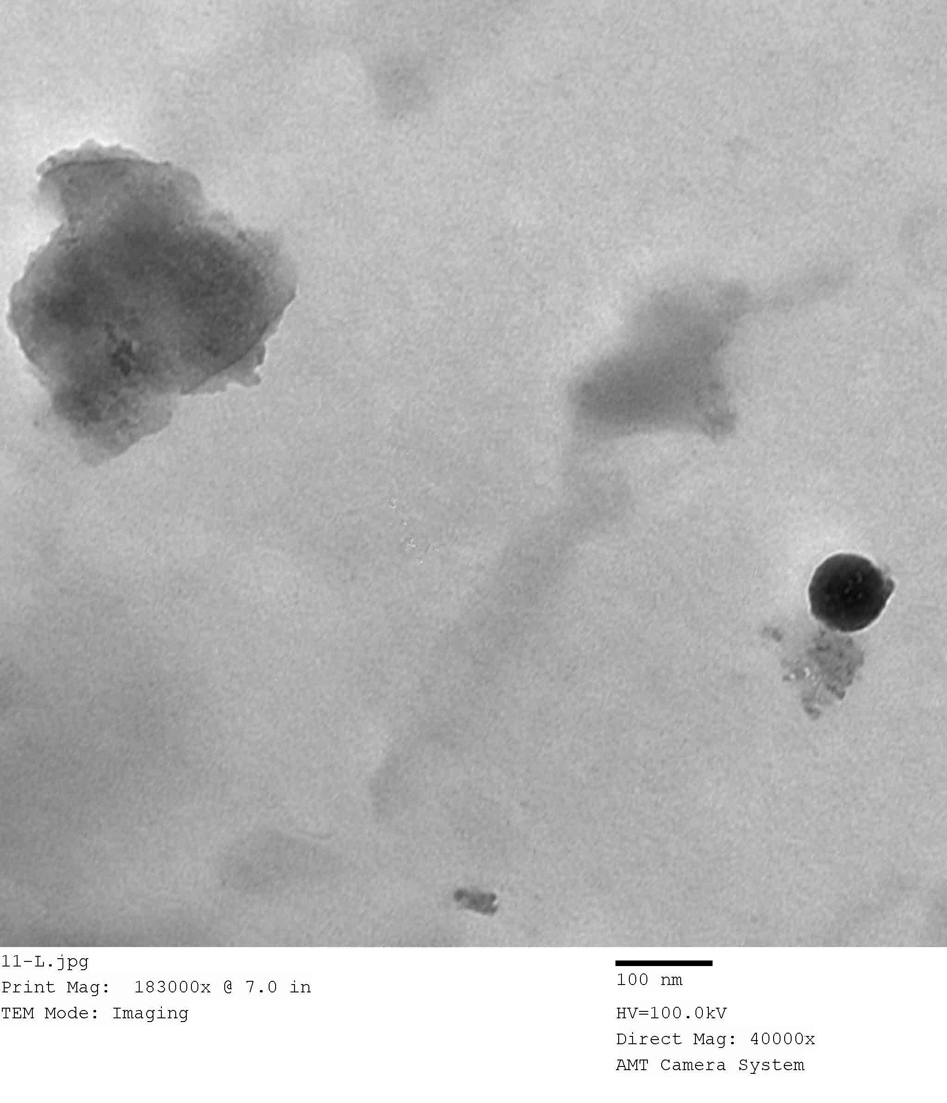
Fig. S2: Surface morphology of L-carnitine-loaded niosomes formulation by TEM (100nm).

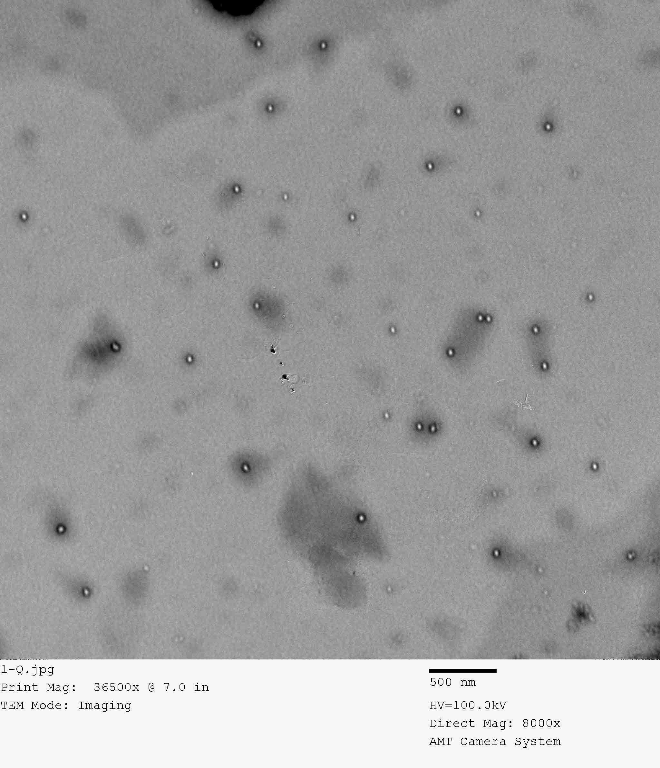

Fig. S3: TEM image of optimum quercetin-loaded niosomes formulation (500nm).

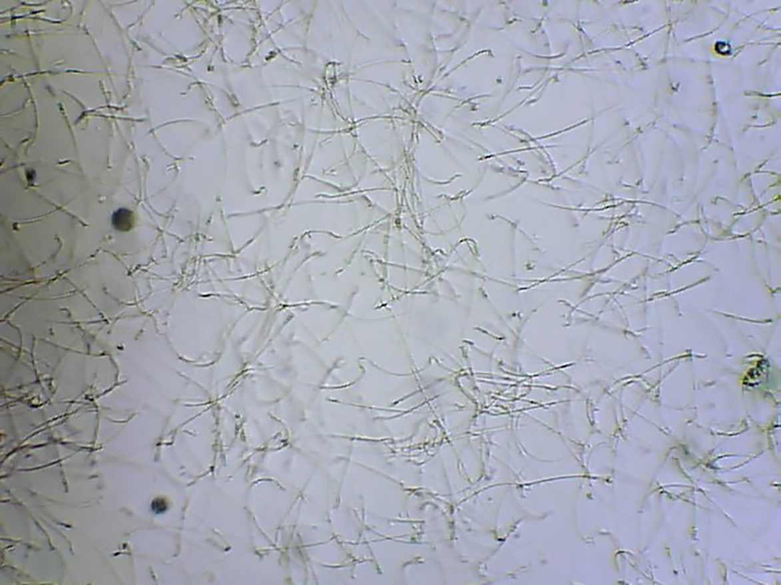
Fig. S4: Image of rat semen sample of control group using CASA system.

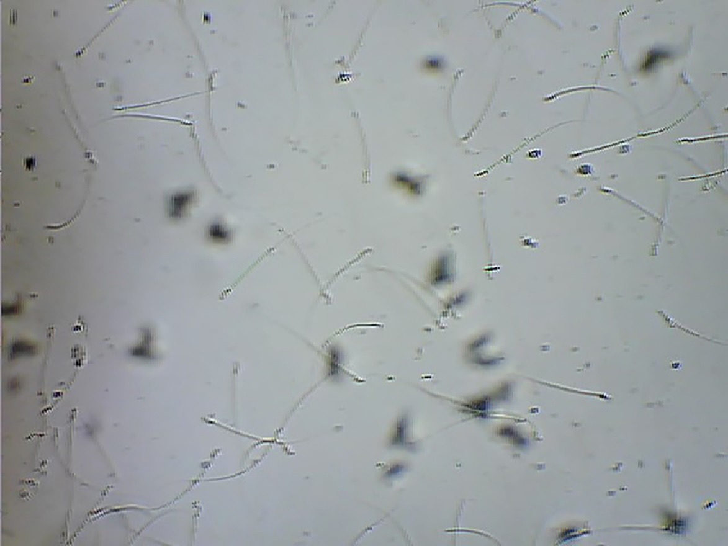
Fig. S5: Image of rat semen sample of ATZ group using CASA system.

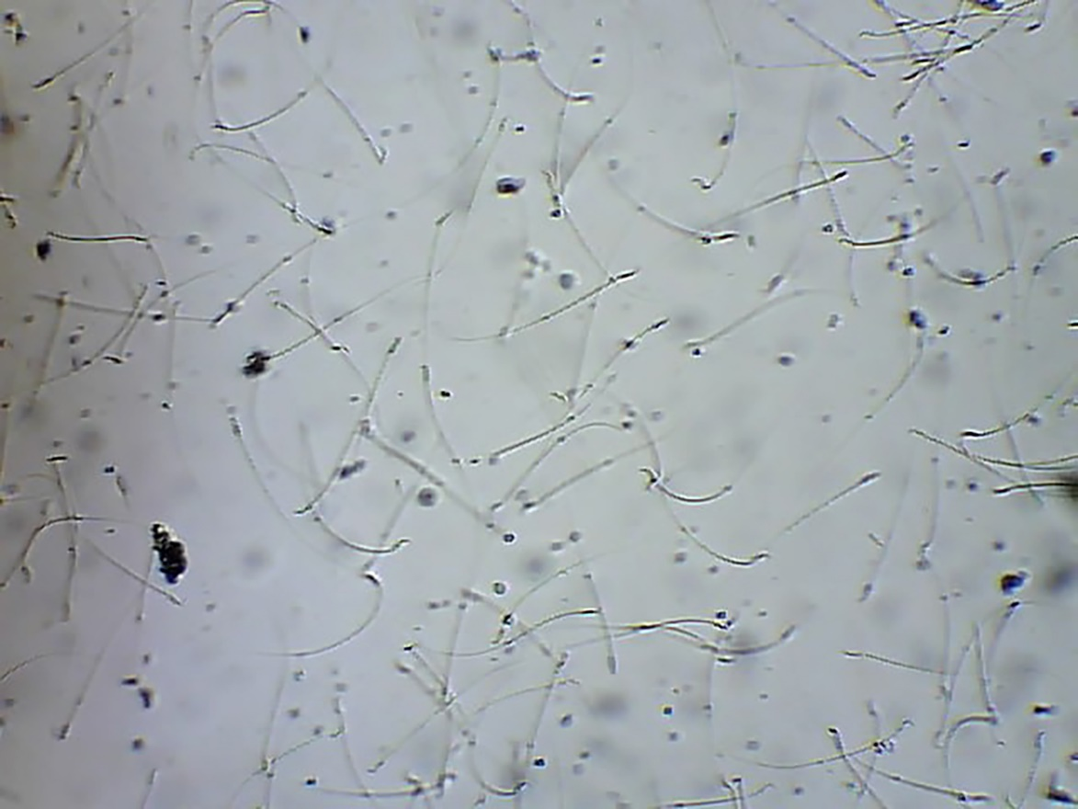
Fig. S6: Image of rat semen sample of LC group using CASA system.

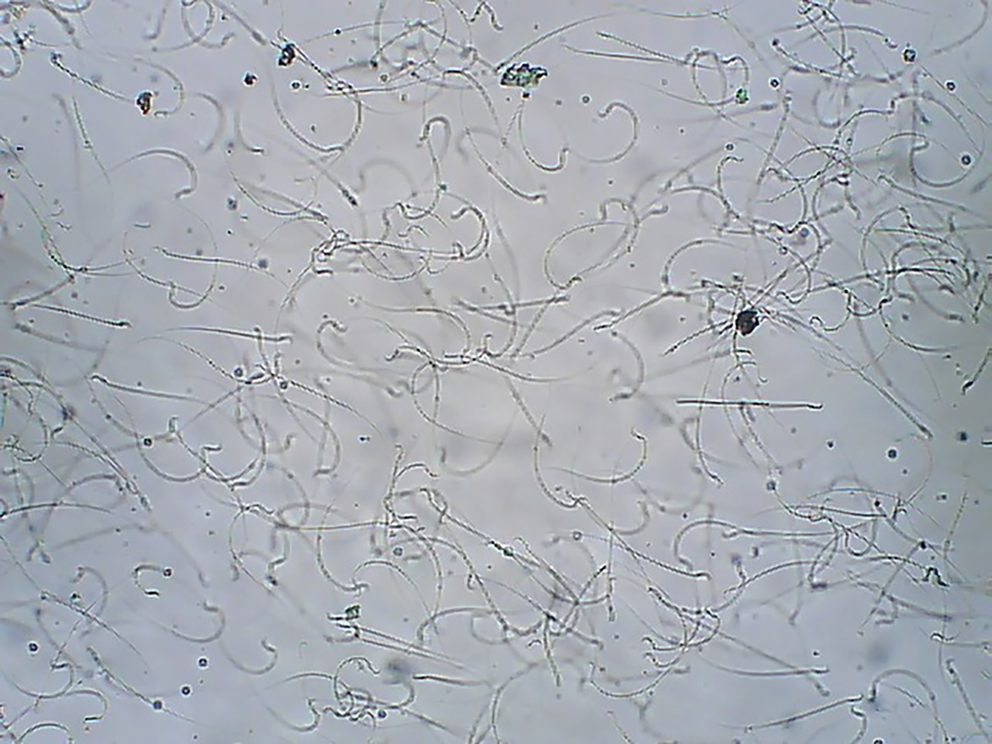
Fig. S7: Image of rat semen sample of LCLN group using CASA system.

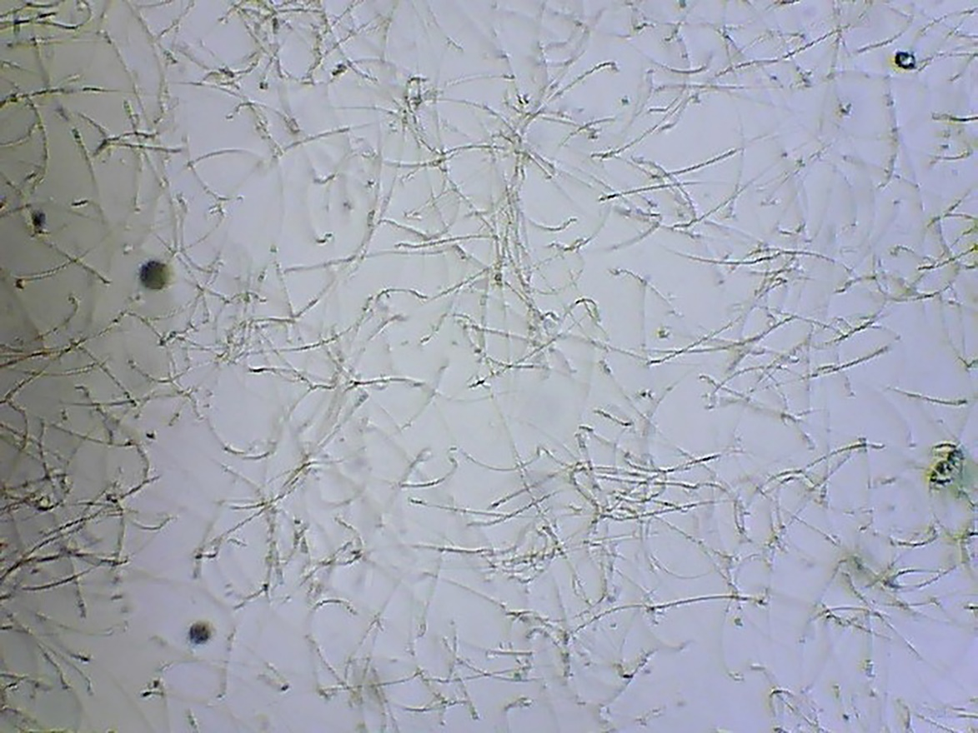
Fig. S8: Image of rat semen sample of QT group using CASA system.

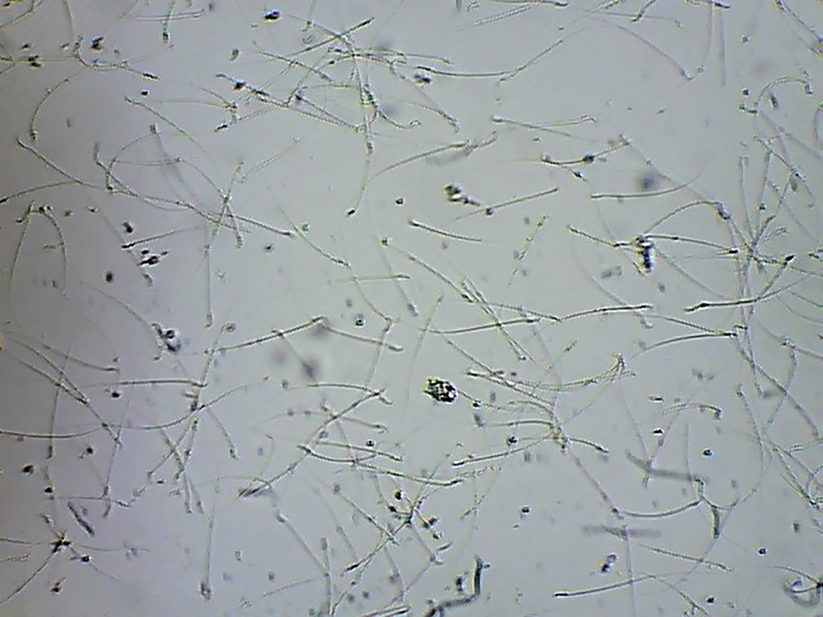
Fig. S9: Image of rat semen sample of QTLN group using CASA system.

