Supplemental Table 1. Volatile compounds consumed by P. aeruginosa respiratory infection isolates.
Compound nameª | Formula | Chemical class | No. of samples (n=48) | References^{b}
Core volatile compounds

2-methylpropanal | C₄H₈O | Aldehyde | 48 | 22
2-methylbutanal | C₅H₁₀O | Aldehyde | 47
3-methylbutanal | C₅H₁₀O | Aldehyde | 48 | 12, 22
Hexanal | C₆H₁₂O | Aldehyde | 48 | 9, 11, 12, 20
Benzaldehyde | C₇H₆O | Aldehyde | 48
Noncore volatile compounds

2-Chloroacetonitrile | C₂H₂ClN | Other | 2
Ethanol | C₂H₆O | Alcohol | 27 | 20,29
Furan-2-carbaldehyde (furfural) | C₅H₄O₂ | Aldehyde | 3 | 12
2-furanmethanol | C₅H₆O₂ | Aromatic Alcohol | 24 | 35
Pentanal | C₅H₁₀O | Aldehyde | 18
3-hexen-2-one | C₆H₁₀O | Ketone | 9 | 31
4-methylpentan-2-one (methyl isobutyl ketone) | C₆H₁₂O | Ketone | 1 | 19, 31
2-phenylacetaldehyde (benzeneacetaldehyde) | C₈H₈O | Aldehyde | 38
Octanal | C₈H₁₆O | Aldehyde | 2
2,4-dimethyl-1-heptene | C₉H₁₈ | Alkene | 5 | 19, 29
Decanal | C₁₀H₂₀O | Aldehyde | 3 | 12
Unknown 3 |  | Unknown | 18
Unknown 7 |  | Unknown | 2
Unknown 8 |  | Unknown | 7
Unknown 13 |  | Unknown | 4

ª Compounds shown in bold represent volatile molecules that have not been previously reported in P. aeruginosa.
^{b} References that document these volatiles in P. aeruginosa cultures.

Supplemental Figures

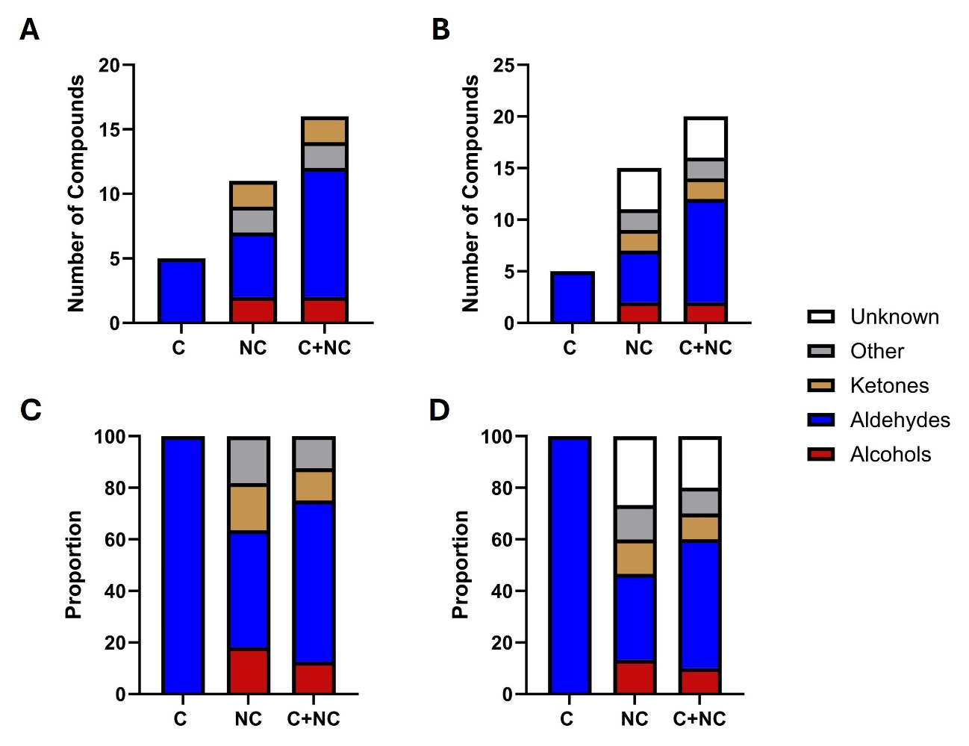
Supplemental Figure 1. Chemical classification and counts of volatile compounds that were depleted to levels significantly different from the medium alone by 48 P. aeruginosa respiratory-infection isolates. (A) identified compounds; (B) all detected compounds, including identified and unassigned compounds; (C) proportion of identified compounds; (D) proportion including both identified and unassigned compounds. C, Core volatilome; NC, Noncore volatilome.

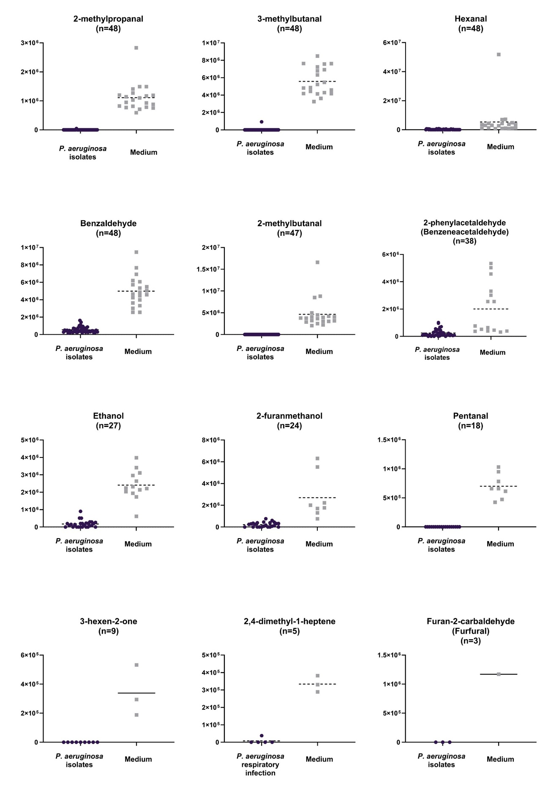

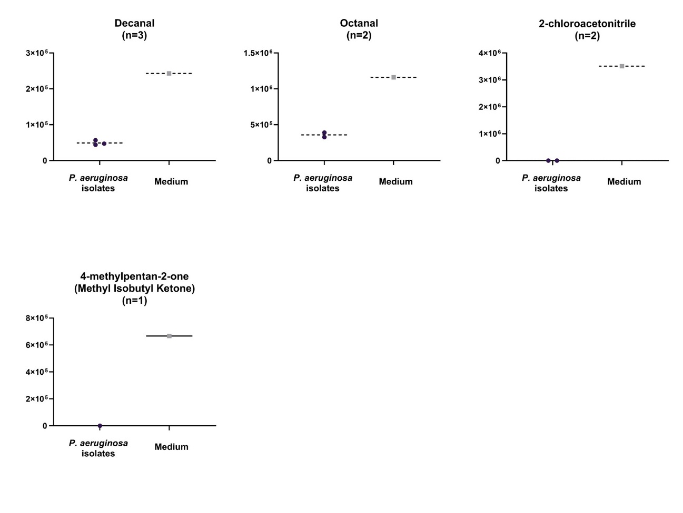

Supplemental Figure 2. Relative abundances of volatile compounds detected at significantly lower levels in at least one P. aeruginosa isolate compared to the control medium. Only compounds with log₂ fold change ≤ -1.5, p < 0.05 are shown. Each dot represents an isolate, plotted as the mean of three experimental replicates. Each box plot shows the metabolite levels represented by peak areas in arbitrary units. Isolates were classified as consumers when VOC levels were significantly lower than those detected in the corresponding blanck medium control (t-test, p<0.05). Only consuming isolates are displayed whereas non-consuming isolates were omitted from the plots for visualization purposes. The number of consuming isolates (n) is indicated below the name of each VOC.

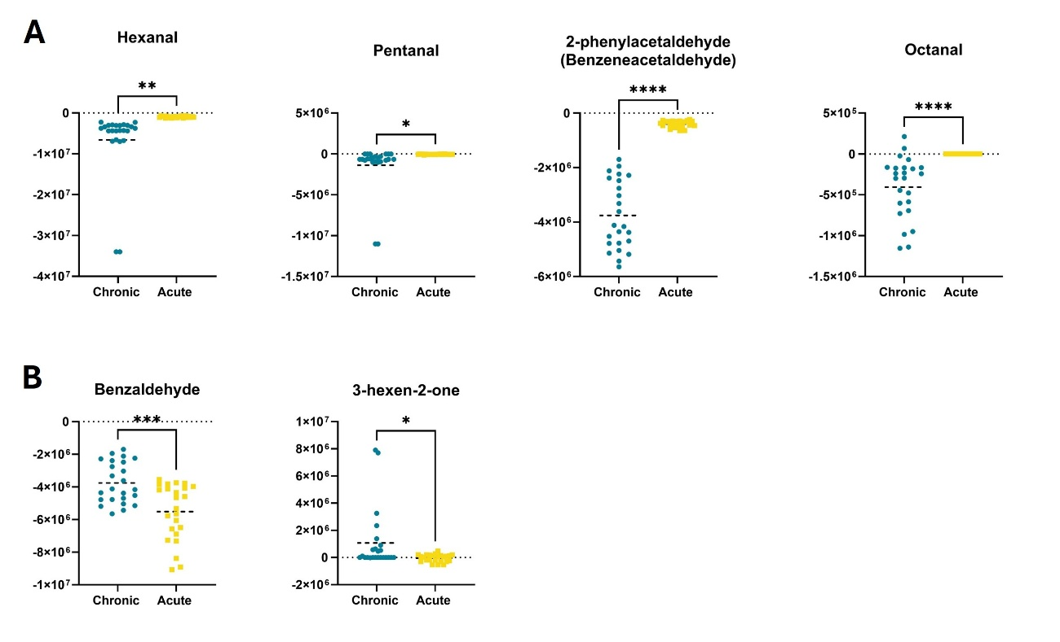
Supplemental Figure 3. Relative consumption of VOCs differed significantly between acute and chronic P. aeruginosa isolates. (A) Compounds consumed to a greater extent by chronic isolates. (B) Compounds showing higher consumption in acute isolates. Each dot represents an isolate, plotted as the mean of three experimental replicates. Each box plot shows the metabolite levels represented by peak areas in arbitrary units. Data were normalized to the medium control. Statistical significance was evaluated using an unpaired t-test with Welch’s correction. *p<0.05; **p<0.01; ***p<0.001; ****p<0.0001

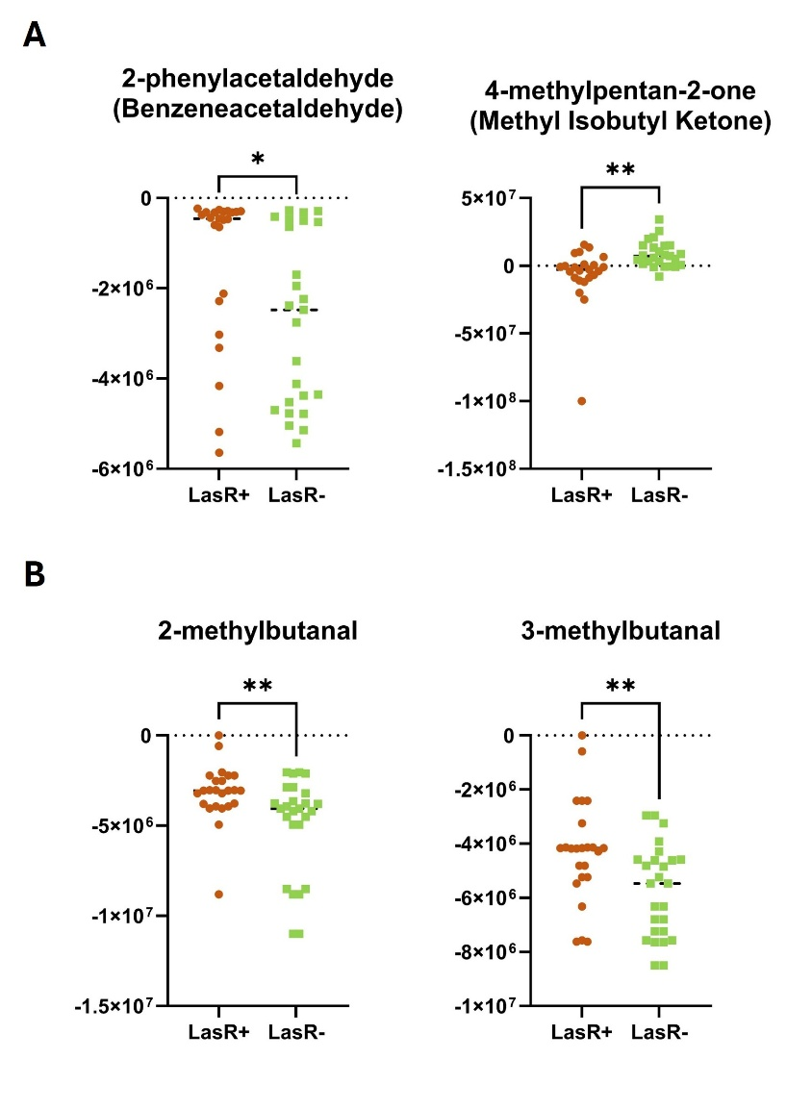

Supplemental Figure 4. Relative abundances of volatile organic compounds differentially consumed by P. aeruginosa respiratory isolates classified as LasR⁺ (functional lasR gene) and LasR⁻ (non-functional lasR gene) groups. (A) Compounds consumed to a greater extent by LasR⁺ isolates. (B) Compounds showing higher consumption in LasR⁻ isolates. Each dot represents an isolate, plotted as the mean of three experimental replicates. Each box plot shows the metabolite levels represented by peak areas in arbitrary units. Data were normalized to the medium control. Statistical significance was assessed using an unpaired t-test with Welch’s correction. *p <0.05; **p<0.01.

