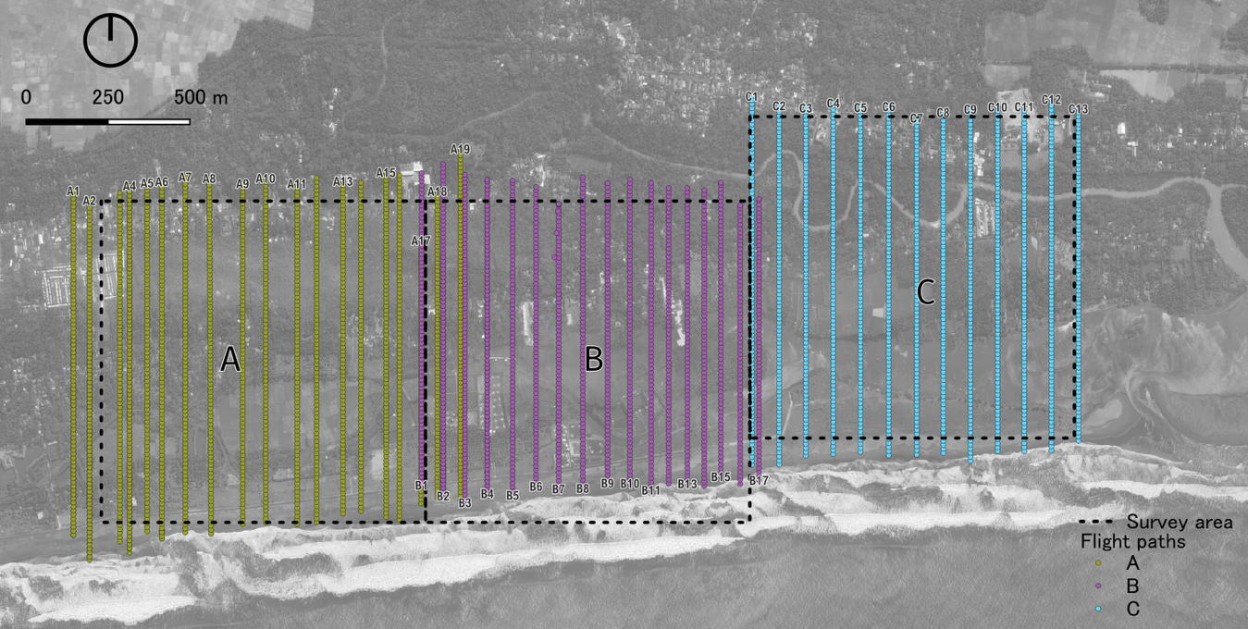
Supplementary file 1: Flight paths and images captured per block. Each yellow (block A), magenta (block B) or blue (block C) point on the map indicate one photo.

