Supplementary Fig. 1S(A-H): Uncropped full-length western blot data.

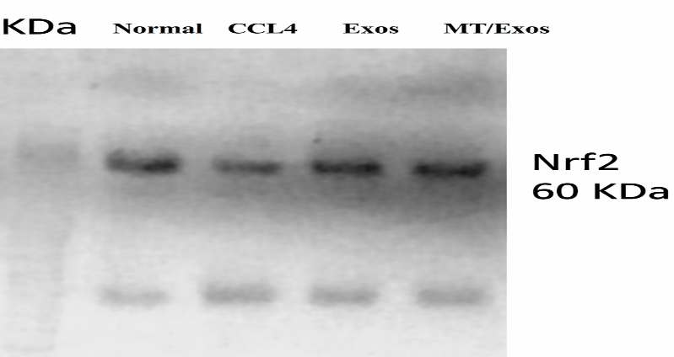
Fig. 1S(A): The uncropped data for NRF2 are as follows: normal control, CCl4, Exos, and MT/Exos
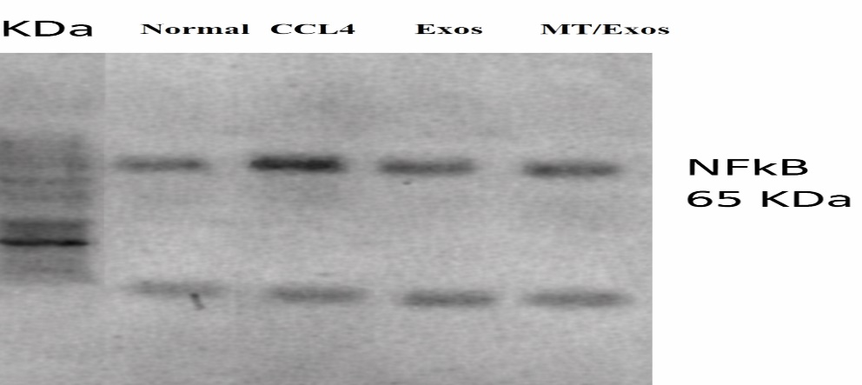

Fig. 1S (B). The uncropped data for NF-kB 65 are as follows: normal control, CCl4, Exos, and MT/Exos.
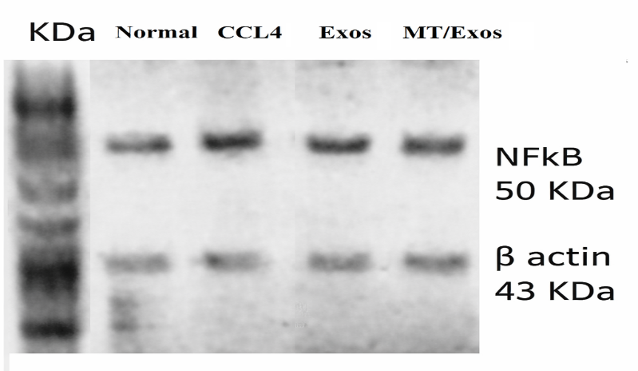
Fig. 1S (C). The uncropped data for NF-kB 50 are as follows: normal control, CCl4, Exos, and MT/Exos.
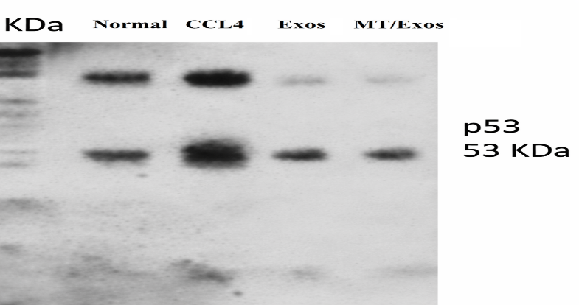
Fig. 1S(D). The uncropped data for P53 are as follows: normal control, CCl4, Exos, and MT/Exos

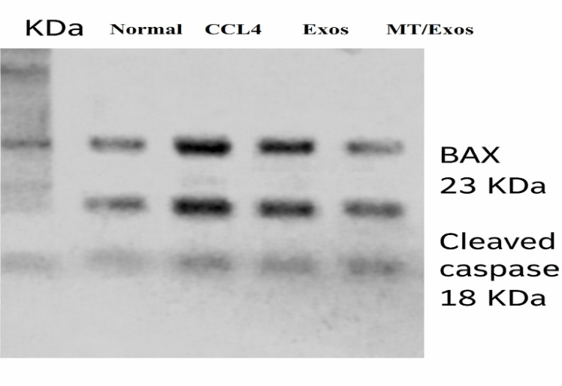
Fig. 1S (E). The uncropped data for Bax, and caspase-3 are as follows: normal control, CCl4, Exos, and MT/Exos.
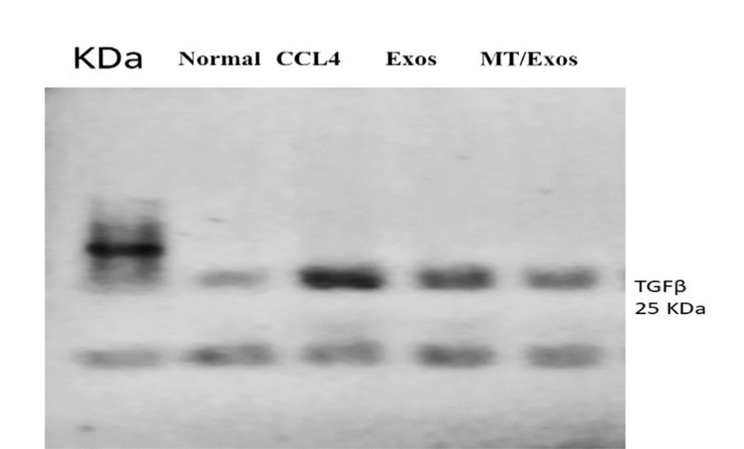
Fig. 1S (F). The uncropped data for TGF-β1 are as follows: normal control, CCl4, Exos, and MT/Exos.

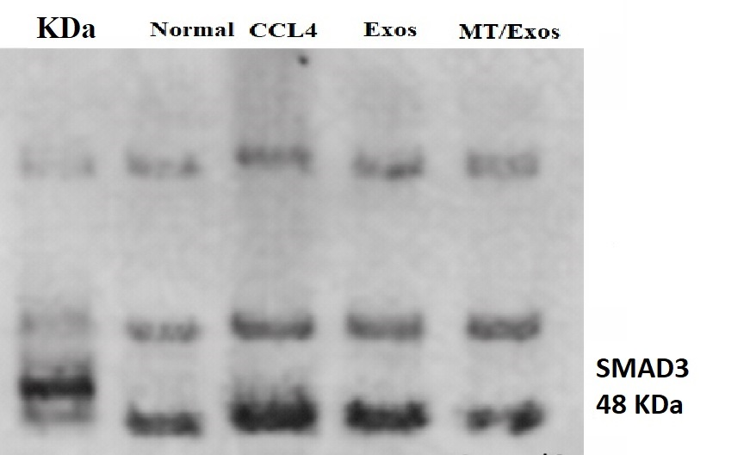
Fig. 1S (G). The uncropped data for SMAD3 are as follows: normal control, CCl4, Exos, and MT/Exos

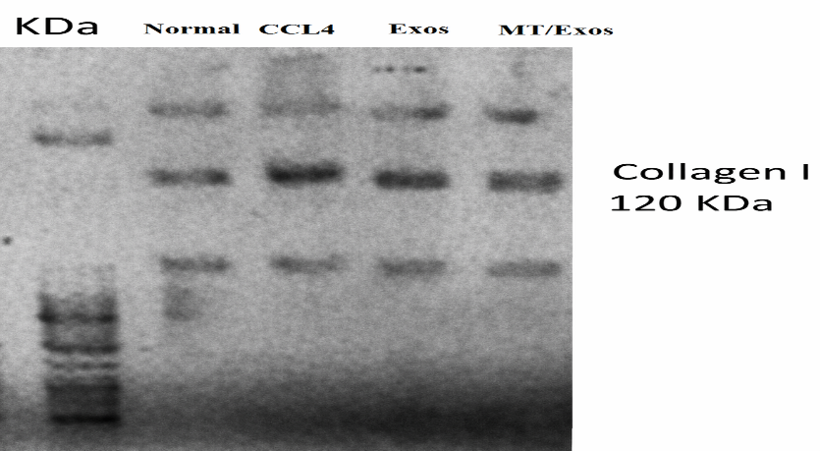
Fig. 1S (H). The uncropped data for collagen I are as follows: normal control, CCl4, Exos, and MT/Exos.

Fig.4S1. Flow cytometry of Exos by logarithmic scale using forward scatter (FS) and side scatter (ss); CD 63 showing positive expression by 84.0 %, CD 81 represents positive expression by 78.0%, and CD represents negative expression by 9.7 %.

Fig. 4S2. Flow cytometry of MT/Exos by logarithmic scale using forward scatter (FS) and side scatter(ss); CD 63 showing positive expression by 95.4 %, CD 81 represents positive expression by 87.9%, and CD represents negative expression by 2.4 %.

Table 3S. METAVIR Scoring of Liver Fibrosis in Different Experimental Groups
Group | METAVIR scoring | Scoring description
Normal | F0 | No fibrosis
CCl4 | F4 | Bridging fibrosis (cirrhosis)
Exos | F2 | Portal fibrosis with fibrous septa
MT/ Exos | F1 | Portal fibrosis without fibrous septa

The table summarizes the METAVIR fibrosis scores for each experimental group. The scoring system ranges from F0 to F4, indicating the severity of liver fibrosis. The fibrosis stage was scored on a scale from F0 to F4 as follows: F0, no fibrosis; F1, portal fibrosis without septa; F2, portal fibrosis with rare septa; F3, numerous septa without cirrhosis; and F4, cirrhosis

List of abbreviations
ALB: albumin
ALT: Alanine Aminotransferase
AST (need to be added): Aspartate Aminotransferase
BCA: Bicinchoninic Acid
CCl4: Carbon tetrachloride
CD: Cluster of Differentiation
Ct: Cycle Threshold
ECM: Extracellular Matrix
EVs: Extracellular Vesicles
Exos: Bone marrow mesenchymal stem cell-derived exosomes
fluorescein isothiocyanate: (FITC)
H&E: Hematoxylin and Eosin
HRP: Horseradish Peroxidase
HR-TEM: High-Resolution Transmission Electron Microscope
HSCs: Hepatic Stellate Cells
IL-10: interleukin-10
IL-17: Interleukin-17
MDA: Malondialdehyde
miR-196: miRNA 196
MSCs: Mesenchymal Stem Cells
MT/Exos: Melatonin-pretreated bone marrow mesenchymal stem cell-derived exosomes
MT: Melatonin
NF-κB: Nuclear Factor Kappa B
SOD: superoxide dismutase
TGF-β: Transforming Growth Factor Beta
TNFα: Tumor Necrosis Factor

