Health-Related Quality of Life in Patients with Cervical Cancer: A Systematic Review and Meta-Analysis of EQ‑5D Utility Scores.
Priyankaa V¹, Harshavardhan K¹, Sananthya Karthikeyan², Hariharan Murugadoss¹, and Madhumitha Haridoss*².
¹Department of Pharmacy practice, SRM College of Pharmacy, Faculty of Medicine and Health Sciences, SRM Institute of Science and Technology, Kattankulathur, Chengalpattu, Tamilnadu, India
²Division of Medical Research, SRM Medical College Hospital and Research Centre, Faculty of Medicine and Health Sciences, SRM Institute of Science and Technology, Kattankulathur, Chengalpattu, Tamilnadu, India
Supplementary Material

Supplementary Table 1: PRISMA checklist
Section and Topic | Item # | Checklist item | Location where item is reported
TITLE
Title | 1 | Identify the report as a systematic review. | Page 1
ABSTRACT
Abstract | 2 | See the PRISMA 2020 for Abstracts checklist. | Page 3
INTRODUCTION
Rationale | 3 | Describe the rationale for the review in the context of existing knowledge. | Page 4,5
Objectives | 4 | Provide an explicit statement of the objective(s) or question(s) the review addresses. | Page 5
METHODS
Eligibility criteria | 5 | Specify the inclusion and exclusion criteria for the review and how studies were grouped for the syntheses. | Page 6
Information sources | 6 | Specify all databases, registers, websites, organisations, reference lists and other sources searched or consulted to identify studies. Specify the date when each source was last searched or consulted. | Page 5
Search strategy | 7 | Present the full search strategies for all databases, registers and websites, including any filters and limits used. | Page 5,6; Supp.table 1-4
Selection process | 8 | Specify the methods used to decide whether a study met the inclusion criteria of the review, including how many reviewers screened each record and each report retrieved, whether they worked independently, and if applicable, details of automation tools used in the process. | Page 6,7
Data collection process | 9 | Specify the methods used to collect data from reports, including how many reviewers collected data from each report, whether they worked independently, any processes for obtaining or confirming data from study investigators, and if applicable, details of automation tools used in the process. | Page 7,8
Data items | 10a | List and define all outcomes for which data were sought. Specify whether all results that were compatible with each outcome domain in each study were sought (e.g. for all measures, time points, analyses), and if not, the methods used to decide which results to collect. | Page 7
Data items | 10b | List and define all other variables for which data were sought (e.g. participant and intervention characteristics, funding sources). Describe any assumptions made about any missing or unclear information. | Page 7,8
Study risk of bias assessment | 11 | Specify the methods used to assess risk of bias in the included studies, including details of the tool(s) used, how many reviewers assessed each study and whether they worked independently, and if applicable, details of automation tools used in the process. | Page 7; Supp.figure 1-2
Effect measures | 12 | Specify for each outcome the effect measure(s) (e.g. risk ratio, mean difference) used in the synthesis or presentation of results. | Page 7
Synthesis methods | 13a | Describe the processes used to decide which studies were eligible for each synthesis (e.g. tabulating the study intervention characteristics and comparing against the planned groups for each synthesis (item #5)). | Page 7,8
Synthesis methods | 13b | Describe any methods required to prepare the data for presentation or synthesis, such as handling of missing summary statistics, or data conversions. | Page 7,8
Synthesis methods | 13c | Describe any methods used to tabulate or visually display results of individual studies and syntheses. | Page 7,8
Synthesis methods | 13d | Describe any methods used to synthesize results and provide a rationale for the choice(s). If meta-analysis was performed, describe the model(s), method(s) to identify the presence and extent of statistical heterogeneity, and software package(s) used. | Page 7,8
Synthesis methods | 13e | Describe any methods used to explore possible causes of heterogeneity among study results (e.g. subgroup analysis, meta-regression). | Page 7,8
Synthesis methods | 13f | Describe any sensitivity analyses conducted to assess robustness of the synthesized results. | Page 7,8
Reporting bias assessment | 14 | Describe any methods used to assess risk of bias due to missing results in a synthesis (arising from reporting biases). | Page 7,8
Certainty assessment | 15 | Describe any methods used to assess certainty (or confidence) in the body of evidence for an outcome. | NA
RESULTS
Study selection | 16a | Describe the results of the search and selection process, from the number of records identified in the search to the number of studies included in the review, ideally using a flow diagram. | Page 8, Supp.table 5
Study selection | 16b | Cite studies that might appear to meet the inclusion criteria, but which were excluded, and explain why they were excluded. | Page 8
Study characteristics | 17 | Cite each included study and present its characteristics. | Page 8; Table 1
Risk of bias in studies | 18 | Present assessments of risk of bias for each included study. | Page 8,9
Results of individual studies | 19 | For all outcomes, present, for each study: (a) summary statistics for each group (where appropriate) and (b) an effect estimate and its precision (e.g. confidence/credible interval), ideally using structured tables or plots. | Page 9,10,11
Results of syntheses | 20a | For each synthesis, briefly summarise the characteristics and risk of bias among contributing studies. | Page 9,10,11
Results of syntheses | 20b | Present results of all statistical syntheses conducted. If meta-analysis was done, present for each the summary estimate and its precision (e.g. confidence/credible interval) and measures of statistical heterogeneity. If comparing groups, describe the direction of the effect. | Page 9,10,11; Figure 2,3; Supp.figure 3-20
Results of syntheses | 20c | Present results of all investigations of possible causes of heterogeneity among study results. | Page 9,10,11
Results of syntheses | 20d | Present results of all sensitivity analyses conducted to assess the robustness of the synthesized results. | Page 10
Reporting biases | 21 | Present assessments of risk of bias due to missing results (arising from reporting biases) for each synthesis assessed. | Page 11
Certainty of evidence | 22 | Present assessments of certainty (or confidence) in the body of evidence for each outcome assessed. | NA
DISCUSSION
Discussion | 23a | Provide a general interpretation of the results in the context of other evidence. | Page 11,12
Discussion | 23b | Discuss any limitations of the evidence included in the review. | Page 13
Discussion | 23c | Discuss any limitations of the review processes used. | Page 12,13
Discussion | 23d | Discuss implications of the results for practice, policy, and future research. | Page 13,14
OTHER INFORMATION
Registration and protocol | 24a | Provide registration information for the review, including register name and registration number, or state that the review was not registered. | Page 5
Registration and protocol | 24b | Indicate where the review protocol can be accessed, or state that a protocol was not prepared. | Page 5
Registration and protocol | 24c | Describe and explain any amendments to information provided at registration or in the protocol. | NA
Support | 25 | Describe sources of financial or non-financial support for the review, and the role of the funders or sponsors in the review. | Page 1
Competing interests | 26 | Declare any competing interests of review authors. | Page 2
Availability of data, code and other materials | 27 | Report which of the following are publicly available and where they can be found: template data collection forms; data extracted from included studies; data used for all analyses; analytic code; any other materials used in the review. | Page 2

Supplementary Table 2: Search strategy-PubMed
Framework |  | Search Terms | On 12/06/2025 | After TiAb
P-Population
I-Intervention OR Exposure | #1 | "Cervical Cancer" OR "Uterine Cervical Neoplasms"[Mesh] OR (cervi* AND (carcinoma OR neoplas* OR cancer OR malignancy OR tumor)) | 184,508
 |  | (((((Cervical Cancer [Title/Abstract])) OR ((cervi*[Title/Abstract] AND (carcinoma [Title/Abstract] OR cancer [Title/Abstract] OR malignancy [Title/Abstract] OR tumor[Title/Abstract]))) |  | 157,318
C-Comparator
O-Outcome | #2 | EQ-5D OR EQ5D OR “EQ 5-Dimension” OR (“EQ 5D”) OR Euroqol OR HRQOL OR (Health-related quality of life) | 653,420 | 654,606
P AND I AND C AND O | #3 | #1 AND #2 | 3,521 | 3,122
 | #4 | #3 NOT ("case report"[Title]) OR ("case series"[Title]) OR (case-report[Title]) OR (Review[Title]) OR ("systematic review"[Title/Abstract]) OR (Meta Analysis[Title/Abstract]) OR (Meta-analysis[Title/Abstract]) | 3,115 | 2767

Supplementary Table 3: Search strategy-Scopus
Framework | Search Terms | Search Hits as on 12/06/2025
P-Population
I-Intervention | "Cervical Cancer" OR (cervi* AND (carcinoma OR cancer OR malignancy OR tumor)) | 242,697
C-Comparator
O-Outcome | EQ-5D OR EQ5D OR “EQ 5-Dimension” OR “EQ 5D” OR Euroqol OR HRQOL OR (Health-related quality of life) | 599,018
P AND I AND C AND O |  | 2,732

Supplementary Table 4: Search strategy - Embase
Framework | Search Terms | Search Hits as on 12/06/2025
P-Population
I-Intervention | ‘Cervical Cancer’ OR (cervi* AND (carcinoma OR cancer OR malignancy OR tumor)) | 295,215
C-Comparator
O-Outcome | EQ-5D OR ‘EQ 5-Dimension’ OR ‘EQ 5D’ OR EQ5D OR Euroqol OR HRQOL OR (Health-related quality of life) | 143,056
P AND I AND C AND O |  | 689

Supplementary Table 5: Search strategy- Cochrane Library
Framework | Search Terms | Search Hits as on 12/06/2025
P-Population
I-Intervention | (Cervical cancer) OR (cervical neoplasm) OR (Uterine cervical cancer) OR (Cervix neoplasm) | 7,622
C-Comparator
O-Outcome | EQ-5D OR ‘EQ 5-Dimension’ OR ‘EQ 5D’ OR EQ5D OR Euroqol OR utility* OR HRQOL OR (Health-related quality of life) | 7,622
P AND I AND C AND O |  | 181

Supplementary Table 6: Excluded studies
S.NO | Study label | Study title | Reason for exclusion
1 | Maissi E et al. 2005 | The psychological impact of human papillomavirus testing in women with borderline or mildly dyskaryotic cervical smear test results: 6-month follow-up. | Wrong outcome
2 | Woodhall S et al. 2008 | Estimation of the impact of genital warts on health-related quality of life. | Wrong population
3 | Whynes DK et al. 2008 | Management of low-grade cervical abnormalities detected at screening: which method do women prefer? | Wrong outcome
4 | Tombola group | Options for managing low grade cervical abnormalities detected at screening: cost effectiveness study. | Wrong outcome
5 | Clinical trial summary | A Double-blind Placebo-controlled Trial of Dietary Supplementation With 15g/Day FOS for Five Weeks in Patients with Endometrial/Cervical Carcinoma or 7.5 Weeks in Patients with Prostate Carcinoma Undergoing Pelvic Radiotherapy. | Wrong publication type
6 | Woodhall S et al. 2011 | Impact of HPV vaccination on young women's quality of life - a five-year follow-up study. | Wrong population
7 | Galante J et al. 2011 | Estimation and comparison of EQ-5D health states' utility weights for pneumococcal and human papillomavirus diseases in Argentina, Chile, and the United Kingdom. | Wrong outcome
8 | Mennini FS et al. 2011 | Time trade-off procedure for measuring health utilities loss with human papillomavirus-induced diseases: a multicenter, retrospective, observational pilot study in Italy. | Wrong outcome
9 | Clinical trial summary | A Randomized Phase III Study of Standard vs. IMRT Pelvic Radiation for Post-Operative Treatment of Endometrial and Cervical Cancer (TIME-C) | Wrong publication type
10 | Korfage IJ et al. 2012 | Having a Pap smear, quality of life before and after cervical screening: a questionnaire study. | Wrong outcome
11 | Drolet M et al. 2012 | The psychosocial impact of an abnormal cervical smear result. | Wrong outcome
12 | Mennini, F.S et al. 2013 | Loss of health utilities due to HPV-induced diseases in men and women: A multicenter italian study | Wrong publication type
13 | Clinical trial summary | The Effect of Postoperative Therapy on the Quality of Life of Patients with Early-Stage Cervical Cancer | Wrong publication type
14 | Pan, X.F et al. 2013 | Quality of life in women with cervical precursor lesions and cancer: A hospital-based study | Wrong publication type
15 | Whynes DK et al. 2013 | Impact of alternative management policies on health-related quality of life in women with low-grade abnormal cervical cytology referred for colposcopy. | Wrong population
16 | Dominiak-Felden G et al. 2013 | Impact of human papillomavirus-related genital diseases on quality of life and psychosocial wellbeing: results of an observational, health-related quality of life study in the UK. | Wrong outcome
17 | Hung, M.C et al. 2014 | Generalized cost-effectiveness analysis for care of major cancers and other major illnesses in Taiwan | Wrong publication type
18 | Korfage IJ et al. 2014 | How distressing is referral to colposcopy in cervical cancer screening? a prospective quality of life study. | Wrong outcome
19 | Lee JA et al. 2014 | Comparison of health-related quality of life between cancer survivors treated in designated cancer centers and the general public in Korea. | Wrong outcome
20 | Endarti D et al. 2014 | Health-Related Quality of Life In Patients with Cervical Cancer in Indonesia. | Wrong publication type
21 | Korfage, I. et al. 2015 | Negative effects on quality of life during Dutch cervical screening program are small | Wrong publication type
22 | Engquist, M. et al. 2015 | Factors affecting the outcome of surgical versus nonsurgical treatment of cervical radiculopathy: A randomized, controlled study | Wrong population
23 | Summary | Optimization Research of Early Cervical Cancer Treatment | Wrong publication type
24 | Lee, S.Y et al. 2015 | The impact of job status on quality of life: General population versus long-term cancer survivors | Wrong outcome
25 | Sielatycki, J.A et al. 2015 | Does cervical sagittal alignment correlate with outcomes following posterior laminectomy and fusion for cervical myelopathy? | Wrong publication type
26 | Clinical trial summary | Comparison of Meperidine and Fentanyl on Pain Scale and Quality of Life in Cervical Cancer Patients Receiving Brachytherapy: A Double-blind, Randomized Controlled Trial | Wrong publication type
27 | Endarti, D et al. 2016 | A comparison of EQ-5D-3L index scores using foreign value sets for Indonesian sample with cervical cancer | Wrong publication type
28 | Radosa, J.C et al. 2016 | Influence of the Preoperative Decision-Making Process on the Postoperative Outcome after Hysterectomy for Benign Uterine Pathologies | Wrong outcome
29 | Clinical trial summary | A Phase III Randomised Trial Investigating the Benefits of the Addition of Modulated Electro-hyperthermia to Chemo-radiation for Cervical Cancer in HIV Positive and Negative Women in South Africa | Wrong outcome
30 | Markovic-Denic L et al. 2017 | Psychological effects of concurrent cytology and colposcopy testing in women referred to cancer counseling outpatient clinic in Belgrade. | Wrong outcome
31 | Noto, S et al. 2017 | Reliability and validity of two proxy versions of EQ-5D-5L in Japan | Wrong outcome
32 | Janssen, S.J et al. 2017 | Validation of the Spine Oncology Study Group Outcomes Questionnaire to assess quality of life in patients with metastatic spine disease | Wrong population
33 | Smith, J et al. 2017 | The health impact of symptomatic adult cervical deformity: Comparison to united states population norms and chronic disease states based on the EQ-5D | Wrong publication type
34 | ACTION Study Group | Health-related quality of life and psychological distress among cancer survivors in Southeast Asia: results from a longitudinal study in eight low- and middle-income countries. | Wrong outcome
35 | Smith JS et al. 2017 | The Health Impact of Adult Cervical Deformity in Patients Presenting for Surgical Treatment: Comparison to United States Population Norms and Chronic Disease States Based on the EuroQuol-5 Dimensions Questionnaire. | Wrong population
36 | Oba S et al. 2017 | Association of Cervical Cancer Screening with Knowledge of Risk Factors, Access to Health-Related Information, Health Profiles, and Health Competence Beliefs among Community-Dwelling Women in Japan. | Wrong outcome
37 | Frumovitz, M et al. 2018 | Quality of life assessment in early-stage cervical cancer patients in undergoing radical hysterectomy via minimally invasive surgery or open approach: The lacc trial | Wrong publication type
38 | Lubelski, D et al. 2018 | Preoperative Nomograms Predict Patient-Specific Cervical Spine Surgery Clinical and Quality of Life Outcomes | Wrong population
39 | Sone, M et al. 2018 | Randomized controlled trial of percutaneous transesophageal gastrotubing for symptom palliation in patients with malignant gastrointestinal obstruction | Wrong publication type
40 | Sycheva, E.G et al. 2018 | Evaluation of health-related quality of life the women with human papillomavirus-associated lesions of the cervical epithelium | Non-English article
41 | Baxi SS et al. 2018 | Long-term quality of life in older patients with HPV-related oropharyngeal cancer. | Wrong population
42 | Kajimoto, Y et al. 2019 | Development of the comprehensive score for financial toxicity (COST) tool and assessment of financial toxicity in patients with gynecologic cancer in Japan | Wrong publication type
43 | Wang, S et al. 2019 | A studyon the related factors of quality of life and pelvic floor function after type piver III hysterectomy for cervical cancer | Wrong publication type
44 | Ryu M et al. 2019 | Cancer site differences in the health-related quality of life of Korean cancer survivors: Results from a Population-based Survey. | Wrong outcome
45 | Paek J et al. 2019 | Association between hand grip strength and impaired health-related quality of life in Korean cancer survivors: a cross-sectional study. | Wrong outcome
46 | Jones DA et al. 2020 | Concurrent cisplatin or cetuximab with radiotherapy for HPV-positive oropharyngeal cancer: Medical resource use, costs, and quality-adjusted survival from the De-ESCALaTE HPV trial. | Wrong population
47 | Croke, J.M et al. 2020 | Patient Reported Outcomes, Physician-Reported Toxicity and Dosimetry in Cervix Cancer Patient Treated with Chemo-Radiation and MR-Guided Brachytherapy | Wrong publication type
48 | Clinical trial summary | A Comparison of Acute Toxicities Between Patients Treated with Protons or Intensity-Modulated Radiation Therapy for Post-Operative Treatment of Endometrial or Cervical Cancers | Wrong outcome
49 | Thaweethamcharoen, T et al. 2020 | Comparison Of Quality of Life Between Colposcopy and Human Papillomavirus Testing in Thai Women with Atypical Squamous Cells of Undetermined Significance | Wrong publication type
50 | Beyan, E et al. 2020 | Comparison of the Effects of Total Laparoscopic Hysterectomy and Total Abdominal Hysterectomy on Sexual Function and Quality of Life | Wrong outcome
51 | Frumovitz M et al. 2020 | Quality of life in patients with cervical cancer after open versus minimally invasive radical hysterectomy (LACC): a secondary outcome of a multicentre, randomised, open-label, phase 3, non-inferiority trial. | Wrong outcome
52 | Hu X et al. 2020 | Responsiveness and minimal clinically important difference of the EQ-5D-5L in cervical intraepithelial neoplasia: a longitudinal study. | Wrong outcome
53 | Kanda, Y et al. 2021 | Surgical outcomes and risk factors for poor outcomes in patients with cervical spine metastasis: a prospective study | Wrong population
54 | Ueno, T et al. 2021 | Patient-reported outcomes after surgery among patients with gynecological diseases in Japan | Wrong outcome
55 | Monk, B et al. 2022 | Patient-Reported Outcomes from the Phase 3 Randomized, Double-Blind, KEYNOTE-826 Trial of Pembrolizumab Plus Chemotherapy Versus Placebo Plus Chemotherapy for the First-Line Treatment of Persistent, Recurrent, or Metastatic Cervical Cancer (023) | Wrong publication type
56 | van Vliet - Perez, S et al. 2022 | Patient experience and time-action analysis during cervical cancer brachytherapy | Wrong publication type
57 | Yee, T.J et al. 2022 | Assessing the Efficacy of the mJOA in Myelopathic Patients: A Cervical QOD Study | Wrong publication type
58 | Honda, K et al. 2022 | O14-4 Association of financial toxicity with quality-of-life in patients with gynecologic cancer | Wrong publication type
59 | Fujii, H et al. 2022 | Pharmaceutical intervention for adverse events improves quality of life in patients with cancer undergoing outpatient chemotherapy | Wrong outcome
60 | Dou Y et al. 2022 | Chopstick technique versus cross technique in LESS hysterectomy (CCLEH study): a prospective randomized controlled trial. | Wrong outcome
61 | Yang, Y et al. 2023 | Study on the Influencing Factors of Minimal Clinically Important Difference of the FACT-G Scale Based on Patients with Cervical Precancerous Lesions | Non-English article
62 | Holch, P et al. 2023 | Online Symptom Monitoring During Pelvic Radiation Therapy: Randomized Pilot Trial of the eRAPID Intervention | Wrong outcome
63 | Conway, J et al. 2023 | Sexual health and vaginal toxicity after chemo-radiation and brachytherapy in cervical cancer | Wrong publication type
64 | Imai, K et al. 2023 | Comparison of quality of life after robotic-transvaginal natural orifice transluminal endoscopic surgery and robot-assisted laparoscopic hysterectomy | Wrong outcome
65 | Azizi, A et al. 2023 | Association between cervical cancer-related anxiety and depression symptoms and health-related quality of life: A Moroccan cross-sectional study | Wrong outcome
66 | Ray-Coquard, I et al. 2023 | Cost-Effectiveness of Pembrolizumab Plus Chemotherapy, With or Without Bevacizumab for the First-Line Treatment of PD-L1-Positive Patients with Persistent, Recurrent, or Metastatic Cervical Cancer in France | Wrong publication type
67 | Kajimoto Y et al. 2023 | Association between financial toxicity and health-related quality of life of patients with gynecologic cancer. | Wrong outcome
68 | Konski A et al. 2023 | Quality-adjusted survival in women with gynecologic malignancies receiving IMRT after surgery: A Ppatient Rreported Ooutcome study of NRG oncology's RTOG 1203. | Wrong population
69 | Tse, K.Y et al. 2024 | Avelumab with axitinib in persistent or recurrent cervical cancer after platinumbased chemotherapy (ALARICE study) | Wrong publication type
70 | Gladieff, L et al. 2024 | Long-term patient-reported outcomes (PROs) with atezolizumab (atezo) + bevacizumab (bev) and chemotherapy (CT) for metastatic, persistent or recurrent cervical cancer (R/M CC): BEATcc (ENGOT-Cx10/GEICO 68-C/JGOG1084/GOG-3030) randomised phase III trial | Wrong publication type
71 | Adachi, K et al. 2024 | The effect of physical therapy integrated with pharmacotherapy on tension-type headache and migraine in children and adolescents | Wrong population
72 | Summary | Dose Escalation to Primary Tumor Improves Outcomes in Stage IV Cervical Cancer | Wrong publication type
73 | Tam, T et al. 2024 | Effectiveness of Office Hysteroscopy on Patient's Health-Related Quality of Life ( HRQoL) Using Euroqol ( EQ-5D) Responses | Wrong publication type
74 | Hariprasad R et al. 2024 | Cost-utility analysis of primary HPV testing through home-based self-sampling in comparison to visual inspection using acetic acid for cervical cancer screening in East district, Sikkim, India, 2023. | Wrong outcome
75 | Kwon, J.S et al. 2024 | COST-EFFECTIVENESS ANALYSIS OF SIMPLE HYSTERECTOMY COMPARED TO RADICAL HYSTERECTOMY FOR EARLY CERVICAL CANCER FROM THE CCTG CX.5 'SHAPE' PHASE III CLINICAL TRIAL | Wrong publication type
76 | Clinical trial summary | A Phase II Trial of Low-dose Pembrolizumab Plus Chemotherapy for the First-Line Treatment of Persistent, Recurrent, or Metastatic Cervical Cancer - ACCESS I | Wrong publication type
77 | Moses, R.A et al. 2024 | Patient-Reported Outcome Measures Following Hyperbaric Oxygen Therapy for Radiation Cystitis: Early Results from the Multicenter Registry for Hyperbaric Oxygen Therapy | Wrong population
78 | van Vliet-Pérez SM et al. 2024 | Time-action and patient experience analyses of locally advanced cervical cancer brachytherapy. | Wrong outcome
79 | Kwon JS et al. 2024 | Cost-effectiveness analysis of simple hysterectomy compared to radical hysterectomy for early cervical cancer: analysis from the GCIG/CCTG CX.5/SHAPE trial. | Wrong outcome
80 | Hao Q et al. 2024 | Application of WeChat-based cognitive behavioural stress management for early-stage cervical cancer patients: a randomised controlled study. | Wrong publication type
81 | Segi, N et al. 2025 | Effects of Palliative Surgical Treatment for Spinal Metastases on the Patient’s Quality of Life With a Focus on the Segment of the Metastasis: A Prospective Multicenter Study | Wrong population
82 | Sukhin, V et al. 2025 | Patient-Reported Outcomes With Pembrolizumab Plus Chemoradiotherapy For High-Risk, Locally Advanced Cervical Cancer: Interim Analysis 2 Results From The Randomised, Double-Blind, Phase 3 ENGOT-Cx11/GOG-3047/KEYNOTE-A18 Study | Wrong publication type
83 | Honda K et al. 2025 | Prospective changes in financial toxicity and health-related quality of life in patients with gynecologic cancer. | Wrong outcome
84 | Clinical trial summary | A Randomized, Open-Label Trial to Compare tisotumab vedotin to Investigator's Choice Chemotherapy in Patients with Cervical Cancer | Wrong publication type
85 | Conference abstract | Effect of WeChat-based cognitive behavioral stress management on anxiety, depression, spiritual well-being, and quality of life in early-stage cervical cancer patients treated by surgical resection: a randomized, controlled study | Wrong publication type
86 | Conference abstract | Standard Versus Intensity-Modulated Pelvic Radiation Therapy in Treating Patients with Endometrial or Cervical Cancer | Wrong publication type
87 | Conference abstract | Trial of TSR-042 for patients with high-risk locally advanced cervical cancer after chemo-radiation | Wrong publication type
88 | Citation | Comparison of Meperidine and Fentanyl on Pain Scale and QOL in Brachytherapy | Wrong publication type
89 | Summary | Dose Escalation to Primary Tumor Improves Outcomes in Stage IV Cervical Cancer | Wrong publication type
90 | Clinical trial summary | A Double-blind Placebo-controlled Trial of Dietary Supplementation With 15g/Day FOS for Five Weeks in Patients with Endometrial/Cervical Carcinoma or 7.5 Weeks in Patients with Prostate Carcinoma Undergoing Pelvic Radiotherapy. | Wrong publication type
91 | Murasawa H. et al 2014 | Evaluation of health-related quality of life for hypothesized medical states associated with cervical cancer. | Wrong outcome
92 | W. Wei et al | Reminiscence Therapy-Engaged Care Exhibits a Pleasing Effect  on Attenuating Psychological Burden and Bolstering Quality of  Life in Elderly Postoperative Cervical Cancer Patients with  Anxiety or Depression | Wrong population
93 | Marcellusi A et al., 2014 | Health Utilities Lost and Risk Factors Associated With  HPV-induced Diseases in Men and Women: The HPV  Italian Collaborative Study Group | Wrong population
94 | M Pirotta et al.,2015 | The psychosocial burden of human papillomavirus related disease and screening interventions | Wrong outcome
95 | Ida J. K et al..,2010 | Anxiety and borderline PAP smear results | Wrong population

Table 7: Country-wise Pooled EQ-5D Utility and VAS Scores Among Women with Cervical Cancer
Country | No of studies | EQ5D mean | EQ5D VAS mean
Indonesia ^{14,15,26,27} | 4 | 0.65 (CI; 0.51- 0.79), I²: 96.4% | 72.51 (CI; 67.18-77.84) I²: 82.9%
Australia²⁹ | 1 | 0.86 (CI; 0.85 – 0.87) | NA
Canada ²⁴ | 1 | 0.78 (CI; 0.68-0.87) | 66.5 (CI; 62.26 – 70.74)
China^{31–34} | 4 | 0.90 (CI; 0.84-0.97), I²: 95.5% | NA
Ethiopia^{13,16} | 2 | 0.89 (CI; 0,88 – 0.91) | 66.27 (CI; 64.96 –67.57)
Germany¹⁷ | 1 | NA | 52.5 (CI; 44.18 – 60.82)
India⁹ | 1 | 0.64 (CI; 0.64 – 0.65) | 67.6 (CI; 67.04 – 68.16)
Netherlands²⁰ | 1 | NA | 84.7 (CI; 82.99 – 87.41)
poland²¹ | 1 | 0.80(CI; 0.73 – 0.87) | 75.00 (CI; 67.72 –82.28)
South Korea³ | 1 | 0.87 (CI; 0.86 – 0.88) | NA
Taiwan²² | 1 | 0.84 (CI; 0.82-0.86) | 72.3 (CI; 71.00 – 73.60)
Southeast Asia¹⁹ | 1 | 0.68 (CI; 0.67 – 0.69) | NA
Thailand^{18,30} | 2 | 0.88 (CI; 0.85 - 0.90) | 80.6 (CI; 78.40 – 82.80)
US ^{25,28} | 2 | 0.78(CI; 0.78 – 0.78) | 72.7 (CI; 71.38 – 74.01)
Multicentre²³ | 1 | NA | 71.20 (CI; 69.50 –72.91)
Overall |  | 0.79(CI; 0.73 – 0.85), I²: 99.6% | 71.82(CI; 67.95 – 75.69), I²: 98.3%
*NA- Not Available

Authors | Q1 | Q2 | Q3 | Q4 | Q5 | Q6 | Q7 | Q8 | Q9 | Q10 | Q11 | Q12 | Q13 | Q14 | Q15 | Q16 | Q17 | Q18 | Q19 | Q20
Setiawan D, et al., 2018 |  |  |  |  |  |  | 
Endarti D, et al., 2018
Dwi Endarti et al., 2015
Jyani G, et al., 2020
Gebremariam et al.,2024
H. Naik et al.,2016
Lang H C et al., 2010
Park J et al., 2022
Katanyoo K et al., 2021
Kucnerowicz1 K et al., 2022
Zhao et al. 2021
Ruchit Shah et al., 2020
Sari S et al.,2024
Hildebrandt T, et al., 2014
Zhao Z et al., 2014
korfage i j et al., 2008
Simonella L et al., 2014
Kimman M,et al., 2015
Zhao M, et al., 2023
Aarya LT, et al., 2020

Supplementary Figure 1: Risk of Bias assessment of included Cross-sectional studies using the AXIS tool.
Legend: Figure showing risk of bias in cross-sectional studies where ‘+’ symbol in green indicate YES (*vice versa) and ‘-‘symbol in red indicate NO (*vice versa) whereas ‘?’ in yellow indicate Do not Know
Q1. Were the aims/objectives of the study clear?
Q2. Was the study design appropriate for the stated aim(s)?
Q3. Was the sample size justified?
Q4. Was the target/reference population clearly defined? (Is it clear who the research was about?)
Q5. Was the sample frame taken from an appropriate population base so that it closely represented the target/reference population under investigation?
Q6. Was the selection process likely to select subjects/participants that were representative of the target/reference population under investigation?
Q7. Were measures undertaken to address and categorize non-responders?
Q8. Were the risk factor and outcome variables measured appropriate to the aims of the study?
Q9. Were the risk factor and outcome variables measured correctly using instruments/measurements that had been trialed, piloted or published previously?
Q10. Is it clear what was used to determine statistical significance and/or precision estimates (e.g., p-values, confidence intervals)?
Q11. Were the methods (including statistical methods) sufficiently described to enable them to be repeated?
Q12. Were the basic data adequately described?
Q13. Does the response rate raise concerns about non-response bias?
Q14. If appropriate, was information about non-responders described?
Q15. Were the results internally consistent?
Q16. Were the results presented for all the analyses described in the methods?
Q17. Were the authors’ discussions and conclusions justified by the results?
Q18. Were the limitations of the study discussed?
Q19. Were there any funding sources or conflicts of interest that may affect the authors’ interpretation of the results?
Q20. Was ethical approval or consent of participants attained?

Authors | Randomization Process | Deviations From the Intended Interventions | Missing Outcome Data | Measurement of the Outcome | Selection of the Reported Result | Overall Risk of Bias
Monk B J, et al., 2023
Randalla L et al., 2025
Thanthong S et al., 2017
Yuan Y, et al., 2023

Supplementary Figure 2: Risk of Bias assessment of included randomized controlled trials using the Cochrane RoB 2.0 tool.
Low risk High risk Some concern

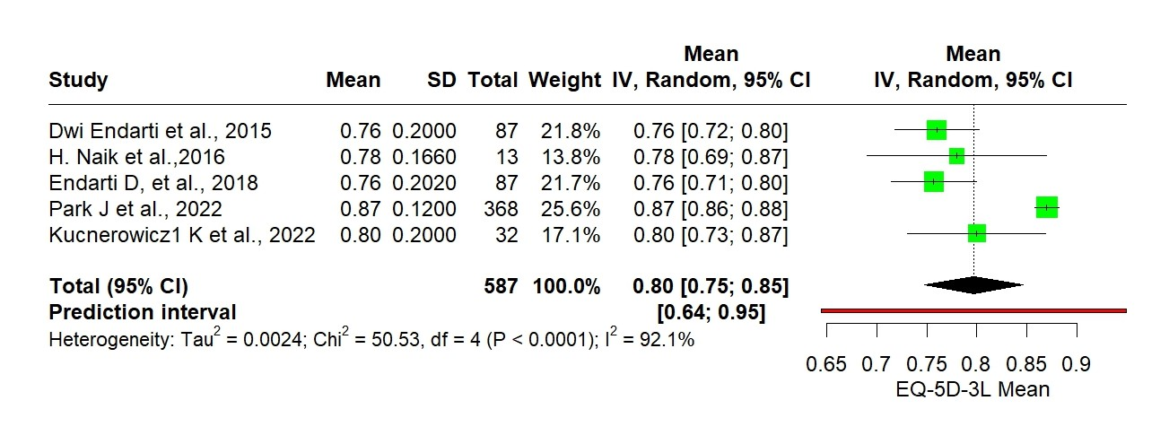Supplementary Figure 3: Subgroup analysis of EQ-5D-3L
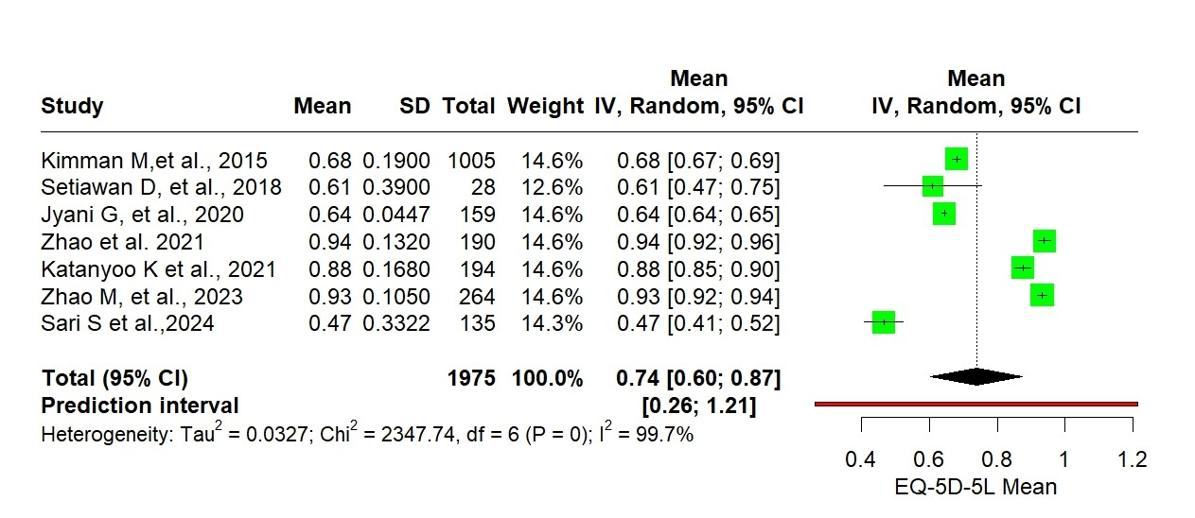
Supplementary Figure 4: Subgroup analysis of EQ-5D-5L
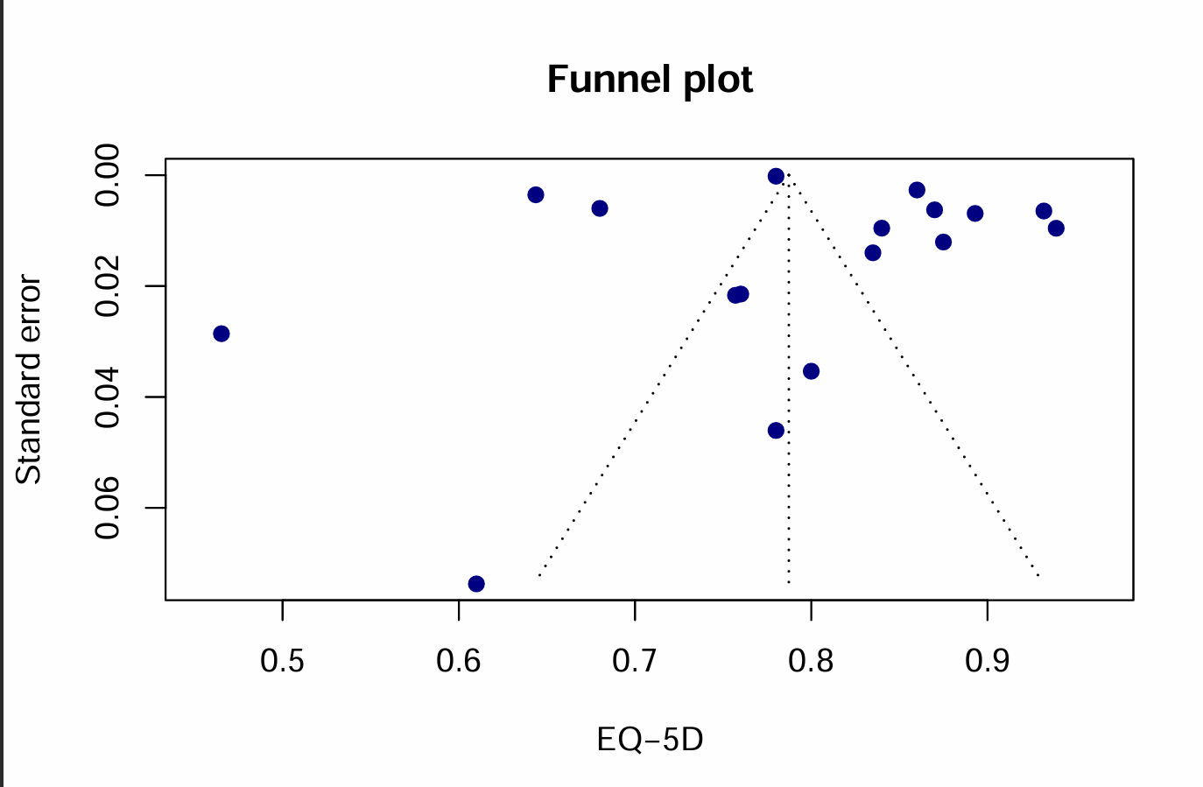
Supplementary Figure 5: Funnel plot for publication bias (EQ-5D utility)
This figure presents the Egger’s regression test plot to assess publication bias among studies reporting EQ-5D index utility scores. A regression line fitted through the funnel plot asymmetry is shown. A more symmetrical distribution of points around the regression line suggests lower likelihood of small study effects / publication bias.
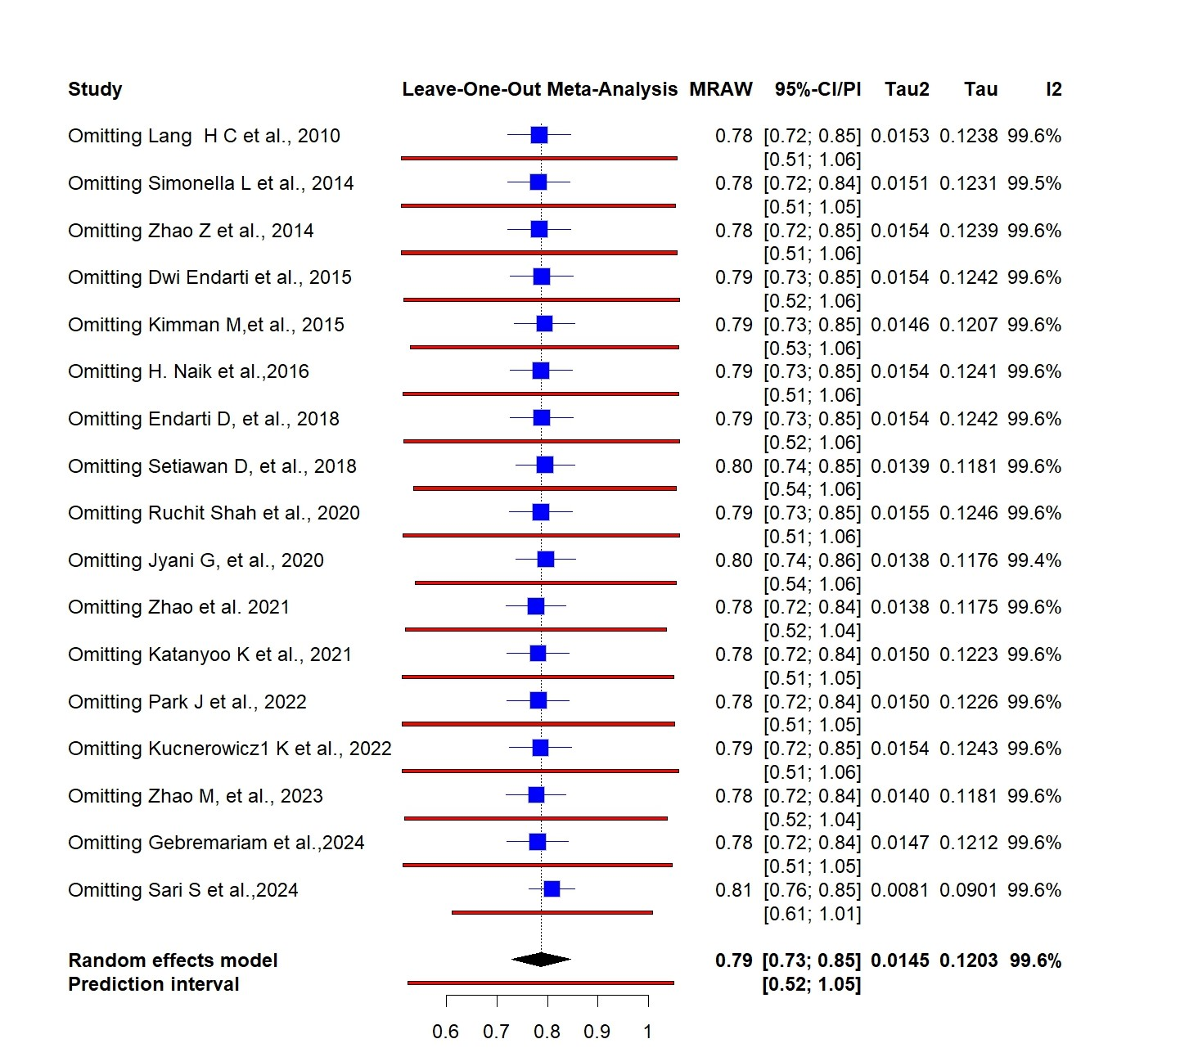
Supplementary Figure 6: Sensitivity analysis for EQ-5D pooled utility estimates
This figure shows the leave-one-out sensitivity analysis of the pooled EQ-5D utility score. Each point represents the pooled mean after removing one study at a time. Stability of the pooled estimate indicates that no single study disproportionately influenced the overall effect size.
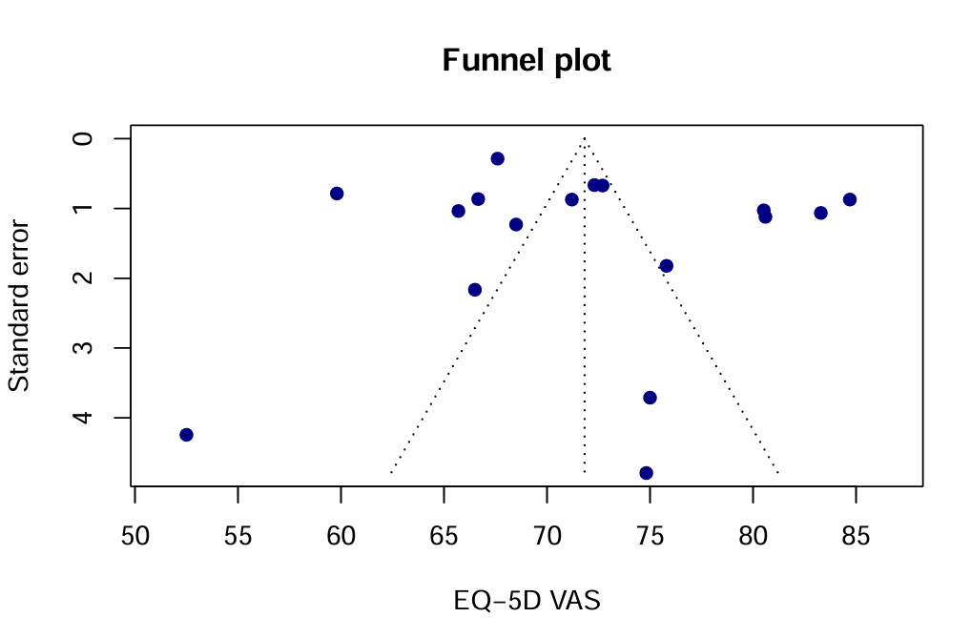
Supplementary Figure 7: Funnel plot for publication bias (EQ-5D VAS)
This figure illustrates the Egger’s regression test plot for assessing publication bias among studies reporting EQ-5D VAS scores. The regression line fitted through the funnel plot points indicates whether small study effects are present. A more symmetrical scatter around the regression line suggests lower risk of publication bias.
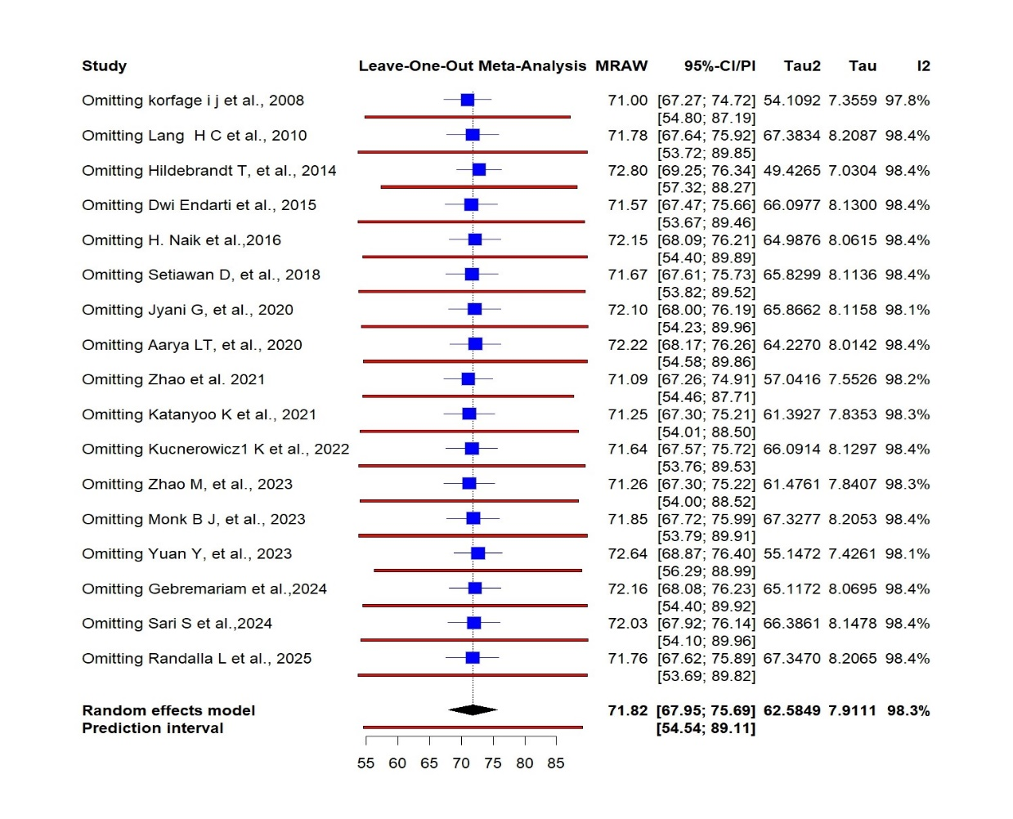
Supplementary Figure 8: Sensitivity analysis for EQ-5D VAS pooled estimates
This figure displays the leave-one-out sensitivity analysis for EQ-5D VAS scores. Removing each study sequentially allows evaluation of robustness of the pooled VAS estimate. Minimal variation across iterations reflects a stable pooled mean.
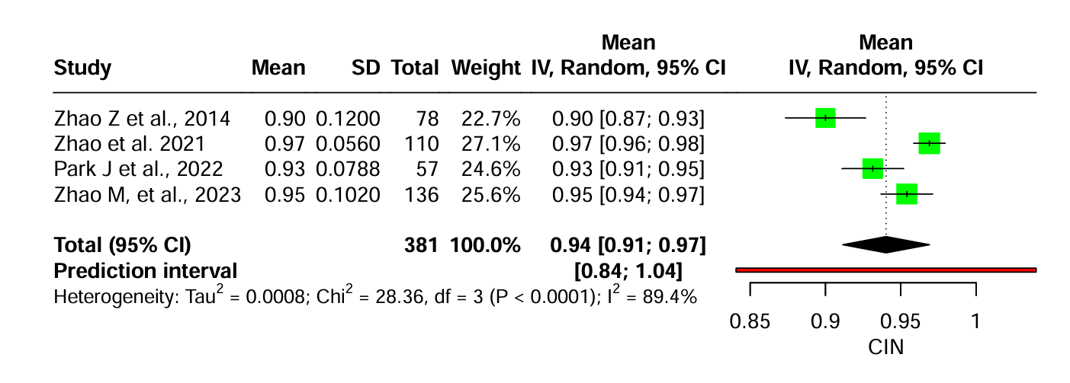
Supplementary Figure 9: Forest plot EQ-5D utility scores among Patients with CIN
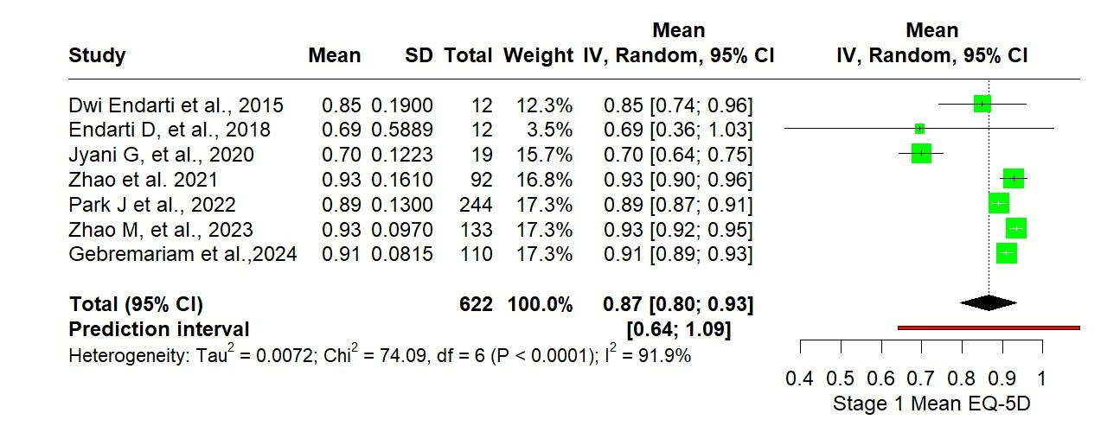
Supplementary Figure 10: Forest plot of EQ-5D Utility Scores – Stage I Cervical Cancer
This figure presents the pooled mean EQ-5D utility estimate for patients with Stage I cervical cancer. Each horizontal line corresponds to a study-level mean with 95% CI, while the diamond represents the overall pooled estimate using a random-effects model.
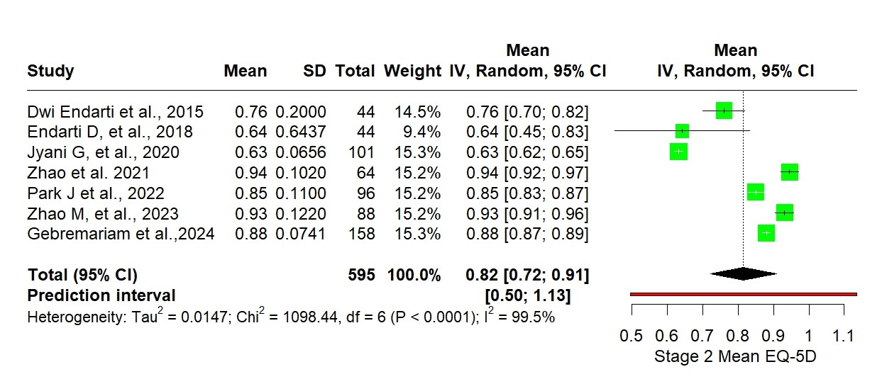
Supplementary Figure 11: Forest plot of EQ-5D Utility Scores – Stage II Cervical Cancer
This figure shows the pooled EQ-5D utility score for included studies that recruited patients with Stage II cervical cancer. Individual study means with 95% CIs and the synthesized random-effects pooled mean are displayed.
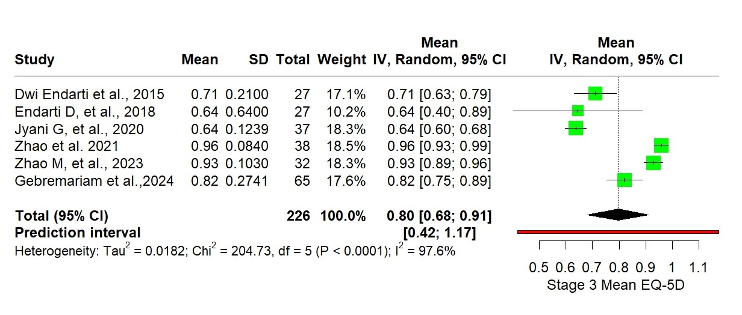
Supplementary Figure 12: Forest plot of EQ-5D Utility Scores – Stage III Cervical Cancer
This figure illustrates pooled EQ-5D utility scores reported among studies that included patients in advanced cervical cancer Stage III. Study-level estimates are shown with 95% CIs, together with the overall pooled mean from the random-effects model.
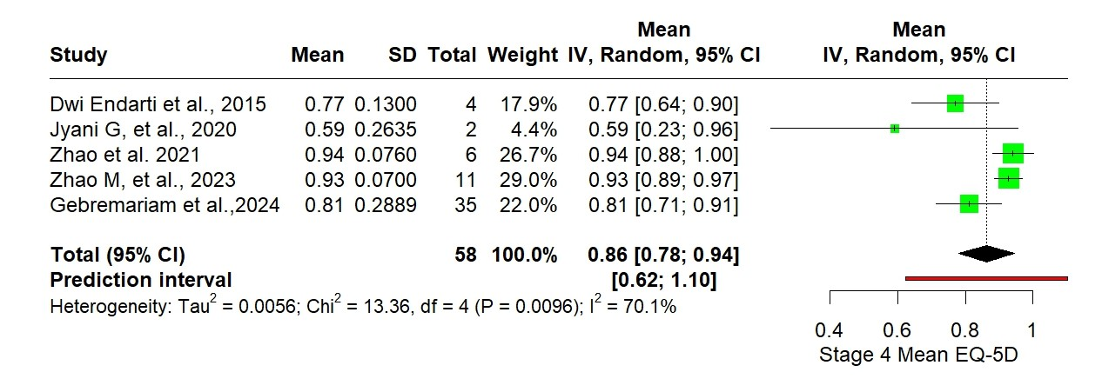
Supplementary Figure 13: Forest plot of EQ-5D Utility Scores – Stage IV Cervical Cancer
This figure illustrates pooled EQ-5D utility scores reported among studies that included patients in advanced cervical cancer Stage IV. Study-level estimates are shown with 95% CIs, together with the overall pooled mean from the random-effects model.
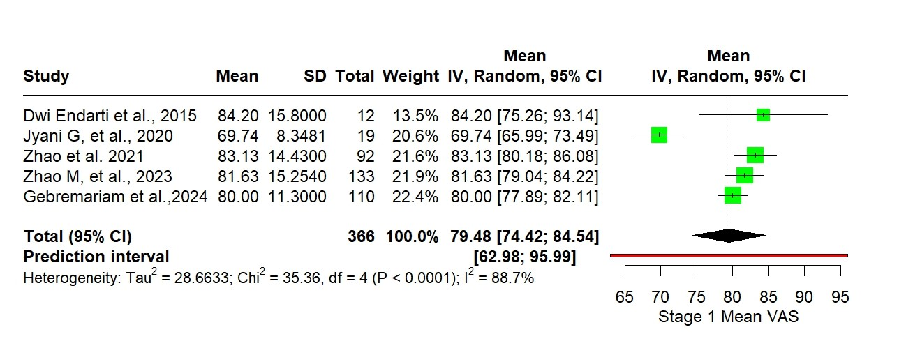
Supplementary Figure 14: Forest plot of EQ-5D VAS – Stage I Cervical Cancer
This figure displays the pooled EQ-5D VAS score for patients with Stage I cervical cancer. Each horizontal line represents the study-specific VAS mean with its 95% CI, and the diamond shows the random-effects pooled estimate.
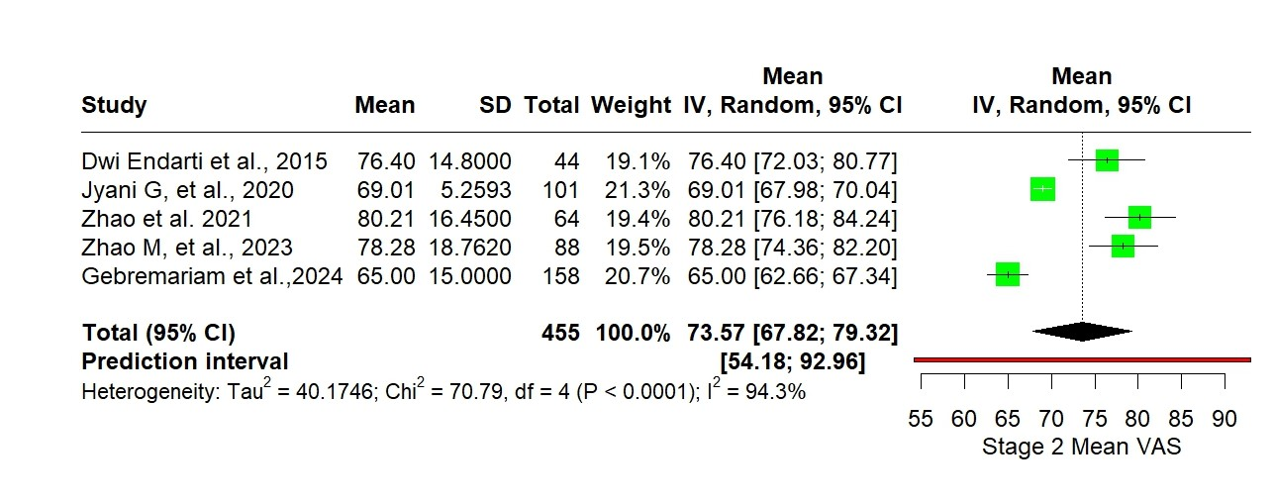
Supplementary Figure 15: Forest plot of EQ-5D VAS – Stage II Cervical Cancer
This figure presents pooled EQ-5D VAS estimates among studies that included Stage II cervical cancer patients. Individual study means with 95% CIs and the combined pooled mean are shown.
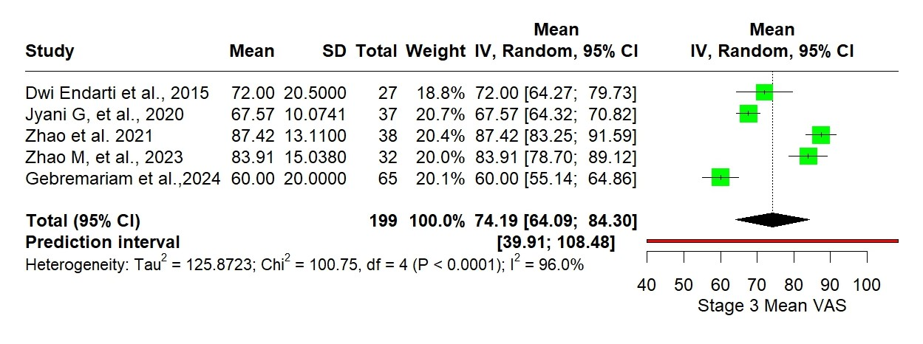
Supplementary Figure 16: Forest plot of EQ-5D VAS – Stage III Cervical Cancer
This figure illustrates the pooled EQ-5D VAS scores for patients with advanced-stage cervical cancer Stage III. Study-level estimates are shown with 95% CIs along with the pooled estimate using random-effects.
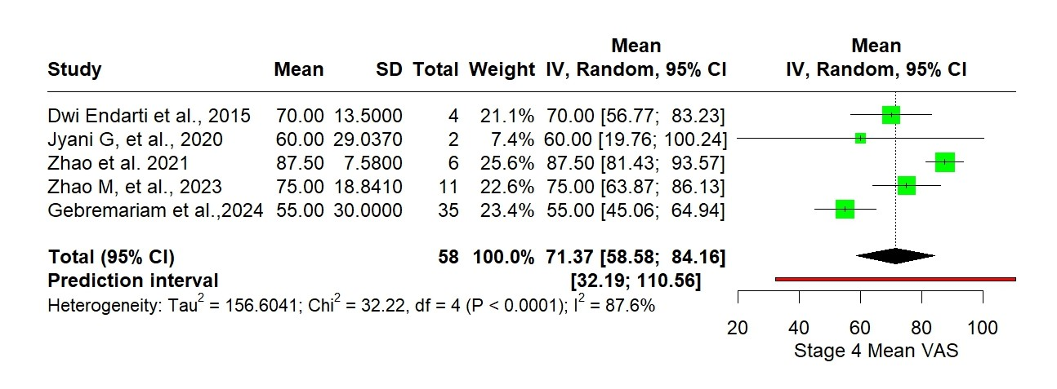
Supplementary Figure 17: Forest plot of EQ-5D VAS – Stage IV Cervical Cancer
This figure illustrates the pooled EQ-5D VAS scores for patients with advanced-stage cervical cancer Stage IV. Study-level estimates are shown with 95% CIs along with the pooled estimate using random-effects.
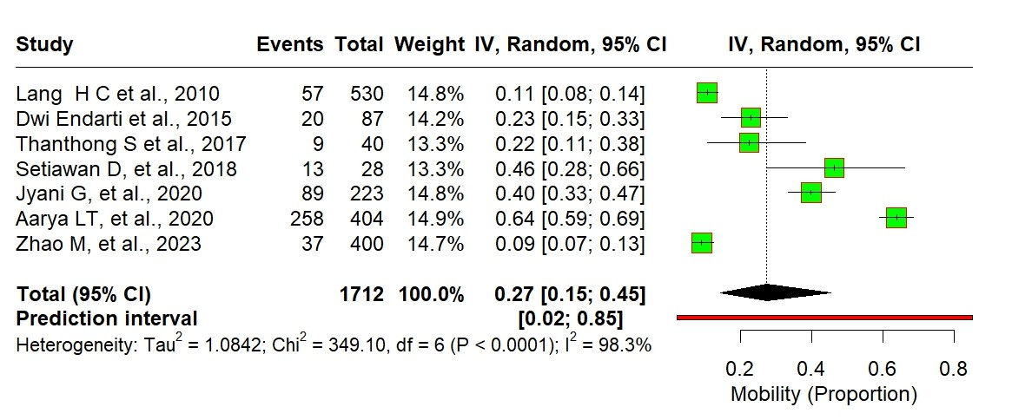
Supplementary Figure 18: EQ-5D Domain – Mobility
This figure shows the proportion of patients reporting levels of impairment in the “Mobility” domain of the EQ-5D across included studies. The pooled estimates reflect the distribution of mobility limitations among cervical cancer patients.
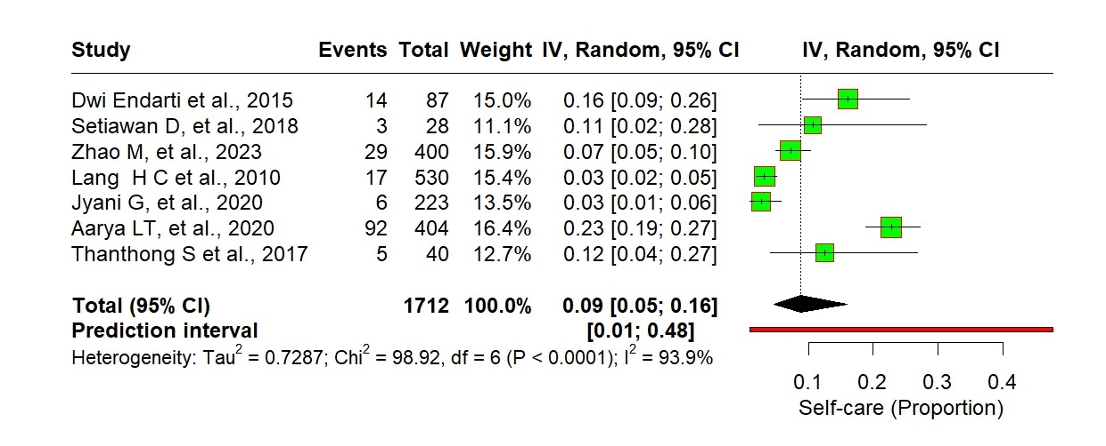
Supplementary Figure 19: EQ-5D Domain – Self-care
This figure presents pooled proportions of EQ-5D responses in the “Self-care” domain. The plot summarises the burden of self-care difficulties among patients with cervical cancer across the included evidence.
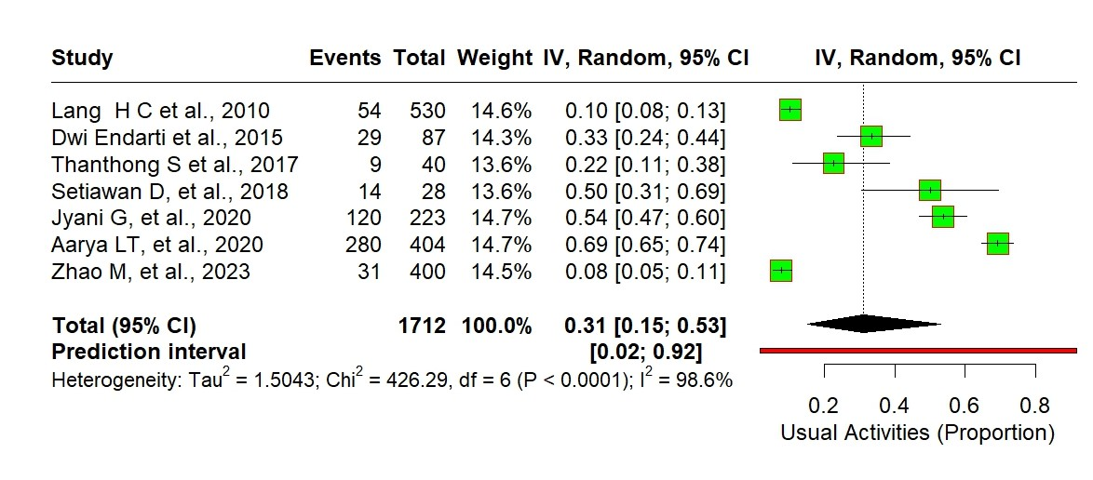
Supplementary Figure 20: EQ-5D Domain – Usual Activities
This figure describes the aggregate proportion of EQ-5D response categories for “Usual activities”. The pooled estimates depict the impact of cervical cancer on performing day-to-day tasks and routine functioning.
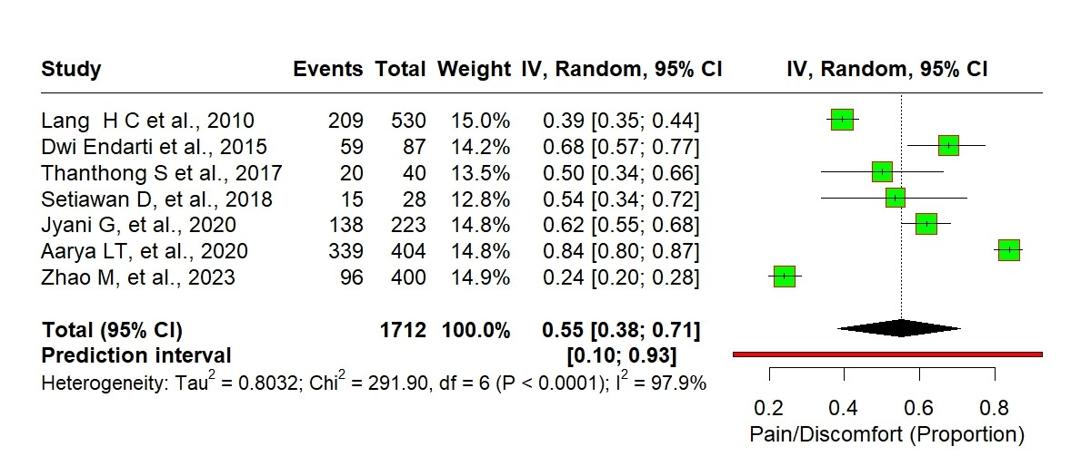
Supplementary Figure 21: EQ-5D Domain – Pain / Discomfort
This figure illustrates pooled estimates of EQ-5D reported pain/discomfort levels among cervical cancer patients. Higher proportions of moderate or severe levels reflect greater symptom burden.
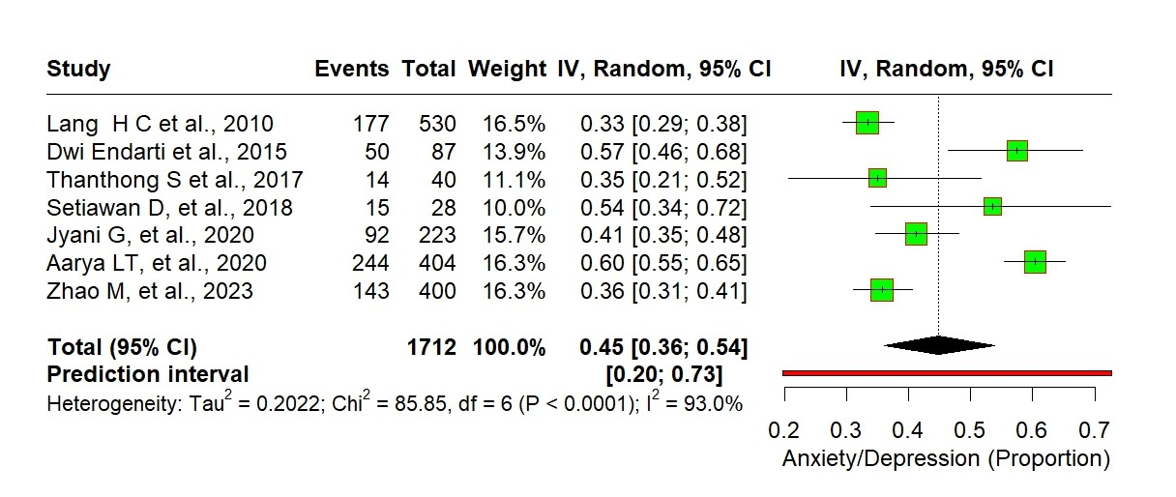Supplementary Figure 22: EQ-5D Domain – Anxiety / Depression
This figure shows pooled proportions of EQ-5D responses for the “Anxiety/Depression” dimension. The estimates represent the degree of psychological distress affecting women diagnosed with cervical cancer.

