Supplementary data

Rhodococcus folensis sp. nov., an orange-red-pigmented bacterium from mining soil

Aleyna NALCAOGLU SENOCAK^{1,2}, Omer Faruk OZTURK^{1,2}, Miray KILIC^{1,2}, Ersan BEKTAS³, Ali Osman BELDUZ⁴, Kadriye INAN BEKTAS¹*

¹Karadeniz Technical University, Faculty of Science, Department of Molecular Biology and Genetics, 61080 Trabzon, Türkiye
²Karadeniz Technical University, Graduate School of Natural and Applied Science, Department of Molecular Biology and Genetics, 61080 Trabzon, Turkey
³Espiye Vocational School, Giresun University, Giresun, Turkey
³Karadeniz Technical University, Faculty of Science, Department of Biology, 61080 Trabzon, Türkiye
* e-mail: kadriyensis@gmail.com, phone: +904623773687
*Corresponding author:
Kadriye İNAN BEKTAS

Article type: Taxonomic description

Contents of Supplementary Materials
1. Supplementary figures S1-S15 with figure legends
2. Supplementary tables S1-S5 with table legends

Fig. S1 Comparative colony morphology of Rhodococcus folensis FMA22ᵀ and closely related reference strains grown on agar medium. A) FMA22^{T}; B) R. corynebacterioides DSM 20151ᵀ; C) R. kroppenstedtii DSM 44908ᵀ; D) R. trifolii T8^{T}

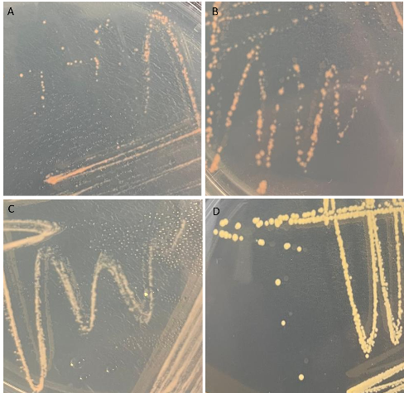

Fig. S2 The relationship between strain FMA1 and other related type strains are depicted in this maximum-parsinomy phylogenetic tree, which is based on 16S rRNA gene sequences. Macrococcoides canis was used as an outgroup. Bar, 0.01 substitutions per nucleotide position

Fig. S3 The relationship between strain FMA9 and other related type strains are depicted in this maximum-parsinomy phylogenetic tree, which is based on 16S rRNA gene sequences. Nocardia vaccinii was used as an outgroup. Bar, 0.01 substitutions per nucleotide position

Fig. S4 The relationship between strain FMAX and other related type strains are depicted in this maximum-parsinomy phylogenetic tree, which is based on 16S rRNA gene sequences. Kytococcus sedentarius was used as an outgroup. Bar, 0.01 substitutions per nucleotide position

Fig. S5 The relationship between strain UGA5 and other related type strains are depicted in this maximum-parsinomy phylogenetic tree, which is based on 16S rRNA gene sequences. Cellvibrio japoninus was used as an outgroup. Bar, 0.01 substitutions per nucleotide position

Fig. S6 The relationship between strain UGA11 and other related type strains are depicted in this maximum-parsinomy phylogenetic tree, which is based on 16S rRNA gene sequences. Bar, 0.01 substitutions per nucleotide position

Fig. S7 The relationship between strain UGA12 and other related type strains are depicted in this maximum-parsinomy phylogenetic tree, which is based on 16S rRNA gene sequences. Alkalihalobacillus alcalophilus was used as an outgroup. Bar, 0.01 substitutions per nucleotide position

Fig. S8 The relationship between strain FMA23 and other related type strains are depicted in this maximum-parsinomy phylogenetic tree, which is based on 16S rRNA gene sequences. Skermania pinensis was used as an outgroup. Bar, 0.01 substitutions per nucleotide position

Fig. S9 The relationship between strain FMA22^{T} and other related type strains are depicted in this maximum-parsinomy phylogenetic tree, which is based on 16S rRNA gene sequences. Bootstrap values exceeding 50% are indicated at the branch points. Micromonospora aurantiaca ATCC 27029^{T} was used as an outgroup.

Fig. S10 The relationship between strain FMA22^{T} and other related type strains are depicted in this neighbour-joining phylogenetic tree, which is based on 16S rRNA gene sequences. Bootstrap values exceeding 50% are indicated at the branch points. Micromonospora aurantiaca ATCC 27029^{T} was used as an outgroup. Bar, 0.01 substitutions per nucleotide position

Fig. S11 Phylogenetic tree based on whole-genome sequences of strain FMA22^{T} and related reference strains. The tree was inferred with FastME 2.1.6.1 from genome blast distance phylogeny (GBDP) distances calculated from genome sequences using the TYGS server (https:// tygs.dsmz.de). The branch lengths are scaled in terms of GBDP distance formula d5. The numbers at branches are GBDP pseudo-bootstrap support values ≥64% from 100 replications with an average branch support of 97.7%. The tree was rooted at the midpoint.
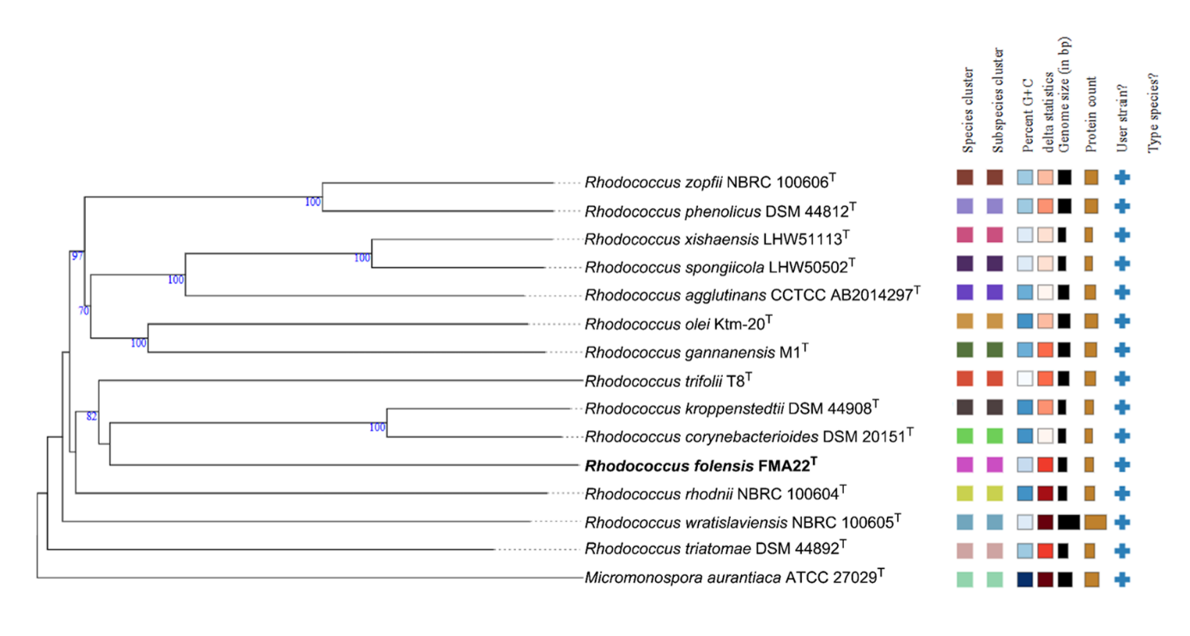

Fig. S12 Comparative antiSMASH analysis of carotenoid-related biosynthetic gene clusters identified in Rhodococcus folensis FMA22ᵀ and closely related Rhodococcus species. A) FMA22^{T}; B) R. corynebacterioides DSM 20151ᵀ; C) R. kroppenstedtii DSM 44908ᵀ; D) R. trifolii T8^{T}

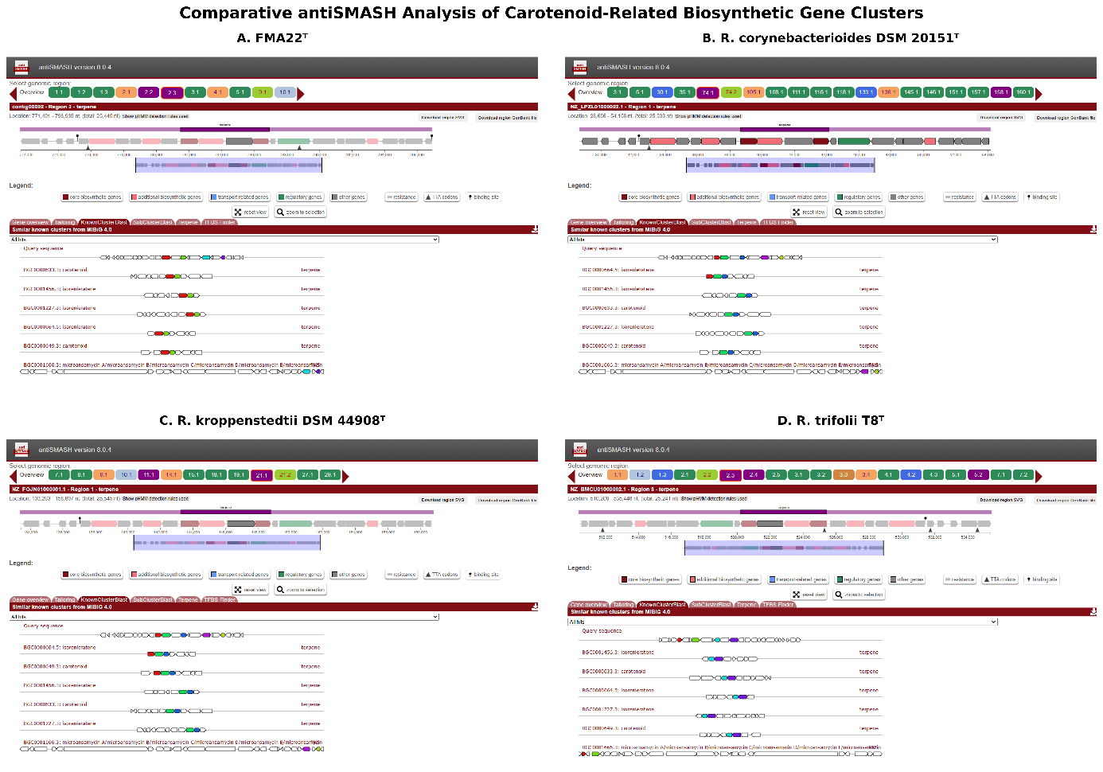

Fig. S13 Comparative heatmap analysis of carotenoid-related proteins among Rhodococcus folensis FMA22ᵀ and closely related Rhodococcus species.

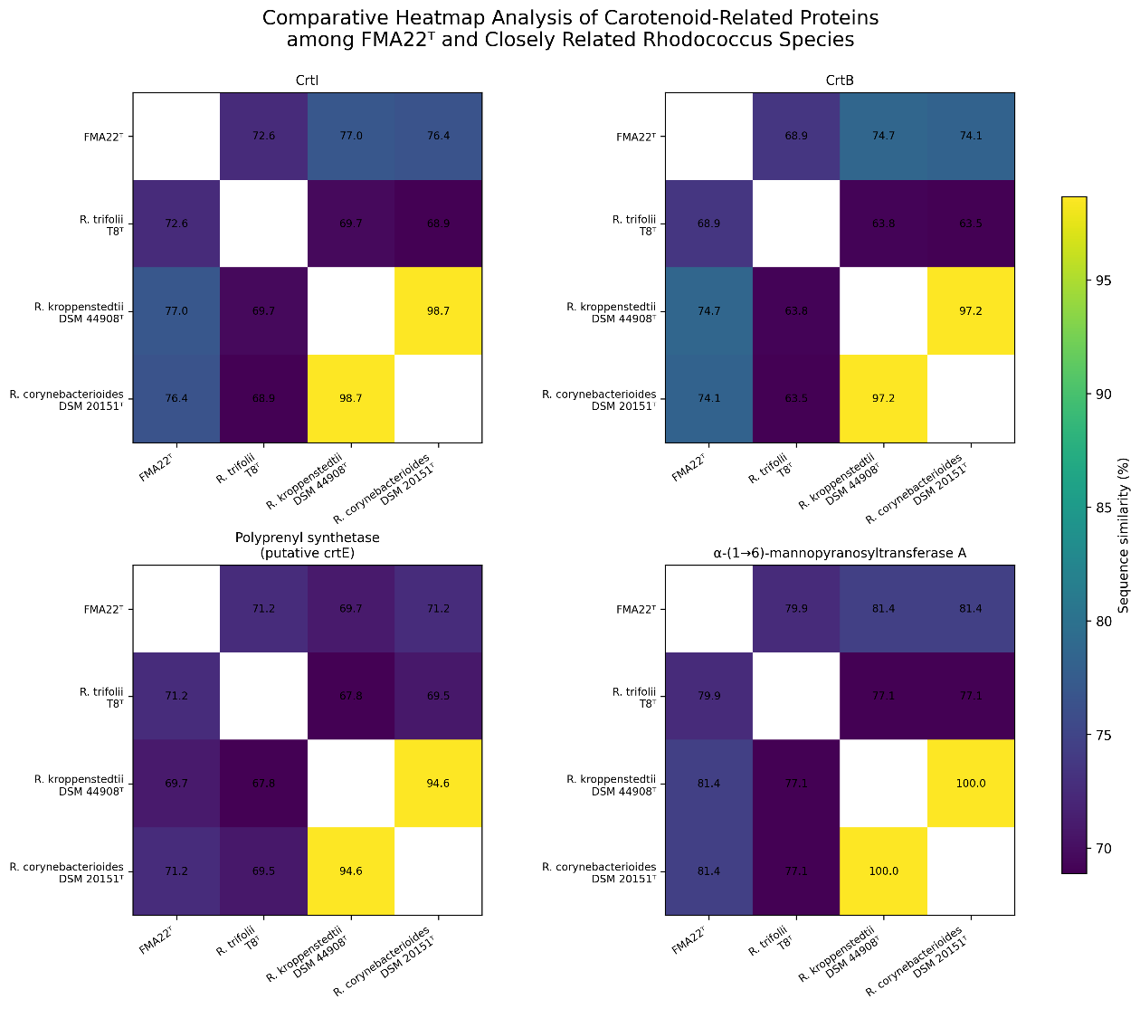

Fig. S14 Visualization of genomic data and analysis of biosynthetic gene clusters: Seed Viewer results. Comparative genomic analyses of strains; A) FMA22^{T}; B) R. corynebacterioides DSM 20151ᵀ; C) R. kroppenstedtii DSM 44908ᵀ; D) R. trifolii T8^{T} were performed using the SEED Viewer.

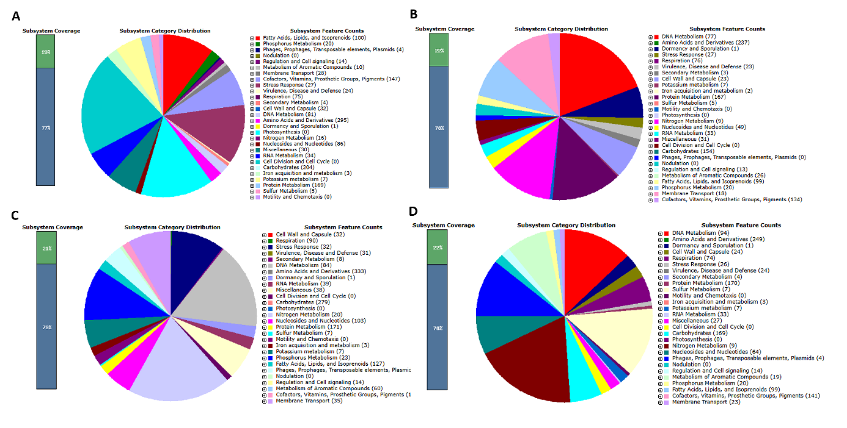

Fig. S15 HIV-1 Reverse Transcriptase (RT) inhibitory activity of the crude carotenoid extract obtained from Rhodococcus folensis FMA22ᵀ.

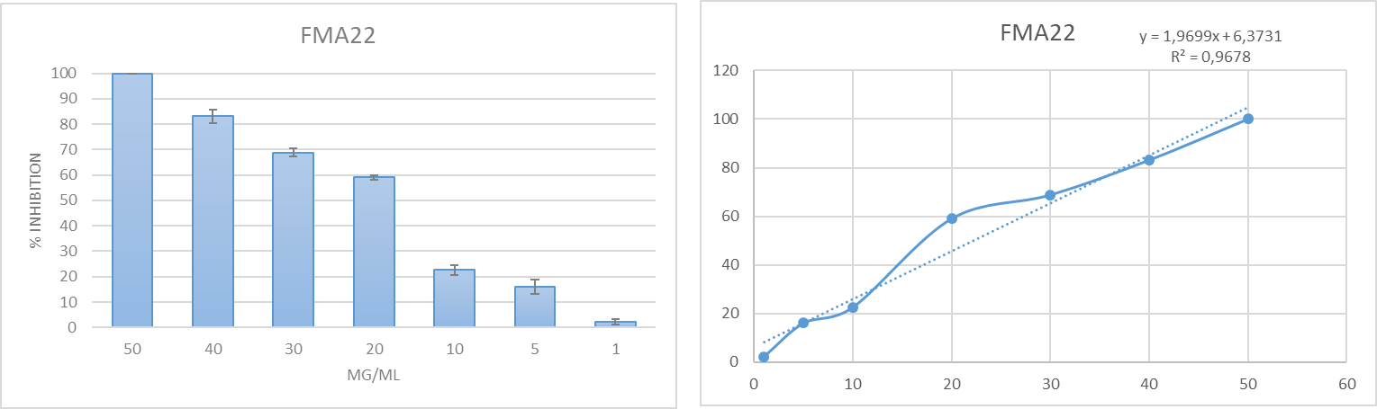

Table S1. Pigmented bacterial isolates obtained from environmental samples and their closest phylogenetic relatives based on 16S rRNA gene sequence analysis.
Strain | Colony Color | Closest Type Strain (16S rRNA) | Similarity (%)
FMA22^{T} | Orange–red | Rhodococcus corynebacterioides | %99.57
FMAX | Dull yellow | Micrococcus luteus | %99.63
FMA9 | Yellowish-brown | Pseudonocardia carboxydivorans | %100
UGA11 | Yellow | Plantibacter flavus | %99.93
FMA23 | Dark orange | Williamsia muralis | %99.63
UGA12 | Orange | Exiguobacterium sibiricum | %99.79
FMA 1 | Dark yellow | Staphylococcus hominis subsp. hominis | %99.86
UGA5 | Bright yellow | Pseudomonas sivasensis | %100

Table S2. Carbohydrate active enzymes (CAZymes) annotation results of strain FMA22^{T} and its closest phylogenetic relative. Carbohydrate active enzymes (CAZymes); glycosyltransferases (GTs), glycoside hydrolases (GHs), carbohydrate-binding modules (CBMs), polysaccharide lyases (PLs), auxiliary activities (AAs) and carbohydrate esterases (CEs)

 | GT | GH | CBM | CE | AA
R. kroppenstedtii DSM 44908ᵀ | 57 | 35 | 6 | 21 | 5
R. trifolii T8ᵀ | 69 | 42 | 5 | 21 | 11
R. corynebacterioides DSM 20151ᵀ | 56 | 31 | 5 | 10 | 6
FMA22^{T} | 60 | 37 | 5 | 12 | 7

Table S3. Numbers of genes associated with the KEGG functional pathways.
1.FMA22^{T}; 2. R. corynebacterioides DSM 20151ᵀ; 3. R. kroppenstedtii DSM 44908ᵀ; 4. R. trifolii T8ᵀ.

Obtain from KEGG pathways | 1 | 2 | 3 | 4
Metabolism
Global and overview maps | 1539 | 1452 | 1449 | 1692
Carbohydrate metabolism | 245 | 231 | 226 | 275
Energy metabolism | 131 | 129 | 129 | 140
Lipid metabolism | 77 | 76 | 73 | 81
Nucleotide metabolism | 85 | 66 | 70 | 87
Amino acid metabolism | 240 | 211 | 212 | 266
Metabolism of other amino acids | 52 | 39 | 41 | 63
Glycan biosynthesis and metabolism | 89 | 88 | 86 | 91
Metabolism of cofactors and vitamins | 166 | 149 | 158 | 171
Metabolism of terpenoids and polyketides | 30 | 29 | 29 | 30
Biosynthesis of other secondary metabolites | 38 | 36 | 37 | 43
Xenobiotics biodegradation and metabolism | 62 | 76 | 53 | 127
Genetic Information Processing
Transcription | 5 | 4 | 5 | 5
Translation | 78 | 78 | 78 | 78
Folding, sorting and degradation | 41 | 40 | 41 | 42
Replication and repair | 69 | 76 | 68 | 69
Information processing in viruses | 1 | 1 | 1 | 1
Environmental Information Processing
Membrane transport | 103 | 94 | 102 | 106
Signal transduction | 57 | 60 | 58 | 62
Cellular Processes
Transport and catabolism | 12 | 11 | 12 | 15
Cell growth and death | 16 | 16 | 16 | 16
Cell motility | 3 | 2 | 2 | 5
Cellular community - prokaryotes | 41 | 44 | 43 | 47
Organismal Systems
Aging | 12 | 12 | 12 | 12
Environmental adaptation | 6 | 6 | 6 | 6
Immune system | 5 | 5 | 5 | 5
Endocrine system | 19 | 18 | 18 | 18
Digestive system | 11 | 11 | 11 | 11
Excretory system | 2 | 2 | 2 | 2
Nervous system | 6 | 7 | 6 | 7
Development and regeneration | 1 | 1 | 1 | 1
Human Diseases
Cancer: overview | 17 | 16 | 17 | 17
Cancer: specific types | 4 | 4 | 4 | 4
Infectious disease: bacterial | 14 | 13 | 13 | 14
Infectious disease: parasitic | 2 | 2 | 2 | 2
Infectious disease: viral | 1 | 1 | 1 | 1
Immune disease | 2 | 2 | 2 | 2
Neurodegenerative disease | 14 | 14 | 16 | 14
Cardiovascular disease | 10 | 10 | 10 | 10
Substance dependence | 3 | 3 | 3 | 3
Endocrine and metabolic disease | 10 | 10 | 9 | 11
Drug resistance: antimicrobial | 15 | 16 | 16 | 16
Drug resistance: antineoplastic | 6 | 6 | 6 | 6

Table S4. Comparative RAST subsystem distribution analysis of Rhodococcus folensis FMA22ᵀ and closely related Rhodococcus species.
1.FMA22^{T}; 2. R. corynebacterioides DSM 20151ᵀ; 3. R. kroppenstedtii DSM 44908ᵀ; 4. R. trifolii T8ᵀ.

 | 1 | 2 | 3 | 4
Fatty Acids, Lipids and Isoprenoids | 100 | 99 | 127 | 99
Phosphorus Metabolism | 20 | 20 | 23 | 20
Phages, Prophages, Transposable elements, Plasmids | 4 | 0 | 3 | 4
Nodulation | 0 | 0 | 0 | 0
Regulation and Cell signaling | 14 | 13 | 14 | 14
Metabolism of Aromatic Compounds | 10 | 26 | 60 | 19
Membrane Transport | 28 | 18 | 35 | 23
Cofactors, Vitamins, Prostheti Groups, Pigments | 147 | 134 | 172 | 141
Stress Response | 27 | 27 | 32 | 26
Virulence, Disease and Defence | 24 | 23 | 31 | 24
Respiration | 75 | 76 | 90 | 74
Secondary Metabolism | 4 | 3 | 8 | 4
Cell Wall and Capsule | 32 | 23 | 32 | 24
DNA Metabolism | 81 | 77 | 84 | 94
Amino Acisd and Derivates | 295 | 237 | 333 | 249
Dormancy and Sporulation | 1 | 1 | 1 | 1
Photosynthesis | 0 | 0 | 0 | 0
Nitrogen Metabolism | 16 | 9 | 20 | 9
Nucleosides and Nucteotides | 86 | 49 | 103 | 64
Miscellaneous | 30 | 31 | 38 | 27
RNA Metabolism | 34 | 33 | 39 | 33
Cell Division and Cell Cycle | 0 | 0 | 0 | 0
Carbonhydrates | 204 | 154 | 279 | 169
Iron acquisition and Metabolism | 3 | 2 | 3 | 3
Potassium Metabolism | 7 | 7 | 7 | 7
Protein Metabolism | 169 | 167 | 171 | 170
Sulfur Metabolism | 5 | 5 | 7 | 7
Motility and Chemotaxis | 0 | 0 | 0 | 0

Table S5. Cellular fatty acid profiles of strain FMA22^{T} and its closest phylogenetic relative.
1.FMA22^{T}; 2. R. corynebacterioides DSM 20151ᵀ; 3. R. kroppenstedtii DSM 44908ᵀ; 4. R. trifolii T8ᵀ.
All data were obtained in this study. Fatty acids amounting to more than 10% are highlighted in bold. –, not detected.

Fatty acid | 1 | 2 | 3 | 4
C_{14:0} | 2.79 | 4.8 | 5.2 | 6.5
C_{15:1} ω5c | 1.0 | 0.9 | 0.8 | 0.6
C_{15:0} | - | - | - | 3.0
anteiso-C_{15:0} | 3.63 | 1.2 | 0.8 | 0.6
C_{16:0} | 18.87 | 21.5 | 28.5 | 21.6
C_{16:0} 2OH | 0.58 | - | - | -
anteiso-C_{16:0} | 1.32 | 0.6 | 0.8 | 0.5
C_{17:1} ω8c | 7.60 | 8.1 | 9.6 | 5.4
C_{17:0} | 1.12 | 0.9 | 2.0 | 1.1
10-methyl C_{17:0} | 1.45 | 0.5 | 1.7 | 2.1
C_{18:1} ω9c | 26.64 | 22.8 | 26.8 | 19.1
10-methyl C_{18:0} | 9.56 | 8.7 | 5.6 | 11.9
Summed feature 3 | 21.83 | 13.1 | 10.7 | 15.7
Summed feature 6 | 1.08 | 1.0 | 1.5 | 3.2

* Summed features consist of one or more fatty acids that cannot be separated by the method used. Summed feature 3 contains C16:1 ω7c / C16:1 ω6c; summed feature 6 contains C19:1 ω11c / C19:1 ω9c.

