Rawª gestational age acceleration (Knight), weeks
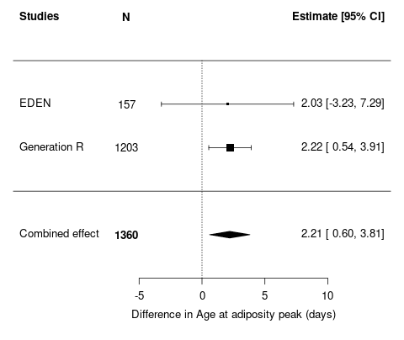  W_{EDEN}=9.3%  W_{GENR}=90.7% | 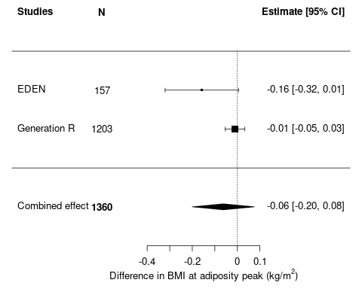  W_{EDEN} =35.2%  W_{GENR} =64.8%
Residual^{b} gestational age acceleration (Knight), weeks
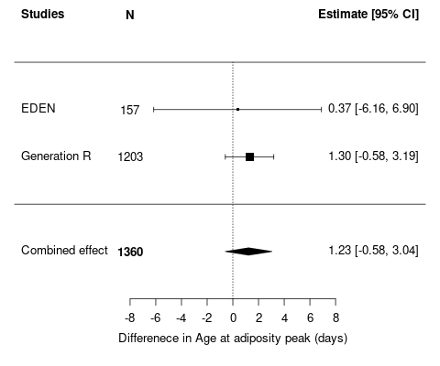  W_{EDEN} =7.7%  W_{GENR} =92.3% | 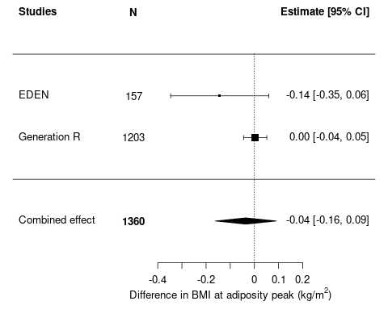  W_{EDEN} =26.5%  W_{GENR} =73.5%
Supplementary Figure S1: Meta-analysis results of linear regression analyses of association between raw and residual gestational age acceleration estimated using the Knight clock and age/BMI at adiposity peak.
Results of analyses after multiple imputation of missing data for covariables, adjusted for maternal age, maternal and paternal education level, maternal and paternal BMI, gestational weight gain, maternal smoking during pregnancy, sex, and cell types. Values represent regression coefficients (SE) and correspond to the difference in age at adiposity peak (in days) or BMI at adiposity peak (in kg/m²) per one-week increase in raw or residual gestational age acceleration at birth.
ª Raw gestational age acceleration (in weeks) was obtained by subtracting the clinical estimate of gestational age from DNA methylation gestational age.
^{b} Residual gestational age acceleration (in weeks) was calculated from the residuals from a regression model of DNA methylation gestational age on clinical gestational age.
The weights assigned to each study (W_{EDEN}: EDEN; W_{GENR}: Generation R) are displayed in the bottom-left corner of each plot.

Rawª gestational age acceleration (Knight), weeks
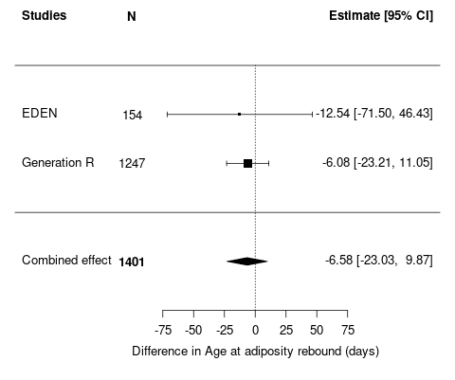  W_{EDEN} =11.6%  W_{GENR} =88.4% | 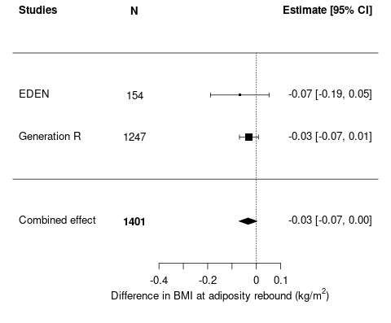  W_{EDEN} =10.4%  W_{GENR} =89.6%
Residual^{b} gestational age acceleration (Knight), weeks
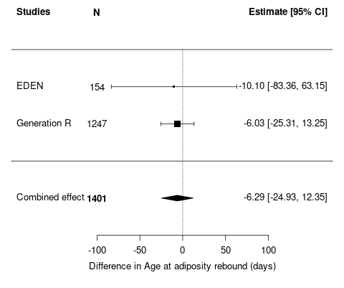  W_{EDEN} =8.6%  W_{GENR} =91.4% | 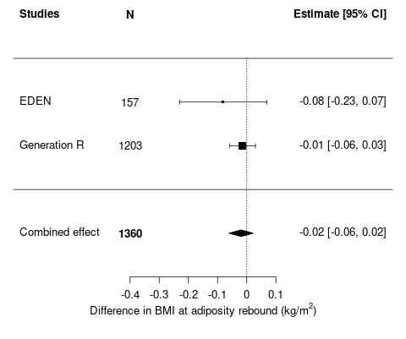  W_{EDEN} =9.8%  W_{GENR} =90.2%
Supplementary Figure S2: Meta-analysis results of linear regression analyses of association between raw and residual gestational age acceleration estimated using the Knight clock and age/BMI at adiposity rebound.
Results of analyses after multiple imputation of missing data for covariables, adjusted for maternal age, maternal and paternal education level, maternal and paternal BMI, gestational weight gain, maternal smoking during pregnancy, sex, and cell types. Values represent regression coefficients (SE) and correspond to the difference in age at adiposity rebound (in days) or BMI at adiposity rebound (in kg/m²) per one-week increase in raw or residual gestational age acceleration at birth.
ª Raw gestational age acceleration (in weeks) was obtained by subtracting the clinical estimate of gestational age from DNA methylation gestational age.
^{b} Residual gestational age acceleration (in weeks) was calculated from the residuals from a regression model of DNA methylation gestational age on clinical gestational age.
The weights assigned to each study (W_{EDEN}: EDEN; W_{GENR}: Generation R) are displayed in the bottom-left corner of each plot

Rawª gestational age acceleration (Bohlin), weeks |  | Residual^{b} gestational age acceleration (Bohlin), weeks
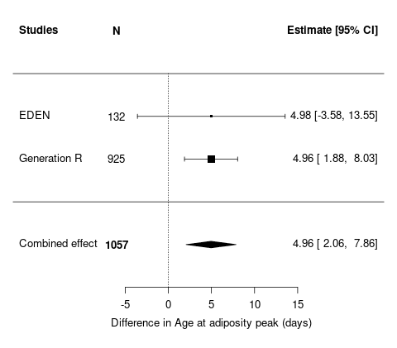  W_{EDEN}=11.4%  W_{GENR}=88.6% | 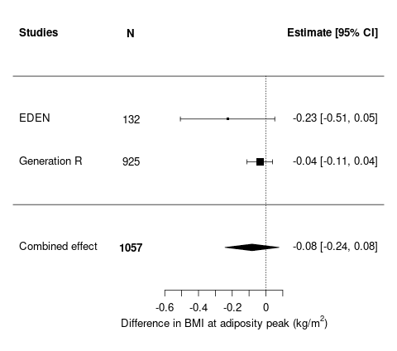  W_{EDEN}=24.1%  W_{GENR}=75.9% | 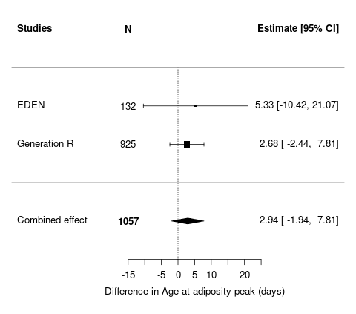  W_{EDEN}=9.6%  W_{GENR}=90.4% | 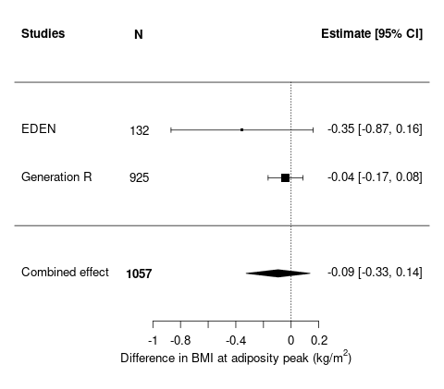  W_{EDEN}=17.1%  W_{GENR}=82.9%
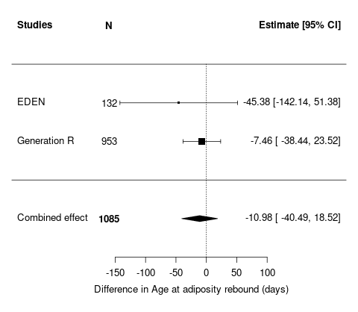  W_{EDEN}=9.3%  W_{GENR}=90.7% | 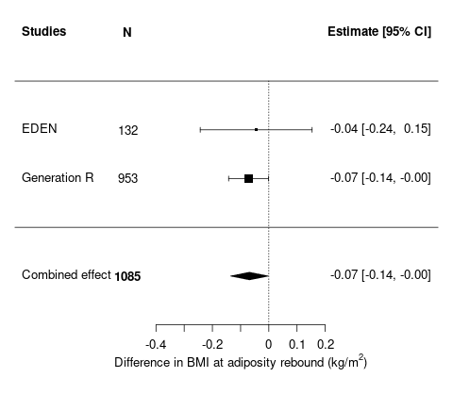  W_{EDEN}=11.3%  W_{GENR}=88.7% | 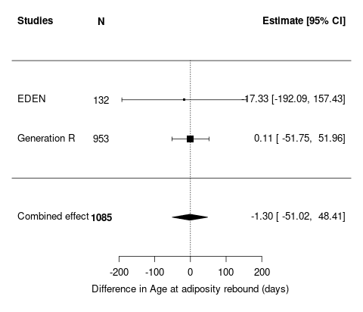  W_{EDEN}=8.1%  W_{GENR}=91.9% | 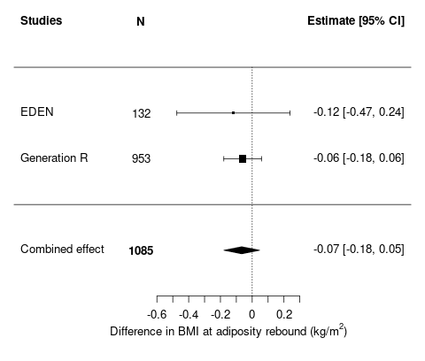  W_{EDEN}=10%  W_{GENR}=90%
Supplementary Figure S3: Results of association analyses between gestational age acceleration estimated using the Bohlin clock and age/BMI at adiposity peak and rebound in complete cases.
Results of analyses adjusted for maternal age, maternal and paternal education level, maternal and paternal BMI, gestational weight gain, maternal smoking during pregnancy, sex, and cell types, without missing data. Values represent regression coefficients (SE) and correspond to the difference in age at adiposity peak/rebound (in days) or BMI at adiposity peak/rebound (in kg/m²) per one-week increase in raw or residual gestational age acceleration at birth.
ª Raw gestational age acceleration (in weeks) was obtained by subtracting the clinical estimate of gestational age from DNA methylation gestational age.
^{b} Residual gestational age acceleration (no unit) was calculated from the residuals from a regression model of DNA methylation gestational age on clinical gestational age.
The weights assigned to each study (W_{EDEN}: EDEN; W_{GENR}: Generation R) are displayed in the bottom-left corner of each plot

Rawª gestational age acceleration (Knight), weeks |  | Residualª gestational age acceleration (Knight), weeks
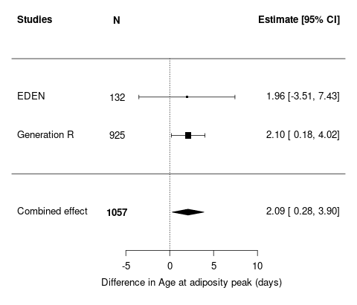  W_{EDEN}=10.9%  W_{GENR}=89.1% | 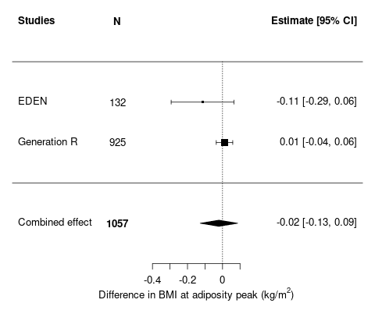  W_{EDEN}=25.4%  W_{GENR}=74.6% | 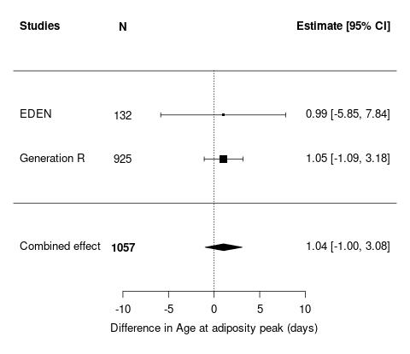  W_{EDEN}=8.9%  W_{GENR}=91.1% | 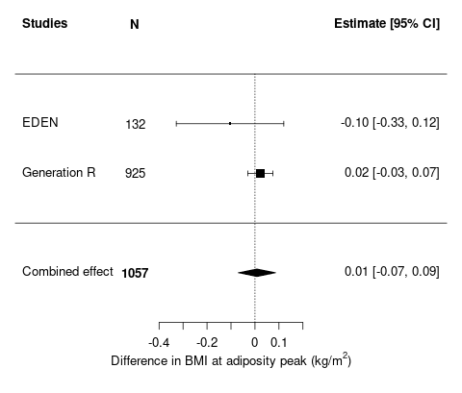  W_{EDEN}=11.2%  W_{GENR}=88.8%
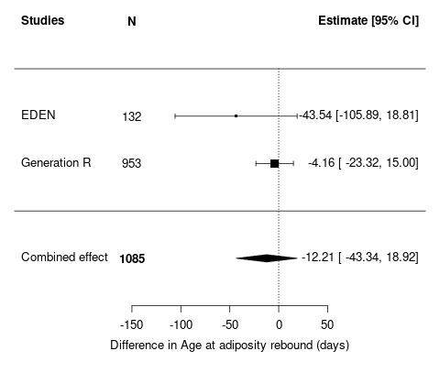  W_{EDEN}=20.5%  W_{GENR}=79.5% | 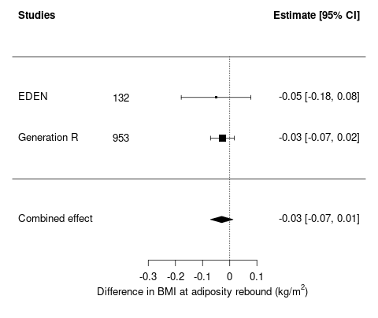  W_{EDEN}=10.5%  W_{GENR}=89.5% | 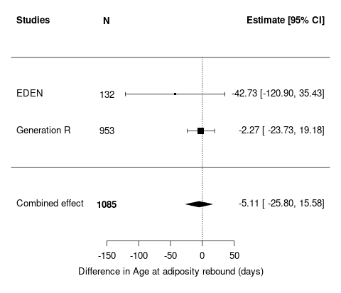  W_{EDEN}=7%  W_{GENR}=93% | 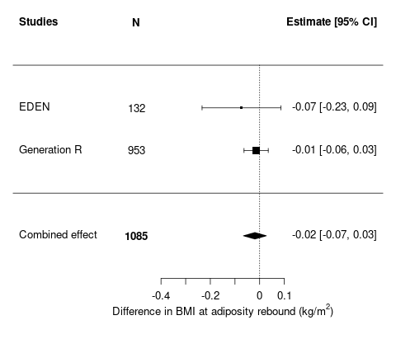  W_{EDEN}=8.6%  W_{GENR}=91.4%
Supplementary Figure S4: Results of association analyses between gestational age acceleration estimated using the Knight clock and age/BMI at adiposity peak and rebound in complete case.
Results of analyses adjusted for maternal age, maternal and paternal education level, maternal and paternal BMI, gestational weight gain, maternal smoking during pregnancy, sex, and cell types, without missing data. Values represent regression coefficients (SE) and correspond to the difference in age at adiposity peak/rebound (in days) or BMI at adiposity peak/rebound (in kg/m²) per one-week increase in raw or residual gestational age acceleration at birth.
ª Raw gestational age acceleration (in weeks) was obtained by subtracting the clinical estimate of gestational age from DNA methylation gestational age.
^{b} Residual gestational age acceleration (in weeks) was calculated from the residuals from a regression model of DNA methylation gestational age on clinical gestational age.
The weights assigned to each study (W_{EDEN}: EDEN; W_{GENR}: Generation R) are displayed in the bottom-left corner of each plot.

Rawª gestational age acceleration (Bohlin), weeks |  | Residual^{b} gestational age acceleration (Bohlin), weeks
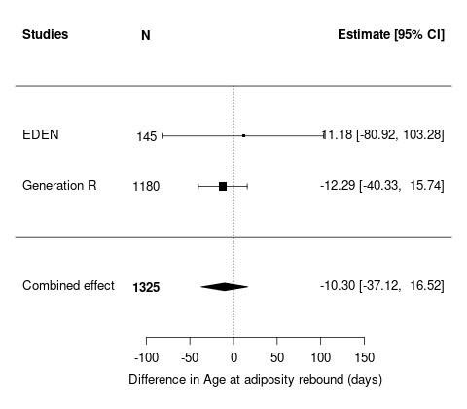  W_{EDEN}=8.5%  W_{GENR}=91.5% | 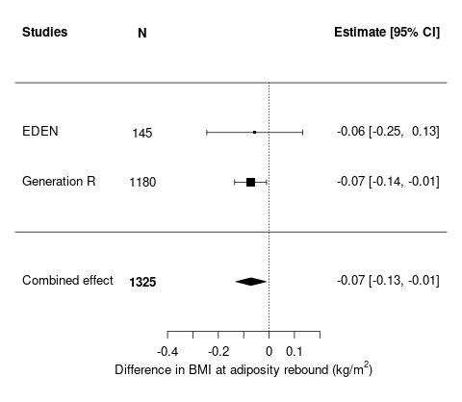  W_{EDEN} =10%  W_{GENR} =90% | 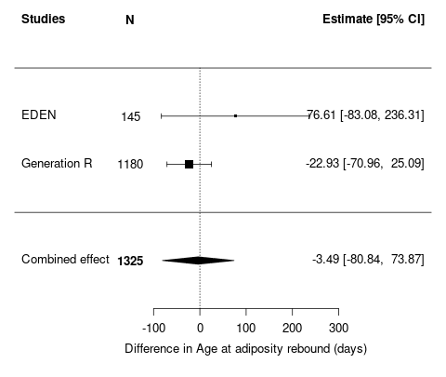  W_{EDEN} =19.5%  W_{GENR} =80.5% | 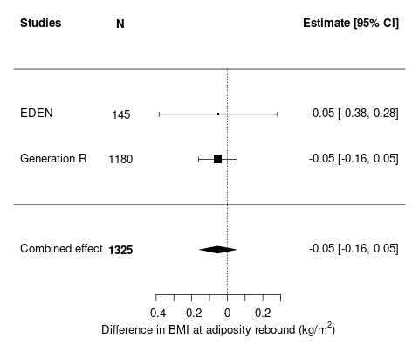  W_{EDEN} =9.5%  W_{GENR} =90.5%
Rawª gestational age acceleration (Knight), weeks |  | Residual^{b} gestational age acceleration (Knight), weeks
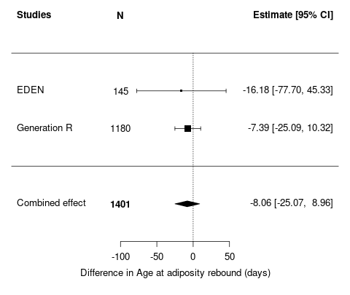  W_{EDEN}=7.7%  W_{GENR}=92.3% | 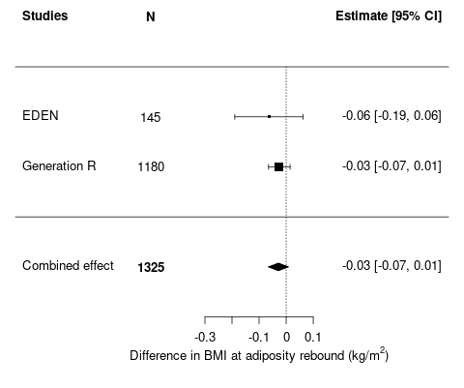  W_{EDEN}=9%  W_{GENR}=91% | W_{EDEN}=6.4%  W_{GENR}=93.6% | 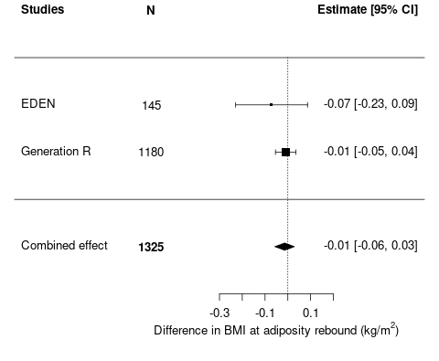  W_{EDEN}=7.5%  W_{GENR}=92.5%
Supplementary Figure S5: Meta-analysis results of association analyses between raw and residual gestational age acceleration using the Bohlin and Knight clock and age/BMI at adiposity rebound by excluding children with no BMI measurement after the estimated rebound
Results of analyses after multiple imputation of missing data for covariables, adjusted for maternal age, maternal and paternal education level, maternal and paternal BMI, gestational weight gain, maternal smoking during pregnancy, sex, and cell types. Values represent regression coefficients (SE) and correspond to the difference in age at adiposity rebound (in days) or BMI at adiposity rebound (in kg/m²) per one-week increase in raw or residual gestational age acceleration at birth.
ª Raw gestational age acceleration (in weeks) was obtained by subtracting the clinical estimate of gestational age from DNA methylation gestational age.
^{b} Residual gestational age acceleration (in weeks) was calculated from the residuals from a regression model of DNA methylation gestational age on clinical gestational age.
The weights assigned to each study (W_{EDEN}: EDEN; W_{GENR}: Generation R) are displayed in the bottom-left corner of each plot

Supplementary Table S1: Study sample characteristics after multiple imputation
 | EDEN study |  | Generation R Study
 | Children with estimated adiposity peak  N=157 | Children with estimated adiposity rebound  N=154 | Children with estimated adiposity peak  N=1203 | Children with estimated adiposity rebound  N=1247
 | Mean (SD) or % (N) | Mean (SD) or % (N) | Mean (SD) or % (N) | Mean (SD) or % (N)
Parental characteristics
Maternal age at delivery, years | 30.2 (4.9) | 30.1 (5.0) | 31.8 (4.1) | 31.9 (41)
Maternal educational level  Primary level  Secondary level  Tertiary level | 23.7*  18.6*  57.7* | 23.2*  18.2*  58.6* | 1.9*  31.6*  66.5* | 1.5*  32.1*  66.4*
Paternal educational level  Primary level  Secondary level  Tertiary level | 30.2*  25.7*  44.1* | 30.1*  26.6*  43.4* | 2.7*  33.9*  63.4* | 2.6*  35.2*  62.2*
Maternal BMI, kg/m² | 23.5 (4.92) | 23.5 (4.87) | 23.5 (4.0) | 23.4 (4.0)
Paternal BMI, kg/m² | 25.8 (4.33) | 25.6 (4.12) | 25.3 (3.5) | 25.5 (3.6)
Gestational weight gain**, kg | 12.9 (4.77) | 12.9 (4.72) | 8.7 (3.8) | 8.6 (3.8)
Never smoking during pregnancy | 76,7* | 77* | 86.2* | 87.3*
Child’s characteristics
Sex, boys | 59.2 (93) | 60.6 (94) | 49.5 (595) | 50.1 (625)
Clinical gestational age, weeks | 39.5 (1.5) | 39.5 (1.5) | 40.2 (1.5) | 40.2 (1.5)
DNA methylation gestational age (Bohlin), weeks | 39.2 (0.9) | 39.2 (0.93) | 39.3 (0.94) | 39.3 (0.98)
Raw gestational age acceleration (Bohlin), weeks | -0.24 (0.88) | -0.23 (0.89) | -0.87 (0.92) | -0.87 (0.94)
Residual gestational age acceleration (Bohlin), weeks | -0.01 (0.53) | -0.01 (0.54) | 0.00 (0.58) | 0.00 (0.60)
DNA methylation gestational age (Knight), weeks | 36.3 (1.4) | 36.3 (1.4) | 36.3 (1.7) | 36.4 (1.75)
Raw gestational age acceleration (Knight), weeks | -3.16 (1.34) | -3.14 (1.33) | -3.84 (1.58) | -3.81 (1.61)
Residual gestational age acceleration (Knight), weeks | -0.01 (1.2) | 0.01 (1.15) | 0.00 (1.48) | 0.03 (1.50)
Age at adiposity peak, months | 8.7 (1.4) | . | 8.6 (1.4) | .
BMI at adiposity peak, kg/m² | 17.3 (1.3) | . | 17.5 (1.1) | .
Age at adiposity rebound, years | . | 5.7 (1.3) | . | 5.6 (1.3)
BMI at adiposity rebound, kg/m² | . | 15.1 (1.0) | . | 15.6 (1.1)
* Obtained after multiple imputation, N not given
** Based on measured weight in the third trimester or self-reported highest weight during pregnancy.

Supplementary Table S2: Results of association analyses between epigenetic gestational age acceleration and age/BMI at adiposity peak and rebound in Generation R Study participants with “optimal” pregnancy dating
 | Gestational age acceleration using Bohlin clock |  |  |  | Gestational age acceleration using Knight clock
Adiposity peak  N= 353 | Age at adiposity peak (days) |  | BMI at adiposity peak (kg/m²) |  | Age at adiposity peak (days) |  | BMI at adiposity peak (kg/m²)
Adiposity peak  N= 353 | β [CI95%] | p value | β [CI95%] | p value | β [CI95%] | p value | β [CI95%] | p value
Rawª gestational age acceleration, weeks | 6.73 [1.6; 5.7] | 0.01 | 0.05 [-0.08; 0.18] | 0.43 | 3.64 [-0.1; 1.7] | 0.06 | 0.08 [-0.02; 0.17] | 0.11
Residual^{b} gestational age acceleration, weeks | 1.76 [-7.7; -9.5] | 0.70 | 0.10 [-0.12; 0.32] | 0.37 | 1.30 [-3.0; -3.7] | 0.55 | 0.09 [-0.02; 0.19] | 0.10
Adiposity rebound  N=349 | Age at adiposity rebound (days) |  | BMI at adiposity rebound (kg/m²) |  | Age at adiposity rebound (days) |  | BMI at adiposity rebound (kg/m²)
Adiposity rebound  N=349 | β [CI95%] | p value | β [CI95%] | p value | β [CI95%] | p value | β [CI95%] | p value
Rawª gestational age acceleration, weeks | 10.56 [-43.0; 64.1] | 0.70 | -0.003 [-0.12; 0.11] | 0.95 | -7.44 [-46.6; 31,7] | 0.71 | 0.05 [-0.03; 0.13] | 0.24
Residual^{b} gestational age acceleration, weeks | 22.42 [-72.0; 116.8] | 0.64 | -0.005 [-0.20; 0.19] | 0.96 | -11.56 [-56.3; 33.2] | 0.61 | 0.07 [-0.03; 0.16] | 0.17
Results of analyses after multiple imputation of missing data for covariables, adjusted for maternal age, maternal and paternal education level, maternal and paternal BMI, gestational weight gain, maternal smoking during pregnancy, sex, and cell types. Values represent regression coefficients (SE) and correspond to the difference in age at adiposity peak/rebound (in days) or BMI at adiposity peak/rebound (in Kg/m²) per one-week increase in raw or residual gestational age acceleration at birth.
In “optimal” pregnancy dating, clinical gestational age was estimated from last menstrual period in women with a regular cycle and a known first day of last menstrual period
ª Raw gestational age acceleration (in weeks) was obtained by subtracting the clinical estimate of gestational age from DNA methylation gestational age.
^{b} Residual gestational age acceleration (no unit) was calculated from the residuals from a regression model of DNA methylation gestational age on clinical gestational age
Supplementary Table S3: Details of the method used for multiple imputation
Variables | Type of variable | Model used to predict missing dataª | Missing value (%)
Variables | Type of variable | Model used to predict missing dataª | EDEN | Generation R
Age at adiposity peak | Continuous |  | 0 | 0
BMI at adiposity peak | Continuous |  | 0 | 0
Age at adiposity rebound | Continuous |  | 0 | 0
BMI at adiposity rebound | Continuous | - | 0 | 0
Clinical gestational age | Continuous | - | 0 | 0
DNA methylation gestational age (Bohlin), weeks | Continuous | - | 0 | 0
Raw gestational age acceleration (Bohlin), weeks | Continuous | - | 0 | 0
Residual gestational age acceleration (Bohlin), weeks | Continuous | - | 0 | 0
DNA methylation gestational age (Knight), weeks | Continuous | - | 0 | 0
Raw gestational age acceleration (Knight), weeks | Continuous | - | 0 | 0
Residual gestational age acceleration (Knight), weeks | Continuous | - | 0 | 0
Center | Binary | - | 0 | -
Sex | Binary | - | 0 | 0
Birth weight | Continuous | - | 0 | 0
Maternal age at delivery | Continuous | - | 0 | 0
Gestational weight gain | Continuous | Linear regression | 3.2 | 4.0
Smoking during pregnancy | Binary | Logistic regression | 3.8 | 8.6
Maternal education | Continuous | Logistic regression | 1.3 | 1.2
Maternal pre-pregnancy BMI | Continuous | Linear regression | 2.6 | 2.7
Paternal education | Continuous | Logistic regression | 6.5 | 13.7
Paternal BMI | Continuous | Linear regression | 5.2 | 6.7
Cell types composition | Continuous | - | 0 | 0
From the variables in the table, we generated 5 independent sets of imputed data (R package MICE). This method assigned data to missing measurements based on the measurement of infants with similar profiles. Then, we computed pooled effect estimates.
BMI, body mass index;
ª Fully conditional specification method.

