Supplementary Supplementary material

Euxinic conditions and altered biogeochemical cycles in a Patagonian fjord influenced by volcanic activity.
Iván Pérez-Santos^{1,2*}, Paulina Montero^{3,2}, Marcelo H. Gutiérrez^{2,4}, Gerdhard L. Jessen^{2,5}, Alexander Galán^{6,7}, Laura Farías^{4,8,9}, Leonardo Castro^{2,4}, Camilo Rodriguéz-Villegas¹, Patricio A. Díaz^{1,10}, Claudia Aracena¹¹, Elías Pinilla^{12,13}, Karen Sanzana^{8,14}, Aranza L. Pérez³, Karina Fuentes², Constanza Asmut³, Guido Mancilla-Gutiérrez¹, Gabriel Soto¹³, Cynthia Urrutia^{15,16}, Claudio Navarro¹⁵, Matías Castro¹⁷, David Silva¹⁵, Salma Espinoza^{4,17}, Laura A. Bristow¹⁸, Morten Larsen¹⁹, Osvaldo Ulloa^{4,17}
¹Centro i-mar, Universidad de Los Lagos, Puerto Montt, Chile.
²Center for Oceanographic Research COPAS Coastal, Universidad de Concepción, Concepción, Chile.
³Patagonia Ecosystem Research Center (CIEP), Coyhaique, Chile.
⁴Department of Oceanography, Faculty of Natural Sciences and Oceanography, Universidad de Concepción, Concepción, Chile.
⁵Institute of Marine and Limnological Sciences (ICML), Universidad Austral, Valdivia, Chile.
⁶Center for Advanced Studies Research in Maule (CIEAM), Office of the Pro-Vice-Chancellor for Research and Graduate Studies, Universidad Católica del Maule, Talca, Chile.
⁷Regional Center for Environmental Research (CREA), Universidad Católica de la Santísima Concepción, Concepción, Chile.
⁸Coastal Social-Ecological Millennium Institute (SECOS), Santiago, Chile.
⁹Center for Climate and Resilience Research (CR2), Santiago, Chile.
¹⁰Center for Biotechnology and Bioengineering (CeBiB), Universidad de Los Lagos, Puerto Montt, Chile.
¹¹Center for Research on Natural Resources and Sustainability (CIRENYS), Universidad Bernardo O'Higgins, Santiago, Chile.
¹²University of Maine, Maine, United States of America.
¹³Fisheries Development Institute (IFOP), Putemún Aquaculture Technology Center (CTPA), Castro, Chile.
¹⁴Graduate Program in Oceanography, Department of Oceanography, Faculty of Natural Sciences and Oceanography, Universidad de Concepción, Concepción, Chile.
¹⁵Department of Natural Resources and the Environment, Universidad de Los Lagos, Puerto Montt 5480000, Chile.
¹⁶Scientific and Technological Bioresource Nucleus (BIOREN), Universidad de La Frontera, Temuco 4811230, Chile.
¹⁷Millennium Institute of Oceanography (IMO), Concepción, Chile.
¹⁸Department of Marine Sciences, University of Gothenburg, Gothenburg, Sweden.
¹⁹Nordcee, Department of Biology, University of Southern Denmark, Odense, Denmark.

*Corresponding author: Iván Pérez-Santos (ivan.perez@ulagos.cl)
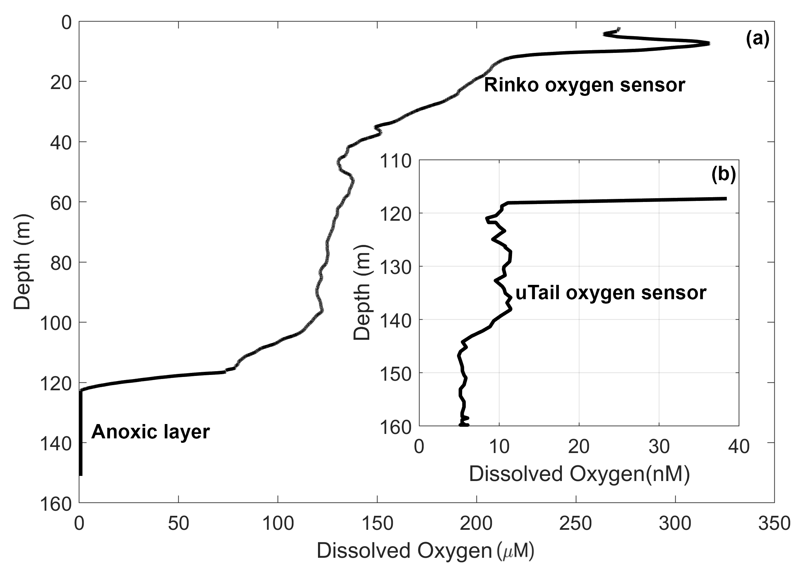
Supplementary Figure 1. Dissolved oxygen profiles measured using: (a) a RINKO oxygen sensor installed in the
VMP-250 Microprofiler; and (b) a uTail trace oxygen sensor, in Quitralco
Fjord basin, December 2024.

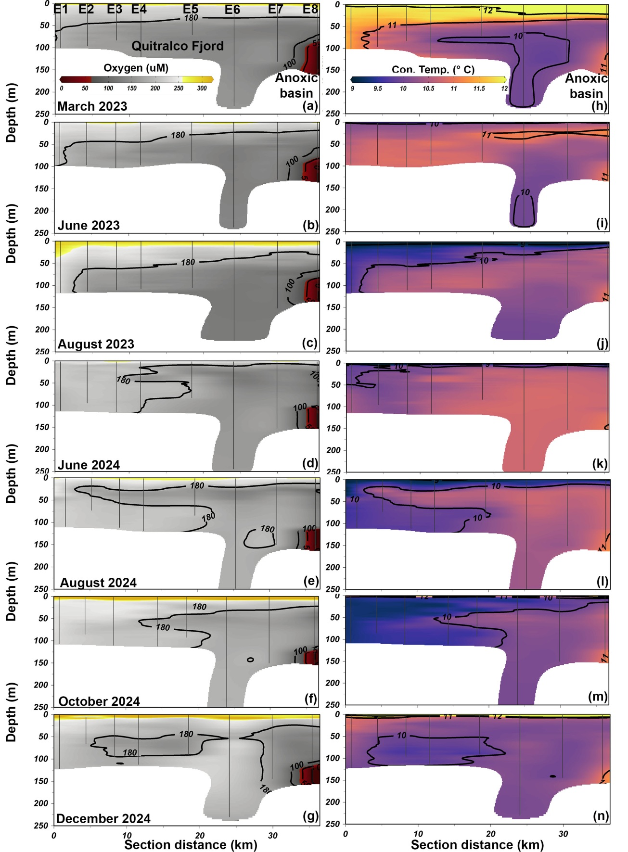
Supplementary Figure 2. Vertical sections from the fjord mouth (Station E1) to the head (Station E8) in Quitralco Fjord,
showing distribution of (a-g) dissolved oxygen and (h-n) water temperature during 2023 and 2024
expeditions.

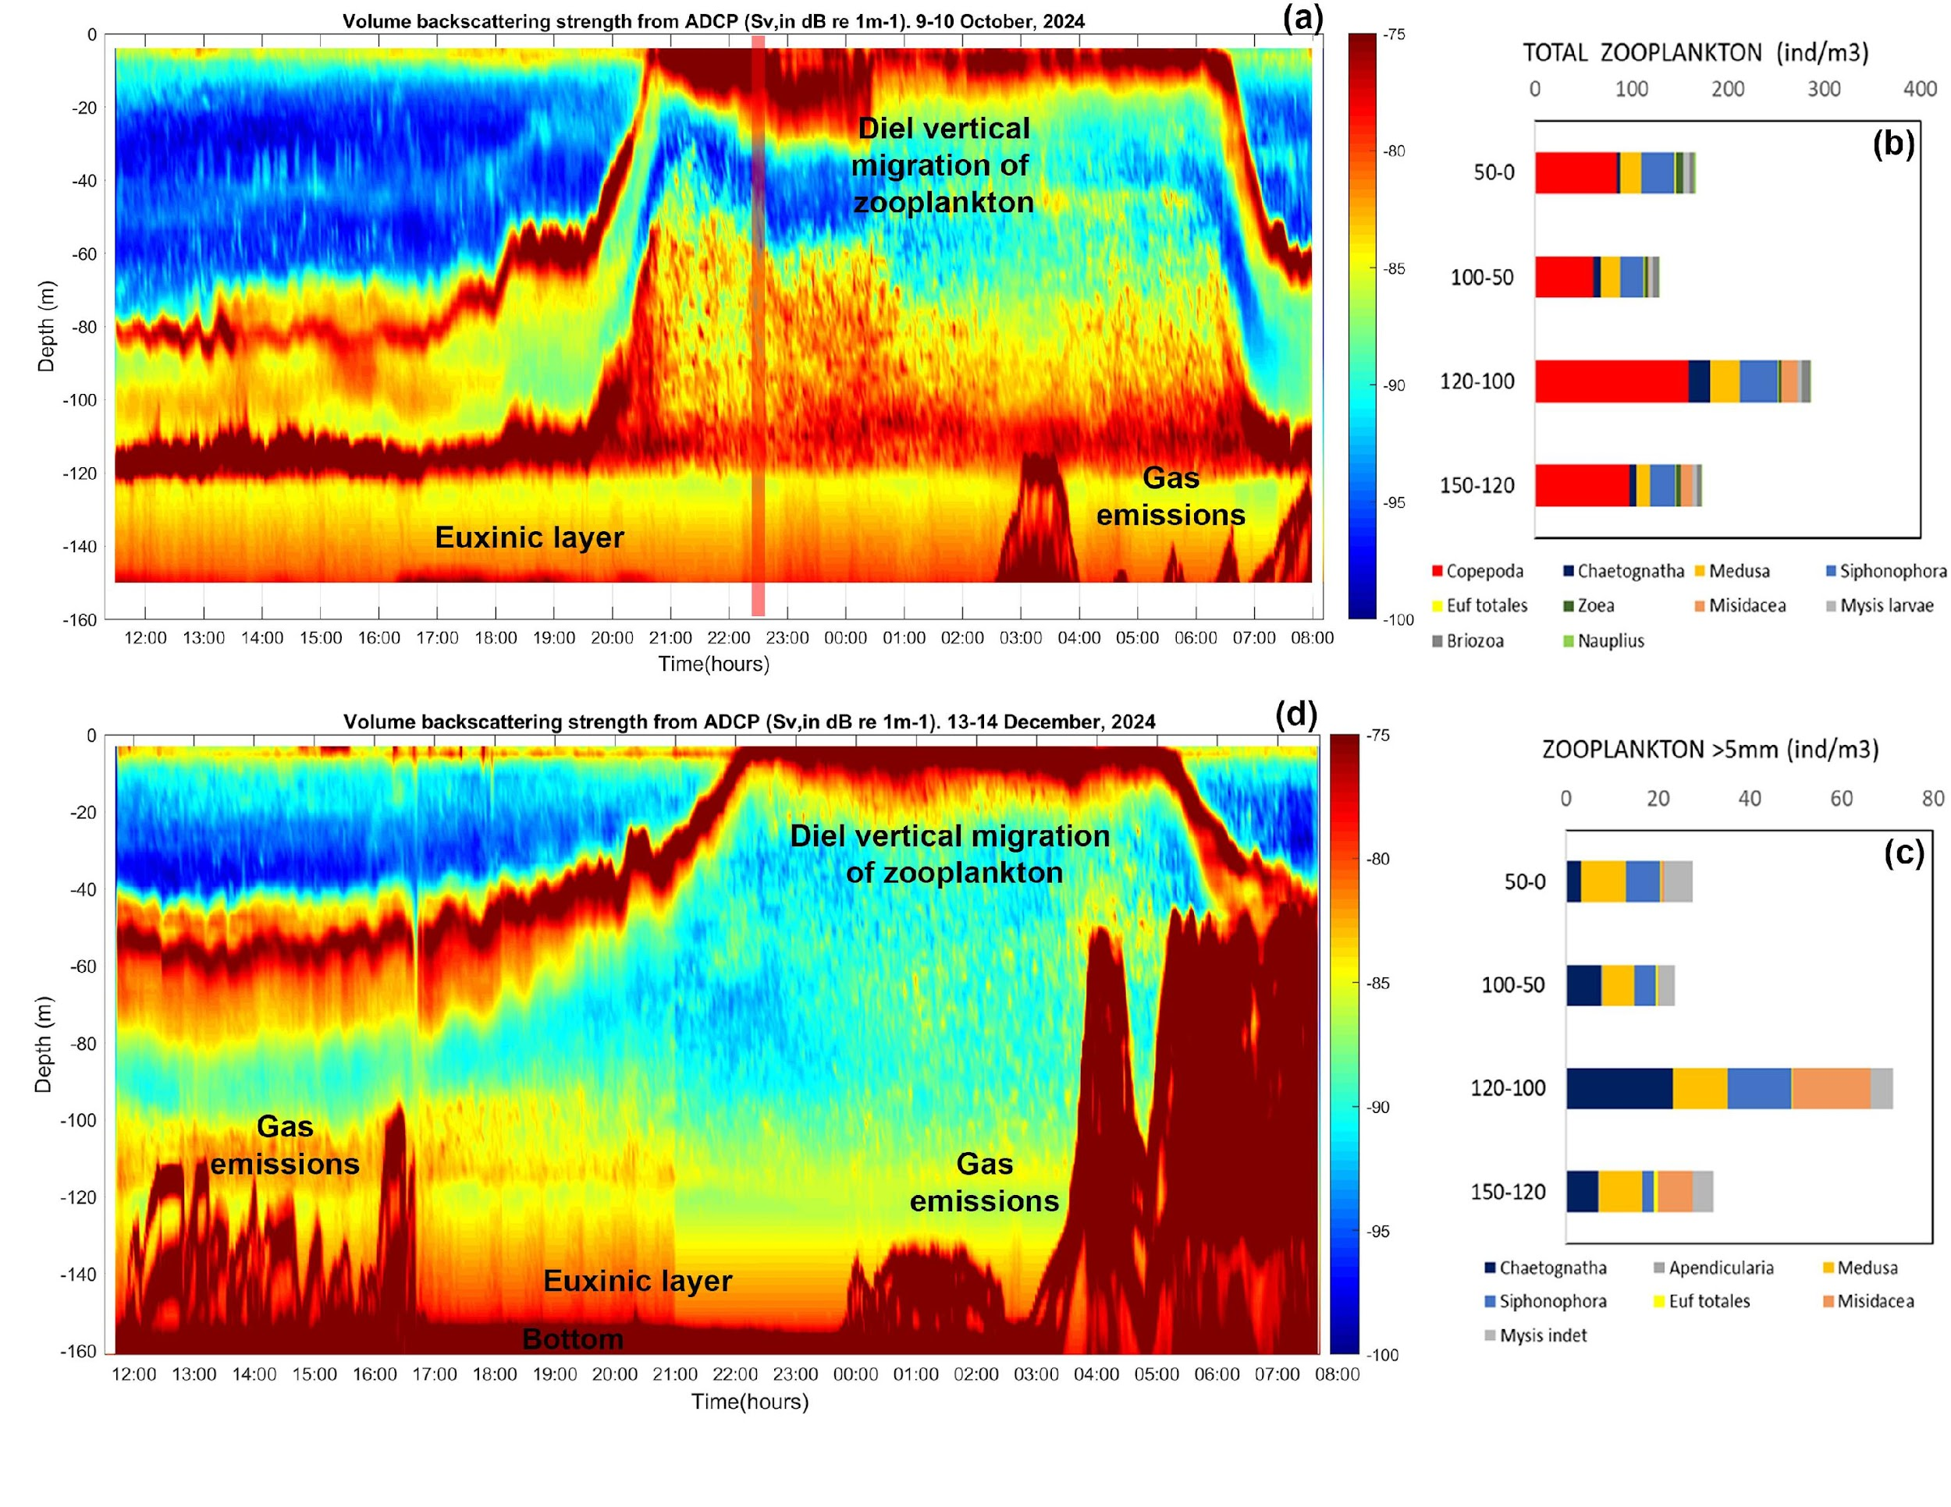
Supplementary Figure 3. (a) Volume backscattering strength recorded by a 300 kHz ADCP moored in the fjord basin, 9-10 October 2024; (b) Total zooplankton community sampled in situ to validate backscatter signal on 9-10 October 2024; (c) Zooplankton species > 5 mm, as detected by ADCP; and (d) Volume backscattering strength recorded by ADCP, moored at a similar location as (a) but from December 13-14, 2024. The red shaded rectangle in (a) indicates the period in which in-situ zooplankton sampling took place.

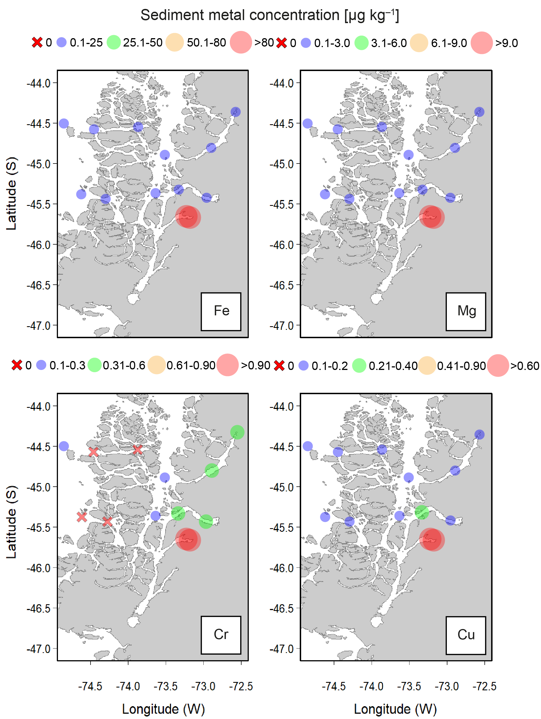
Supplementary Figure 4. Spatial distribution of arithmetic-mean concentrations of iron (Fe), magnesium (Mg),
chromium (Cr), and copper (Cu) in the sediments (µg kg⁻¹) from across sites in the northern Patagonia fjord
system.

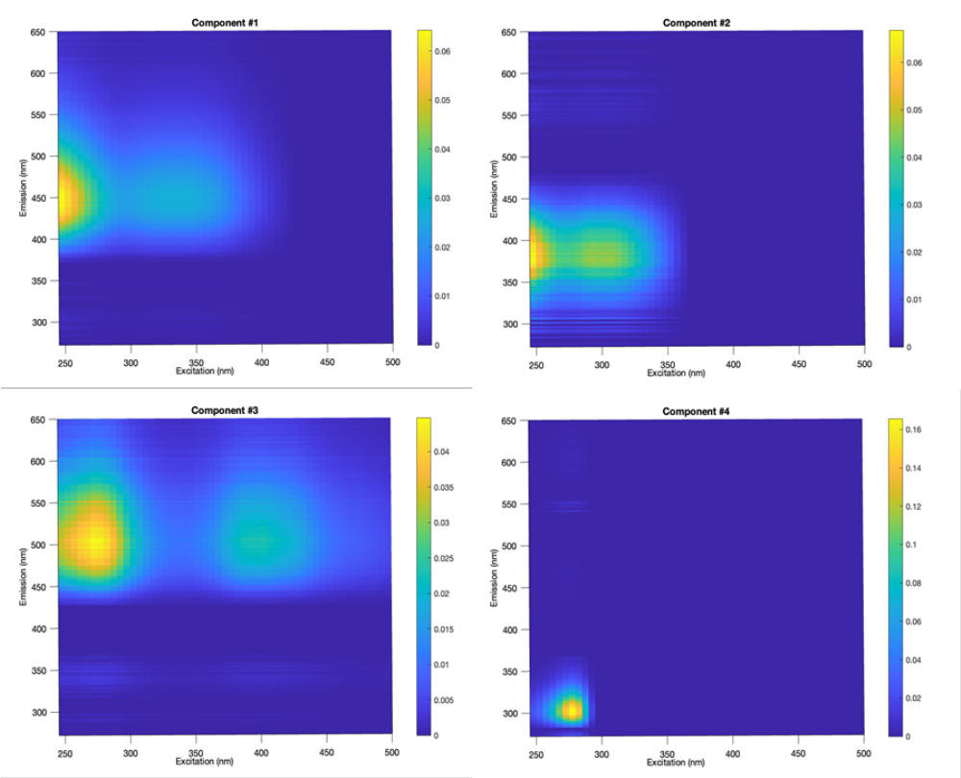

Supplementary Figure 5. Excitation-emission contour plots of four components (C1-C4), as determined by PARAFAC analysis model.

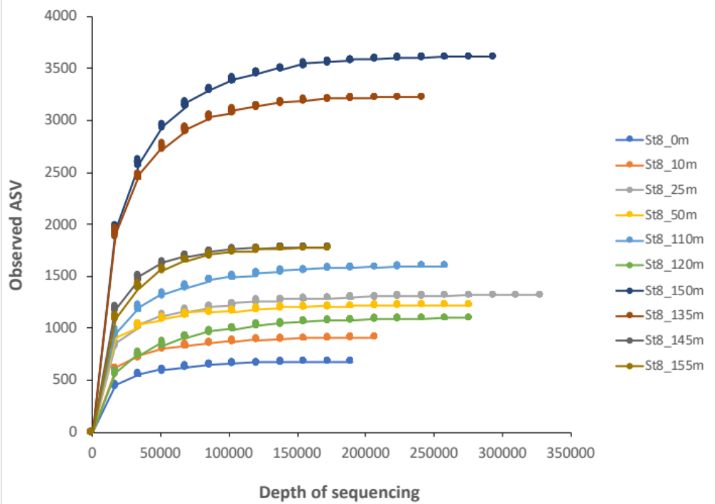
Supplementary Figure 6. Rarefaction curves for prokaryote assemblages from samples collected in waters at station E8, Quitralco Fjord.

Supplementary Figure 7. Vertical profile of representative bacterial orders at station E8.

Supplementary Table 1. Results of HIX (humification index) and BIX (Index of recent autochthonous contribution) fluorescence indices according to Huguet et al., (2009).
Stations | Depth (m) | HIX | BIX
E8 | 0 | 3.0 | 0.77
E8 | 5 | 7.1 | 0.64
E8 | 10 | 5.5 | 0.81
E8 | 15 | 2.6 | 0.86
E8 | 25 | 4.1 | 0.79
E8 | 50 | 4.0 | 0.79
E8 | 75 | 6.8 | 0.72
E8 | 100 | 0.9 | 1.20
E8 | 110 | 6.2 | 0.68
E8 | 120 | 6.5 | 0.56
E8 | 130 | 9.9 | 0.52
E8 | 140 | 12.7 | 0.53
E8 | 150 | 7.2 | 0.64
E7 | 0 | 5.4 | 0.62
E7 | 5 | 5.9 | 0.65
E7 | 15 | 2.4 | 0.66
E7 | 50 | 5.3 | 0.93
E7 | 75 | 2.9 | 0.72
E7 | 100 | 3.2 | 0.65
E7 | 110 | 3.0 | 0.70
E7 | 120 | 7.9 | 0.67
E7 | 130 | 7.5 | 0.68
E7 | 140 | 6.7 | 1.02

Supplementary Table 2. Bacterial production (BP) results in the euxinic basin of Quitralco Fjord.
Stations | Depth (m) | BP (μg C L⁻¹d⁻¹)
E8 | 0 | 53.64
E8 | 5 | 33.97
E8 | 10 | 9.37
E8 | 15 | 10.80
E8 | 25 | 9.90
E8 | 50 | 1.30
E8 | 75 | 8.46
E8 | 100 | 4.03
E8 | 110 | 7.48
E8 | 120 | 6.08
E8 | 130 | 0.70
E8 | 140 | 0.34
E8 | 150 | 0.78

