A taphonomic reassessment of Qafzeh 25 and its implications for violence, health and funerary practices
Ana Pantoja-Pérez^{1,2*}, Laura Martín-Francés^{1,3}, Hila May^{4,5}, Israel Hershkovitz^{4,5}, Nohemi Sala^{1,2*}

Supplementary material

1. Skeletal Preservation of the Specimen and general Taphonomic Analysis
Qafzeh 25 (Fig. 1), was discovered within Layer XVII, positioned along a northeast-southwest axis. The skeleton was found in a supine position, with the upper limbs bent and the hands placed close to the head, while the skull was rotated toward the southwest. Unfortunately, the lower section of the skeleton, including the pelvis and lower limbs, was lost due to an exploratory trench dug in 1934 during excavations led by René Neuville, who served as the French consul in Jerusalem at the time (Coutinho-Nogueira, 2019; Vandermeersch and Bar-Yosef 2019).
As part of this study, a comprehensive taphonomic assessment was performed on the preserved skeletal remains of Qafzeh 25. All available elements were examined using a binocular stereomicroscope (Nikon SMZ745T) in order to document fracture patterns, surface modifications, and post-depositional alterations. This approach allowed for the identification and recording of fractures and surface features across the skeleton, most of which were consistent with post-depositional processes (Table S1).
Modifications inconsistent with depositional damage were confined to the mandible and, possibly, the maxillary region, although in the latter case no secure association could be established. Because the mandibular mark is small and relatively subtle in depth, we conducted a high-resolution micro-computed tomography (mCT) analysis to examine its internal structure and extent. The mandible, cranium, and maxillary region were scanned, enabling detailed internal assessment of the affected areas.
Cranium and Mandible
Qafzeh 25 preserves both the cranium and mandible. The cranial vault is nearly complete but exhibits extensive postmortem fracturing and marked compressive damage, with collapsed cortical areas and displaced fragments maintained in anatomical association by concretion, as previously described by Coutinho-Nogueira¹. The mandible is largely preserved and shows a similar pattern of compressive fragmentation; it lacks the right ascending ramus and the left condyle. In addition, several superficial alterations related to post-excavation handling, preparation, and cleaning are present on the specimen, including linear marks, localized surface exfoliation, and areas of cortical removal affecting both the bone surface and the adhering concretion. These modifications are readily distinguishable from the features discussed in the present study due to their distinct coloration, morphology, and taphonomic appearance.
The entire lower dentition is present, though in varying states of preservation. In the maxillary dentition, the left side is complete, except for the crown of the left canine, which is missing, while its root remains embedded in the alveolus. The right maxilla is significantly more deteriorated and highly deformed. Despite this, the two incisors, the canine, a small portion of the P³ root, and the three molars, and are still preserved.
Axial Skeleton
The thoracic and vertebral elements are partially preserved. A fragment of the sternum is in the same block as the left clavicle. Additionally, there is a cluster of bone fragments that appear to represent vertebrae and ribs and also, fifteen rib fragments of varying sizes have been identified, with the longest measuring 9 cm and the shortest 3 cm.
The cervical vertebrae are preserved in articulation with each other and with the first two thoracic vertebrae. Additionally, four lumbar vertebrae remain articulated, although their precise identification remains uncertain. Despite the extensive fragmentation, the high degree of concretion and the nature of the fractures suggest that the thoracic cage was largely complete at the time of excavation. Most fractures appear to be modern.
Appendicular Skeleton
Upper Limb
The right upper limb is relatively well preserved, with most long bones present, albeit highly fractured. The humerus, radius, and ulna remain largely complete and articulated, with the elbow positioned in flexion. A fragment of the right clavicle and part of the right scapula are also preserved, the latter embedded in the same block as three proximal phalanges from the left hand.
The left upper limb is also relatively complete. The proximal two-thirds of the left humerus are articulated with the scapula. The radius and ulna are well preserved, with their distal portions articulated with several carpal bones. Among the left wrist bones, the capitate is intact, while fragments of the hamate and scaphoid are also identifiable. At least three additional carpal fragments are present, embedded in the block containing the metacarpals of the left hand and the right humerus, suggesting that the wrist was originally complete.
Hand
The left hand preserves three proximal phalanges, which, based on their positioning, likely correspond to digits two, three, and four. The metacarpals of the left hand rest on the right humerus. Although highly fragmented, they are clearly distinguishable, and modern fracturing patterns suggest that they were originally complete.
Lower Limb
The only preserved element of the lower appendicular skeleton is the distal quarter of the left femur, which remains articulated with a fragment of the proximal epiphysis of the left tibia.
Taphonomic Observations
The entire skeleton exhibits significant fracturing, with all fractures showing characteristics of postmortem breakage, many of them modern (excavation fractures). These fractures display right angles, jagged edges and complete diaphysis circumferences. The bones exhibit extensive concretion, with no significant traces of manganese deposits. Additionally, there are no signs of weathering, trampling, root etching, carnivore tooth marks, or cut marks. This preservation pattern aligns with the hypothesis proposed by Vandersmeersch and Bar-Yosef² suggesting that the specimen remained largely undisturbed post-burial.

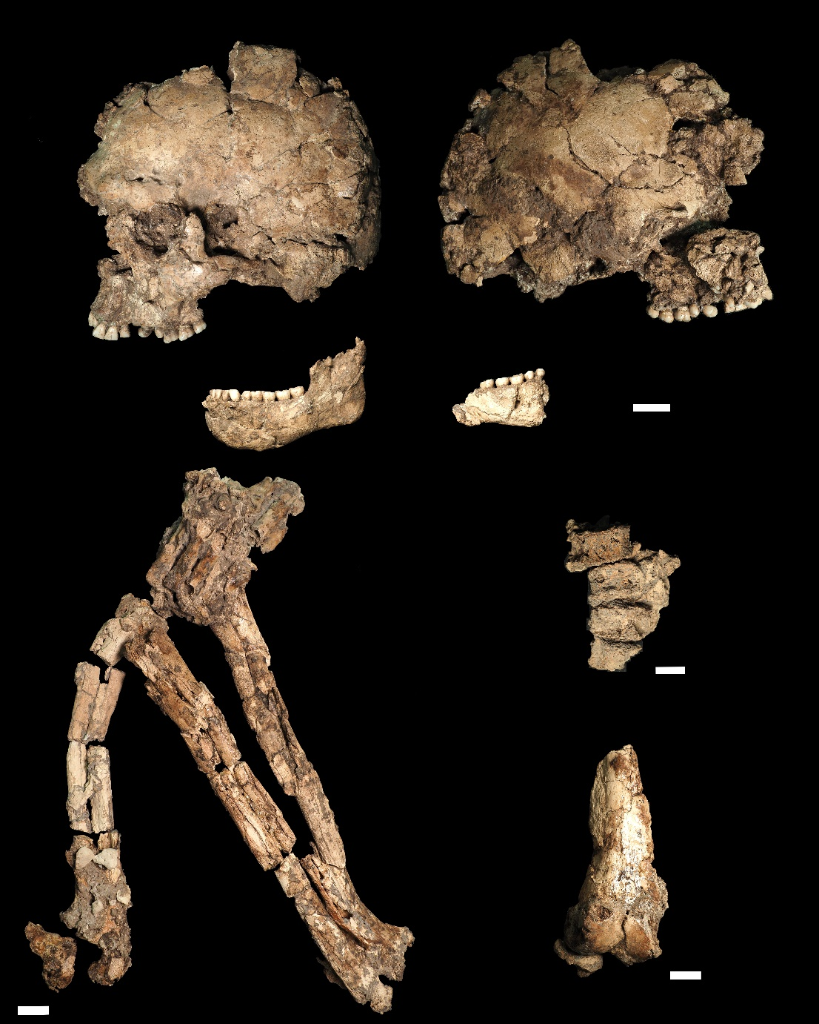
Figure S1. Qafzeh 25. Selected anatomical elements. Cranium in right and left lateral views (top); right and left hemimandibles (middle); right and left arms and the left hand in articulation, the latter placed over the proximal portion of the right humerus (bottom left); articulated lumbar vertebrae and the distal fragment of the left femur together with a fragment of the proximal epiphysis of the tibia (bottom right). Scale bars are 2 cm.

Segmentation and reconstruction
The segmentation process for reconstructing the mandible primarily utilized semi-automatic methods. For the LP₃ reconstruction, the initial task was to manually isolate the tooth, which remained in its original position from the displaced crown and the surrounding mandibular bone. This manual segmentation was executed using the thresholding mask editor in Mimics software (v.18), necessitated by the similar contrast between sediment, bone, and dentine, which prevented the establishment of unique Hounsfield values for each structure, resulting in significant overlap.
Once both the root and crown fragment had been isolated, a virtual reconstruction of the tooth was carried out. A modern male Homo sapiens premolar was used as a reference model to reposition the displaced crown fragment relative to its original anatomical position on the root. The right P₃ of Qafzeh 25 was not used for this purpose due to its badly state of preservation.
The reconstruction process (Fig. S2) began with the superimposition of the modern reference tooth onto the preserved root of Qafzeh 25 left P₃. Subsequently, nine points were registered on both the modern tooth and the crown fragment for alignment using the point registration method available in Mimics software version 18. This method involves placing landmark points on the STLs, parts, and images, allowing Mimics to calculate and apply the transformation matrix that achieves the best fit between the start and end points.

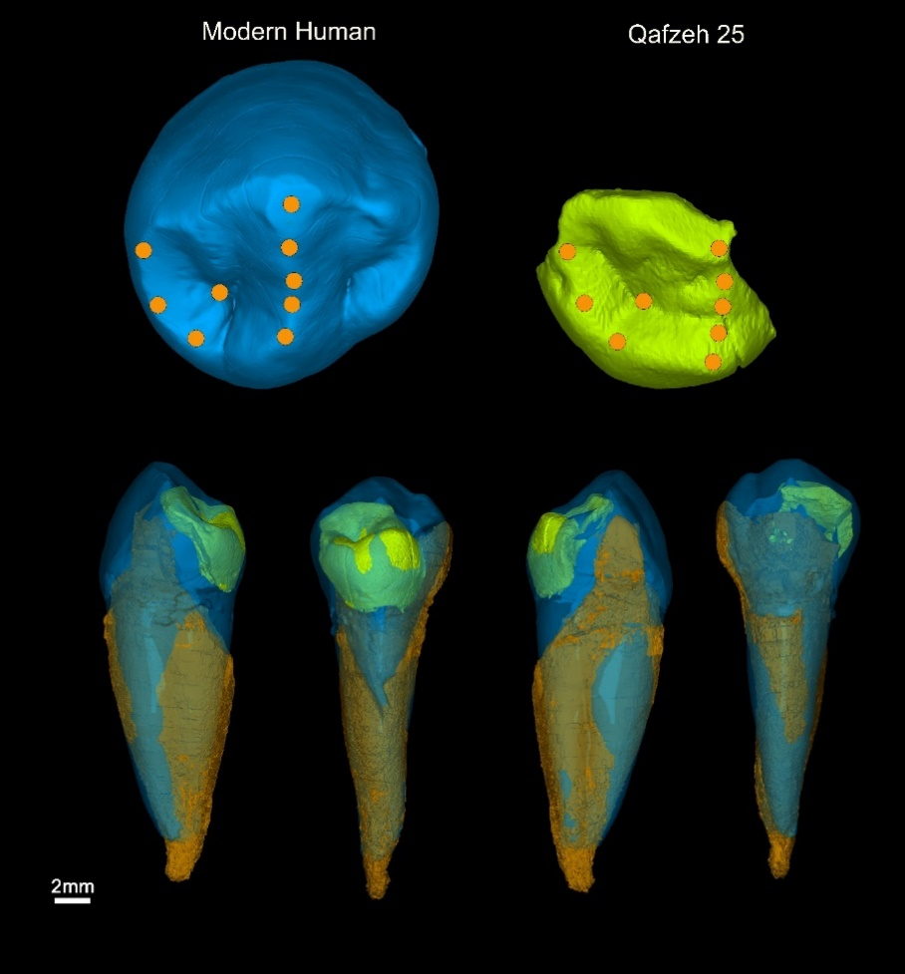
Figure S2. Virtual reconstruction of the Qafzeh 25 left inferior P₃. The landmarks used included the apex of the lingual cusp (apex cuspidis lingualis), three points on the crest of the mesiolingual cusp (crista cuspidis mesiolingualis), the triangular fossa (fossa triangularis medialis), one point in the middle of the medial triangular crest (crista triangularis medialis), another in the middle of the buccal triangular crest (crista triangularis buccalis), the apex of the buccal cusp (apex cuspidis buccalis), and the middle of the central developmental groove (sulcus developmentalis centralis).

Visualization of the mCT images
In the context of mCT visualization, non-linear pseudo-color scales are employed to enhance the perception of subtle variations in image data. Unlike linear grayscale scales, where brightness changes proportionally to intensity, non-linear pseudo-color scales exhibit more complex variations³. This complexity allows specific features of soft tissue or bone to be highlighted, which may not be visible with a linear scale, thereby facilitating the analysis of details such as porosity in materials and other fine properties. To analyze variations in dental tissue densities in Qafzeh 25, the Sawtooth color scale was applied alongside grayscale imaging. This scale was specifically chosen to enhance contrasts between tissues with similar density values. The color scheme includes distinct hues, orange, green, red, blue, and yellow, ensuring clear differentiation.
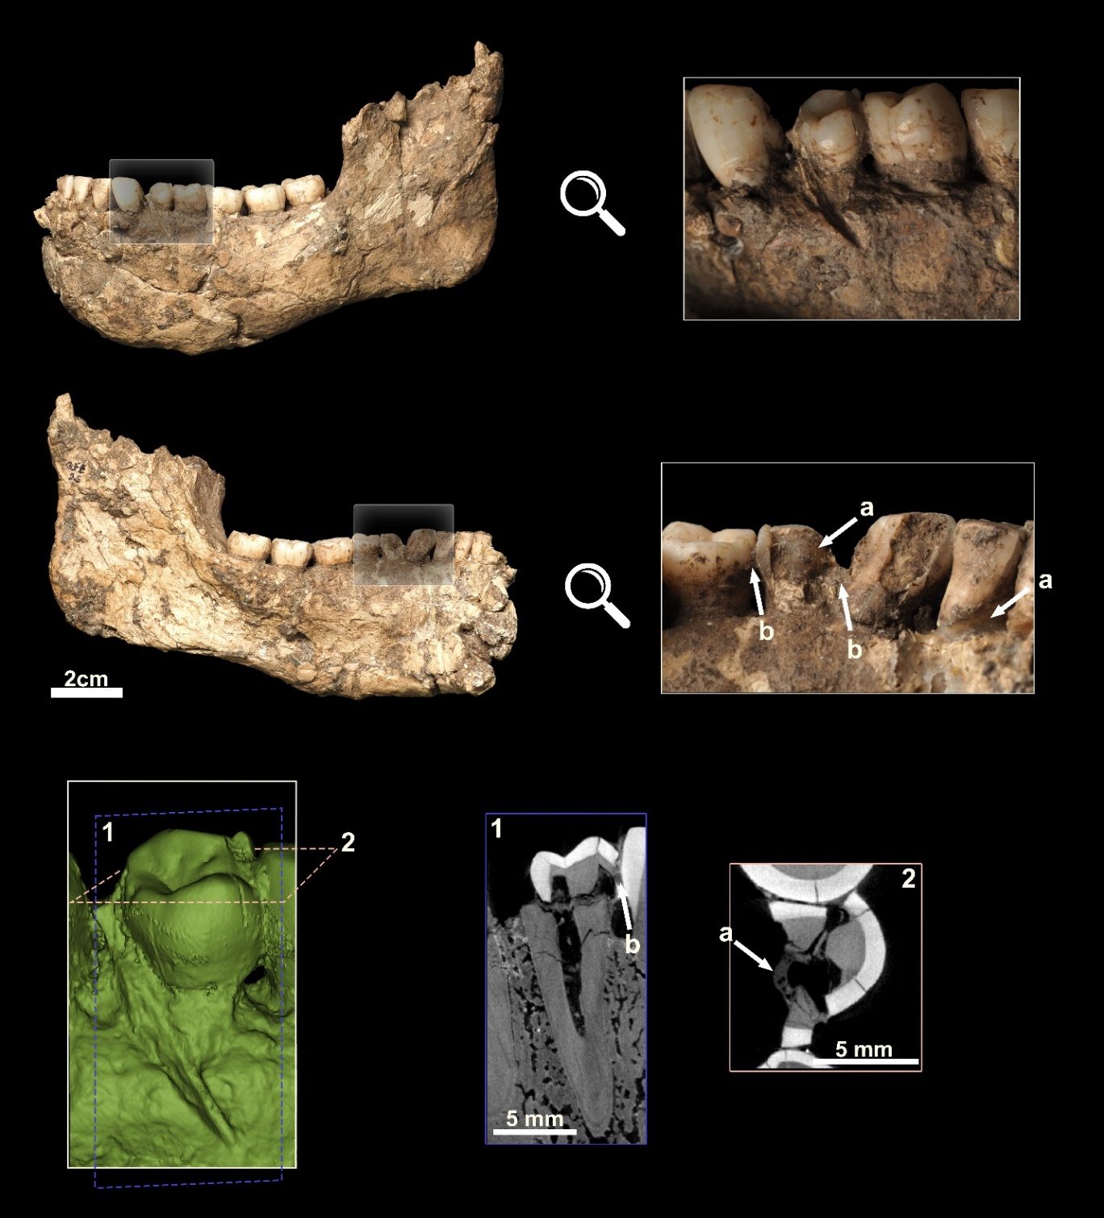
Figure S3. Left hemimandible of Qafzeh 25 in lateral (upper) and medial (lower) views. Chemical substance (a) was applied to stabilize the fragments, while calcite concretion (b) is also visible. 1: mCT sagittal section of the left lower P₃. 2: axial section of the same tooth. A transverse fracture affecting the crown can be observed, along with the distal displacement of the crown fragment.
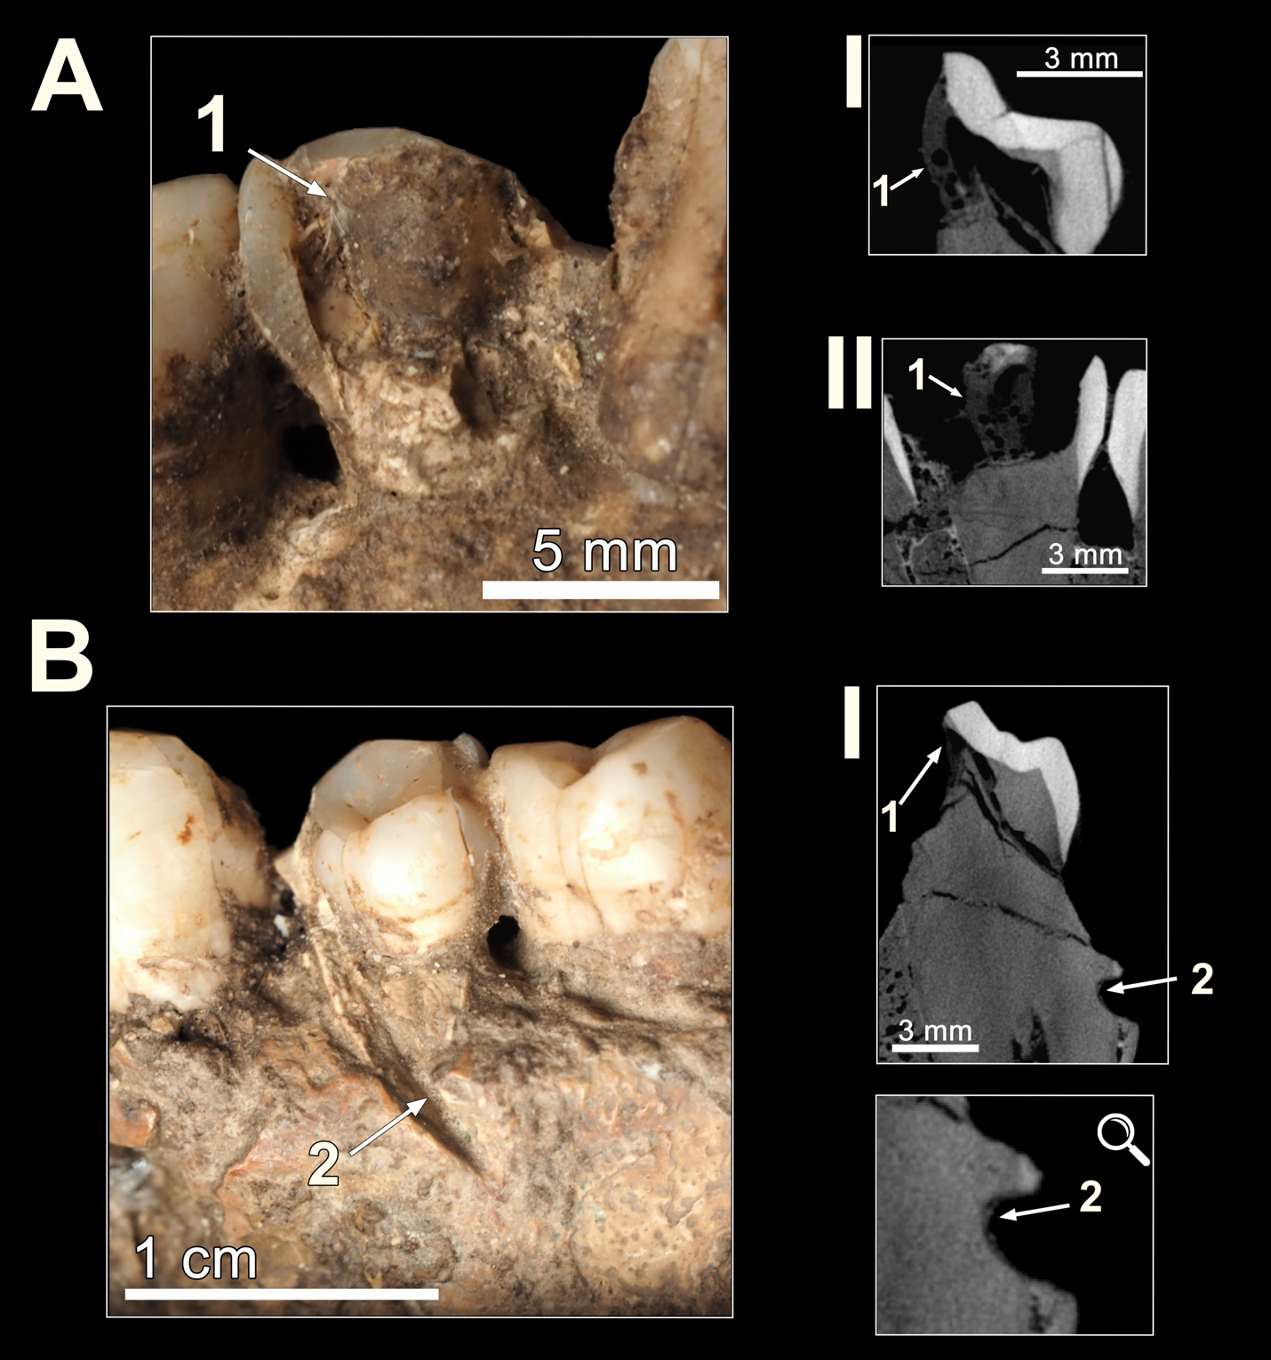
Figure S4. Comparison between restoration adhesive and adherent sediment observed in Qafzeh 25. (A) Internal surface of the left lower premolar crown, showing chemically bonded restoration adhesive (1). Panels I and II show coronal and sagittal mCT sections of the area where the adhesive is present. (B) Adherent sediment or concretion (2) observed within the linear mark on the external surface of the mandible and on the left premolar I, sagittal mCT section illustrating sediment adhering to the deepest portion of the mark.

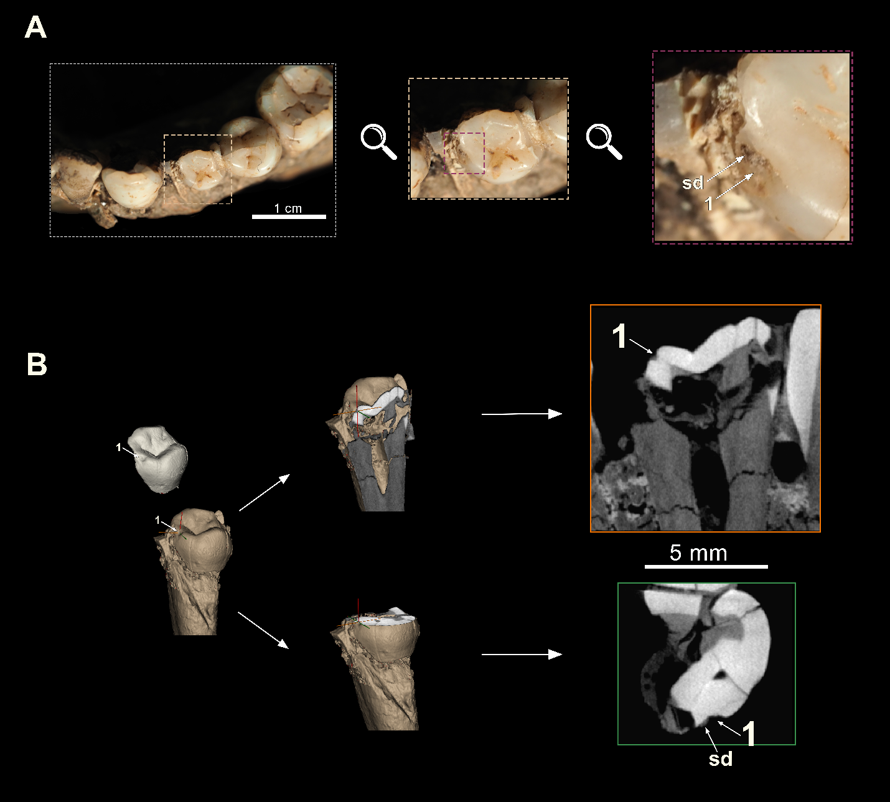
Figure S5. High-magnification documentation of the antemortem enamel chip observed on the crown of the left lower third premolar. (A) Macroscopic image acquired with a macro objective, showing the enamel chip. (B) Corresponding mCT sagittal and axial sections through the same region, illustrating the morphology of the enamel loss (1) and the presence of sediment adhering to the affected surface (sd).
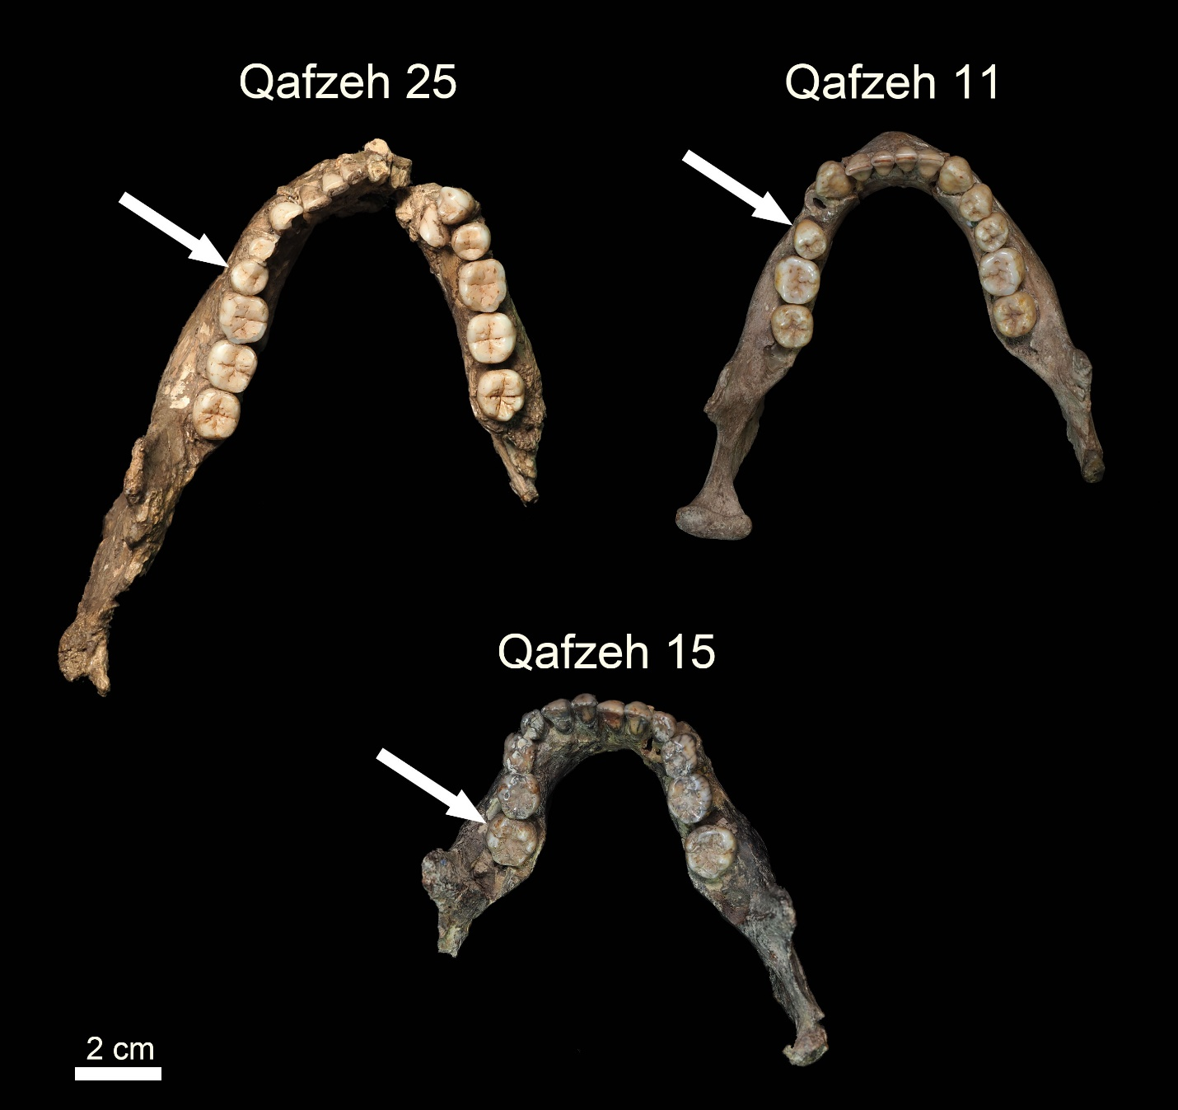
Figure S6. Qafzeh individuals exhibiting dental rotation. Arrows indicate specific cases: Qafzeh 25 with disto-buccal rotation of the left P₄; Qafzeh 11 with mesio-buccal rotation of the left P₄; Qafzeh 15 also presents a mesio-buccal rotation of the left second molar⁴⁻⁶, along with the agenesis of both lower second premolars⁷.

Table S1. Skeletal part representation and taphonomic observations of Qafzeh 25.
Bone | Side | Portion preserved | Taphonomic observations
Cranium | — | Nearly complete; parietals fragmented and deformed; left upper canine absent | Extensive postmortem fracturing; cortical surface partially lost; deformation consistent with compressive damage; abundant concretion
Mandible | — | Nearly complete and deformed; dentition mostly in situ; right ascending ramus and left condyle absent | Marked cortical collapse; multiple dry-bone fractures; concretion adhering to surface; no evidence of carnivore or root damage. Linear mark compatible with a sharp force trauma
Scapula | Right | Fragmented | Severe fragmentation; crushed
Scapula | Left | Fragment attached to proximal humerus | Postmortem breakage; preserved in concretion mass
Clavicle | Right | Fragment | Modern-appearing dry fracture; concretion present
Clavicle | Left | Fragment attached to manubrium | Dry fracture; preserved in articulated cluster
Sternum (manubrium) | — | Preserved; attached to clavicle and rib mass | Preserved within concretion mass; no surface weathering
Ribs | — | Multiple shaft fragments (more than 15) | Extensive dry-bone fracturing; jagged edges; cortical collapse; no carnivore tooth marks
Vertebrae – Cervical | — | Several preserved, associated with cranial base | Preserved in anatomical cluster; postmortem fractures; concretion
Vertebrae – Thoracic | — | Two preserved | Postmortem fracturing; compressive damage
Vertebrae – Lumbar | — | At least four; one associated with lithic fragment | Fragmentation; concretion; no evidence of weathering or predepositional modifications
Humerus | Right | Shaft and distal epiphysis preserved in separate fragments | Extensive postmortem dry fractures (jagged edges, right angles, complete shaft circumferences); cortical crushing; abundant concretion
Humerus | Left | Proximal two-thirds preserved; distal trochlea fragment | Dry-bone fractures; cortical collapse; fragments remain in anatomical association
Radius | Right | Multiple shaft fragments; proximal fragment | Extensive postmortem dry fractures (jagged edges, right angles, complete shaft circumferences); cortical crushing; abundant concretion
Radius | Left | Shaft fragments; proximal epiphysis; distal fragment attached to carpals | Postmortem dry fractures (jagged edges, right angles, complete shaft circumferences); concretion maintaining fragment cohesion
Ulna | Right | Diaphisys fragments | Postmortem fracturing (jagged edges, right angles, complete shaft circumferences); cortical crushing
Ulna | Left | Shaft fragments; proximal epiphysis | Postmortem fracturing (jagged edges, right angles); concretion; no weathering observed
Capitate | Left | Complete | Preserved within concretion mass; no evidence of weathering or biogenic modification
Hamate | Left | Fragmentary | Postmortem fracture; cortical crushing; concretion present, preserved in anatomical cluster
Scaphoid | Left | Fragmentary | Postmortem fracture; cortical crushing; concretion present, preserved in anatomical cluster
Carpal (indet.) | Left | Fragment | Postmortem fracture; cortical crushing; concretion present, preserved in anatomical cluster
Carpal (indet.) | Left | Fragment | Postmortem fracture; cortical crushing; concretion present, preserved in anatomical cluster
Carpal (indet.) | Left | Fragment | Postmortem fracture; cortical crushing; concretion present, preserved in anatomical cluster
Metacarpals I–V | Left | Complete or nearly complete | Dry fractures; preserved cohesion within concretion
Phalanges (hand) | Left | Three proximal phalanges preserved | Fragmented but articulated; no surface weathering
Femur | Left | Distal fragment associated with tibia | Postmortem fracturing (jagged edges, right angle, complete shaft circumference); crushed; concretion
Tibia | Left | Epiphysis fragment | Fragmented; trabecular exposure; postmortem breakage

Table S2. Density measurements of Left P₄
Region | Area  (mm²) | Density  (Gray values*)  Mean ± SD
Adjacent unaltered enamel | 0.07 | 52969.9 ± 934
Adhered sediment | 0.07 | 28083.1 ± 929
Enamel layer closing the demineralization region | 0.02 | 34886.9 ± 2197
Crown dentine | 20.9 | 209281 ± 35442.3
* In mCT imaging, material density is commonly assessed using either Hounsfield units (HU) or grayscale values. Hounsfield units are a standardized scale that quantifies radiodensity, originally developed for clinical CT scans, where water is assigned a value of 0 HU and air a value of –1000 HU. Although HU are widely used in medical imaging, in mCT systems, absolute calibration to Hounsfield units is not always performed. Instead, relative grayscale values are typically used, which represent the degree of X-ray attenuation of different materials. These grayscale values are directly proportional to the material's density and atomic composition: denser materials or those with higher atomic numbers absorb more X-rays and therefore appear brighter (with higher grayscale values) in the images. Consequently, by analyzing grayscale intensities in mCT datasets, it is possible to infer relative differences in material composition and density, allowing for the identification of features such as enamel demineralization, sediment infiltration, or bone alterations.

S3 Hominin specimens with carious lesions in the fossil record

Table S3. Hominin specimens with carious lesions in the fossil record
Species | Specimen | Site | Chronology | References
H. erectus s.l. | SK 15 | Swartkrans, South Africa | ~1.5–2.0 Ma | Clement⁸; Towle et al.⁹
H. erectus s.l. | D2600 | Dmanisi, Georgia | 1.77 Ma | Margvelashvili et al.¹⁰
H. naledi | UW 101-001 | Rising Star, South Africa | 236–335 ka | Towle et al.⁹
MP African Homo | Broken Hill 1 | Kabwe, Zambia | ~500 ka | Constable¹¹;  Barstiokas and Day¹²
H. neanderthalensis | Mandible 1 | Banyoles, Spain | 45–100 ka | Lalueza et al.^{13,14}
H. neanderthalensis | Palomas 25 & 59 | Sima de las Palomas, Spain | 43 ka | Walker et al.¹⁵
H. neanderthalensis | Aubesier 5 & 12 | Bau de l’Aubesier, France | 170–190 ka | Trinkaus et al.¹⁶;  Lebel and Trinkaus¹⁷
H. neanderthalensis | Kebara 27 | Mugharet el-Kebara, Israel | 64–60 ka | Tillier et al.¹⁸
H. neanderthalensis | Amud 1 | Amud, Israel | 70-50 ka | Lacy¹⁹
H. neanderthalensis | Tabun 2 | Mugharet et-Tabun, Israel | 160-200 ka | Lacy¹⁹
H. neanderthalensis | SD-2158 | El Sidrón, Spain | 49 ka | Estalrrich et al.²⁰
Fossil H. sapiens | Zhiren 2 | Zhirendong, China | 106.2 ka | Lacy et al.²¹
Fossil H. sapiens | Skhul II | Es-Skhul, Israel | 100–135 ka | Sognnaes²²
Fossil H. sapiens | Qafzeh 3 | Qafzeh, Israel | 90–130 ka | Boydstrum et al.²³;  Trinkaus and Pinilla²⁴
Fossil H. sapiens | Qafzeh 4 | Qafzeh, Israel | 90–100 ka | Lacy¹⁹
Fossil H. sapiens | Qafzeh 6 | Qafzeh, Israel | 90–100 ka | Tillier²⁵
Fossil H. sapiens | Qafzeh 7 | Qafzeh, Israel | 90–100 ka | Lacy¹⁹
Fossil H. sapiens | Qafzeh 9 | Qafzeh, Israel | 90–100 ka | Tillier et al.²⁶; Lacy¹⁹
Fossil H. sapiens | Qafzeh 11 | Qafzeh, Israel | 90–100 ka | Lacy¹⁹
Fossil H. sapiens | Qafzeh H4 | Qafzeh, Israel | 90–100 ka | Lacy¹⁹
Late H. sapiens | Villabruna 1 | Italy | 14 ka | Oxilia et al.²⁷
Late H. sapiens | Taforalt | Grotte des Pigeons, Morocco | 13.7–15 ka | Humphrey et al.²⁸

References

1 Coutinho-Nogueira, D. Paléoimagerie appliquée aux Homo sapiens de Qafzeh (Paléolithique moyen, Levant sud). Variabilité normale et pathologique, Université Paris sciences et lettres, (2019).
2 Vandermeersch, B. & Bar-Yosef, O. The Paleolithic Burials at Qafzeh Cave, Israel. PALEO Revue d'archéologie préhistorique 30, 256-275 (2019).
3 Preim, B. & Bartz, D. Visualization in medicine: theory, algorithms, and applications. (Elsevier, 2007).
4 Tillier, A.-M. Les enfants moustériens de Qafzeh. Interprétation phylogénétique et paleoauxologique. 239 (CNRS Éditions, 1999).
5 Tillier, A.-M. Aspects of health status in Pre-Sedentism Populations of Southwestern Asia. Evidence from Qafzeh Site, Lower Galilee. Paléorient. Revue pluridisciplinaire de préhistoire et de protohistoire de l’Asie du Sud-Ouest et de l’Asie centrale, 31-34 (2021).
6 Sarig, R. & Tillier, A.-m. Reconstructing cultural behavior from dental wear studies: Is para-facets analysis approach scientifically valid? Homo - J Comp Hum Biol 65, 181-186 (2014).
7 Tillier, A. M., Kaffe, I., Arensburg, B. & Chech, M. Hypodontia of permanent teeth among Middle Palaeolithic hominids: an early case dated to ca. 92 000±5000 years BP at the Qafzeh site. Int J Osteoarchaeol 8, 1-6 (1998).
8 Grine, F. E., Gwinnett, A. J. & Oaks, J. H. Early hominid dental pathology: Interproximal caries in 1.5 million-year-old Paranthropus robustus from Swartkrans. Archives of Oral Biology 35, 381-386, doi:https://doi.org/10.1016/0003-9969(90)90185-D (1990).
9 Towle, I., Irish, J. D., De Groote, I., Fernée, C. & Loch, C. Dental caries in South African fossil hominins. South African Journal of Science 117, doi:10.17159/sajs.2021/8705 (2021).
10 Margvelashvili, A., Zollikofer, C. P. E., Lordkipanidze, D., Tafforeau, P. & Ponce de León, M. S. Comparative analysis of dentognathic pathologies in the Dmanisi mandibles. Am J Phys Anthropol 160, 229-253, doi:https://doi.org/10.1002/ajpa.22966 (2016).
11 Constable, G. & Books, T.-L. The Neanderthals. (No Title) (1973).
12 Bartsiokas, A. & Day, M. H. Lead poisoning and dental caries in the Broken Hill hominid. J Hum Evol 24, 243-249, doi:https://doi.org/10.1006/jhev.1993.1019 (1993).
13 Lalueza, C., Pérez-Pérez, A. & Turbón, D. Microscopic study of the Banyoles mandible (Girona, Spain): diet, cultural activity and toothpick use. J Hum Evol 24, 281-300, doi:https://doi.org/10.1006/jhev.1993.1022 (1993).
14 Lalueza, C. in La mandíbula de Banyoles en el context dels fossils humans del Pleistocè 135-144 (1993).
15 Walker, M. J., Zapata, J., Lombardi, A. & Trinkaus, E. New evidence of dental pathology in 40,000-year-old Neandertals. Journal of Dental Research 90, 428-432 (2011).
16 Trinkaus, E., Smith, R. J. & Lebel, S. Dental caries in the Aubesier 5 Neandertal primary molar. J Archaeol Sci 27, 1017-1021 (2000).
17 Lebel, S. & Trinkaus, E. Middle Pleistocene human remains from the Bau de l’Aubesier. J Hum Evol 43, 659-685 (2002).
18 Tillier, A.-m., Arensburg, B., Rak, Y. & Vandermeersch, B. Middle Palaeolithic dental caries: new evidence from Kebara (Mount Carmel, Israel). J Hum Evol 29, 189-192 (1995).
19 Lacy, S. A. Oral health and its implications in Late Pleistocene Western Eurasian humans Dissertation thesis, (2014).
20 Estalrrich, A., Alarcón, J. A., Tabernero, A. G. & Rosas, A. Brief Communication: An Incipient Coronal Caries Lesion on a Neandertal Molar Tooth From El Sidrón Cave (Northern Spain). American Journal of Biological Anthropology 187, e70088, doi:https://doi.org/10.1002/ajpa.70088 (2025).
21 Lacy, S. A. et al. Dentoalveolar paleopathology of the early modern humans from Zhirendong, South China. Int J Paleopathol 2, 10-18, doi:https://doi.org/10.1016/j.ijpp.2012.06.003 (2012).
22 Sognnaes, R. F. Histologic evidence of developmental lesions in teeth originating from Paleolithic, prehistoric, and ancient man. The American Journal of Pathology 32, 547 (1956).
23 Boydstun, S., Trinkaus, E. & Vandermeersch, B. Dental caries in the Qafzeh 3 early modern human. Am J Phys Anthropol 75, 188-189 (1988).
24 Trinkaus, E. & Pinilla, B. Dental caries in the Qafzeh 3 Middle Paleolithic modern human. Paléorient, 69-76 (2009).
25 Tillier, A.-M. New middle palaeolithic hominin dental remains from Qafzeh, Israel. Paléorient, 13-24 (2014).
26 Tillier, A.-M. in Human paleoecology in the Levantine Corridor 135-148 (2004).
27 Oxilia, G. et al. Earliest evidence of dental caries manipulation in the Late Upper Palaeolithic. Sci Rep 5, 12150, doi:10.1038/srep12150 (2015).
28 Humphrey, L. T. et al. Earliest evidence for caries and exploitation of starchy plant foods in Pleistocene hunter-gatherers from Morocco. Proc Natl Acad Sci 111, 954-959, doi:doi:10.1073/pnas.1318176111 (2014).

