Supplementary Figures
The satellite imagery used derived from publicly available USGS Landsat datasets (LE07_L2_C2_T1, LC08_L2_C2_T1, and LC09_L2_C2_T1). Image processing, classification, and LULC analyses were conducted using GEE (https://earthengine.google.com/). All maps were generated by the authors using QGIS version 3.40.3 (QGIS Development Team, 2024; https://qgis.org) and ArcGIS 10.7.1 (Esri Inc., Redlands, CA, USA; https://www.esri.com/en-us/arcgis/about-arcgis/overview).
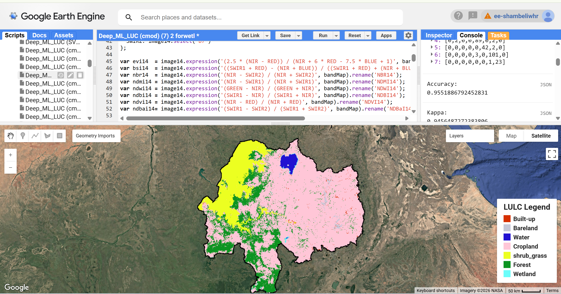
Fig. S1 LULC Classification Map of the Upper Blue Nile River Basin in 2004. LULC map produced using the RF classifier applied to LE07_L2_C2_T1 imagery in GEE ( https://earthengine.google.com/). Background satellite basemap and map visualization provided via the GEE interface.
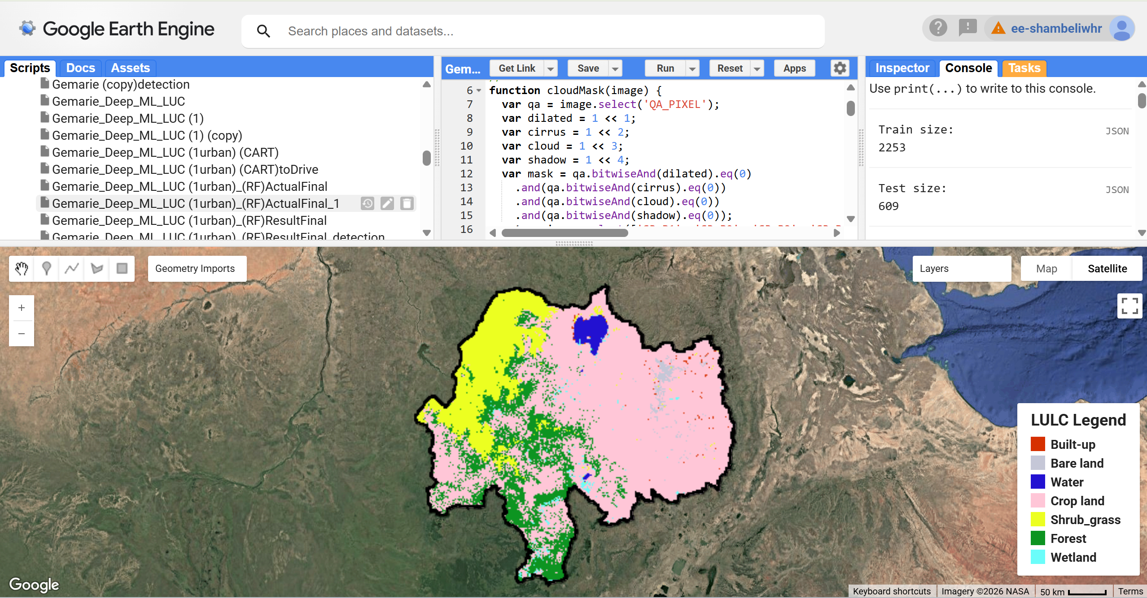
Fig. S2. LULC Classification Map of the Upper Blue Nile River Basin in 2014. LULC map produced using the RF classifier applied to LC08_L2_C2_T1 imagery in GEE ( https://earthengine.google.com/). Background satellite basemap and map visualization provided via the GEE interface.
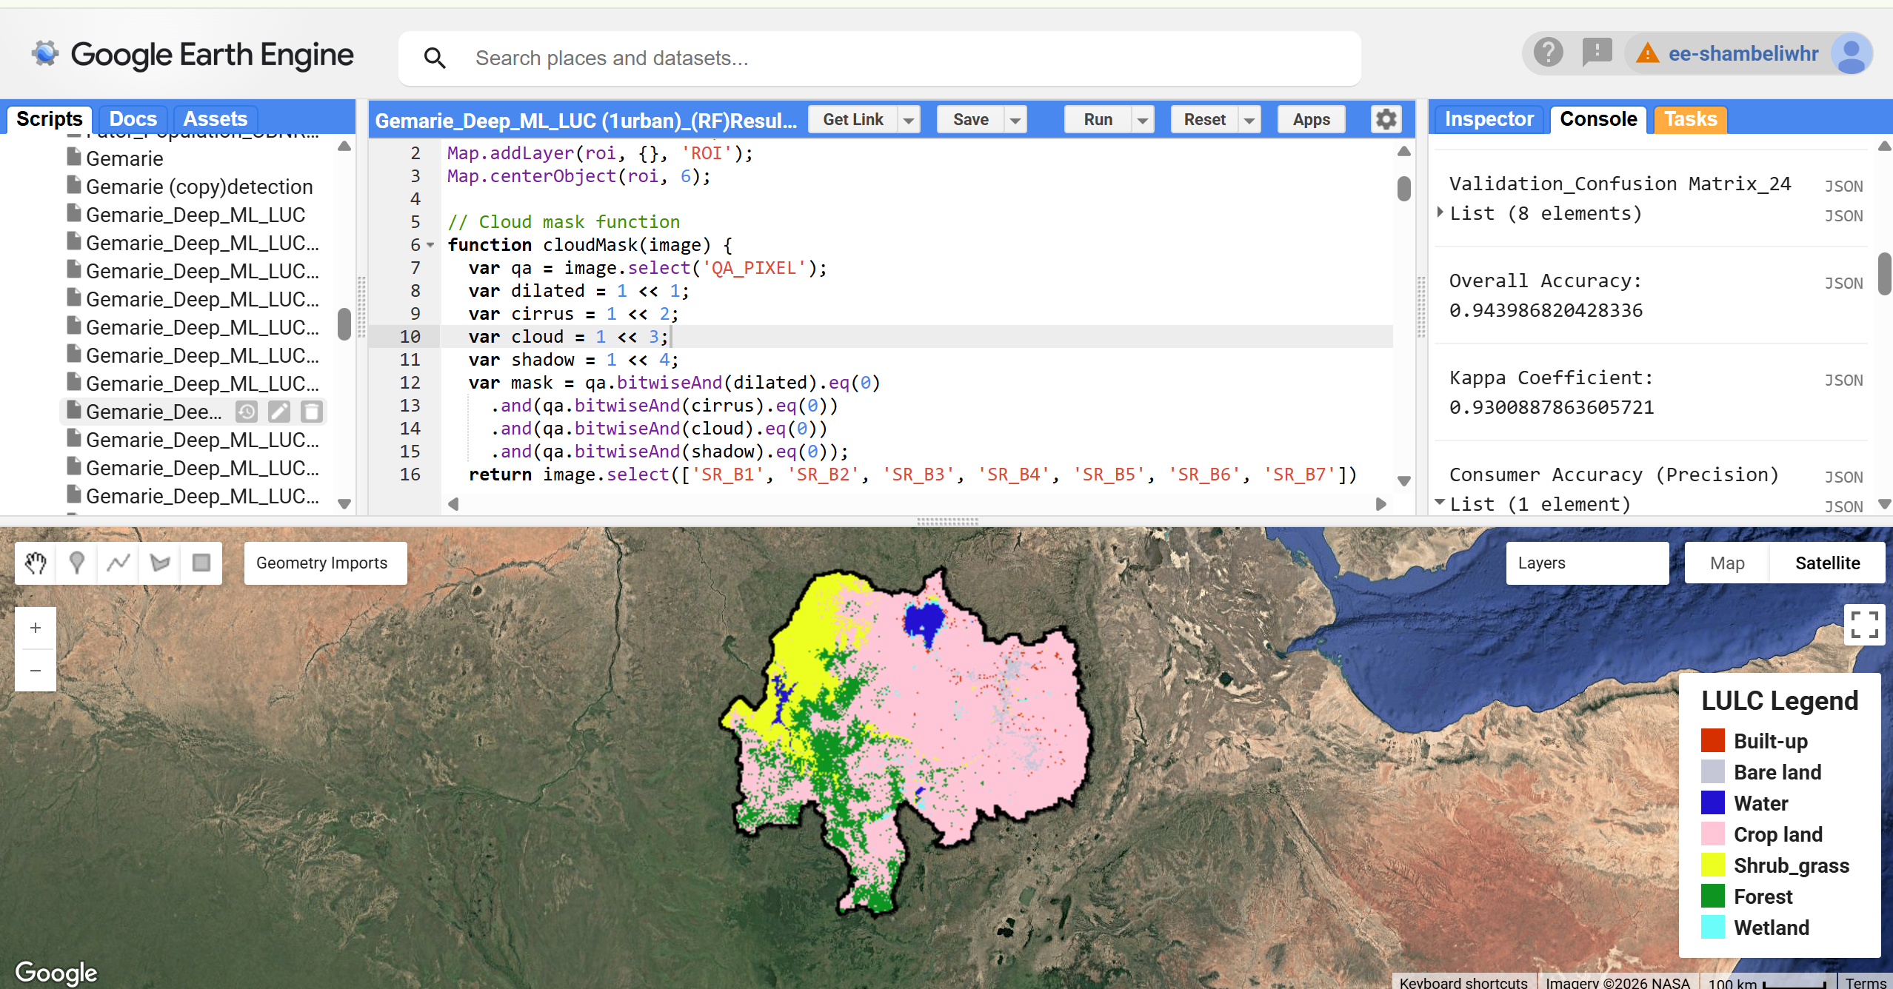
Fig. S3. LULC Classification Map of the Upper Blue Nile River Basin in 2024. LULC map produced using the RF classifier applied to LC09_L2_C2_T1 imagery in GEE ( https://earthengine.google.com/). Background satellite basemap and map visualization provided via the GEE interface.
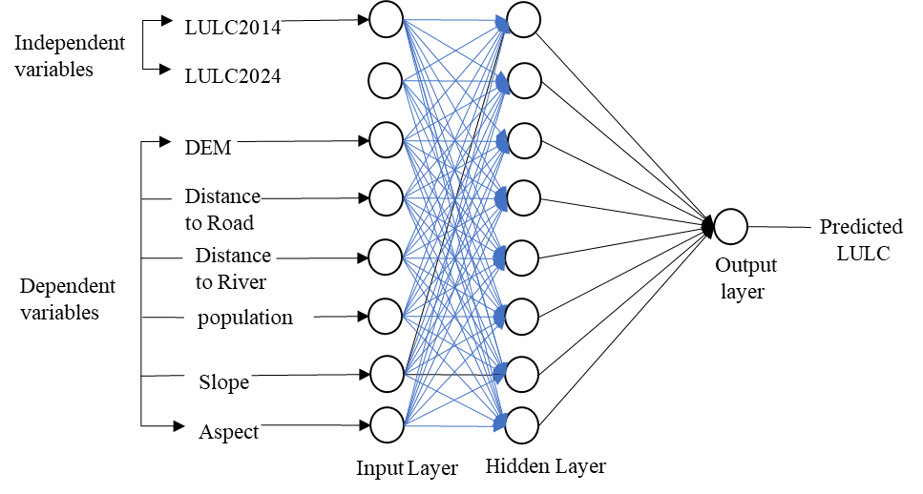

Fig. S4 The flow chart of dependent variables used for prediction of LULC change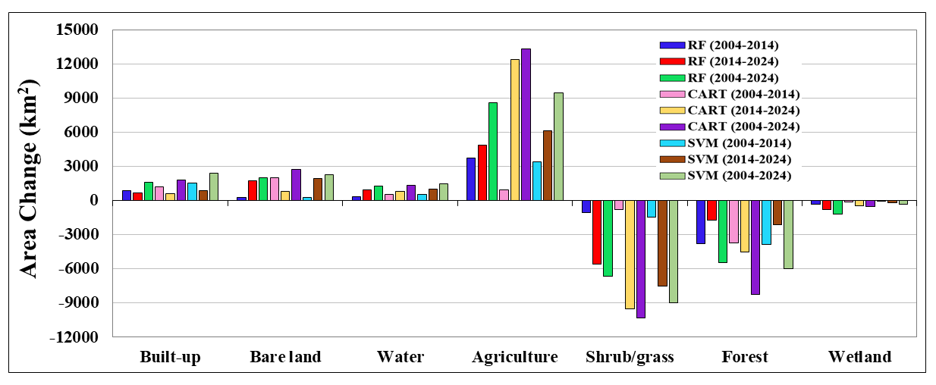
Fig. S5. Historical LULC change trends of all three of classifiers from 2004 to 2024

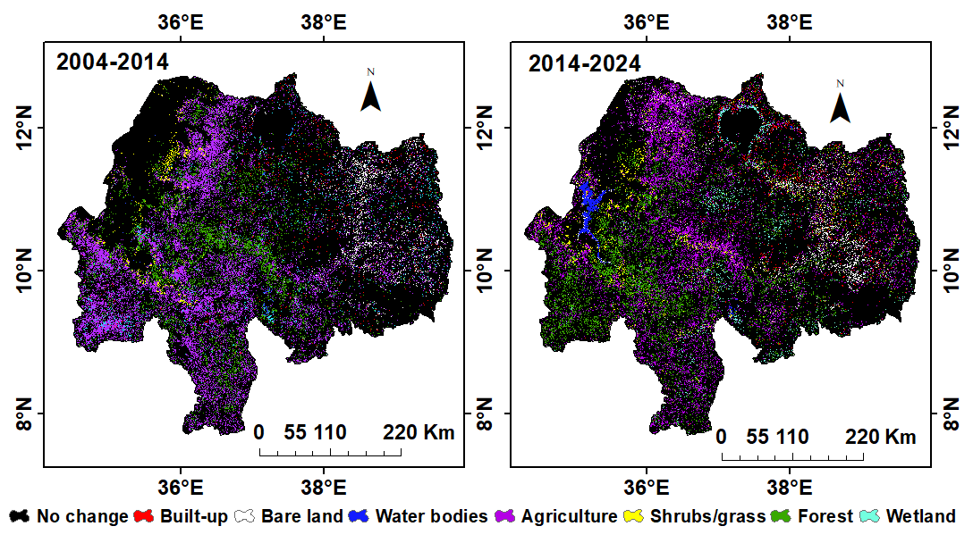
Fig.S6 Spatial distribution of LULC transitions for a specific change type between the periods 2004–2014 and 2014–2024
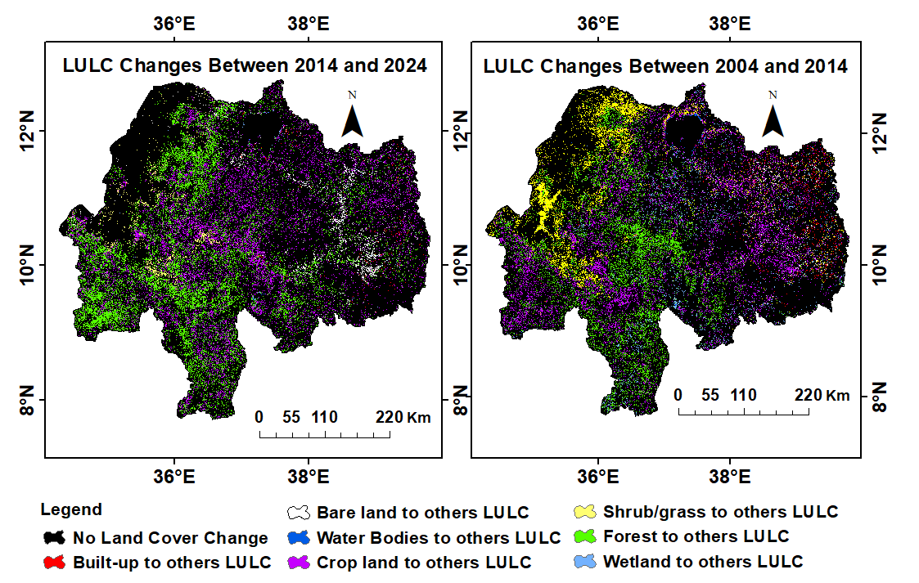
Fig. S7. Spatial distribution of LULC transitions from one specific to other change between 2004–2014 and 2014–2024
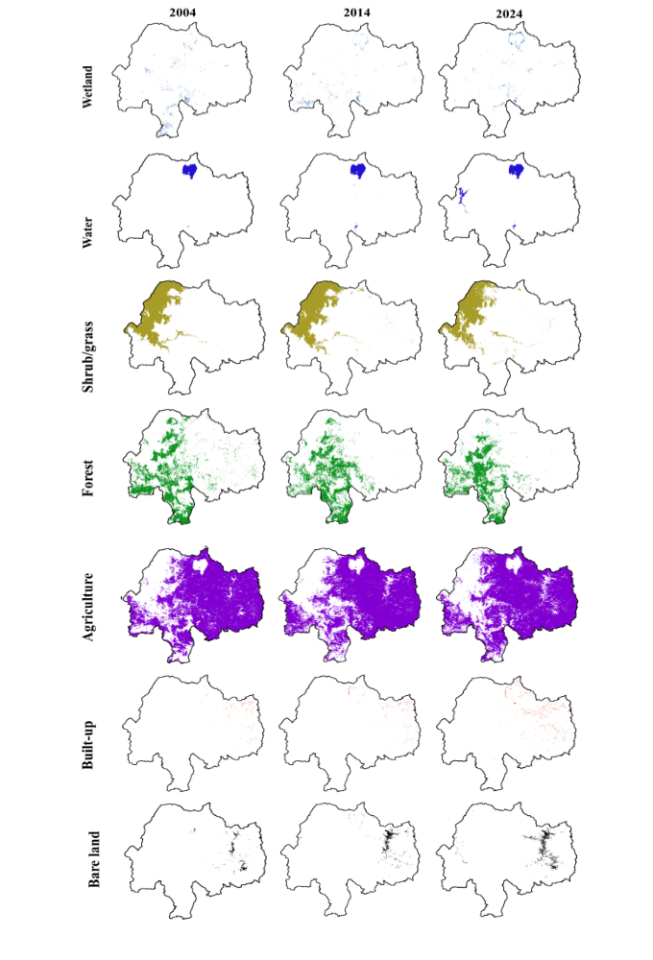
Fig. S8 Assessment of land use and land cover changes (2004, 2014 and 2024) of the study area

