Supplementary Table 1

Demographic and clinical characteristics of the participants
Participant | EDSS | Gender | Age range | Number of falls in the past 6 months
1 | 3.5 | f | 30-34 | 0
2 | 3.0 | f | 45-49 | 0
3 | 4.5 | m | 55-59 | 2
4 | 4.0 | f | 55-59 | 2
5 | 4.0 | f | 50-54 | 0
6 | 3.5 | f | 45-49 | 0
7 | 4.5 | f | 65-69 | 1
8 | 1.5 | f | 40-44 | 0
9 | 4.0 | m | 60-64 | 0
10 | 5.5 | f | 45-49 | 0
11 | 4.5 | m | 45-49 | 3
12 | 4.5 | m | 40-44 | 1
13 | 5.0 | m | 45-49 | 1
14 | 4.5 | f | 45-49 | 1
15 | 4.5 | f | 60-64 | 4
16 | 4.0 | m | 50-54 | 2
17 | 4.5 | m | 50-54 | 0
18 | 2.0 | m | 40-44 | 0
19 | 3.0 | f | 55-59 | 0
20 | 3.0 | f | 55-59 | 0
21 | 3.0 | f | 55-59 | 0
22 | 2.0 | m | 30-35 | 0
23 | 4.0 | f | 60-65 | 0
24 | 1.5 | f | 40-45 | 0
25 | 3.0 | f | 45-49 | 0
26 | 5.5 | f | 25-29 | 0
27 | 2.0 | f | 55-59 | 0
28 | 3.0 | f | 25-29 | 0
29 | 3.0 | f | 55-59 | 0
30 | 3.0 | f | 65-69 | 0
Participant characteristics. EDSS = Expanded Disability Status Scale

Supplementary Figure 1
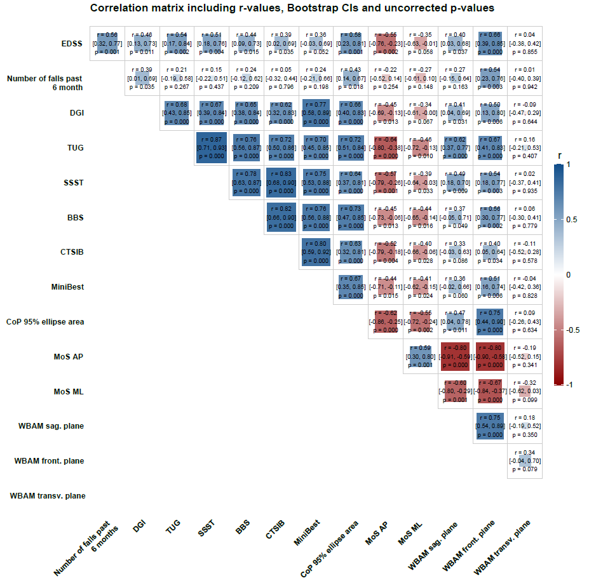
Correlation matrix for all pairwise comparisons including r-values, bootstrap confidence intervals and uncorrected p-values. The r-values are color-coded (see scale), and the size of the background squares is scaled according to magnitude and direction. Associations are greyed out and displayed in italics if the bootstrap confidence interval included r = 0 or did not include |r| ≥ 0.5. BBS = Berg Balance Scale; CoP = Center of Pressure; CTSIB = Clinical Test of Sensory Interaction on Balance; DGI = Dynamic Gait Index; MoS = Margin of Stability; SSST = Six Spot Step Test; TUG = Timed Up and Go Test; WBAM = Whole-Body Angular Momentum; AP = anteroposterior; ML = mediolateral.
Supplementary Table 2

Results of the clinical balance assessments and motion-analysis-derived measures
Test | Mean | SD
MiniBest | 23.3 | 3.9
DGI | 19.8 | 3.6
TUG | 8.3 | 3.0
SSST | 11.3 | 3.8
BBS | 53.9 | 3.0
CTSIB | 11.4 | 3.0
CoP 95% ellipse (mm²) | 483.4 | 471.4
MoS_ap | 20.1 | 60.7
MoS_ml | 80.7 | 17.3
WBAM sag. plane | 0.04 | 0.014
WBAM front. plane | 0.06 | 0.017
WBAM trans. plane | 0.02 | 0.004

