Supplementary Material
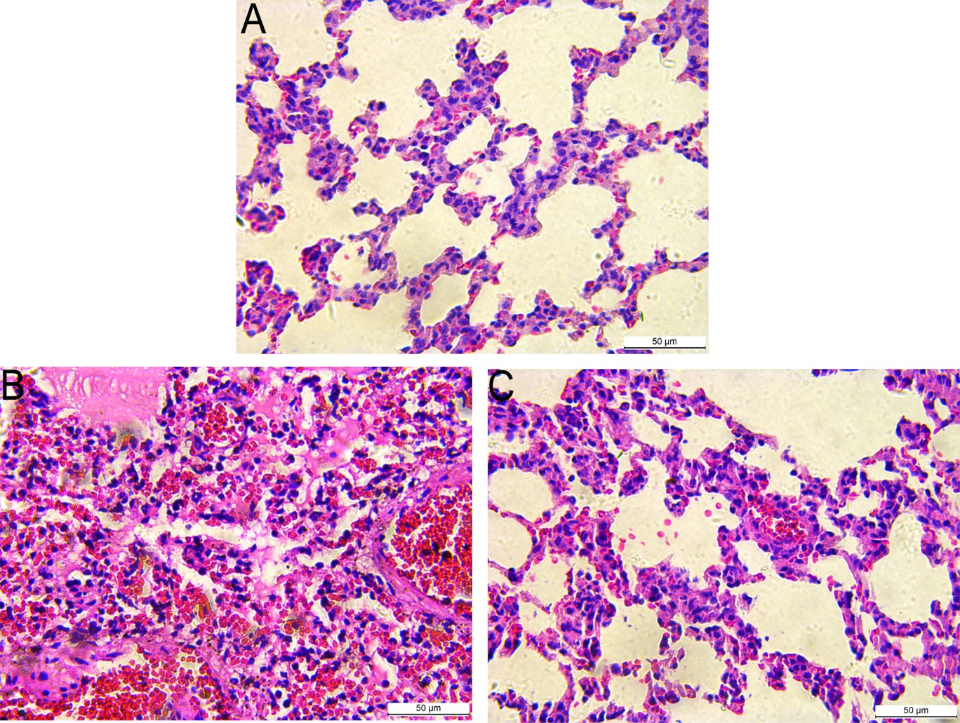
Figure S1. High-Magnification Histopathology of Lung Tissue. High-magnification H&E-stained lung sections (×400) from the control (A), BLI model (B), and IL-17A inhibitor (C) groups. Scale bar: 50 µm.

Figure S2. Original uncropped Western blot images corresponding to the proteins presented in Figure 5. The full-length blots for IL-17A, IKK-β, p65, p-p65, and their corresponding β-actin loading controls are provided. These images were obtained from the same experiments used for quantitative analysis in the main manuscript and are included to improve transparency and facilitate independent assessment of band integrity, protein loading consistency, and data reliability.
β-Actin (p65)

β-Actin (p-p65)

IL-17A

IKK-β

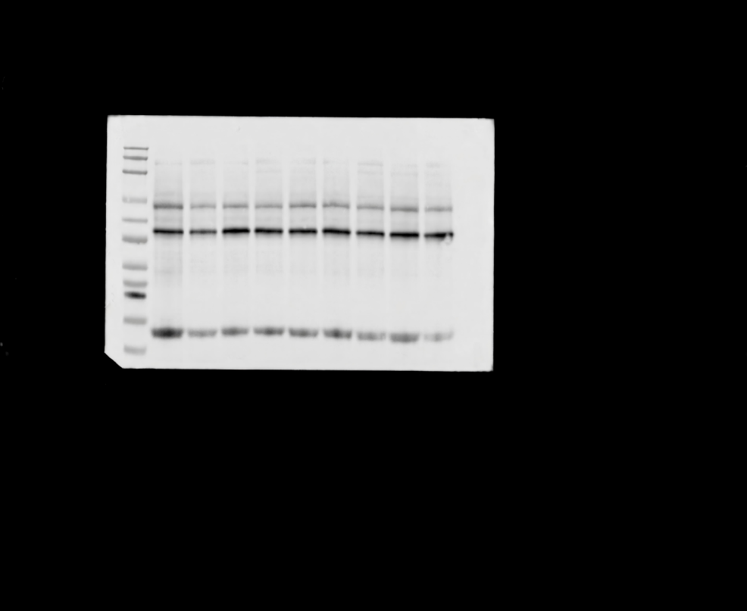
NF-κB
p-NF-κB

