Supplementary Material of the article:

Co-evolution of seismic b-values and pre-earthquake ionospheric magnetic anomalies across the Iranian Plateau
H. Alimoradi ¹, H. Rahimi ¹ and A. De Santis ²
¹Institute of Geophysics, University of Tehran, Tehran, Iran; alimoradi.h@ut.ac.ir (H.A.); rahimih@ut.ac.ir (H.R.)
²Istituto Nazionale di Geofisica e Vulcanologia (INGV), Rome, Italy; angelo.desantis@ingv.it
corresponding authors: A. De Santis and H. Rahimi

Supplementary Material
This Supplementary Material provides additional figures and analyses that complement the results presented in the main manuscript. It includes a detailed inspection of magnetic-field anomalies, seismic b-value variations, and entropy computations for each of the earthquakes analyzed in this study. The supplementary figures document the full temporal evolution of these parameters during the one-year interval preceding each mainshock, offering further insight into the multi-parameter behavior of the lithosphere–atmosphere–ionosphere system prior to significant seismic events.
Supplementary Figures 1S–3S present the temporal evolution of magnetic anomalies and b-values for the Azgeleh, Sefidsang and Turkmen-chai earthquakes. The b⁺ method is applied only for the Azgeleh and Sefidsang earthquakes, due to catalogue completeness limitations in their border-zone locations; all other earthquakes use the classical b-value estimation. Supplementary Figures 4S–9S illustrate the evolution of the seismic b-value and entropy H(t) during the 365-day windows preceding each event. Together, these supplementary materials provide an extended view of the spatio-temporal patterns discussed in the main text and reinforce the correlations and interpretations presented in this work.

Fig. 1S| Magnetic anomalies and b-value evolution before the Azgeleh earthquake. Magnetic field anomalies and changes in b-value for the Azgeleh earthquake in Kermanshah province from one year before to one month after the occurrence of the earthquake on November 11, 2017, with a magnitude of 7.3. The X-axis represents the days relative to the earthquake occurrence. The Y-axis shows the number of anomalies on each day. Panel (A) corresponds to the Alpha satellite, panel (B) corresponds to the Bravo satellite, and panel (C) corresponds to the Charlie satellite. The earthquake occurrence time is indicated by a solid black line and triangle. Foreshocks are marked with a black dashed line. The red bars represent the number of magnetic anomalies on each day within a 300-kilometer radius of the earthquake. The green curve represents changes in b-value as estimated with the b+ method, and the blue curve represents the envelope in magnetic anomalies. The red-colored area in the lower panels of each subfigure represents the area under the 10th-degree polynomial fit to the anomalies. The dashed black line with a triangle indicates earthquakes that occurred before the main earthquake within a 300-kilometer radius
A
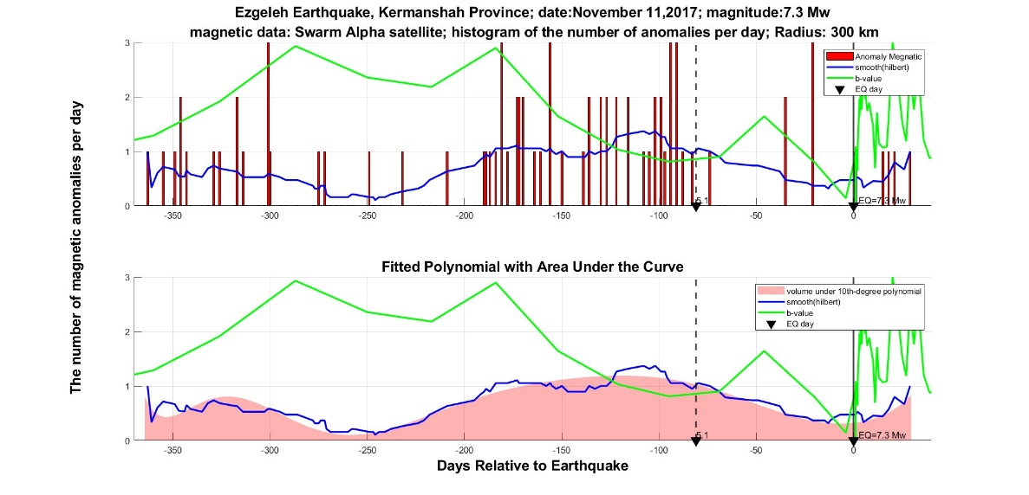
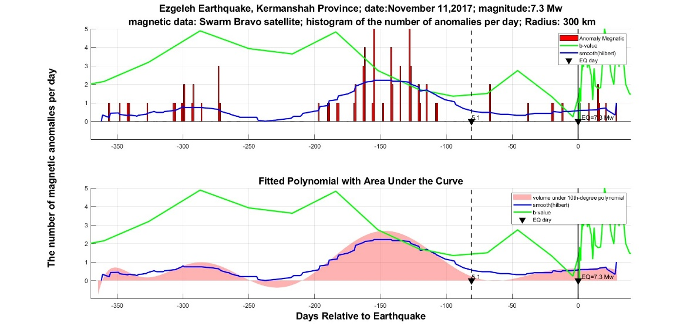
B
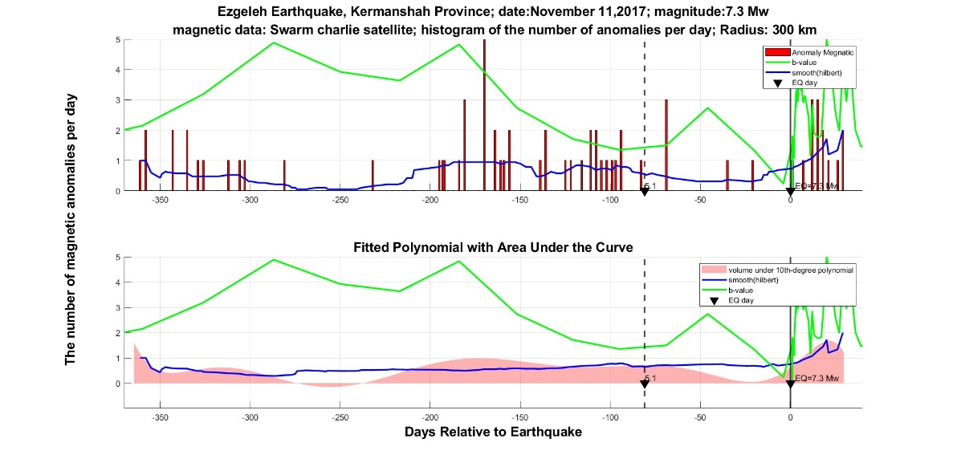
C

Fig. 2S| Magnetic anomalies and b-value evolution before the Sefidsang earthquake. Magnetic field anomalies and changes in b-value for the Sefidsang earthquake in Khorasan Razavi province from one year before to one month after the occurrence of the earthquake on April 5, 2017, with a magnitude of 6. The X-axis represents the days relative to the earthquake occurrence. The Y-axis shows the number of anomalies on each day. Panel (A) corresponds to the Alpha satellite, panel (B) corresponds to the Bravo satellite, and panel (C) corresponds to the Charlie satellite. The earthquake occurrence time is indicated by a solid black line and triangle. The red bars represent the number of magnetic anomalies on each day within a 300-kilometer radius of the earthquake. The green curve represents changes in b-value as estimated with the b+ method, and the blue curve represents the envelope in magnetic anomalies. The red-colored area in the lower panels of each subfigure represents the area under the 10th-degree polynomial fit to the anomalies. The dashed black line with a triangle indicates earthquakes that occurred before the main earthquake within a 300-kilometer radius

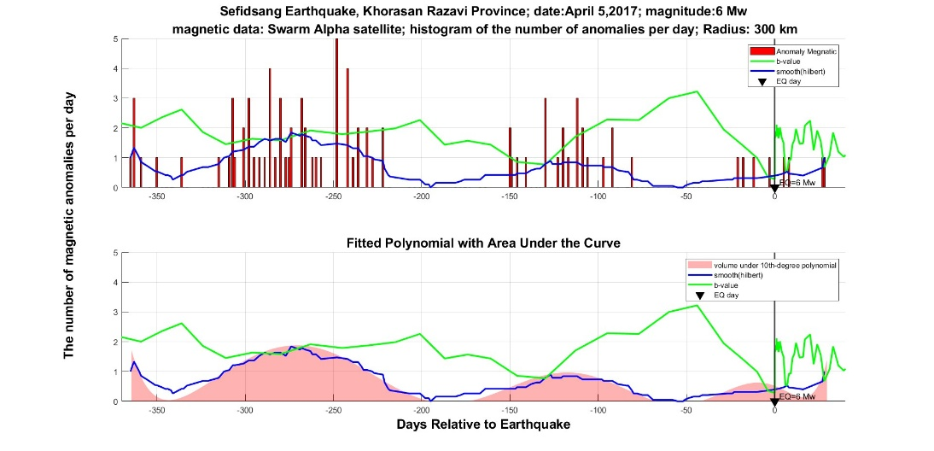
A

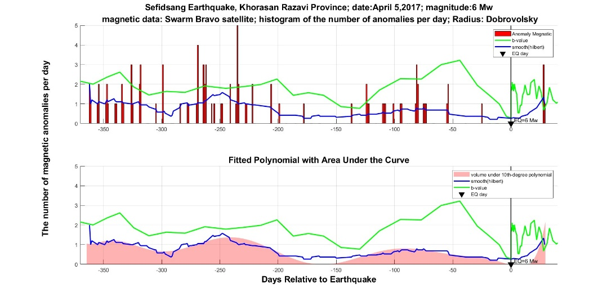
B
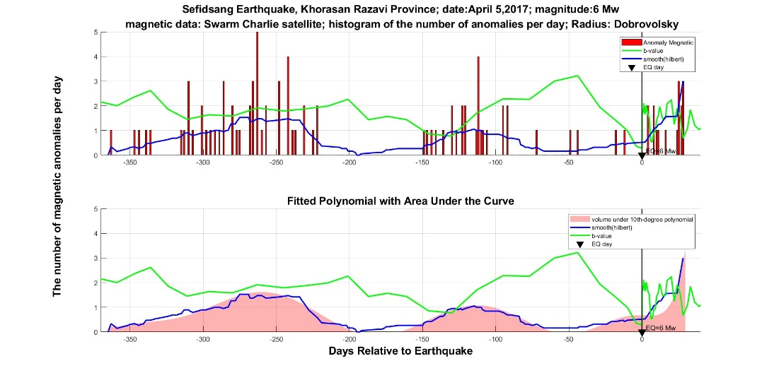
C

Fig. 3S| Magnetic anomalies and b-value evolution before the Turkmen-chai earthquake. Magnetic field anomalies and changes in b-value for the Turkmen-chai earthquake in East Azerbaijan province from one year before to one month after the occurrence of the earthquake on November 8, 2019, with a magnitude of 6. The X-axis represents the days relative to the earthquake occurrence. The Y-axis shows the number of anomalies on each day. Panel (A) corresponds to the Alpha satellite, panel (B) corresponds to the Bravo satellite, and panel (C) corresponds to the Charlie satellite. The earthquake occurrence time is indicated by a solid black line and triangle. Foreshocks are marked with a black dashed line. The red bars represent the number of magnetic anomalies on each day within a 300-kilometer radius of the earthquake. The green curve represents changes in b-value, and the blue curve represents the envelope in magnetic anomalies. The red-colored area in the lower panels of each subfigure represents the area under the 10th-degree polynomial fit to the anomalies. The dashed black line with a triangle indicates earthquakes that occurred before the main earthquake within a 300-kilometer radius.

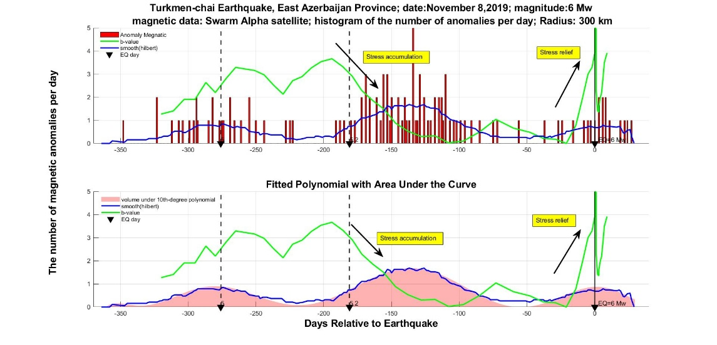
A
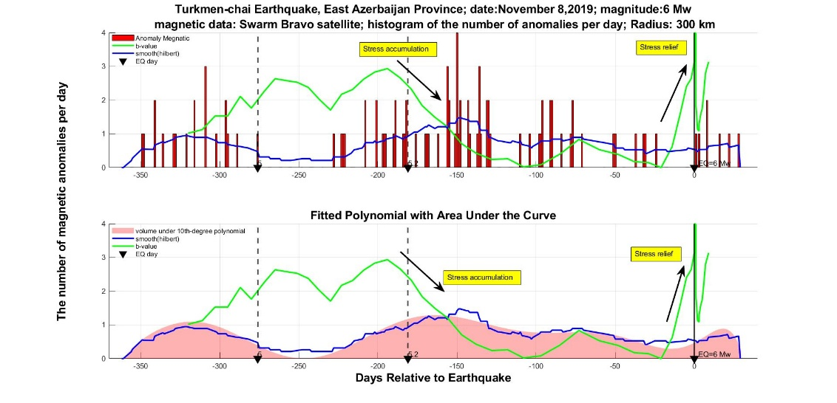
B
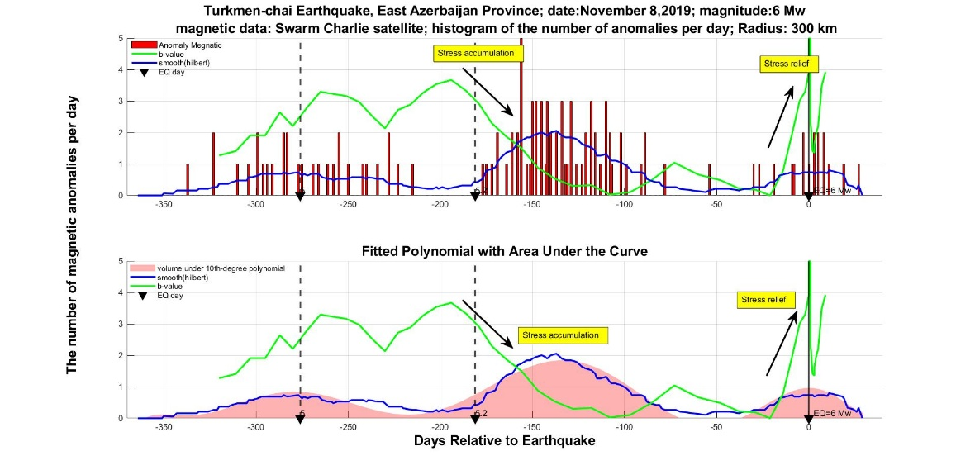
C

Fig. 4S| Temporal evolution of b-value and entropy before the Azgeleh earthquake. Temporal evolution of the seismic b-value (green line, left y-axis) and the entropy H(t) (blue line, right y-axis) during the 365 days leading up to the 2017 Azgeleh earthquake (Mw 7.3), with the mainshock marked by the vertical red dashed line. The vertical black dashed line indicates the main foreshock.

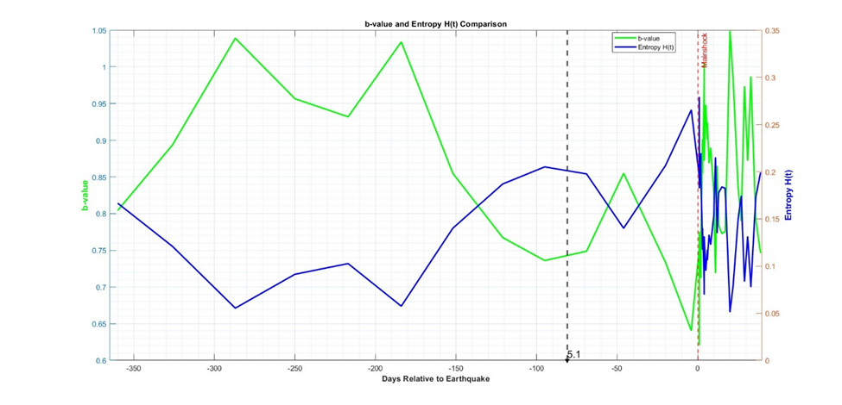

Fig. 5S| Temporal evolution of b-value and entropy before the Fin earthquake. Temporal evolution of the seismic b-value (green line, left y-axis) and the entropy H(t) (blue line, right y-axis) during the 365 days leading up to the 2021 Fin earthquake (Mw 6.4), with the mainshock marked by the vertical red dashed line. The vertical black dashed lines indicate the main foreshocks, while the small number at the base represents the foreshock magnitude.
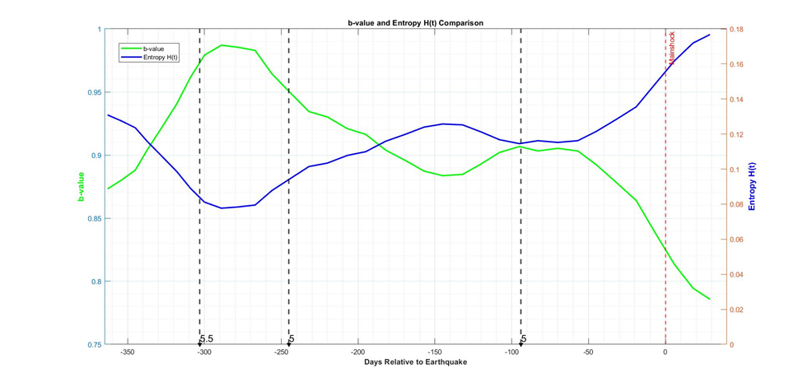
Fig. 6S| Temporal evolution of b-value and entropy before the Hojedk earthquake. Temporal evolution of the seismic b-value (green line, left y-axis) and the entropy H(t) (blue line, right y-axis) during the 365 days leading up to the 2017 Hojedk earthquake (Mw 6.2), with the mainshock marked by the vertical red dashed line. The vertical black dashed lines indicate the main foreshocks, while the small number at the base represents the foreshock magnitude.
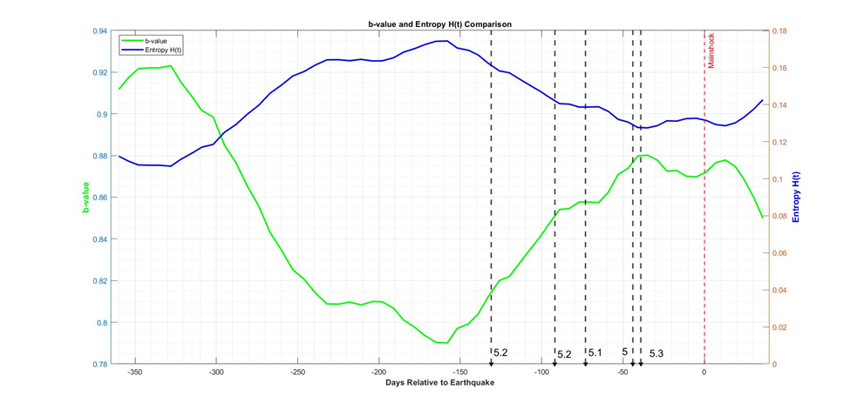

Fig. 7S| Temporal evolution of b-value and entropy before the Murmuri earthquake. Temporal evolution of the seismic b-value (green line, left y-axis) and the entropy H(t) (blue line, right y-axis) during the 365 days leading up to the 2014 Murmuri earthquake (Mw 6.2), with the mainshock marked by the vertical red dashed line.
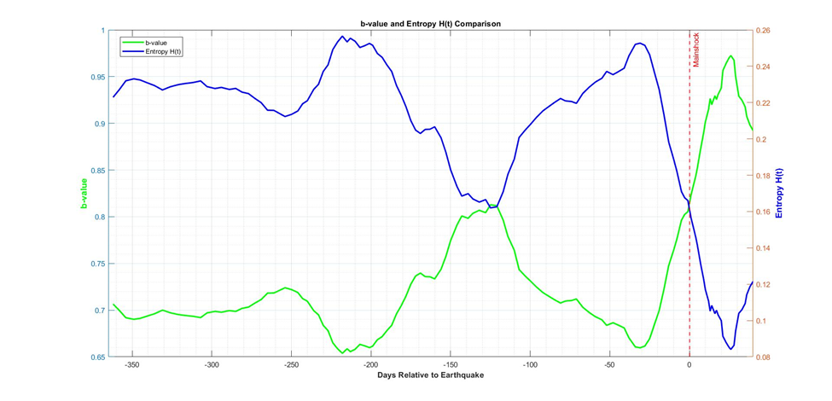

Fig. 8S| Temporal evolution of b-value and entropy before the Sefidsang earthquake. Temporal evolution of the seismic b-value (green line, left y-axis) and the entropy H(t) (blue line, right y-axis) during the 365 days leading up to the 2017 Sefidsang earthquake (Mw 6), with the mainshock marked by the vertical red dashed line.
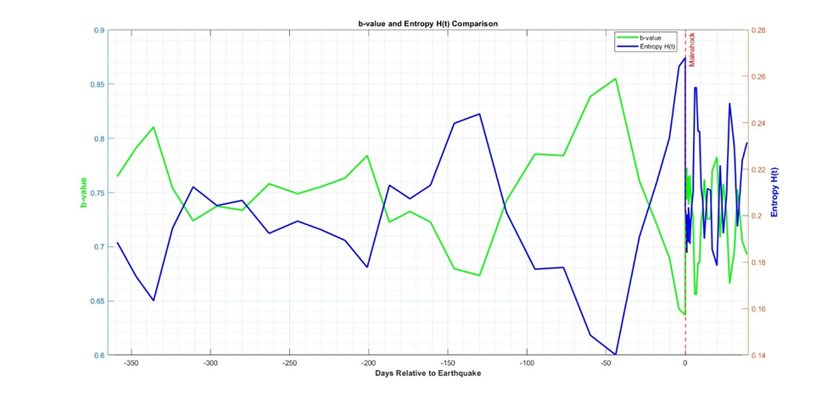

Fig. 9S| Temporal evolution of b-value and entropy before the Turkmen-chai earthquake. Temporal evolution of the seismic b-value (green line, left y-axis) and the entropy H(t) (blue line, right y-axis) during the 365 days leading up to the 2019 Turkmen-chai earthquake (Mw 6), with the mainshock marked by the red dashed line. The black dashed lines indicate the foreshocks, while the small number at the base represents the foreshock magnitude.
