Dominance, drivers and thresholds of DEN, ANA, and DNRA quantified using a global dataset of cross-ecosystems and machine-learning

Yao Ma¹, Song Jiang^{1,2}, Yibing Ma^{1, *}

¹National Observation and Research Station of Coastal Ecological Environments in Macao, Macau Environmental Research Institute, Macau University of Science and Technology, Macao SAR 999078, China.
²Heilongjiang Forestry Institute, Harbin 150040, China

*Corresponding author
- mail: ybma@must.edu.mo
Tel: +853 8897-2926
Fax: +853 2883-3280
*A423, Macau University of Science and Technology, Avenida Wai Long, Taipa, Macau, China.

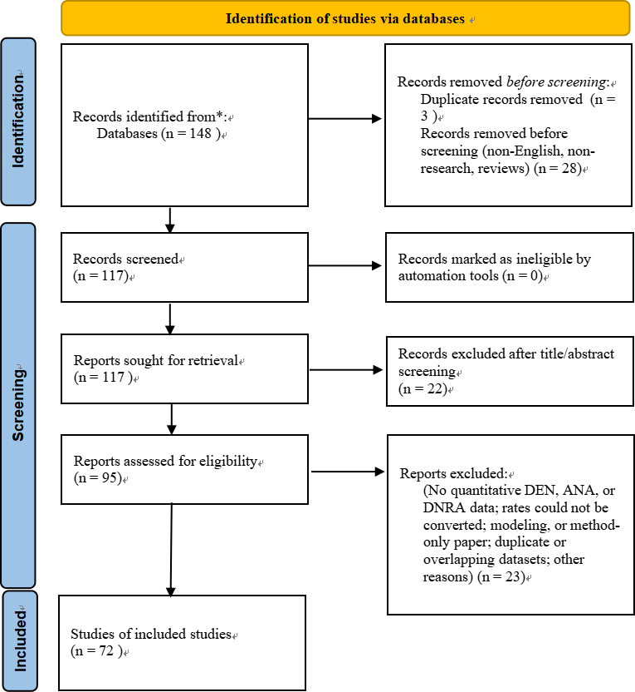
Fig. S1. PRISMA-style flow diagram of literature screening and study inclusion

Table S1. Pearson correlation coefficients (R) and significance (*p ≤ 0.05, **p ≤ 0.01) among variables (note: MAP denotes mean annual precipitation, MAT denotes mean annual temperature, TOC denotes total organic carbon, TN denotes total nitrogen, NO₃⁻ denotes nitrate, and NH₄⁺ denotes ammonium).
Environmental variables | DNRA | DEN | ANA
MAT | -0.07 | 0.29** | 0.09
MAP | 0.17** | 0.13* | -0.07
Depth | 0.09 | -0.08 | 0.09
pH | 0.06 | -0.02 | 0.1
TOC | 0.01 | 0.01 | 0.07
TN | -0.08 | -0.05 | -0.06
NO₃⁻ | -0.04 | -0.18** | 0
NH₄⁺ | 0.05 | -0.08 | -0.06
Moisture | -0.09 | 0.14* | 0.28**
DNRA | 1 | 0.09 | 0.13*
DEN |  | 1 | 0.51**
ANA |  |  | 1

Table S2. Factor loadings of environmental variables and nitrogen transformation rates on principal components
 | Component
 | 1 | 2 | 3 | 4 | 5 | 6 | 7
TOC | 0.826 | 0.034 | 0.173 | 0.216 | -0.138 | 0.189 | -0.02
TN | 0.81 | -0.172 | 0.24 | 0.187 | -0.096 | 0.092 | -0.205
Temp | -0.66 | 0.254 | -0.071 | -0.289 | -0.303 | 0.009 | 0.112
MAP | -0.641 | -0.159 | -0.119 | 0.559 | 0.105 | -0.04 | -0.034
MAT | -0.616 | 0.048 | 0.478 | 0.199 | -0.123 | -0.124 | -0.017
ANA rate | -0.021 | 0.729 | 0.307 | 0.145 | 0.182 | 0.142 | -0.04
Fe(II) | 0.048 | 0.602 | -0.191 | 0.067 | 0.321 | 0.239 | 0.024
DEN rate | -0.184 | 0.522 | 0.408 | 0.43 | -0.064 | 0.03 | -0.086
Depth | 0.155 | 0.49 | -0.517 | -0.264 | 0.085 | -0.257 | -0.094
Moisture | 0.167 | 0.408 | 0.484 | -0.338 | -0.032 | -0.105 | -0.184
NH₄⁺ | -0.187 | -0.225 | -0.347 | 0.216 | 0.272 | 0.229 | -0.203
P | 0.037 | -0.02 | -0.324 | 0.287 | -0.291 | -0.173 | -0.231
NO₃⁻ | -0.145 | -0.242 | 0.377 | -0.421 | 0.478 | 0.264 | 0.197
pH | 0.202 | 0.434 | -0.337 | -0.025 | -0.439 | -0.053 | 0.266
C/N | 0.35 | -0.061 | 0.017 | 0.371 | 0.434 | -0.427 | 0.225
Density | 0.144 | 0.136 | -0.263 | -0.212 | 0.379 | -0.083 | 0.19
Salinity | 0.05 | 0.1 | 0.149 | 0.202 | 0.157 | -0.54 | 0.423
DNRA rate | -0.064 | 0.28 | -0.289 | 0.285 | 0.26 | 0.393 | -0.071
SOM | 0.091 | -0.054 | -0.015 | 0.198 | -0.273 | 0.434 | 0.723

Table S3. Random forest model performance under different validation methods
Validation | Process | R2 | RMSE
Leave-one-ecosystem-out | ANA | 0.082 | 1.289
Leave-one-ecosystem-out | DEN | 0.335 | 1.375
Leave-one-ecosystem-out | DNRA | -0.219 | 2.145
Leave-one-study-out | ANA | 0.158 | 1.236
Leave-one-study-out | DEN | 0.465 | 1.216
Leave-one-study-out | DNRA | -0.146 | 2.084
Out-of-bag | ANA | 0.557 | 0.899
Out-of-bag | DEN | 0.658 | 0.986
Out-of-bag | DNRA | 0.264 | 1.66

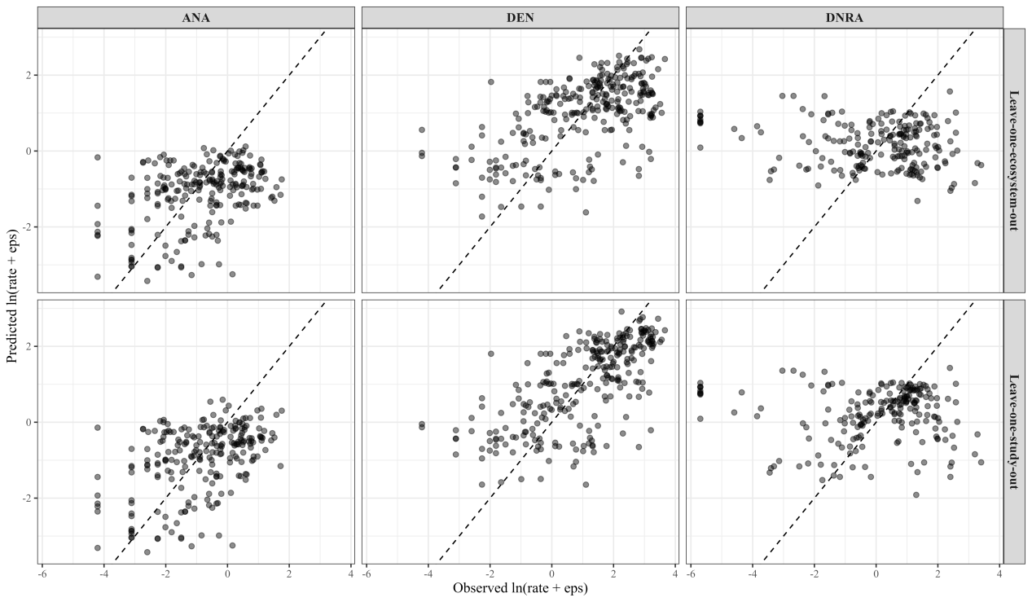
Fig. S2. Observed-versus-predicted plots for random forest models based on grouped validation

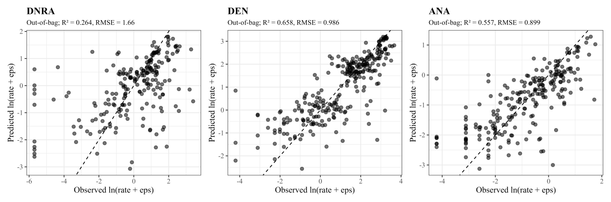
Fig. S3. Observed-versus-predicted plots for random forest models based on out-of-bag prediction

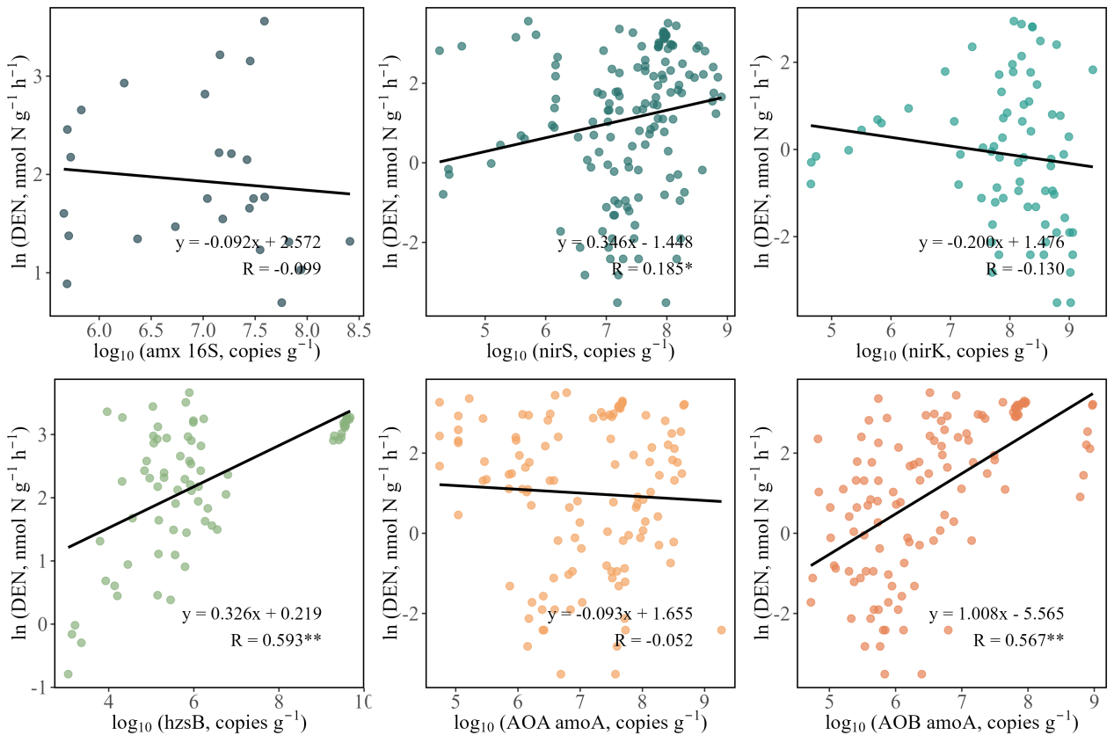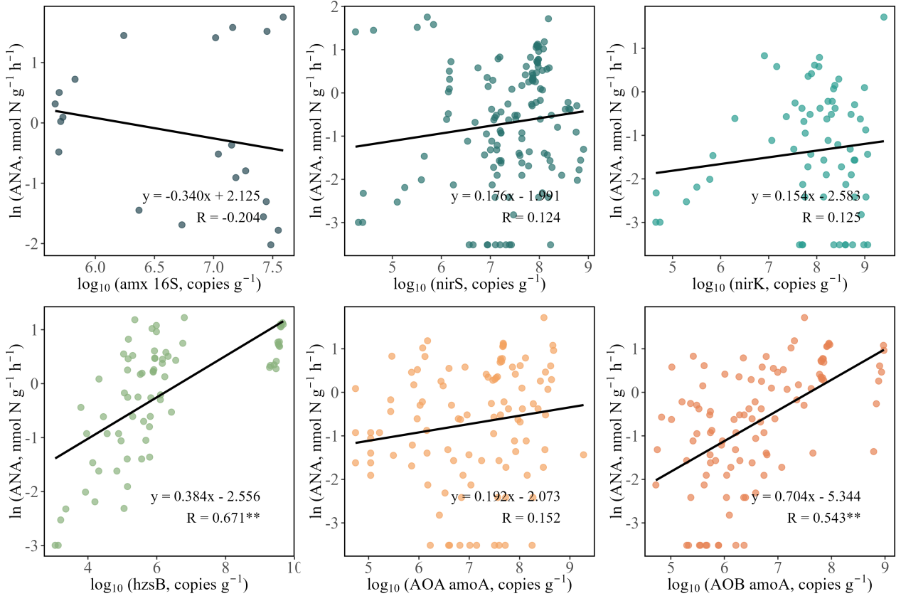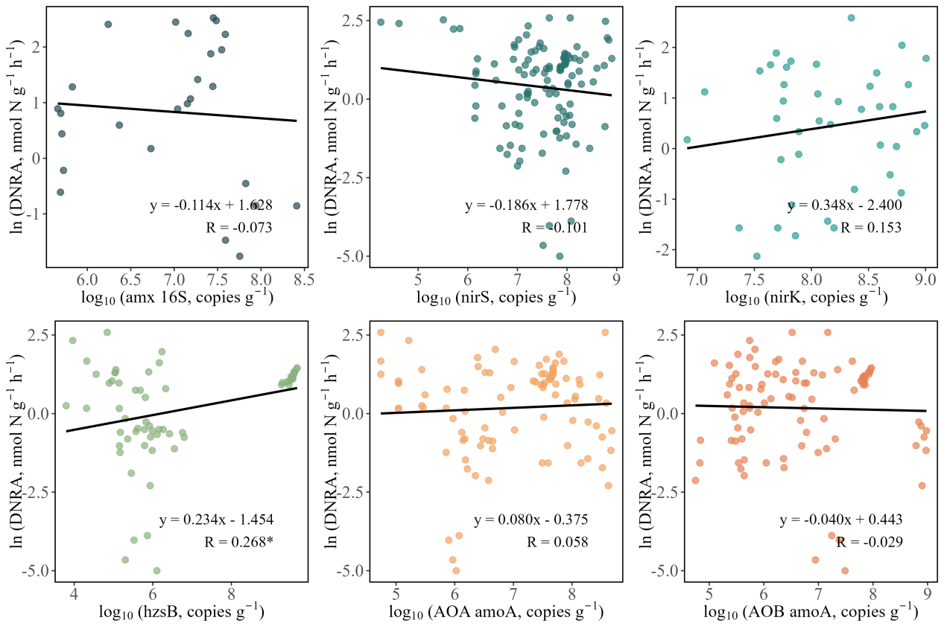

Fig. S4. Linear mixed model relationship between nitrogen transformation rate and functional gene abundance

