Supplementary Figure and Table Legends

Supplementary Figures
Supplementary Figure 1: Experimental Timeline of the regrouping process for two groups (Group A and Group B), day number and grouping phase (introduction, integration, stabilization, consolidation and follow-up).

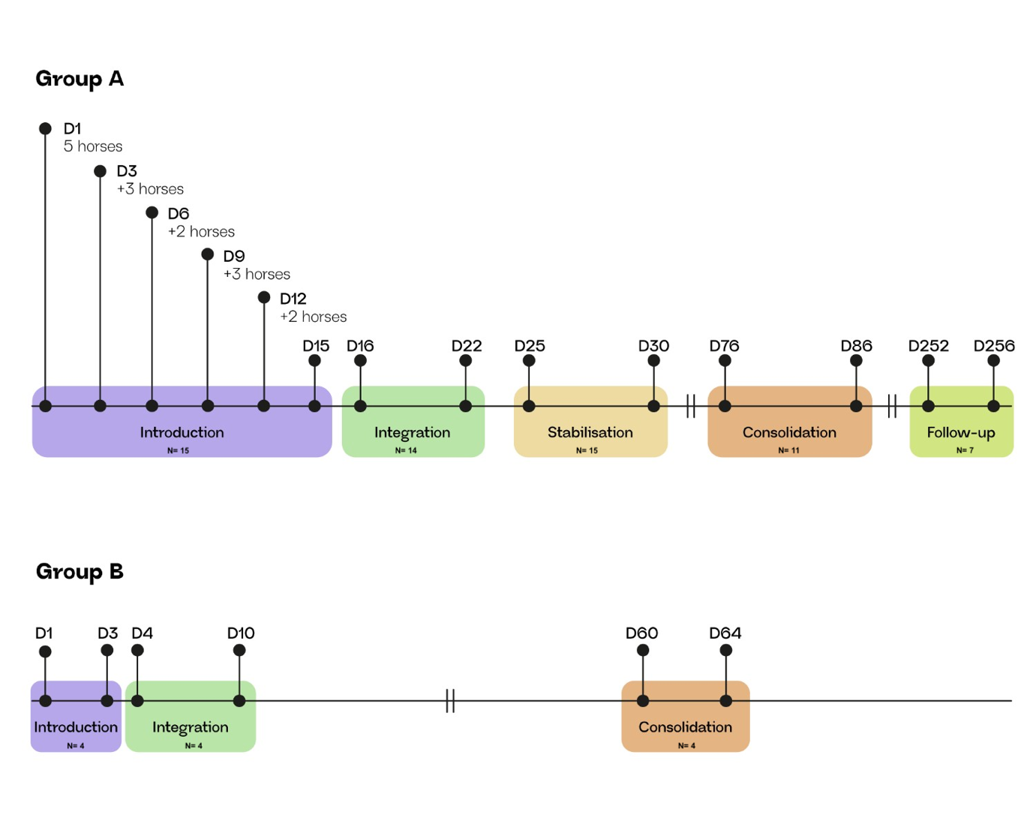
Supplementary Figure 2

Blue (group A-Y) and red (group B) represent horses introduced together, cyan represents horses introduced separately (A–N). Statistical significance is indicated as * p<0.05, ** p<0.01, *** p<0.001, **** p<0.0001
A): Inter-individual distances (median ± 95% CI) per phase
B) Percentage of time (median ± 95% CI) spent in close proximity (< 3 m) per phase.
C) Agonistic approaches per hour (median ± 95% CI) per phase
D) Affiliative approaches per hour (median ± 95% CI) per phase
E) High intensity retreats per hour (median ± 95% CI) per phase

F) Allogrooming events per hour (median ± 95% CI) per phase
G) Low intensity retreats per hour (median ± 95% CI) per phase

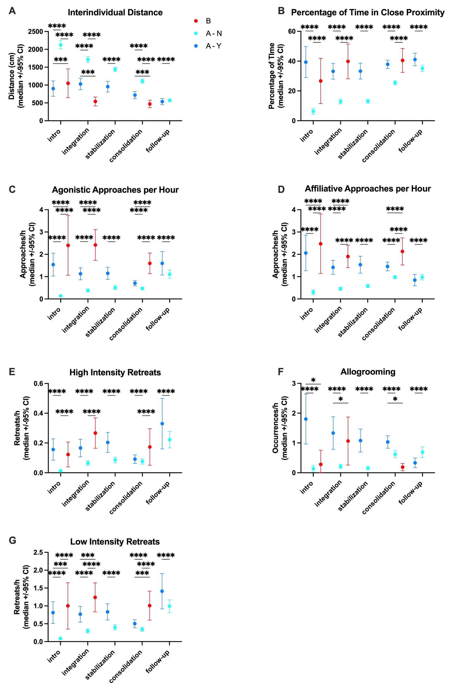
Supplementary Figure 3: Proximity-based association networks for only Group A, away and near the hay feeders. Across grouping phases (stabilisation, follow up).
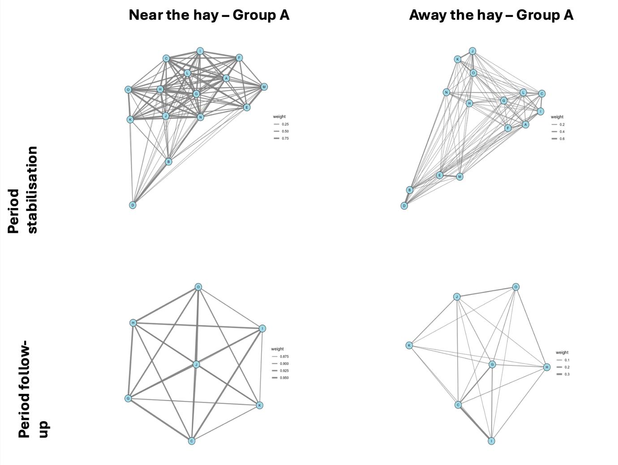
Supplementary Tables

Supplementary Table 1: List of horses included in this study with group, ID, subgroup of integration, age, breed and familiar horses. Sex: M= mare, G= gelding, S= stallion.
Group A | Horse ID | Sub-group | Age | Sex | Breed | Familiar horses
Group A | A | C | 22 | G | Tinker-Pinto Mix | C, F, I, L, O
Group A | B | E | 30 | M | Arabian | D
Group A | C | C | 24 | M | Haflinger | A, F, I, L, O
Group A | D | E | 20 | G | Riding pony | B
Group A | E | A | 25 | G | Haflinger | M
Group A | F | D | 29 | M | Haflinger | A, C, I, L, O
Group A | G | B | 18 | G | South German Draft | H, N
Group A | H | B | 19 | M | Haflinger | G, N
Group A | I | D | 29 | M | Haflinger | A, C, F, L, O
Group A | J | A | 15 | M | Arabian | K
Group A | K | A | 18 | M | Arabian | J
Group A | L | D | 23 | G | Haflinger | A, C, F, I, O
Group A | M | A | 29 | M | Arabo-Haflinger | E
Group A | N | B | 19 | G | Warmblood | G, H
Group A | O | A | 15 | G | Haflinger | A, C, F, I, L
Group B | P | A | 20 | S | Freiberger | S
Group B | Q | A | 16 | S | Freiberger
Group B | R | A | 13 | S | Freiberger
Group B | S | A | 25 | S | Freiberger | P

Supplementary Table 2: Descriptive statistics of the different spatiotemporal and behavioural parameters measured and calculated in this study around the hay resource by group (A vs. B)/subgroup (introduced together: A-Y, not introduced together: A-N) and grouping phase (introduction, integration, stabilization, consolidation and follow-up).
 |  |  | A overall | A - Y | A - N | B
Distance | Intro. | Median (95%CI) | 1684.0 (277.0 – 1745.0) | 185.8 (143.5 – 217.8) | 1757.0 (1720.2 – 1779.0) | 241.8 (168.0 – 645.0)
Distance | Integrat. | Median (95%CI) | 331.0 (274.0 – 1378.5) | 173.0 (152.5 – 193.5) | 1305.2 (331.5 – 1464.5) | 202.0 (178.5 – 238.5)
Distance | Stabil. | Median (95%CI) | 1566.5 (348.0 – 1779.0) | 187.2 (163.0 – 253.6) | 1749.5 (423.5 – 1793.0)
Distance | Consol. | Median (95%CI) | 172.0 (165.2 – 178.0) | 146.2 (136.5 – 159.0) | 178.0 (171.5 – 186.0) | 169.0 (135.0 – 186.5)
Distance | Follow. | Median (95%CI) | 150.5 (146.0 – 157.0) | 142.2 (129.0 – 152.0) | 152.8 (147.5 – 158.5)
% Time | Intro. | Median (95%CI) | 41.6 (30.5 – 51.1) | 73.8 (64.0 – 89.6) | 25.8 (22.0 – 31.4) | 68.8 (0.0 – 93.7)
% Time | Integrat. | Median (95%CI) | 46.5 (38.4 – 53.6) | 81.6 (72.0 – 88.4) | 38.4 (30.9 – 46.0) | 85.0 (78.8 – 90.6)
% Time | Stabil. | Median (95%CI) | 42.4 (36.7 – 45.6) | 78.2 (59.4 – 84.1) | 38.6 (34.1 – 42.8)
% Time | Consol. | Median (95%CI) | 84.6 (80.4 – 87.4) | 87.2 (82.4 – 94.7) | 82.9 (78.6 – 87.0) | 93.8 (84.5 – 97.2)
% Time | Follow. | Median (95%CI) | 93.3 (92.5 – 94.0) | 95.0 (93.7 – 96.1) | 92.9 (91.9 – 93.5)
Affiliative Approaches | Intro. | Median (95%CI) | 0.0 (0.0 – 0.0) | 0.0 (0.0 – 0.0) | 0.0 (0.0 – 0.0) | 0.0 (0.0 – 0.0)
Affiliative Approaches | Integrat. | Median (95%CI) | 0.0 (0.0 – 0.0) | 0.0 (0.0 – 0.0) | 0.0 (0.0 – 0.0) | 0.0 (0.0 – 0.0)
Affiliative Approaches | Stabil. | Median (95%CI) | 0.0 (0.0 – 0.0) | 0.0 (0.0 – 0.0) | 0.0 (0.0 – 0.0)
Affiliative Approaches | Consol. | Median (95%CI) | 0.0 (0.0 – 0.0) | 0.0 (0.0 – 0.0) | 0.0 (0.0 – 0.0) | 0.0 (0.0 – 0.0)
Affiliative Approaches | Follow. | Median (95%CI) | 0.0 (0.0 – 0.0) | 0.0 (0.0 – 0.0) | 0.0 (0.0 – 0.0)
Allogrooming | Intro. | Median (95%CI) | 0.00 (0.00 – 0.00) | 0.06 (0.00 – 0.25) | 0.00 (0.00 – 0.00) | 0.00 (0.00 – 0.00)
Allogrooming | Integrat. | Median (95%CI) | 0.00 (0.00 – 0.00) | 0.05 (0.00 – 0.39) | 0.00 (0.00 – 0.00) | 0.00 (0.00 – 0.00)
Allogrooming | Stabil. | Median (95%CI) | 0.00 (0.00 – 0.00) | 0.22 (0.00 – 0.48) | 0.00 (0.00 – 0.00)
Allogrooming | Consol. | Median (95%CI) | 0.11 (0.05 – 0.29) | 0.79 (0.31 – 0.99) | 0.08 (0.03 – 0.22) | 0.00 (0.00 – 0.52)
Allogrooming | Follow. | Median (95%CI) | 0.16 (0.06 – 0.22) | 0.12 (0.00 – 0.28) | 0.16 (0.07 – 0.52)
Agonistic Approaches | Intro. | Median (95%CI) | 0.00 (0.00 – 0.00) | 0.03 (0.01 – 0.07) | 0.00 (0.00 – 0.00) | 0.00 (0.00 – 0.45)
Agonistic Approaches | Integrat. | Median (95%CI) | 0.02 (0.00 – 0.03) | 0.07 (0.03 – 0.27) | 0.00 (0.00 – 0.03) | 0.12 (0.00 – 0.26)
Agonistic Approaches | Stabil. | Median (95%CI) | 0.04 (0.03 – 0.08) | 0.23 (0.04 – 0.30) | 0.04 (0.00 – 0.07)
Agonistic Approaches | Consol. | Median (95%CI) | 0.09 (0.08 – 0.11) | 0.19 (0.11 – 0.32) | 0.08 (0.07 – 0.11) | 0.46 (0.25 – 0.80)
Agonistic Approaches | Follow. | Median (95%CI) | 0.29 (0.19 – 0.38) | 0.53 (0.19 – 0.82) | 0.24 (0.18 – 0.33)
High Intensity Retreats | Intro. | Median (95%CI) | 0.00 (0.00 – 0.00) | 0.00 (0.00 – 0.00) | 0.00 (0.00 – 0.00) | 0.00 (0.00 – 0.00)
High Intensity Retreats | Integrat. | Median (95%CI) | 0.00 (0.00 – 0.00) | 0.00 (0.00 – 0.01) | 0.00 (0.00 – 0.00) | 0.00 (0.00 – 0.00)
High Intensity Retreats | Stabil. | Median (95%CI) | 0.00 (0.00 – 0.00) | 0.00 (0.00 – 0.01) | 0.00 (0.00 – 0.00)
High Intensity Retreats | Consol. | Median (95%CI) | 0.00 (0.00 – 0.00) | 0.00 (0.00 – 0.00) | 0.00 (0.00 – 0.00) | 0.00 (0.00 – 0.00)
High Intensity Retreats | Follow. | Median (95%CI) | 0.00 (0.00 – 0.03) | 0.02 (0.00 – 0.04) | 0.00 (0.00 – 0.03)
Low Intensity Retreats | Intro. | Median (95%CI) | 0.00 (0.00 – 0.00) | 0.00 (0.00 – 0.00) | 0.00 (0.00 – 0.00) | 0.00 (0.00 – 0.26)
Low Intensity Retreats | Integrat. | Median (95%CI) | 0.00 (0.00 – 0.00) | 0.02 (0.00 – 0.11) | 0.00 (0.00 – 0.00) | 0.07 (0.00 – 0.32)
Low Intensity Retreats | Stabil. | Median (95%CI) | 0.01 (0.00 – 0.03) | 0.03 (0.01 – 0.09) | 0.00 (0.00 – 0.02)
Low Intensity Retreats | Consol. | Median (95%CI) | 0.03 (0.00 – 0.03) | 0.07 (0.02 – 0.11) | 0.03 (0.00 – 0.03) | 0.35 (0.11 – 0.43)
Low Intensity Retreats | Follow. | Median (95%CI) | 0.12 (0.08 – 0.17) | 0.20 (0.03 – 0.38) | 0.09 (0.06 – 0.17)

Supplementary Table 3: Descriptive statistics of the different spatiotemporal and behavioural parameters measured and calculated in this study distant to the hay resource by group (A vs. B)/subgroup (introduced together: A-Y, not introduced together: A-N) and grouping phase (introduction, integration, stabilization, consolidation and follow-up).
 |  |  | A overall | A - Y | A - N | B
Distance | Intro. | Median (95%CI) | 1952.0 (1835.5 – 2052.0) | 825.5 (587.0 – 1324.8) | 2107.0 (2009.0 – 2223.0) | 772.5 (452.0 – 1556.6)
Distance | Integrat. | Median (95%CI) | 1561.2 (1443.8 – 1698.0) | 906.8 (619.8 – 1228.0) | 1680.5 (1512.8 – 1772.5) | 523.4 (179.0 – 892.0)
Distance | Stabil. | Median (95%CI) | 1416.2 (1355.5 – 1476.9) | 1017.2 (832.5 – 1205.8) | 1474.8 (1412.0 – 1539.8)
Distance | Consol. | Median (95%CI) | 1146.5 (1118.5 – 1190.0) | 1011.5 (918.0 – 1089.2) | 1192.5 (1141.2 – 1253.0) | 607.4 (348.0 – 758.5)
Distance | Follow. | Median (95%CI) | 849.0 (817.0 – 890.8) | 1007.5 (819.5 – 1080.6) | 838.5 (792.0 – 867.5)
% Time | Intro. | Median (95%CI) | 0.4 (0.3 – 0.5) | 19.1 (13.8 – 26.3) | 0.2 (0.2 – 0.3) | 9.8 (4.3 – 30.9)
% Time | Integrat. | Median (95%CI) | 0.5 (0.4 – 0.6) | 11.7 (3.3 – 18.7) | 0.4 (0.3 – 0.5) | 20.6 (4.2 – 71.7)
% Time | Stabil. | Median (95%CI) | 0.7 (0.6 – 0.9) | 7.4 (3.8 – 10.7) | 0.6 (0.5 – 0.7)
% Time | Consol. | Median (95%CI) | 5.1 (4.6 – 5.9) | 12.1 (9.4 – 14.8) | 4.2 (3.8 – 4.8) | 20.9 (13.7 – 38.8)
% Time | Follow. | Median (95%CI) | 5.0 (4.4 – 5.9) | 6.0 (4.6 – 6.6) | 4.8 (4.2 – 5.4)
Affiliative Approaches | Intro. | Median (95%CI) | 0.0 (0.0 – 0.0) | 0.0 (0.0 – 0.1) | 0.0 (0.0 – 0.0) | 1.1 (0.3 – 3.8)
Affiliative Approaches | Integrat. | Median (95%CI) | 0.0 (0.0 – 0.0) | 0.1 (0.1 – 0.2) | 0.0 (0.0 – 0.0) | 1.3 (0.9 – 1.8)
Affiliative Approaches | Stabil. | Median (95%CI) | 0.0 (0.0 – 0.0) | 0.1 (0.0 – 0.1) | 0.0 (0.0 – 0.0)
Affiliative Approaches | Consol. | Median (95%CI) | 0.1 (0.1 – 0.1) | 0.2 (0.1 – 0.2) | 0.0 (0.0 – 0.1) | 1.3 (0.8 – 1.9)
Affiliative Approaches | Follow. | Median (95%CI) | 0.0 (0.0 – 0.0) | 0.0 (0.0 – 0.1) | 0.0 (0.0 – 0.0)
Allogrooming | Intro. | Median (95%CI) | 0.0 (0.0 – 0.0) | 0.2 (0.0 – 0.8) | 0.0 (0.0 – 0.0) | 0.0 (0.0 – 0.1)
Allogrooming | Integrat. | Median (95%CI) | 0.0 (0.0 – 0.0) | 0.1 (0.0 – 0.4) | 0.0 (0.0 – 0.0) | 0.0 (0.0 – 0.0)
Allogrooming | Stabil. | Median (95%CI) | 0.0 (0.0 – 0.0) | 0.2 (0.0 – 0.5) | 0.0 (0.0 – 0.0)
Allogrooming | Consol. | Median (95%CI) | 0.1 (0.1 – 0.2) | 0.8 (0.4 – 1.0) | 0.1 (0.0 – 0.1) | 0.0 (0.0 – 0.2)
Allogrooming | Follow. | Median (95%CI) | 0.1 (0.1 – 0.2) | 0.1 (0.0 – 0.3) | 0.2 (0.1 – 0.3)
Agonistic Approaches | Intro. | Median (95%CI) | 0.0 (0.0 – 0.0) | 0.0 (0.0 – 0.1) | 0.0 (0.0 – 0.0) | 1.2 (0.5 – 2.6)
Agonistic Approaches | Integrat. | Median (95%CI) | 0.0 (0.0 – 0.0) | 0.1 (0.1 – 0.2) | 0.0 (0.0 – 0.0) | 1.5 (0.9 – 2.9)
Agonistic Approaches | Stabil. | Median (95%CI) | 0.0 (0.0 – 0.0) | 0.1 (0.1 – 0.2) | 0.0 (0.0 – 0.0)
Agonistic Approaches | Consol. | Median (95%CI) | 0.1 (0.1 – 0.1) | 0.2 (0.2 – 0.2) | 0.1 (0.1 – 0.1) | 0.9 (0.7 – 1.4)
Agonistic Approaches | Follow. | Median (95%CI) | 0.1 (0.1 – 0.1) | 0.1 (0.0 – 0.1) | 0.1 (0.1 – 0.1)
High Intensity Retreats | Intro. | Median (95%CI) | 0.0 (0.0 – 0.0) | 0.0 (0.0 – 0.0) | 0.0 (0.0 – 0.0) | 0.1 (0.0 – 0.2)
High Intensity Retreats | Integrat. | Median (95%CI) | 0.0 (0.0 – 0.0) | 0.0 (0.0 – 0.0) | 0.0 (0.0 – 0.0) | 0.2 (0.1 – 0.2)
High Intensity Retreats | Stabil. | Median (95%CI) | 0.0 (0.0 – 0.0) | 0.0 (0.0 – 0.0) | 0.0 (0.0 – 0.0)
High Intensity Retreats | Consol. | Median (95%CI) | 0.0 (0.0 – 0.0) | 0.0 (0.0 – 0.0) | 0.0 (0.0 – 0.0) | 0.0 (0.0 – 0.1)
High Intensity Retreats | Follow. | Median (95%CI) | 0.0 (0.0 – 0.0) | 0.0 (0.0 – 0.0) | 0.0 (0.0 – 0.0)
Low Intensity Retreats | Intro. | Median (95%CI) | 0.0 (0.0 – 0.0) | 0.0 (0.0 – 0.0) | 0.0 (0.0 – 0.0) | 0.5 (0.1 – 1.1)
Low Intensity Retreats | Integrat. | Median (95%CI) | 0.0 (0.0 – 0.0) | 0.1 (0.0 – 0.1) | 0.0 (0.0 – 0.0) | 0.7 (0.4 – 1.4)
Low Intensity Retreats | Stabil. | Median (95%CI) | 0.0 (0.0 – 0.0) | 0.1 (0.0 – 0.1) | 0.0 (0.0 – 0.0)
Low Intensity Retreats | Consol. | Median (95%CI) | 0.1 (0.1 – 0.1) | 0.1 (0.1 – 0.1) | 0.1 (0.1 – 0.1) | 0.5 (0.3 – 0.6)
Low Intensity Retreats | Follow. | Median (95%CI) | 0.0 (0.0 – 0.1) | 0.1 (0.0 – 0.1) | 0.0 (0.0 – 0.1)

Supplementary Table 4: Network centrality metrics across groups, phases, and spatial contexts. Values represent mean centrality measures across individuals within each group, phase, and spatial context (near vs. away from hay).
Group | Context | Phase | Mean Strength | Mean Betweenness | Mean Closeness
A | Near hay | Introduction | 5.526 | 0.120 | 2.522
A | Away from hay | Introduction | 1.301 | 0.005 | 1.092
A | Near hay | Integration | 5.696 | 0.078 | 2.077
A | Away from hay | Integration | 0.969 | 0 | 1.081
A | Near hay | Stabilization | 5.940 | 0.038 | 1.915
A | Away from hay | Stabilization | 0.744 | 0 | 1.056
A | Near hay | Consolidation | 6.983 | 0.032 | 3.642
A | Away from hay | Consolidation | 0.91443892 | 0 | 1.10126846
A | Near hay | Follow-up | 5.520 | 0.029 | 13.080
A | Away from hay | Follow-up | 0.459 | 0 | 1.084
A | Near hay | Overall | 6.380 | 0.045 | 2.034
A | Away from hay | Overall | 1.003 | 0 | 1.078
B | Near hay | Introduction | 1.549 | 0.333 | 2.822
B | Away from hay | Introduction | 0.828 | 0 | 1.431
B | Near hay | Integration | 2.368 | 0.167 | 6.280
B | Away from hay | Integration | 1.196 | 0 | 1.828
B | Near hay | Consolidation | 2.635 | 0.083 | 8.950
B | Away from hay | Consolidation | 0.855 | 0 | 1.419
B | Near hay | Overall | 2.619 | 0 | 8.150
B | Away from hay | Overall | 1.045 | 0 | 1.620

