Appendix 1: Sampling procedure and sample size determination for each selected country survey, DHS 2015-2024.
Sub Saharan African Countries (SSA)
(N=46)

SSA countries that have DHS datasets
(N= 41)

SSA countries that haven’t DHS datasets
(N=6)

SSA countries that have PNC report between 2015 and 2024
(N=28)

SSA countries that haven’t PNC report between 2015 and 2024
(N=13)

Enumeration area of selected SSA countries (n = 17,506)

Selected enumeration area that had latitude and longitude information (n = 17,416)

Some DHS clusters had missing GPS coordinates and were excluded (n = 90)

Total weighted sample of women aged 15–49 years in selected enumeration area of Sub-Saharan Africa (n = 200,935)

Appendix 2: Measurement of each predictor
Predictors | Measurement of variables
Women age in year | 15-19  20_34  35_49
Residence | Urban  Rural
Women education | No education  Primary  Secondary and above
Father education | No education  Primary  Secondary and above
Marital status | Single  Married  Formerly married
Sex of household head | Male  Female
Husband occupation
Wealth index | Poor  Middle  Rich
Covered by health insurance | Yes  No
Antenatal care visits | ≥ 4 visits  1–3 visits  No at all
Women access to decision making | Yes  No
Place of delivery | Home  Health facilities
Women occupation | Employed  Unemployed
Cesarean section delivery | Yes  No
Distance from health facility  variable | Not big problem  Big problem
Media exposure | Yes  No

Appendix 3: Missing data management
Missing data mechanisms
Missing data mechanisms are commonly classified into three categories:
- Missing Completely at Random (MCAR): when the probability of missingness is unrelated to both observed and unobserved data.
- Missing at Random (MAR): when the probability of missingness is related to observed data but not to the unobserved missing values themselves.
- Missing Not at Random (MNAR): when the probability of missingness depends on the unobserved data, even after accounting for all observed information.
In this study, the assessment of missing data mechanisms was guided by these definitions and by standard Demographic and Health Survey (DHS) analytical recommendations.
Extent of missing data
Among the explanatory variables included in the analysis, eight variables contained missing observations. The proportion of missing values was assessed using the mdesc command in Stata. As shown in Table 1, most variables were complete, indicating a high level of data completeness. For variables with missing observations, the proportion of missingness ranged from less than 0.01% to 4.86%. The highest proportion of missing data was observed for husband's education level (4.86%), followed by the person who usually decides on the respondent's health care (4.5%), husband's occupation (4.3%), health insurance coverage (3.2%), respondent's occupation (3.08%), getting permission to seek medical care (2.89%), distance to a health facility (2.89%), , and frequency of reading newspapers (0.01%).
Table 1: Proportion of missing for each predictor
Variable | Missing | Total | Percent Missing
Place of residence | 0 | 200,935 | 0.00
Marital status | 0 | 200,935 | 0.00
Women education level | 0 | 200,935 | 0.00
Sex of household head | 0 | 200,935 | 0.00
Frequency of reading newspapers | 3 | 200,935 | 0.0015
Frequency of listening to radio | 0 | 200,935 | 0.00
Frequency of watching television | 0 | 200,935 | 0.00
Wealth index | 0 | 200,935 | 0.00
Number of children in the household | 0 | 200,935 | 0.00
Contraceptive use and intention | 0 | 200,935 | 0.00
ANC visit during pregnancy | 0 | 200,935 | 0.00
Place of delivery | 0 | 200,935 | 0.00
Getting permission to go | 5807 | 200,935 | 2.89
Distance to health facility | 5807 | 200,935 | 2.89
Covered by health insurance | 6430 | 200,935 | 3.2
Husband education level | 9765 | 200,935 | 4.86
Husband occupation | 8640 | 200,935 | 4.3
Respondent's occupation | 6,234 | 200,935 | 3.08
Person who usually decides on respondent's health care | 9042 | 200,935 | 4.5
Respondents age | 0 | 200,935 | 0.00
Missing Data Patterns
The pattern of missing data across selected explanatory variables showed that approximately 76% of observations were complete for all variables included in the analysis. The remaining 24% of observations contained missing values in one or more variables, with no single pattern dominating, suggesting that missingness was distributed across multiple variables.
Variables with missing observations included frequency of reading newspaper, respondent's occupation, getting permission to go, distance to health facility, covered by health insurance, husband occupation, person who usually decides on respondent's health care, and husband education level. Most incomplete observations involved a limited number of variables, while only a small proportion of respondents had missing values across multiple variables simultaneously. Overall, the observed distribution of missing values is consistent with the Missing at Random (MAR) assumption, whereby the probability of missingness is related to observed respondent characteristics rather than the unobserved values themselves (Table 2). This pattern supports the application of DHS-recommended approaches for handling missing data in the analysis.
Table 2: Missing-value patterns (1 means complete)
Percent | 1 | 2 | 3 | 4 | 5 | 6 | 7 | 8
76% | 1 | 1 | 1 | 1 | 1 | 1 | 1 | 1
14 | 1 | 1 | 1 | 1 | 1 | 0 | 0 | 0
3 | 1 | 0 | 1 | 1 | 1 | 1 | 1 | 1
3 | 1 | 1 | 0 | 0 | 0 | 1 | 1 | 1
2 | 1 | 1 | 1 | 1 | 0 | 1 | 1 | 1
1 | 1 | 1 | 0 | 0 | 0 | 0 | 0 | 0
<1 | 1 | 1 | 1 | 1 | 0 | 0 | 0 | 0
<1 | 1 | 1 | 1 | 1 | 1 | 1 | 0 | 0
<1 | 1 | 0 | 1 | 1 | 1 | 0 | 0 | 0
<1 | 1 | 1 | 1 | 1 | 1 | 0 | 1 | 1
<1 | 1 | 1 | 0 | 0 | 0 | 0 | 1 | 1
<1 | 1 | 1 | 0 | 0 | 0 | 1 | 1 | 0
<1 | 1 | 1 | 1 | 1 | 0 | 1 | 1 | 0
<1 | 1 | 1 | 1 | 1 | 1 | 1 | 1 | 0
<1 | 1 | 0 | 1 | 1 | 1 | 0 | 1 | 1
<1 | 1 | 1 | 1 | 1 | 0 | 0 | 1 | 1
<1 | 1 | 1 | 1 | 1 | 1 | 0 | 1 | 0
<1 | 1 | 0 | 0 | 0 | 0 | 0 | 1 | 1
<1 | 1 | 1 | 1 | 1 | 1 | 1 | 0 | 1
<1 | 1 | 1 | 0 | 0 | 0 | 0 | 1 | 0
<1 | 0 | 1 | 1 | 1 | 1 | 1 | 1 | 1
<1 | 1 | 0 | 1 | 1 | 0 | 0 | 1 | 1
<1 | 1 | 0 | 0 | 0 | 0 | 1 | 1 | 1
<1 | 1 | 0 | 1 | 1 | 0 | 0 | 0 | 0
<1 | 1 | 1 | 0 | 0 | 0 | 1 | 0 | 1
100%
Notes; Variables are (1) frequency of reading newspaper (2) respondent's occupation (3) getting permission to go (4) distance to health facility (5) covered by health insurance (6) husband occupation (7) person who usually decides on respondent's health care (8) husband education level
Missing Data Management according to guide to DHS statistics
Missing values were managed using approaches consistent with standard Demographic and Health Survey (DHS) analytical guidelines (Table 3). For variables with missing values, the following DHS-based approaches were applied:
- Frequency of reading newspapers: Missing responses were treated as indicating no newspaper exposure. Consistent with DHS reporting practices for media exposure indicators, missing values were excluded from the numerator but retained in the denominator, effectively classifying them as no exposure.
- Getting permission to go for medical treatment: Missing values were recoded as “not a big problem.” This approach follows DHS conventions for women's perceived barriers to accessing healthcare, whereby missing responses are assumed to indicate the absence of a reported problem.
- Distance to health facility: Missing responses were categorized as “not a big problem,” consistent with DHS reporting guidelines for healthcare access barriers.
- Covered by health insurance: Missing values were treated as indicating no health insurance coverage. Following DHS reporting conventions, respondents with missing information were excluded from the numerator but retained in the denominator when calculating insurance coverage indicators.
- Husband’s occupation: Missing values were classified as “not working,” following DHS conventions where respondents with missing employment information are generally considered not currently employed.
- Husband’s education level: Missing values were treated as indicating no education level. Following DHS reporting conventions, respondents with missing information were excluded from the numerator but retained in the denominator when calculating education level indicators.
- Respondent’s occupation: Missing values were classified as “not working,” following DHS conventions where respondents with missing employment information are generally considered not currently employed.
- Person who usually decides on respondent’s health care: Missing responses were categorized as indicating no participation in healthcare decision-making. This approach is consistent with DHS reporting practices for women's empowerment and decision-making indicators, where missing responses are assumed to represent non-involvement in household decisions.
Given the relatively low proportion of missing data across variables (all <5%), a separate missing category was not created.
Table 3: Missing data management according to guide to DHS statistics
Variable | Missing | Total | Percent Missing | Missing Data Management (DHS Guide)
Place of residence | 0 | 200,935 | 0.00 | No missing values
Marital status | 0 | 200,935 | 0.00 | No missing values
Women education level | 0 | 200,935 | 0.00 | No missing values
Sex of household head | 0 | 200,935 | 0.00 | No missing values
Frequency of reading newspapers | 3 | 200,935 | 0.0015 | Missing values were excluded from the numerator but retained in the denominator
Frequency of listening to radio | 0 | 200,935 | 0.00 | No missing values
Frequency of watching television | 0 | 200,935 | 0.00 | No missing values
Wealth index | 0 | 200,935 | 0.00 | No missing values
Number of children in the household | 0 | 200,935 | 0.00 | No missing values
Contraceptive use and intention | 0 | 200,935 | 0.00 | No missing values
ANC visit during pregnancy | 0 | 200,935 | 0.00 | No missing values
Place of delivery | 0 | 200,935 | 0.00 | No missing values
Getting permission to go | 5807 | 200,935 | 2.89 | Considered as not a big problem
Distance to health facility | 5807 | 200,935 | 2.89 | Considered as not a big problem
Covered by health insurance | 6430 | 200,935 | 3.2 | Missing values were excluded from the numerator but retained in the denominator
Husband education level | 9765 | 200,935 | 4.86 | Missing information were excluded from the numerator but retained in the denominator
Husband occupation | 8640 | 200,935 | 4.3 | Categorized as no occupation
Respondent's occupation | 6,234 | 200,935 | 3.08 | Categorized as no occupation
Person who usually decides on respondent's health care | 9042 | 200,935 | 4.5 | Coded as non-involvement in household decisions
Respondents age | 0 | 200,935 | 0.00 | No missing values

Appendix 4: Level of Analysis
The unit of analysis for this spatial study was the enumeration area (EA) within each of the 28 Sub-Saharan African countries included in the analysis. Prior to spatial analysis, shapefiles containing the geographic coordinates (latitude and longitude) of each EA were obtained from the MEASURE DHS program (www.dhsprogram.com), along with African country boundary shapefiles sourced from the African Boundaries Repository (https://hub.arcgis.com/datasets/geoduck::africa-boundaries/explore) to provide geographic context for spatial visualization.
Individual-level postnatal care (PNC) utilization data were aggregated at the EA level using the DHS cluster identifier (V001). DHS sampling weights were applied to generate weighted cluster-level estimates, ensuring representativeness of the complex survey design. The resulting dataset contained EA-level proportions of postnatal care utilization, which were used for all spatial analyses.
A key challenge in combining multiple DHS datasets was that cluster identifiers are only unique within countries. Consequently, identical cluster numbers (e.g., 1, 2, 3, etc.) occurred across different countries. To resolve this, a sequential renumbering procedure was implemented to generate unique EA identifiers across all countries.
Step-by-Step Data Processing
1. Renaming Original Cluster IDs
The original cluster number variable (V001) was renamed to preserve its original values while creating new unique identifiers.
- Stata command: rename v001 v100
- v100 now contains the original cluster numbers, which will be used to generate unique IDs.

2. Generating Unique Cluster IDs across Countries
To avoid duplicate cluster IDs across countries, cluster numbers were reassigned sequentially.
Example
- Ethiopia: Original clusters v100 = 1–645. These remain unchanged.
- Kenya: Original clusters v100 = 1–1692. To prevent overlap, Kenya’s cluster numbers start immediately after Ethiopia’s last cluster (645).
- Stata command: gen v001 = v100 + 645
Here, 645 is Ethiopia’s total number of clusters. After this step, Kenya’s clusters are numbered 646–2337. This process is repeated sequentially for all 28 countries, cumulatively adding the previous country’s maximum cluster number.

3. Aggregating Outcome and Predictor Variables at the Cluster Level
After generating unique EA identifiers, postnatal care (PNC) utilization and key covariates were aggregated at the cluster level to produce weighted EA-level proportions. These proportions were used for spatial mapping and subsequent geospatial analyses. This procedure was consistently applied across all EAs in the pooled dataset.
For example, Table 1 illustrates how the first 19 EAs were processed in STATA using postnatal care utilization as an illustrative outcome. In this example, a value of 0 represents "no PNC" and a value of 1 represents "yes PNC." Individual-level responses were aggregated within each EA to calculate cluster-level proportions, which were subsequently used for mapping and spatial analyses.
The final dataset combined EA-level outcome measures, explanatory variables, and geographic coordinates. All spatial analyses, including spatial autocorrelation, hotspot analysis (Getis-Ord Gi*), ordinary kriging interpolation, spatial scan statistics (SaTScan), Ordinary Least Squares (OLS) regression, spatial lag and spatial error models, Geographically Weighted Regression (GWR), and Multiscale Geographically Weighted Regression (MGWR), were conducted using these EA-level aggregated values rather than individual-level observations. Consequently, the resulting spatial patterns, clusters, and regression coefficients should be interpreted as representing cluster-level associations rather than individual-level relationships.
Table 1: sample data extraction for 19 enumeration areas
v001 | 0 | 1 | Total
1 | 19.549602 | 0 | 19.549602
2 | 2.7786201 | .42748001 | 3.2061001
3 | 34.964643 | 19.071623 | 54.036266
4 | 5.9660158 | 0 | 5.9660158
5 | 1.623832 | .115988 | 1.73982
6 | 3.9644989 | .36040899 | 4.3249079
7 | 3.1100699 | 0 | 3.1100699
8 | 13.82516 | 12.442644 | 26.2678045
9 | 12.139348 | 2.801388 | 14.940736
10 | 35.05584 | 5.39320612 | 40.4490459
11 | 17.019234 | 19.855773 | 36.875007
12 | 3.49716 | 3.934305 | 7.4314649
13 | 5.4364772 | 0 | 5.4364772
14 | 6.38697809 | .49130601 | 6.8782841
15 | 1.677054 | 8.9442883 | 10.6213423
16 | 8.0166843 | 2.6722281 | 10.688912
17 | 9.7814877 | 0 | 9.7814877
18 | 11.87376 | 5.9368801 | 17.81064
19 | 44.72938 | 2.63114 | 47.36052
Total | 241.39585 | 85.078659 | 326.4745

Appendix 5: Decision tree for global regression model.
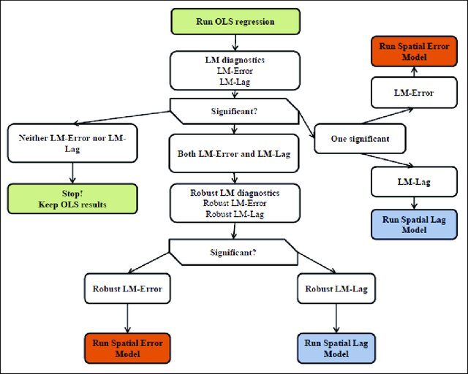

Appendix 6: Characteristics of study participants
Variables | Category | Weighted frequency (%)
Age of respondent | 15-19 | 15,384 (7.66)
Age of respondent | 20_34 | 137,473 (68.42)
Age of respondent | 35_49 | 48,078 (23.93)
Women education level | No education | 69,073 (34.38)
Women education level | Primary | 65,805 (32.75)
Women education level | Secondary and above | 66,057 (32.88)
Sex of household head | Male | 155,900 (77.59)
Sex of household head | Female | 45,034 (22.41)
Marital status | Single | 16,628 (8.28)
Marital status | Married | 169,570 (84.39)
Marital status | Formerly married | 14,737 (7.33)
Wealth index | Poor | 86,341 (42.97)
Wealth index | Middle | 39,996 (19.91)
Wealth index | Rich | 74,598 (37.13)
Place of delivery | Home | 54,553 (27.15)
Place of delivery | Health facility | 146,382 (72.85)
Respondent currently working | Yes | 122,607 (61.02)
Respondent currently working | No | 78,328 (38.98)
Covered by health insurance | Yes | 169,674 (84.44)
Covered by health insurance | No | 31,261 (15.56)
Getting permission to go | Yes | 159,395 (79.33)
Getting permission to go | No | 41,540 (20.67)
Media exposure | Yes | 131,310 (65.35)
Media exposure | No | 69,625 (34.65)
Distance to health facility | Big problem | 82,014 (40.82)
Distance to health facility | Not big problem | 118,921 (59.18)
Place of residence | Urban | 70,716 (35.19)
Place of residence | Rural | 130,219 (64.81)

Appendix 7: Spatial Autocorrelation Report
Moran's Index: | 0.486646
z-score: | 109.135151
p-value: | p < 0.001
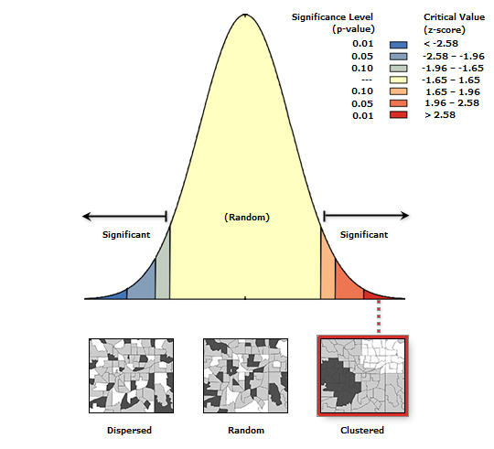
Given the z-score of 109.135151047, there is a less than 1% likelihood that this clustered pattern could be the result of random chance.

Appendix 8: High-Low Clustering Report
Observed General G: | 0.000688
z-score: | 94.819639
p-value: | p < 0.001
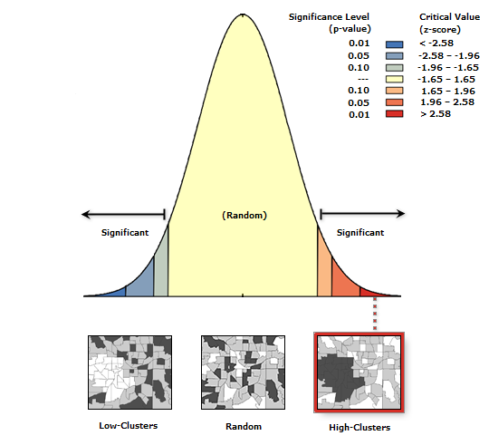
Given the z-score of 94.8196388566, there is a less than 1% likelihood that this high-clustered pattern could be the result of random chance.

LATITUDE | LONGITUDE | RADIUS | NUMBER_LOC | LLR | P_VALUE | REL_RISK
14.033877 | 37.105922 | 2624.510355 | 4699 | 3104.14979 | P_value < 0.01 | 0.497031496
12.999745 | 4.617114 | 524.3453634 | 515 | 1417.857631 | P_value < 0.01 | 0.358908789
25.404782 | -10.743642 | 1029.172561 | 719 | 383.866946 | P_value < 0.01 | 0.399831803
-15.246551 | 39.354509 | 181.2470743 | 74 | 187.1721049 | P_value < 0.01 | 0.342147239
-24.13878 | 44.493452 | 247.0368553 | 81 | 178.2120987 | P_value < 0.01 | 0.341250676
-10.046804 | 18.753719 | 607.8477071 | 386 | 163.7940441 | P_value < 0.01 | 0.62705547
4.994014 | -7.4592005 | 503.6360548 | 852 | 113.5905685 | 0.005 | 0.776746345
-14.336877 | 35.091008 | 46.01409268 | 29 | 88.71987267 | 0.03 | 0.347098518
Appendix 9: Satscan analysis

Notes; LLR stands for log likelihood ratio, REL-RISK denotes relative risk, and NUMBER-LOC stands for number of locations detected

Appendix 10: Model diagnosis for global regression model
Regression Diagnostics
Multicollinarity condition number | 7.14
Test on normality of error
Test | DF | Value | Probability
Jarque bera test | 2 | 0.99 | 0.24
Diagnostic for heteroskedascity
Test | DF | Value | Probability
Breush-Pagan test | 5 | 39262.1 | P <0.01
Koenker Bassett test | 5 | 5841.0 | P <0.01
Diagnostics for spatial dependence
Test | MI/DF | Value | Probability
Moran’s I (error) | 0.4197 | 92.3259 | P <0.01
Lagrange Multiplier (Lag) | 1 | 5593.0 | P <0.01
Robust LM (Lag) | 1 | 123.5 | P <0.01
Lagrange Multiplier (Error) | 1 | 8507.1 | P <0.01
Robust LM (Error) | 1 | 3037.5 | P <0.01
Lagrange Multiplier (SARMA) | 2 | 8630.5 | P <0.01
Notes: Results are obtained from global regression diagnostics in GeoDa. MI = Moran’s I, DF = Degree of freedom

Appendix 11: The effectiveness of global and local regression models in assessing postnatal care utilization in SSA, DHS 2015-2024.
Category | OLS | SLM | SEM | GWR | MGWR
$${Adjusted R}^{2}$$ | 50.1% | 62% | 67% | 68.3 | 82.3
AICc | 52577.6 | 48256 | 46826.8 | 45291.2 | 23175.4
Notes: The findings are derived from both global and local regression models. OLS = Ordinary Least Square, SLM = Spatial Lag Model, SEM = Spatial Error Model, GWR = Geographic Weighted Regression, MGWR = Multi-scale Geographic Weighted Regression.

Appendix 12. Summary Statistics and Bandwidth Parameters of MGWR Coefficient Estimates for Postnatal Care Utilization in Sub-Saharan Africa, DHS 2015–2024
Explanatory variable | Mean | Standard deviation | Minimum | Median | Maximum | Optimal Number of Neighbors | Effective Number of Parameters | P value | t-statistics
Intercept | -0.0228 | 0.3747 | -1.3761 | -0.0784 | 2.1920 | 30 | 1513.62 | P-value <0.001 | 4.1528
No ANC | -0.0600 | 0.1418 | -0.6428 | -0.0507 | 0.3791 | 397 | 64.48 | P-value <0.001 | 3.3622
Secondary and above education | 0.1457 | 0.2914 | -1.5033 | 0.1445 | 1.6902 | 44 | 808.62 | P-value <0.001 | 4.0069
Poor wealth index | 0.2088 | 0.2424 | -1.3488 | 0.1986 | 1.0795 | 72 | 457.35 | P-value <0.001 | 3.8700
Media exposure | 0.2974 | 0.2330 | -0.1732 | 0.2628 | 1.2324 | 127 | 183.97 | P-value <0.001 | 3.6417
Health facility delivery | 0.1431 | 0.1130 | -0.0814 | 0.1323 | 0.3831 | 1358 | 8.81 | P-value <0.01 | 2.7664
 | Optimal number of neighbors |  |  |  | Effective number of parameters
GWR model Result | 4.8 for each independent variables |  |  |  | 217.9 for each independent variables

