Appendix A. Supplementary data

The impact of PM_{2.5} component exposure during early pregnancy on congenital heart disease: Evidence from Guangdong, China
Yanbing Chen^{1†}, Peiming Su^{2,3†}, Qixian Gu³, Huili Wei^{3,4}, Jialing Qiu^{5*}, Guangming Tan^{3**}
¹Medical Genetic Center, Guangdong Women and Children Hospital, 521 Xingnan Road, Panyu District, Guangzhou 511442, China
²School of Public Health, Guangzhou Medical University, 1 Xinzao Road, Xinzao Town, Panyu District, Guangzhou 511436, China
³Department of Medical Information and Statistics, Guangdong Women and Children Hospital, 521 Xingnan Road, Panyu District, Guangzhou 511442, China
⁴Department of Public Health and Preventive Medicine, School of Medicine, Jinan University, Guangzhou 510632, China
⁵Department of Human Resources, Guangdong Women and Children Hospital, 521 Xingnan Road, Panyu District, Guangzhou 511442, China
* Correspondence: qiujialingcn@126.com (J. Q.), guangmingtannhh@163.com (G. T.)
† These authors contributed equally to this work.

Contents of this file

Table S1
Figure S1

Table S1 Logistic regression analysis of PM_{2.5} components and congenital heart disease in different pregnancy periods (excluding stillbirths)
Gestational weeks | OM | $${SO}_{4}^{2−}$$ | $${NO}_{3}^{−}$$ | $${NH}_{4}^{+}$$ | BC
Gestational weeks | OR [95% CI] | OR [95% CI] | OR [95% CI] | OR [95% CI] | OR [95% CI]
1 | 1.94(1.90-1.97) | 2.29(2.25-2.34) | 1.64(1.60-1.68) | 1.49(1.45-1.53) | 1.97(1.94-2.00)
2 | 1.91(1.88-1.95) | 2.29(2.25-2.33) | 1.61(1.57-1.65) | 1.48(1.44-1.51) | 1.97(1.93-2.00)
3 | 1.88(1.84-1.91) | 2.26(2.22-2.30) | 1.57(1.54-1.61) | 1.45(1.41-1.49) | 1.95(1.92-1.98)
4 | 1.82(1.79-1.86) | 2.20(2.16-2.24) | 1.52(1.48-1.55) | 1.40(1.36-1.44) | 1.90(1.87-1.94)
5 | 1.77(1.74-1.80) | 2.12(2.08-2.16) | 1.47(1.44-1.51) | 1.35(1.31-1.38) | 1.85(1.82-1.89)
6 | 1.76(1.73-1.80) | 2.11(2.07-2.15) | 1.48(1.44-1.51) | 1.34(1.30-1.37) | 1.84(1.81-1.87)
7 | 1.74(1.71-1.77) | 2.06(2.03-2.10) | 1.46(1.42-1.49) | 1.33(1.30-1.36) | 1.80(1.78-1.83)
8 | 1.74(1.71-1.77) | 2.05(2.01-2.08) | 1.45(1.41-1.48) | 1.33(1.30-1.37) | 1.82(1.79-1.85)
9 | 1.72(1.69-1.75) | 2.03(1.99-2.06) | 1.40(1.36-1.43) | 1.28(1.25-1.31) | 1.81(1.78-1.84)
10 | 1.68(1.65-1.71) | 2.00(1.96-2.03) | 1.34(1.31-1.37) | 1.23(1.19-1.26) | 1.78(1.75-1.81)
11 | 1.71(1.69-1.75) | 2.07(2.03-2.11) | 1.38(1.35-1.41) | 1.27(1.24-1.30) | 1.83(1.80-1.86)
12 | 1.76(1.72-1.79) | 2.14(2.10-2.18) | 1.38(1.35-1.41) | 1.27(1.24-1.30) | 1.88(1.85-1.91)
*OM: organic matter; ${SO}_{4}^{2−}$: sulfate;${NO}_{3}^{−}$: nitrate; ${NH}_{4}^{+}$: ammonium; BC: black carbon. All the above models were adjusted according to the age of the mother, gravidity, parity, neonatal gender, gestational age, conception season and temperature

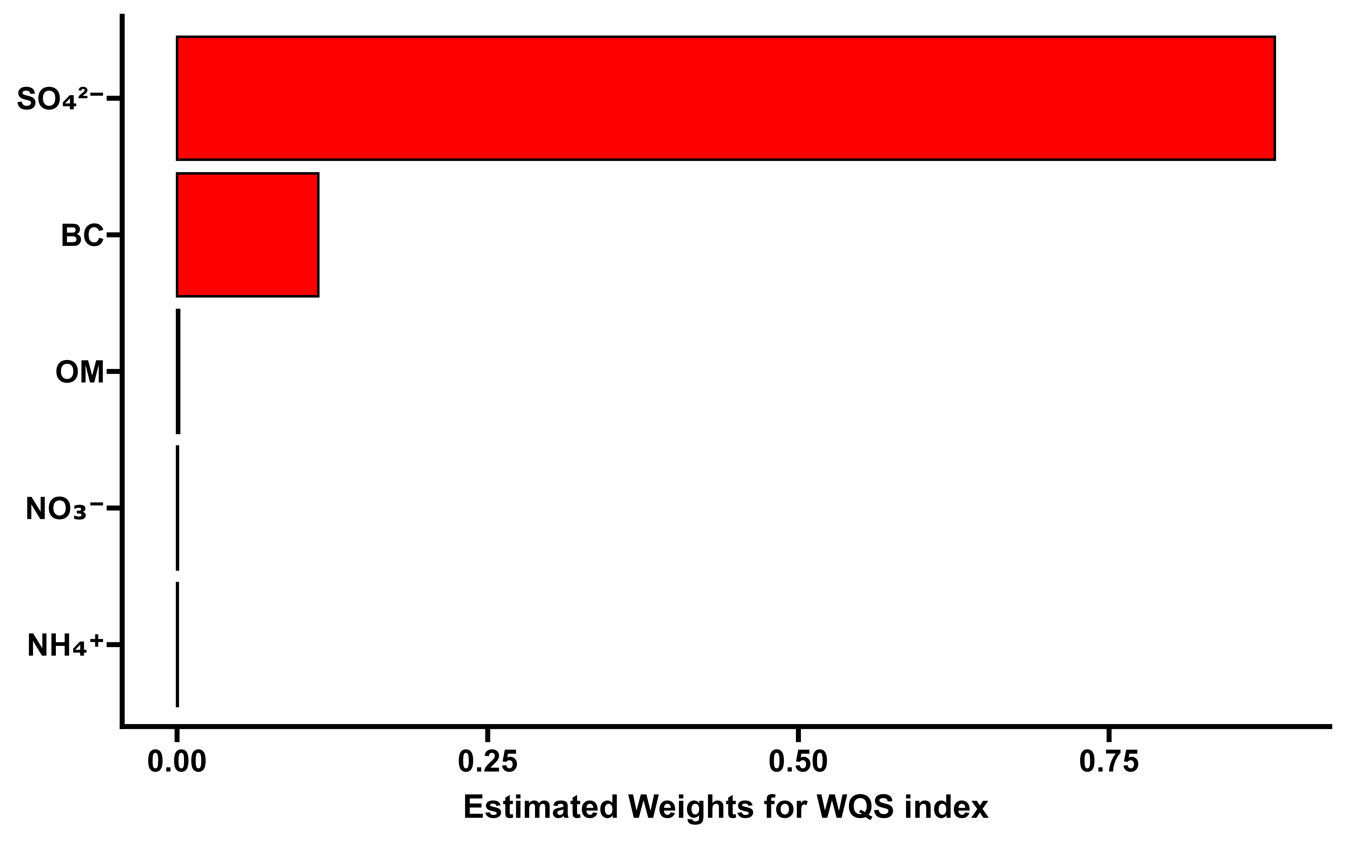
Fig. S1 The contribution weights of the five main components of PM_{2.5} to the overall effect on congenital heart disease.

