Global Metabolomic Profiling of Serum Biomarkers in Women with Polycystic Ovary Syndrome
Jalpa Patel¹, Hiral Chaudhary¹, Sonal Panchal², Rushikesh Joshi¹*
¹Department of Biochemistry and Forensic Science, University School of Sciences, Gujarat University, Ahmedabad-380009, Gujarat, India.
²Dr. Nagori's Institute for Infertility and IVF, Ahmedabad, Gujarat, India.

*Correspondence:
Dr. Rushikesh Joshi,
Assistant Professor,
Department of Biochemistry & Forensic Science,
University School of Sciences,
Gujarat University, Ahmedabad-380009, India.
Email ID: rushikeshjoshi@gujaratuniversity.ac.in
Supplementary Figure S1. Heatmap of differential serum metabolites between PCOS and control groups.
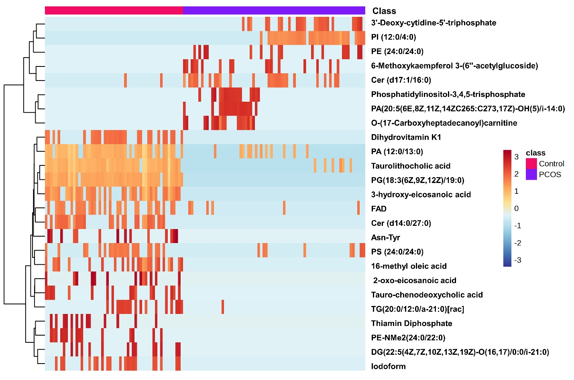
Legend: Hierarchical clustering heatmap of significantly altered serum metabolites. Rows represent metabolites and columns represent individual serum samples. Colors indicate relative abundance (red, high; blue, low).

