Detection of early-stage lung adenocarcinoma using a novel extracellular vesicle and particle-based blood test

Authors: Ibukunoluwapo O. Zabroski¹, Daniel P. Salem¹*, Aaron Chevalier¹, Timothy Santos-Heiman¹, Nina A. Insixiengmay¹, Brittany Grimes¹, Katherine S. Yang¹, Gabrielle N. Barcaskey¹, MacKenzie S. King¹, Syrena C. Fernandes¹, Troy B. Hawkins¹, Michael J. Smith¹, Brendan J. Manning¹, Dawn R. Mattoon¹, Toumy Guettouche¹*
¹Mercy BioAnalytics, Inc., Waltham, MA, USA
*Corresponding authors (email: daniel@mercybio.com and toumy@mercybio.com)

Supplemental Figures

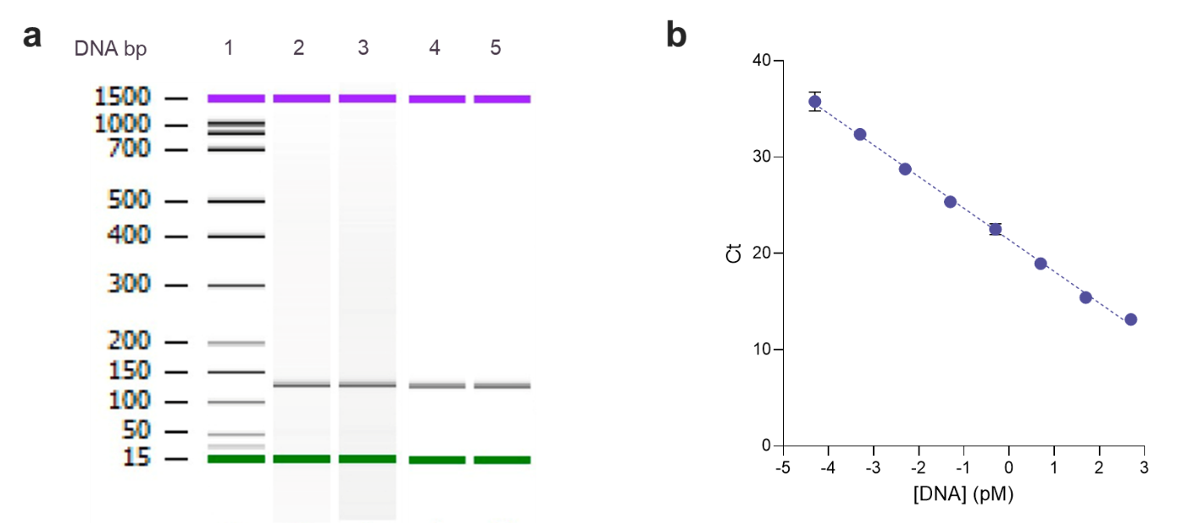
Figure S1. Characterization of assay amplicon. (a) Characterization of amplicon length using capillary electrophoresis. Lane 1: DNA ladder, Lanes 2 & 3: technical replicates of amplicon generated from solution-phase testing, Lanes 4 & 5: technical replicates of amplicon generated from the complete assay workflow. (b) Amplicon standard curve (slope = -3.28, R² = 0.998, qPCR efficiency = 101.8%).

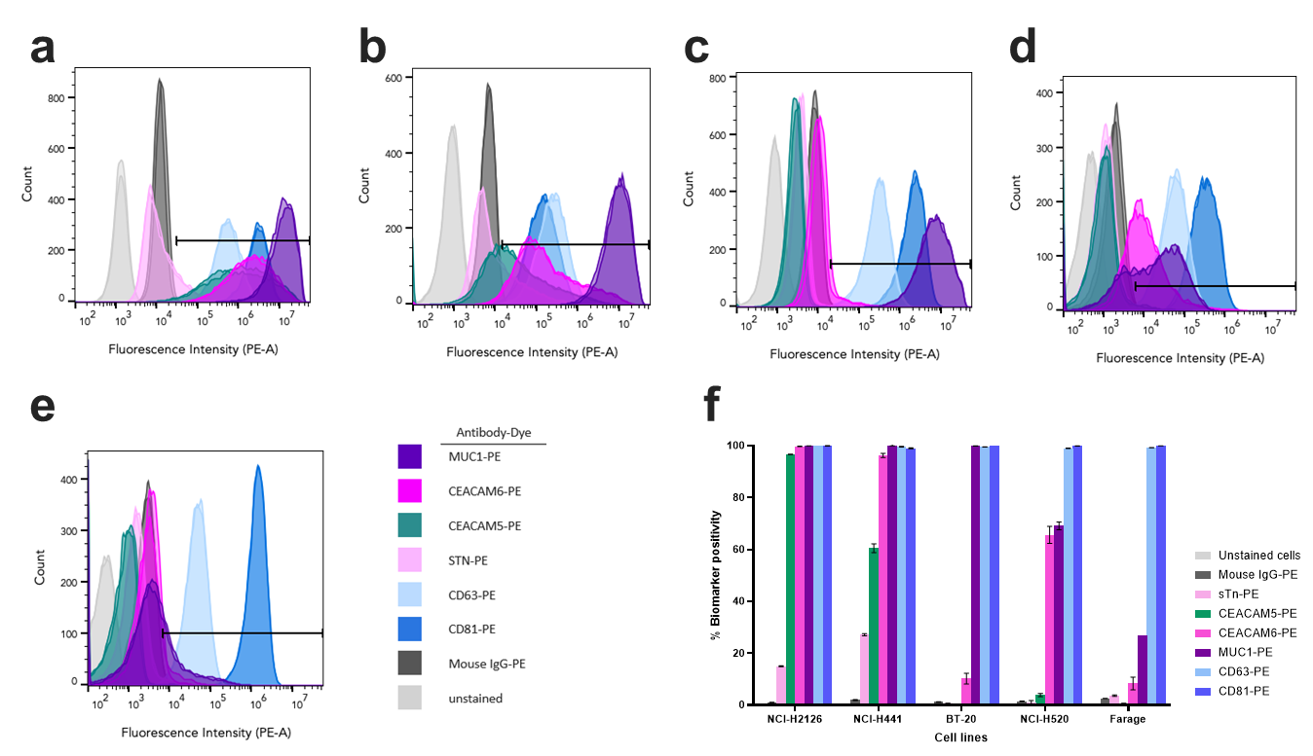
Figure S2. Characterization of biomarker expression in cell lines using cell flow cytometry. Histograms of biomarker expression for (a) NCI-H2126, (b) NCI-H441, (c) BT-20, (d) NCI-H520, and (e) Farage cell lines. (f) Percentage of biomarker-positive cells for each biomarker of interest. Unstained cells and Mouse IgG were included as controls.

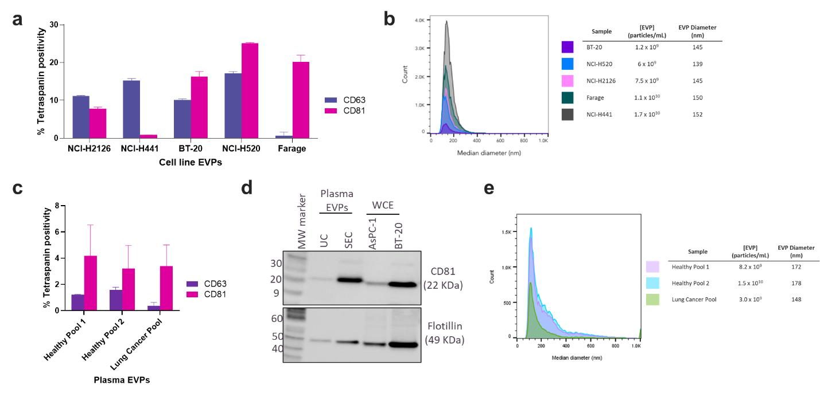
Figure S3. Characterization cell line-derived and plasma-derived EVPs. (a) Expression of CD63 and CD81 in cell line EVPs as measured by EVP flow cytometry. (b) Overlay of EVP particle size distributions for five different cell lines using EVP flow cytometry. (c) Expression of CD63 and CD81 in plasma-derived EVPs (two healthy pools, one lung cancer pool) as measured by EVP flow cytometry. (d) Western blot analysis of healthy plasma EVPs isolated by ultracentrifugation (UC) and SEC demonstrating the presence of canonical EV markers CD81 and Flotillin. Whole cell extracts (WCE) from AsPC-1 and BT-20 were included as controls for biomarker expression and biotinylated molecular weight (MW) markers were used to determine apparent molecular mass. (e) Overlay of EVP particle size distributions for three different plasma samples (two healthy pools, one lung cancer pool) using EVP flow cytometry.

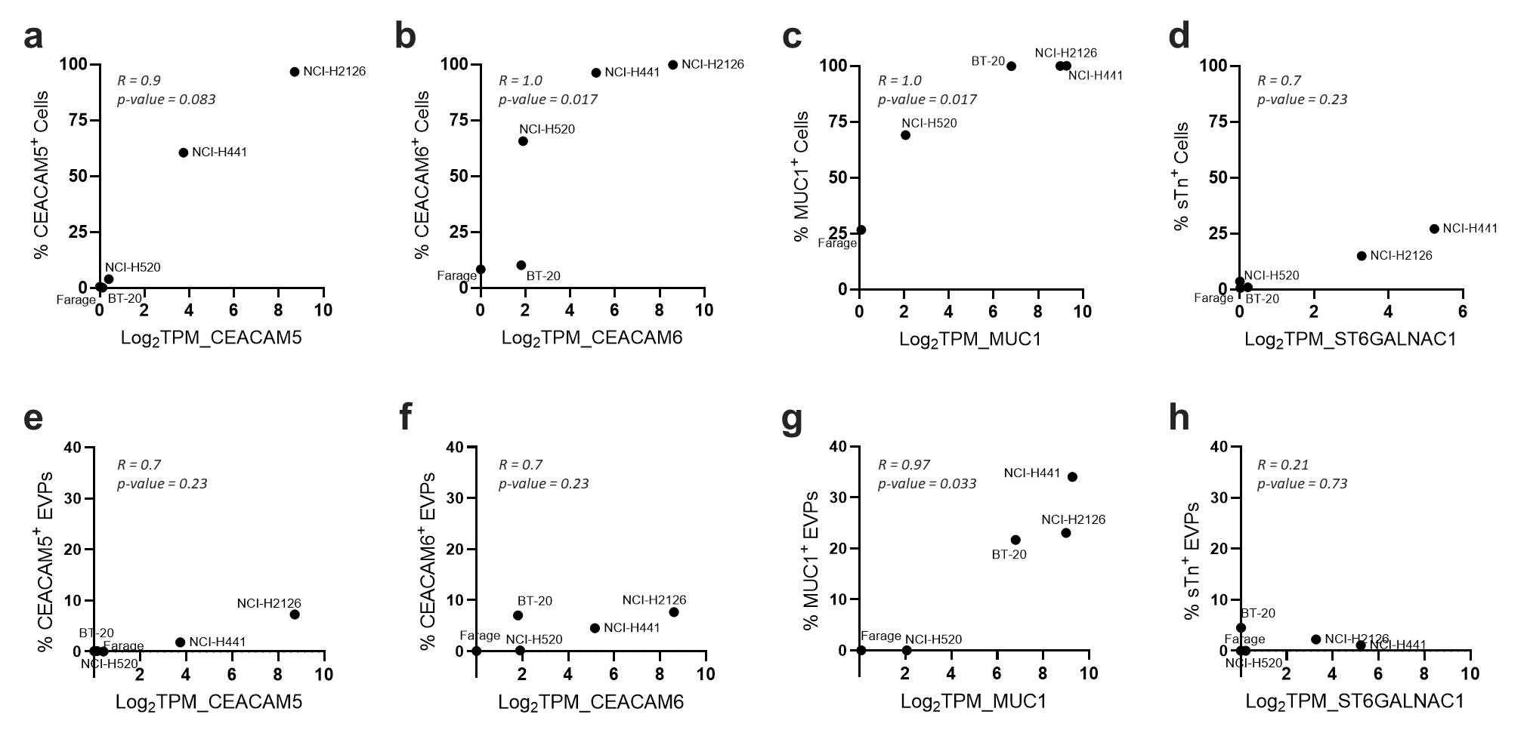
Figure S4. Correlation between gene expression and cell protein expression for (a) CEACAM5, (b) CEACAM6, (c) MUC1, and (d) sTn as measured by flow cytometry in five different cancer cell lines. Gene expression represented as log2(transcripts per million (TPM)) and cell protein expression represented as percentage of biomarker-positive cells. Correlation between gene expression and EVP protein expression for (e) CEACAM5, (f) CEACAM6, (g) MUC1, and (h) sTn as measured by EVP flow cytometry in five different cancer cell lines. EVP protein expression represented as percentage of biomarker-positive EVPs. ST6GALNAC1 used as a surrogate for sTn gene expression. Spearman correlation coefficients and associated p-values are shown on all plots.

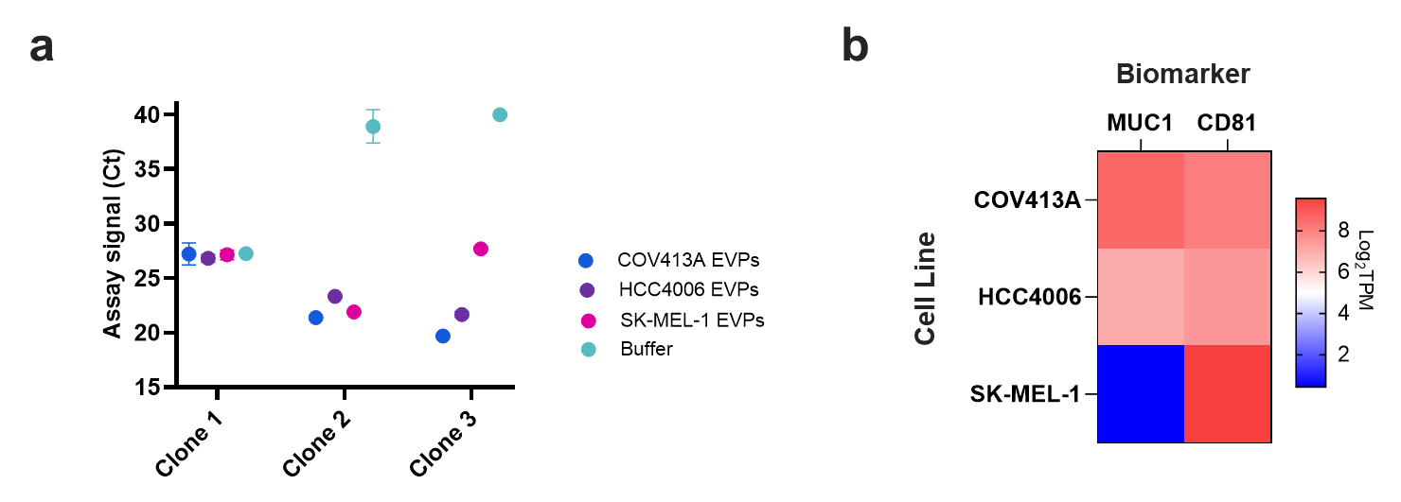
Figure S5. Evaluation of antibody functionality and specificity in cell line-derived EVPs. (a) Performance of three different monoclonal antibody clones against MUC1. Antibodies were screened for their ability to capture MUC1-positive (COV413A, HCC4006) or MUC1-negative (SK-MEL-1) EVPs, and captured EVPs were interrogated using anti-CD81 detection antibodies. (b) Heat map representing gene expression levels for MUC1 and CD81 across all cell lines. Gene expression represented as log2(transcripts per million (TPM)).

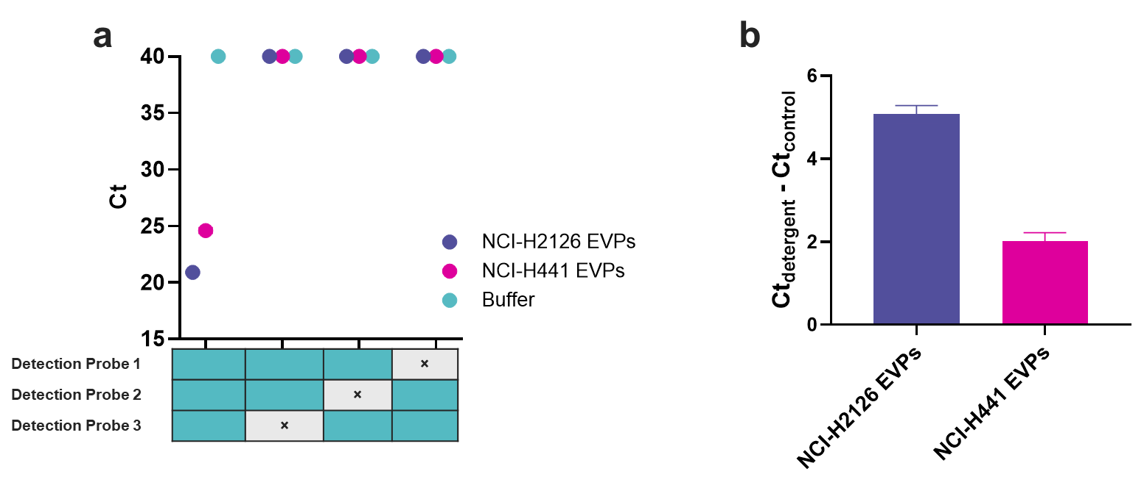
Figure S6. Demonstration of assay functionality using the lung cancer biomarker combination CEACAM5/CEACAM6/MUC1/sTn in cell line EVPs. (a) Assay signal from NCI-H2126 EVPs (purple), NCI-H441 EVPs (magenta), and Buffer (teal). Heat map indicates the detection probes added to each reaction mixture. Data are represented as mean ± SD of four technical replicates. (b) Reduction in assay signal following detergent exposure of captured NCI-H2126 EVPs and NCI-H441 EVPs. Data are represented as mean ± SD of four technical replicates.

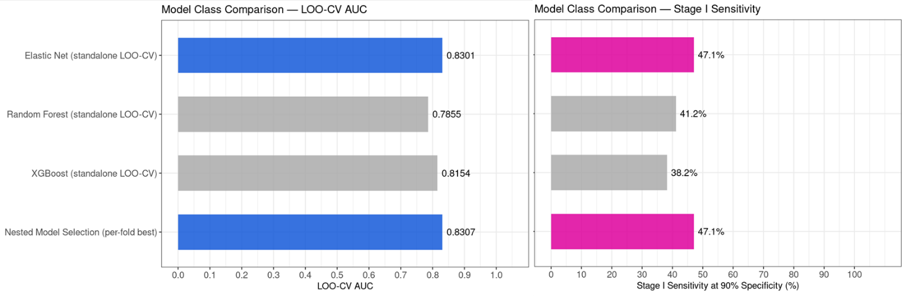
Figure S7. Model evaluation and selection during cross-validation. Comparison of standalone Elastic Net, Random Forest, and XGBoost model performance using leave-one-out cross-validation (LOO-CV) versus a nested selection approach. Elastic Net was selected as the best performing model in 100% of folds based on maximizing (left) AUC and (right) stage I sensitivity at 90% specificity.

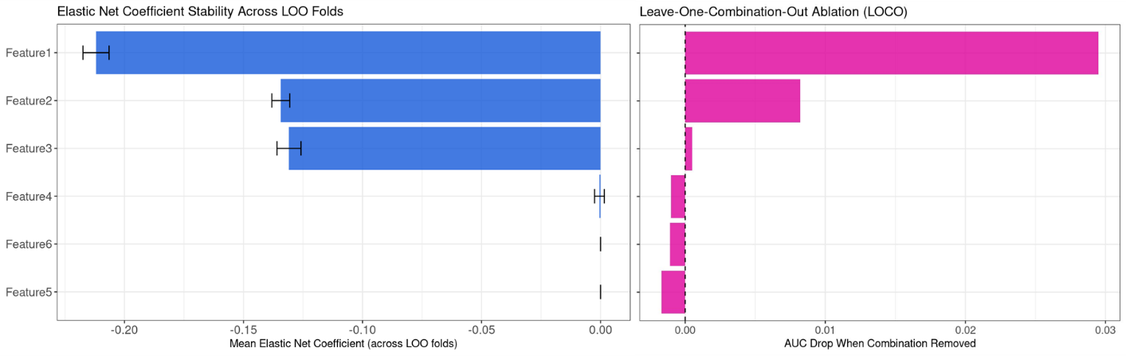
Figure S8. Feature coefficient stability and importance in the Elastic Net model. (left) Feature coefficient stability across folds during leave-one-out (LOO) cross-validation and (right) leave-one-combination-out (LOCO) retraining of the complete dataset.

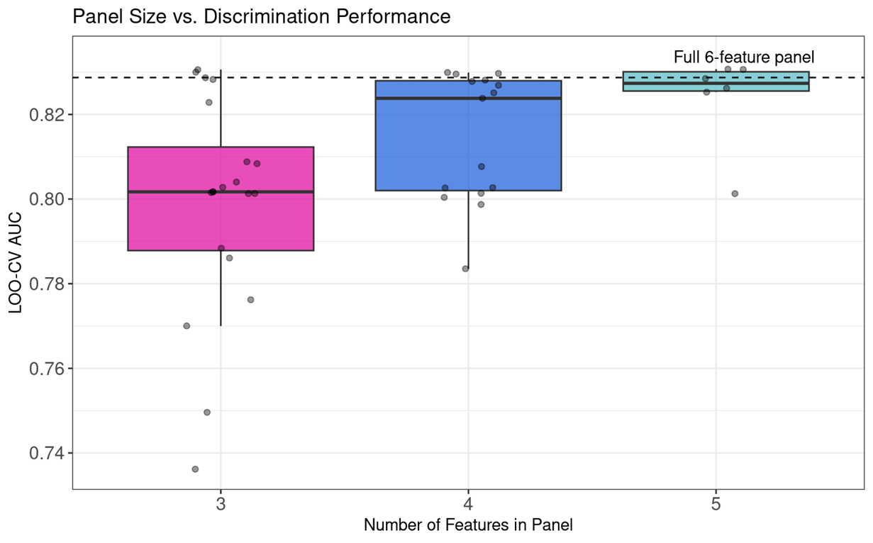
Figure S9. Panel size and model stability. Comparison of model discrimination performance (AUC) across sub-panels of three, four, or five biomarker combinations. Dotted line denotes the performance of the six-combination panel evaluated in this study.

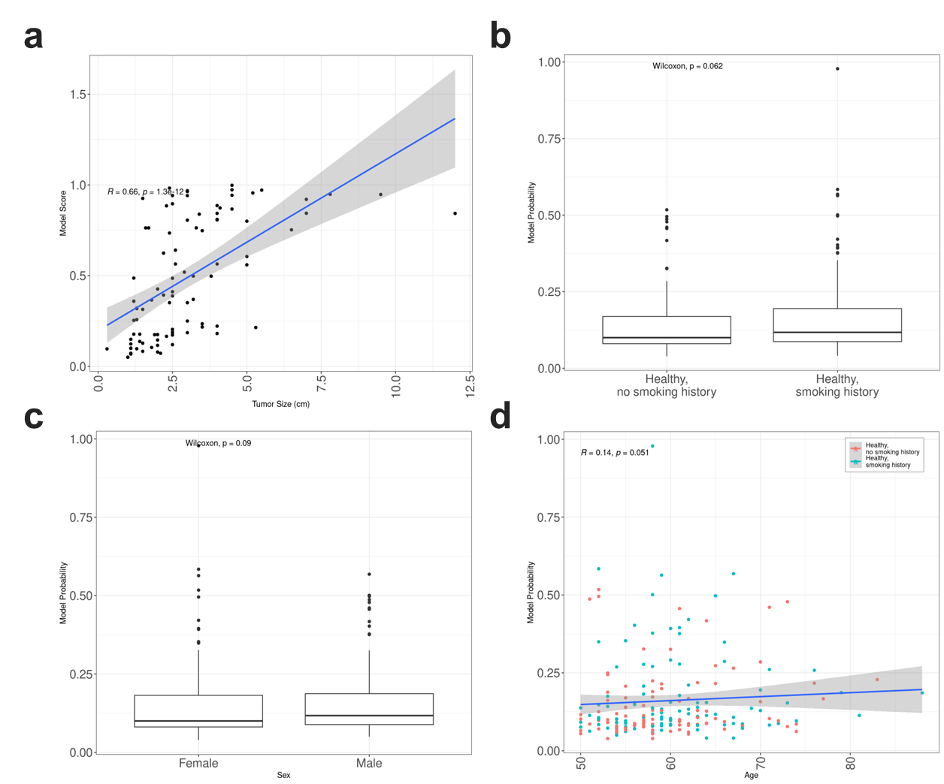
Figure S10. Correlation between assay signal and select clinical covariates. (a) Assay signal versus greatest tumor dimension among all LUAD cases with tumor sizing information available. (b) Comparison of assay signal across healthy individuals with/without a history of smoking. (c) Comparison of assay signal versus donor sex for healthy individuals with/without a history of smoking. (d) Assay signal versus donor age for healthy individuals with/without a history of smoking.

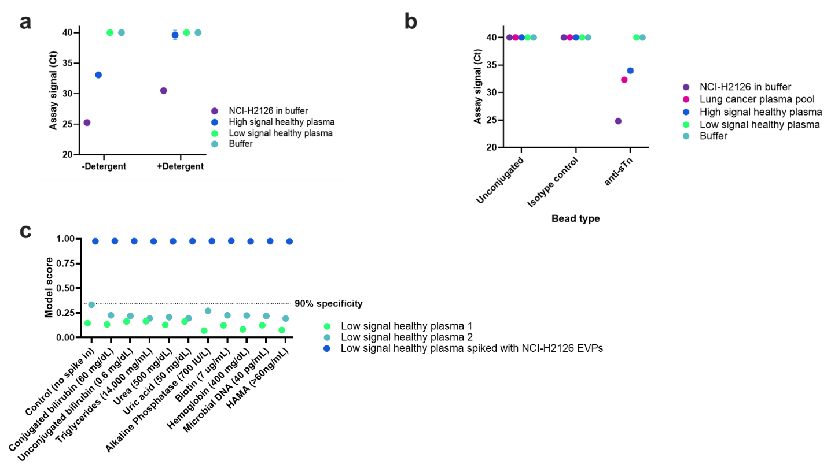
Figure S11. Characterization of healthy background signal. (a) Impact of detergent exposure on assay signal for EVPs derived from NCI-H2126 cells (purple), a representative high-signal healthy plasma sample (blue), a representative low-signal healthy plasma sample (green), and buffer only (teal) using the lung cancer biomarker combination CEACAM5/CEACAM6/MUC1/sTn. Data are represented as mean ± SD of four technical replicates. (b) Impact of capture bead on assay signal using the detection marker set, CEACAM5/CEACAM6/MUC1. Capture beads included unconjugated beads, mouse isotype control-functionalized beads, and anti-sTn-functionalized beads. Unconjugated beads were Tris-quenched prior to testing. Data are represented as mean ± SD of four technical replicates. (c) Impact of common endogenous interfering substances on assay signal for two low-signal healthy plasma samples and one healthy plasma sample spiked with NCI-H2126 EVPs.

