Supplementary Table 1. Characteristics of the Selected Randomized Controlled Trials
Author, year | Group | n | Age, mean (SD) | Severity (Quinnell grading) | Intervention | Follow-up | Measurement of disease severity
Abdoli et al., 2021¹⁹ | CI + LI | 40 | 52.54 (11.45) | I–IV | 0.9 mL of lidocaine + 1 mL of methylprednisolone | 6 weeks and 24 weeks after the intervention | Quinnell grading
Abdoli et al., 2021¹⁹ | PR | 43 | 52.54 (11.45) | I–IV | Percutaneous A1 pulley release | 6 weeks and 24 weeks after the intervention | Quinnell grading
Atthakomol et al., 2023²⁰ | CI + LI | 40 | 54 (12) | I–III | 1 mL of 1% lidocaine + 1 mL of triamcinolone acetonide (10 mg/mL) | 12 and 52 weeks after the intervention | MHQ
Atthakomol et al., 2023²⁰ | SPL | 43 | 56 (14) | I–III | A volar, hand-based, off-the-shelf splint applied to the affected finger at least 8 hours per day for 6 consecutive weeks | 12 and 52 weeks after the intervention | MHQ
Atthakomol et al., 2023²⁰ | CI + LI + SPL | 37 | 57 (10) | I–III | 1 mL of 1% lidocaine + 1 mL of triamcinolone acetonide (10 mg/mL) with a volar, hand-based, off-the-shelf splint applied to the affected finger at least 8 hours per day for 6 consecutive weeks | 12 and 52 weeks after the intervention | MHQ
Callegari et al., 2012²¹ | CI + LI + HAI | 15 | 52.5 (mean) | II and III | Methylprednisolone acetate (40 mg/mL) + 0.8 mL of lidocaine + 1 mL of 0.8% hyaluronic acid | 24 weeks after the intervention | DASH
Callegari et al., 2012²¹ | OS | 15 | 52.5 (mean) | II and III | Open A1 pulley release | 24 weeks after the intervention | DASH
Chao et al., 2009²² | PR | 46 | 48 (27–65), mean (range) | III and V | Percutaneous A1 pulley release | 4 and 48 weeks after the intervention | Pain
Chao et al., 2009²² | CI | 47 | 49 (28–72), mean (range) | III and V | 1 mL of triamcinolone acetonide (10 mg/mL) | 4 and 48 weeks after the intervention | Pain
Chen et al., 2021²³ | HI-ESWT | 20 | 56.2 (8.9) | II | Focused shockwaves with 1,500 impulses at an energy flux density of 0.01 mJ/mm² (5.8 bar) once per week for 4 weeks | 12 and 24 weeks after the intervention | qDASH
Chen et al., 2021²³ | MI-ESWT | 20 | 55.6 (7.3) | II | 1,500 impulses of focused shockwaves at an energy flux density of 0.006 mJ/mm² (3 bar) once per week for 4 weeks | 12 and 24 weeks after the intervention | qDASH
Choi et al., 2025²⁴ | CI + HTP | 38 | 61.0 (8.8) | I and III | Corticosteroid injection + hand therapy program twice per day for 8 weeks | 24 weeks after the intervention | Quinnell grading
Choi et al., 2025²⁴ | CI | 38 | 63.1 (8.3) | I and III | Corticosteroid injection | 24 weeks after the intervention | Quinnell grading
Dierks et al., 2008²⁵ | OS | 16 | 64 (13) | N/A | Open A1 pulley release | 12 weeks after the intervention | Pain
Dierks et al., 2008²⁵ | PR | 20 | 62 (10) | N/A | Percutaneous A1 pulley release | 12 weeks after the intervention | Pain
Guillermo et al., 2023³⁵ | PR | 42 | 60.1 (33–86), mean (range) | III (Froimson’s classification) | Percutaneous A1 pulley release | 12 and 48 weeks after the intervention | qDASH
Guillermo et al., 2023³⁵ | OS | 42 | 60.4 (32–83), mean (range) | III (Froimson’s classification) | Open A1 pulley release | 12 and 48 weeks after the intervention | qDASH
Jami et al., 2020²⁶ | CI | 42 | 53 (7) | I–III | Methylprednisolone injection | 12 and 48 weeks after the intervention | Quinnell grading
Jami et al., 2020²⁶ | NSAIDsI | 42 | 52 (9) | I–III | Diclofenac injection | 12 and 48 weeks after the intervention | Quinnell grading
Jegal et al., 2018²⁷ | PR + CI | 45 | 58 (7.6) | III–VI | Percutaneous A1 pulley release + 0.5 mL of 40 mg/mL triamcinolone acetonide injection | 12 weeks after the intervention | Modified Quinnell grading
Jegal et al., 2018²⁷ | PR | 46 | 58 (7.4) | III–VI | Percutaneous A1 pulley release | 12 weeks after the intervention | Modified Quinnell grading
Kanchanathepsak et al., 2020²⁸ | CI | 33 | 54.7 (11.0) | I–III | 1 mL of triamcinolone acetate (10 mg/mL) | 12 and 24 weeks after the intervention | Quinnell grading
Kanchanathepsak et al., 2020²⁸ | HAI | 33 | 58.3 (11.2) | I–III | 1 ml of low-molecular-weight hyaluronic acid | 12 and 24 weeks after the intervention | Quinnell grading
Kwang et al., 2018²⁹ | PR | 17 | 52.4 (11.4) | II–IV | Percutaneous A1 pulley release | 12 and 24 weeks after the intervention | DASH
Kwang et al., 2018²⁹ | OS | 15 | 53.1 (9.22) | II–IV | Open A1 pulley release | 12 and 24 weeks after the intervention | DASH
Lan et al., 2023³⁰ | PR | 42 | 53.24 (12.87) | II–IV | Percutaneous A1 pulley release | 4 and 24 weeks after the intervention | Quinnell grading
Lan et al., 2023³⁰ | OS | 30 | 51.58 (13.74) | II–IV | Open A1 pulley release | 4 and 24 weeks after the intervention | Quinnell grading
Leow et al., 2018³¹ | CI + LI | 62 | 60 (44–87), mean (range) | I–III | 0.5 mL of triamcinolone acetonide (10 mg/mL) + 0.5 mL of 1% lidocaine (10 mg/mL) | 12 and 24 weeks after the intervention | Quinnell grading
Leow et al., 2018³¹ | NSAIDsI + LI | 59 | 60 (44–87), mean (range) | I–III | 0.5 mL of ketorolac trometamol (30 mg/mL) + 0.5 mL of 1% lidocaine (10 mg/mL) | 12 and 24 weeks after the intervention | Quinnell grading
Liu et al., 2015³² | CI | 17 | 65.8 (11.8) | ≥I | 1 mL of 10 mg/mL triamcinolone acetonide | 12 weeks after the intervention | MHQ
Liu et al., 2015³² | HAI | 19 | 60.4 (13.6) | ≥I | 1 mL of hyaluronic acid | 12 weeks after the intervention | MHQ
Nadar et al., 2023³³ | HTP | 27 | 59.30 (7.21) | II and III (Green grade) | Hand therapy program (1 session of therapy per week for 6 consecutive weeks) | 12 weeks after the intervention | DASH
Nadar et al., 2023³³ | HTP + SPL | 28 | 60.68 (5.98) | II and III (Green grade) | A PIP joint splint + hand therapy program (1 session of therapy per week for 6 consecutive weeks) | 12 weeks after the intervention | DASH
Ranjeet et al., 2018³⁴ | PR | 28 | 55.8 | II–IV (Green grade) | Percutaneous A1 pulley release | 8 weeks after the intervention | Pain
Ranjeet et al., 2018³⁴ | OS | 28 | 55.8 | II–IV (Green grade) | Open A1 pulley release | 8 weeks after the intervention | Pain
Saito et al., 2023³⁶ | OS + HTP | 28 | 65.1 | I–III | Open A1 pulley release + hand therapy program within a week of the procedure | 24 weeks after the intervention | DASH
Saito et al., 2023³⁶ | OS | 29 | 67.8 | I–III | Open A1 pulley release | 24 weeks after the intervention | DASH
Salim et al., 2011³⁷ | HTP | 35 | 58.9 | <III | 10 sessions of hand therapy | 6 weeks after the intervention | Pain
Salim et al., 2011³⁷ | CI + LI | 39 | 58.9 | <III | 1 mL of triamcinolone acetonide + 1 mL of 2% lidocaine | 6 weeks after the intervention | Pain
Shakeel et al., 2012³⁸ | CI | 50 | 57 (40–71), mean (range) | II–IV | 0.5 mL of triamcinolone acetonide (20 mg) | 3 weeks after the intervention | Quinnell grading
Shakeel et al., 2012³⁸ | NSAIDsI | 50 | 58 (40–75), mean (range) | II–IV | 0.5 mL of diclofenac sodium (12.5 mg) | 3 weeks after the intervention | Quinnell grading
Tajik et al., 2022³⁹ | CI + LI | 30 | 41.3 (7.4) | N/A | 40 mg of methylprednisolone + 0.5 mL of lidocaine | 12 weeks after the intervention | Pain
Tajik et al., 2022³⁹ | CI + LI + SPL | 30 | 41.7 (7.8) | N/A | 40 mg of methylprednisolone + 0.5 mL of lidocaine + splint | 12 weeks after the intervention | Pain
Xie et al., 2019⁴⁰ | PR | 46 | 45.38 (10.77) | ≥II | Percutaneous A1 pulley release | 4 and 24 weeks after the intervention | Quinnell grading
Xie et al., 2019⁴⁰ | OS | 43 | 47.44 (11.83) | ≥II | Open A1 pulley release | 4 and 24 weeks after the intervention | Quinnell grading
Yang et al., 2019⁴¹ | PR | 35 | 64 (4.6) | II and III | Percutaneous A1 pulley release | 12 and 24 weeks after the intervention | Range of motion of the PIP joint
Yang et al., 2019⁴¹ | PR + SPL | 30 | 63.7 (5.8) | II and III | Percutaneous A1 pulley release + splint | 12 and 24 weeks after the intervention | Range of motion of the PIP joint
Yildirim et al., 2016⁴² | CI + LI | 20 | 54 (9) | II | 0.5 mL of betamethasone + 0.5 mL of 2% lidocaine | 12 and 24 weeks after the intervention | qDASH
Yildirim et al., 2016⁴² | MI-ESWT | 20 | 55 (8) | II | 1,000 shocks at an energy flux density of 2.1 bar (frequency: 15 Hz) for 3 sessions (1-week interval between the sessions) | 12 and 24 weeks after the intervention | qDASH
CI, corticosteroid injection; DASH, Disabilities of the Arm, Shoulder, and Hand; HAI, hyaluronic acid injection; HI-ESWT, high-intensity extracorporeal shockwave therapy; HTP, hand therapy program; LI, lidocaine injection; MHQ, Michigan Hand Outcomes Questionnaire; MI-ESWT, moderate-intensity extracorporeal shockwave therapy; N/A, not applicable; NSAIDsI, NSAID injection; OS, open surgery; PIP, proximal interphalangeal; PR, percutaneous release; qDASH, Quick Disabilities of the Arm, Shoulder, and Hand; RCT, randomized controlled trial; SD, standard deviation; SPL, splint.

Supplementary Table 2. Network Meta-Analysis Results for Disease Severity Associated With Different Interventions in the Short-Term Assessment
Pairwise meta-analysis
CI | — | −0.68 [−2.18; 0.81] | −1.29 [−2.76; 0.18] | — | — | — | — | — | — | — | −2.82 [−4.93; −0.71] | — | — | —
−0.74 [−3.73; 2.25] | PRSPL | — | — | — | — | — | — | — | — | — | −2.08 [−4.20; 0.04] | — | — | —
−0.68 [−2.18; 0.81] | 0.06 [−3.28; 3.40] | HAI | — | — | — | — | — | — | — | — | — | — | — | —
−1.29 [−2.76; 0.18] | −0.55 [−3.88; 2.78] | −0.61 [−2.71; 1.49] | NSAIDsI | — | — | — | — | — | — | — | — | — | — | —
−1.67 [−4.98; 1.64] | −0.93 [−4.25; 2.38] | −0.99 [−4.62; 2.64] | −0.38 [−4.00; 3.24] | CILISPL | — | — | −0.57 [−2.04; 0.91] | — | — | −0.60 [−2.68; 1.48] | — | — | — | —
−2.10 [−6.31; 2.12] | −1.36 [−5.58; 2.87] | −1.41 [−5.89; 3.06] | −0.81 [−5.27; 3.66] | −0.42 [−3.77; 2.92] | HIESWT | −0.05 [−2.17; 2.07] | — | — | — | — | — | — | — | —
−2.14 [−5.79; 1.50] | −1.40 [−5.05; 2.24] | −1.46 [−5.40; 2.48] | −0.85 [−4.78; 3.08] | −0.47 [−3.06; 2.11] | −0.05 [−2.17; 2.07] | MIESWT | −0.09 [−2.22; 2.03] | — | — | — | — | — | — | —
−2.24 [−5.20; 0.72] | −1.50 [−4.46; 1.47] | −1.56 [−4.87; 1.76] | −0.95 [−4.25; 2.36] | −0.57 [−2.04; 0.91] | −0.14 [−3.14; 2.86] | −0.09 [−2.22; 2.03] | CILI | — | — | −0.53 [−2.61; 1.54] | −0.58 [−2.66; 1.49] | −1.14 [−3.22; 0.95] | −1.21 [−3.28; 0.85] | —
−2.40 [−6.59; 1.79] | −1.66 [−5.85; 2.54] | −1.72 [−6.17; 2.73] | −1.11 [−5.55; 3.33] | −0.73 [−4.04; 2.59] | −0.30 [−4.52; 3.92] | −0.25 [−3.90; 3.39] | −0.16 [−3.13; 2.81] | HTPSPL | — | — | — | −0.97 [−3.08; 1.13] | — | —
−2.51 [−5.46; 0.45] | −1.77 [−4.73; 1.20] | −1.82 [−5.14; 1.49] | −1.22 [−4.52; 2.09] | −0.83 [−4.12; 2.45] | −0.41 [−4.61; 3.79] | −0.36 [−3.98; 3.26] | −0.27 [−3.20; 2.67] | −0.11 [−4.28; 4.06] | PRCI | — | −0.31 [−2.39; 1.76] | — | — | —
−2.52 [−6.06; 1.02] | −1.78 [−5.33; 1.77] | −1.84 [−5.68; 2.01] | −1.23 [−5.07; 2.60] | −0.85 [−2.80; 1.09] | −0.43 [−4.00; 3.15] | −0.38 [−3.26; 2.50] | −0.28 [−2.23; 1.66] | −0.12 [−3.67; 3.42] | −0.02 [−3.54; 3.50] | SPL | — | — | — | —
−2.82 [−4.93; −0.71] | −2.08 [−4.20; 0.04] | −2.14 [−4.72; 0.45] | −1.53 [−4.10; 1.04] | −1.15 [−3.70; 1.40] | −0.72 [−4.38; 2.93] | −0.68 [−3.65; 2.29] | −0.58 [−2.66; 1.49] | −0.42 [−4.04; 3.20] | −0.31 [−2.39; 1.76] | −0.30 [−3.14; 2.55] | PR | — | — | −0.99 [−1.86; −0.13]
−3.37 [−7.00; 0.25] | −2.63 [−6.26; 1.00] | −2.69 [−6.61; 1.23] | −2.08 [−5.99; 1.83] | −1.70 [−4.26; 0.86] | −1.28 [−4.93; 2.38] | −1.23 [−4.21; 1.75] | −1.14 [−3.22; 0.95] | −0.97 [−3.08; 1.13] | −0.87 [−4.47; 2.73] | −0.85 [−3.71; 2.00] | −0.55 [−3.50; 2.39] | HTP | — | —
−3.45 [−7.06; 0.16] | −2.71 [−6.33; 0.90] | −2.77 [−6.68; 1.14] | −2.16 [−6.06; 1.74] | −1.78 [−4.32; 0.76] | −1.36 [−5.00; 2.29] | −1.31 [−4.27; 1.65] | −1.21 [−3.28; 0.85] | −1.05 [−4.67; 2.56] | −0.95 [−4.54; 2.64] | −0.93 [−3.77; 1.91] | −0.63 [−3.56; 2.30] | −0.08 [−3.02; 2.86] | NSAIDsILI | —
−3.81 [−6.09; −1.53] | −3.07 [−5.36; −0.78] | −3.13 [−5.86; −0.40] | −2.52 [−5.24; 0.19] | −2.14 [−4.83; 0.55] | −1.72 [−5.47; 2.04] | −1.67 [−4.76; 1.42] | −1.57 [−3.82; 0.68] | −1.41 [−5.14; 2.31] | −1.31 [−3.55; 0.94] | −1.29 [−4.26; 1.68] | −0.99 [−1.86; −0.13] | −0.44 [−3.51; 2.63] | −0.36 [−3.42; 2.70] | OS
Network meta-analysis
Data are expressed as SMDs with 95% confidence intervals. Significant results are underlined. “—” means data not applicable.
CI, corticosteroid injection; HAI, hyaluronic acid injection; HIESWT, high-intensity extracorporeal shockwave therapy; HTP, hand therapy program; LI, lidocaine injection; MIESWT, moderate-intensity extracorporeal shockwave therapy; NSAIDsI, NSAID injection; OS, open surgery; PR, percutaneous release; SPL, splint.

Supplementary Table 3. Inconsistencies in Disease Severity Across Different Interventions in the Short-Term Assessment
Comparison | Number of studies | Network meta-analysis | Direct comparison | Indirect comparison | Difference between direct and indirect comparisons | Lower limit of 95% confidence interval | Upper limit of 95% confidence interval | P value
CILI: SPL | 1 | −0.28 | −0.53 | 1.49 | −2.02 | −7.93 | 3.89 | 0.50
CILISPL: SPL | 1 | −0.85 | −0.6 | −2.62 | 2.02 | −3.88 | 7.92 | 0.50
CI, corticosteroid injection; LI, lidocaine injection; SPL, splint.

Supplementary Table 4. Network Meta-Analysis Results for Disease Severity Associated with Different Interventions in the Long-Term Assessment
Pairwise meta-analysis
CI | −0.04 [−2.06; 1.97] | −0.14 [−2.16; 1.89] | — | −1.59 [−3.62; 0.43] | — | −3.49 [−5.56; −1.43] | — | — | — | — | — | — | — | —
−0.04 [−2.06; 1.97] | CIHTP | — | — | — | — | — | — | — | — | — | — | — | — | —
−0.14 [−2.16; 1.89] | −0.09 [−2.95; 2.76] | HAI | — | — | — | — | — | — | — | — | — | — | — | —
−0.81 [−3.74; 2.12] | −0.76 [−4.32; 2.79] | −0.67 [−4.23; 2.89] | PRSPL | — | — | −2.69 [−4.76; −0.61] | — | — | — | — | — | — | — | —
−1.59 [−3.62; 0.43] | −1.55 [−4.41; 1.31] | −1.45 [−4.32; 1.41] | −0.78 [−4.35; 2.78] | NSAIDsI | — | — | — | — | — | — | — | — | — | —
−2.28 [−5.38; 0.82] | −2.24 [−5.94; 1.46] | −2.15 [−5.85; 1.56] | −1.48 [−4.58; 1.63] | −0.69 [−4.39; 3.01] | OSHTP | — | — | — | — | — | −2.20 [−4.28; −0.13] | — | — | —
−3.49 [−5.56; −1.43] | −3.45 [−6.34; −0.56] | −3.36 [−6.25; −0.46] | −2.69 [−4.76; −0.61] | −1.90 [−4.80; 0.99] | −1.21 [−3.52; 1.10] | PR | — | — | — | −0.94 [−2.96; 1.07] | −0.99 [−2.01; 0.03] | — | — | —
−3.60 [−7.70; 0.51] | −3.55 [−8.13; 1.02] | −3.46 [−8.04; 1.12] | −2.79 [−6.90; 1.32] | −2.01 [−6.58; 2.57] | −1.31 [−5.55; 2.92] | −0.10 [−3.65; 3.44] | HIESWT | — | −0.65 [−2.72; 1.41] | — | — | — | — | —
−4.29 [−7.81; −0.77] | −4.25 [−8.31; −0.19] | −4.16 [−8.22; −0.09] | −3.49 [−7.01; 0.04] | −2.70 [−6.76; 1.36] | −2.01 [−5.68; 1.66] | −0.80 [−3.65; 2.05] | −0.70 [−4.24; 2.85] | CILISPL | — | −0.14 [−2.16; 1.87] | — | — | −0.48 [−2.49; 1.54] | —
−4.25 [−7.80; −0.70] | −4.21 [−8.29; −0.13] | −4.11 [−8.20; −0.03] | −3.44 [−7.00; 0.11] | −2.66 [−6.74; 1.43] | −1.97 [−5.66; 1.73] | −0.76 [−3.64; 2.13] | −0.65 [−2.72; 1.41] | 0.04 [−2.84; 2.93] | MIESWT | −0.19 [−2.25; 1.88] | — | — | — | —
−4.44 [−7.32; −1.55] | −4.39 [−7.92; −0.87] | −4.30 [−7.83; −0.77] | −3.63 [−6.52; −0.73] | −2.84 [−6.37; 0.68] | −2.15 [−5.22; 0.91] | −0.94 [−2.96; 1.07] | −0.84 [−3.76; 2.08] | −0.14 [−2.16; 1.87] | −0.19 [−2.25; 1.88] | CILI | — | −0.29 [−2.29; 1.71] | −0.33 [−2.35; 1.68] | —
−4.49 [−6.79; −2.18] | −4.44 [−7.51; −1.38] | −4.35 [−7.42; −1.28] | −3.68 [−5.99; −1.37] | −2.90 [−5.96; 0.17] | −2.20 [−4.28; −0.13] | −0.99 [−2.01; 0.03] | −0.89 [−4.58; 2.80] | −0.19 [−3.22; 2.83] | −0.24 [−3.30; 2.82] | −0.05 [−2.31; 2.21] | OS | — | — | −1.66 [−3.79; 0.47]
−4.73 [−8.24; −1.21] | −4.68 [−8.73; −0.63] | −4.59 [−8.64; −0.53] | −3.92 [−7.44; −0.40] | −3.13 [−7.19; 0.92] | −2.44 [−6.10; 1.22] | −1.23 [−4.07; 1.61] | −1.13 [−4.66; 2.41] | −0.43 [−3.27; 2.40] | −0.48 [−3.35; 2.39] | −0.29 [−2.29; 1.71] | −0.24 [−3.25; 2.78] | NSAIDsILI | — | —
−4.77 [−8.29; −1.25] | −4.73 [−8.78; −0.67] | −4.63 [−8.69; −0.57] | −3.96 [−7.49; −0.44] | −3.18 [−7.24; 0.88] | −2.49 [−6.15; 1.18] | −1.28 [−4.12; 1.57] | −1.17 [−4.72; 2.37] | −0.48 [−2.49; 1.54] | −0.52 [−3.40; 2.36] | −0.33 [−2.35; 1.68] | −0.28 [−3.31; 2.74] | −0.04 [−2.88; 2.79] | SPL | —
−6.15 [−9.29; −3.01] | −6.11 [−9.84; −2.37] | −6.01 [−9.75; −2.27] | −5.34 [−8.49; −2.19] | −4.56 [−8.29; −0.82] | −3.87 [−6.84; −0.89] | −2.65 [−5.02; −0.29] | −2.55 [−6.81; 1.71] | −1.86 [−5.56; 1.85] | −1.90 [−5.63; 1.83] | −1.71 [−4.82; 1.40] | −1.66 [−3.79; 0.47] | −1.42 [−5.12; 2.27] | −1.38 [−5.08; 2.32] | CILIHAI
Network meta-analysis
Data are expressed as SMD with 95% confidence intervals. Significant results are underline. “—” means data not applicable.
CI, corticosteroid injection; HAI, hyaluronic acid injection; HIESWT, high-intensity extracorporeal shockwave therapy; HTP, hand therapy program; LI, lidocaine injection; MIESWT, moderate-intensity extracorporeal shockwave therapy; NSAIDsI, NSAID injection; OS, open surgery; PR, percutaneous release; SPL, splint.

Supplementary Figure Legends
Supplementary Figure 1. Distribution of the probabilities of effectiveness for each intervention in the short-term assessment.
Supplementary Figure 2. Distribution of the probabilities of effectiveness for each intervention in the long-term assessment.
Supplementary Figure 3. Comparison-adjusted funnel plot for the assessment of publication bias in the short-term disease severity network.
Supplementary Figure 4. Comparison-adjusted funnel plot for the assessment of publication bias in the long-term disease severity network.
Supplementary Figure 1. Distribution of the probabilities of effectiveness for each intervention in the short-term assessment. CI, corticosteroid injection; HAI, hyaluronic acid injection; HIESWT, high-intensity extracorporeal shockwave therapy; HTP, hand therapy program; LI, lidocaine injection; MIESWT, moderate-intensity extracorporeal shockwave therapy; NSAIDsI, NSAID injection; OS, open surgery; PR, percutaneous release; SPL, splint.

Supplementary Figure 2. Distribution of the probabilities of effectiveness for each intervention in the long-term assessment. CI, corticosteroid injection; HAI, hyaluronic acid injection; HIESWT, high-intensity extracorporeal shockwave therapy; HTP, hand therapy program; LI, lidocaine injection; MIESWT, moderate-intensity extracorporeal shockwave therapy; NSAIDsI, NSAID injection; OS, open surgery; PR, percutaneous release; SPL, splint.

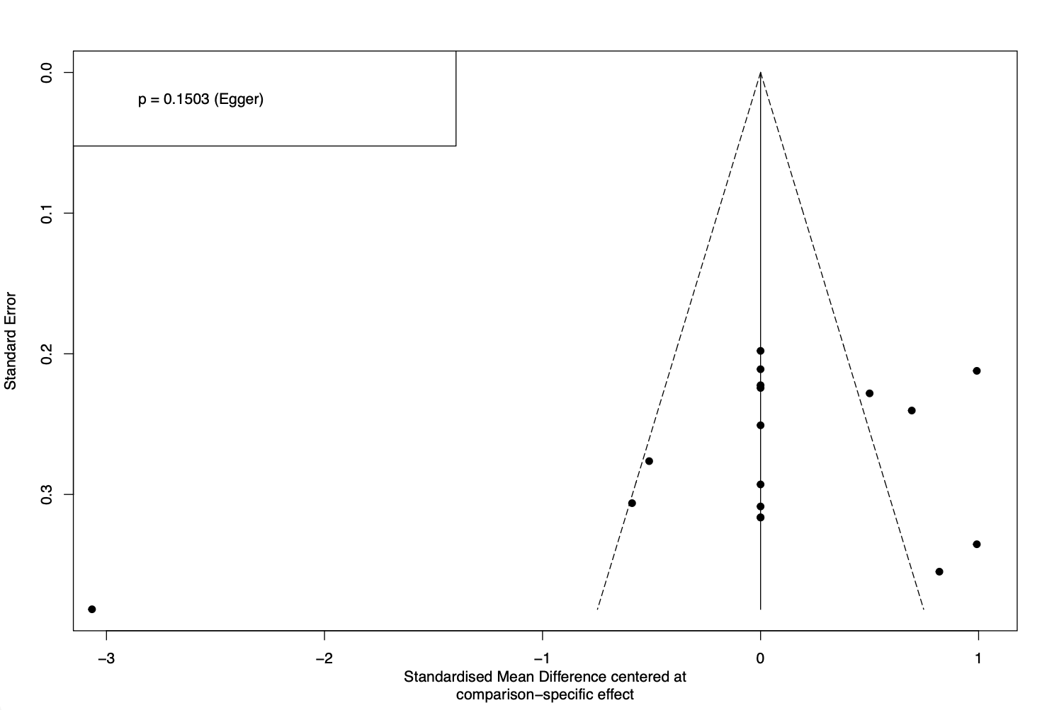
Supplementary Figure 3. Comparison-adjusted funnel plot for the assessment of publication bias in the short-term disease severity network. The X-axis represents the standardized mean difference centered at the comparison-specific effect, and the Y-axis represents the standard error. The symmetrical distribution and Egger's test result (p = 0.1503) indicate a low risk of publication bias.

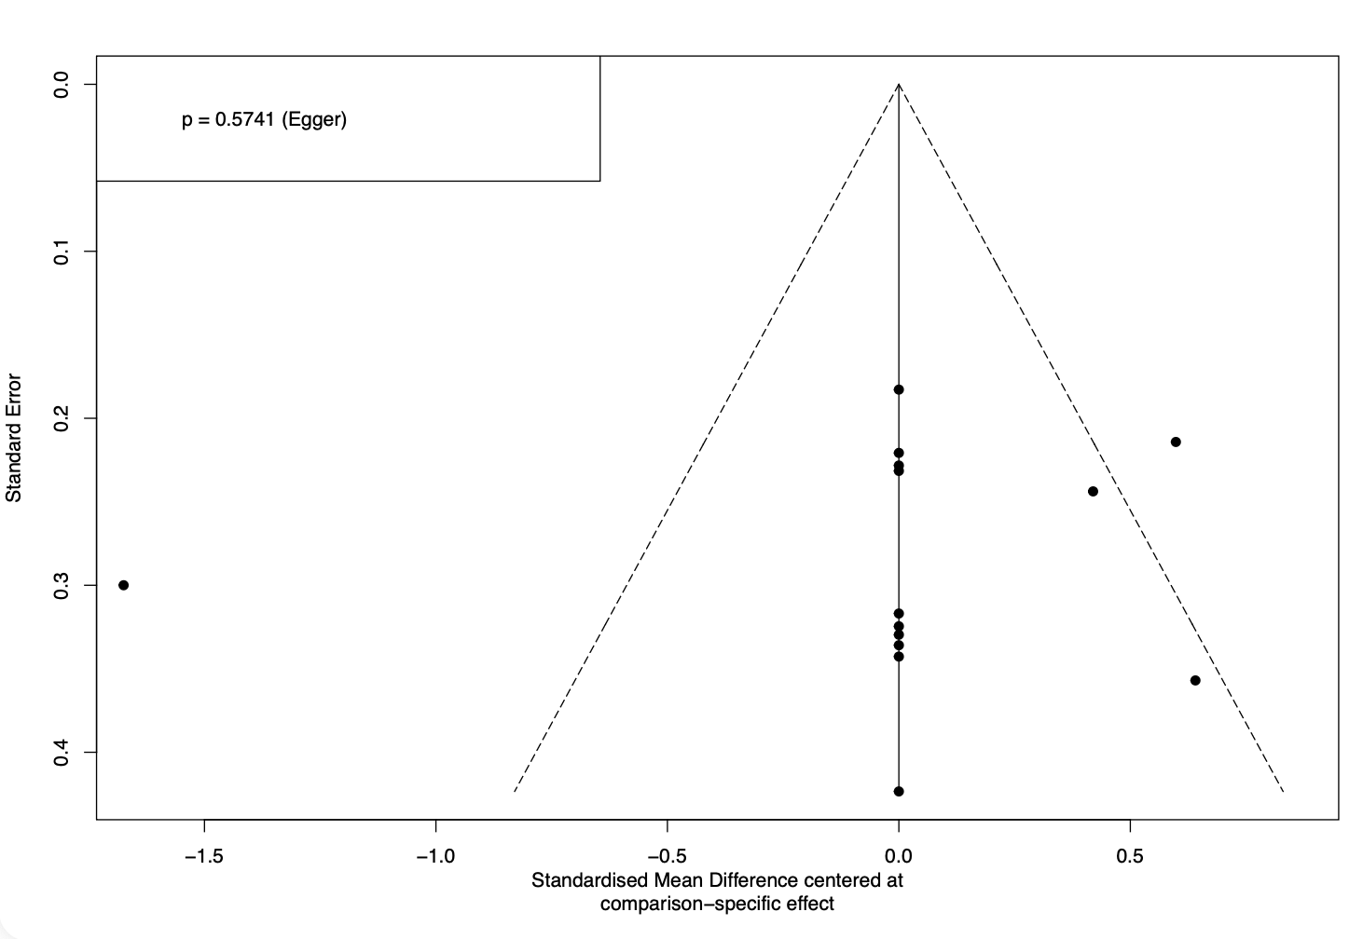
Supplementary Figure 4. Comparison-adjusted funnel plot for the assessment of publication bias in the long-term disease severity network. The X-axis represents the standardized mean difference centered at the comparison-specific effect, and the Y-axis represents the standard error. Egger's test (p = 0.5741) confirmed the absence of significant asymmetry.

