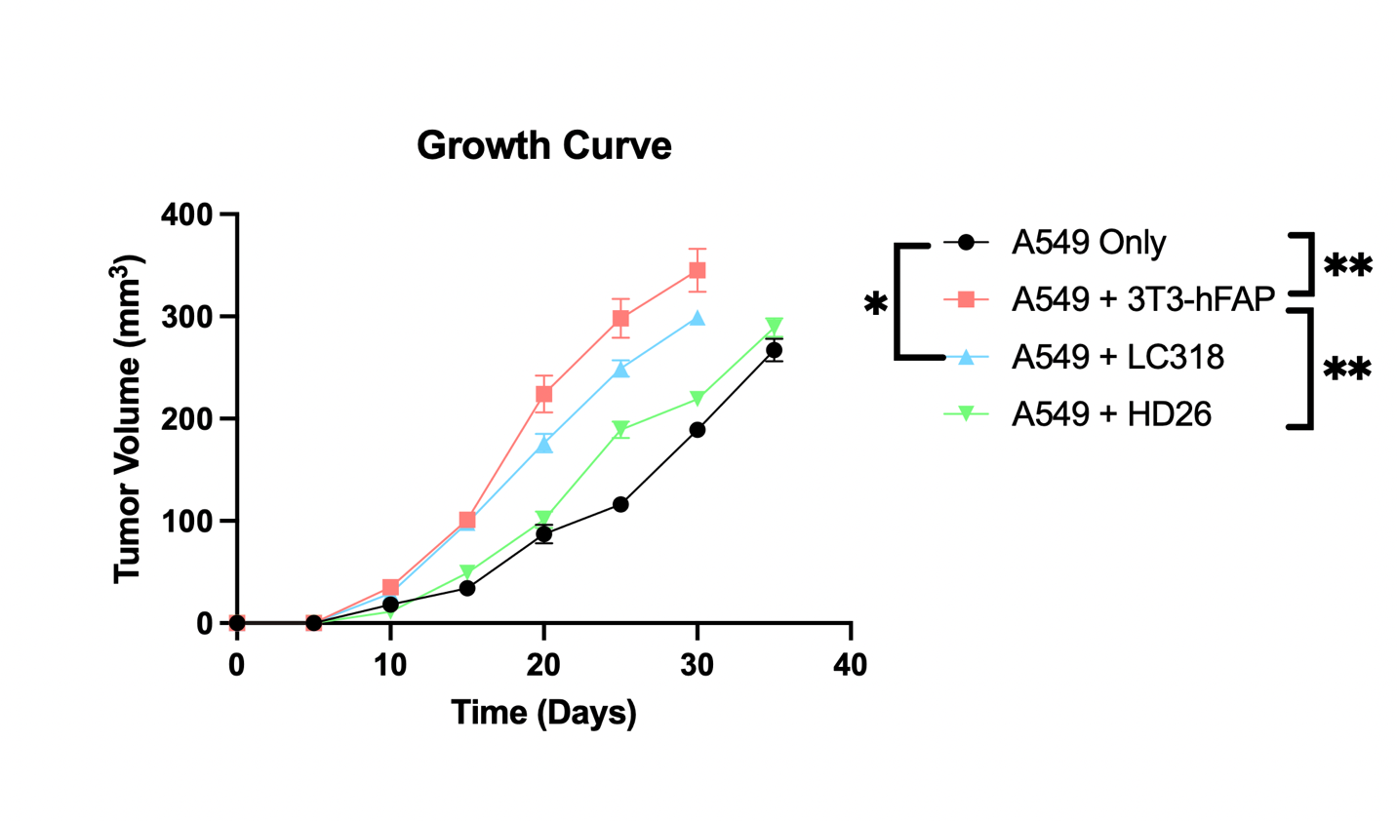
Supplementary Figure 1: Growth curve of A549 xenograft model co-cultured with 3T3 hFAP, LC318, and HD26 fibroblasts demonstrates presence of fibroblasts is associated with faster and larger flank xenografts with largest effect seen with the presence of CAFs as compared to normal lung fibroblasts. *(p<0.05), **(p<0.01). Individual growth values are provided in supplementary table 1.

