Figure S1. Bootstrapped confidence intervals of edge weights
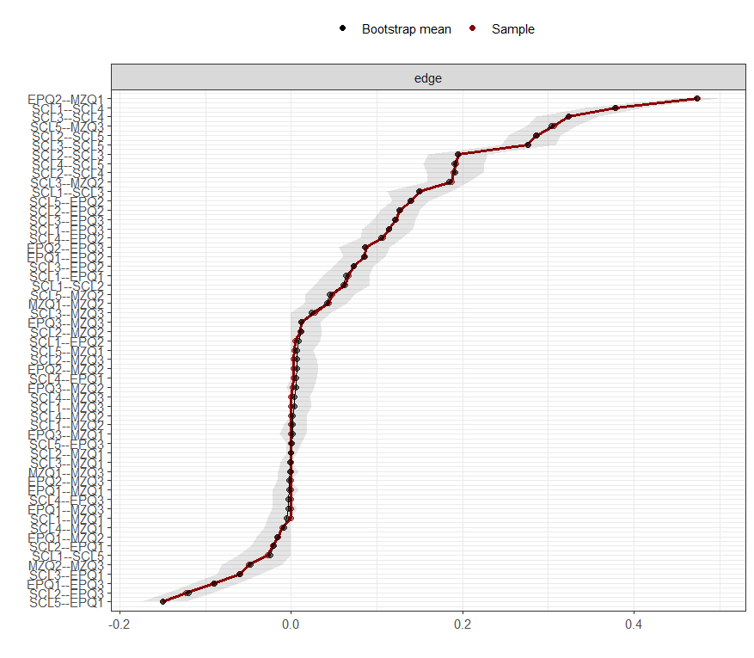

Figure S2. Estimation of edge weight difference by bootstrapped difference test
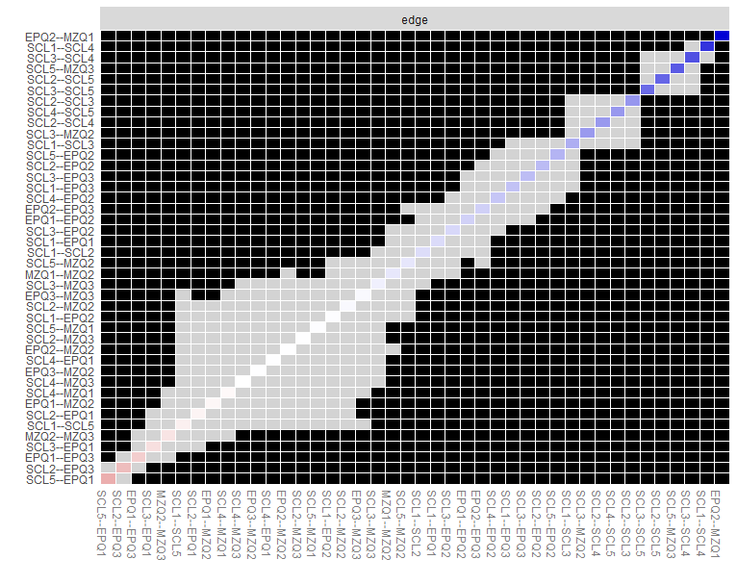
Figure S3. Nonparametric bootstrapped difference test
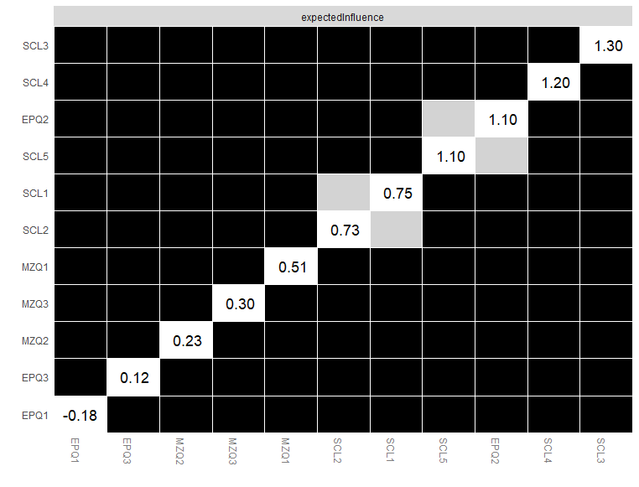
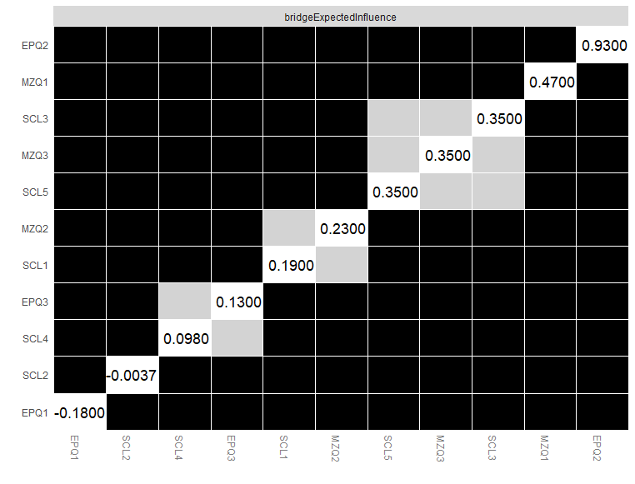

Table S1. Correlation matrix of the items
 | SCL1 | SCL2 | SCL3 | SCL4 | SCL5 | EPQ1 | EPQ2 | EPQ3 | MZQ1 | MZQ2 | MZQ3
SCL1 | 0.000
SCL2 | 0.063 | 0.000
SCL3 | 0.150 | 0.195 | 0.000
SCL4 | 0.379 | 0.189 | 0.324 | 0.000
SCL5 | -0.027 | 0.286 | 0.275 | 0.192 | 0.000
EPQ1 | 0.067 | -0.020 | -0.06 | 0.002 | -0.150 | 0.000
EPQ2 | 0.004 | 0.126 | 0.073 | 0.106 | 0.140 | 0.086 | 0.000
EPQ3 | 0.114 | -0.123 | 0.122 | 0.000 | 0.000 | -0.090 | 0.087 | 0.000
MZQ1 | 0.000 | 0.000 | 0.000 | -0.01 | 0.006 | 0.000 | 0.474 | 0.000 | 0.000
MZQ2 | 0.000 | 0.011 | 0.187 | 0.000 | 0.047 | -0.015 | 0.002 | 0.001 | 0.044 | 0.000
MZQ3 | 0.000 | 0.002 | 0.028 | 3.400 | 0.306 | 0.000 | 0.000 | 0.012 | 0.000 | -0.050 | 0.000

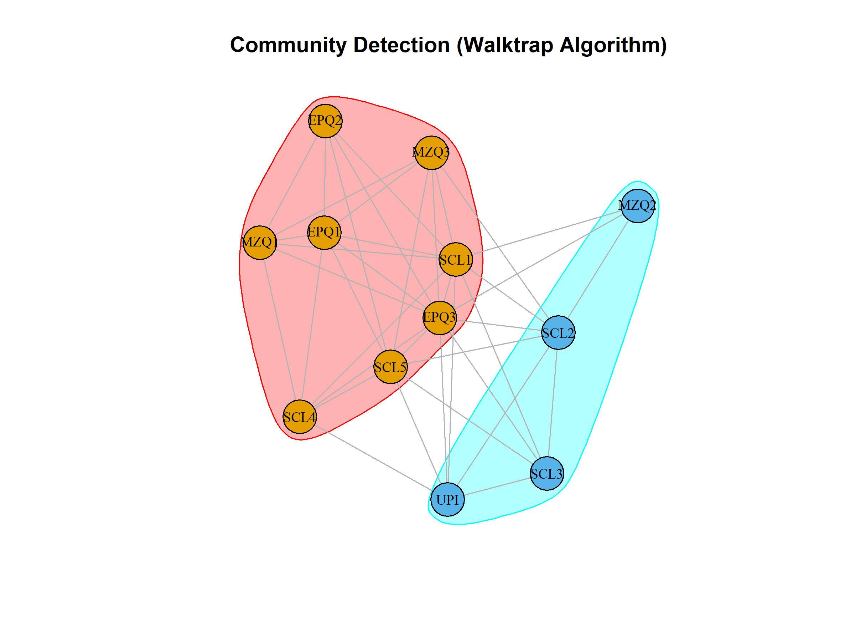

1. Community Detection via Walktrap Algorithm

Methods
Community detection was conducted using the walktrap algorithm (igraph package, R), based on 3-step random-walk similarity. Optimal community partitioning was determined by maximizing modularity (Q).

Results
Modularity Q = 0.062, confirming a weak-to-moderate community structure in this trans-domain psychological network.As shown in Supplementary Figure 1, the walktrap algorithm identified two empirical communities:
- Red community: EPQ1, EPQ2, EPQ3, MZQ1, MZQ3, SCL1, SCL4, SCL5 (personality-mentalizing-interpersonal distress cluster)
- Cyan community: MZQ2, SCL2, SCL3, UPI (general psychological distress cluster)

Figure Interpretation
The two data-driven communities partially overlapped with our theoretical a-priori grouping (Personality, Mentalizing, Psychological Distress). The merging of personality, mentalizing, and interpersonal distress nodes into one cluster empirically supports our core finding: neuroticism (EPQ2) acts as a critical bridge trait linking personality, mentalizing deficits, and distress. The cyan cluster reflects shared variance among general psychological distress symptoms and hypermentalizing (MZQ2).

