Supplementary Materials
Solanum incanum L. Ethanolic Extract: Phytochemical Profile, Multiple Target Bioactivities and In Silico Properties
Mejdi Snoussi¹, Ines El Mannoubi^{2,3}, Mongi Saoudi⁴, Awatef Elwej⁵, Qusai Alsenani¹, Mamdouh Alshammari¹, Mohd Adnan¹, Eid M.S. Azzam⁶, Arif Jamal Siddiqui¹, Flavio Polito⁷, Vincenzo De Feo⁷*, Emira Noumi¹, Adel Kadri^{2,8}*
¹Department of Biology, College of Science, University of Ha’il, P.O. Box 2440, Ha’il 2440, Saudi Arabia
²Department of Chemistry, Faculty of Science, Al-Baha University, Al-Baha, Kingdom of Saudi Arabia.
³Department of Chemistry, Faculty of Sciences of Gabes, University of Gabes, 6072 Gabes, Tunisia
⁴Laboratory of Biomathematics LR22ES01, Faculty of Sciences of Sfax, Sfax 3000, Tunisia
⁵Laboratory of Toxicology and Environmental Health, LR17ES06, Sciences Faculty of Sfax, University of Sfax, BP1171, 3000, Sfax, Tunisia
⁶Department of Chemistry, College of Science, University of Ha’il, Ha’il 81451, Saudi Arabia
⁷Department of Pharmacy. University of Salerno. Via Giovanni Paolo II. 132. Fisciano. 84084 Salerno. Italy
⁸Faculty of Science of Sfax, Department of Chemistry, Sfax University, B.P. 1171, Sfax 3000, Tunisia

*Corresponding Authors:
Prof. Vincezo De Feo, defeo@unisa.it
Prof. Adel Kadri, lukadel@yahoo.fr.

Table S1. UPLC Q-TOF–MS/MS of the ESIAPE untargeted metabolomics using negative and positive ESI modes
Peak  ID | Putative  metabolite  name ª  (Class) | RT  (min) | Precursor  m/z | Relative abundance (%) ^{b} | Error  (ppm) | Adduct | Reference  (m/z) | Formula | Dot product | Reverse dot product | Total score | MS/MS fragments | References
1 | Choline  (Cholines) | 1.144 | 104.1065 | 33.1 | -0.48 | [M]⁺ | 104.10645 | C₅H₁₄NO | 64.4 | 67.1 | 77.1 | 58.06541 (100%), 59.0731, 60.08010, 104.1066 | [58]
2 | alpha-Methyl-DL-serine  (Amino acids) | 1.158 | 118.0501 | 0.6 | 7.28 | [M-H]⁻ | 118.05096 | C₄H₉NO₃ | 49 | 85.2 | 79.7 | 86.02423, 88.03789, 118.05 (100%) | Massbank  MoNA
3 | Trigonelline  (Alkaloids) | 1.251 | 138.0546 | 13.3 | 2.61 | [M+H]⁺ | 138.05496 | C₇H₇NO₂ | 86.3 | 92.8 | 93.9 | 65.03814,  78.03293, 80.04895, 92.04791, 94.06359, 138.05325 (100%) | Massbank  MoNA  [59]
4 | D-(-)-Quinic acid  (Organic acids) | 1.270 | 191.0568 | 3.8 | -3.61 | [M-H]⁻ | 191.05611 | C₇H₁₂O₆ | 74.3 | 84 | 84.2 | 85.02903, 93.03408  111.04368, 127.04014, 173.04555,  191.05631 (100%) | Massbank  [60]
5 | Pipecolic acid  (Amino acids) | 1.299 | 130.0859 | 6.9 | 2.77 | [M+H]⁺ | 130.08626 | C₆H₁₁NO₂ | 82.9 | 83.6 | 90.6 | 82.06367,  84.07888 (100%),  130.08482 | Massbank  MoNA
6 | (-)-Shikimic acid  (Organic acids) | 1.308 | 173.0462 | 0.4 | -3.76 | [M-H]⁻ | 173.04555 | C₇H₁₀O₅ | 87.7 | 35 | 75.9 | 73.02885, 83.05064  93.03406 (100%), 99.04591, 111.04493, 137.02345, 155.03342, 173.04574 | HMDB  [61]
7 | Cytidine  (Pyrimidine nucleosides) | 1.326 | 244.0927 | 0.8 | 0.41 | [M+H]⁺ | 244.0928 | C₉H₁₃N₃O₅ | 79.8 | 78.9 | 83 | 95.02408, 112.04969 (100%), 244.11468 | Massbank  MoNA
8 | Uridine  (Pyrimidine nucleosides) | 1.414 | 245.0779 | 0.2 | -4.45 | [M+H]⁺ | 245.07681 | C₉H₁₂N₂O₆ | 68.3 | 68.5 | 76.9 | 70.06605, 113.03506 (100%), 133.04474, 245.16422 | Massbank  MoNA  HMDB
9 | D-(+)-Malic acid  (Organic acids) | 1.487 | 133.0141 | 0.4 | 1.13 | [M-H]⁻ | 133.01425 | C₄H₆O₅ | 96.1 | 62 | 85.8 | 71.01335, 72.99321  89.023, 115.00396 (100%), 132.86807, 133.01395 | Massbank  MoNA  [62]
10 | Adenine  (6-aminopurines) | 1.507 | 136.0613 | 3.8 | 3.45 | [M+H]⁺ | 136.06177 | C₅H₅N₅ | 82.7 | 84.7 | 90.8 | 65.01382, 67.02957,  92.02455, 94.03988,  119.03513, 136.06202 (100%) | Massbank  MoNA
11 | L-5-Oxoproline  (L- Pyroglutamic acid) | 1.598 | 128.0351 | 0.8 | 1.72 | [M-H]⁻ | 128.03532 | C₅H₇NO₃ | 88 | 79.5 | 85.9 | 128.03482 (100%) | Massbank MoNA
12 | L-Leucine  (Amino acids) | 1.623 | 130.0871 | 0.7 | 2 | [M-H]⁻ | 130.08736 | C₆H₁₃NO₂ | 63.2 | 74.5 | 76.5 | 130.08746 (100%) | Massbank MoNA
13 | Uracil  (Pyrimidones) | 1.642 | 113.0334 | 0.2 | 10.17 | [M+H]⁺ | 113.03455 | C₄H₄N₂O₂ | 88 | 70.2 | 83.8 | 70.02732, 96.00844  113.03269 (100%) | Massbank  MoNA
14 | D-Alloisoleucine  (Amino acids) | 1.653 | 132.101 | 2.7 | 6.81 | [M+H]⁺ | 132.1019 | C₆H₁₃NO₂ | 74.3 | 68.5 | 80.7 | 56.04969, 57.05771,  58.06554, 69.0699,  86.09565 (100%), 132.10163 | Massbank  MoNA
15 | Nicotinic acid  (Carboxylic acids) | 4.101 | 124.0384 | 0.3 | 7.34 | [M+H]⁺ | 124.03931 | C₆H₅NO₂ | 59.5 | 79.1 | 76.3 | 71.01502, 96.04654,  124.03946 (100%) | Massbank  MoNA
16 | L-tryptophan  (Amino acids) | 4.996 | 203.0825 | 0.5 | 0.49 | [M-H]⁻ | 203.0826 | C₁₁H₁₂N₂O₂ | 92 | 43.6 | 80.3 | 74.02487, 116.05104  142.06703, 159.093,  186.05813, 203.08389 (100%) | Massbank  MoNA
17 | Chlorogenic acid  (Phenolic acids) | 5.947 | 355.1024 | 3.4 | -0.11 | [M+H]⁺ | 355.10236 | C₁₆H₁₈O₉ | 85.9 | 72.1 | 83.5 | 89.03736, 117.03286,  135.04273, 145.02675,  163.03694 (100%), 355.1008 | Massbank  MoNA  [62]
18 | p- Hydroxybenzoic acid  (Phenolic acids) | 5.956 | 137.0242 | 1.1 | 1.53 | [M-H]⁻ | 137.02441 | C₇H₆O₃ | 86.3 | 86.3 | 92.4 | 93.03456 (100%), 137.02408 | Massbank  MoNA  [63]
19 | Luteolin di-O-glucoside (Flavonoids) | 6.034 | 609.1472 | 0.3 | -1.77 | [M-H]⁻ | 609.14612 | C₂₇H₃₀O₁₆ | 79.7 | 52.8 | 77.2 | 285.04094, 447.09503  489.10462, 609.14679 (100%) | Massbank  [64, 65]
20 | Daphnetin  (Coumarins) | 6.421 | 177.0197 | 1.0 | -2.09 | [M-H]⁻ | 177.01933 | C₉H₆O₄ | 92.3 | 73.9 | 86.1 | 89.0393, 105.03457  133.02965, 149.02513,  177.01951 (100%) | MoNA  [65]
21 | 5-Methoxysalicylic acid  (Phenolic acids) | 6.515 | 167.0343 | 0.3 | 4.13 | [M-H]⁻ | 167.03499 | C₈H₈O₄ | 75.5 | 69.4 | 79.5 | 108.02142, 123.04506,  152.01183 (100%), 167.03535 | Massbank  MoNA  HMDB  [66]
22 | Piperidine  (Piperidines) | 6.70 | 86.09581 | 0.1 | 7.2 | [M+H]⁺ | 86.09643 | C₅H₁₁N | 65.9 | 73.6 | 82.8 | 58.06491, 69.03134,  86.05598 (100%) | Massbank  MoNA
23 | 2-Hydroxy-4-methylpentanoate  (fatty acids) | 6.908 | 131.0715 | 0.3 | -0.99 | [M-H]⁻ | 131.07137 | C₆H₁₂O₃ | 86.6 | 84.7 | 88.4 | 85.06528 (100%), 131.07156 | Massbank  MONA
24 | Quercetin O-hexosyl-pentoside (Flavonoids) | 7.215 | 597.1443 | 1.7 | 1.21 | [M+H]⁺ | 597.14502 | C₂₆H₂₈O₁₆ | 74.8 | 69.3 | 78.4 | 303.05012 (100%), 597.14366 | Massbank  MoNA  [67]
25 | Cyanidin O-diglucoside  (Flavonoids) | 7.328 | 611.1614 | 0.2 | -2.13 | [M]⁺ | 611.1601 | C₂₇H₃₁O₁₆ | 75 | 68.3 | 80.9 | 287.05572 (100%),  449.10762, 611.17007 | [68]
26 | p-coumaric acid  (Phenolic acids) | 7.603 | 163.0407 | 0.2 | -3.86 | [M-H]⁻ | 163.04007 | C₉H₈O₃ | 87.7 | 67.8 | 83.2 | 119.05067 (100%), 163.04091 | Massbank  MoNA  [65]
27 | quercetin O-hexoside isomer 1  (Flavonoids) | 7.692 | 463.0878 | 1.0 | 0.86 | [M-H]⁻ | 463.0882 | C₂₁H₂₀O₁₂ | 91 | 59.1 | 81.5 | 300.02806, 301.03668,  463.08842 (100%) | Massbank  HMDB  [69]
28 | Cyanidin di-O-hexoside-pentoside (Flavonoids) | 7.766 | 581.1507 | 5.2 | -2 | [M]⁺ | 581.14954 | C₂₆H₂₉O₁₅ | 77.4 | 77.4 | 87.4 | 287.05419 (100%), 449.1076, 581.14957 | Massbank  MoNA  HMDB  [70]
29 | Quercetin  (Flavonoids) | 7.862 | 303.0507 | 0.1 | -2.54 | [M+H]⁺ | 303.04993 | C₁₅H₁₀O₇ | 77.4 | 77.4 | 87.4 | 137.01836, 153.0162, 165.01562, 201.052, 229.04763, 257.04331, 285.03743, 303.04801 (100%) | Massbank  MoNA  [71, 66]
30 | Kaempferol O-neohesperidoside (Flavonoids) | 7.897 | 593.1512 | 0.9 | -0.03 | [M-H]⁻ | 593.15118 | C₂₇H₃0O₁₅ | 88.4 | 81.1 | 86.4 | 284.03416, 285.04133, 593.15214 (100%) | Massbank  MoNA  [67, 72]
31 | Cyanidin O-rutinoside  (Flavonoids) | 8.149 | 595.1658 | 0.6 | -0.97 | [M]⁺ | 595.16522 | C₂₇H₃₁O₁₅ | 68.9 | 78 | 84.7 | 287.05396 (100%), 449.1089, 595.17914 | Massbank  MoNA  [73]
32 | quercetin O-hexoside isomer 2  (Flavonoids) | 8.211 | 463.0897 | 0.4 | -3.24 | [M-H]⁻ | 463.0882 | C₂₁H₂₀O₁₂ | 82.6 | 39.9 | 74.7 | 227.03462, 255.03187, 271.02247, 272.03502, 283.0312, 300.02919  301.03913, 343.07221,  463.09102 (100%) | Massbank  MoNA  HMDB  FOODB  [74]
33 | Beta-Indoleacetic acid  (Indoles) | 8.244 | 176.0696 | 0.1 | 5.68 | [M+H]⁺ | 176.0706 | C₁₀H₉NO₂ | 71.2 | 39.5 | 71.4 | 130.06356 (100%), 176.06956 | Massbank  MoNA
34 | Kaempferol O-glucoside (Flavonoids) | 8.271 | 447.0927 | 46.3 | 1.32 | [M-H]⁻ | 447.09329 | C₂₁H₂₀O₁₁ | 87 | 87.5 | 90.1 | 227.03488, 255.02985, 284.03193 (100%), 285.03941, 447.09138 | Massbank  MoNA  HMDB  FOODB  [63]
35 | Cyanidin 3-O-glucoside  (Flavonoids) | 8.311 | 449.1076 | 2.7 | -0.67 | [M]⁺ | 449.1073 | C₂₁H₂₁O₁₁ | 83.4 | 83.4 | 90.8 | 287.05241 (100%), 449.10681 | Massbank  MoNA  [73, 75]
36 | Isorhamnetin O-glucoside (Flavonoids) | 8.334 | 477.1037 | 17.5 | 0.31 | [M-H]⁻ | 477.10385 | C₂₂H₂₂O₁₂ | 85.8 | 78.6 | 88.5 | 243.03184, 257.0472  271.02618, 285.04239,  286.05071, 299.02129,  314.04408 (100%), 315.0538,  477.10415 | Massbank  MoNA  [76]
37 | Scopoletin  (Coumarins) | 8.356 | 193.0494 | 3.0 | 0.67 | [M+H]⁺ | 193.04953 | C₁₀H₈O₄ | 92.7 | 31 | 75.8 | 66.04567, 77.03759, 81.03251, 94.03974, 105.03202, 122.03553,  133.02855 (100%), 137.05964, 150.03073, 178.02602, 193.04932 | [77]
38 | Luteolin  (Flavonoids) | 8.492 | 287.0551 | 7.5 | 0.07 | [M+H]⁺ | 287.05502 | C₁₅H₁₀O₆ | 76.6 | 79.8 | 82.1 | 121.02719, 153.01771,  165.01726, 241.04871,  257.05232, 287.0546 (100%) | Massbank  MoNA  [78]
39 | Petunidin O-glucoside (Flavonoids) | 8.595 | 479.1173 | 10.8 | 1.17 | [M]⁺ | 479.11786 | C₂₂H₂₃O₁₂ | 84.3 | 85.8 | 90 | 85.02656, 203.03147,  217.04614, 245.04344,  246.05125, 274.0454,  302.04051, 317.0632 (100%), 479.1152 | Massbank  MoNA  HMDB  [68, 71]
40 | Isorhamnetin  (Flavonoids) | 8.604 | 317.0645 | 3.3 | 3.41 | [M+H]⁺ | 317.06558 | C₁₆H₁₂O₇ | 88.8 | 80.2 | 85.5 | 153.01804, 217.04906, 245.04485, 257.04365, 274.04669, 285.03815, 302.04053, 317.06223 (100%) | Massbank  MoNA  HMDB  FOODB  [71, 76]
41 | Indole-3-carbaldehyde  (Indoles) | 8.865 | 144.0449 | 2.5 | 4.1 | [M-H]⁻ | 144.04549 | C₉H₇NO | 68 | 74.6 | 83.7 | 126.03405, 142.02871,  143.58649, 144.04493 (100%) | Massbank  MoNA  HMDB
42 | Peonidin O-glucoside (Flavonoids) | 9.236 | 463.1227 | 0.2 | 0.48 | [M]⁺ | 463.12292 | C₂₂H₂₃O₁₁ | 84.3 | 85.8 | 90 | 258.05678, 286.04922,  301.07388 (100%), 463.12397 | Massbank  HMDB  [68, 71]
43 | L-β-homotyrosine-HCl  (Amino acids) | 14.747 | 194.0829 | 0.8 | -3.3 | [M-H]⁻ | 194.08226 | C₁₀H₁₃NO₃ | 66.4 | 55.9 | 75.3 | 133.06578, 134.03698,  149.06085, 176.07114,  194.08204 (100%) | Massbank  MoNA
44 | γ-Linolenic acid  (Fatty acids) | 21.050 | 277.2174 | 20.2 | -0.29 | [M-H]⁻ | 277.21732 | C₁₈H₃₀O₂ | 67.9 | 73.5 | 79.7 | 233.22795, 259.20792,  277.21763 (100%) | Massbank  MoNA
ª All compounds were putatively annotated at Metabolomics Standards Initiative (MSI) Level 2
^{b} Values are semi-quantitative and not indicative of absolute concentrations

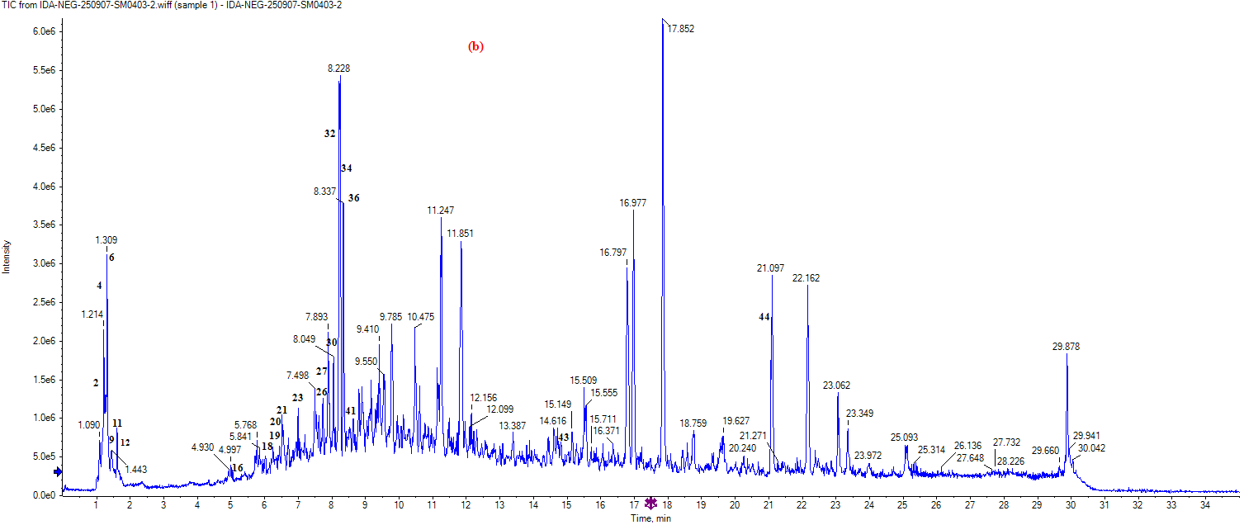
Fig. S1. Total ion chromatograms (TIC) of the ESIAPE in (a) ESI positive mode, (b) ESI negative mode

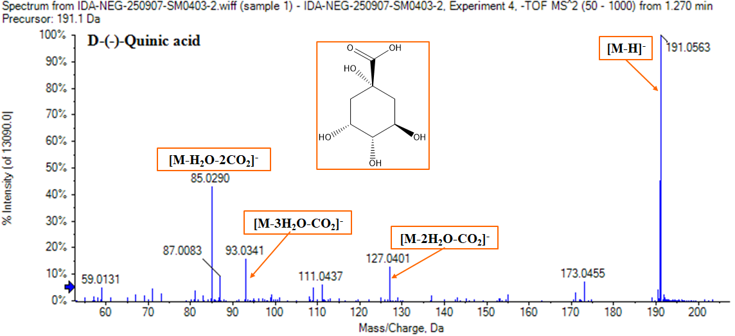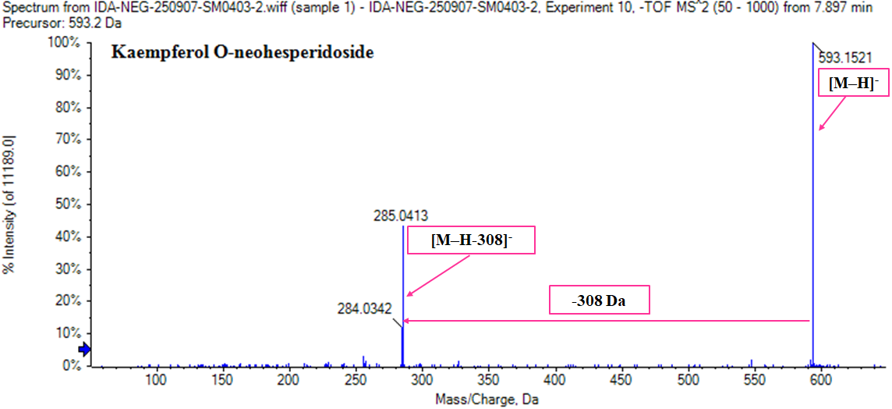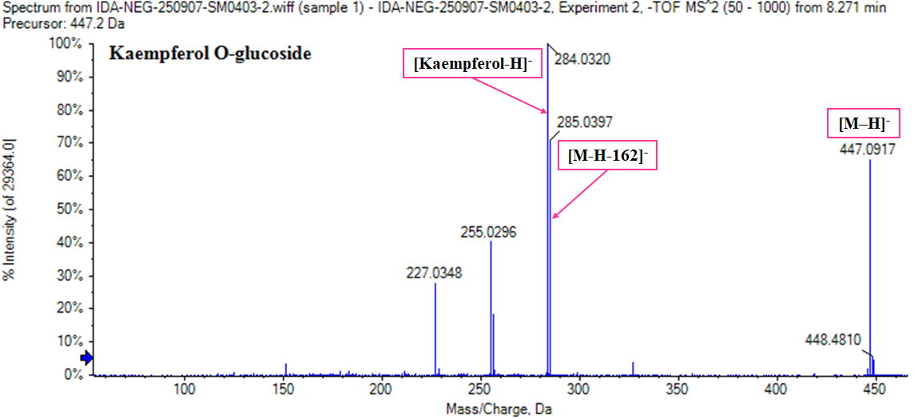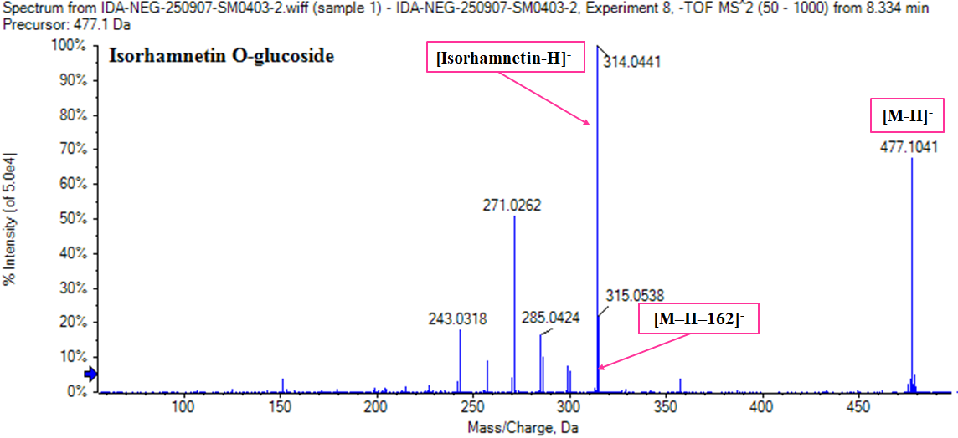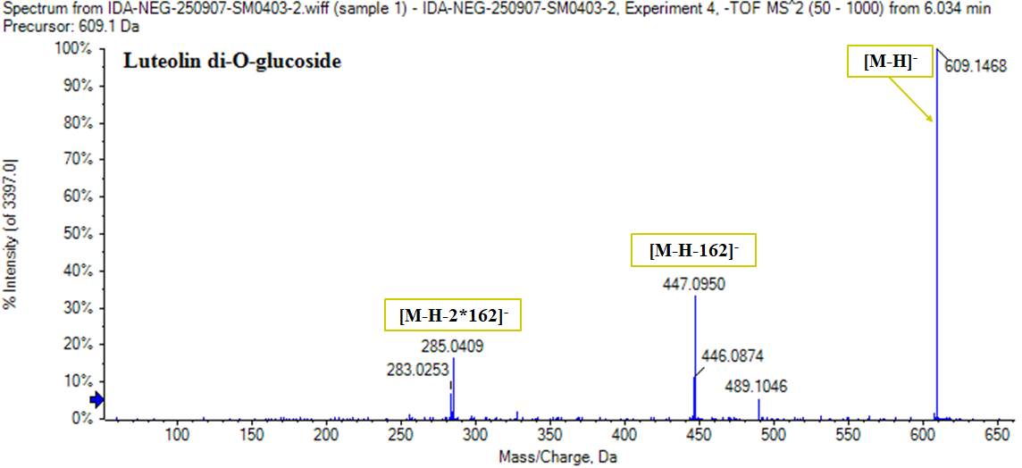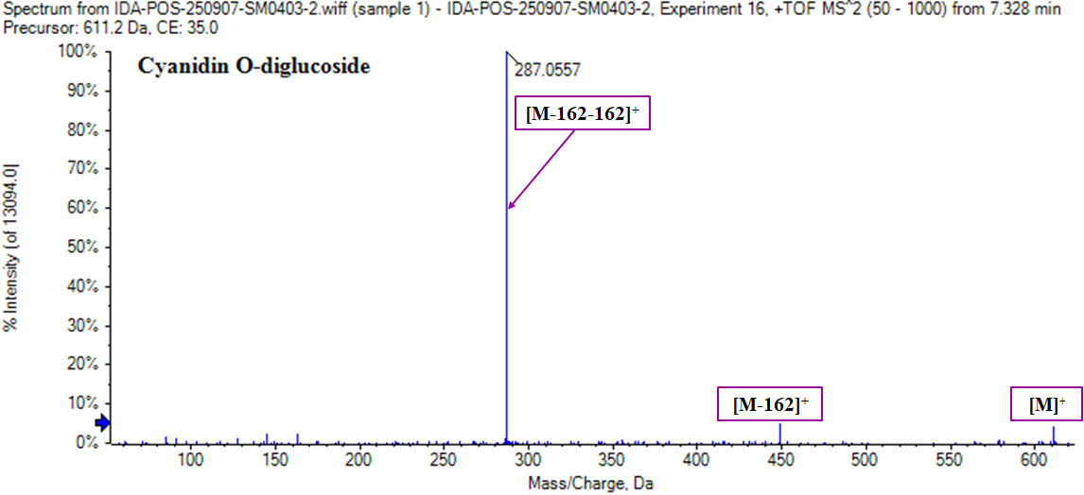
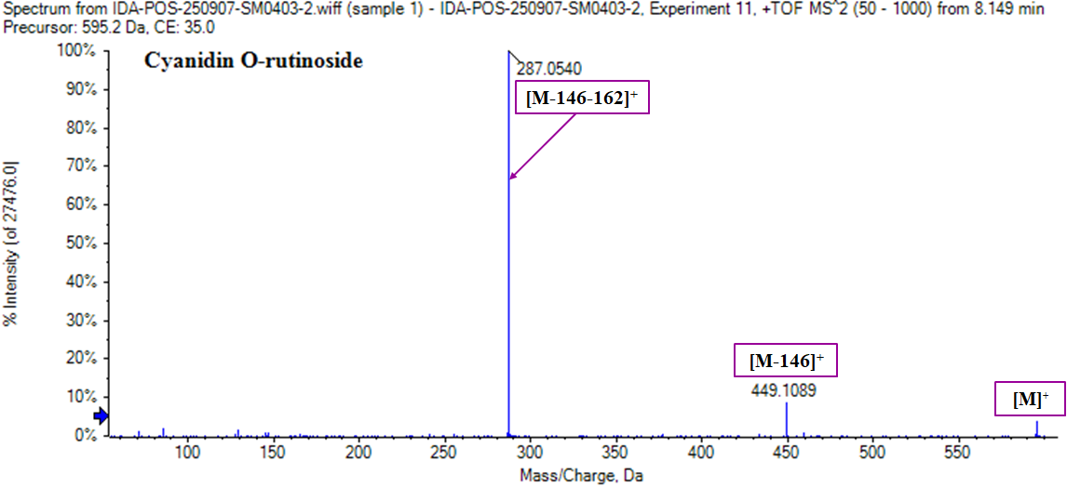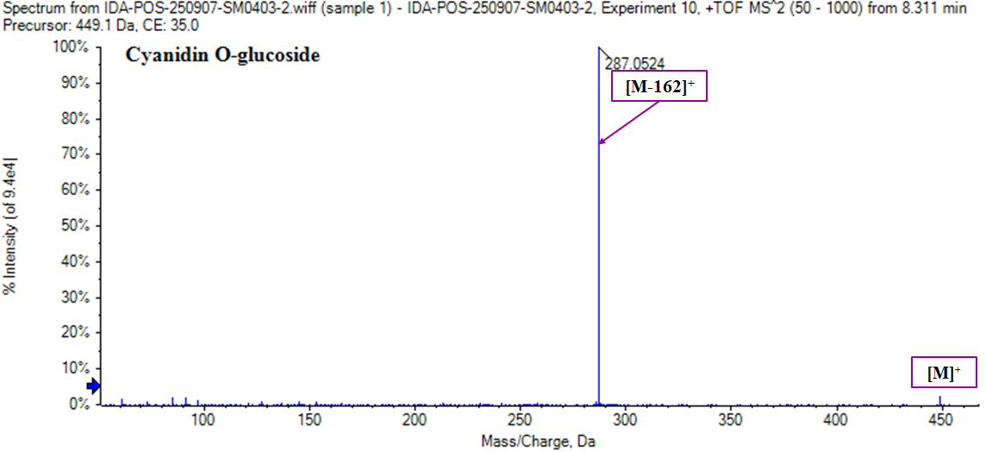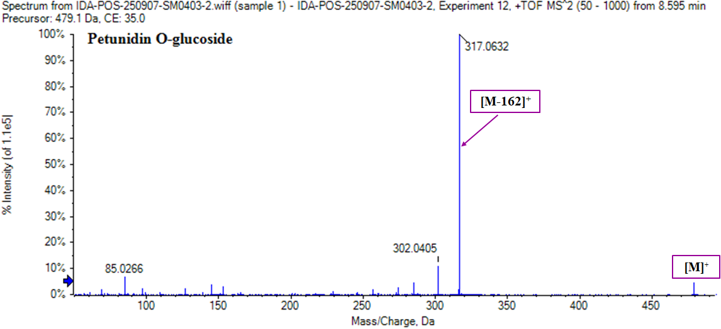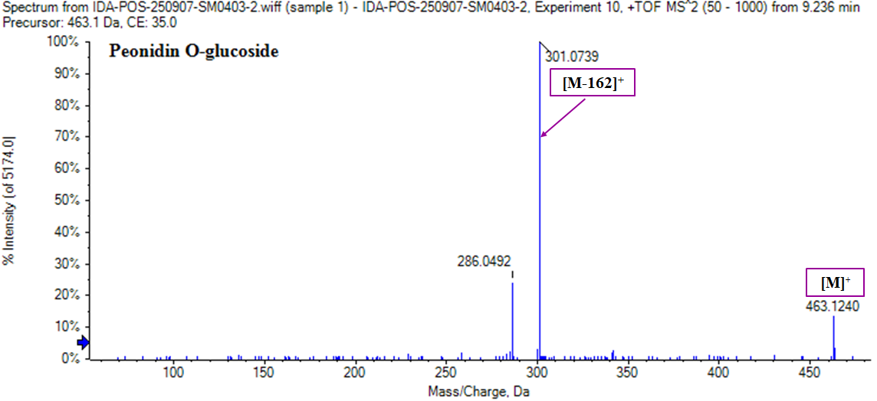
Fig. S2. The MS/MS spectra and structures of some identified metabolomics of the ESIAPE.

