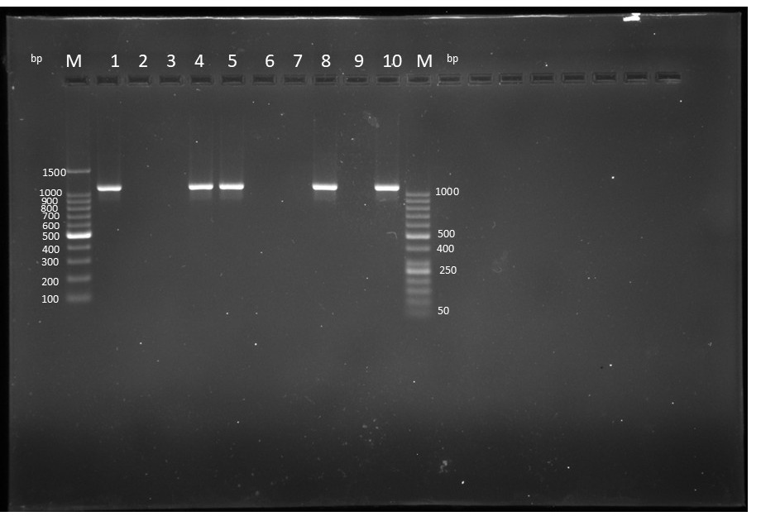

Suppl. Fig. S1a. 2% agarose gel showing PCR amplicons targeting Theileria genus-specific gene(1098bp) Lane M: 100 bp DNA Ladder (Takara, 3422A), Lane 1: Positive control, Lane 2: Non-template control, Lanes 4,5,8,10: Field samples from bovines positive for Theileria spp., Lanes 3,6,7,9: Field samples from bovines negative for Theileria spp., Lane M: 50 bp DNA Ladder (Fermentas, SM0371) (Original).
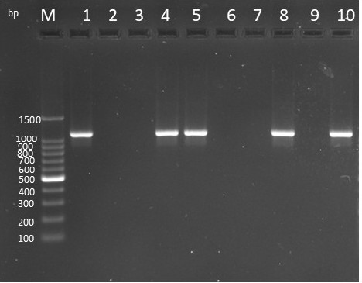

Suppl. Fig. S1b. 2% agarose gel showing PCR amplicons targeting Theileria genus-specific gene(1098bp) Lane M: 100 bp DNA Ladder (Takara, 3422A), Lane 1: Positive control, Lane 2: Non-template control, Lanes 4,5,8,10: Field samples from bovines positive for Theileria spp., Lanes 3,6,7,9: Field samples from bovines negative for Theileria spp. (Cropped).

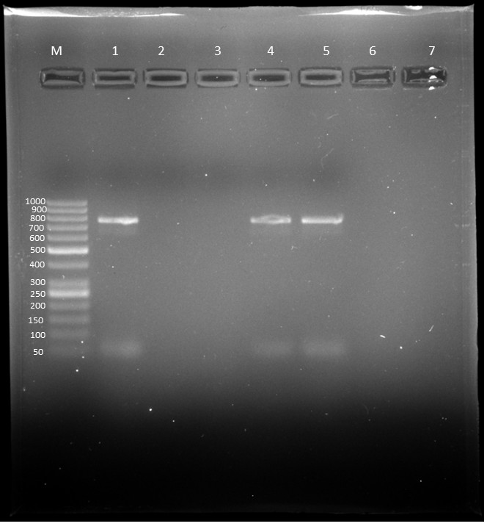

Suppl. Fig. S2a. 2% agarose gel showing PCR amplicons targeting MPSP gene of Theileria orientalis (776bp). Lane M: 50 bp DNA Ladder (Fermentas, SM0371), Lane 1: Positive control, Lane 2: Non-template control, Lane 3: Field sample of cattle negative for Theileria orientalis, Lanes 4,5: Field samples of cattle positive for Theileria orientalis. (Original).
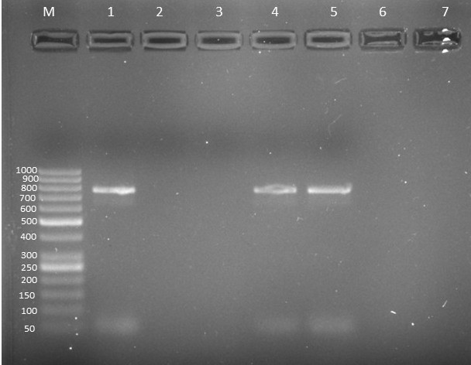

Suppl. Fig. S2b. 2% agarose gel showing PCR amplicons targeting MPSP gene of Theileria orientalis (776bp). Lane M: 50 bp DNA Ladder (Fermentas, SM0371), Lane 1: Positive control, Lane 2: Non-template control, Lane 3: Field sample of cattle negative for Theileria orientalis, Lanes 4,5: Field samples of cattle positive for Theileria orientalis.(Cropped).

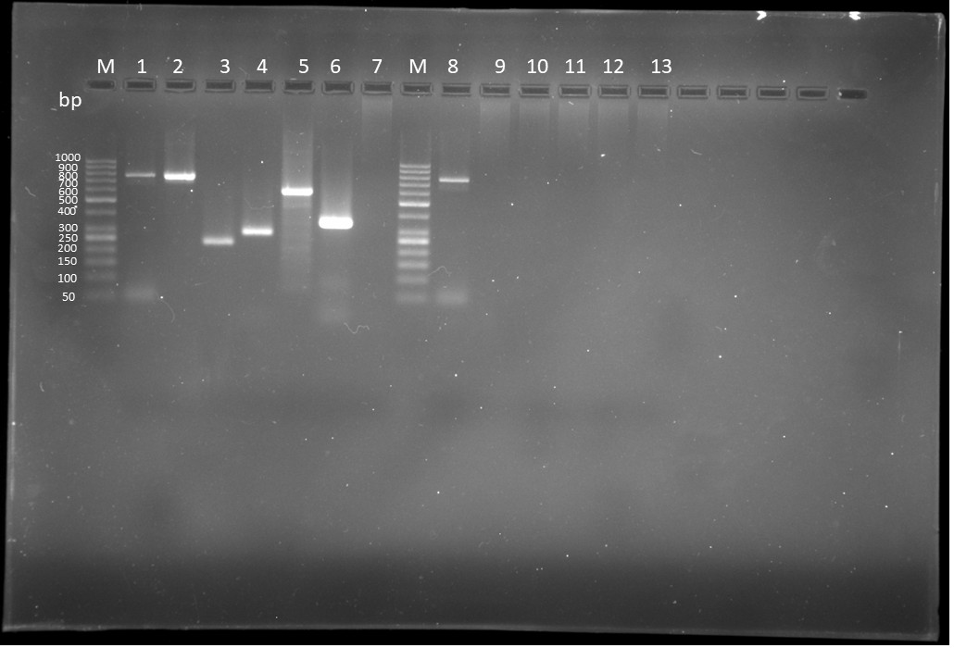

Suppl. Fig. S3a. 1.5% agarose gel showing analytical specificity of MPSP primer for Theileria orientalis. Lane M: 50 bp DNA Ladder (Fermentas, SM0371), Lane 1: Positive control for T. Orientalis (776 bp), Lane 2: Positive control for T.annulata (785 bp), Lane 3: Positive control for Trypanosoma evansi (227 bp), Lane 4: Positive control for Babesia bigemina (278 bp), Lane 5: Positive control for Theileria equi (595 bp), Lane 6: Positive control for Anaplasma marginale (344 bp), Lane 7: Negative control, Lane M: 50 bp DNA Ladder (Fermentas, SM0371), Lane 8: MPSP primer amplifying 776 bp specific for Theileria orientalis, Lanes 9-13: MPSP primer not showing cross reactivity to Theileria annulata, Trypanosoma evansi, Babesia bigemina, Theileria equi and Anaplasma marginale DNA, respectively.(Original).
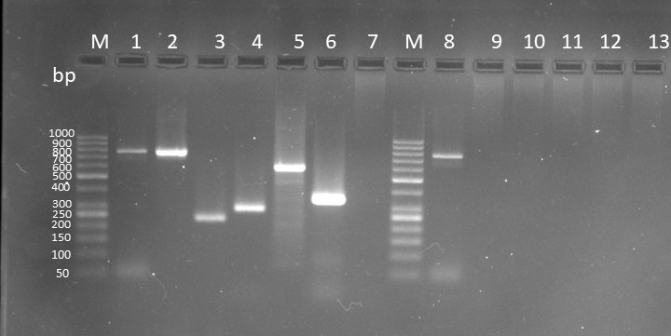

Suppl. Fig. S3b. agarose gel showing analytical specificity of MPSP primer for Theileria orientalis. Lane M: 50 bp DNA Ladder (Fermentas, SM0371), Lane 1: Positive control for T. Orientalis (776 bp), Lane 2: Positive control for T.annulata (785 bp), Lane 3: Positive control for Trypanosoma evansi (227 bp), Lane 4: Positive control for Babesia bigemina (278 bp), Lane 5: Positive control for Theileria equi (595 bp), Lane 6: Positive control for Anaplasma marginale (344 bp), Lane 7: Negative control, Lane M: 50 bp DNA Ladder (Fermentas, SM0371), Lane 8: MPSP primer amplifying 776 bp specific for Theileria orientalis, Lanes 9-13: MPSP primer not showing cross reactivity to Theileria annulata, Trypanosoma evansi, Babesia bigemina, Theileria equi and Anaplasma marginale DNA, respectively. (Cropped).

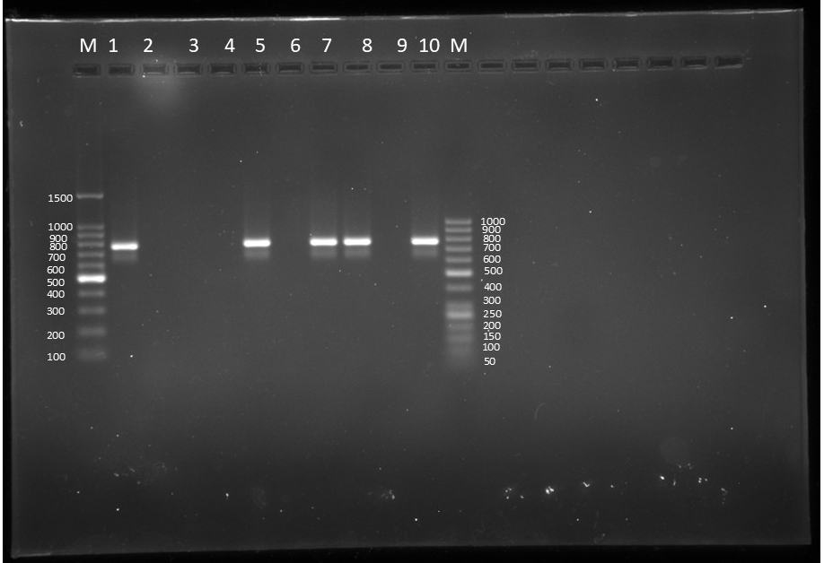

Suppl. Fig. S4a. 2% agarose gel showing PCR amplicons targeting T. annulata Tams1 (785 bp). Lane M: 100 bp DNA Ladder (Takara, 3422A), Lane 1: Positive control, Lane 2: Non-template control, Lanes 5, 7, 8, 10: Field samples from bovines positive for Theileria annulata, Lanes 3, 6,9: Field bovine samples negative for Theileria annulata, Lane M:50 bp DNA ladder (Fermentas, SM0371).(Original).
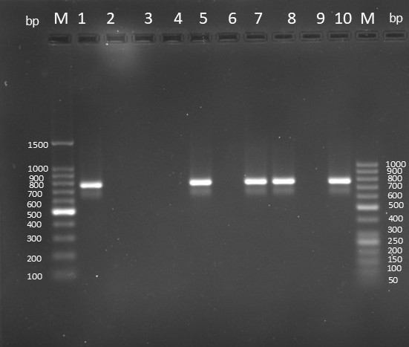

Suppl. Fig. S4b. 2% agarose gel showing PCR amplicons targeting T. annulata Tams1 (785 bp). Lane M: 100 bp DNA Ladder (Takara, 3422A), Lane 1: Positive control, Lane 2: Non-template control, Lanes 5, 7, 8, 10: Field samples from bovines positive for Theileria annulata, Lanes 3, 6,9: Field bovine samples negative for Theileria annulata, Lane M:50 bp DNA ladder (Fermentas, SM0371). (Cropped).

