Supplementary material S1:
Soil water holding capacity
Before placing the seeds, 5.4 L pots were fully soaked with tap water based on their maximum soil water holding capacity (WHC). The soil WHC was calculated using method described by Bajwa et al. ¹¹ to create drought/water stress conditions. The WHC was calculated using Eq. 1
$Soil water holding capacity (\%)=\frac{Wet soil weight-dry soil weight}{dry soil weight} × 100$ Eq. 1

Specific leaf area
Leaf area was recorded using the Li-Cor (LI-3100C) leaf area meter. A uniform sized leaf from each treatment was cut and leaf area was determined. The leaf was then placed in a paper bag and dried at 60°C for 72h and dry weight was recorded. The specific leaf area was calculated using the below formula (Eq. 2) as described by Perez-Harguindeguy et al.¹⁵.
$Specific leaf area =\frac{Leaf area ({cm}^{2})}{Dry weight (g)}$ Eq. 2
Relative water content
A fully expanded leaf from the top was excised using a pair of scissors and weighed using the 4 decimal points weighing balance (OHAUS Adventurer ARRV70). The excised leaf was then placed immediately in a zip-locked plastic bags and filled with water for 24 h. The turgid weight of the soaked leaf was recorded using the weight balance. Similarly, the leaf dry weighed was noted and relative water content of the leaves was measured using the formula (Eq. 3) established by Fariñas et al. ¹⁶:
$Relative water content (\%)=\frac{Fresh weight-turgid weight}{Fresh weight-dry weight} ×100$ Eq. 3

Supplementary Figure S1. Effect of different drought levels on seed germination percentage of the two annual ryegrass populations tested under Lab conditions in a preliminary experiment prior to main glasshouse experiment. The drought levels were imposed using solutions of different osmotic potentials roughly aligned with the drought levels chosen for glasshouse study. Data presented are the means with ± standard error

Supplementary Table S1. Effect of different drought levels on the specific leaf area of two populations of annual ryegrass at 7 weeks after imposing the drought treatment.
 | Specific leaf area at 7 weeks after drought (cm² g⁻¹)
Drought levels | Resistant population | Susceptible population | Mean (Drought)
100% of WHC | 206 ± 17.5 | 195 ± 32.1 | 201 ± 25.9
75% of WHC | 210 ± 12.5 | 261 ± 32.9 | 236 ± 26.1
50% of WHC | 234 ± 32.0 | 277 ± 42.3 | 256 ± 38.1
25% of WHC | 192 ± 15.5 | 221 ± 30.7 | 206 ± 24.7
12.5% of WHC | 206 ± 21.5 | 207 ± 30.2 | 206 ± 26.2
Mean (Populations) | 210 ± 21.4 | 232 ± 35.3
Significance (p value) | Population = 0.235, Drought = 0.270, Population × Drought = 0.795

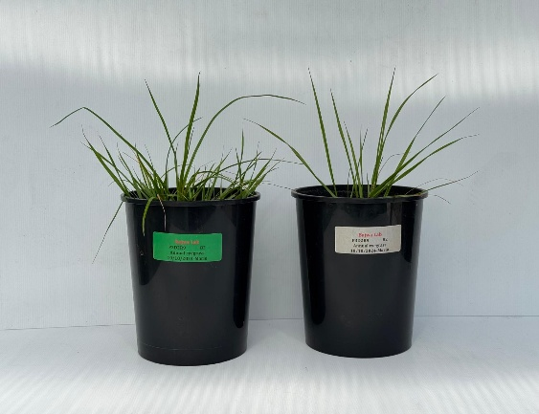  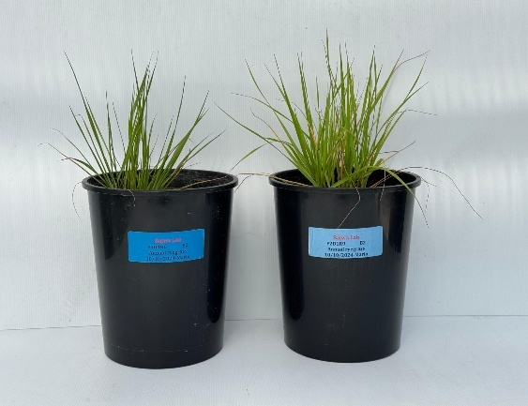  Susceptible  (a)  Resistant | Susceptible  (b)  Resistant
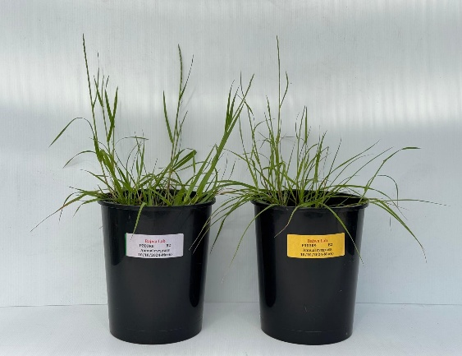  Susceptible  (c)  Resistant | 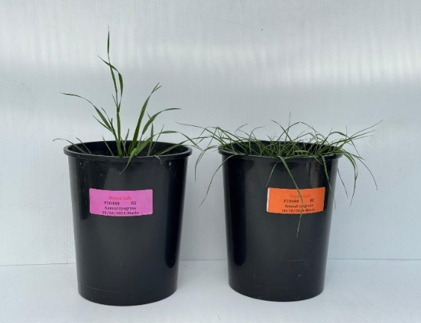  Susceptible  (d)  Resistant
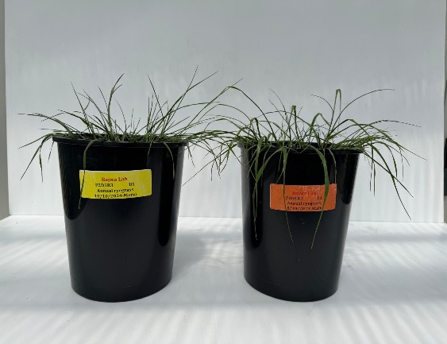  Susceptible  (e)  Resistant | 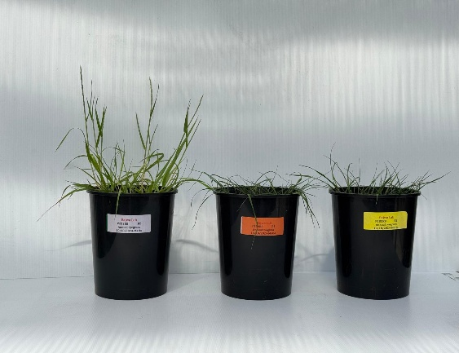  (f)  (12.5%)  (25%)  (50%)
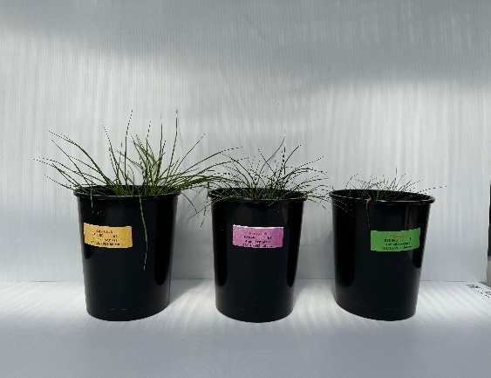  Susceptible  (g)  (12.5%)  (25%)  (50%) | 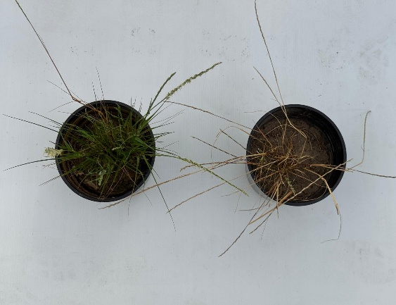  Resistant  (h)  (100%)  (12.5%)

Supplementary Figure S2. Differences in the number of tillers and leaves between herbicide susceptible and resistant populations of annual ryegrass under different varying soil moisture levels (a) 100, (b) 75, (c) 50, (d) 25, and (e) 12.5% of soil water holding capacity after 5 weeks of drought treatments under glasshouse conditions. (f) Tillers and leaves difference in resistant, and (g) susceptible populations after 5 weeks of drought treatments. (h) Visual response of resistant population of annual ryegrass grown under 100 and 12.5% of soil water holding capacity at harvest (after 14 weeks of drought treatment).

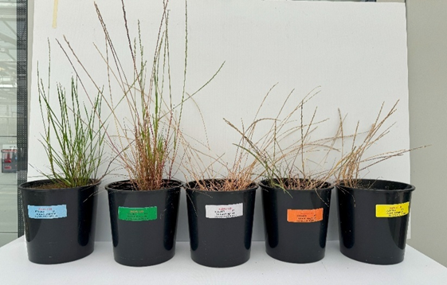

100% 75% 50% 25% 12.5%

Supplementary Figure S3. Effect of different soil moisture levels on plant height at harvest (after 14 weeks of drought treatment).

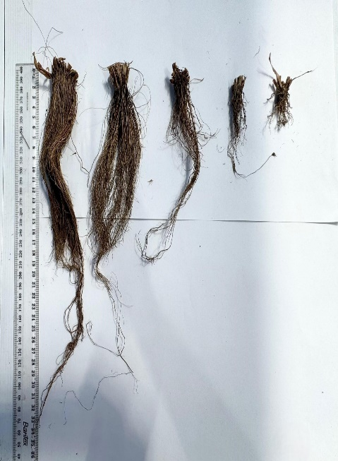 | 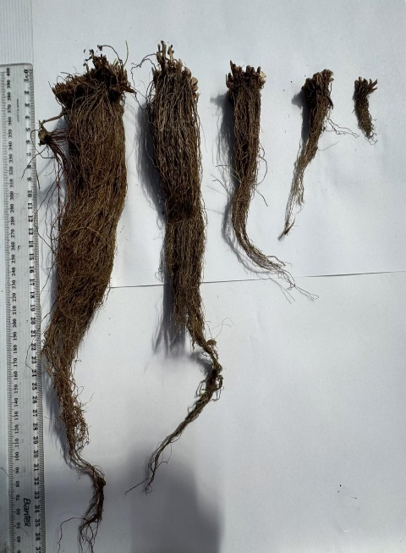
Supplementary Figure S4. Root lengths of herbicide susceptible (left) and herbicide resistant (right) populations of annual ryegrass harvested at 14 weeks after drought treatment. Both images represent the roots of plants grown under different soil moisture levels: 100%, 75%, 50%, 25%, and 12.5%, from left to right.

