A “turn-on” CRISPR-mediated method using enhanced fluorescent bimetallic DNA nanoclusters for EGFR mutation detection in non-small cell lung cancer
Fatemeh Goudarzi¹, Pouya Salehipour², Mohammad Hossein Modarressi^{2*}& Morteza Hosseini^{1*}
¹Nanobiosensors Lab, Department of Nanobiotechnology and Biomimetics, School of Life Science Engineering, College of Interdisciplinary Science and Technology, University of Tehran, Tehran, Iran
²Department of Medical Genetics, School of Medicine, Tehran University of Medical Sciences, Tehran, Iran

Corresponding Authors
*Mohammad Hossein Modarressi: Modaresi@tums.ac.ir
*Morteza Hosseini: Hosseini_m@ut.ac.ir

Table S1. Comparison of different nanocluster-based CRISPR detection methods.
Assay Principle | Reporter | Target | Detection Mode | LOD | Linear Range | Reference
Fluorescence | guanine-rich silver DNA-nanocluster | Meat Adulteration | Signal-off | 1.9 × 10⁻³ nM | 10 pM to 1 μM | ¹
Fluorescence | dual-color silver DNA-nanocluster | Salmonella Typhimurium | Ratiometric | 1 CFU/mL | 1 to 108 CFU/mL | ²
Fluorescence | Subak silver DNA-nanocluster | N/A | Fragmentation-induced  colour-switching | 1.19× 10⁻³ nM | N/A | ³
Fluorescence | DFN-1 silver DNA-nanocluster | Salmonella Typhimurium | Signal-off | 33 full genomic copies | N/A | ⁴
Colorimetric | Ag/Pt DNA-nanocluster | Carcinoembry-onic Antigen (CEA) | Signal-off | 0.94 pg/mL | 2.5 pg/mL to 2.0 ng/mL | ⁵
Fluorescence | CBMSR enhanced Ag/Au DNA-nanocluster | EGFR exon 19 deletion | Signal-on | 0.35 nM | N/A | This work

Table S2. Sequences of primers, gRNA, and DNA templates used in this work.
Name | Sequence (5′ to 3′)
F1 | GGTGAGAAAGTTAAAATTCCCGTC
R1 | CGAGGATTTCCTTGTTGGCTT
Deleted E746_A750  (Synthesized ssDNA) | GGTGAGAAAGTTAAAATTCCCGTCGCTATCAAAACATCTCCGAAAGCCAACAAGGAAATCCTCG
gRNA for normal EGFR | UAAUUUCUACUAAGUGUAGAUGGAGAUGUUGCUUCUCUUA
Nanocluster main DNA template | CCCTTAATCCCCTATAATAAATTT
Enhancer probe | AAATTTATTATAGGGTGGGGTGGGGTGGGG

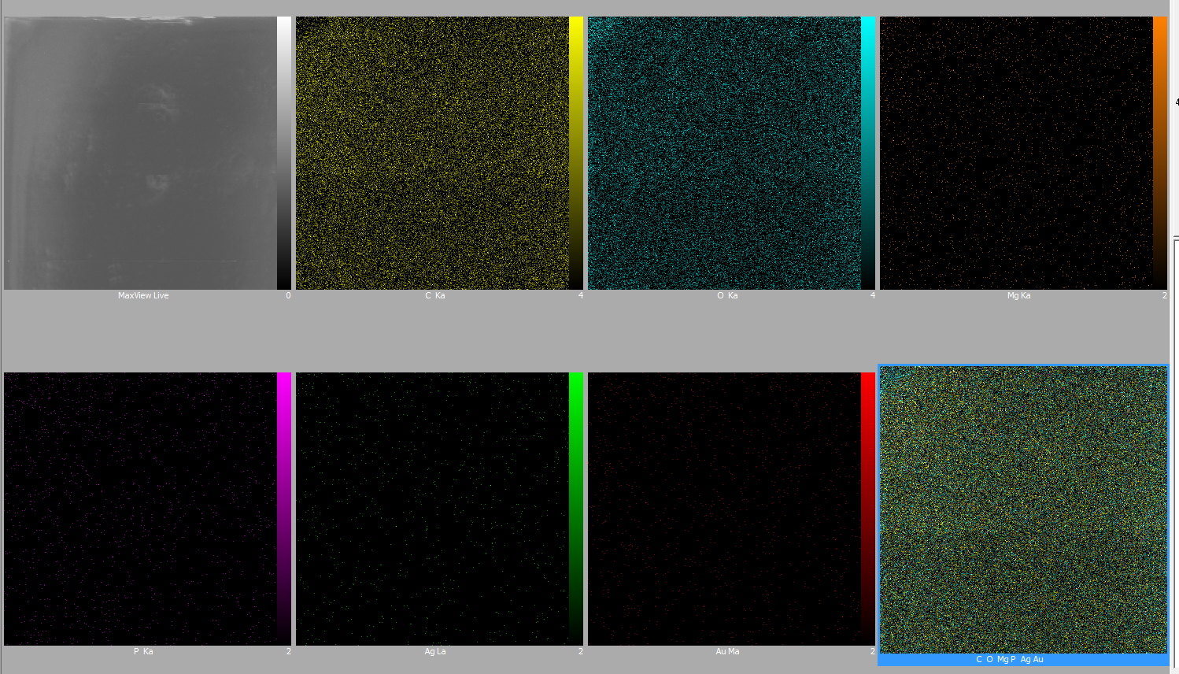
Fig. S1. EDX mapping images of different existing elements (C, O, Mg, P, Ag, Au) in the synthesized bimetal nanocluster.

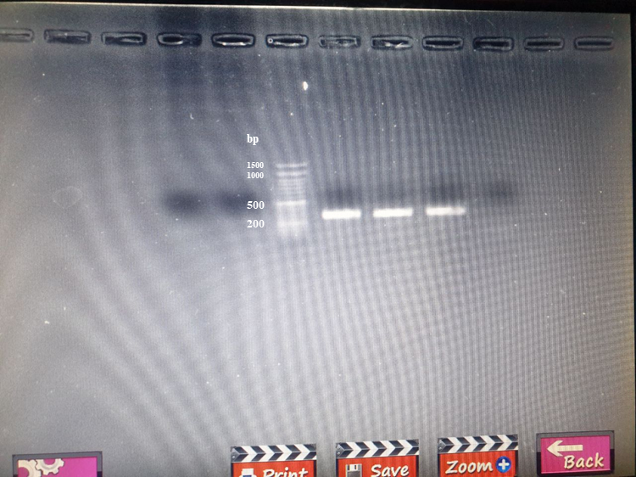
Fig. S2. PCR products of extracted genomic DNA gel electrophoresis.

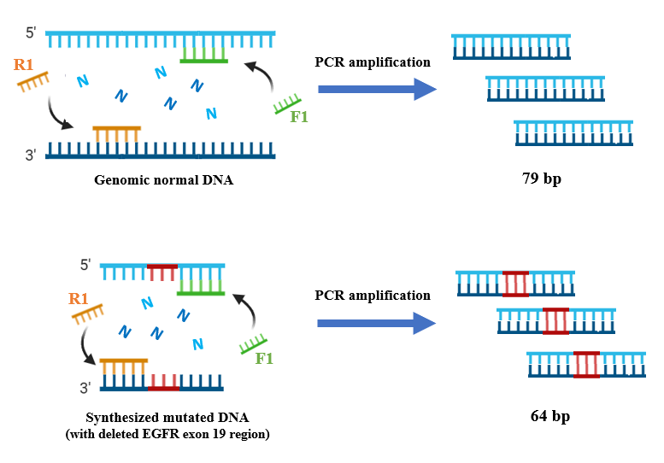
Fig. S3. Schematic of the PCR amplification process for normal and mutated EGFR (delE746_A750 subtype).

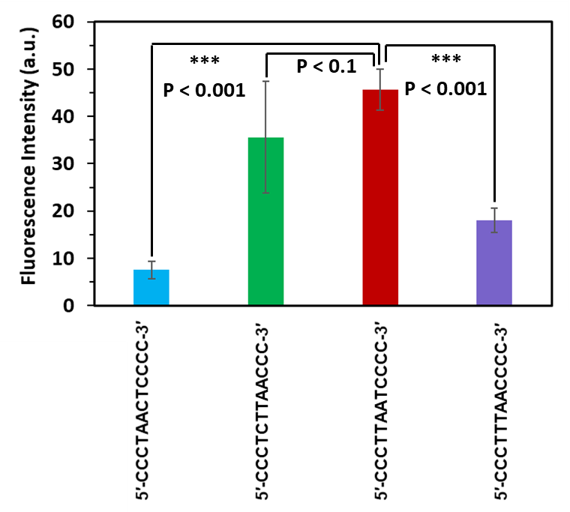
Fig. S4. Fluorescence intensity of different primary nanoclusters formed on four different 12-mer DNA templates. The 5′-CCCTTAATCCCC-3′ sequence showed the best result with the highest and most stable emission intensities through different measurements. Other sequences were not used due to low fluorescence intensity, large standard deviation and varying intensity levels observed across our different syntheses. Data are presented as mean ± SD (n = 3 independent experiments). Error bars represent Standard Deviation (SD). Statistical significance was determined using Student's t-test.

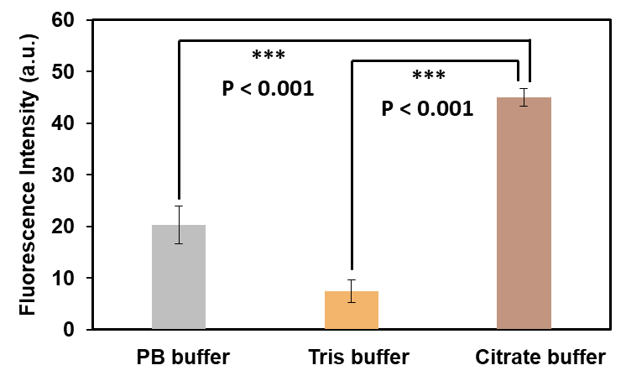

Fig. S5. The effect of three different buffers used in the synthesis of the bimetal nanocluster. The nanocluster made in Tris buffer had the least intensity, while Citrate buffer showed an improvement in nanocluster formation and its emission. PB buffer was also reported as an effective buffer in Ag DNA-nanocluster synthesis, which didn’t show promising results in Ag/Au DNA-nanocluster formation. Data are presented as mean ± SD (n = 3 independent experiments). Error bars represent Standard Deviation (SD). Statistical significance was determined using Student's t-test.

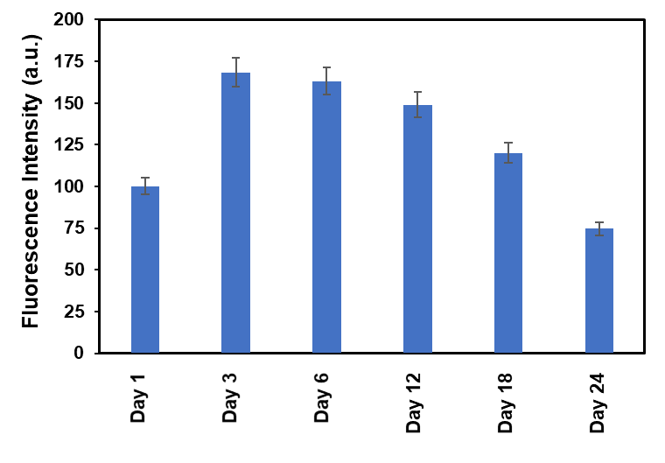
Fig. S6. Stability of the nanocluster through different time phases, which shows the nanocluster reached its highest emission on the third day and was stable and usable for over two weeks. Data are presented as mean ± SD (n = 3 independent experiments). Error bars represent ±5% of the mean.

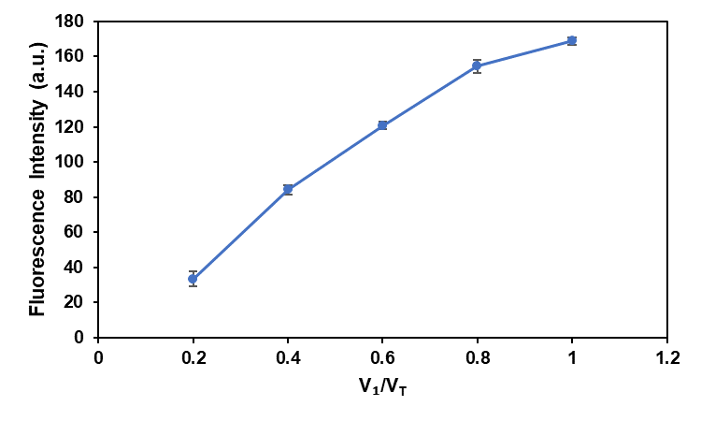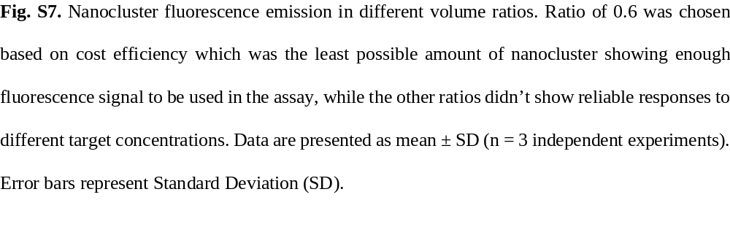

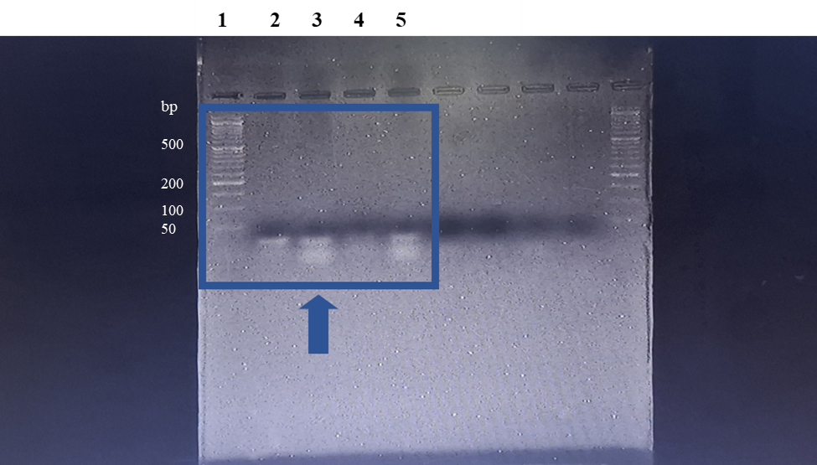

Fig. S8. Uncropped gel agarose electrophoresis image with DNA ladder. The 5 lanes from the left side show the samples related to our work.

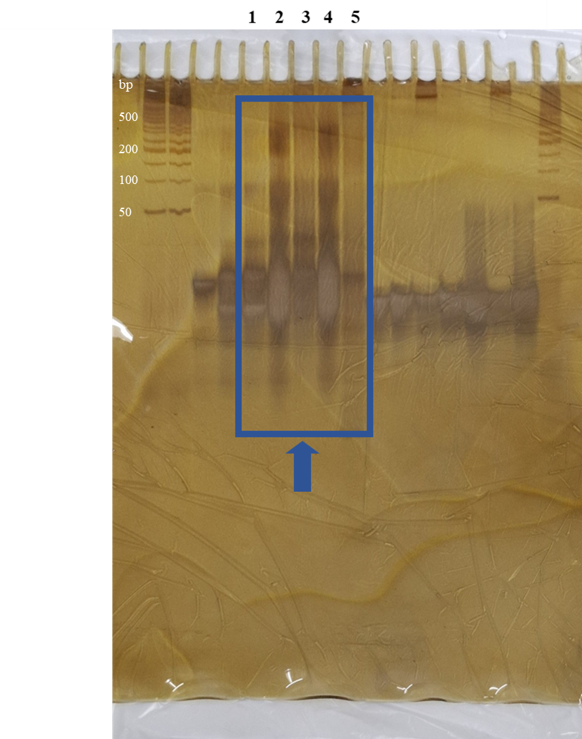

Fig. S9. Uncropped PAGE gel electrophoresis image with DNA ladder. The 5 lanes from the left side, which are numbered above, show the samples related to our work.

References
- Chen J., Liu J., Wu D. et al. CRISPR/Cas Precisely Regulated DNA-Templated Silver Nanocluster Fluorescence Sensor for Meat Adulteration Detection. J. Agric. Food Chem. 70, 14296–14303 (2022).
- Ma L., Wang J., Li Y. et al. A ratiometric fluorescent biosensing platform for ultrasensitive detection of Salmonella typhimurium via CRISPR/Cas12a and silver nanoclusters. J. Hazard. Mater. 443, 130234 (2023).
- Hong S., Walker J. N., Luong A. T. et al. A non-FRET DNA reporter that changes fluorescence colour upon nuclease digestion. Nat. Nanotechnol. 19, 810–817 (2024).
- Hanson E., Kalla N., Tharu R. J. et al. CRISPR-Responsive Reprogrammable Label-Free Fluorescent Nanoclusters for ML-Assisted Pathogenic Genome Detection on Solid Substrates. Small 21, 2500784 (2025).
- Mu X., Li J., Xiao S. et al. Peroxidase-mimicking DNA-Ag/Pt nanoclusters mediated visual biosensor for CEA detection based on rolling circle amplification and CRISPR/Cas 12a. Sens. Actuators B Chem. 375, 132870 (2023).

